ECOR 1010 – Introduction to Engineering

[Type Authors¹]
Assignment #6
Assignment Title: Bivariate Data: Linear Least-Square Regression
TO Marking TA:
Name: [Email]
Email: [Email]

Lab Section: [Email]
Room: – Carleton University

FROM:
Email: [Email]
Student Number: [Email]

Number of Figures and Tables (Including handwritten ones): 7
Last Date and Time of Revision: 19 November 2017

Introduction
The strength of two new types of steel needs to be determined based on their carbon contents. Recorded data of 9 other types of steel shows that the carbon content and strength of the steel are mostly proportional. In this case, strength will increase as the carbon content does. The first new steel has a carbon content weight of 0.33% which is in the range of the given data while the other type has a weight of 1.0% which is outside of the range. To predict the strength of these two steels we must interpolate and extrapolate using the data of the 9 other steels, respectively.

Materials and Methods
Recorded data from 9 other steels is organized into tables for analysis. The relationship of the two sets of data is to be analysed in 3 scatter plots regressed with different trends. The plotted data will be tested to see what regression trend is best to represent it. To see if it’s the best fit, the coefficient of correlation and determination will be calculated and compared to the generated ones using cubic and 6th order polynomial regression trends. Finally, using the three regression trends from the graphs, a prediction of both new steels will be determined.

Results
Calculating the predicted strength of the two new steels using the linear regression trend resulted in a strength of 386.6 MPa for 0.33% carbon content and 612.4 MPa for 1.0% carbon content, shown in table 3. Using the cubic regression trend, the predicted strength of the 0.33% carbon content steel is 379.1 MPa and 520.7 MPa for 1.0% carbon content. Lastly, using the 6th order polynomial regression trend, the predicted strength of the 0.33% carbon content steel is 360.3 MPa and -43.22 MPa for 1.0% carbon content.

Discussion
For accuracy and precision, the 6th order polynomial regression trend, in figure 5, best describes the given pairs of data since the R-squared value is 0.9941. But, as seen in the results, the predicted strength of the 1.0% carbon content steel using this trend is unreasonable and impossible since it is a negative pressure. The accuracy of the prediction made using a linear regression trend, in figure 3, is the highest. The strength of the 0.33% carbon content sits in between the 0.3% and 0.4% carbon contents steels where it should be as the data is proportional in that range. The strength of the 1.0% carbon content steel is also realistic. Even though the data isn’t completely proportional, as seen towards the end of the cubic regression line (figure 4), the linear prediction for the 1.0% steel is accurate since overall the plotted data has a consistent upward trend which means the steel has a better chance at having a higher strength than the previous 0.95% steel. Comparing the linear trend to the cubic trend, since the last data point causes a dip in the regression, the predicted values using a cubic trend will have a downwards trend past the last data point which is unrealistic.

Conclusions
While the 6th order polynomial and cubic trends describe the plotted data the best, the linear trend gives the most realistic prediction for the strength of the new 0.33% and 1.0% carbon content steels. The 6th order polynomial trend gives an impossible prediction for the 1.0% steel which makes it very unreliable. The cubic trend doesn’t predict an impossible strength but does predict an unrealistic downwards trend after the last data point.

APPENDIces- Figures and Tables
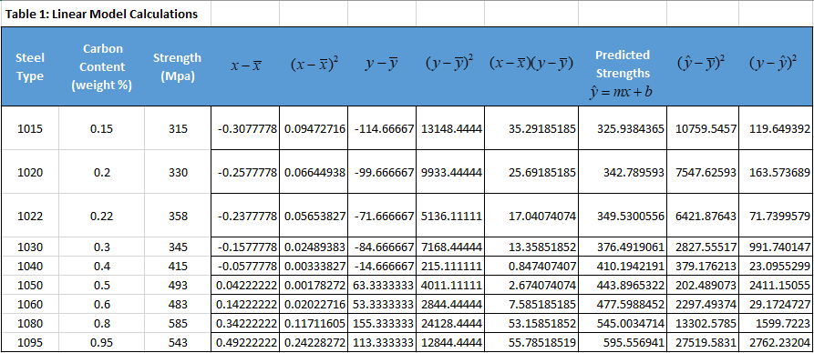
Figure 1: Analysis of given steel data
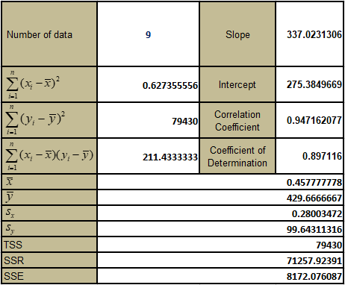

Figure 2: Excel Regression Summary Output Data
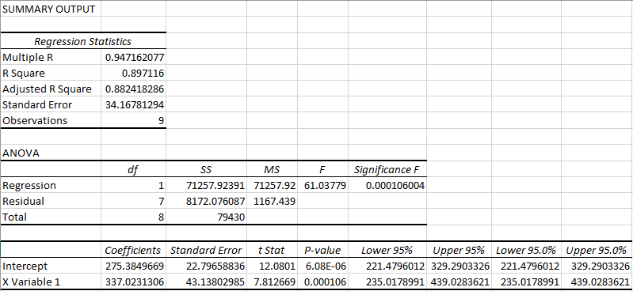

Figure 3: Carbon Content vs Strength graph with linear trend
Figure 4: Carbon Content vs Strength graph with cubic trend

Figure 5: Carbon Content vs Strength graph with 6th order polynomial trend

Table 3: Predicted strengths based on carbon content using three different trends
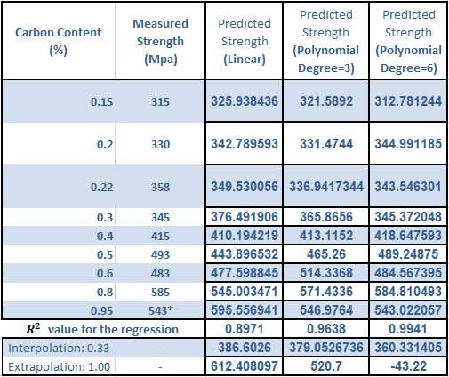

Sample Calculations:
$$r_{xy}=\frac{\sum_{i=1}^{n}{(x_{i}-\overline{x})(y_{i}-\overline{y})}}{\left(n-1\right)s_{x}s_{y}}$$
$$r_{xy}=\frac{\sum_{i=1}^{9}{[\left(0.15-\overline{0.4578}\right)\left(315 MPa-429.67 MPa\right)+…+\left(0.95-\overline{0.4578}\right)\left(543 MPa-429.67 MPa\right)]}}{\left(9-1\right)(0.28003)(99.64311 MPa)}$$
$$r_{xy}=0.95$$

$$SSR= \sum_{i=1}^{n}{{\left(\hat{y_{i}}-\overline{y}\right)}^{2}}= \sum_{i=1}^{9}{{\left(325.94 MPa-429.67 MPa\right)}^{2}+…+{\left(595.56 MPa-429.67 MPa\right)}^{2}}$$
$$=71257.92391 {MPa}^{2}=71258 {MPa}^{2}$$

$$SSE= \sum_{i=1}^{n}{{\left(y_{i}-\hat{y}\right)}^{2}}= \sum_{i=1}^{9}{{\left(315 MPa-325.94 MPa\right)}^{2}+…+{\left(543 MPa-595.56 MPa\right)}^{2}}$$
$$=8 172.076087 MPa^{2}=817 MPa^{2}$$

$$TSS=SSR+SSE=71 257.92391 MPa^{2}+8 172.076087 MPa^{2}$$
$$=79 429.999997 MPa^{2}=79 430 MPa^{2}$$

$$R^{2}=\frac{SSR}{TSS}=\frac{71 257.92391 MPa^{2}}{79 429.999997 MPa^{2}}$$
$$=0.897116=0.8971$$

