Q1
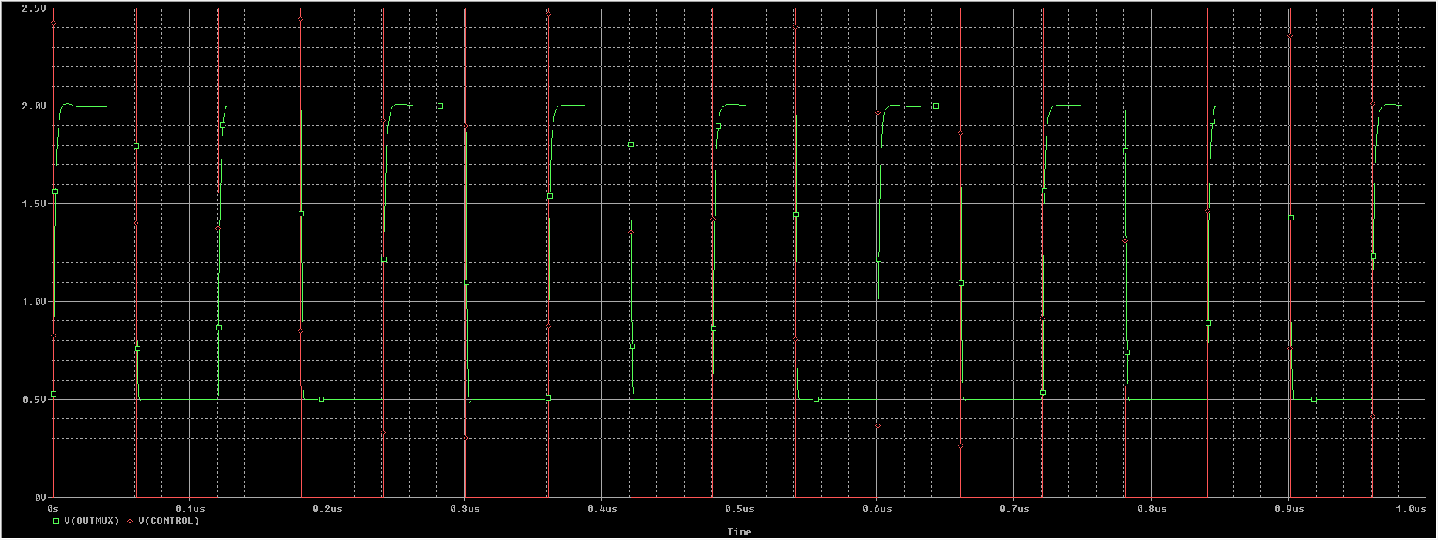
Q2.
Valid high
481.762n(clk) – 481.775n(output) = 12.5ps(delay)
Valid low
481.763n (clk) - 481.763n (output) = -134.304f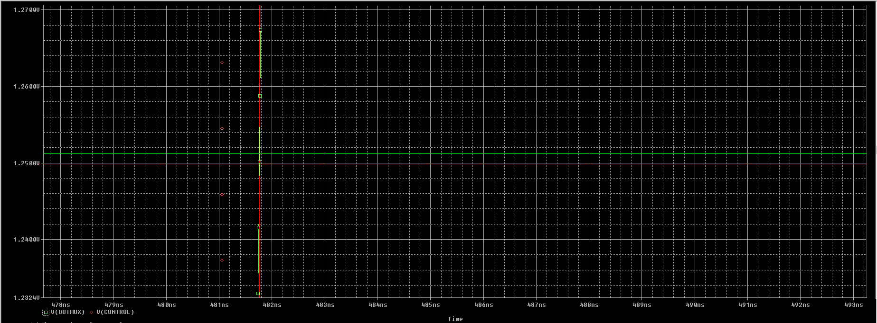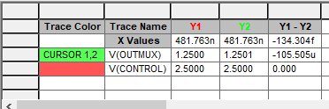

Q3.
Q4.
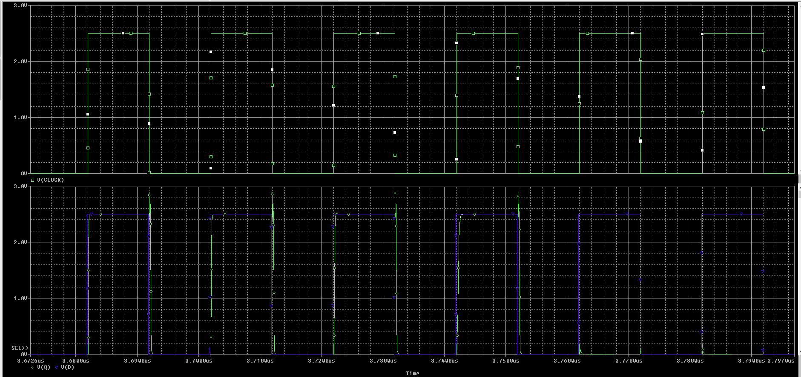

Q5
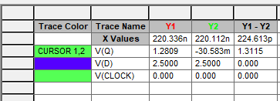
3.6718u-3.6723=436.934ps

Q6.
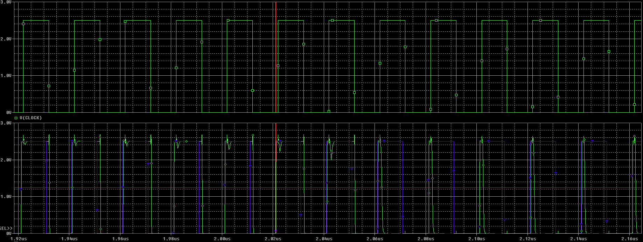

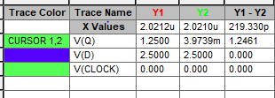
2.0212u(Vq) - 2.0210u(vD) = 219.591p
Capcitor not enough time to charge.
Q7.
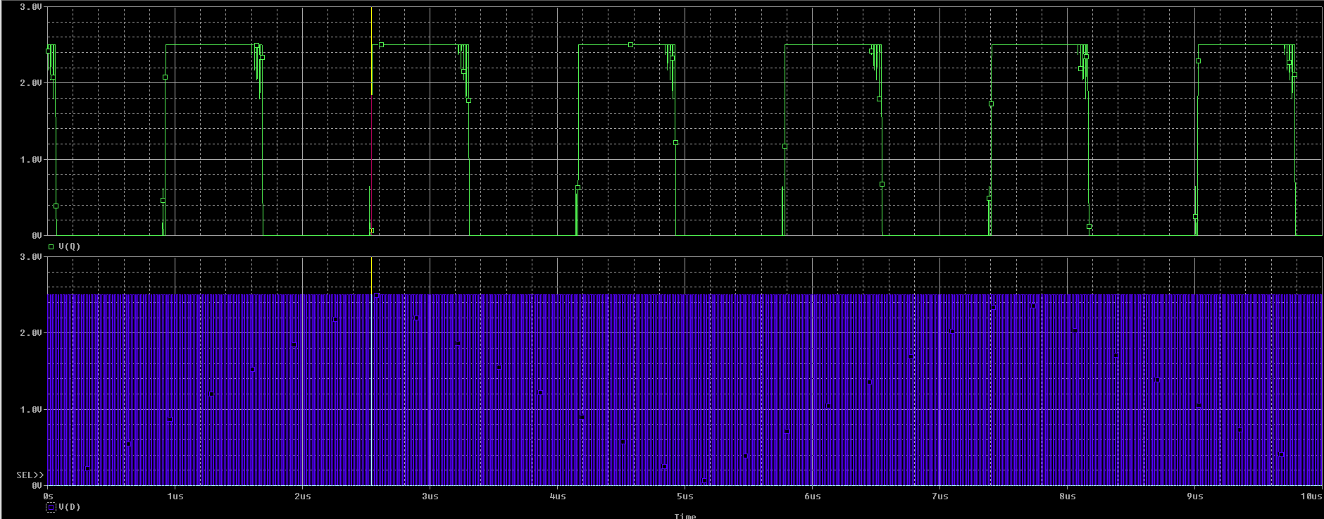
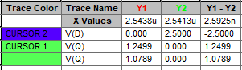

2.5413us(Vd) – 2.5438us(vQ) = - 2.5925ns

