Ch1 AIS and Firm Value
- AIS
What is “System”?
Accounting Information System (AIS), defined as a system that records, processes and reports on transactions* to provide financial and non-financial information to make decisions and have appropriate levels of internal controls (security measures to protect sensitive data) for those transactions.
* better: business information needs and events
An AIS is important because it provides information that companies are required to have and also information that can be used to make important decisions.
- 5 components of AIS:
  - People:
The people in an AIS are simply the system users. Professionals who may need to use an organization's AIS include accountants, consultants, business analysts, managers, chief financial officers and auditors.
people are the main component of any system. Systems cannot operate itself, not even the most automated system. A lot of people think that AIS is all computerised based. No, the system can be either manual or automated. Having good people to manage other components of the accounting system is very important. The human resource team flex their muscle in hiring and retaining the best of breeds in a company. People are the only asset that a company has that cannot be included in either the asset register or the statement of financial position.
  - Procedures
The procedure and instructions of an AIS are the methods it uses for collecting, storing, retrieving and processing data. These methods will be both manual and automated, and the data can come from both internal sources (e.g., employees) and external sources (e.g., customers' online orders). Procedures and instructions will be coded into AIS software; they should also be "coded" into employees through documentation and training. Procedures and instructions must be followed consistently to be effective.
To store information, an AIS must have a database structure such as structured query language (SQL), a computer language commonly used for databases. The AIS will also need various input screens for the different types of system users and different types of data entry, as well as different output formats to meet the needs of different users and different types of information.
  - Data
The data contained in an AIS is all the financial information pertinent to the organization's business practices. Any business data that impacts the company's finances should go into an AIS. The data included in an AIS will depend on the nature of the business, but it may consist of the following: sales orders, general ledger, tax information…
This data can then be used to prepare accounting statements and reports such as accounts receivable aging, depreciation/amortization schedules, trial balance, profit and loss, and so on. Having all this data in one place - in the AIS - facilitates a business's recordkeeping, reporting, analysis, auditing and decision-making activities. For the data to be useful, it must be complete, correct and relevant.
On the other hand, examples of data that would not go into an AIS include memos, correspondence, presentations and manuals. These documents might have a tangential relationship to the company's finances, but excluding the standard footnotes, they are not really part of the company's financial recordkeeping.
  - Software
The software component of an AIS is the computer programs used to store, retrieve, process and analyze the company's financial data. Before there were computers, AISs were manual, paper-based systems, but today, most companies are using computer software as the basis of the AIS. Small businesses might use Intuit's Quickbooks, Sage Peachtree Accounting, or Microsoft's Small Business Accounting but there are many others. Small to mid-sized businesses might use SAP's Business One. Mid-sized and large businesses might use Microsoft's Dynamics GP, Sage Group's MAS 90 or MAS 200, Oracle's Peoplesoft or Epicor Financial Management.
Quality, reliability and security are key components of effective AIS software. Managers rely on the information it outputs to make decisions for the company, and they need high-quality information to make sound decisions.
AIS software programs can be customized to meet the unique needs of different types of businesses. If an existing program does not meet a company's needs, software can also be developed in-house with substantial input from end users or can be developed by a third-party company specifically for the organization. The system could even be outsourced to a specialized company.
For publicly traded companies, no matter what software program and customization options the business chooses, Sarbanes-Oxley regulations will dictate the structure of the AIS to some extent. This is because SOX regulations establish internal controls and auditing procedures that public companies must comply with.
  - IT infrastructure
Information technology infrastructure is just a fancy name for the hardware used to operate the accounting information system. Most of these hardware items are things a business would need to have anyway - they include personal computers, servers, printers, surge protectors, routers, storage media, and possibly a backup power supply. In addition to cost, factors to consider in selecting hardware include speed, storage capability and whether it can be expanded and upgraded.
Perhaps most importantly, the hardware selected for an AIS must be compatible兼容的 with the intended software. Ideally, it would be not just compatible, but optimal, a clunky system will be much less helpful than a speedy one. One way businesses can easily meet hardware and software compatibility requirements is by purchasing a turnkey system that includes both the hardware and the software that the business needs. Purchasing a turnkey system means, theoretically, that the business will get an optimal combination of hardware and software for its AIS.
A good AIS should also include a plan for maintaining, servicing, replacing and upgrading components of the hardware system, as well as a plan for the disposal of broken and outdated hardware so that sensitive data is completely destroyed.
  - (Controls ?)
The internal controls of an AIS are the security measures it contains to protect sensitive data. These can be as simple as passwords or as complex as biometric identification. An AIS must have internal controls to protect against unauthorized computer access and to limit access to authorized users which includes some users inside the company. It must also prevent unauthorized file access by individuals who are allowed to access only select parts of the system.
An AIS contains confidential information belonging not just to the company but also to its employees and customers. This data may include Social Security numbers, salary information, credit card numbers, and so on. All of the data in an AIS should be encrypted, and access to the system should be logged and surveilled. System activity should be traceable as well.
An AIS also needs internal controls that protect it from computer viruses, hackers and other internal and external threats to network security. Furthermore, it must be protected from natural disasters and power surges that can cause data loss.

Who makes decisions in the company? What is the role of accountant in organization?
  - Accounting is an information providing activity, so accountants need to understand:
    - How the system that provides that information is designed, configured, and used
    - How financial information is reported
    - How information is used to make decisions
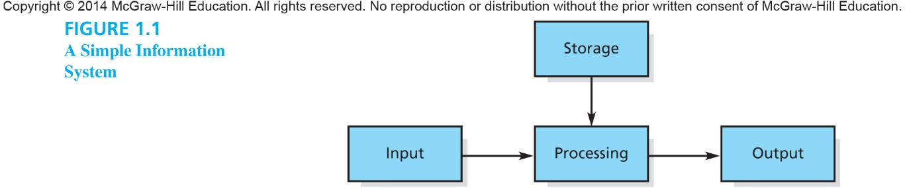
Possible Input: Sales at Starbucks
Possible Storage: Database of all Sales at Starbucks
Possible Processing: Queries of What Sells Best at Night
Possible Output: Reports of What Sells Best at Night

- Quality of information in AIS
One of the most competitive advantages for an organization is the quality of information. The quality of the information provided is imperative必要的 to the success of the systems in an AIS.
Attributes of Useful Information: To be useful information must have these attributes:
  - Relevant – information that is capable of making a difference in a decision. To be useful, information must be relevant to the decision maker.
    - Predictive Value (helps with forecasting the future)
    - Feedback Value (corrects or confirms what had been predicted in the past)
    - Timely (available when needed or in time to have an impact on decision)
  - Reliable – information that is free from bias and error
    - Verifiable (can be confirmed by an independent party)
    - Representational Faithfulness (reports what actually happened)
    - Neutrality (information not biased)
Best Info may be info that becomes reliable once audit is complete. But waiting for an audit to be completed may take so long that it is no longer relevant. The most relevant info may require an estimate of the value of a building, but that estimate may be subject to bias of appraiser估价人 limiting the reliability.
- Impact of AIS on firm business processes
Data vs. Information
Data: Raw facts or statistics that, absent a context, may have little meaning.
Information: Data organized in a meaningful way to the user.
Information Overload: the difficulty a person faces in understanding a problem and making a decision as a consequence of too much information.
- Computers can process and organize a large amount of data.
- Too much information causes information overload.
  - Decision making is hindered. e.g.Big Data phenomenon
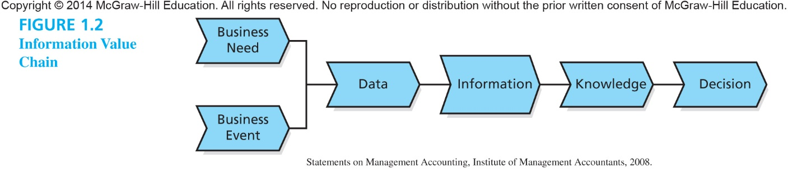
Information value chain: the overall transformation from a business need and business event to the collection of data and information to an ultimate decision.

Discretionary vs. Mandatory Information
- Discretionary information is information that is not required by law. Info that is generated according to one’s own judgement.
  - Using an ABC system to determine the overheads costs associated with each pound of chicken at Tyson Foods.
  - Managers must decide if the benefits of discretionary information outweigh the costs of obtaining it.
- Mandatory information is information that is required by law or regulation.
  - Examples include: Annual Reports that include Financial Statements and Tax Returns

Role of Accountants in AIS
Accountant have a role as business analysts gather info to solve problems/address opportunitiesdetermine what info is relevant in solving problemsanalyze information.
AIS provides a systematic means for the AIS user role and at least one other of the listed roles (manager, designer, or evaluator)
User of AIS – accountant, recording Journal Entries, using financial spreadsheet to calculate the cost of a product.
Manager – Financial manager, Controller, CFO
Designer -System Analyst: person responsible for both determining the information needs of the business and designing a system to meet those needs.
Evaluator – IT Auditor (risks and controls), assessor of internal controls, tax advisor, general auditor. (SOX requires an evaluation of the internal controls in an AIS.)
Implementer -System Developer (no writing code) or Implementer (configuration)
Certifications in AIS
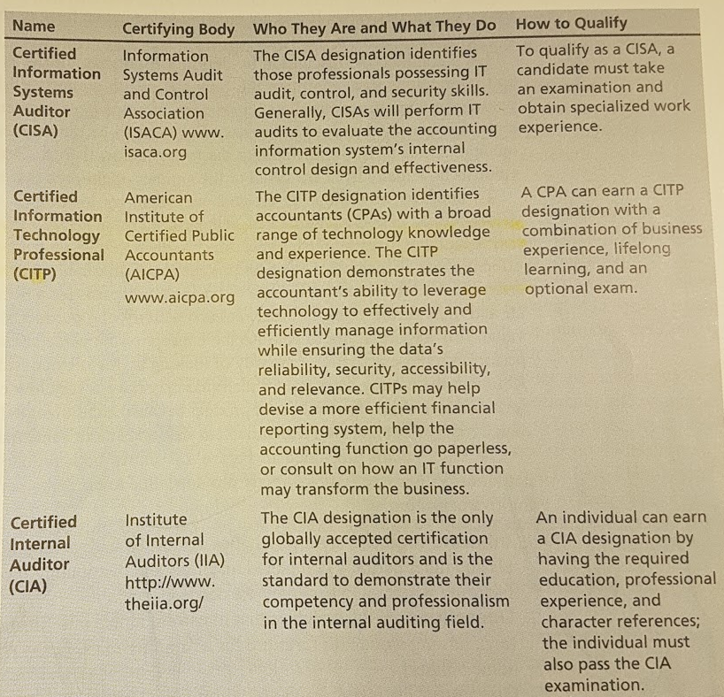
CISA (certified information systems auditor): identifies those professionals possessing IT audit, control and security skills. Generally, CISAs will perform IT audits to evaluate the accounting information system’s internal control design and effectiveness. A candidate must take exam and obtain specialized work experienced.
CITP (Certified Info Technology Professional): identifies accountants(CPAs) with abroad range of technology knowledge and experience. CITP demonstrates the accountant’s ability to leverage technology to effectively and efficiently manage information while ensuring the data’s reliability, security, accessibility and relevance.
CIA (Certified Internal Auditor): the only globally accepted certification for internal auditors and is the standard to demonstrate their competency and professionalism in the internal auditing field.
The Value Chain: a chain of business processes for a firm.
Primary Activities:
Inbound Logistics采购运筹OperationsOutbound Logistics出货物流MarketingServices
Support Activities:
Procurement采购Information TechnologyHuman resources ManagementInfrastructure.
Inbound Logistics: receiving and storing raw materials and distributing those materials to manufacturing when needed.
Operations: transform inputs into finished goods and services. E.g. building a house for a home builder.
Outbound Logistics: warehouse and distribute the finished goods to the customers.
Marketing and sales: identify the needs and wants of customers to help attract them to the firm’s products and, buy them
Services: provide the support of customers after the products and services are sold. E.g. warranty repairs, instruction manuals安装手册.

5 primary activity are sustained维持 by the following support activities:
- Firm infrastructure: activities are needed to support the firm, including the CEO and the finance, accounting and legal department.
- Human resource management: activities include recruiting, hiring, training and compensating employees.
- Technology: activities include all of the technologies necessary to support value-creating activities. These technologies also include research and development to develop products or determine ways to produce products at a cheaper price.
- Procurement: activities involve purchasing inputs such as raw materials, supplies and equipment.
AIS add value to the firm by making each primary activity more effective and efficient.
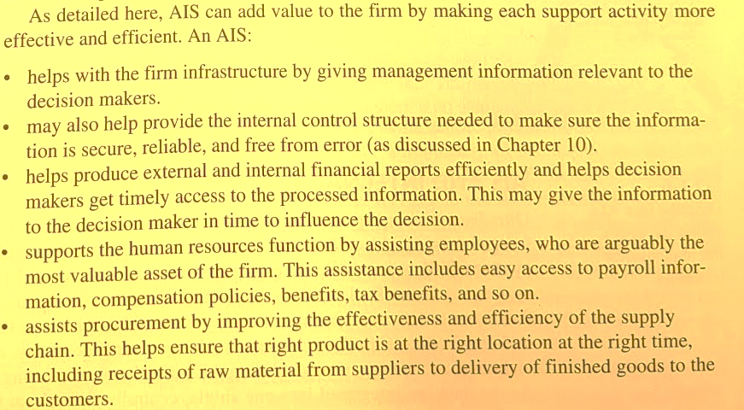
- AIS and Internal Business Process
An AIS within a firm is usually the foundation for an Enterprise System (ES).
ES is a centralized database that collects data from throughout the firm. E.g. the ES gives all within the firm the most current info to address these issues.
ES serves as the backbone of the firms’ internal business process and as a connection with the external business processes with external partners.
- AIS and External Business Process
The firm’s interaction with the suppliers is generally called supply chain management.
The firm’s interaction with the customers is generally called customer relationship management.
Focal firm 焦点公司
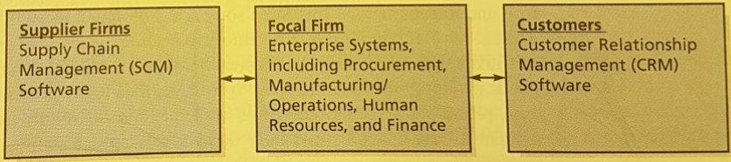
Supply Chain： the flow of materials, information, payments and services from raw material suppliers, through factories and warehouses, all the way to the final customers of the firm’s products. Also includes the firms and processes that create and deliver products, information and services to the final customers. The supply chain refers to a network of processes that delivers a finished good or service to the final customer.
supply chain management SCM: the software used to connect the focal firm with its suppliers. It addresses specific segments of the supply chain, especially in manufacturing, scheduling, inventory control and transportation.
customer relationship management CRM: software used to manage and nurture a firm’s interactions with its current and potential clients.

- AIS, Firm Profitability and Stock Prices
One way to consider how AIS creates value look income statement
Firm Profitability：A recent study has suggested there was a correlation between the firm’s annual IT investment and the subsequent accounting earnings (measured by ROS, ROA ratios)
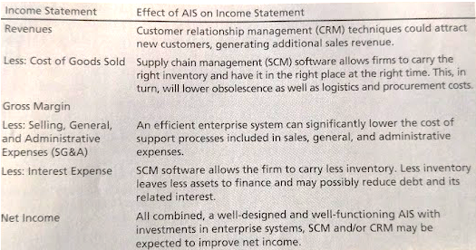
The Potential Effect of AIS on an Income Statement
Stock Prices and AIS Investments
- With regards to stock prices, when a public firm announces their investment to the public, external members generally analyze whether or not the investment will increase profitability
  - A study conducted with 315 firms suggested that AIS investments increased the firm market value as they made the businesses more efficient and had the pubic agree with their investment
There are 3 types of AIS investments:
- Automate (+0.05%):
  - Replacing human labor by automating business processes
- Informate (+0.4%):
  - Up: Providing business activity information to senior management
  - Down: Providing business activity information to employees across the firm
Informate-up/down are consolidated in a single strategic role: Inormate.
- Transform (+1.51%):
  - Fundamentally redefining the business processes and relationships

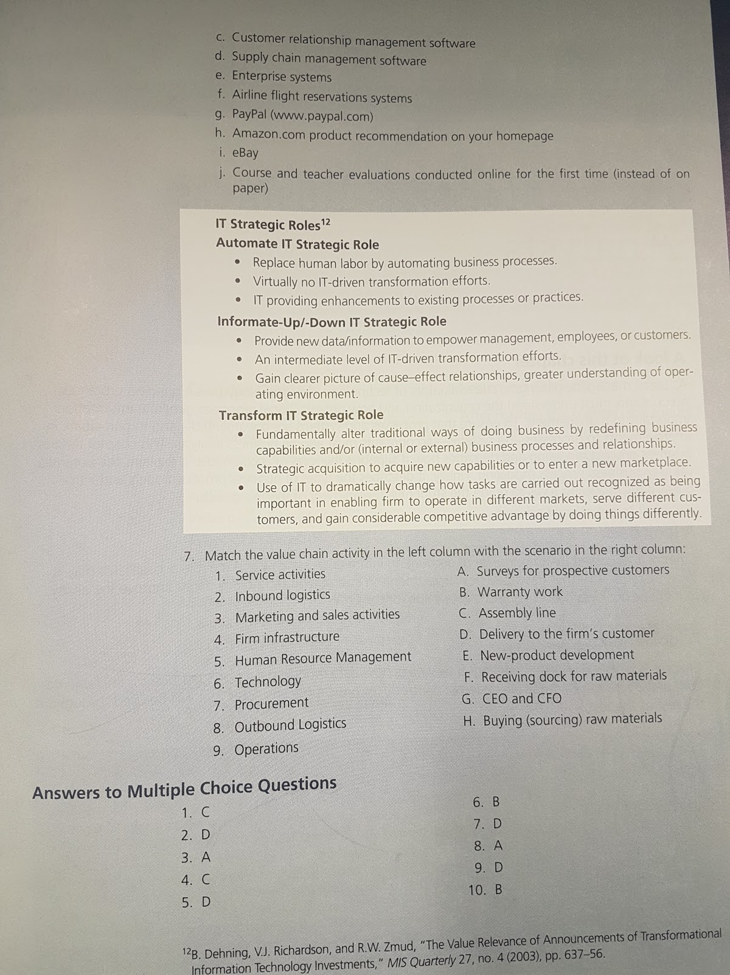

TB
26. | Accounting information systems are:  Accounting Information System (AIS), defined as a system that records, processes and reports on transactions* to provide financial and non-financial information to make decisions and have appropriate levels of internal controls (security measures to protect sensitive data) for those transactions.
  A. | Always computerized.
  B. | Report only accounting information.
  C. | Records, processes and reports
  D. | Are for computer games

27. | Which of the following are NOT a characteristic of useful information?
  A. | Easy to understand
  B. | Feedback value.
  C. | Timely
  D. | Representational Faithfulness

34. | The income statement line item most likely affected by an AIS investment in enterprise systems ES would be:
  A. | Revenues
  B. | Cost of Goods Sold
  C. | Selling, General and Administrative Expenses
  D. | Unearned Revenue

35. | The income statement line item most likely affected by an AIS investment in supply chain that would interface with suppliers would be:
  A. | Revenues
  B. | Cost of Goods Sold
  C. | Selling, General and Administrative Expenses
  D. | Research and Development Expenses

36. | The IT strategic roles of AIS investments are classified as:
  A. | Automate, Informate, Transform
  B. | Value creation, Value Destruction, Value Neutral
  C. | Digitize, Report, Transform
  D. | Automate, Digitize, Transport

37. | According to a recent study, the transform IT strategic role is defined as systems that:
  A. | replacing human labor in automating business processes
  B. | provides information about business activities to all employees
  C. | provide information about business activities to senior management
  D. | fundamentally redefine business processes and relationships

38. | According to a recent study, the informate-up IT strategic role is defined as systems that:  3 types of AIS investments:  - Automate (+0.05%):  - Replacing human labor by automating business processes  - Informate (+0.4%):  - Up: Providing business activity information to senior management  - Down: Providing business activity information to employees across the firm  Informate-up/down are consolidated in a single strategic role: Inormate.  - Transform (+1.51%):  - Fundamentally redefining the business processes and relationships
  A. | replacing human labor in automating business processes
  B. | provides information about business activities to all employees
  C. | provide information about business activities to senior management
  D. | fundamentally redefine business processes and relationships

39. | The income statement account most likely affected by an AIS investment in customer relationship management (CRM) would be:
  A. | Revenues
  B. | Cost of Goods Sold
  C. | Selling, General and Administrative Expenses
  D. | Unearned Revenue

40. | Many hospitals and doctor's offices are beginning to digitize the medical records of their patients. This is an example of the ____________ strategic role.
  A. | Automate
  B. | Informate - up
  C. | Transform
  D. | Informate - down

TEXTBOOK QUESTIONS
MC
1.C 2.D
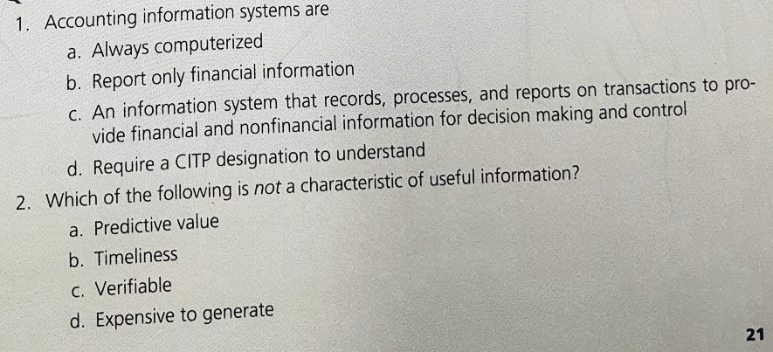
3. A 4. C 5.D
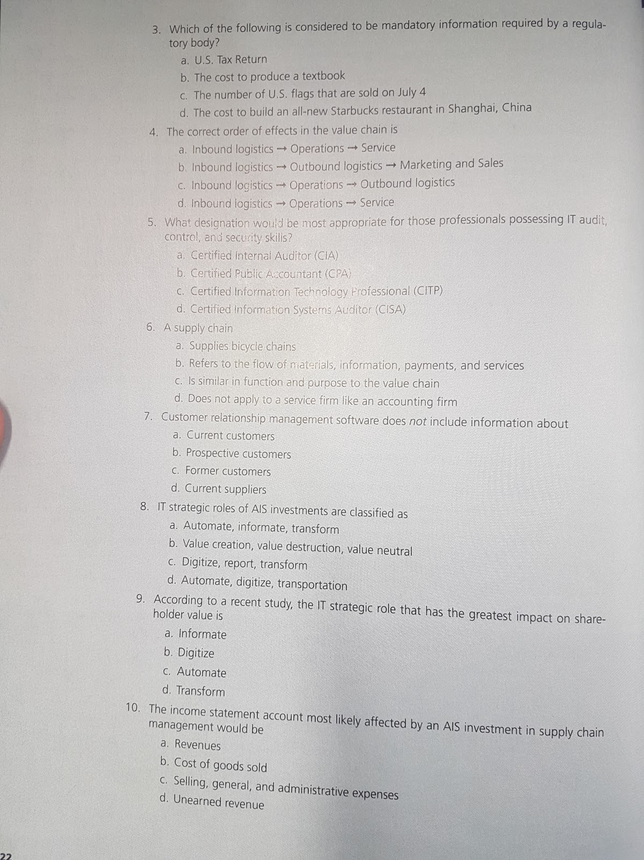
6.B 7.D
8.A. 9. D. 10. B.

7.
Primary Activity:
2. H
9.
8. D
3.
1.
Support Activities:
7.
6.
5.
4. G

SLIDES QUESTION
A recent article suggests:
- A monumental change is emerging in accounting: the movement away from the decades-old method of periodic financial statement reporting and its lengthy closing process, and toward issuing financial statements on a real-time, updated basis . . . real-time financial reporting provides financial information on a daily basis. Current technology allows for financial events to be identified, measured, recorded, and reported electronically, with no paper documentation. (Source: Real-Time Accounting, The CPA Journal, April 2005 Issue).
- Would a shift toward real-time financial statements make the financial information more useful or less useful? More or less relevant? More or less reliable?

