ECOR 1010 – Lecture Notes
Lecture 2
- What is an engineer?
- Engineers design the stuff that society, scientist and other engineers use
- Problem solvers
- Design
- Professionalism (formal organization, ethics)
- Ingenium (Latin) for innate quality, metal power, capable of clever invention
- First came when they had people who could invent/ operate weapons of war – Military engineer
- People who were not military engineers where called “civil engineers”
- Def engineer: someone who uses science, math, experience and judgment to create, operate, manage, control or maintain devices mechanisms, processes, structures, or complex systems with human, societal and natural resources and environmental constraints (laws of physics)
- Role of engineers
- Team of involves individuals with different abilities, interest and education who cooperate to advance the project
- A technical team may consist of: engineers, scientists, technologist, technicians, social scientist, skilled workers
- Provides the key link between theory and practical application
- Has: Extensive theoretical knowledge, ability to think creatively, ability to lead a team towards a common goal, knack for obtaining practical results
- Professional engineer
- In Canada; it is illegal to say you are an engineer unless you have a P. Eng with a license from the Professional Engineering Licensing Association
- Canadian Engineering Accreditation Board (CEAB)
- PEO and other provincial association rely on CEAB to evaluate and accredit engineering programs at university in Canada
- CEAB conducts regular rigorous reviews of engineering programs
- All of Carleton engineering programs are accredited for the maximum 6 years
- Math is 1/8, Science is 1/8, design 1/8, complementary studies 1/8 of the program
- The university that you came from must be accredited program or else you cannot become a professional engineer
- Other requirements: 4 years of experience, professional practice examination, character attested by references, Canadian citizenship, or permanent residence
- Technologist
- Works under direction of engineer/applies engineering principles and methods to complex technical problems
- 3 years community college
- Technician
- Works under supervision of an engineer or a technologist
- Does the practical stuff like making tests, maintaining equipment
- May have certification but does not need one
- Skilled worker
- Skilled in trade such as electrician, welder, carpenter, machinist…
- Caries out design and plans of others
- Great expertise acquired by apprenticeships or years of experience
- Most trades have a trade organization and certification procedure
- Open-Ended problems
- Most engineering problems are open-ended; they don’t have a single solution
- Skills needed for open-ended problems: broad base of knowledge, critical thinking, innovation, perseverance
- Ingenuity
- Engineers often find ways to skirt the laws of nature
- Innovation, critical thinking, problem solving
- Canadian engineering accomplishments
- Transcontinental railway 1885
- De Havilland beaver plane 1947
- St Lawrence seaway – canals that opened great lakes to the ocean ships 1959
- Athabasca oil sands
- High voltage transmission – Quebec was the first to develop transmition lines at very high voltages to go far
- CANDU nuclear power – uses natural uranium not enriched meaning cant make a bomb
- Alouette satellite – 3rd country into space 1962
- Trans-Canada telephone network – worlds longest microwave network 1958
- So on
- Quebec bridge 1907
- Longest contilevered span in the world
- Collapsed during construction killing 75
- All engineers need more knowledge of everything
Lecture 3
- Before writing think about
- Who is the reader
- What does the reader already know
- What does the reader want to know
- What do you want the reader to know
- Be concise and clear while writing
- Avoid verbs turning into nouns
- “Determination of procedure occurs at the committee level.” Do: “The committee determines procedure.”
- Use strong subjects
- “The decision was made by the supervising engineer.” Do: “The supervising engineer made the decision.”
- Useless Adverbs
- “The project was completed really well.” Do: “The project was completed well.”
- The adverb really is only because you think it was done really well doesn’t mean everybody else will
- Minimize the number of words
- Internal memos are a rapid transfer of information
- Project proposals:
- Research papers
- Patents
- Engineering Communication Centre (UofT): http://www.ecf.utoronto.ca/~writing/handbo ok.html
- Writing Guidelines for Engineering and Science Students: http://www.writing.engr.psu.edu/
- Measurements: Physical quantity that has been observed
- Standard quantity: called a unit
- Ex: 1 kg is a standard unit. So mass of object 5 times greater than a standard unit is 5 kg
- A measurement consists of a numerical value and a name/symbol(s) that define the reference standard
- Derived units
- Derived in terms of base units; ex: 1 Newton = 1 kg m/s²
- All other units are made by base units
- Systeme international d’unites (SI units) (absolute system) (mass is a fundamental unit)
- System is adopted by almost all countries (US is not one of them)
- It uses the metric system
- Where the meter was originally chosen to be 1/millionth of the distance between the equator and the north pole
- One meter is now the length light travels in a vacuum at 1/299,792,458 of a second
- 7 base units in SI
- Length: Meter
- Mass: Kilogram
- Time: Second
- Electric current: Ampere
- Temperature: Kelvin
- Luminous intensity: Candela
- Amount of substance: Mole
- FBS unit system (gravitational system) (force is a fundamental unit)
- Feet, pounds, and seconds
- lb is not a mass is a force
- To have pounds mass: lbm, and pounds force: lbf
- Newton’s 2nd law: F=ma; in SI = 1 kg*1 m/s²; in American = ma/g_{c} where g_{c}=32.17$\frac{ft∙lbm}{lbf∙\sec^{2}}$
Lecture 4
- Rules for writing with units
- Always a space between numeric value and unit: 23.67 Kg not 23.67Kg
- Unit symbols are treated like algebraic factors that can be multiplied or divided with numbers or other unit symbols. Ex: 27 kg·m/s 2 or 27 kgm/s 2 or 27 kg·m·s−2
- Units do not have subscripts: V_{max} = 200 V not V = 200 V_{max}
- Relation between numerical quantity and unit symbols must be clear:
Ex: 3.7 km × 2.8 km for an area; not 3.7 × 2.8 km
Ex: 87.2 g ± 0.4 g or (87.2 ± 0.4) g; but not 87.2 ± 0.4 g
- Either use unit symbols or unit names, not both:; kg/m² not kilograms/m²
- Groups of numbers must be separated by a space 93 000 000 miles not 93,000,000 miles
- Fixed notation is normal numbers: 30 140.0
- Scientific: 3.014x10⁴
- Engineering notation: 30.14x10³
- Derived dimensions
- Dimensional homogeneity: The dimension on either side of an equation must be the same: f=ma both sides are newtons
- Non-Dimensional numbers – ratios where the numerator has the same dimension as the denominator meaning the given answer does not have a unit
- Gimli Glider
- Air Canada flight 143 – Montreal to Winnipeg
- Problem with fuel gauge in plane - so fuel was calculated by hand (The man was not a flight engineer)
- They used 1.77 lb/L as the constant to calculate the fuel not 0.8 kg/L – but this is an all metric aircraft
- Pilot initiated side slip to land plane
- Uncertainty
- Measuring instruments are not perfect
- To find uncertainty: True value – measured value = measurement error
- Systematic errors: errors that have a consistent deviation from the true value (bias or offset). Other words, error has same magnitude and sign when repeated in the same conditions. Can be detected by: calibration or comparison with results obtained with an independent method
- 3 types of errors
- Natural Error – from environmental effects such as heat
- Instrument Error – Also called offset, cause by imperfections in adjust/construct
- Personal Error – Result of habits of the observer, reduced with proper training
- Random Error – small variation in measurements
- If there is a continuous bias then it can be set as the offset with just random errors remaining/ Or find the source of random errors and then getting better training to remove those errors to have more precise readings of a tool
- A measurement is only complete when a statement of its uncertainty is included
- Uncertainty is plus or minus
- If the uncertainty on a tool is not stated then it is the next significant number to the right and is ±5. Ex: 94 km/h ± 0.5 km/h.

Lecture 5
- Engineers convey information in three principal ways
- Written Documents
- Oral Presentations
- Graphically
- Importance of engineering graphics
- Majority of engineering info is transmitted through graphical means
- But unambiguous written and verbal communication
- Clear, concise, Efficient, reduced ambiguity
- Technical illustration / pictorial drawings
- Decribes Product in catalogues, maintenance manuels
- Useful to describe difficult to visualize components or assemblies
- Shoes how to put components together not how to make them
- Three common types
- Perspective
- Oblique
- Isometric (Axonometric)
- In perspective projection the projectors intersect at finite points, called vanishing points
- The representation the view seen by a single eye
- Picture is drawn so that all points go through the eye
- There’s is one point perspective and two point perspective
- Two perspective has two vanishing points
- Just because you can draw it doesn’t mean you can build it
- Oblique projection
- Front face of object is parallel to the viewer
- Projection lines do not cover vanishing points
- the front face is the only face to have true size
- there is a lack of perspective
- Isometric projection
- Parallel line remain parallel instead of converging to a vanishing point
- Axis are each 120º apart. Or to draw have two line going out at 30º
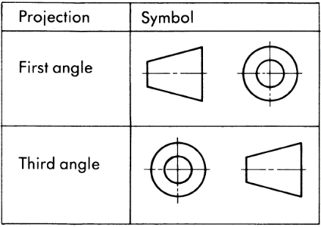
- Shows more then one face
- Orthographic projection
- The most important graphical drawing method
- It is a 2D representation of a 3D object
- Useful when technical information is needed
- They enable parts to be made
- Often an isometric view is included
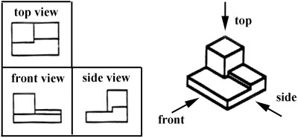
- Third-angle orthographic projection (first-angle used in Europe)
- It uses an imaginary glass box then takes 3 sides
- But 6 views can be made
- The most descripted view is usually selected to be the front view
- The rest of the views are chosen to have the least hidden lines
Lecture 6
- Important engineering graphics
- Graphical mathematics
- Nomography
- Empirical equations
- Engineering computer graphics: CAD
- Graphical mathematics
- All possible position a robot can have
- Must use Cartesian point and matrixes to find points, when moving a object around in cad its doing a lot of math
- Nomographs or alignment chart
- Is a calculating chart with scales that contain values of three or more mathematical variables
- Widely used in engineering, industry and the natural and physical sciences
- Is pretty much just a graph already made. Showing what values would be if x axis = something and y=something. So you don’t have to do long math in time of need
- Can use graphical mathematics
- Empirical equations
- Modeling relations between empirical data with mathematical equations
- Ex: find an empirical equation to describe how different parts of a robot heat up from moving
- It just gives you an equation for the graph it will create
- Equations come from 3 places
- Any equation that reproduces the data in an acceptable way can be used if the goal is to have an equation for interpolation
- A theoretically-based equation that is derived from some physical insight (used for interpolation and extrapolation within limits
- Or a combination of the above
Introduction to CAD
- Evolution of drafting
- They were drafted by hand and you had to wear a black tie
- Computer aided drafting (CAD)
- Replaced drafting tables and creates electronic drawings
- Can be used to create pictorial perspective, isometric, oblique, and orthographic drawings as well as electrical, pneumatic, hydraulic and control system schematics
- Is used when we want to create something the way we intended and to give it to other people to also understand and create
- Why do we need it?
- It is an effective way to communicate ideas and designs
- Manufacturing is becoming more integrated and more global meaning that when one object on a data base is changed all the other ones in the world are too. Not like old days where they needed to change all the papers
- Systems are becoming more complex
- Working drawings are needed in all disciplines (Electrical, civil, mechanical, architecture, manufacturing
- Solid modeling: Using CAD to design prototype and run through simulations before actually creating anything
- Freehand sketch
- Usually drawn on napkins to make a quick show of what you want to build
- Not for use in technical drawings for manufacturing a part
- Sketching is used when “on - site” problems are encountered • These are “back -of -the - envelope” solutions • The ability to communicate by any means is a great asset • Sketching is the best way to communicate engineering ideas • Sketching skills must be used on -the -job to explain ideas, delegate work assignments, or to get help
Lecture 7
Note: review pictures on lecture 7 slides
- The standard view for technical drawings is a three-view orthographic projection where all the views are aligned
- Conventions:
- For lines
- Measurement lines – leave a gap between the end of an extension line and the object
- Crossing perpendicular lines of center lines must have short dashes
- Object lines: indicate all visible edges of an object, must stand out and be apparent
- Hidden lines: shows object lines that are hidden from view. Marked with dotted lines
- Cutting plane lines: indicates edge view of an imaginary cutting plane
- Center lines: indicates centers of holes and symmetrical features of an object
- Dimensions must describe the complete geometry of the part and must not have redundant dimensions
- 2X Ø3 = two times the circle with a radius of 3
- Never dimension holes or cylinders with radii
- Angles may use decimals and are drawn with an arc
- Dimensioning rules:
- Rule Zero: when dimensioning a drawing do not draw too small and make sure it is readable
- Rule 1: The first dimensions should be 3 times the letter high and the second being only two. Meaning that the dimensions should not be drawn too close or too far
- Rule 2: If there is 2 views, then but the dimension in between so it is close to both figures
- Rule 3: Dimension the most descriptive view
- Rule 4: Dimension visible lines not hidden features
- Rule 5: Do not give useless dimensions that can be figured out my math
- Rule 6: Organize the dimensions to reduce clutter and ease readability
- Rule 7: Do not duplicate dimensions, to avoid confusion
- Rule 8: Dimension lines never cross any other dimension lines unless completely necessary
- Rule 9: Extension lines may cross other extension lines or object lines
- Rule 10: Place dimensions outside objects
- Rule 11: Dimension diameter of cylinder in rectangular view (side view not seeing the circle)
- Rule 12: Dimension circular holes in the view where they look like holes
- Orthographic projection
- Advantages: able to contain a high degree of detail / angle and length measurements can be made on all views
- Disadvantages: Effort is needed to interpret the object / Many conventions must be followed – not as easy as the other three
- Sometimes it is possible to only need 2 views
- Orthographic other views
- Section views: is cutting a face and seeing what’s inside
- Auxilary views: Connecting isometric view with a side view
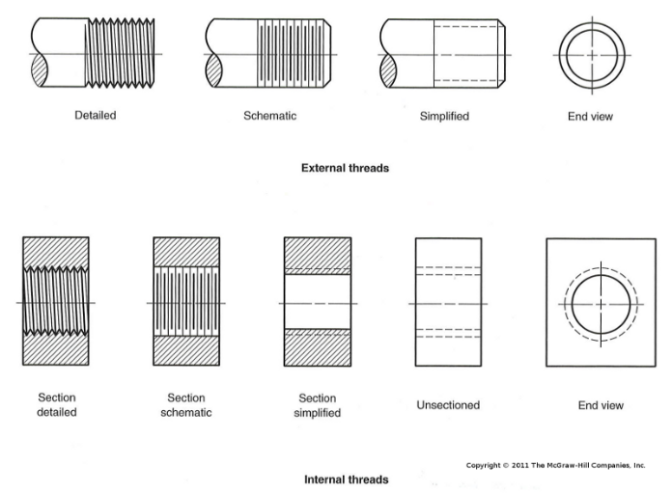
- Drawing a disk with 4 holes: one must only show where the holes are at their optimum positions see page 39/42 lecture 7
- Orthographic – threads
- Schematic external thread
- Simplified external thread
- Hidden internal thread
- Schemetic internal thread
- Simplified internal thread
- See p.41
- Title block
- Contains important information about the drawing such as the part name and number, the person who made it and the scale used
- Usually located in the lower right corner
- All working drawings have a title block
- Examples p.44
Lecture 8
- What is design
- A creative process that incorporates all areas of engineering
- Design is basically what engineers do
- Almost always involves team effort
- Usually only a handful of good solutions to open-ended problems
- Most design problems can be categorized as; “system design” or “product design
- System design
- System design is the arrangement of available products into a unique combination that gives the desired result
- Ex: residential building has heating, plumbing, electrical system and so on, all products that are already available
- System design requires additional professionals
- Product design
- Deals with design, testing, manufacture and sale of mass-produced foods
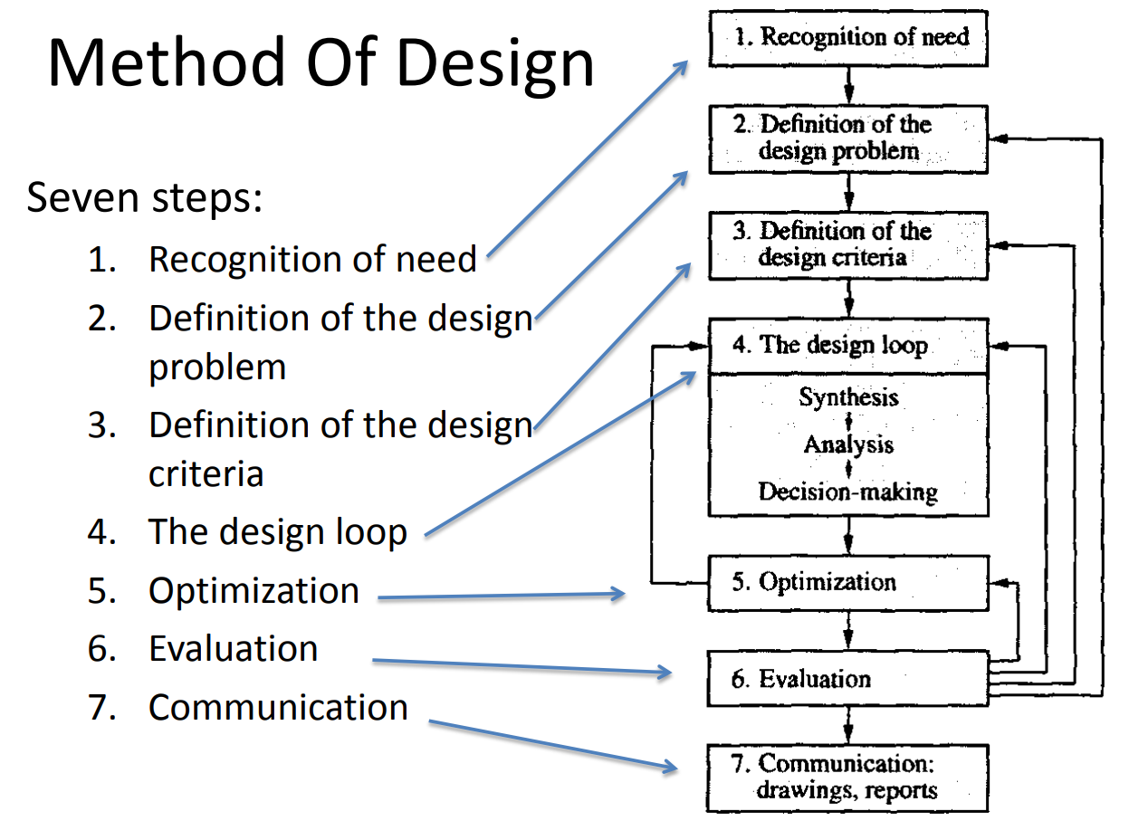
- Can be large or small systems
- Design process
- Design involves as much art as science
- There are 7 steps to be followed
- Recognition of need
- A need can be either very obvious or hidden
- Usually very vague
- The vagueness of the need can cause the design process to become open ended
- Often need is written in statement of requirements (SoR)
- Definition of the design problem
- Critical for good design
- May require the gathering of information on the topic
- Must define the problem correctly in order to provide a solution
- Definition of the design criteria
- Design criteria are performance standards to be met by the design
- Design constraints are limitations placed on the designer
- The design criteria and constraints must be quotative values otherwise it may be impossible to agree whether the final design is acceptable
- Design loop
- Synthesis – suggesting ideas or methods to solve the problem
- Analysis – calculation the expected results of each idea or method
- Decision-making – Deciding which alternative is best
- Optimization
- Optimum implies a compromise between costs and benefits - the best design at a reasonable cost
- In order to judge whether the design is optimum, the design criteria in step 3 are used
- If design is not optimum, the design loop may need to be re-done
- Evaluation
- Review design completed
- Senior engineer and others must approve the design before it is finalized
- If flaws are found, it must be set back, all the way to step 2 if needed
- Communication
- Once the design is approved, it can be built or manufactured
- The final design must be communicated effectively by: Reports and technical drawings
- Code and standards
- Code – is set of specifications for the analysis, design, manufacture and construction of things. The purpose is to achieve a specified degree of safety, efficiency, performance or quality
- Standard – Set of specifications for parts, materials, or processes intended to achieve uniformity. Places limits so as to provide reasonable inventory of tooling, sizes, shapes, varieties. Etc
- Standard organizations
- International Standards Organization – Is there to make sure companies document all their projects, the materials used etc. The companies that materials are bought are best from these places
- Design reports – There is written, oral and graphical. An engineer must be good at all three forms
- Proposals
- Are written to convince people with money that they should pay for the project
- Proposals should reflect the interests and language of the reader (know your audience)
- Ex: investors are interested in profits and returns, managers are interested in benefits and costs to the company, engineers are more concerned with function and feasibility
- Includes these elements
- Problem statement – benefits of the work
- Proposed work plan – how are you going to do it
- Personnel and facilities needed
- Schedules for milestones and deliverables
- Budget
- Summary
- Progress reports
- Periodic reports on the status of the project
- Usually brief letters or memos
- Tells your customer how things are going – Any problem? You on budget? You on time? What you doing to correct any problems? Discovered something?
- Final reports
- Is the final step in the project
- Generally contains
- Abstract (executive summary, implications etc)
- Introduction (problem statement)
- Methods used
- Results and findings
- Discussions
- Conclusion
- reports have cover saying the authors and the affiliations
- Some have letter of transmittal – letters that are simply cover letters sent with documents to intended readers summarizing the contents
Lecture 9
- Creo Parametric is created by PTC (Parametric Technologies Corporation) and is a design program for engineering
- Pro/Engineer wildfire is 1980
- PTC was the first to offer a parametric feature-based solid modeling design platform
- Creo gives visual realism with real time photo rendering and adds texture, reflection, shadows and background
- Important changes can be easily incorporated at any point
- Has many additional software modules for just about every product development
- It saves time during the design phase
- Solid modeling
- Solid models are representations of the part or product as it will appear when manufactured
- A computer model will contain all the parametric information that a real solid object has
- Wireframe models a inadequate for many design, manufacturing and visualization tasks
- Feature-based
- Each separate operation is called a feature
- Model is created by defining a series of features
- Protrusion – add materials
- Cut – remove materials
- Rounds and fillets – make round edges and strengthen the part
- Holes- create holes
- STL files – Stereolithography files were introduced in software by 3D systems of Valencia, is used for making 3D prints
- Additive Rapid Prototyping (SRP)
- The machine starts off with a block of plastic and uses cutting tools to carve the material into the desired shape
- Additive Rapid Prototyping (ARP)
- The machine reads in data from a CAD drawing and lays down layers of liquid plastic one layer at a time
- Stereolithography
- Patented in 1986 and it started the rapid prototyping revolution
- Uses a light sensitive polymer
- Builds a 3D model from liquid photosensitive polymers that solidify when exposed to ultraviolet light
- Usually used in aerospace
- Laminated object manufacturing
- Developed by helisys of torrance
- Layers of adhesive-coated sheet material are bonded together to form a prototype
- Low cost for raw materials
- Since no chemical reaction, part can be made quite large
- Selective laser sintering
- Developed by Carl Deckard for his master’s thesis in 1989
- Uses a laser beam to selectively fuse powdered materials such as nylon, elastomers and metal into solid object
- Fused deposition modeling
- Developed by Scott Crump 1988
- Uses melted materials and puts them on one layer at a time
- Does not have good accuracy
- Solid ground curing (SGC)
- Invented by Cubital inc
- Similar to stereolithography because it uses ultraviolet light to harden polymers
- But it does on layer at a time, so it has many lights that flash on specific spots at a time
- 3-D ink-jet printing
- Is like a printer
- Produces brittle parts
- Is fast
Lecture 11, 12, 13
- Overview of statistics
- Statistical analysis o=us the science of data collection and data interpretation
- Uses formal probabilistic methods for drawing inferences and making decisions
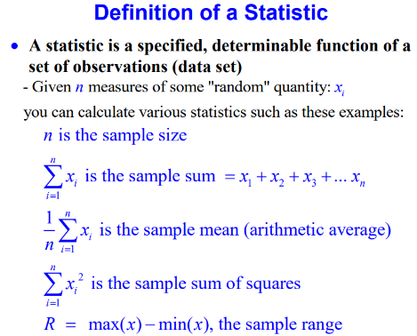
- Summarize data
- Maximize information derived from data
- Test alternate hypotheses or models
- Compute probabilities of future occurrences
- Make rational decisions based on data and information
- Quantify our ignorance (uncertainty)
- Statistics are numbers that we use to describe a large number of measurements
- Depending on what is being measured, some statistics are better than others (just because you can calculate something doesn’t mean it is useful)
- Different types of arithmetic averages
- Mean – is the “average”, sum of all the data divided by the number of data points
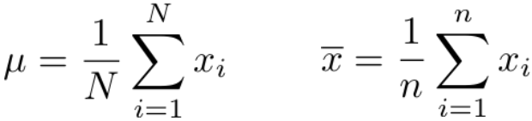
- Where N=population and n=sample

- Median – used to indicate the center value
- If the data set is even then it is the 2 middle points added and divided by 2
- Mode – is the number(s) that repeat the most in a data set
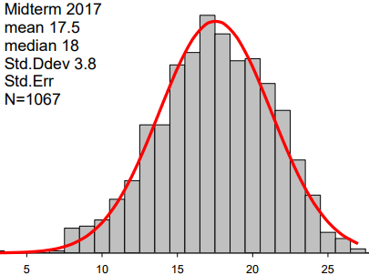
- Histograms – valuable tool for showing frequency distribution
- Normal distributions are also called Gaussian distributions, and sometimes Bell curves
- The appearance of the histogram is dependent on the number of bins and how the bins boundaries are computed
- “There are three types of falsehoods, each worse than the one before – lies, damned lies, and statistics.”
- Outliers and censoring
- Extreme values (outliers) pose a problem
- Extreme values should never be deleted without careful evaluation and reason
- Although they can bias the results like Bill Gates coming to town
- Censoring data will always make the data look better
- Measures of Variation
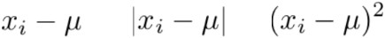
- Deviation from the mean
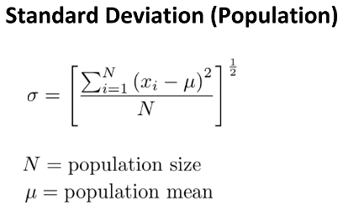
- Standard deviation (Population)
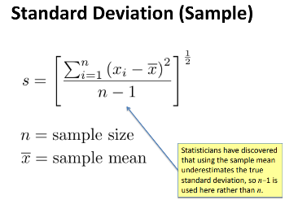
- Standard deviation (Sample)
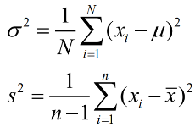
- Variance – is simply the square of the standard deviation (population and sample)
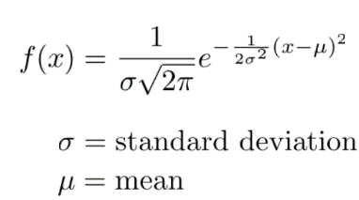
- Continuous form of the Gaussian distribution
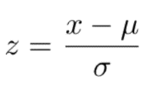
- Standard Normal distribution
- Population
- Sample
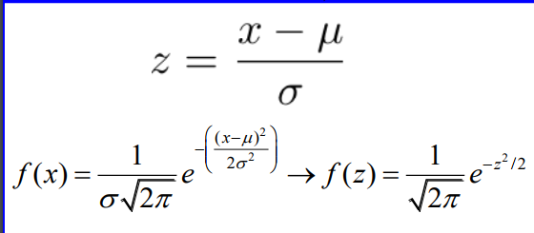
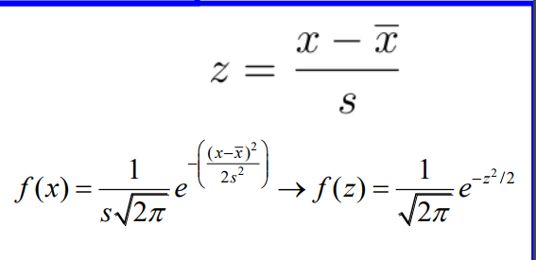

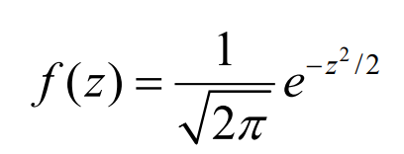
- So, z-statistics of normal distribution is

- Small samples
- Small samples are those with n<30 elements
- Z-statistics are no longer accurate
- Must use t-statistics
- t-statistics
- The sample variance is weighted
- Result is a different distribution from the normal distribution, but similar shape
- Appropriate for small numbers
- t-statistics have larger confidence levels than x-statistics when using small sample sizes
- Although, when DOF (degrees of freedom = ν – n – 1) or sample size becomes large, it forms a gaussian distribution
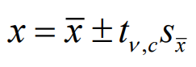
- The formula is
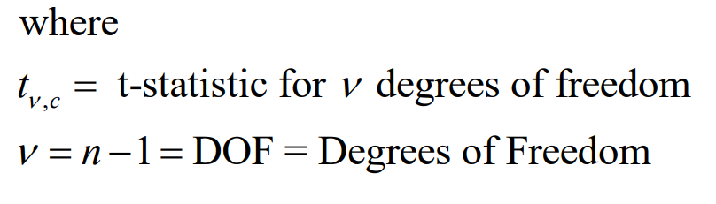

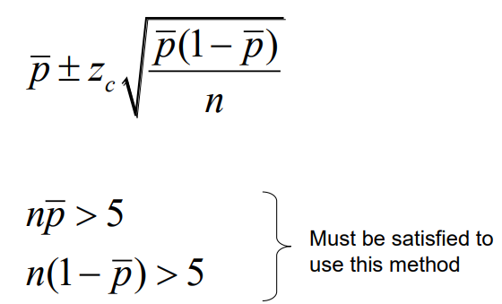

- Estimating proportional mean values
- Proportion = p
- To estimate the proportion must do samples

Lectures 14 & 15
- Bivariate relationships
- Uses two variable (x_{i}, y_{i})
- Used to see if there is a relationship between the two (correlation coefficient)
- Can be represented in a scatterplot
- Linear Correlation (and correlation coefficient)
- How well does the line of best fit represent a trend in the data
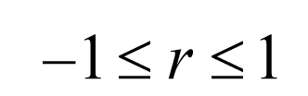
- To compute a correlation coefficient (r)
- When r is close to 1
- X is large when y is large etc
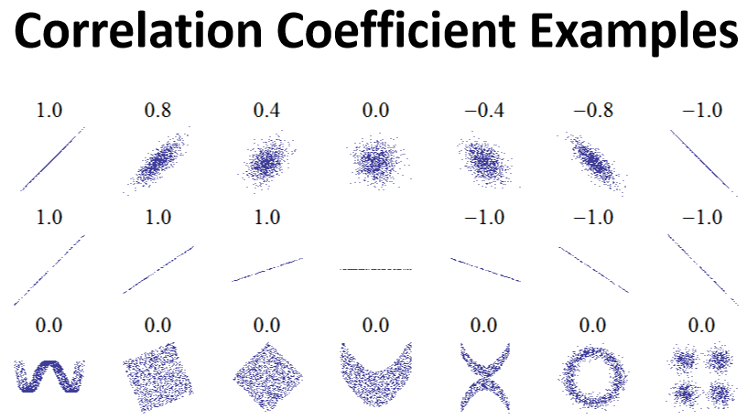
- Plot is tightly packed
- Good positive correlation
- When r is close to 0
- Little or no linear correlation exists between x and y
- When r is close to -1
- X is large when y is small, x is small when y is large
- Tightly pack
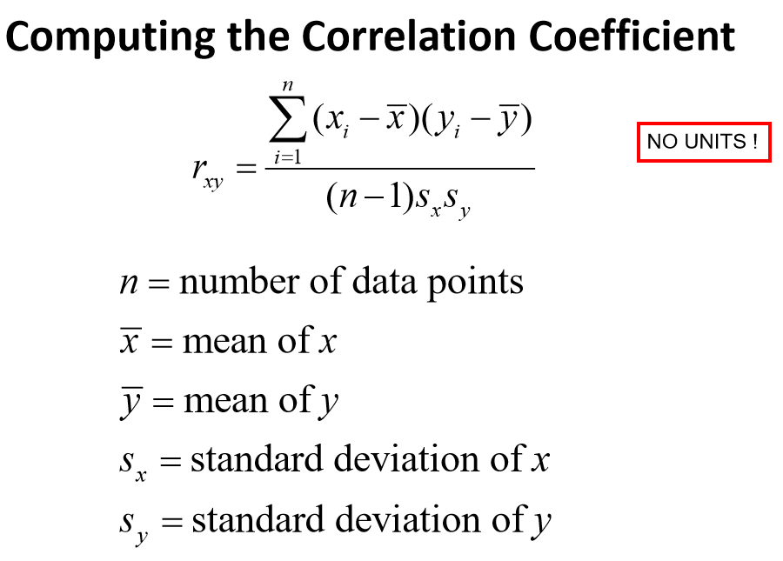
- Good negative correlation
- Just because two variabels are correlated does not mean there is any connection between them
- “Giraffes and center” -Mcrae

- Regression
- Regression is a process by which a mathematical model is fitted to a set of data
- To test whether the model provides a reasonable description of the observation
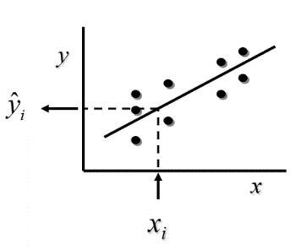
- To give confidence that predictions we make with the model will be good
- Father of regression is – Sir Francis Galton
- Regression line – the straight line relationship that best predicts the values of y, given x
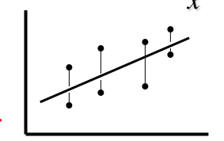
- Once the line is found, we can be given x and ŷ can be found (ŷ = predicted value)
- The line is essentially ŷ=mx+b
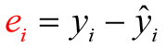
- The best regression – line that minimizes the sum of squared deviations of the data from that line
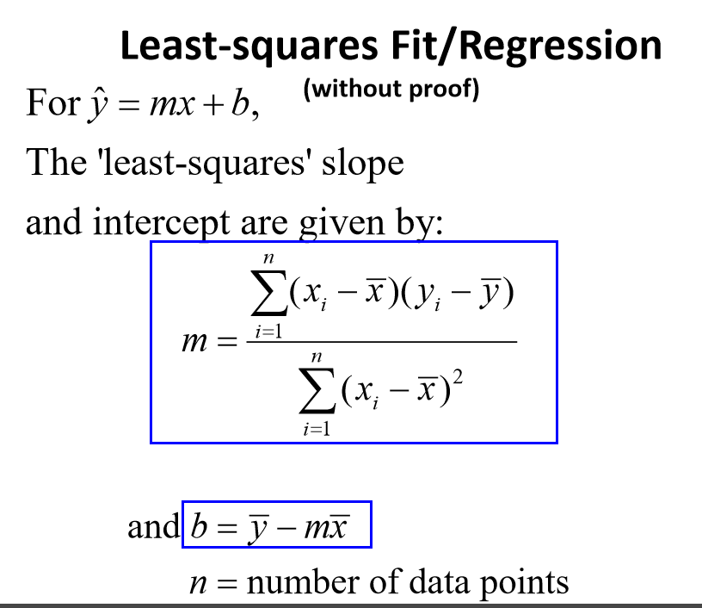
- Deviation of the observed y_{i} (residuals) - where y_{i} is the observed and ŷ_{i} is the value found from the regression line (p. 29)
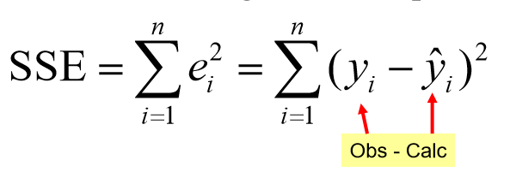
- Sum of Squared Errors (SSE) – is a measure of how well the model fits the data, the best fitting line is when the SSE is minimized

- Residuals
- Points who are usually equally distributed
- Coefficient of determination (r²)
- Represents the proportion of the variation of the observed y data that can be explained by the model
- Lies in the range [0. 1]
- Close to 1= a good fit
- Close to 0= bad fit
- r² = SSR/TSS
- Accuracy of prediction
- Total variation = Explained + Residual
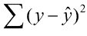
- Residual = - is the sum of squared errors, or what is left over that cannot be explained (SSE)
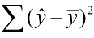
- Explained = - sum of squared of the deviations from the regression line to mean of all the y’s (SSR)
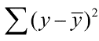
- Total = - total sum of squares from the mean of all the y data (TSS)
- Explained variation = SSR/TSS, Unexplained variation = SSE/TSS
- The accuracy of prediction is measured by SSR/TSS the explained variation is also r²
- Do not used trend line options in programs, they don’t always give the correct function
- Bee careful, science magazine

Lecture 16-17-18
- Many problems in engineering can be approximated by linear relationships
- All can be done in MATlLAB (Matrixes laboratories)
- Global variables
- Function m-Files
Lecture 22
- Need to get a license to do activities
- Difference to licensed professionals
- License proffesinals are a select few, self -diciplined group
- Self selected, we get to decide who gets to be in or not
- Why
- Cause preffesionals pretect people from technology
- They have a exclusive legal right to practice
- Quebec bridge
- One that fell down to to make ring
- Put on working hand to hear it when signing something
- PEO – Professional engineers Ontario
- Scientist cannot become an engineer or do the same work
- What is the purpose of a professional engineer
- Public safety
- Responsibility
- Accountability
- No unreasonable errors or omissions that involve public safety
- Liability and liability insurance
- Code of ethics
- Duties of a professional engineer
- Responsibilities to employer’s and clients and fellow engineers (No talking shit)
- Technical standards and protocol
- International treaties
- Business
- If see something not right its job to say something
- EIT – Engineer in training
- Write 2 exams – one in law court law terms of money – PPE (professional practice exam)
- 3-way communication
- Do not want the names in the blue pages
- Certificate of authorization
- Allows to work for the public
- Companies must have this
- If want new equipment, must have to be a professional engineer to accept
- Safety reviews
- Liable under the OHSA act and the PEO act

