HTH 102 Final Exam Notes – Review Slides

Chapter 5 – Service Vision, Service Design, and Service Encounter

Vision Statements
- A shared image of what we want the organization to become expressed in terms of:
  - A focused concept: a value creation premise that people can actually picture as existing
  - A sense of purpose: something that is really worth doing and wins peoples commitment
  - A chance of success: something that has a plausible chance of success

What is the Strategy
- The strategy is about how to achieve the vision
  - Strategies focus on:
    - What you do (including what you do not do)
    - What you want to become
    - How you plan to get there
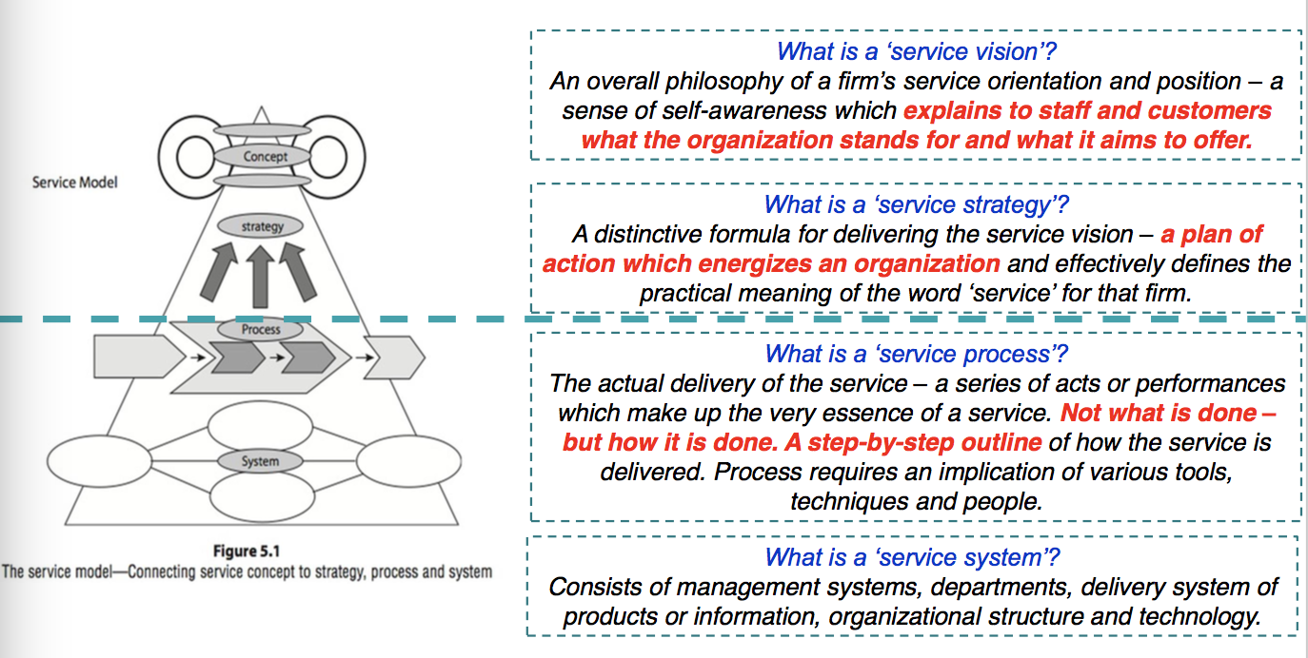

Tim Horton’s Background
- Started in 1964 in Hamilton as a Coffee, and donut shop
- Today it is a quick service restaurant which serves a full menu
- 2015 revenue of $4 Billion (US)
  - $1.4 Billion in 2005
- 4613 restaurants (29 are company owned, rest are franchises)
How does Tim Horton’s Generate Revenue?
- Sale of Tim Horton’s products to franchisees
- Collection of rent from franchisees who sublease locations
- Royalties, 6% of gross sales + franchise fee to start
- Revenue from operating 29 stores

Tim Horton’s Mission and Vision
- Mission Statement:
  - Our guiding mission is to deliver superior quality products and services for our guests and communities through leadership, innovation and partnerships.
- Our Vision:
  - Our vision is to be the quality leader in everything we do

Tim Horton’s Strategies
- Accelerate Global Restaurant Growth
- Enhance Guest Service and Experience at Our Restaurants
- Increase Restaurant Sales and Profitability
- Become the most efficient franchised QSR operator through a constant focus on costs and sharing best practices
- Preserve rich heritage of brands

Enhancing Guest Service and Experience
- Training
- Reimaged Restaurants
- Appealing Menu Options

Vision and Mission Example – Zipcar
- Zipcar is the world’s largest car sharing and car club service. It is an alternative to traditional car rental and car ownership.
- Zipcar’s mission is:
  - “to enable simple and responsible urban living”
- Core values/strategies of Zipcar:
  - Obsess about the member experience
  - Be the best we can be
  - Deliver results
  - Keep it simple
  - Have an impact

Zipcar: Key Messages from Video
- Have a human centred mission and values
  - Keep it simple – cars by hour or day – gas and insurance included
  - Obsess about member services
  - Join, reserve, unlock, drive
- Experience drives loyalty & loyalty drives growth
  - Great experiences don’t just happen you have to design them
- Understand your own ecosystem

What was Zipcars Vision and Strategy
- Vision/Concept:
  - To enable simple and responsible urban living”
- Strategy
  - 5 core values
- Process
  - 6 step process to delivering great service
- System
  - How it all comes together; but we did not discuss much of this

Service Design: Identifying Inbuilt Flaws
- If there is a fault in the system (rather than the service personnel) then it can cause recurrent lapses in service quality
- Pareto Chart: the Pareto Principle suggests that most effects come from relatively few causes (80/20 effect)
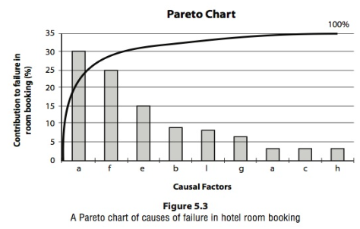
- The Fishbone Diagram shows how various factors could be related to cause and outcome/effect
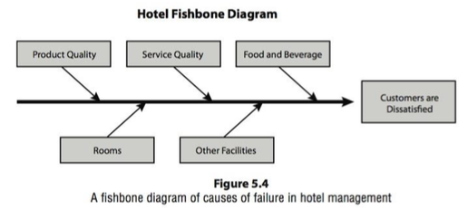

Combining Fishbone + Pareto Delayed Departures at an Airport
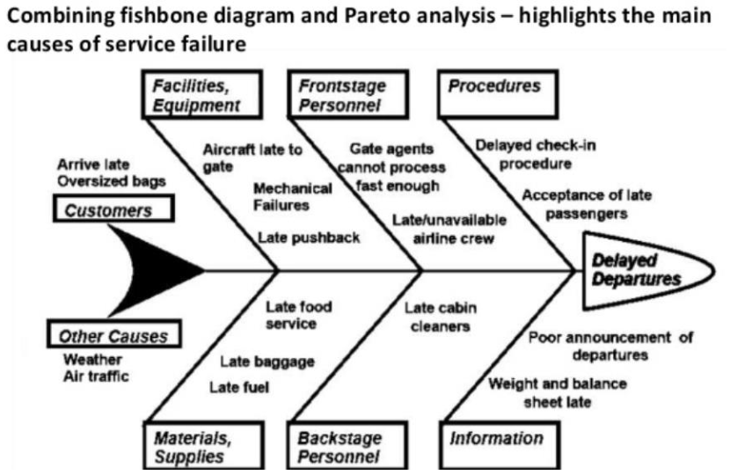

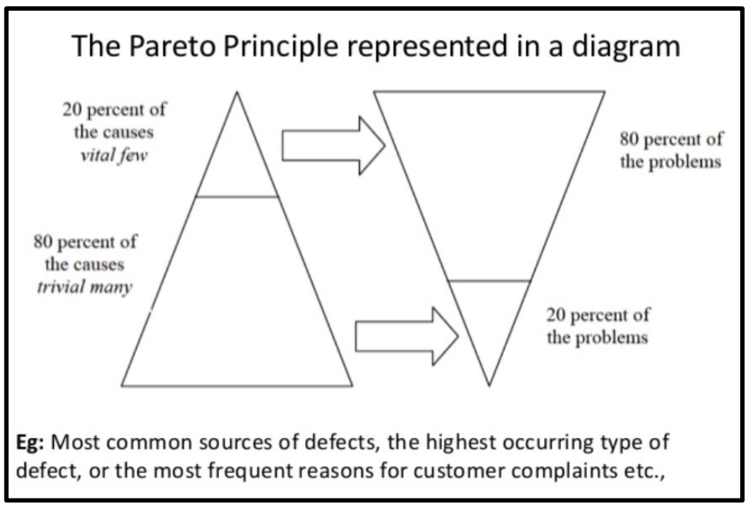

Late Passenger Reported Causes
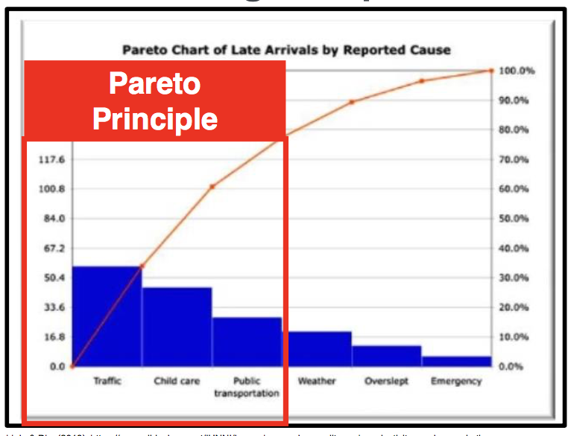

Week 7 – WBEY City of Toronto

The 4 P’s of WBEY
- We have broken WBEY down to 4P’s
  - Prepared
    - Learn about Toronto, its neighbourhoods and all they have to offer
    - Familiarize yourself with resources and tools used to assist visitors, including languages spoken by colleagues
    - Ensure work environment is appealing and ready to receive visitors
  - Proactive
    - Seek out visitor contact, as appropriate
    - Assist other even if it is not your responsibility
    - Look for opportunities to share your knowledge and experiences of Toronto and its neighbourhoods
  - Positive
    - Project an optimistic attitude, even when faced with a challenging situation
    - Be receptive to new ideas and ways to do things
  - Proud
    - Recommend/suggest favourites (restaurants, attractions)
    - Talk about unique features of Toronto
    - Embrace and celebrate differences
How to apply the 4P’s Welcome Guidelines
- Acknowledge visitors (10/5 rule)
- Smile
- Introduce yourself
- Maintain eye contact
- Provide a welcome
- Build a rapport and use a friendly tone
- Speak sincerely

Reading 5 – Service Blueprinting
Service Innovation
- Society has had a habitual fascination with innovation for tangible products and hard technologies
  - Services are
    - Process and experience based, and
    - Dependent upon human delivery systems
- Innovation in service comes from
  - Process innovation
  - Performance innovation
  - Experience innovation

Service Blueprinting Introduction
- Is a process for plotting the customer process against the organizational structure
- Is customer focused and allows managers to visually identify the service process, points of customer contact, and physical evidence associated with the service from a customer’s perspective.

Taco Bell
- Early 1980s Taco Bell reviewed the process for delivering service
- Systems approach: goal was to increase quality of offerings while reducing time spent on food preparation and paperwork.
  - K -: Kitchen (subtract from restaurant)
- The commissaries cooked the meat, ground the beans, and chopped the cheese and veggies (other than tomatoes) that were shipped pre-packaged to the restaurants
- The reengineering process allowed the firm to improve the quality of its products, reduce employee accidents, save on prep time, and reduce store space to kitchen activities.
- Reported that K- program saved Taco Bell $7 million per year
  - BEFORE: 70% kitchen, 30% customer area
  - AFTER: 30% kitchen, 70% customer area

Examples from the reading
- Yellow transportation
- ARAMARK parks and resorts
- IBM
- Marie Stopes International Global Partnerships
- San Francisco Giants

Reading 6 – Designing the Soft Side of Customer Service
The Articles Main Questions
- How can service organizations make their encounters more positive?
  - The soft side of customer service requires the same management intensity as, say the supply chain redesign

Designing for the ETC (Emotions, Trust, Control)
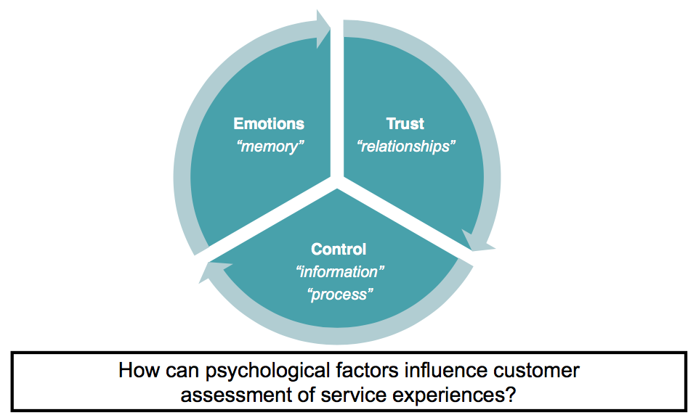

Designing for Emotions
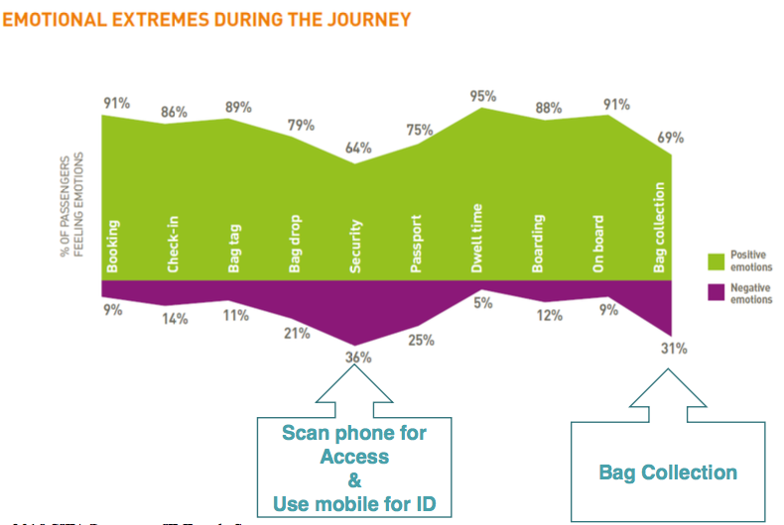

Design for Emotions
- Tracking
- Responding
- Influencing

Design for Trust
- Professional appearance
- Clear communication
- Active involvement
- Smart follow up
- Likability
- Take the high road

Design for Control
- Outcome information
- Process information
- Control and decision making

Tracking Emotions
- Five factors cause us to experience an emotion:
  - Change in outcome improves our situation or makes it worse.
  - The new outcome is associated with a penalty or reward
  - The new outcome is certain or just a possibility
  - The casual event is significant or powerful, and its resultant change difficult to cope with
  - You are responsible for the event and incumbent change; alternatively, an outside agency is responsible for the event and change.
- Use the appraisal theory to systematically analyze customer-facing processes and anticipate customer emotions = “emotionprints”

Responding to Emotions
- Prescribe the attitude for employees during moments of truth:
  - Invitation attitude – bellman to have eye contact and smile
  - Celebration attitude – cheer and applaud a customer
  - Compassion attitude – attentive listening and speaking softly
- Transaction history can influence emotions
  - If it is the 4th time a customer is calling, likely to have stronger emotions. Need information systems to track situation

Influencing Emotions
- In times where the customer is going through a bad experience that was not expected and not caused by them, insurance agents need to support the customer
- Some restaurants give a free meal when someone visits on their birthday
- When the home team scores in sports, the in arena announcer has fun and celebrates

Designing for Trust
- Professional Experience
  - A travel agent with a messy office is less competent than one with a more organized office
  - Patients trust doctors who are dressed professionally more than those dressed casually
- Clear communication
  - Relating to the customer in language they are familiar with is important, think technical problems
  - Beware of interrupting
- Active involvement
  - For doctors and healthcare workers it is important that you practice active listening
  - Employee engagement is related to satisfaction of the customers
- Smart follow-up
  - Follow up with customers after an experience
  - Waiters check in with you shortly after you receive your meal
- Likability
  - Employees that can connect with customers are more likable and establish trust easier
  - Professors who know their students name score higher on student evaluations
- Take the High Road
  - When you tell the customer that your product is not the right fit for their needs, it builds trust.
  - Insurance companies quoting rates from competitors to medical specialists encouraging a second opinion

Emotional Moments and Organizational Responses
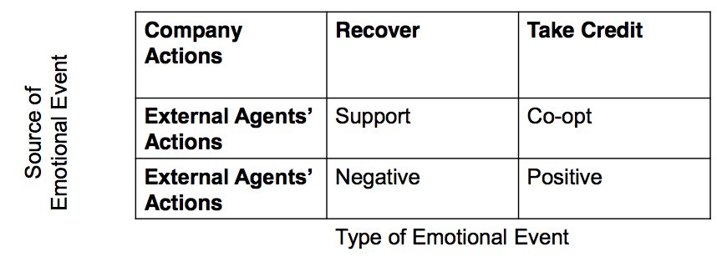

Designing for Control
- Service encounters that involve uncertainty in outcome or process will cause customers to lose control
- Behavioural Control
  - Selection
  - Customers are empowered select or customize elements of the service themselves
  - THINK scheduling room service, picking cable channels
- Cognitive Control
  - Information
  - Customers cannot control the process, but they have information about what is going on
  - THINK flight delays, busy restaurant, fedex tracking

Reading 7 – Service Profit Chain
The Book & Theory
- Business theory developed by a group of researchers from Harvard University
  - Published in 1994
- Profitability and Customer Loyalty are linked to Employee satisfaction, loyalty, and productivity

Service Profit Chain
- The service profit chain companies increased stock value by 147% while nearest competitors only increased stock value by 110%
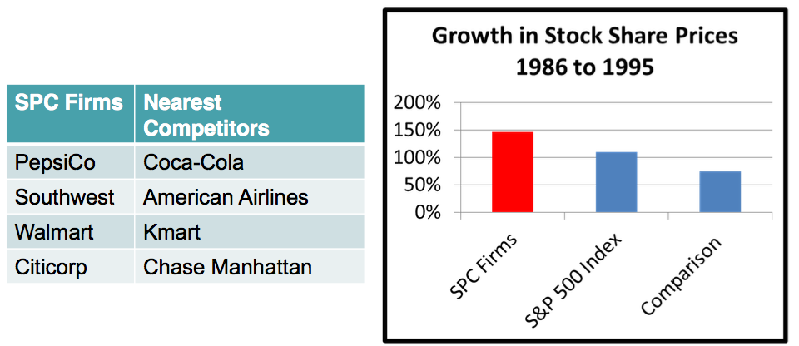

The Service Profit Chain – How Leading Companies Link Profit and Growth to Loyalty, Satisfaction and Value
- Customer loyalty drives profitability and growth
  - a 5% improvement in customer loyalty results in improved results (25-85%)
- customer loyalty
  - retention
  - repeat business
  - referral
- Customer satisfaction drives customer loyalty
- Customer satisfaction: service designed and delivered to meet targeted customer needs

- Value drives customer satisfaction
  - Value is subjective, not all customers want or need the same things. Southwest airline customers want a lower price more than they want amenities or roomier seats.
- Quality and productivity drive value
  - Employees who are engaged and have the product knowledge better meet the needs of the customer than unengaged and inexperienced employees.
- Employee loyalty drives service quality and productivity
  - Employees who are enthusiastic and satisfied are more effective at engaging the customer than employees who are not satisfied and looking for other work.
- Employee satisfaction drives employee loyalty
  - Low employee turnover is linked to higher customer satisfaction
- A: internal quality drives employee satisfaction
  - Internal quality is a measure of the feelings that employees have towards their jobs, fellow employees and the company they work for. It is related to training, recognition, job design, and having the right tools to service the customer.
- 7B: internal quality drives employee satisfaction
  - Internal service quality
    - Workplace design
    - Job design
    - Employee selection and development
    - Employee rewards and recognition
    - Tools for serving customers
- Top management leadership underlies the chains success
  - Service profit chain leaders develop and maintain a culture that is focused on service to customers and employees
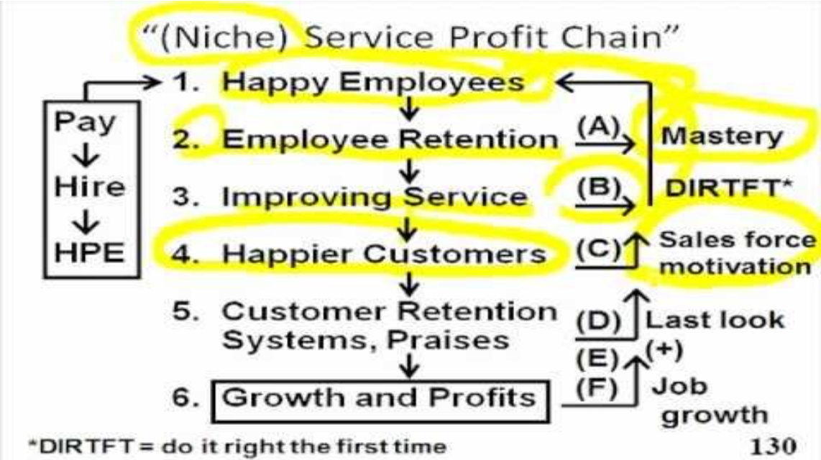

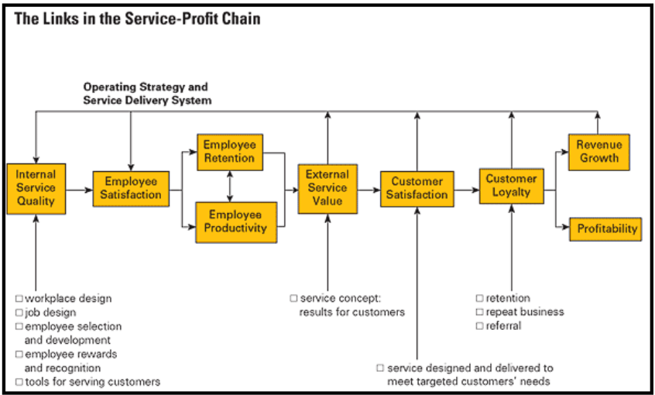

Internal Service Quality – 1. Hiring
- You must hire the right people
  - Be the preferred employer
  - Intensify the selection process to hire the right people

Motivating Employees – Workplace Design 2. Enable your People
- Build a high performance team – cross functional and customer centric
- Empower the frontline
- Extensive training – organizational, interpersonal, product knowledge

Chapter 7 – Managing and Engaging Employees in Service Organizations
Why are employees important?
- Employees in service organizations are important because they are the:
  - Service
  - Organization in the customers eyes
  - Brand
  - Marketer
  - Salesperson
- “if you take care of your employees they will take care of your customer and business will take care of itself” – J.W. Marriott

Employee Engagement
- employee engagement is the emotional commitment the employee has to the organization and its goals

Why engagement is hard in Service Industries
- Workplace characteristics that make management challenging
  - High turnover of staff
  - Low commitment levels
  - Low job satisfaction
  - High job stress
- Service job characteristics
  - Long hours
  - Irregular hours
  - Split shifts
  - Seasonality
  - Low wages
  - Low industry image
  - Lack of career path
  - Dominated by part-time

Employee Empowerment
- Employees need to be empowered to read situations and act as necessary in order to meet or exceed customer expectations
- The guiding philosophy of empowerment is non-bureaucratic and employee-oriented
  - Service organizations must evolve systems and processes so as not to restrict employees
- Empowerment fosters an environment of commitment and ownership
- Employees should receive the same sort of respect as they are expected to offer to their customers
- Superior service comes from employees showing initiative in a trusting work environment in which management assumes a supporting role
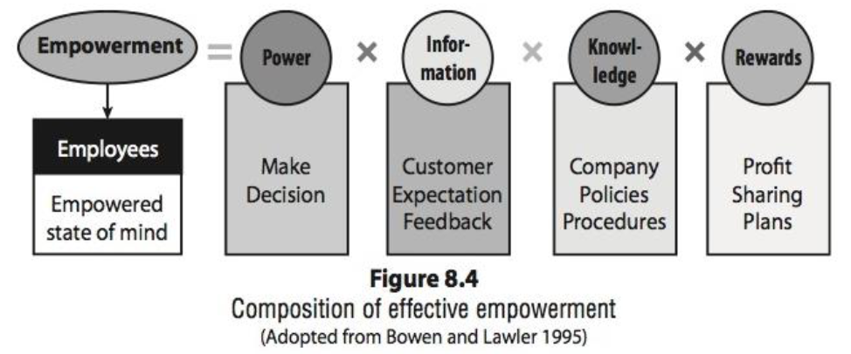

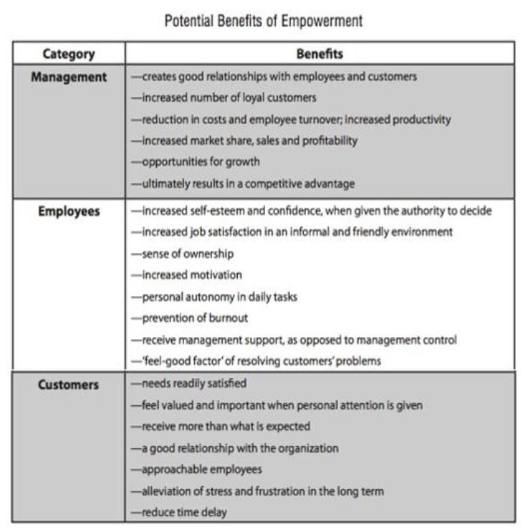

Empowerment in Practice
- Theory X
  - In theory X, managers assume employees inherently dislike work and are generally lazy
- Theory Y
  - In theory Y, managers assume employees may be ambitious and self-motivated and generally will work well

What is Organizational Psychology?
- Closely connected to HRM, it is the field of study and practice that investigates and seeks understanding about the impact that individuals, groups and structures have on behaviour in the workplace
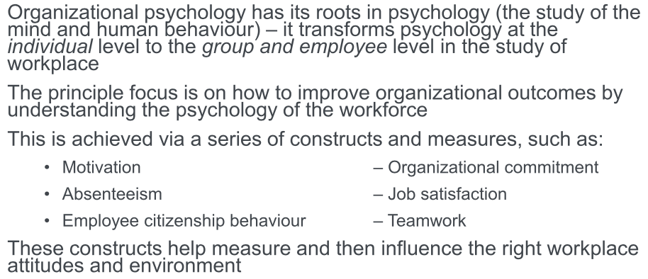

What is Human Resource Management (HRM)
- Concerned with the design of formal systems and continual proactive measures to ensure the effective and efficient use of a firms people to accomplish organizational goals
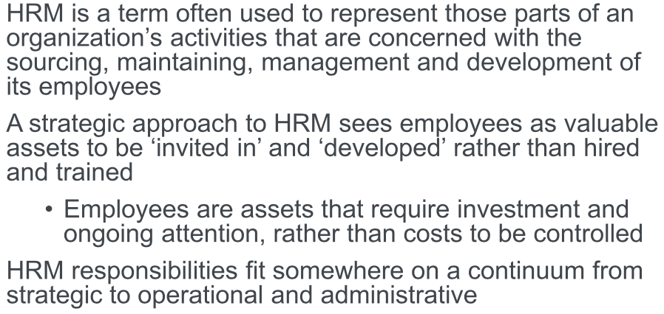

HRM in Service Context
- There are some important differences when managing service employees:
  - Coproduction: employees must engage with an involve customers in the process of service delivery
  - Hiring for attitude: employee selection and recruitment must focus on customer-relationship skills and place more emphasis on personality, energy, and attitude than on education, training, and experience
  - Managing employee actions: organizational norms and values are needed to guide behaviour
  - Emotional labour: service employees have to exert labor beyond just physical and mental labor; the required emotions for different service positions can vary
  - Part-time marketers: employees are expected to perform a marketing function as they coproduce the service experience

What is Emotional Labor?
- The work service employees perform that goes beyond physical or mental duties, when they are required to demonstrate an emotion.
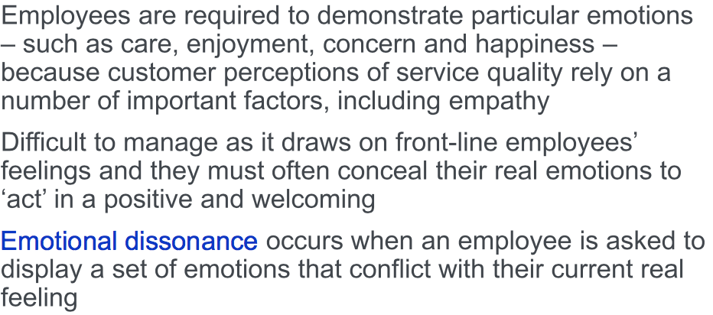

HRM + Internal Work
- Every organization, whether intended or not, has a culture of some kind
- Organizational culture describes the specific collection of values and norms that are shared by people in an organization and that control the way they interact with each other and with stakeholders outside the organization
- In a service business, organizational culture has the ability to fill the gaps between:
  - What the organization can anticipate and train its people to deal with, and
  - The opportunities and problems that arise in daily encounters with customers
- Important for service organizations to develop a predominating norm of behaviour that is customer-centric and focused on service quality

Chapter 8 – Service Guarantees, Failure, and Recovery
Why is Customer Service Important?
- It is 6-7 times more costly to attract a new customer than it is to retain an existing one
- 89% of customers have stopped doing business with a company after experiencing poor customer service.
- It takes 12 positive customer experiences to make up for one negative experience.
- Customers are 2 times more likely to share their bad customer service experiences than they are to talk about positive ones.
- 33% of consumers would recommend a brand that provides a quick but ineffective response.
- 17% of consumers would recommend a brand that provides slow but effective response

Strategies for Service as a Competitive Advantage

Service Guarantees
- a service guarantee is an explicit promise made by the service provider to deliver a certain level of service to satisfy the customer and remunerate the customer if the service is not sufficiently delivered

Service Recovery
- a service recovery is a systematic process undertaken by an organization in an effort to return aggrieved customer to a state of satisfaction after a service has failed to live up to expectations

Examples of Service Guarantees
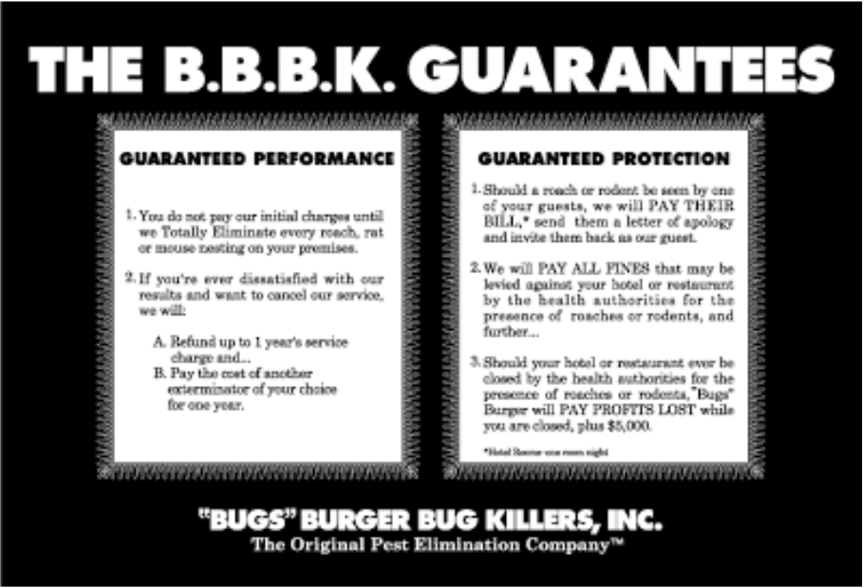

- Time Guarantee
  - Free pizza within 40 minutes if not delivered
- Hampton Inn
  - First hotel with a guarantee started in October, 1999
  - Over 10 years gave out 6 million in free rooms
  - Tracked 41 million in repeat business
  - Empowers employees
  - Benefits the chain by learning from guests and tracking service failures

What makes an effective Service Guarantee?
- Unconditional
  - When excuses are given, the customer feels cheated
- Meaningful to the customer
  - Promising something of real value if service is not delivered properly
- Believable/credible
  - Promising something that could legitimately be delivered upon
- Easy to invoke
  - An unpleasant situation should not be exacerbated by a service guarantee that is difficult to invoke
- Easy to fulfill
  - When a customer invokes a guarantee, the service provider should pay out immediately
Benefits of Service Guarantees
- Assuring reliability and encouraging sales
- Clarifying expectations by indicating to everyone the level of expected service
- Receiving immediate customer feedback
- Improving service delivery systems
- Identifying “fail points” in the service system

Service Guarantees
- Service guarantees perform both a marketing and operational function
- Service guarantees operate as an auto-alignment system by coordinating every system in the organization to be focused on the customer

Why are complaints and recovery important?
- Moments of Truth:
  - One of the most important moments of truth is when a customer has a problem. How an employee handles the problem is the difference between losing a customer or creating a customer for life
- Empowered Employees make a difference:
  - Frontline employees should be empowered to respond with flexibility to customer needs
- Service Failure/Recovery Reduces Churn Rate:
  - You must analyze customer defections to understand why customers are not returning
- Service Recovery Paradox
  - Customers who experience excellent service recovery feel more satisfied than customers who had no problem or complaint

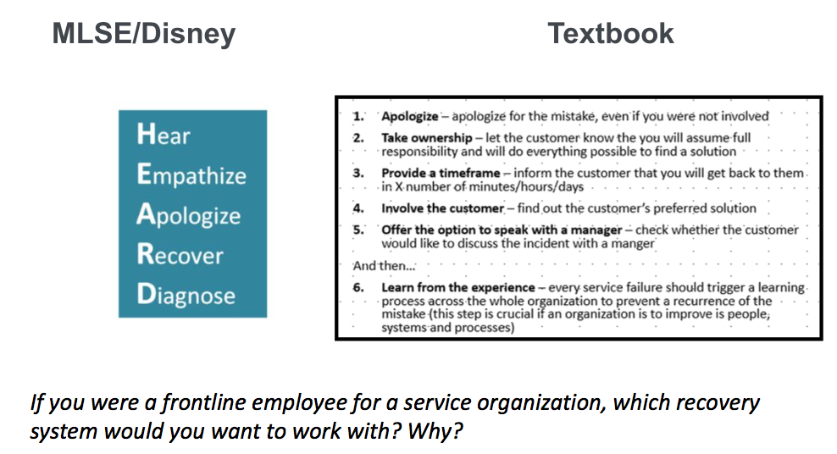
What do Customers Do?
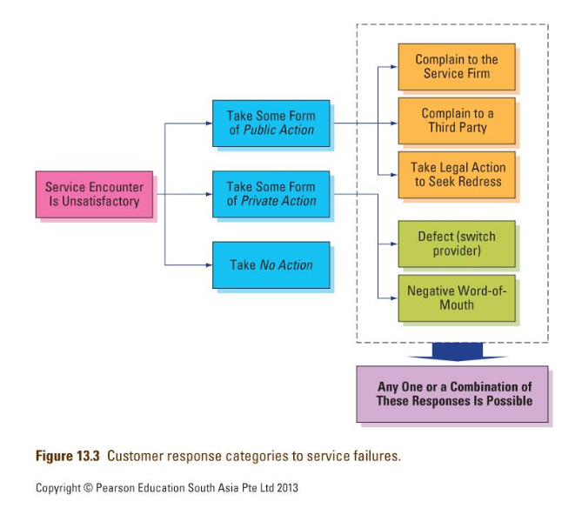

Why do Service Failures Happen?
- The Service Itself
  - You introduce new policies or make a change in a procedure that affects a customer
    - Hotel room not available, steak M vs. MR
- The Service Provider
  - Employee who is dealing with service is uncaring or rude causing dissatisfaction with a service.
    - Employee attitude, body language
- Things outside the control of the service provider
  - The point of sale system breaks down and you need to operate your restaurant/store
    - Airlines, Weather, power outage
- The customer
  - Service experiences are co-produced based on customer, employee and physical environment
    - Showing up late to reso, drunk fans near families

Why do Customers Complain?
- Obtain restitution or compensation
  - Customers complain to recover from economic loss; refund, upgrades, or have the service performed again.
- Release their anger
  - When there are too many rules, employees are rude or unreasonable they can become angry and emotional
- Help to improve service
  - Sometimes customers are invested in a business or service – they will give feedback to contribute and improve service
- Out of concern for others
  - Customers want to spare other customers from experiencing the same problems to feel good about helping improve the services

Do all Customers Complain?
- More income or education:
  - Research finds that people with better education, higher income, and greater involvement complain more than those in lower levels. Also customers with more knowledge about a product are more likely to complain.
- Face-to-face
  - During a consulting contract, less than 1% of all complaints were submitted via email, letters, customer feedback cards or website. 99% was face to face
- 5-10% Complain
  - Research has shown that only 5-10% of customers who have been unhappy with a service actually complain

Barriers to Customer Complaints
- Inconvenience
  - Customer feels like it would be too much effort to complain or cannot find a way to complain
- Doubtful payoff
  - The customer is uncertain any action will be taken by the company
- Unpleasantness
  - The customer has a fear of being treated rudely or feeling embarrassed about complaining or they have never complained before and feel awkward.

Effective Service Recovery
- Should be proactive
  - Front line staff and managers should look for signs of dissatisfaction (body language)
    - Anxious guest fidgeting to check out of hotel, restaurant guest swiveling their head
- Needs to be planned
  - Back up plans and procedures need to be set in place before they happen – what are the most common service failures
    - Airline or hotel overbooking
- Must be trained
  - Frontline staff needs to be trained on how to deal with most customer service failures
    - Service too slow, customer didn’t like meal
- Requires empowered employees
  - The faster you do the recovery the better. Provide front line staff with the tools to solve the problem
    - Waiters provide free dessert for error

AND SO:
- Organizations should see service failures as opportunities to create satisfied customers
- The goal of service recovery is not to return to a normal state, but to enhance perception
- After a service failure, has been successfully resolved, consumers may feel a stronger commitment to the service provider than if no failure had occurred in the first place.

What Should a Company Do?
- To maximize customer satisfaction, service providers must respond quickly and respond with empathy/courtesy
- Service recovery makes a difference
- All a service provider needs to do is delight customers by offering prompt and courteous service recovery response to service failures.
- Ineffective customer service can be just as bad and maybe do more damage than not actively offering customer service.

Encouraging Complaints
- Because complaints provide an organization with the opportunity to recover from service failure and prevent negative behaviours on the part of customers, an increasing number of organizations actively encourage customers to complain.

Non-verbal communication is important
- 55% body language
- 38% voice
- 7% words

Chapter 9 – Leadership for Service Organizations
Why is leadership important to service management?
- People/Employees
  - Your most important asset as a service organization is your people
- Heterogeneity
  - The variability of service performance varies from service performer to service performer
- Service profit chain
  - Engaged employees are linked to profitability

Management vs. Leadership
Management focuses on predictability, order and results:
- Planning
- Budgeting
- Organizing
- Controlling
- Problem solving
Leadership focuses on producing change:
- Vision setting
- Alignment of vision to strategy
- Alignment of vision to people
- Creating culture
- Future thinking
  - NOTE: leadership is distinct from but not better than management, both are important

Types of Leadership
- Situational
  - Supportive Behaviour
    - Helpful
    - Collaborative
  - Directive Behaviour
    - Telling of what and how
- Transactional
  - Compliance of followers through reward or punishment
  - Active leader who monitors to make sure no problems happen
  - Passive leader who intervenes after to rectify and discipline
- Transformational
  - Interpersonal and motivational form of leadership
  - Focused collaborative relationships via communication, team effort, and resource sharing
  - Enhances the motivation and performance of followers

- Servant
  - servant leaders actively listen to employees
  - servant leaders score high in empathy – walk a mile in the employees shoes
  - servant leaders treat employees special, special treatment of employees leads to excellent treatment of customers by employees.

EI: Emotional Intelligence
- Emotional intelligence is the ability to monitor ones own and other peoples emotions, to discriminate between different emotions and label them appropriately, and to use emotional information to guide thinking and behaviour.

How to Create EI in Employees
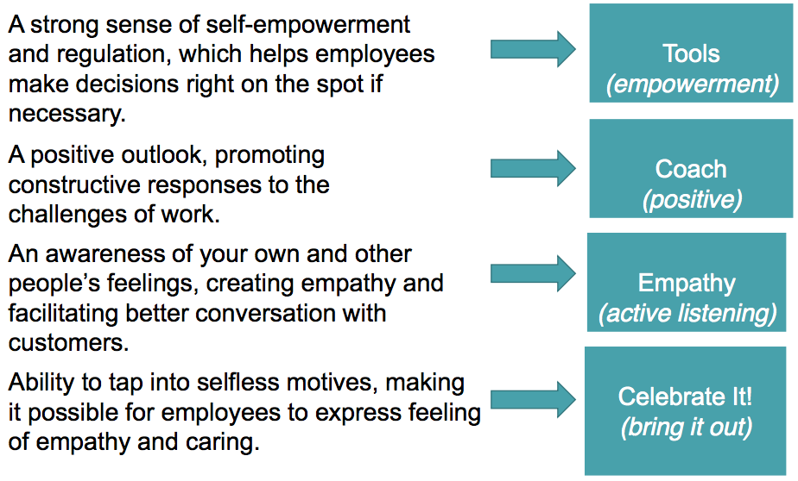

EQ (Emotional Quotient) vs. IQ (Intelligence Quotient)
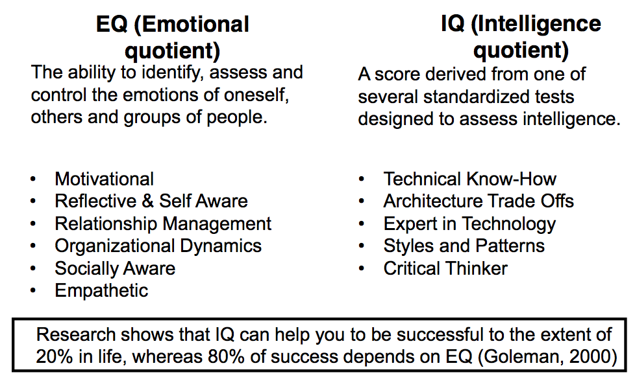

Emotional Intelligence (EQ) is the ability to:
- Perceive emotions
- Access and generate emotions
- Understand emotions
- Regulate emotions

Emotional Intelligence (EQ) is important because it:
- Improves personal life satisfaction
- Reduces conflict with others
- Helps manage impulse control
- Enhances leaders to be more effective
  - EQ is not teachable, but its learnable

Dimensions of EQ
Inner Theatre
- Know your own emotions
- Managing your emotions
- Motivating oneself
Outer Theatre
- Recognizing emotions in others
- Handling relationships with others

Chapter 6 – Service Marketing
Products vs. Services (IHIP)
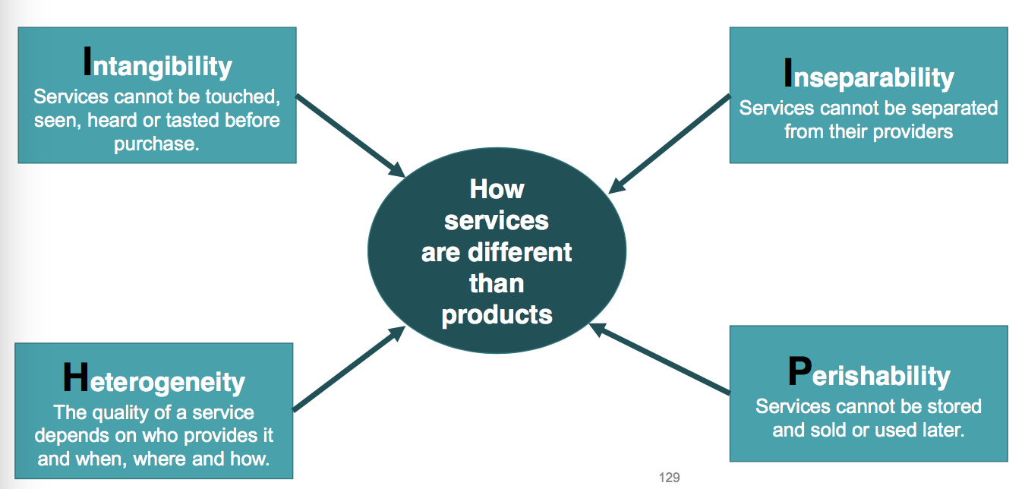

Marketing Goods vs. Services
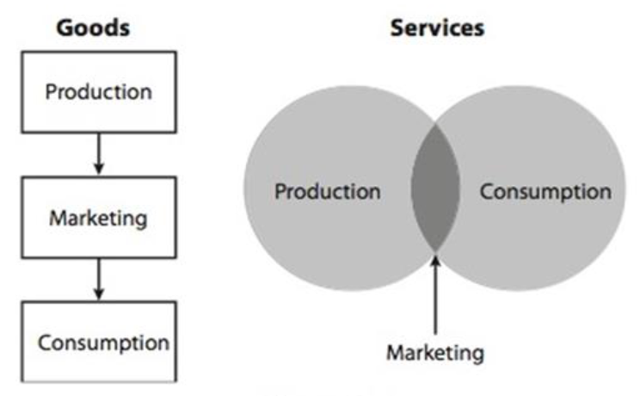

4P’s and 3P’s of Service Marketing
People
- People are intrinsic to service, the emotions and attitudes of employees are important – from a customer’s perspective, they represent the organization itself
- Employees can provide cues to customers regarding the nature of the service
- Customers also take cues from other customers that affect perceptions of the service
Process
- Of greatest importance in marketing a service, it provides evidence of the quality of the service
- Customers actively participate in most service processes – thus need to be customer-centric
- Efficiency is not everything – personalized and customized processes are crucial to service marketing
Physical Evidence
- No service is truly intangible – almost always accompanied by products
- The servicescape is the physical environment/surroundings of the service
- Plays a vital role in the service delivery processes and customers assessment of the process
- Must be coordinated into coherent marketing message and should reinforce the firm’s image
Product
Place
Price
Promotion

Service Marketing is experience based
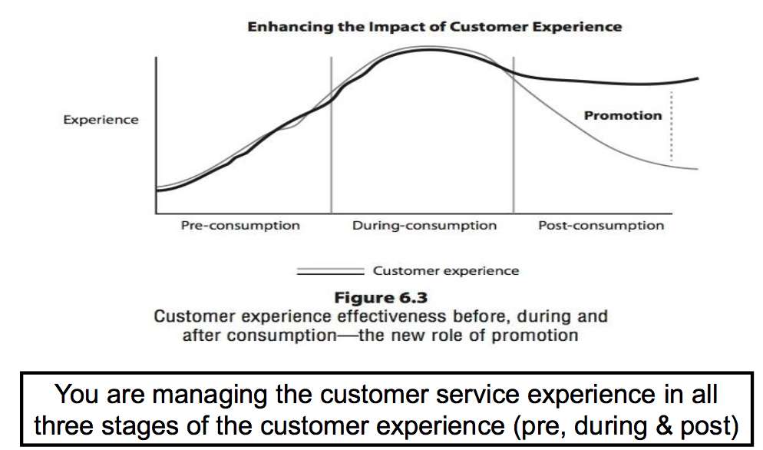
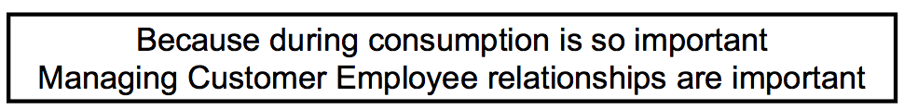
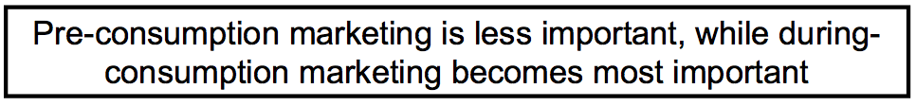
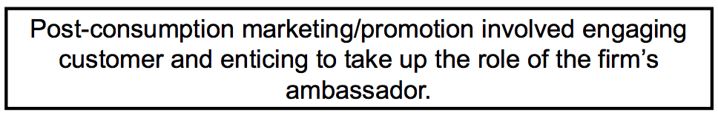

Post Consumption Marketing
- Review sites
  - Yelp
  - Tripadvisor
- Picture/Video Sharing
  - Instagram
  - Youtube
  - Vimeo
- Social Media
  - Facebook
  - Twitter
  - Google +
- Personal blogs
  - Travel blog
  - Food blog
- Travel Writers
  - Newspaper
  - Magazine

Relationships & Experiences
- Customers want to develop relationships with their service providers
- These relationships are important – whether interaction with the firm is frequent or intermittent – because customers will chose to go back to the service provider with whom they’ve formed a good relationship
- Employees interactions have a profound effect on customers’ perceptions of the quality of the service experience
- Successful service marketing strategies are based on the development of a personal relationship between employees and customers

Critical Moments of Truth
- The moments of truth are critical individual interactions that have the potential to determine a customers attitude towards the overall service offering
  - Such moments illustrate to the customer the true value of the organization (at least as the customer perceives it) and can make or break a service experience
  - If left unmanaged, these moments of truth can lead to loss of customer confidence
  - Thus, it is imperative to identify, analyse and manage these individual moments to ensure positive experiences
- It is the employees who have the opportunity, ability, and willingness to fulfil the service promise and go beyond their call of duty to provide customers with a superior experience.
  - Therefore, effective management of the service experience and effective marketing of service involves an appreciation of the importance of the people at the coalface, and a real commitment to their recruitment, training, motivation, and welfare
The ‘Cascade’ in ‘Moments of Truth’
- Service interactions that occur in the first stages of an overall service experience are particularly critical
- A failure at an early point in the relationship results in greater risk of dissatisfaction at each stage
- Conversely, a cascade in goodwill can occur, where each positive experience reinforces the likelihood of the next encounter being viewed positively and the overall experienced being perceived as enjoyable.
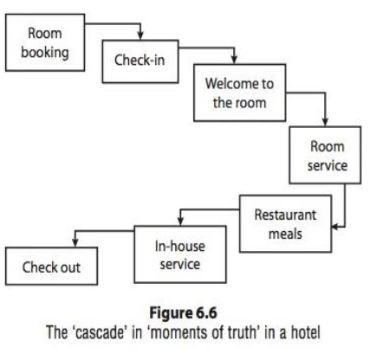
Internal Marketing
- Employees are service organizations greatest assets, since they are only people who can create and maintain relationships with external customers
- Service management views employees as ‘internal customers’
- Internal marketing aims to create a trustful relationship with the firms employees so that they can live the brand
- The overall objectives of internal marketing are:
  - To ensure that employees are motivated towards customer-oriented and service-minded performance, and thus towards fulfilling their roles as part time marketers during the service interface
  - To attract and retain service-minded employees
- Many of the external marketing process can be equally applied to internal
- To enhance the effectiveness of internal marketing, firms should:
  - Compete for talent
  - Offer a vision
  - Prepare people to perform
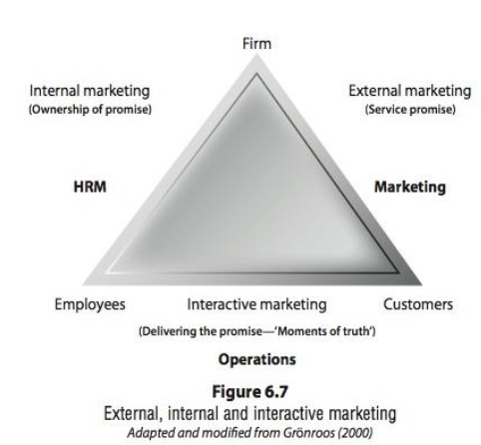

Lifetime Value of a Customer
Purpose of Lifetime Value
- Estimate how much a customer is worth and how much you can spend acquiring each customer
- Measure of customer loyalty
- Helps you allocate ongoing marketing activities
- Encourages staff to look at the long term value of a customer

Lifetime Value
- Simple calculation
  - Average Value of Sale x Number of Repeat Transactions x Average Retention Time
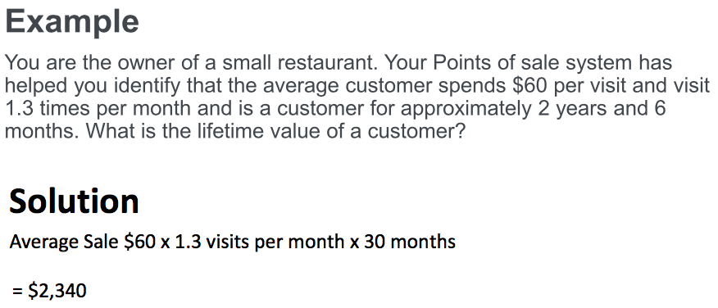
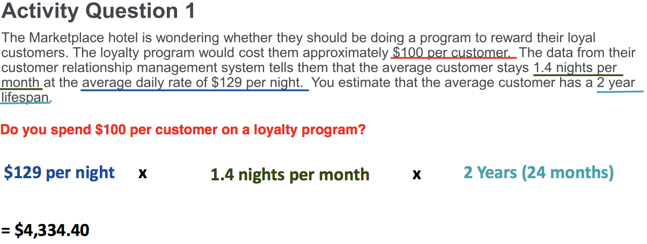

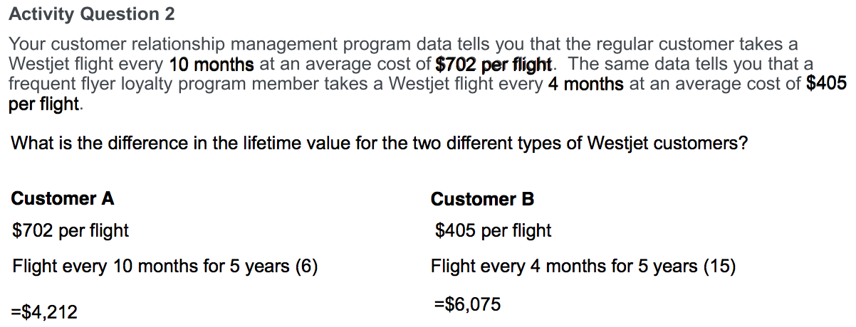

Online Reputation Management
Reading 8 Highlights
- Research in 2010 identified that customer reviews became the dominant factor in hotel selection
  - 51% of respondents said that guest experience factored into hotel selection
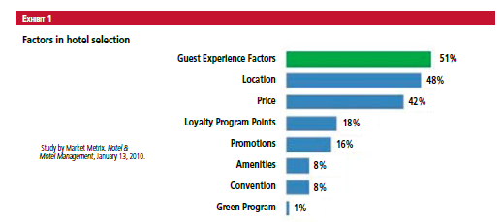
Online Hotel Reviews Matter
- Study by Cornell’s Center for Hospitality Research using data from TripAdvisor, ReviewPro, STR, and Travelocity. First academic research to measure economic value to hotel reviews.
  - Increasing Pricing
    - A hotel with a one point increase in hotel review scores (e.g. from 3.3 to 4.3 out of 5) can increase prices by 11.2% and still maintain occupancy and market share.
  - Occupancy Increase
    - A 1% increase in reputation leads to an occupancy increase of .5%
  - Revenue Per Available Room
    - A 1% increase in reputation leads up to a 1.4% increase in revenue per available room.

What is Reputation Management?
- Activities performed by individuals or organizations which attempt to maintain or create a certain frame of mind regarding themselves in the public eye.
- Reputation management is the process of identifying what other people are saying or feeling about you or your business; and taking steps to ensure that the general consensus is in line with your goals. Many people and organizations use various forms of social media to monitor their reputation.

Viral Customer Experiences

Key Reputation Sources for Hotels
- TripAdvisor
- OTA Sites (Expedia, Kayak, Hotwire)
- Yelp
- Zoover
- Social Media Sites

How do you Respond to Reviews
- 5 Things to think about
  - treat most reviews as if they are authenic and true
  - your reviewers are often paying customers
  - by standers may be reading reviews as well
  - your reputation may be controlled by the way you respond
  - we are all human beings at the end of the day

Customer Response Frameworks


