ECOR 1010 – Introduction to Engineering

xxxx
Assignment #7
Assignment Title: Matrix Operations with MATLAB
TO Marking TA:
Name: xxxx
Email: xxxx

Lab Section: L2
Room: ME2256 – Carleton University

FROM:
Email: xxxx
Student Number: xxxx

Number of Figures and Tables (Including handwritten ones): 0 tables, 10 figures
Last Date and Time of Revision: 29 November 2016

Introduction
MATLAB is perhaps one of the most useful tools to manage, compute, and model engineering data. As such, it is crucial that exposure to this tool is established early on, thereby ensuring that students have sufficient skills to tackle any engineering problem. To accomplish this, this lab will focus on developing a basic level of skill and knowledge in the language by solving a variety of problems, all of which either deal with linear systems and systems of linear equations, matrix and vector manipulation, and setting up and solving related engineering problems. The report, in turn, will report on the results for each of these problems, and will interpret and explain them accordingly, not only in a physical and mathematical sense, but also in the context of the language of MATLAB itself.

Materials and Methods
Simply stated, to accomplish this objective, our primary material and method will be MATLAB R2016b, version 9.1.0.441655. Additionally, IntelliCAD will be used very limitedly for one of the problems.

Results
For each problem, the results were as follows: for part 1.1, the first two operations gave us 23 and [1.92; 0.96; 0; 0.32] respectively, with the last two operations yielding errors due to the differences in the sizes of the matrices in c) and the differences in the dimensions of the matrices for d). For part 1.3, MATLAB outputted the proper graph of the function with its specified ranges, as expected.

For part 2.1, all our results were as expected, and can be seen within the figure 4 of the appendix. In part 2.2, our result was not as expected, as the ship did not go back to its original position. In part 2.3, our result for the solution x was [0.4969;0.0314;-0.1069] and unique. For part 2.3, our result for the solution x was not unique, and was [65;-10;50;-65;55;0] with only integers, and [295/6,-155/6,205/6,-485/6,235/6,-95/6] when finding the least squares solution. In part 2.4, our system was found to be inconsistent, and therefore no solution for x existed. For part 2.5, our solution for the described system was unique and came out to be [-19079/8200;-21127/8200;-203/200]. Lastly, for part 2.6, we got a value of 91 for c and 28.9662 for E.

Discussion
The significance of the results, both in context to the mathematics involved and the code itself is described in sufficient detail within the comments of the figures in the appendix.

As for the advantages and disadvantages of using MATLAB for matrix and vector manipulations and computations, I have this to say: the biggest and most notable advantage is its sheer computational power, whereas the biggest drawback would be its syntax, as in many cases, coding matrices and vector operations can get quite inefficient.

Conclusions

In conclusion, it can be said that our objective was, indeed, achieved, with our results as described above.

APPENDIces- Figures and Tables

H = [8;5;-6];  I = [0;1;-3];  J = [8,4,-7];  K = [6;3;0;1];  L = [10;8];  p = 0.32;  q = 2.35;  r = -0.4;  %Dot product of vectors 'H' and %'I'  V1 = dot(H,I)  %Multiplication of vector 'K' w/ %scalar p  V2 = p*K  %returns error because 'L' and 'H' %are not of same size  V3 = dot(L,H)  %Subtraction of transpose of vector %J by vector K ... returns error %because dimensions do not agree  V4 = (J.') - K | >> H = [8;5;-6];  I = [0;1;-3];  J = [8,4,-7];  K = [6;3;0;1];  L = [10;8];  p = 0.32;  q = 2.35;  r = -0.4;  V1 = dot(H,I)  V2 = p*K  V1 =  23  V2 =  1.9200  0.9600  0  0.3200  >> V3 = dot(L,H)  Error using dot (line 33)  A and B must be same size.  >> V4 = (J.') - K  Matrix dimensions must agree.
Figure 1: solution to part 1.1

P1 = [0;0];  P2 = [1;10];  P3 = [9;-9];  P4 = [-5;-20];  P5 = [-18;26];  P6 = [1;10];  x = [P1(1),P2(1),P3(1),P4(1),P5(1),P6(1)];  y = [P1(2),P2(2),P3(2),P4(2),P5(2),P6(1)];  plot(x,y)  xlabel('x');  ylabel('y');  title('Change in position of CCGS Panda, as a function of x and y (created by xxxx)'); | 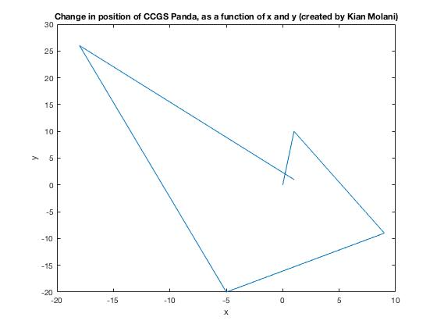
Figure 2: solution to part 1.2
%Function to plot, w/ specified %function handle 'x' and named %function  fp = (@(x) sin(x.^2) + ((10-(4*x)+(x.^2))./(7+(2*(x.^2)))));  %Defining values (e.g. range %and %number of plotted points) %along %named function using %'linspace'  numOfPoints = 100;  xcomp = linspace(-3,3,numOfPoints);  %Evaluate y components using %'feval' functionality and then %plot  ycomp = feval(fp,xcomp);  plot(xcomp,ycomp)  xlabel('x');  ylabel('y');  title('Graph of function f(x) over interval [-3,3] (created by xxxx)');  legend('f(x) = sin(x^2) + (10 - 4x + x^2) / (7 + 2x^2)'); | 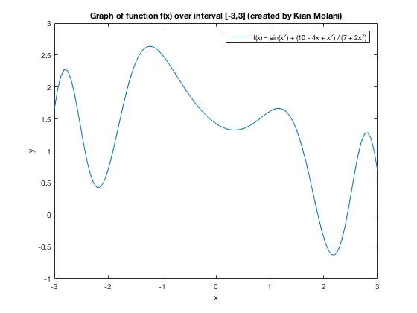
Figure 3: Solution to part 1.3

F =[3,9;7,-1;3,0;6,8;9,5;5,2];  G = [-9,3,8,5,-1,2;7,-1,-2,9,3,3];  Q = [2,-7,2;1,0,7;-5,3,5];  U = [1,0;0,1];  %Multiplies product of F and G %with scalar r, defined above  M1 = (F*G)*r  W = F-(G.')  % sorts W in ascending order  S = sort(W,2)  N = [1 2 3 4 5 6].';  %Plotting W, w/ N acting as x %indices  %Marker indices (*) placed at %every plotted point along range %of plot defined by W  plot(N,W,'-*','MarkerIndices',1:1:length(W))  xlabel('x');  ylabel('y');  title('Graph of matrix S, w/ elements of vector N acting as x-indices (created by xxxx)');  M2 = U*G  M3 = F*U  M4 = Q*H  M5 = (q*G) + (p*(F.')) | 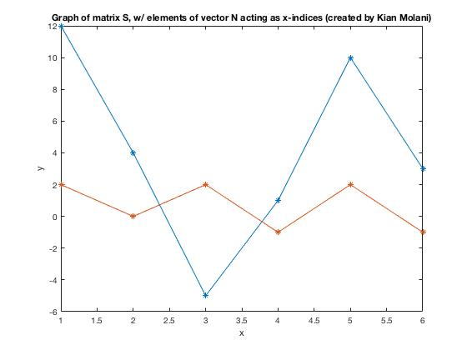  >> F = [3,9;7,-1;3,0;6,8;9,5;5,2];  G = [-9,3,8,5,-1,2;7,-1,-2,9,3,3];  Q = [2,-7,2;1,0,7;-5,3,5];  U = [1,0;0,1];  M1 = (F*G)*r  W = F-(G.')  S = sort(W,2)  N = [1 2 3 4 5 6].';  plot(N,W,'-*','MarkerIndices',1:1:length(W))  xlabel('x');  ylabel('y');  title('Graph of matrix S, w/ elements of vector N acting as x-indices (created by xxxx)');  M2 = U*G  M3 = F*U  M4 = Q*H  M5 = (q*G) + (p*(F.'))  M1 =  Columns 1 through 5  -14.4000 0 -2.4000 -38.4000 -9.6000  28.0000 -8.8000 -23.2000 -10.4000 4.0000  10.8000 -3.6000 -9.6000 -6.0000 1.2000  -0.8000 -4.0000 -12.8000 -40.8000 -7.2000  18.4000 -8.8000 -24.8000 -36.0000 -2.4000  12.4000 -5.2000 -14.4000 -17.2000 -0.4000  Column 6  -13.2000  -4.4000  -2.4000  -14.4000  -13.2000  -6.4000  W =  12 2  4 0  -5 2  1 -1  10 2  3 -1  S =  2 12  0 4  -5 2  -1 1  2 10  -1 3  M2 =  -9 3 8 5 -1 2  7 -1 -2 9 3 3  M3 =  3 9  7 -1  3 0  6 8  9 5  5 2  M4 =  -31  -34  -55  M5 =  Columns 1 through 5  -20.1900 9.2900 19.7600 13.6700 0.5300  19.3300 -2.6700 -4.7000 23.7100 8.6500  Column 6  6.3000  7.6900
Figure 4: Solution to part 2.1

A = [9,2,5;6,4,1;2,7,2];  B = [4;3;1];  %find a solution to matrix equation %defined by AX=B  X = linsolve(A,B) | A = [9,2,5;6,4,1;2,7,2];  B = [4;3;1];  X = linsolve(A,B)  X =  0.4969  0.0314  -0.1069
Figure 5: SOlution to part 2.2

%defines a system of linear %equation with unknowns of %x1,x2,x3,x4,x5,x6  syms x1 x2 x3 x4 x5 x6  eqn1 = x1 - x2 == 75;  eqn2 = x2 - x3 == -60;  eqn3 = x3 - x4 == 115;  eqn4 = x4 - x5 == -120;  eqn5 = x5 - x6 == 55;  eqn6 = -x1 + x6 == -65;  %transforms system defined above to %matrix forms of A and B  [A,B] = equationsToMatrix([eqn1, eqn2, eqn3, eqn4, eqn5, eqn6], [x1, x2, x3, x4, x5, x6]);  %checking to see that system is %consistent. If it is, is solution %unique?  %places B after last column of A  C = [A(:,1:6) B A(:,7:end)];  %row reduces matrix C ... shows %system is consistent, with at %least one free variable  rref(C)  %solves for a solution to the %system (integers only)  X = linsolve(A,B)  %checks to see that solution is %valid, by checking that 0 vector %is returned  if (A*X-B == 0)  disp('Solution is valid')  else  disp('Solution is not valid')  end  %uses pseudoinverse function to %find least squares solution x  pinv(A)*B | >> syms x1 x2 x3 x4 x5 x6  eqn1 = x1 - x2 == 75;  eqn2 = x2 - x3 == -60;  eqn3 = x3 - x4 == 115;  eqn4 = x4 - x5 == -120;  eqn5 = x5 - x6 == 55;  eqn6 = -x1 + x6 == -65;  [A,B] = equationsToMatrix([eqn1, eqn2, eqn3, eqn4, eqn5, eqn6], [x1, x2, x3, x4, x5, x6]);  C = [A(:,1:6) B A(:,7:end)];  rref(C)  X = linsolve(A,B)  if (A*X-B == 0)  disp('Solution is valid')  else  disp(‘Solution is not valid’)  end  pinv(A)*B  ans =  [ 1, 0, 0, 0, 0, -1, 65]  [ 0, 1, 0, 0, 0, -1, -10]  [ 0, 0, 1, 0, 0, -1, 50]  [ 0, 0, 0, 1, 0, -1, -65]  [ 0, 0, 0, 0, 1, -1, 55]  [ 0, 0, 0, 0, 0, 0, 0]  Warning: The system is rank-deficient.  Solution is not unique.  > In symengine  In sym/privBinaryOp (line 946)  In sym/linsolve (line 63)  X =  65  -10  50  -65  55  0  Solution is valid  ans =  295/6  -155/6  205/6  -485/6  235/6  -95/6
Figure 6: Solution to part 2.3

syms x1 x2  eqn1 = 26.6*x1 + 30.2*x2 == 162;  eqn2 = 3100*x1 + 6400*x2 == 23616;  eqn3 = 240*x1 + 340*x2 == 1566;  [A,B] = equationsToMatrix([eqn1, eqn2, eqn3], [x1, x2]);  %system shown to be inconsistent  X = linsolve(A,B)  C = [A(:,1:2) B A(:,3:end)];  %shows inconsistency of system %(after reduction, last eqn of form %0 = b, where b DNE 0)  rref(C) | >> syms x1 x2  eqn1 = 26.6*x1 + 30.2*x2 == 162;  eqn2 = 3100*x1 + 6400*x2 == 23616;  eqn3 = 240*x1 + 340*x2 == 1566;  [A,B] = equationsToMatrix([eqn1, eqn2, eqn3], [x1, x2]);  X = linsolve(A,B)  C = [A(:,1:2) B A(:,3:end)];  rref(C)  Warning: The system is inconsistent. Solution  does not exist.  > In symengine  In sym/privBinaryOp (line 946)  In sym/linsolve (line 63)  X =  Inf  Inf  ans =  [ 1, 0, 0]  [ 0, 1, 0]  [ 0, 0, 1]
Figure 7: solution to part 2.4

R1 = 6;  R2 = 5;  R3 = 1;  R4 = 8;  V1 = 5.06;  V2 = 3.06;  syms i1 i2 i3  eqn1 = V1 + R2*(i1-i3) + R1*(i1-i2) == 0;  eqn2 = V2 + R3*(i2-i3) + R1*(i2-i1) == 0;  eqn3 = R2*(i3-i1) + R3*(i3-i2) + R4*i3 == 0;  [A,B] = equationsToMatrix([eqn1, eqn2, eqn3], [i1, i2, i3]);  %unique solution...negative value %means that current flowing %opposite to convention  X = linsolve(A,B) | R1 = 6;  R2 = 5;  R3 = 1;  R4 = 8;  V1 = 5.06;  V2 = 3.06;  syms i1 i2 i3  eqn1 = V1 + R2*(i1-i3) + R1*(i1-i2) == 0;  eqn2 = V2 + R3*(i2-i3) + R1*(i2-i1) == 0;  eqn3 = R2*(i3-i1) + R3*(i3-i2) + R4*i3 == 0;  [A,B] = equationsToMatrix([eqn1, eqn2, eqn3], [i1, i2, i3]);  X = linsolve(A,B)  X =  -19079/8200  -21127/8200  -203/200
Figure 8: solution to part 2.5

A = [1,0,1;0,3,9;8,0,6];  b = [1,2,2];  c = b * A * b.'  %value pi defined to 4 decimal %places  E = c/pi | >> A = [1,0,1;0,3,9;8,0,6];  b = [1,2,2];  c = b * A * b.'  E = c/pi % value pi defined to 4 decimal places  c =  91  E =  28.9662
Figure 9: Solution to part 2.6

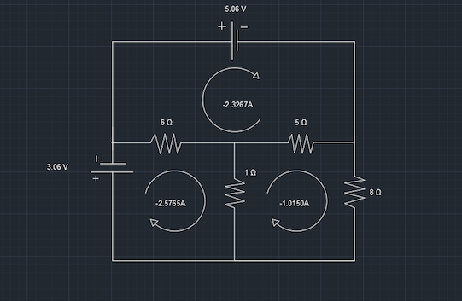
Figure 10: Intellicad drawing of circuit, showing results found in part 2.5

