ECOR 1010 – Introduction to Engineering

jaden r trent
Assignment #2
Assignment Title: Unit Conversions, & Introduction to CAD
TO Marking TA:
Name: Craig Jee
Email: craigjee@cmail.carleton.ca

Lab Section: ---
Room: --- – Carleton University

FROM:
Email: ----
Student Number: ----

Number of Figures and Tables (Including handwritten ones): 3
Last Date and Time of Revision: 10 March 2017

Introduction
Converting between units appears to be complicated and repetitive, but is necessary to display one’s results amongst others. If someone is not aware of which units must be utilized, or are using it could lead to serious altercations, such as the, “Gimli Glider” incident. This was when there were a series of mistakes which led to the pilot having to do an emergency landing. This lab required us to figure out which of the given pumps are most efficient. To accomplish that, we need to convert units between SI, FPS and the Hybrid American system.
Furthermore, this lab introduced a component of 3D modelling. All items, structures, etc. utilized in daily life has undergone a similar cycle of designing, testing, and prototyping with the use of 3D computer models.

Materials and Methods
For Part 1 of the lab, to determine which pump was most efficient, there were a variety of resources used. Primarily the conversion table given in the lab outline, a calculator, and the internet to find some unknown conversions. For part 2 of the lab, CREO Parametric was used to design the model and determine the surface area of the model.

Results
According to calculations in appendices (Pump calculations), the three pumps resulted in a variety of efficiencies. However, the first pump was the most efficient amongst the three, since it had an efficient of approximately 71%(Figure 1). Whereas the other two pumps had an efficiency of 51% for pump 2(Figure 2) and 63% for pump 3(Figure 2). Although the efficiencies were not vastly different, overtime using the most efficient pump will have less repercussions.
The volume and surface area of the model created were determined by CREO Parametric, and the screen was captured and displayed in appendices (Figure 3).

Discussion
In any calculations, whether it is in this lab or elsewhere, one must be aware of the units they are using and be careful to ensure that the proper units are being used for each part of the calculation. Since there are numerous steps, prior to achieving the efficiencies, it is possible that the calculations may have been incorrect due to not writing down which units were in use. In addition, rounding may affect the result significantly, and to avoid this problem, it must be kept until the end.

Conclusions
This lab entails several instances, where the units or figures itself could have been incorrect. But it was required to convert all figures into the same units and continue working from there. Ensuring that the units are consistent throughout each of the calculations, results in accurate calculations.
The CREO Parametric program displayed that all items need to undergo designing, testing and prototyping prior to being produced. It showed that every single side and edge needed to be precise to ensure the desired model. Knowing how to use this program will be useful in the future, as it allows for more one to design different objects, etc.

APPENDIces- Figures and Tables

Pump Calculations
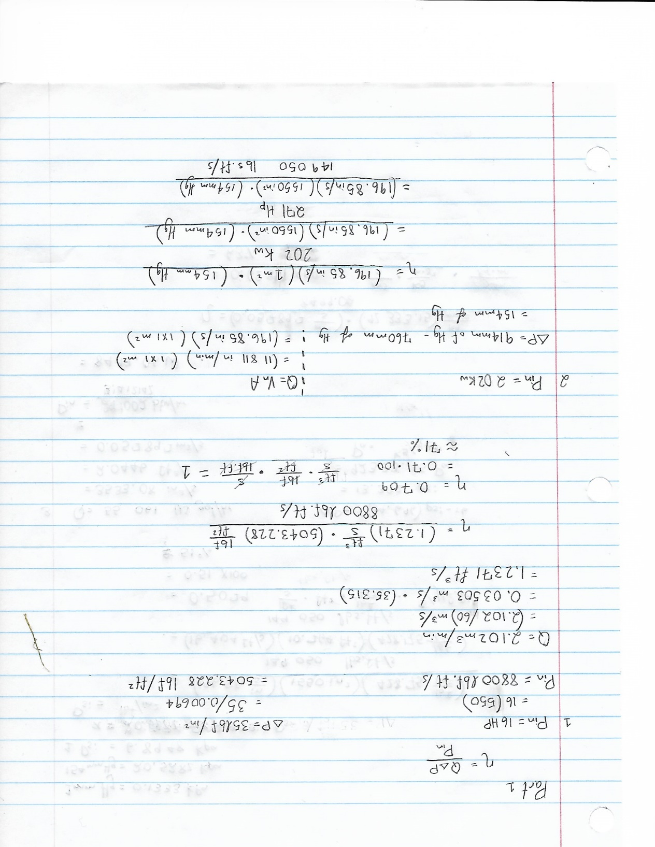
Figure 1

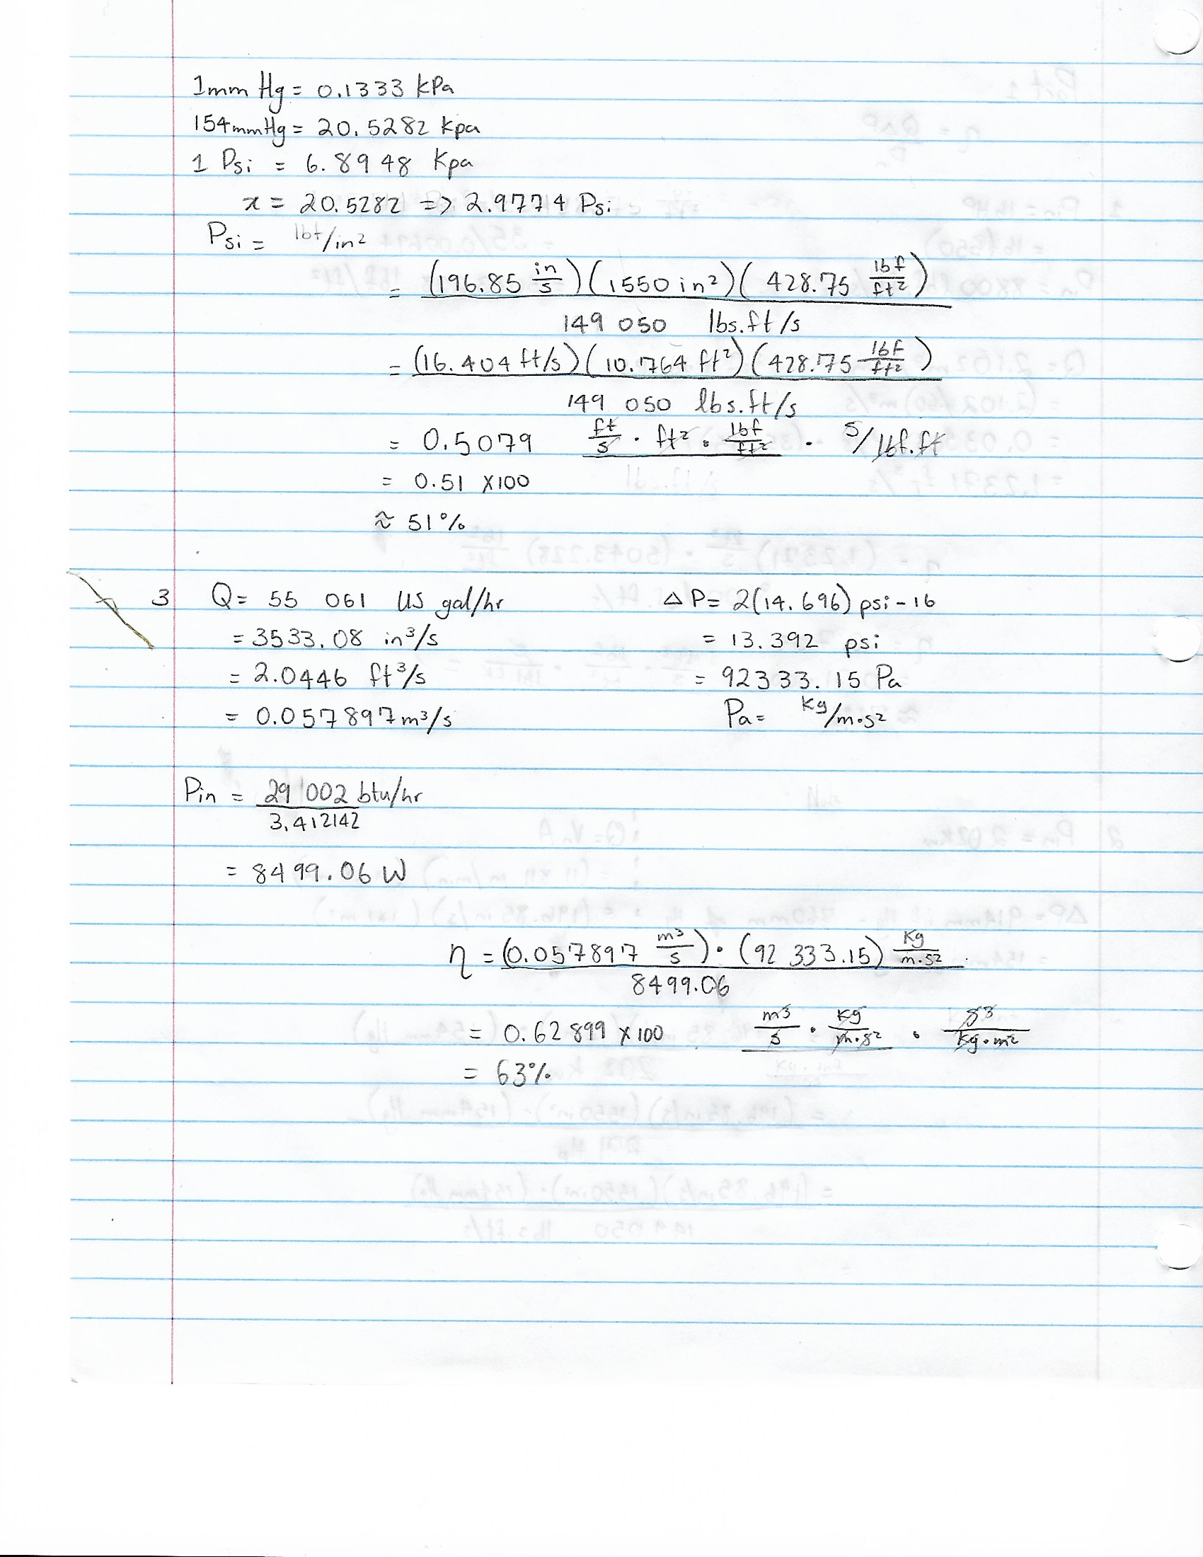
Figure 2

Properties of Model
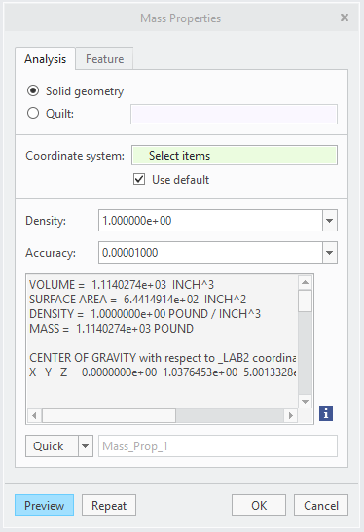
Figure 3

