CAUSES AND CONSEQUENCES OF THE FINANCIAL CRISIS OF 2008

GEO208: GEOGRAPHY OF THE GLOBAL ECONOMY
ESSAY ASSIGNMENT
WINTER 2017

Question 2: What factors account for the current financial crisis in the United States and which sectors of the economy are most affected by the recession? Why & how did this financial problem spread to the rest of the world?

Causes and Consequences of the Financial Crisis of 2008

Introduction
The financial crisis of 2008 is known to be one of the worst economic crisis since the Great Depression of 1929. The financial crisis had a great impact on the rest of the world since the world is tremendously integrated with what is happening in the United States through the investments into the real estate and financial markets. In order to understand the Depression of 2008, we must understand the definition of financial crisis. It can be explained by some sort of financial assets to lose large value rapidly. Historical data suggests that most of the financial crisis were related to banks crashing and many recessions have been associated with banking crashes. The root cause of the crisis happened because of sequential events leading to the markets crashing that will be discussed in this paper.

Financial deregulation
Financial deregulations of the 1990s were one of the many significant factors that led to the financial crisis of 2007-08. In order to understand the reason deregulations took place, we need to look at the reason regulations were made. In 1792, there was a major credit markets freeze that is a close resemblance to the 2008 financial crisis. Since then every 15 to 20 years for about 140 years the United States has seen a crash in the market. But this changed when the Great Depression of 1929 took place. After this crash, the government took action by placing three regulations. the first regulation is glass Steagall that separates personal banks from Wall Street banks, which divides the investment activities from personal banking activities. The second regulation is the FDIC insurance which makes the money in banks safe and trustworthy. The third and final regulation is SEC regulation which its purpose is to protect investors, maintain fair and efficient markets and smoothen capital formation. In about 50 years after the regulation was placed with no crashes and bank failures, the financial deregulation occurred (Verick and Islam, 2010). In 1980s innovations took placed and the United States started to deregulate because the regulations were old and many disastrous things happened since then. In the late eighties, savings and loans crisis occurred, in late nineties the long term capital management hedge, and finally, in early 2000s, Enron lied about their bad books. This all were warning of what to come in 2007-08.

Loose monetary policy
Loose monetary policy is a way for the government to expand the economy through lower interest rates and an increase of bank notes (printing money). Interest rates were low since the 1980s since every crash caused the governments to decrease rates to bring the economy out of the bust. Between the year of 2002 and 2005, the interest rates were at its lowest because of the dot-com bubble that burst in 2001. In order to bring the economy out the bust, the government put interest rates at 1%, which makes borrowing very attractive.

Financial and housing markets
With extremely low-interest rates, domestic and international investors started to look at higher returns since Treasury bills were only giving 1% interest on the investment and this made investors to look at mortgage debts for investing. Mortgage debts were a good investment if the homeowners were good on their repayments. The demand for mortgage debts was rose and investors wanted more mortgage, but everyone who has good credit had a home. In order to increase demand lenders loosened standards and made subprime mortgages and some loans did not consider income verification and this made mortgages were affordable. Credit agencies did not know about the risk of these mortgages since the agencies looked at historical data which made mortgage debt safe. The lenders, banks and investors kept throwing money into the housing market which made the housing prices to increase rapidly. Even if the homeowner's default on their mortgage the lender will get the house and can sell the house for a higher price since the prices are expected to rise (Shahrokhi, 2011). This was not true for this scenario; bubbles are rapid growth that is driven by irrational decisions, and they burst because homeowners started to default and with more houses being on the market. Demand for houses decreased, but the supply was increasing as more and more houses defaulted which led to an extreme decrease in housing prices.

Households and inequality
In Treeck (2013), it is argued that low and middle-income households have reduced savings and increased debt since income inequality has started to be present in the United States in the 1980s. Through borrowing household consumption and employment has been kept high, but this has created a credit bubble. The government promoted credit to households with declining incomes through loose policies with extremely low-interest rates. In figure 1, we can wee that the expenditure has raised steadily, but upward. This cannot be said for the wages since there is a stagnant increase. This could be the reason households demanding more credit from the banks.

Figure 1: personal consumption expenditures and median weekly earnings
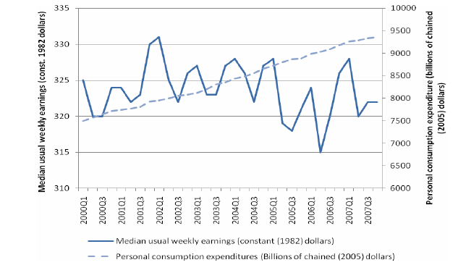
Source: Bureau od Labour Statistics

Sectors most affected by the financial Crisis
The financial markets and housing markets saw the most damage at the end of the boom of the economy since the government inserted more and more money into those markets in order to increase the value and promote international and domestic investments. There are more sectors that are affected by the financial crisis. Logging has also seen a decrease since demand for houses decreased, houses did not need to be build so that decreased demand for construction.
The automotive industry was part of a global financial downturn. The Big Three (GM, Chrysler and Ford) in the United States have focused on manufacturing big trucks and SUVs. In 2008, when gasoline prices rose which decreased demand for big vehicles and profits drop for the Big Three. The tourism sector experienced challenges as a result of the global economic crisis. As household increase debt and the saving portion decrease, less money is available to spend on leisure and this has shrunk the tourism sector.

Global impact
The reason the financial crisis was impacted globally is because economies of nations are interdependence and interconnected. The global financial market saw the potential the housing and financial markets had and started to invest their money into it. The reason it spread was because the financial regulations were loose and banks loans were easily distributed through other banks and companies.

Conclusion
The global financial crisis of 2008 happened because of the creation of too much money at a great speed and this tactic was used to insert money into the housing market to increase housing prices. Banks doubled their money the created in seven years. As new loans were made, more money was created by banks. Most of the money created were put into the financial markets, such as real estate. This tactic was to raise house prices. The debt created to push property market up eventually became hard to pay due to personal debt rising more and more, but income staying steady. This made repayment on some loans hard to keep. Financial systems did not constrain personal debts and money printing. The slowdown in lending took place which made a drop in markets such as real estate. House prices dropped and the bubble burst. Banks cut lending and the economy went into a recession. The shrink in the economy made wages and prices fall, but the household debts have not changed at all.

References

Orhangazi. (n.d.). Financial deregulation and the 2007–08 US financial crisis. The Demise of Finance-dominated Capitalism, 289-307. doi:10.4337/9781784715076.00014
Shahrokhi, M. (2011). The Global Financial Crises of 2007–2010 and the future of capitalism. Global Finance Journal,22(3), 193-210. doi:10.1016/j.gfj.2011.10.010
Wallison, P. J. (2009). CAUSE AND EFFECT: GOVERNMENT POLICIES AND THE FINANCIAL CRISIS. Critical Review, 21(2-3), 365-376. doi:10.1080/08913810902934158
Ohanian, L. E. (2010). Understanding Economic Crises: The Great Depression and the 2008 Recession. Economic Record,86, 2-6. doi:10.1111/j.1475-4932.2010.00667.x
Treeck, T. V. (2013). Did Inequality Cause The U.s. Financial Crisis? Journal of Economic Surveys,28(3), 421-448. doi:10.1111/joes.12028
Islam, I., & Verick, S. (2011). The Great Recession of 2008–09: Causes, Consequences and Policy Responses. From the Great Recession to Labour Market Recovery, 19-52. doi:10.1057/9780230295186_2
Rose, A., & Spiegel, M. (2009). Cross-Country Causes and Consequences of the 2008 Crisis: Early Warning. doi:10.3386/w15357

