Unit 1: Polymerization
Functional group/moiety: A functional group is a specific group of atoms within a molecule that is responsible for characteristic chemical reactions of that molecule.
Group Prefix vs group suffix vs compound class: In chemistry, a number of prefixes, suffixes and infixes are used to describe the type and position of functional groups in the compound. When compounds contain more than one functional group, the order of precedence determines which groups are named with prefix or suffix forms. The highest-precedence group takes the suffix, with all others taking the prefix form. However, double and triple bonds only take suffix form (-en and -yn) and are used with other suffixes. Each compound class has its own designated prefix and suffix for naming.
Amino acid:
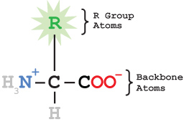
Amino Group vs. Carboxylate Group vs. Alpha carbon:
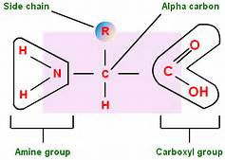
Amino/Amine/Aminium: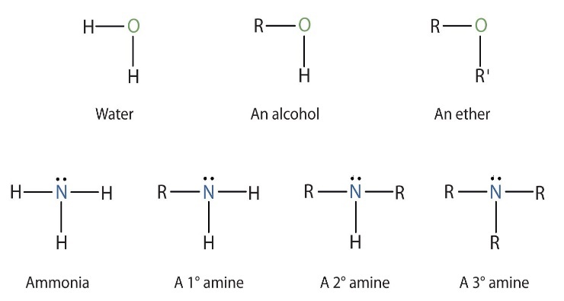
Amino = R-NH3+

Carboxyl/Carboxylic Acid/Carboxylate:
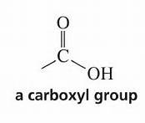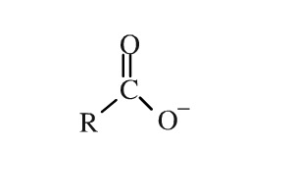
Carboxylate Ion: a carboxylate is a salt or ester of a carboxylic acid. Carboxylate salts have the general formula M(RCOO) n, where M is a metal.
Condensation/Dehydration vs. Hydrolysis: Condensation is a chemical process by which 2 molecules are joined together to make a larger, more complex, molecule, with the loss of water.
It is the basis for the synthesis of all the important biological macromolecules (carbohydrates, proteins, lipids, nucleic acids) from their simpler sub-units. Hydrolysis is the opposite to condensation. A large molecule is split into smaller sections by breaking a bond, adding -H to one section and -OH to the other.
The products are simpler substances. Since it involves the addition of water, this explains why it is called hydrolysis, meaning splitting by water.
Amide group/peptide bond: Amides are derived from carboxylic acids. A carboxylic acid contains the -COOH group, and in an amide the -OH part of that group is replaced by an -NH₂ group. So amides contain the -CONH₂ group.
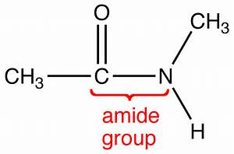
Peptide/dipeptide vs. oligopeptide/polypeptide: a peptide is a compound consisting of two or more amino acids linked in a chain, the carboxyl group of each acid being joined to the amino group of the next by a bond of the type -OC-NH. Three amino acids can be joined by two peptide bonds to form a tripeptide; similarly, four amino acids can be linked to form a tetrapeptide, five to form a pentapeptide, and so forth. When a few amino acids are joined in this fashion, the structure is called an oligopeptide. When many amino acids are joined, the product is called a polypeptide. Molecules referred to as polypeptides generally have molecular weights below 10,000, and those called proteins have higher molecular weights.
Amino group vs. carboxy group in polypeptide: In a peptide, the amino acid residue at the end with a free -amino group is the amino-terminal (or N-terminal) residue; the residue at the other end, which has a free carboxyl group, is the carboxyl-terminal (C-terminal) residue.
U1-02: Nucleotide Functional Groups:

Nucleoside vs. Nucleotide (Nucleoside Phosphate): Nucleotides have three characteristic components: (1) a nitrogenous (nitrogen-containing) base, (2) a pentose, and (3) one or more phosphates. The molecule without a phosphate group is called a nucleoside. Nucleic acids have two kinds of pentoses. The recurring deoxyribonucleotide units of DNA contain 2’-deoxy-D-ribose, and the ribonucleotide units of RNA contain D-ribose. In nucleotides, both types of pentoses are in their Beta-furanose (closed five-membered ring) form. It is the pentoses that define the identity of a nucleic acid. If the nucleic acid contains 2’-deoxy-D-ribose, it is DNA by definition even though it may contain uracil. Similarly, if the nucleic acid contains D-ribose, it is RNA regardless of its base composition.
Hydroxyl/alcohol: A hydroxyl or hydroxy group is a chemical functional group containing one oxygen atom connected by a covalent bonding to one hydrogen atom (−OH). It is sometimes called the alcohol functional group because when bonded to carbon in a molecule that otherwise contains only hydrogen and carbon the hydroxy (not hydroxyl) group defines the molecule as an alcohol, resulting in a name ending in -ol. Ribose has a hydroxyl group (OH) on the 2' carbon and deoxyribose does not. This makes deoxyribose more stable than ribose.
Carbon Tetravalent Bonding vs. Phosphorous pentavalent bonding: Carbon can form four bonds and have a full octet. Phosphorous can form an expanded octet or bond hypervalently. Phosphorous can thus form 5 bonds.
Phosphonoxy/Phosphate:
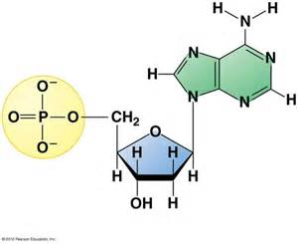
Yellow is a phosphate group
Purine vs. Pyrimidine: Purines and pyrimidines are two of the building blocks of nucleic acids. Only two purines and three pyrimidines occur widely in nucleic acids. Purines consist of a six-membered and a five-membered nitrogen-containing ring, fused together. Pyridmidines have only a six-membered nitrogen-containing ring. Purines include adenine and guanine. Pyrimidines include cytosine, thymine and uracil.
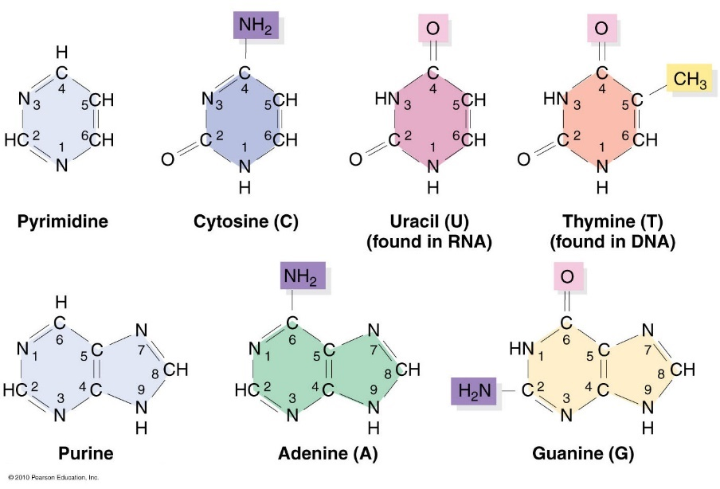
Glycosyl (pentose/furanose) and Prime numbering for Pentose: The base of a nucleotide is joined covalently (at N-1 of pyrimidines and N-9 of purines) in an N-Beta-glycosyl bond to the 1’ carbon of the pentose, and the phosphate is esterified to the 5’ carbon. The N-Beta-glycosyl bond is formed by removal of the elements of water (a hydroxyl group from the pentose and hydrogen from the base), as in O-glycosidic bond formation.
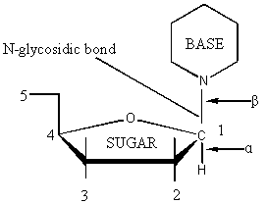

U1-03: Esters and Anhydrides:
Ester vs. Diester group: In chemistry, esters are chemical compounds derived from an acid in which at least one –OH group is replaced by an –O–alkyl group. Usually, esters are derived from a carboxylic acid and an alcohol. 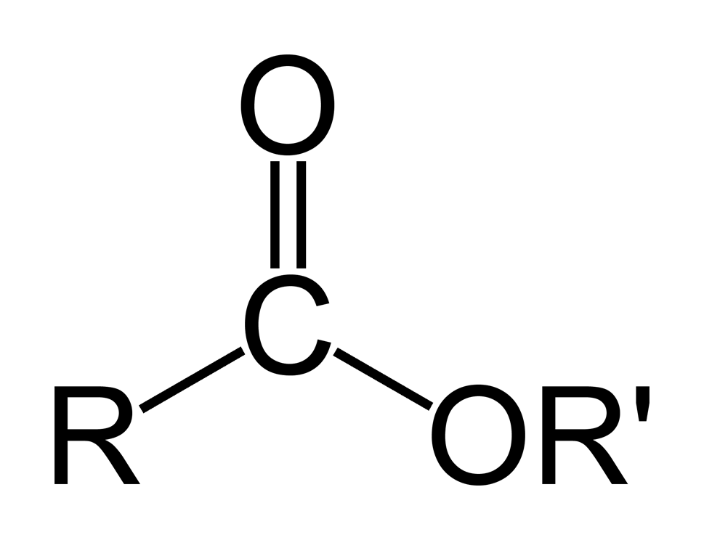A diester is a compound with 2 esters.
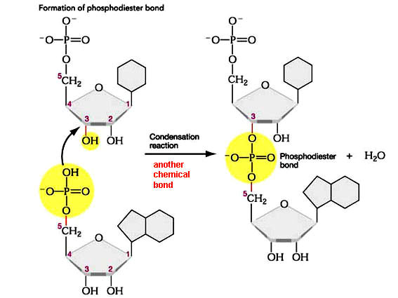
Oligonucleotide vs. polynucleotide: A short nucleic acid is referred to as an oligonucleotide. The definition of “short” is somewhat arbitrary, but polymers containing 50 or fewer nucleotides are generally called oligonucleotides. A longer nucleic acid is called a polynucleotide.
Free Terminal Groups: refers to the ends of DNA. At one end of a DNA strand is a free phosphate group and at the other end is a free 3’ hydroxyl group. The hydroxyl groups of the sugar residues form hydrogen bonds with water. The phosphate groups, with a pKa near 0, are completely ionized and negatively charged at pH 7, and the negative charges are generally neutralized by ionic interactions with positive charges on proteins, metal ions, and polyamines. A DNA strand is synthesized from in the 5’-3’ direction as nucleotides are added to by reacting with the 3’ hydroxyl group in a condensation reaction to form a phosphodiester bond.
5’ vs. 3’ Direction in a Polynucleotide: All the phosphodiester linkages in DNA and RNA have the same orientation along the chain, giving each linear nucleic acid strand a specific polarity and distinct 5’ and 3’ ends. By definition, the 5’ end lacks a nucleotide at the 5’ position and the 3’ end lacks a nucleotide at the 3’ position.
Carbonic Anhydride (Carboxylic Acid Anhydride):
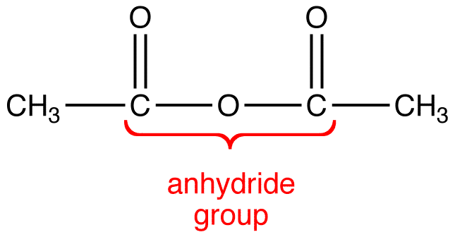

Phosphate Anhydride:
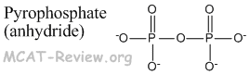
ATP vs. ADP vs. AMP: The phosphate group covalently linked at the 5’ hydroxyl of adensoine may have one or two additional phosphates attached. The resulting molecules are referred to as adenosine mono-, di-, and triphosphate. Starting from the ribose, the three phosphates are generally labeled alpha, beta and gamma. Hydrolysis of nucleoside triphosphates like ATP provides the chemical energy to drive many cellular reactions because the breaking of the bond between phosphate groups releases a lot of energy. Adenosine 5’-triphosphate, ATP, is by far the most widely used for this purpose. Nucleoside triphosphates also serve as the activated precursors of DNA and RNA synthesis.
Pyrophosphate (PPi) vs. Inorganic Phosphate (Pi): Pyrophosphates are very important in biochemistry. The anion P2O74− is abbreviated PPi and is formed by the hydrolysis of ATP into AMP in cells.
ATP → AMP + PPi
For example, when a nucleotide is incorporated into a growing DNA or RNA strand by a polymerase, pyrophosphate (PPi) is released. Pyro-phosphorolysis is the reverse of the polymerization reaction in which pyrophosphate reacts with the 3'-nucleosidemonophosphate (NMP or dNMP), which is removed from the oligonucleotide to release the corresponding triphosphate (dNTP from DNA, or NTP from RNA). The pyrophosphate anion has the structure P2O74−, and is an acid anhydride of phosphate. It is unstable in aqueous solution and hydrolyzes into inorganic phosphate:
PPi + H2O → 2 Pi
In the absence of enzymic catalysis, hydrolysis reactions of simple polyphosphates such as pyrophosphate, linear triphosphate, ADP, and ATP normally proceed extremely slowly in all but highly acidic. (The reverse of this reaction is a method of preparing pyrophosphates by heating phosphates.) This hydrolysis to inorganic phosphate effectively renders the cleavage of ATP to AMP and PPi irreversible, and biochemical reactions coupled to this hydrolysis are irreversible as well.
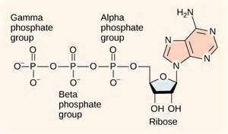
domain: A distinct structural unit of a polypeptide; domains may have separate functions and may fold as independent, compact units
U1-04: Acyl Group Transfer:
Leaving Group vs. Attacking Group: In a reaction where one group breaks off from a molecule to become a separate molecule ("species"), that group is a leaving group. Calling something a leaving group does not say what atoms it contains. But sometimes the leaving group leaves behind a group that cannot exist as a stable species. A group that cannot exist stably alone (like an acyl) cannot be a leaving group: it can however be transferred, if another incoming group arrives in time to replace the leaving group. The role of the incoming group (in this case, an amine) is "attacking group". An attacking group is almost always a NUCLEOPHILE, meaning it has an unshared pair of electrons on N or O. Conversely, the atom that is attacked (in the transferred group) will be an ELECTROPHILE, meaning it is electropositive (C or P). A group transfer reaction when reversed is simply a transfer in the other direction. Whatever was the leaving group in one reaction direction will be the attacking group in the opposite reaction direction. -OH is a worse leaving group than a phosphate so in the cell. This means that polymerization of nucleotides or amino acids (making esters or amides) would not work efficiently if it relied on -OH to be the leaving group from the acid. Therefore, polymerizing enzymes use acid derivatives instead of an acid functional group.
For polymerization of nucleotides: Instead of monophosphates (dNMP, NMP), polymerases use phosphor-anhydrides (i.e. nucleoside triphosphates, dNTP or NTP) The O atom in the OH group is ACTIVATED for leaving, by being first incorporated into an anhydride. In a great many metabolic reactions, a phosphoryl group (OPO3 ) is transferred from ATP to an alcohol, forming a phosphate ester or to a carboxylic acid, forming a mixed anhydride. A general theme in metabolism is the attachment of a good leaving group to a metabolic intermediate to “activate” the intermediate for subsequent reaction which is what happens when a phosphoryl group is transferred from ATP to an alcohol or a carboxylic acid. Phosphoryl groups are not the only groups that activate molecules for reaction. Thio-alcohols (thiols), in which the oxygen atom of an alcohol is replaced with a sulfur atom, are also good leaving groups. Thiols activate carboxylic acids by forming thioesters (thiol esters).
Group Transfer (Substitution) Reaction: The transfer of acyl, glycosyl, and phosphoryl groups from one nucleophile to another is known as a group transfer reaction. Acyl group transfer generally involves the addition of a nucleophile to the carbonyl carbon of an acyl group to form a tetrahedral intermediate:
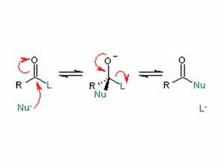
Glycosyl group transfers: involve nucleophilic substitution at C-1 of a sugar ring, which is the central atom of an acetal. In principle, the substitution could proceed by an SN1 or SN2 pathway. Phosphoryl group transfers play a special role in metabolic pathways. A general theme in metabolism is the attachment of a good leaving group to a metabolic intermediate to “activate” the intermediate for subsequent reaction. Among the better leaving groups in nucleophilic substitution reactions are inorganic orthophosphate (the ionized form of H3PO4 at neutral pH, a mixture of H2PO2 and HPO2, commonly abbreviated Pi) and inorganic pyrophosphate (P2O7, abbreviated PPi); esters and anhydrides of phosphoric acid are effectively activated for reaction. Nucleophilic substitution is made more favorable by the attachment of a phosphoryl group to an otherwise poor leaving group such as -OOH. Nucleophilic substitutions in which the phosphoryl group (OPO2) serves as a leaving group occur in hundreds of metabolic reactions.
Acyl Group: An acyl group is an acid that has lost its -OH (hydroxyl) group. Typically, acyl groups are not stable species in aqueous solution.
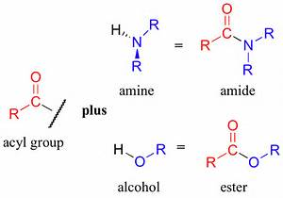
Phosphoryl group: A phosphoryl group is the chemical entity PO₃²⁻. It may exist in different protonation states. The term is usually used to refer to compounds in which the phosphoryl group is attached to other atoms, e.g. phosphoryl chloride, or in the description of catalytic mechanisms. In biochemical reactions involving phosphates (e.g. Adenosine triphosphate), a phosphoryl group is usually transferred between the substrates (phosphoryl transfer reactions). A phosphoryl group should not be confused with a phosphate group.
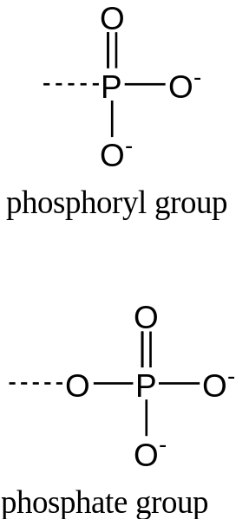
Biosynthesis Substrates and Products: Biosynthesis (also called biogenesis or anabolism) is a multi-step, enzyme-catalyzed process where substrates (reactants) are converted into more complex products in living organisms. In biosynthesis, simple compounds are modified, converted into other compounds, or joined together to form macromolecules. This process often consists of metabolic pathways. Some of these biosynthetic pathways are located within a single cellular organelle, while others involve enzymes that are located within multiple cellular organelles. Examples of these biosynthetic pathways include the production of lipid membrane components and nucleotides.
dNMP vs. dNTP, NMP vs. NTP: nucleoside triphosphate (NTP) forms by phosphoryl group transfer to the corresponding nucleoside diphosphates (NDPs) and monophosphates (NMPs). dNMP is deoxynucleoside monophosphate and dNTP is deoxynucleoside triphosphate. A nucleoside consists of a nitrogenous base covalently attached to a sugar (ribose or deoxyribose) but without the phosphate group. Deoxynucleoside is a nucleoside specifically attached to a deoxyribose sugar.
ASK ABOUT THIS IN TUTORIAL OR ASK T.A.!!!!!!!!!!!!!!!!!!!!!!!!!!!!!!
Phosphodiester Linkage: A phosphodiester bond occurs when exactly two of the hydroxyl groups in phosphoric acid react with hydroxyl groups on other molecules to form two ester bonds. Phosphodiester bonds are central to all life on Earth, as they make up the backbone of the strands of nucleic acid. In DNA and RNA, the phosphodiester bond is the linkage between the 3' carbon atom of one sugar molecule and the 5' carbon atom of another, deoxyribose in DNA and ribose in RNA. Strong covalent bonds form between the phosphate group and two 5-carbon ring carbohydrates over two ester bonds.
Electronegativity Series: Electronegativity, symbol χ, is a chemical property that describes the tendency of an atom or a functional group to attract electrons towards itself. An atom's electronegativity is affected by both its atomic number and the distance at which its valence electrons reside from the charged nucleus. The higher the associated electronegativity number, the more an element or compound attracts electrons towards it. O>N>C=S>P=H (Electronegativity decreases from left to right)
Electron Rich vs. Electron Poor:
Lewis Base vs. Lewis Acid: A Lewis acid is therefore any substance, such as the H⁺ ion, that can accept a pair of nonbonding electrons. In other words, a Lewis acid is an electron-pair acceptor. A Lewis base is any substance, such as the OH⁻ ion, that can donate a pair of nonbonding electrons. A Lewis base is therefore an electron-pair donor.
U1-05: DNA Electrophoresis:
Electrophoresis: Gel electrophoresis is a technique commonly used in laboratories to separate charged molecules like DNA, RNA and proteins according to their size. Charged molecules move through a gel when an electric current is passed across it. An electric current is applied across the gel so that one end of the gel has a positive charge and the other end has a negative charge. The movement of charged molecules is called migration. Molecules migrate towards the opposite charge. A molecule with a negative charge will therefore be pulled towards the positive end, Anode (opposites attract!).
Permeable Matrix/Gel: The gel consists of a permeable matrix, a bit like a sieve, through which molecules can travel when an electric current is passed across it. Smaller molecules migrate through the gel more quickly and therefore travel further than larger fragments that migrate more slowly and therefore will travel a shorter distance. As a result, the molecules are separated by size.
Agarose: Agarose gels are typically used to visualise fragments of DNA. The concentration of agarose used to make the gel depends on the size of the DNA fragments you are working with. The higher the agarose concentration, the denser the matrix and vice versa. Smaller fragments of DNA are separated on higher concentrations of agarose whilst larger molecules require a lower concentration of agarose.
Loading Well: The DNA samples are placed in wells at one end of the gel and an electrical current passed across the gel.
Visualization/Staining: Once the DNA has migrated far enough across the gel, the electrical current is switched off and the gel is removed from the electrophoresis tank. To visualise the DNA, the gel is stained with a fluorescent dye that binds to the DNA, and is placed on an ultraviolet trans-illuminator which will show up the stained DNA as bright bands. Alternatively, the dye can be mixed with the gel before it is poured.
Dye/Fluorescent: ethidium bromide has played an important part in the development of molecular cloning: Staining with a low concentration of ethidium bromide has been the standard method of detecting small quantities of DNA in agarose gels for more than 25 years. The usefulness of ethidium bromide for these tasks derives from its fluorescent properties in combination with its ability to intercalate between the base pairs of double-stranded DNA.
Radioactive Label (Radiolabels): A radioactive tracer, or radioactive label, is a chemical compound in which one or more atoms have been replaced by a radioisotope so by virtue of its radioactive decay it can be used to explore the mechanism of chemical reactions by tracing the path that the radioisotope follows from reactants to products. Radiolabeling is thus the radioactive form of isotopic labeling.The use of dyes, fluorescent tags or radioactive labels enables the DNA on the gel to be seen after they have been separated. They will appear as bands on the gel. A DNA marker with fragments of known lengths is usually run through the gel at the same time as the samples. By comparing the bands of the DNA samples with those from the DNA marker, you can work out the approximate length of the DNA fragments in the samples.
Band: Marker vs. Sample: If the gel has run correctly the banding pattern of the DNA marker/size standard will be visible. It is then possible to judge the size of the DNA in your sample by imagining a horizontal line running across from the bands of the DNA marker. You can then estimate the size of the DNA in the sample by matching them against the closest band in the marker. The length of the DNA fragments is compared to a marker containing fragments of known length.
Base Pair as Length Measurement Unit:
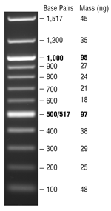
Intercalation: In biochemistry, intercalation is the insertion of molecules between the planar bases of DNA. This process is used as a method for analyzing DNA and it is also the basis of certain kinds of poisoning.
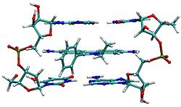
Ethidium intercalated between two adenine-thymine base pairs.
There are several ways molecules (in this case, also known as ligands) can interact with DNA. Ligands may interact with DNA by covalently binding, electrostatically binding, or intercalating.^{[1]} Intercalation occurs when ligands of an appropriate size and chemical nature fit themselves in between base pairs of DNA. These ligands are mostly polycyclic, aromatic, and planar, and therefore often make good nucleic acid stains. Intensively studied DNA intercalators include berberine, ethidium bromide, proflavine, daunomycin, doxorubicin, and thalidomide. DNA intercalators are used in chemotherapeutic treatment to inhibit DNA replication in rapidly growing cancer cells. Examples include doxorubicin (adriamycin) and daunorubicin (both of which are used in treatment of Hodgkin's lymphoma), and dactinomycin (used in Wilm's tumour, Ewing's Sarcoma, rhabdomyosarcoma).
Planar Ring System: a chemical ring where all the atoms involved in the ring structure are located within the same plane => this means that the ring is flat
Ultraviolet (UV) vs. Visible Spectrum Radiation: Ultraviolet (UV) is an electromagnetic radiation with a wavelength from 10 nm (30 PHz) to 400 nm (750 THz), shorter than that of visible light but longer than X-rays. UV radiation is present in sunlight. It is also produced by electric arcs and specialized lights such as mercury-vapor lamps, tanning lamps, and black lights. Although lacking the energy to ionize atoms, long-wavelength ultraviolet radiation can cause chemical reactions and causes many substances to glow or fluoresce. The visible spectrum is the portion of the electromagnetic spectrum that is visible to the human eye. Electromagnetic radiation in this range of wavelengths is called visible light or simply light. A typical human eye will respond to wavelengths from about 390 to 700 nm.^{[1]} In terms of frequency, this corresponds to a band in the vicinity of 430–770 THz.
Nanometre Wavelength: The nanometre (International spelling as used by the International Bureau of Weights and Measures; SI symbol: nm) or nanometer (American spelling) is a unit of length in the metric system, equal to one billionth of a metre (0.000000001 m). The name combines the SI prefix nano- (from the Ancient Greek νάνος, nanos, "dwarf") with the parent unit name metre (from Greek μέτρον, metrοn, "unit of measurement"). It can be written in scientific notation as 1×10⁻⁹ m, in engineering notation as 1 E−9 m, and is simply 1/1000000000 metres. One nanometre equals ten ångströms.
U1-06: Genome Structure:
Chromosome: A chromosome is a packaged and organized structure containing most of the DNA of a living organism. DNA is not usually found on its own, but rather is structured by being wrapped around protein complexes called nucleosomes, which consist of proteins called histones. The DNA in chromosomes serves as the source for transcription. Most eukaryotic cells have a set of chromosomes with the genetic material spread among them.
Gene vs. Gene Product: a gene is a segment of genetic material that determines, or codes for, one polypeptide. A gene product is the polypeptide that the gene codes for and is produced after transcription and translation. A gene is all the DNA that encodes the primary sequence of some final gene product, which can be either a polypeptide or an RNA with a structural or catalytic function. DNA also contains other segments or sequences that have a purely regulatory function.
Intergenic Region: An Intergenic region is a stretch of DNA sequences located between genes. Intergenic regions are a subset of Noncoding DNA. Occasionally some intergenic DNA acts to control genes nearby, but most of it has no currently known function. It is one of the DNA sequences sometimes referred to as junk DNA, though it is only one phenomenon labeled such and in scientific studies today, the term is less used. Recently DNA fragments in intergenic regions were known as "dark matter" or "dark matter transcripts".
Regulatory Sequence vs. Intron (Intervening Sequence) vs. Exon: Many, if not most, eukaryotic genes have a distinctive and puzzling structural feature: their nucleotide sequences contain one or more intervening segments of DNA that do not code for the amino acid sequence of the polypeptide product. These non-translated inserts interrupt the otherwise co-linear relationship between the nucleotide sequence of the gene and the amino acid sequence of the polypeptide it encodes. Such non-translated DNA segments in genes are called intervening sequences or introns, and the coding segments are called exons. A regulatory sequence is a segment of a nucleic acid molecule which is capable of increasing or decreasing the expression of specific genes within an organism. Regulation of gene expression is an essential feature of all living organisms and viruses.
Simple Sequence Repeat (SSR)/Satellite DNA/Highly Repetitive DNA: Approximately 3% of the human genome consists of highly repetitive sequences, also referred to as simple sequence DNA or simple sequence repeats (SSR). These short sequences, generally less than 10 bp long, are sometimes repeated millions of times per cell. The simple sequence DNA has also been called satellite DNA, so named because its unusual base composition often causes it to migrate as “satellite” bands (separated from the rest of the DNA) when fragmented cellular DNA samples are centrifuged in a cesium chloride density gradient. Studies suggest that simple-sequence DNA does not encode proteins or RNAs. Unlike the transposable elements, the highly repetitive DNA can have identifiable functional importance in human cellular metabolism, because much of it is associated with two defining features of eukaryotic chromosomes: centromeres and telomeres.
Centromeres, Mitotic Spindle: The centromere is a sequence of DNA that functions during cell division as an attachment point for proteins that link the chromosome to the mitotic spindle. This attachment is essential for the equal and orderly distribution of chromosome sets to daughter cells.
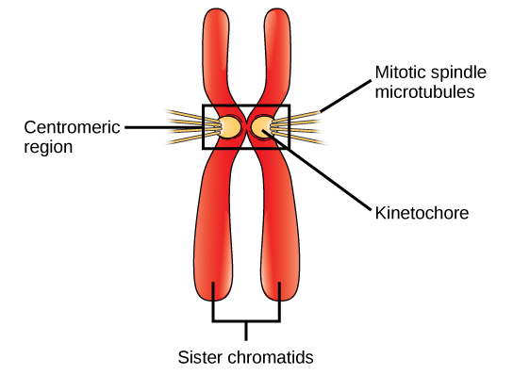
Telomere, Telomerase: Telomeres (Greek telos, “end”) are sequences at the ends of eukaryotic chromosomes that help stabilize the chromosome. The ends of a linear DNA molecule cannot be routinely replicated by the cellular replication machinery (which may be one reason why bacterial DNA molecules are circular). Repeated telomeric sequences, (TTAGGG)n, are added to eukaryotic chromosome ends primarily by the enzyme telomerase.
U1-07: Processive Mechanism:
Nascent Polymer:
Coding (Nontemplate) Strand: When referring to transcription, the coding strand is the DNA strand which has the same base sequence as the RNA transcript produced. It is this strand which contains codons, while the non-coding (template) strand contains anti-codons. During transcription, RNA Pol II binds the non-coding or template strand, reads the anti-codons, and transcribes their sequence to synthesize an RNA transcript with complementary bases. By convention, the coding strand is the strand used when displaying a DNA sequence. It is presented in the 5' to 3' direction.
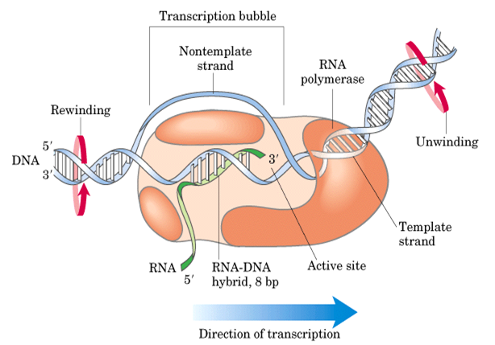
Active Site: A DNA polymerase active site has two parts. The incoming nucleotide is initially positioned in the insertion site. Once the phosphodiester bond is formed, the polymerase slides forward on the DNA and the new base pair is positioned in the post-insertion site. These elements are located in a pocket that resembles the palm of a hand.


