Ryerson University

FIN300
Midterm Exam
Fall 2016

Version A – Solution Key

Student Name (Please print)

Student Number

Notes:

- This is a 2-hour exam. There are 11 pages in this exam, including the cover page.
- This is a closed book exam. You should only have writing instruments, calculators, and one double-sided note sheet (8.5x11”) at your desk.
- Please fill out the scanner sheet as you go during the exam – there is no extra time to fill it out at the end.
- Select the best possible answer for each multiple-choice question.
- Each of the 31 MC questions is worth 1 mark. However, I will mark the midterm is out of 30.

- Your bank account pays monthly interest with an EAR of 10%. You are planning to buy a house in 10 years, and you wish to save $100,000 for the down payment. If you currently have no money in your account, how much will you need to save at the end of each month?
  - $488.17
  - $500.35
  - $9646.39
  - $833.33
  - $475.13

- Given a nominal interest rate of 3% and an inflation rate of 4.5%, what is the real interest rate?
  - 7.5%
  - 0%
  - -1.4%
  - 3%
  - -1.5%

- Faisal has $15,000 in his savings account and can save an additional $5000 per year. If interest rates are 12%, how long will it take his savings to grow to $50,000?
  - 4 years
  - 3 years
  - years
  - years
  - 5 years

Use the table for the question(s) below.

Investment | Rate | Compounding
A | 6.25% | Annual
B | 6.10% | Daily
C | 6.125 | Quarterly
D | 6.120 | Monthly
E 6.15% Semi-annual

- The highest effective rate of return you could earn on any of these investments is closest to:
- 6.300%
- 6.267%
- 6.245%
- 6.310%
- 6.250%

- A firm has $20 million in equity and $20 million of debt, it pays dividends of 20% of net income, and has a net income of $5 million. What is the firm's sustainable growth rate?
- 18%
- 19%
- 21%
- 22%
- 20%

- Why must care be taken when comparing a firm's share price to its operating income?
- Share price is a quantity related to the enterprise value of the firm, while operating income is related to the equity holders.
- Share price is a quantity related to equity holders, while operating income is an amount that is related to the whole firm.
- Share price is a quantity related to the entire firm, while operating income is an amount that is related solely to equity holders.
- Both share price and operating income are related solely to equity holders.
- Both share price and operating income are related to the whole firm.

- Given that the interest rate is 10% per annum, what is the present value of an investment that has 5 equal payments of $50,000 each year for 5 years, starting today?
  - $250,000
  - $ 78,493.27
  - $208,493.27
  - $158,493.27
  - $175,000

- Heavy Duty Inc., a manufacturer of power tools, decides to offer a rebate of $100 on its 16-inch mid-range chain saw, which currently has a retail price $470. Heavy Duty's marketers estimate that, as a result of the rebate, sales of this model will increase from 50,000 to 80,000 units next year. The profit margin for Heavy Duty before the rebate is $150. Based on the given information, is the decision to give the rebate a wise one?
  - No, since costs are $5.0 million more than benefits.
  - Yes, since the benefits are $0.5 million more than the costs.
  - Yes, since the benefits are $0.2 million more than the costs.
  - No, since costs are $3.5 million more than benefits.
  - Yes, since the benefits are $1.5 million more than the costs.

Use the information for the question(s) below.

Two years ago you purchased a new SUV. You financed your SUV for 60 months (with payments made at the end of the month) with a loan at 5.9% per year compounded monthly. You monthly payments are $617.16 and you have just made your 24th monthly payment on your SUV.

- The amount of your original loan is closest to:
  - $29,000
  - $20,300
  - $37,000
  - $31,250
  - $32,000

- Assuming that you have made all of the first 24 payments on time, then the outstanding principal balance on your SUV loan is closest to:
  - $32,000
  - $29,000
  - $31,250
  - $20,300
  - $19,200

Use the information for the question(s) below.

Initial Payment | $40,000
Growth of Cash Flow | 4%
Interest Rate | 6%
No. of years (Annuity) | 5

- What is the future value of this annuity?
A) $181,692.35
B) $200,000
C) $243,145.35
D) $238,301.70
) $168,494.55

Use the information about Billy's Burgers to answer the following question(s):

Billy's Burgers
Figures in $ millions
Income Statement | 2015 | Balance Sheet | 2015
Net Sales | 246.0 | Assets
Costs exc. Dep. | 187.0 | Cash | 8.0
EBITDA | 59.0 | Accts. Rec. | 21.0
Depreciation | 17.2 | Inventories | 23.0
EBIT | 41.8 | Total Current Assets | 52.0
Interest | 12.0 | Net PP&E | 145.0
Pretax Income | 29.8 | Total Assets | 197.0
Taxes | 10.4
Net Income | 19.4 | Liabilities and Equity
 |  | Accts. Payable | 18.0
 |  | Long-Term Debt | 82.0
 |  | Total Liabilities | 100.0
 |  | Total Stockholders' Equity | 97.0
 |  | Total Liabilities and Equity | 197.0

- Using the percent of sales method, and assuming 20% growth in sales and no change in interest expense, estimate Billy's Burgers' net income for 2016.
  - $24.84 million
  - $28.16 million
  - $35.76 million
  - $23.28 million
  - $30.29 million

- A businessman wants to buy a truck. The dealer offers to sell the truck for either $120,000 now, or six yearly payments of $25,000. Which of the following is closest to the interest rate being offered by the dealer?
  - 6.8%
  - 9.2%
  - 6.1%
  - 11.5%
  - 8.4%

- A homeowner has a $200,000 home with a 20-year mortgage, paid monthly at a quoted rate of 7.25% per year compounded semi-annually. After five years he receives $50,000 as an inheritance. If he pays this $50,000 toward his mortgage along with his regular payment, by approximately how many years will it reduce the amount of time it takes him to pay off his mortgage?
  - 5 years
  - 2 years
  - 4 years
  - 3 years
  - 6 years

- A perpetuity will pay $1000 per year, starting five years after the perpetuity is purchased. What is the present value (PV) of this perpetuity on the date that it is purchased, given that the interest rate is 4%?
  - $34,604
  - $25,000
  - $21,370
  - $20,582
  - $20,548

Use the following information for the next question:

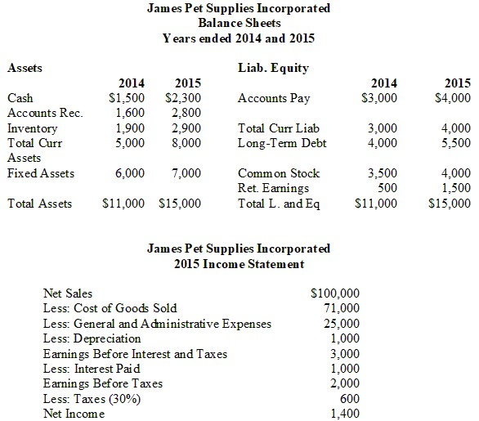

- Suppose James Pet Supplies is projecting a 20% increase in sales for the coming year, and that cost of goods sold and general and administrative expenses remain a constant percentage of sales. In addition, the firm is projecting that current assets, fixed assets and current liabilities will increase with sales. The firm believes that depreciation and interest paid will not change next year. In addition, the firm believes that long-term debt and common stock will not change. Finally, the firm believes its tax rate and dividend payout ratio will remain unchanged. What is the projected Retained Earnings in 2016?
- $3,000
- $2,900
- $2,700
- $2,500
- $3,200

- Drew receives an inheritance that pays him $5,000 every four months for the next 5 years. Which of the following is closest to the present value (PV) of this inheritance if the interest rate is 8.5% per year compounded monthly?
  - $72,871
  - $60,283
  - $75,000
  - $68,883
  - $64,195

Use the table for the question(s) below.

Luther Corporation
Consolidated Income Statement
Year ended December 31 (in $ millions)
 | 2015 | 2014
Total sales | 610.1 | 578.3
Cost of sales | (500.2) | (481.9)
Gross profit | 109.9 | 96.4
Selling, general, and  administrative expenses | (40.5) | (39.0)
Research and development | (24.6) | (22.8)
Depreciation and amortization | (3.6) | (3.3)
Operating income | 41.2 | 31.3
Other income | --- | ---
Earnings before interest and taxes (EBIT) | 41.2 | 31.3
Interest income (expense) | (25.1) | (15.8)
Pretax income | 16.1 | 15.5
Taxes | (5.5) | (5.3)
Net income | 10.6 | 10.2
Price per share | $16 | $15
Shares outstanding (millions) | 10.2 | 8.0
Stock options outstanding (millions) | 0.3 | 0.2
Shareholders' Equity | 126.6 | 63.6
Total Liabilities and Shareholders' Equity | 533.1 | 386.7

- Refer to the income statement above. Luther's return on assets (ROA) for the year ending December 31, 2015 is closest to:
  - 2.0%
  - 6.5%
  - 8.4%
  - 12.7%
  - 32.5%

Term in years: | 1 | 2 | 3 | 4 | 5
Rate: | 1.8% | 2.25% | 2.30% | 2.66% | 3.13%

- The table above shows the interest rates available from investing in risk-free Government of Canada securities with different investment terms. What is the present value (PV) of cash flows from an investment that yields $4000 at the end of each year for the next four years?
- $14,898
- $14,822
- $14,956
- $14,990
- $15,093

Use the table for the question(s) below.

AOS Industries Statement of Cash Flows for 2015

Operating activities
Net Income | 3.2
Depreciation and amortization | 1.4
Cash effect of changes in
Accounts receivable | -2.1
Accounts payable | 1.1
Inventory | -0.8
Cash from operating activities | 2.8
Investment activities
Capital expenditures | 2.2
Acquisitions and other investing activity | -0.4
Cash from investing activities | 2.6
Financing activities
Dividends paid | -1.5
Sale or purchase of stock | 2.1
Increase in short-term borrowing | 1.4
Increase in long-term borrowing | 3.2
Cash from financing activities | 5.2
Change in Cash and Cash Equivalents | 5.4

- Consider the above statement of cash flows. In 2015, AOS Industries had contemplated buying a new warehouse for $2 million, the cost of which would be depreciated over 10 years. If AOS Industries has a tax rate of 25%, what would be the impact on the amount of cash held by AOS at the the end of the 2015?
- It would have $1,800,000 less cash at the end of 2015.
- It would have $150,000 less cash at the end of 2015.
- It would have $1,950,000 less cash at the end of 2015.
- It would have $2,00,000 less cash at the end of 2015.
- It would have an additional $50,000 in cash at the end of 2015.

- Consider the above statement of cash flows. If all amounts shown above are in millions of dollars, what was AOS Industries' change in retained earnings for 2015?
- $1.7 million
- $1.3 million
- $5.4 million
- $3.2 million
- $2.1 million

- Which of the following are major duties of a financial manager?
I. To make investment decisions
II. To make financing decisions
III. To manage cash flow from operating activities
- I only
- I and II only
- I and III only
- II and III only
- I, II and III

- A firm has ROE of 5.5% and an asset turnover ratio of 1.2. If the firm has 10 dollars in assets per dollar of equity, what is the firm's net profit margin?
    - 6.6%
    - 0.46%
    - 5.5%
    - 0.66%
    - 1.2%

- If $476 invested today yields $500 in one year's time, what is the discount rate?
- 0.05
- 0.24
- 1.50
- 0.95
- 1.05

- A firm has EBIT of $24 million and has a corporate tax rate of 25%. The firm has total debt of $40 million, and excess cash of $8 million. If the firm's book value of equity is $72 million, what is the firm's return on invested capital (ROIC)?
- 17%
- 23%
- 6%
- 16%
- 15%

- What is the future value (FV) of $10,000 in 50 years, assuming the interest rate is 4% per year?
- $71,067
- $20,000
- $52,000
- $520,000
- $100,804

Consider the following timeline detailing a stream of cash flows:
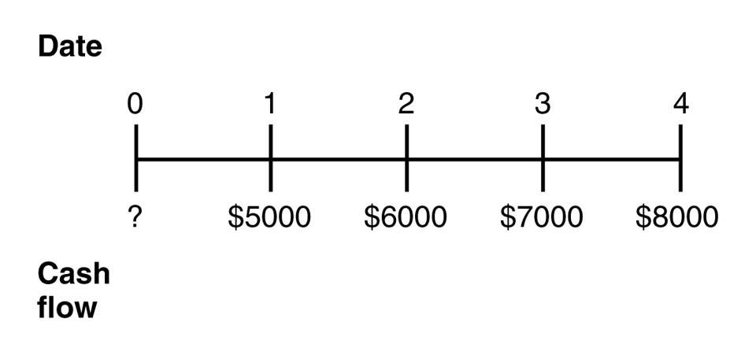

- If the current market rate of interest is 8%, then the present value (PV) of this stream of cash flows is closest to:
- $21,211
- $19,111
- $24,074
- $22,871
- $26,000

- Your bank account pays monthly interest with an EAR of 8%. What interest rate will you earn each month?
- 0.60%
- 0.80%
- 0.64%
- 0.67%
- 1.00%

- Michael has credit card debt of $60,000 that has an 18% APR, compounded monthly. The minimum monthly payment only requires him to pay the interest on his debt. He receives an offer for a credit card with an APR of 10% compounded monthly. If he rolls over his debt onto this card and makes the same monthly payment as before, how long will it take him to pay off his credit card debt?
- 98 months
- 78 months
- 72 months
- 104 months
- 84 months

- You are thinking about investing in a mine that will produce $10,000 worth of ore in the first year. As the ore closest to the surface is removed it will become more difficult to extract the ore. Therefore, the value of the ore that you mine will decline at a rate of 8% per year forever. If the appropriate interest rate is 6%, then the value of this mining operation is closest to:
- $71,429
- $500,000
- $41,667
- $166,667
- This problem cannot be solved.

- Which version of the exam are you writing?
- Version A (white)
- Version B (yellow)

1) B
2) C
3) C
4) A
5) E
6) B
7) C
8) D
9) E
10) D
11) C
12) A
13) A
14) E
15) C
16) B
17) B
18) A
19) E
20) C
21) A
22) E
23) B
24) A
25) A
26) A
27) A
28) C
29) A
30) A
31) No Correct Answer Was Provided.

