Mengyu Jiang 100922925
Part 2.2
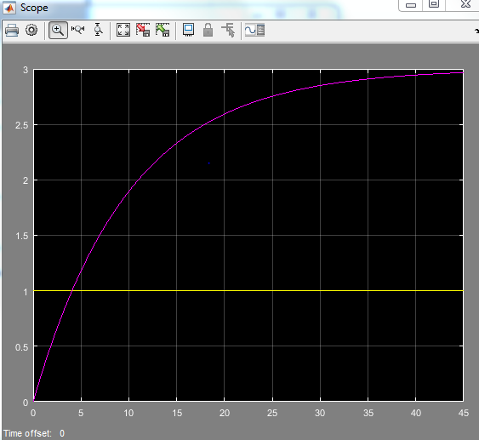
K=3; tao=10
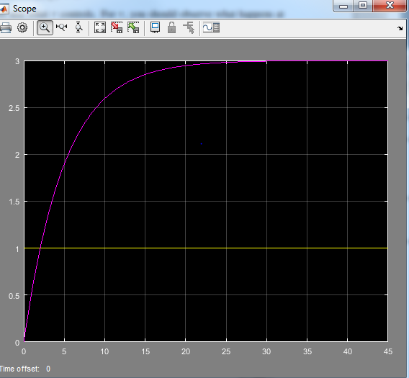
K=3; tao=5
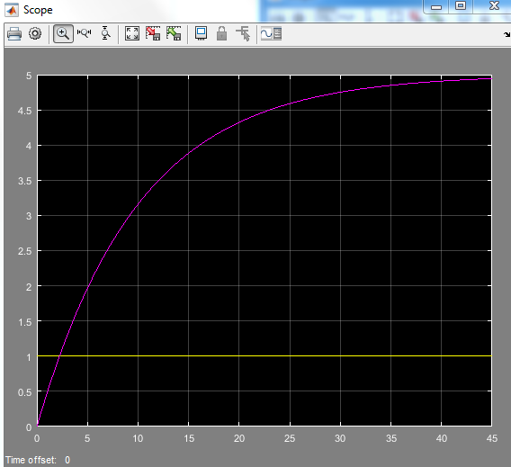
K=5; tao=10

Report:
K and tao will decide the slope of the plot. At t=4τ, the value will be reach to k nearly, However it is not touched at the value of k.

Part 2.3
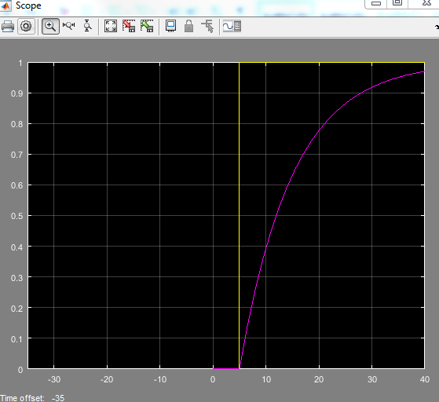
Step time: -30
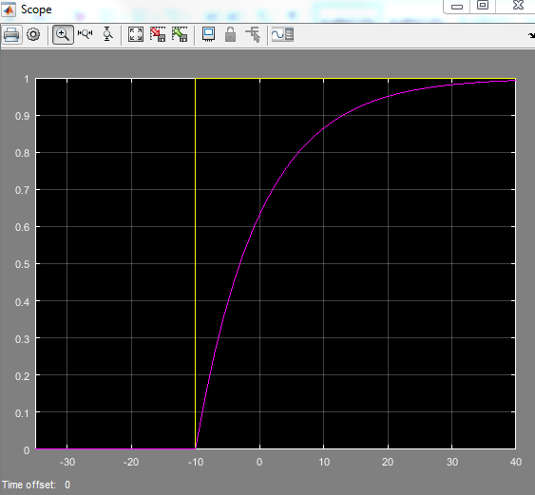
Step time: -10
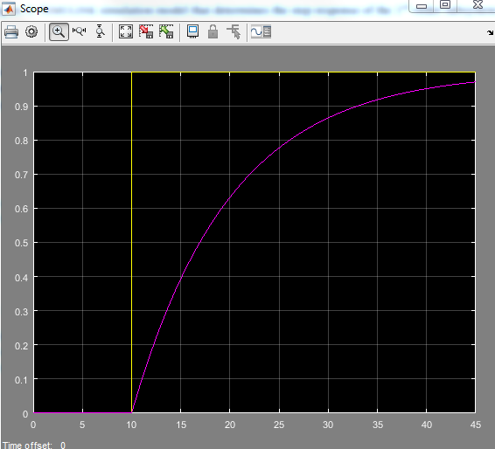
Step time: 10
Report:
From the plots, the time delay decides the start point of the graph.

Part 2.4:
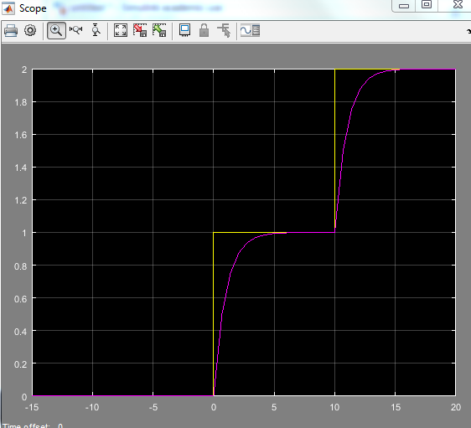
x(t) = u(t) + u(t − 10)
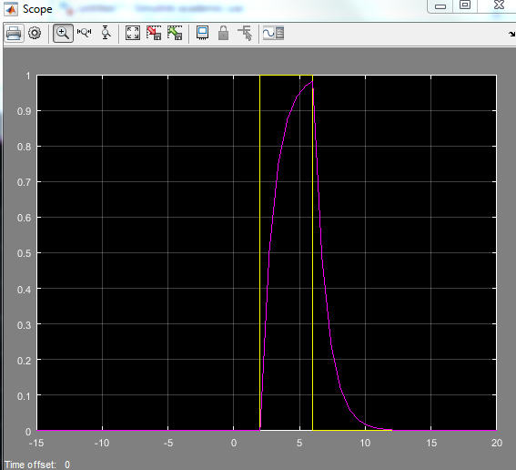
x(t) = u(t − 2) − u(t − 6)
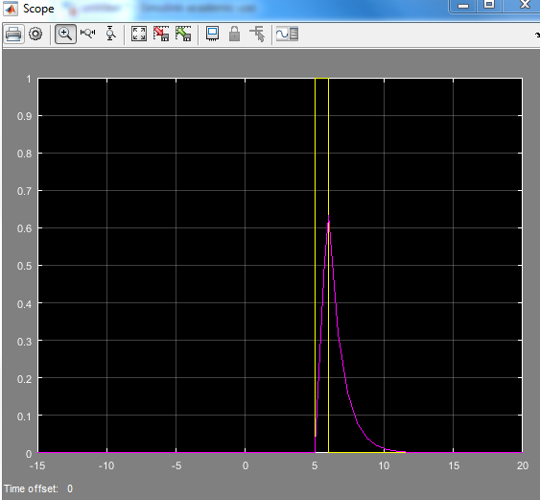
x(t) = u(t − 5) − u(t − 6)
Report: Basically, the first part of u(t) is the increasing part of the graph with the start point, and the trend of the second u(t) will be decided by whether it is positive or negative. Then add them together.

Part 2.5
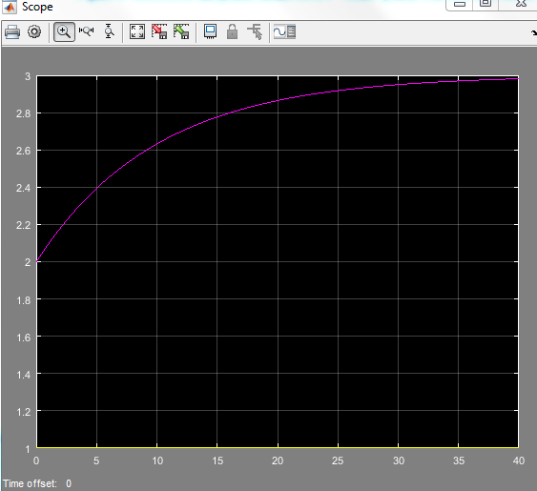
x(t) = u(t), k = 3, τ = 10 seconds, y(t0 ) = 2, and t0 = 0

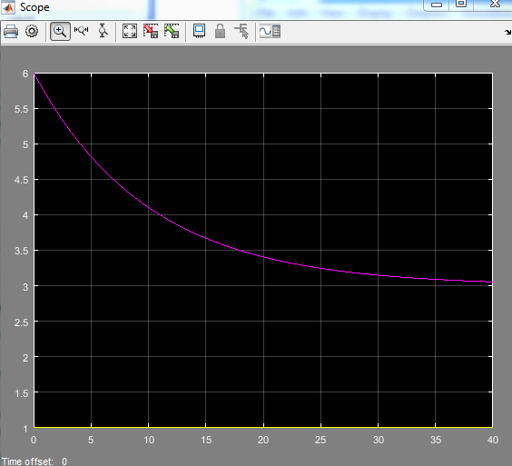
x(t) = u(t), k = 3, τ = 10 seconds, y(t0 ) = 6, and t0 = 0

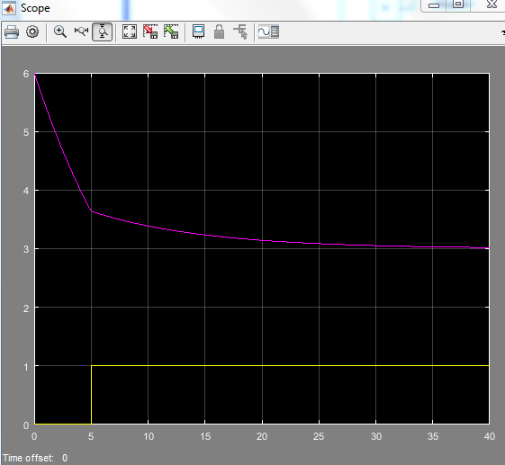
x(t) = u(t − 5), k = 3, τ = 10 seconds, y(t0 ) = 6, and t0 = 0
Report:
Basically, the 2% settling time will be approached to K with the time increased. Also, the input (x(t-u)) will decide how the curve will be change at point u slowly. So the initial conditions will be decide the slope, trend, positive or negative of the plot.

Part 2.6:
- K= ; τ=M/b
- M=0.125; b=1/4
- K=; τ =RC
- R and C controls τ.



