SYSC 3600
LAB3
Control of an Inverted Pendulum

Mengyu Jiang 100932239
Xinlai Chen 100968823

Pre-Lab
3 Preparation
K_{d} = 2ζω_{n}Ml = 2 x 0.7 x 0.5 x 1000 x 10 = 7000
K_{p} = Mlω_{n}² + (M + m) g = 1000 x 10 x 0.5² + (1000 + 200) x 9.81 = 14272

Lab
4.1 Inverted pendulum demo in SIMULINK
When θ_{o}(t) was always positive, the inverted pendulum would balance itself, which means the inverted pendulum would always move. If θ_{o}(t) changed from positive to negative, the inverted pendulum moved slowly and became stop.
4.2 Testing the pendulum
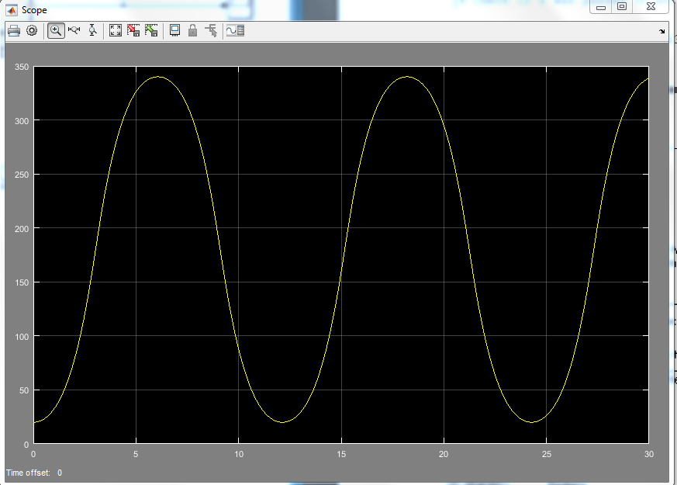
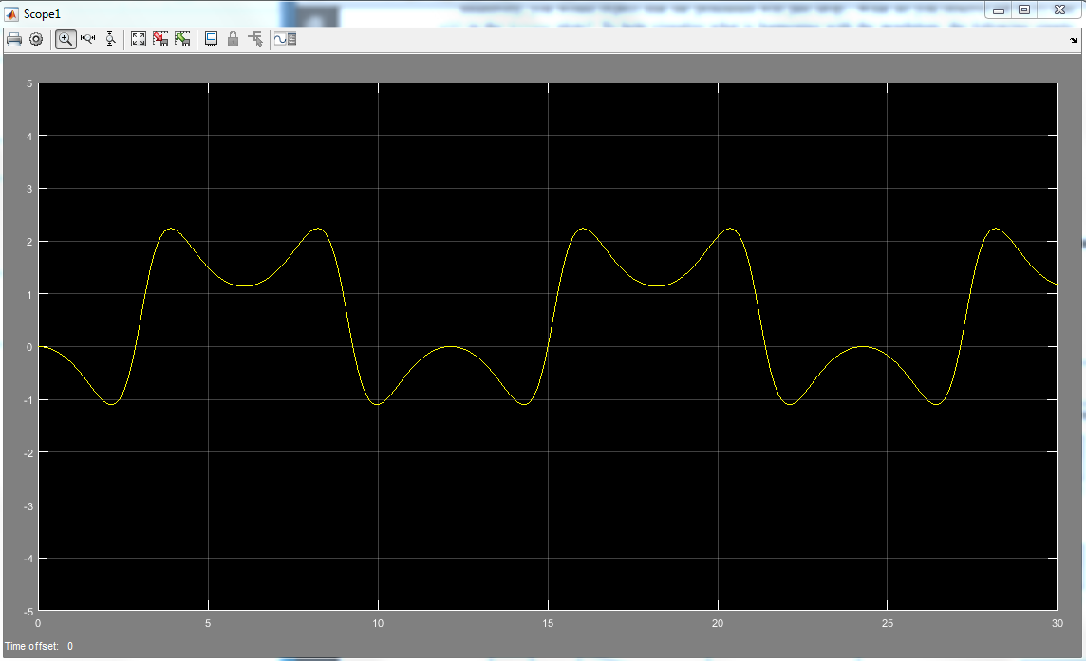
When the pendulum was rotating, if the start angle was 20 degrees, the cart would move forward and then move backward. If the start angle was increased, the cart would move forward faster and further and then move backward.

4.3.1 Problem of derivative with the PD controller
ω_{cf} = 100 rad/s
H_{LP}(s) = = =
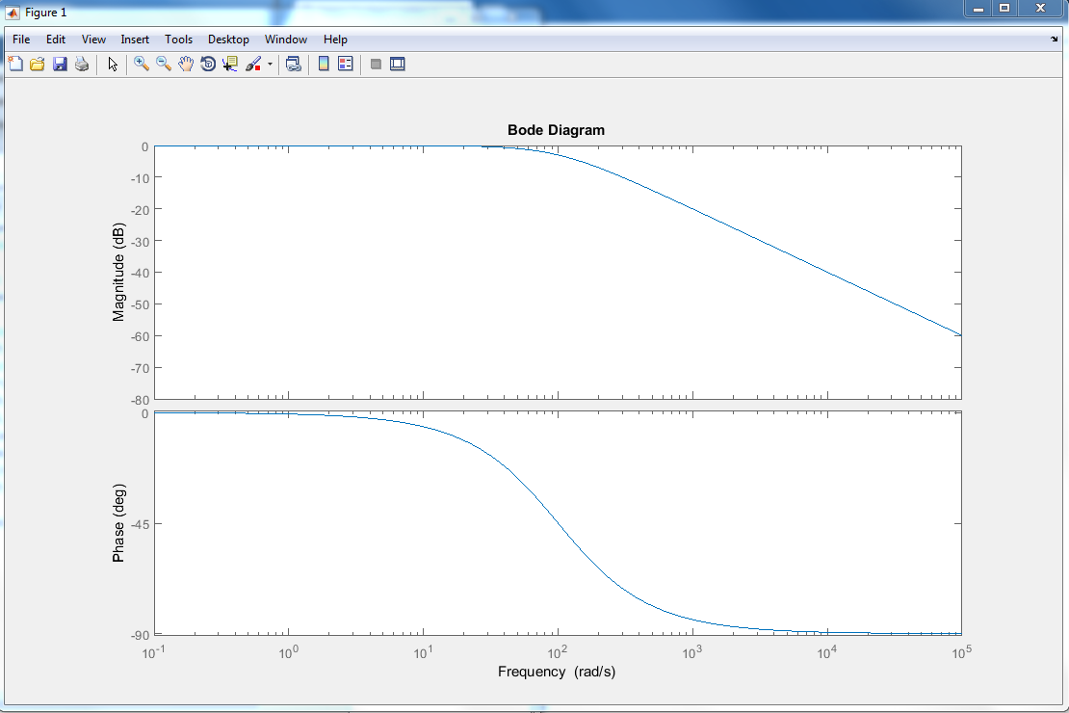
From the graph above, the magnitude is almost 0 dB when the frequency is less than 10² rad/s.
When the frequency is increasing, the magnitude is decreased and the rate of decreasing is -20dB/decade, which is the slope of the graph 1.

4.3.3 Simulating the PD controlled inverted pendulum
θ_{o} (t₀⁻ ) = 5°
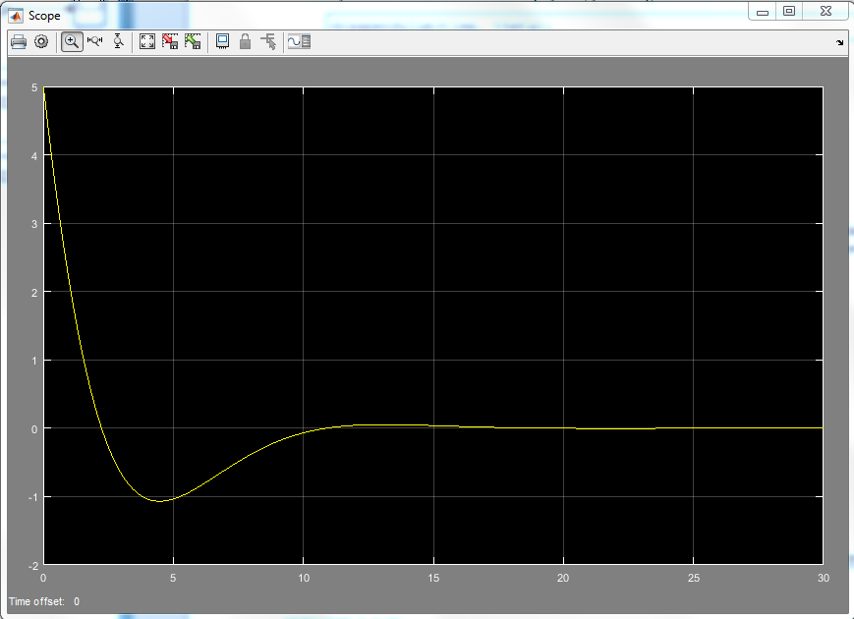
θ_{o} (t₀⁻ ) = -30°
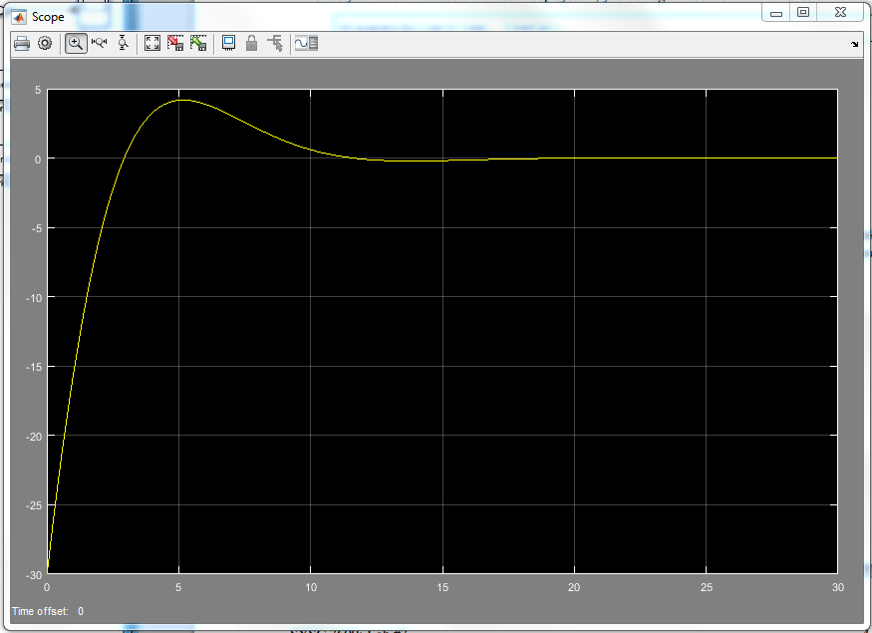

θ_{o} (t₀⁻ ) = 65°
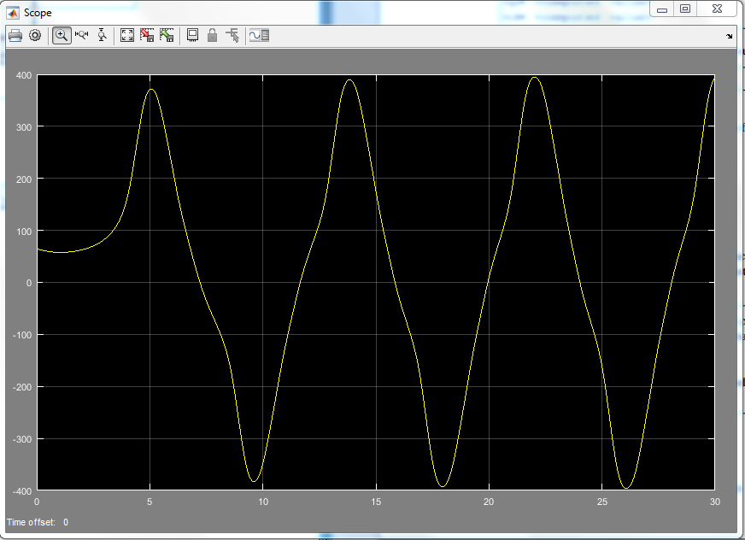

θ_{o} (t₀⁻ ) = 75°
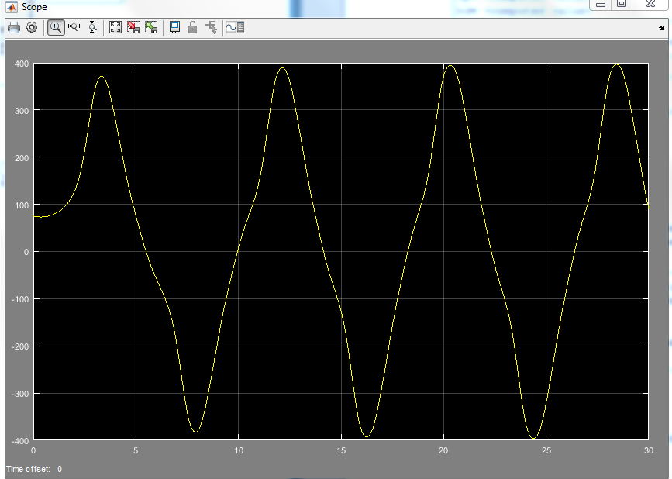

From the graphs above, when θ = 5 and -30, pendulum is inverted. But in the case of θ = 65 and 75, the PD controller cannot invert pendulum because of the value of k_{d} and k_{p}.

4.4 Additional questions:
1. Changed cutoff frequency pole position, however cutoff frequency did not change. Angle is calculate by difference

