CHAPTER 2: ATOMIC STRUCTURE AND INTERATOMIC BONDING

Electrons in Atoms
- The two atomic models are Bohr and wave-mechanical
- Bohr assumes electron to be particles orbiting the nucleus in discrete paths
- Wave-mechanics assume electrons to be wavelike and treat electron position in terms of a probability distribution/electron cloud
- The electron energies are quantized
- Quantum numbers
- Principal Quantum Number - n → specifies shells - size of electron orbital/avg distance from the nucleus
- Azimuthal Quantum Number - l → designates subshell - restricted by magnitude of n and can on integer values that range from l = 0 and l = (n-1)
- Magnetic Quantum Number - mi → defines no of electron orbitals - can take integer values between -l to +l, including 0 (0 = s subshell)
- Spin Moment - ms → +0.5 = spin up | | -0.5 = spin down
- According to the Pauli exclusion principle, each electron state can accommodate no more than 2 electrons with opposite spins

The Periodic Table
- Elements of a column/group in the table have distinctive electron configurations and properties
- Electronegativity increases in moving from left to right and from bottom to top
Atoms are more likely to accept electrons if their outer shells are almost full and if they are less “shielded” from (i.e. closer to) the nucleus
- Group IIIB through IIB are good conductors of electricity and heat - exhibit varying degrees of ductility. The nonmetals are insulators and are brittle in nature
- Group !VA elements increase in electrical conductivity down the column
- Group VB metals have very high melting points, increasing down the column

Bonding Forces and Energies
- Bonding force and bonding energy are related to one another according to the following equations
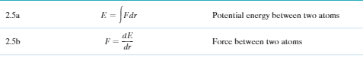
- Attractive, repulsive, and net energies for two atoms or ions depend on interatomic separation per the schematic plot of Figure 2.10b
- The magnitudes of the attractive and repulsive forces depends on the separation or interatomic distance
- Bonding energy is the energy required to separate two atoms to an infinite separation
- From a plot of interatomic separation versus force for two atoms/ions, the equilibrium separation corresponds to the value at zero force
- From a plot of interatomic separation versus potential energy for two atoms/ions the bonding energy corresponds to the energy value at the minimum of the curve

Primary Interatomic Bonds
- For ionic bonds, electrically charged ions are formed by transference of valence electrons from one atom type to another
- The attractive bonding forces are coulombic - that is positive and negative ions, attract each other.
- Ionic bonding is nondirectional - magnitude of the bond is equal in all directions around the ion
- The attractive force between two isolated ions that have opposite charges may be computed using
- There is sharing of valence electrons between adjacent atoms when bonding is covalent - found in atoms who have small difference in electronegativity
- Covalent bonidng is directional - between specific atoms and may exist only in particular direction
- Electron orbitals for some covalent bonds may overlap or hybridize
- With metallic bonding the valence electrons form a “sea of electrons” that is uniformly dispersed around the metal ion cores and acts as a form of glue for them
- Bond Hybridization in Carbon
- Hybridization is associated with covalent bonding in carbon - the mixing of two or more atomic orbitals with the result that more orbital overlap during bonding results
Under certain circumstances, one of the carbon 2 orbitals i promoted to the empty 2p orbital --” 1s2, 2s1, 2p3. Then the 2s and 2p mix to produce four sp3 that are equivalent to one another, having parallel spins and are capable of covalently bonding with other atoms.
Each sp3 holds one electron, therefore is half-filled.
The four sp3 orbitals are directed symmetrically from a carbon atom have an angle of 109.5 between adjacent bonds.
2. Sp2 hybridization: one s orbital and 2 p orbitals (2pz represents the unhybridized p
3 sp2 hybrids belong to each carbon atom - angle = 120...mostly found in graphite
- Metallic bonding - the valence electrons are referred to as “sea of delocalised electrons”
The remaining non valence electrons and atomic nuclei form ion cores
The free electrons shield the positively charged ion cores from the mutually repulsive electrostatic forces
Non directional in nature - free electrons glue the ion cores together
Secondary Bonding/van der Waals Bonding
- Evidenced in inert gases, which have stable electron structures
- It is possible between atoms with atoms/group of atoms which are joined together by primary bonds
- Arise form from atomic or molecular dipoles - some separation of positive & negative portions of an atom/molecule
- Bonding occurs form due to the coulombic attraction
- Relatively weak van der Waals bond result from attractive forces between electric dipoles, which may be induced or permanent
- For hydrogen bonding, highly polar molecules for when hydrogen covalently bonds to a nonmetallic element such as fluorine
- Permanent dipole moments exist by virtue of an asymmetrical arrangement of positively and negatively charged regions - forming polar molecules
- They can induce dipoles in adjacent non polar molecules too

Mixed Bonding
- In addition to van der Waals bonding and the three primary bonding types, covalent-ionic, covalent-metallic, and metallic-ionic mixed bonds exist
- Mixed covalent-ionic bonding - there is a continuum between the two bonding vertices
- The percent ionic character (%IC) of a bond between two elements (A and B) depends on their electronegativities (X’s) according to the equation:

Bonding Type-Material classification correlations
- Correlations between bonding type and material class were noted:
Polymers → Covalent
Metals → Metallic
Ceramics → ionic/mixed ionic-covalent
Molecular solids → van der Waals forces
Semi metals - mixed covalent-metallic
Intermetallics - mixed metallic-ionic
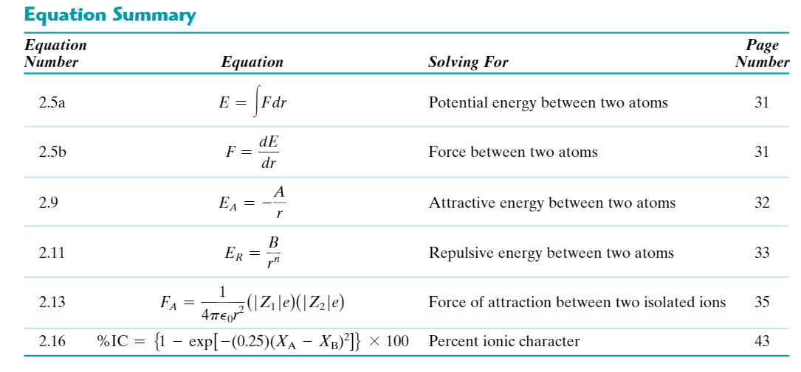

CHAPTER 3: THE STRUCTURE OF CRYSTALLINE SOLIDS

Fundamental Concepts
- Atoms in crystalline solids are positioned in orderly and repeated patterns that are in contrast to the random and disordered atomic distribution found in noncrystalline or amorphous materials
- When crystalline structures are described, the atoms and ions are described using the atomic hard-sphere model in which spheres representing nearest-neighbor atoms touch one another

Unit Cells
- Crystal structures are specified in terms of parallelepiped unit cells, which are characterized by geometry and atom positions within
- We, generally, use the unit cell having the highest level of geometrical symmetry

Metallic Crystal Structures
- Atomic bondng = metallic and nondirectional in nature
- Most common metals exist in at least one of three relatively simple crystal structures:
  - Face-centered cubic, (FCC) which has a cubic unit cell
Common examples = gold, aluminium, silver
The spheres/ion cores touch one another across a face diagnol
8 corner atoms (Nc = 8)
6 face atoms (Nf = 6)
0 interior atoms (Ni = 0)
→ Total number of atoms = 4
  - Body-centered cubic (BCC), which also has a cubic unit cell
Examples: Chromium, iron, tungsten
8 corner atoms (Nc = 8)
0 face atoms (Nf =0)
1 interior atom (Ni = 1)
→ Total number of atoms = 2
  - Hexagonal close-packed, which has a unit cell of hexagonal symmetry
12 corner atoms (Nc = 12)
2 face atoms (Nf = 2)
3 interious atoms (Ni = 3)
→ Total number of atoms = 6
- Unit cell edge length (a) and atomic radius are related by:
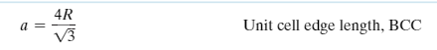
- Two features of a crystal structure are
Coordination number - no of nearest neighbor atoms
→ FCC = 12
→ BCC = 8
→ HCP = 12
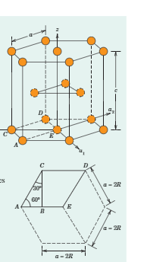
Atomic Packing Factor - fraction of solid sphere volume in unit cell
→ FCC = 0.74
→ BCC = 0.68
→ HCP = 0.74
- A unit cell that consists of atoms situated only at the corners of a cube = Simple Cubic Structure
No metals have this structure because of the relatively low packing factor
Only cubic element = polonium- metalloid
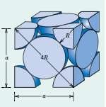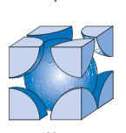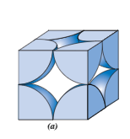
FCC BCC Simple Cubic HCP

Density Computations
- The theoretical density of a metal is a function of the number of equivalent atoms per unit cell, the atomic weight, unit cell volume, and Avogadroès number
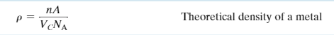

Polymorphism and Allotropy
- Polymorphism is when a specific material can have more than one crystal structure.
- Allotropy is polymorphism for elemental solids

Crystal Systems
- The unit cell geometry is completely defined in terms of 6 lattice parameters:
3 edge lengths; x y, z
3 interaxial angles α, β, γ
- The concept of a crystal system is used to classify crystal structures on the basis of unit cell geometry - that is, unit cell edge lengths and interaxial angles.
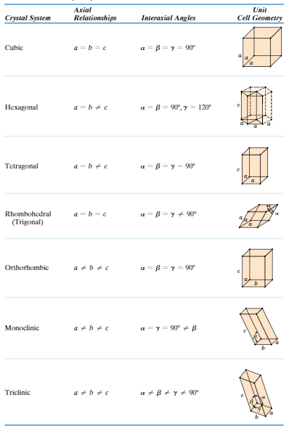

Key Question: What is the difference between crystal structure and crystal system?

Point Coordinates | Crystallographic Directions | Crystallographic Planes
- Crystallographic points, directions, and planes are specified in terms of indexing schemes. The basis for the determination of each index is a coordinate axis system defined by the unit cell for the particular crystal structure.

The location of a point within a unit cell is specified using coordinate axis system defined by the unit cell for the particular crystal structure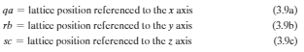

Directional indices are computed in terms of difference between vector head and tail coordinates
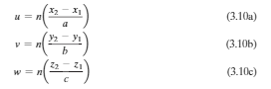
Planar (or Miller) indices are determined from the reciprocals of axial intercepts
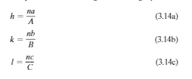
- For hexagonal unit cells, a four-index scheme for both directions and planes is found to be more convenient. Directions may be determined using the following equations
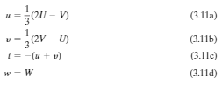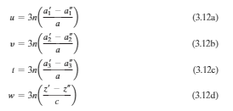
- For some crystal structures, several non parallel directions with different indices are crystallographically equivalent, meaning that the spacing of atoms along each direction is the same

Linear and Planar Densities
- Crystallographic directional and planar equivalencies are related to atomic linear and planar densities, respectively.
Linear density (for a specific crystallographic direction) is defined as the number of atoms per unit length whose centers lie on the vector for this direction
Planar density (for a specific crystallographic plane) is taken as the number of atoms per unit area that are centered on the particular plane
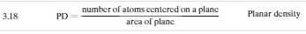
- For a given crystal structure, planes having identical atomic packing yet different Miller indices belong to the same family.

Closed Packed Crystal Structures
- Both FCC and HCP crystal structures may be generated by the stacking of close packed planes of atoms on top of one another. With this scheme, A, B, and C denote possible atom positions on a close-packed plane
The stacking sequence for HCP is ABABAB…
The stacking sequence for FCC is ABCABCABC....
- Close-packed planes for FCC and HCP are {111} and {0001}, respectively.

Single Crystals | Polycrystalline Materials
- Single crystals are materials in which the atomic order extends uninterrupted over the entirety of the specimen; under some circumstances, single crystals may have flat faces an regular geometric shapes.
- The vast majority of crystalline solids, however, are polycrystalline, being composed of many small crystals or grains having different crystallographic orientations
- The grain boundary is the boundary region separating two grains where there is some atomic mismatch

Anisotropy
- Anisotropy is the directionality dependence of properties. For isotropic materials, properties are independent of the direction of measurement.

X-Ray Diffraction: Determination of Crystal Structures
- X-Ray diffractometry is used for crystal structure and interplanar spacing determinations. A beam of x-rays directed on a crystalline material may experience diffraction (constructive interference) as a result of its interaction with a series of parallel atomic planes.

- Bragg’s Law specifies the condition for diffraction of x-rays

Noncrystalline solids
- Noncrystalline solid materials lack a systematic and regular arrangement of atoms or ions over relatively large distances (on an atomic scale). Sometimes the term amorphous is also used to describe these materials.


