Introduction to Computer Sciences
What is a computer?
- Electronic device that stores, retrieves, and processes data
What is a computer programming?
- Set of instructions that can manipulate data
- Can also be stored in the computer memory
Logical (conceptual) view of a computer:
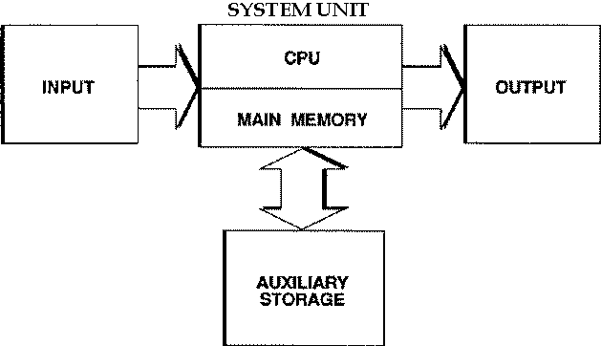
CPU central processing unit
- Fetches, recognizes and executes instructions
Main Memory circuits that can store data
- CPU can get the data from memory very fast
Auxillary Storage device that stores large amounts of memory
- Usually slower then main memory
The Fetch Cycle
- Turn on the computer, goes into a cycle called fetch cycle (instructions and execute it)
- Computer program consists of lists of instructions that can change the memory
- Memory changes when program proceeds and we can look at it
- If we get the results we want, it’s a successful program
- Computer doesn’t care in any way
Different types of computers
- Supercomputer
- Mainframe computer used for massive calculations (scientific calculations, weather forecasting)
- Minicomputers (between personal and mainframe)
- Workstations (high-end personal computer, one user at a time)
- Personal computer
  - Desktop (e.g., PC’s , I-Macs....)
  - Notebook and Laptop
  - Personal Data Assistant (PDA) hand held computers or palmtop computers
The components of a personal computer (The physical view)
- Not so recent typical home computer workstation
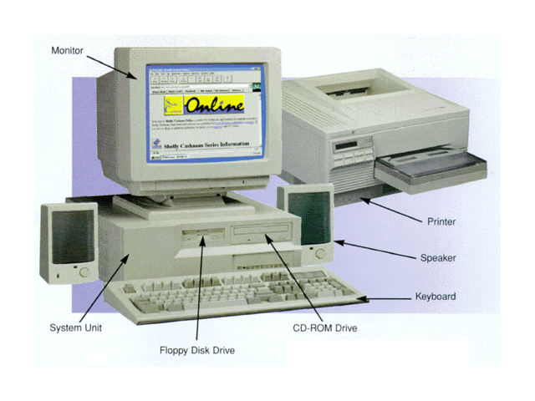
Newer-looking computers (MAC G3 Cube, I-Mac, IBM Aptiva)
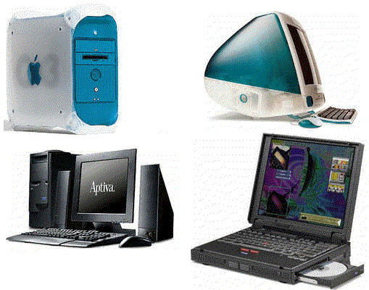
Computer parts are categorized as:
- Input device
- Output device
- Auxiliary device
- Central Processing Unit (Main Computer)
Devices both input and output?
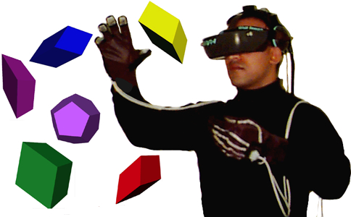 VR Helmet
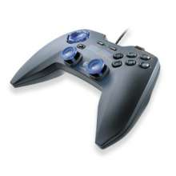Rumble Joystick
Input devices
- Used to get data, user commands into the computer
  - keyboard - the main form of input (allows numbers/alphabetic characters etc. to be entered directly).
  - Standard letters, numbers, punctuation etc...
  - Special keys:
    - Enter key: Used in typing for new line, used to indicate that the user has finished a selection and is ready to continue
    - Tab key: Allows text to be ligned up vertically
    - Shift key: Used to get capital letters, used with mouse for special selection features
    - Cntrl key: Used with a letter key to indicate that a special function is to be performed
    - F1...F12: Depending on program these have specific functionality
    - Print Scrn: Captures the contents of the screen into a "clipboard" for copying purposes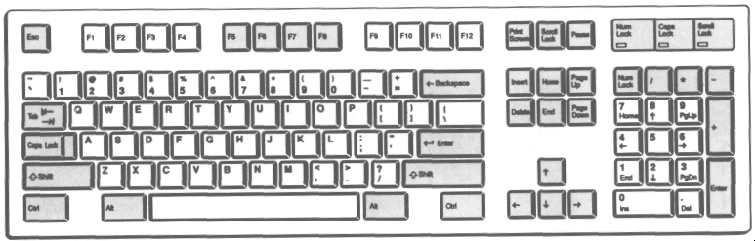
List of some special characters on a computer keyboard and the names often associated with
~ tilde
! bang, exclamation mark
@ at
# pound, hash, number sign
% percent
^ caret
& ampersand, and
* asterix, multiply
/ slash, forward-slash
\ backslash
| bar
Mouse:
- Allows pointing and clicking
- Used to select or choose something
- Used to position the “cursor” on the screen
- Nice for intuitive drawing operations
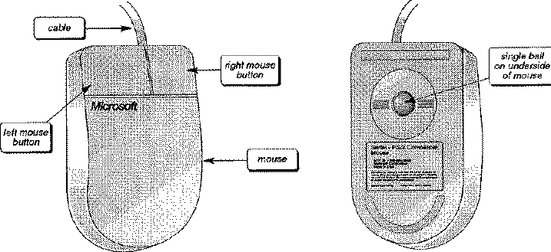
Some mice have a scroll wheel between the buttons: 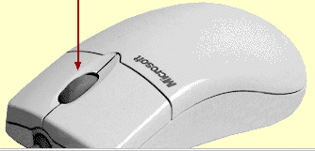

  - Some mice have no ball underneath, instead they have a light.
    - do not need to be cleaned as often, does not wear out
    - many work with special mouse pads
    - more accurate than ball mouse...good for sensitive drawings
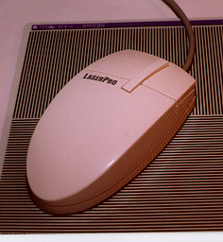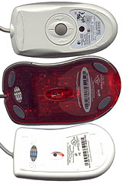
  - Some mice are cordless...can you think of advantages and disadvantages of this?
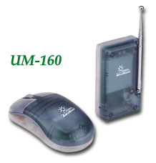
Advantage:
- No need to worry about long cables that connect mouse with computer
- Wireless mouse are optical mice’s
- Used on most surfaces
Disadvantage:
- They lose battery power very often, costs a lot to replace
- Heavy
- Breaks easily
- Other things can interfere with the signal
- Trackball
  - kinda like an upside-down mouse
  - ball is controlled usually by thumb and one finger
  - used as a replacement for a mouse
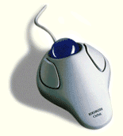
- Joysticks and Gamepads
  - For fun games.
  - Many types with different buttons, feedback etc...
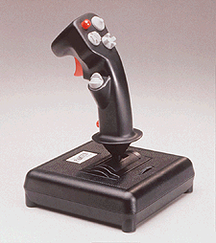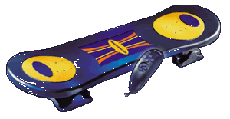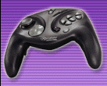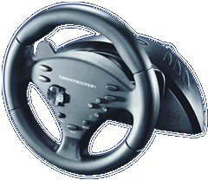

- Scanners
  - some are hand held, some are flatbed
  - kind of like coloured photocopiers.
  - vary in price according to resolution (i.e., picture quality)
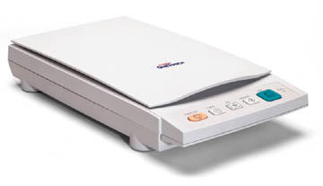
- PC cameras:
  - many from different companies
  - different resolutions, features
  - different software
  - Different connections (parallel, USB etc...!!!)
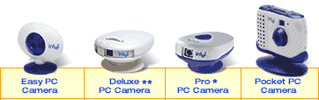
- Light pen
  - same idea as mouse but pen works on screen

- Bar code readers
  - we've all seen these in grocery stores
  - used to read in product codes quickly and without error
  - also used for security cards
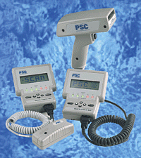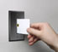
- there are others - for example...virtual reality suits and gloves

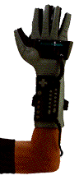

Output devices:
Output devices are used to show output to the user typically in the form of paper, sound or video.
Display Devices (i.e. computer screen or monitor)

  - Cathode Ray Tube (CRT)
    - standard TV-like screens but vary in quality, size, clarity, etc...
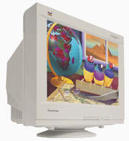

  - Liquid Crystal Display (LCD)
    - like on lap-top computers (passive or active matrix)
      - Passive matrix
        - Not very bright
        - Motion looks a little smeared
        - Slow refresh rate
        - Not good in brightly-lit places
      - Active matrix
        - Also known as TFT (Thin Film Transistors)
        - Better clarity & brightness
        - More expensive
    - more expensive than CRT
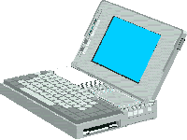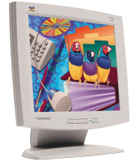
  - 3D Headsets - used in virtual reality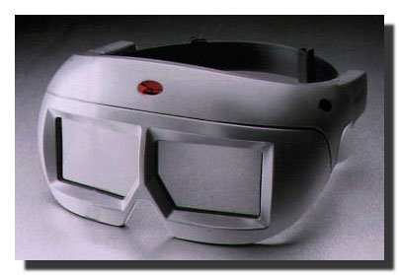

Pixels
    - Short for "picture elements" (i.e. dots).
    - Pixels are the smallest electronic elements that compose digital pictures.
    - Digital images are composed of a grid (rows & columns) of pixels.

Common Features of All Display Devices
    - Size
      - length of diagonal of monitor
      - sometimes viewable length, sometimes tube length (tricky)
      - common values are 13", 14", 15", 17", 19", 20", 21"
    - Dot Pitch
      - size of a single dot on the screen
      - 0.23mm, 0.24mm, 0.26mm, 0.28mm are common
      - smaller is more crisp/less blurry
    - Refresh options
      - interlaced (every second row shown first) vs. non-interlaced
      - refresh rate 60Hz, 72Hz, 90Hz
    - Maximum "Resolution"
      - number of columns and rows of pixels
      - common values are 640x480, 800x600, 1024x768, 1280x1024.
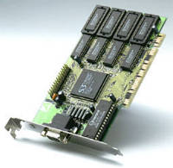
Video Cards
  - one required for every computer
  - many new ones have 3D acceleration features
  - some cards ONLY for 3D, still need a regular video card
          - A typical video card
Speakers
  - many varieties (differing quality, wattage etc...)
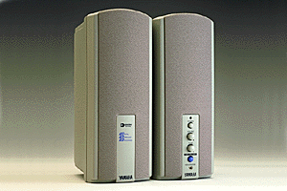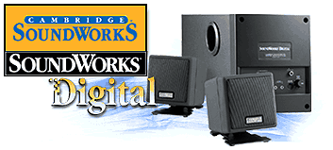
  - sometimes built-in to the monitor
  - sometimes built-in to the computer case
  - home PC's used to require a sound card - often built-in now
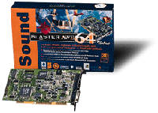
Printers
  - Dot-Matrix printers
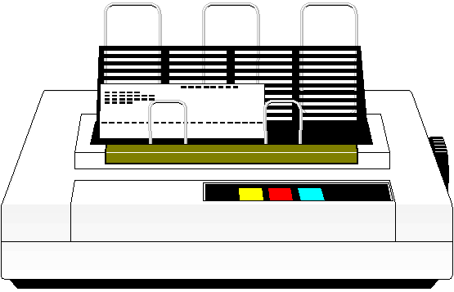
    - older technology (not unlike typewriters) where array of dots make up characters
    - noisy but really cheap to maintain
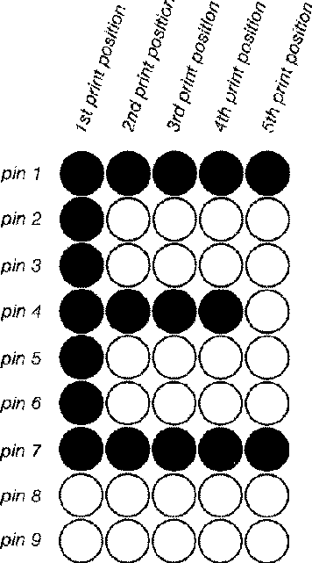
  - Ink/Bubble Jet printers
    - ink is sprayed onto paper (very accuracte though)
    - not bad quality
    - cheap to maintain (ink is cheap)
    - CMYK color is easily formed by combining (Cyan, Magenta, Yellow & blacK)
  - Laser printers (black and white / color)
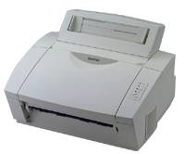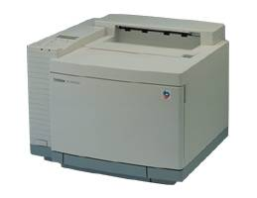
    - best quality - similar to photocopying technology
    - very quiet
    - most expensive
    - high maintenance costs (toner)
  - Plotters
    - Used for drawing blue prints, wiring diagrams etc....
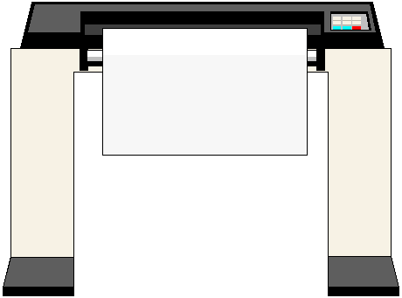

Auxiliary Storage Devices:
Auxiliary storage devices are used to store information more permanently.
They can be used as input and output devices. There are many types.
- 3.5" Floppy diskettes
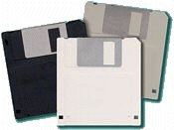
  - can transfer from machine to machine
  - requires a floppy disk drive
  - typical diskettes hold 1.44 million bytes (more later on megabytes, kilobytes, gigabytes.. etc)
  - slower than main computer memory, they can be bent or lost
  - have write-protection capability (like VHS tapes and audio cassette tapes).
  - when square is openned, the disk is write protected and cannot be written to. (WHITE PROTECT WINDOW OPEN MEANS DISKETTE IS WRITE PROTECTED)
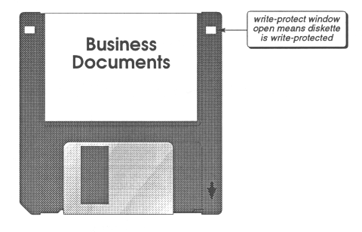
  - Data is stored in tracks/ sectors of a rotating disk.
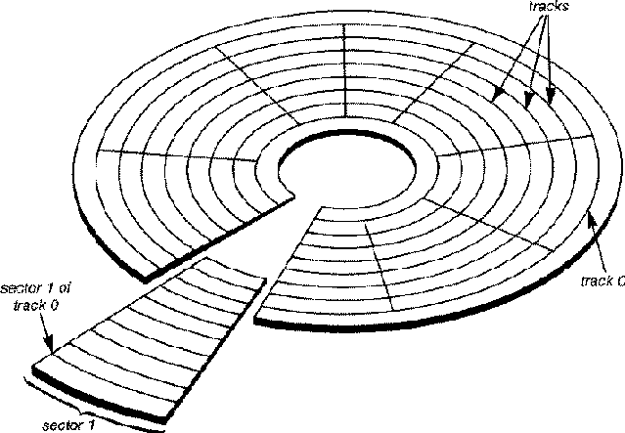

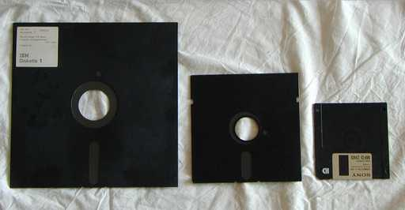
- Floppy Disk History
  - 1967: 8" floppy disk (IBM) (200 KB)
  - 1976: 5.25" floppy disk (360 KB, later 1.2 MB)
  - 1981: 3.5" floppy disk (720 KB, later 1.44 MB)
  - Mid 90's: 5.25" mostly disappeared

- Hard Disk Drives
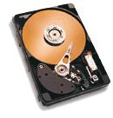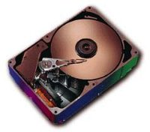
  - faster than floppy
  - can hold thousands of more times more data than a floppy disk
  - often internal to the computer (not removed unless broken or upgraded)

- Zip / Jazz Drives
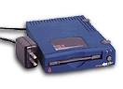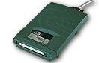
  - removable
  - store much more than single diskette (i.e. 100MB, 250MB or 1GB)
  - faster than diskettes (almost as fast as some hard disk drives)

- Tape Drives
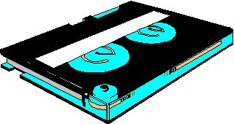
  - slower than disks (we must read/write the whole tape in one shot)
  - good for backups (cheap)

- CD-ROM Drives
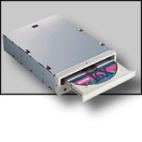
  - come in different speeds (2x, 4x, 8x, 24x, 52x, ...)
  - some read only, some write once, some re-writable
  - most new software comes on CD's and so new computers often come with a CDrom drive.
  - data is stored as a bunck of holes which are burned onto the CD. Once a regular CD has been written to, it cannot be unwritten, erased or overwritten. This is why they call it a ROM (Read Only Memory).
  - some CD's are re-writable
    - must go through an "erasure" stage where a layer is burned off
    - can only be re-written a fixed number of times (e.g., 10)

- DVD (Digital Video Disks)
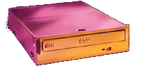
  - read-only (writable nowadays)
  - contains high-quality movies
  - often interactive with menus

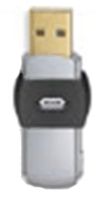
USB flash memory or USB memory key.

Flash memory can retain information without power (non-volatile memory) . It is fast. Called "flash memory" because it erases blocks of memory "in a flash". Invented in 1980

also
Flash cards for cameras (same technology)
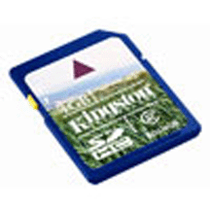

The System Unit:
The system unit is made up of many smaller components.
- Main Processor (or central processing unit: CPU)

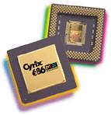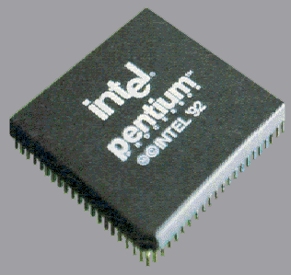
  - the "main brain" that does all of the coordination and computation
  - different types from different companies
    - Intel: 80386, 80486, Pentium, Pentium II, Pentium III, Pentium IV, Celeron, Coppermine, Xeon, Core2, Atom
    - Motorola: 68000
    - AMD: Athlon, Duron, Thunderbird, Sempron, Opteron
    - Cyrix
  - different speeds
    - 166MHz, 233MHz, 450MHz, 733MHz, 850MHz, 1000MHz = 1GHz ...
    - faster is better. but fastest is not worth it
    - speeds increase every couple of months.
Some detailed facts about a couple of Intel processors. There are large numbers of them.
Intel Atom™ Processor Family

Processor ClockSpeed(s) Intro Date(s) Transistors Cache Memory Addressable Memory

Intel Atom™ Z540 1.86 GHz Apr-08 47 million 512 kB 4 GB
Intel Core™2 Processor Family. ( A very large family)

Processor Clock Speed(s) Intro Date(s) Transistors Cache memory Addressable Memory
Intel Core™2 Duo E8500 3.16 GHz Jan-08 410 million 6 MB 64 GB
Intel Core™2 Duo E8400 3 GHz Jan-08 410 million 6 MB 64 GB
Multicore Processors
Today almost any computer you buy is "multicore". A multi-core processor is basically composed of two , four six etc or more independent CPUs. They usually have their own cache memory but use a common main memeory.
As an example of a few multi-core processors.
* Celeron Dual-Core, the first dual-core processor for the budget/entry-level market.
* Core 2 Quad, 2 dual-core dies packaged in a multi-chip module.
* Core i3, Core i5 and Core i7, a family of multi-core processors
* Itanium 2, a dual-core processor.
* Xeon dual-, quad-, hexa-, and octo-core processors.
Are they two or four times faster? No because not all programs can make use of parallelism. They require co-ordination. They share memory. But in principle they can do multiprocessing, i.e run more then one program at once. So there is an improvement but not as much as one would expect for the casual user.

- Main Memory (RAM - Random Access Memory)

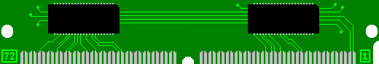
  - holds programs/data when computer is on
  - the more memory, the more you programs you can run at once
  - often more memory translates to faster computer performance
  - different amounts (16MB, 32MB, 64MB, 128MB, 256MB, 512MB, 2GB)
  - different types/speeds (EDO, SDRAM, cache)

- Motherboard

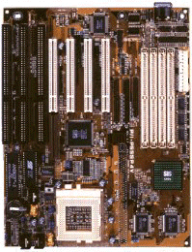
  - holds everything together (CPU, memory, video card, i/o cards).
  - different kinds that vary in speed, quality, number of expansion slots, maximum memory)
- Case
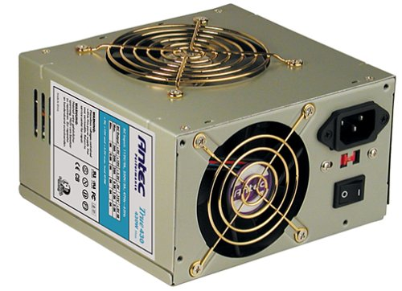
  - all the above fit into a case with all disk drives and a power supply
A typical computer power supply

  - different types - desktop, tower, mini tower etc...

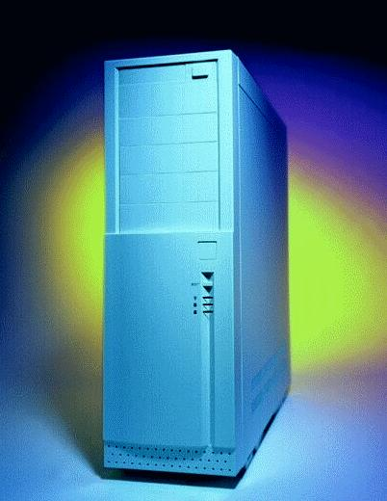
A popular case today is the see-through acrylic case, with neon lights!
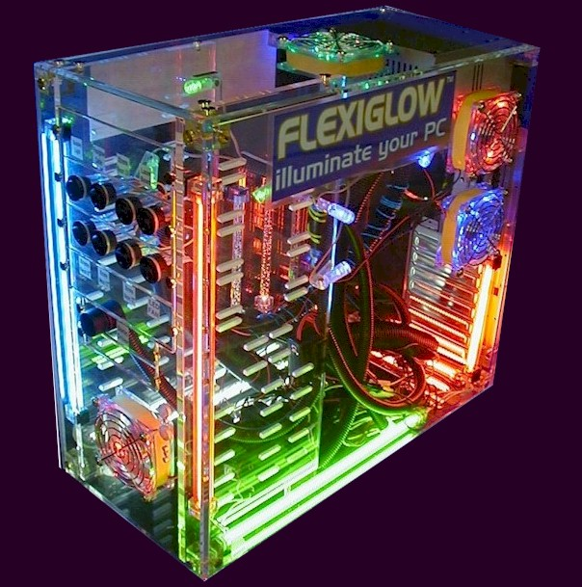

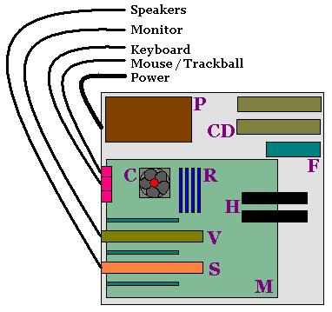
What's inside a typical computer case.

What is computer hardware/software ?
- Hardware
  - the physical components that make the machine
  - processor, motherboard, memory, drives, video/sound cards etc...
- Firmware
  - a program (set of instructions) that sit on a microchip in hardware
  - often used to start up (i.e. boot) the machine.
  - keeps settings such as "bios" (i.e., configuration) system settings
- Software
  - a program that runs on the computer
  - comes initially on a diskette, CD rom or downloaded from internet
  - usually needs to be installed on the hard disk of your computer
  - may be a game/drawing package/ etc...

What kinds of Software are there ?
- System software (Operating System)
  - either DOS, Windows95/98, Windows NT, OS/2, System 7 (Macs), System 8 (Macs), Unix, Solaris, Linux
  - responsible for
    - starting up (booting) the computer
    - interfacing with users
    - coordinating system devices
    - coordinating applications (i.e. running programs)
- Application software types
  - business applications
    - word processing and desktop publishing
    - spreadsheets
    - databases
    - graphics and presentations
    - communications (e-mail, internet, etc.)
  - utility applications (disk clean, virus scan etc...)
  - personal applications (diary, planners, tax returns, budgetting)
  - entertainment applications (games, movie-players)
  - learning (encyclopedias, kids learning, typing)

What is Communications ?
Communicating with other computers over networks.
- Modem
  - used to connect to another computer over phone lines
  - can download (get) information from remote (far away) computers.
  - can upload (put) information onto remote computers.
  - connect at different speeds (14,400 baud, 56k baud) indicating bits per second for transfer rates
  - there are many services such as Bulliten Board Systems (BBS) and Internet Service Providers (ISP)
  - you can send e-mail back and forth to friends provided that you have an account somewhere.
    - Example: In Ottawa: NCF (National Capital Freenet)
- Communication Networks

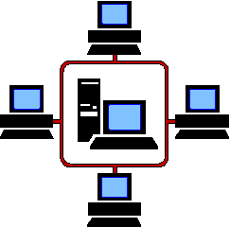
  - Local Area Network (LAN)
    - many computers connected physically (usually on a single floor or in a single building)
  - Wide Area Network (WAN)
    - many computers connected logically but separated physically by phone lines (i.e. different countries)

Internet is a....?

What are some of the ethical issues in computers ?
- Copywrite
  - software piracy - copying software and reselling is illegal
  - site licences and network versions - usually indicate the number of users at one time
  - shareware - distributed freely, but creator usually expects honour system payment of small amount (e.g. $10)
  - freeware - free for everyone (YAY!). Often crappy stuff that nobody would buy, but sometimes good stuff.
- Bugs
  - 1945 Harvard: A moth found inside huge calculator computer - not actually the origin of the term
  - programs you buy are not perfect, they may "crash" your computer in certain situations. This is a "bug" in the software.
  - some "bugs" do not cause a "crash" but just cause weird or undesirable effects.
  - some "bugs" are known and documented ... they will be fixed in future releases
  - some "bugs" are intermittent and not documented.
  - beta versions of software are versions that are currently being tested in the workplace.
  - the "year 2000" problem is a well-known bug (Y2K) for many systems.

The Y2K bug did not cause milk cartons to leak.

- Viruses
  - some believe ... more hype than its worth
  - malicious people create programs that deliberately do bad things
    - famous example: Stoned virus
      - Student at University of Wellington in New Zealand, 1987
      - Wrote message on disk: "Your PC is now stoned! LEGALIZE MARIJUANA!"
    - another: Cascade virus (1988)
      - Letters fall downward on the screen
      - Pile up in a heap at the bottom
    - another: Green Caterpillar (1991)
      - Crude green caterpillar crawls across the screen
      - First detected here in Ontario
  - can erase your programs, delete some files, corrupt some files,...some are harmless but cause anoying effects
  - can lie dormant for periods of time and then emerse or "come to life" on certain days
  - can be a program but cannot lie in data.
  - can be transferred from disk to disk unknowingly.
  - lotsa software that can detect the common viruses by scanning all disks and software installed on your machine
  - this slows down your work progress however.
  - mainly, these viruses come with pirated software or shareware
- Security
  - theft - top secret data must be encrypted with passwords to be protected
  - intruders or hackers - they break into computers just because they can (lots of free time).
  - interception of transmissions - very important with military data and planning
- Privacy
  - emails or instant-messenger messages should be private (Skype).
- Ergonomics
  - the study of making people comfortable when working on computers
  - new keyboards come with warnings that sitting all day at the computer can cause severe problems
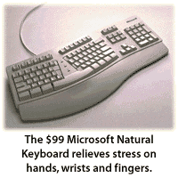
  - newer keyboards, mice, joysticks, chairs, desks, etc... are being developed.

Colour depth | 1 bit | 2 bit | 4 bit | 8 bit | 24 bit
Example |  |  |  |  | 
Description | Mono-chrome, only stores black and white | stores white, black and two greys | Stores limited colours | close to reality | damn close to reality
Number of colours
per pixel
Example: Calculating file size for different colour depths
All the images above are of the same resolution:
300*225 = 67500 pixels
If the first image uses 1 bit to store the colour for each pixel, then the image size would be:
Number of Pixels * Colour Depth = Image Size
67500 * 1 bit = 67500 bits
For the second image uses 2 bits to store the colour for each pixel, then the image size would be:
Number of Pixels * Colour Depth = Image Size
67500 * 2 bit = 135000 bits

DATA STORAGE AND FILES

Representation of Data in Computer Memory
- The basic information unit in the computer is a bit (short for binary digit).
- In memory the bit is stored in electronic or magnetic form and can take on two values.
  - For simplicity these two values are designated 0 and 1.
THE CHALLENGE:
How do we represent all information in memory using only these two symbols?
What kinds of things need to be represented?
  - computer instructions which are stored in memory.
  - characters such as 'A' and 'B' and '7' which allows us to store text.
  - integer numbers such as 125 and 9878.
  - decimal numbers such as 3.14159 and 53.5x10³.
  - graphic information which allows storage of photographic images.
  - sound information which allows us to store music.
All of the above need to be represented and we have only two symbols, 0 and 1.
In order to do this we get groups of bits together to form a bit pattern and the different patterns represent the different "things".
The way in which we choose these bit patterns is called "Data representation".
Main Example:
Representing characters for text
If we wish to represent text we need a different bit pattern for each character.
How many characters do we need?
We have to represent...
  - all the upper case letters (26)
  - all the lower case letters (26)
  - all the digits 0,1,2,3,4,5,6,7,8,9
  - all the punctuation such as . , ? ! etc
  - and other characters such as > < ( ) { } [ ] etc.
  - In particular we also need to represent the character "blank" and a bunch of other special characters.

QUESTION:
How many bits do we need to do this?
If we use 1 bit there are 2 different bit patterns and they are:
0 1
this is not sufficient to assign each character a separate pattern
If we use 2 bits there are 4 different bit patterns and they are:
00 01 10 11
this is not sufficient to assign each character a separate pattern
If we use 3 bits there are 8 different bit patterns and they are:
000 001 010 011 100 101 110 111
this is not sufficient to assign each character a separate pattern
If we use 4 bits there are 16 different bit patterns.
0000 0001 0010 0011 0100 0101 0110 ...etc.
this is not sufficient to assign each character a separate pattern
If we use 5 bits there are 32 different bit patterns...not sufficient
If we use 6 bits there are 64 different bit patterns...not sufficient
If we use 7 bits there are 128 different bit patterns...
this is sufficient...
but in computer science we don't like 7
SO ...
we use 8 bits which gives 256 different bit patterns which is also sufficient.

DEFINITION of a BYTE:
The basic addressable memory cell is called a byte and is typically composed of 8 bits.
A byte is a memory cell which can store one character.
Half a byte - 4 bits - sometimes called a nibble (or nybble)
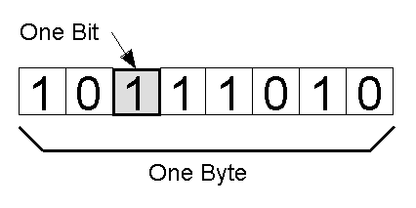

QUESTION:
How do we decide which bit pattern corresponds to which character?
This is decided by a standards organization.
There are a few standards and the most common one is called ASCII,
which stands for American Standard Code for Information Interchange.
This standard gives each character a specific bit pattern.
A more recent standard is the UNICODE standard
which has much more bit patterns (16-bits) which allows support for different language characters.
A sample of these bit patterns are:
A 01000001 a 01100001
B 01000010 b 01100010
C 01000011 c 01100011
0 00110000 blank 00100000
1 00110001 ? 00111111
2 00110010
How would a phrase look if written in ASCII ?
"THE CAT"
01010100010010000100010100100000010000110100000101010100
01010100 01001000 01000101 00100000 01000011 01000001 01010100
T H E _ C A T
This is not of much use to us but its just the right form for computer memory.

How is text stored in memory ?
Memory can be viewed as a succession of bytes and each byte containing a bit pattern.
So we can conceptualize the text "THE CAT" as stored in memory (RAM or ROM) as follows...
01010100
01001000
01000110
00100000
01000011
01000001
01010100

which if we use characters would look like:
T
H
E
blank
C
A
T

How is Other Kinds of Information Stored?
What about integer numbers such as: 1234, 971, 22, 1, 456, 345, 567, 789?
It is somewhat outside the scope of the course to see what the bit patterns are but we might ask how many bits are required to store an integer number.
What if we want to store all of the positive numbers from zero to one billion...
How many bytes are needed?
Is one byte enough?
No! because one byte gives only 256 different patterns and that's not enough.
How many patterns are there for bigger numbers of bytes?
1 byte is 8 bits and that gives 256 different bit patterns
2 bytes is 16 bits and that gives 65536 different bit patterns
4 bytes is 32 bits and that gives 4,294,967,296 different bit patterns
So... To store all of the integers from 0 to 1,000,000,000
we would want each integer to be 4 bytes
which gives us 4,294,967,296 different possiblities (more than we needed).
Computers often use 4 bytes to store an integer but this is not written in stone.
They could use more bytes and store bigger numbers (but this might waste space)
Or they could use fewer bytes and only be able to store smaller numbers (but they could then store more of these numbers).
It is the job of computer engineers to figure out how many bytes are needed for various purposes.

How do we store graphic information such as a photo?
We break up the photo into a grid pattern.
Each element of the grid pattern is called a PIXEL or PIcture ELement.
The following is an example of a picture broken down into a 10 by 10 grid of 100 pixels
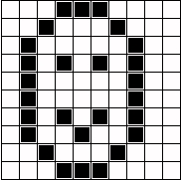
How much information is required for each pixel?
It depends on the kind of photo.
Black and white photo (Grey Scale):
Grey scale photographs typically have 256 levels of grey from black to white.
So each pixel requires 1 byte. So the photo schematically represented above requires:
10 x 10 x (1 byte) = 100 bytes.
More realistically the grid pattern may be more like 1280 x 1024.
In this case the photograph may require
1280 x 1024 x (1 byte) = 1,310,720 bytes or ~1.3 MB
How many of these files fit on a 258 Mb USB key?

Colour photo:
Images on the screen of your computer are made up of 3 primary colours for each pixel (Red, Green, Blue) (RGB):
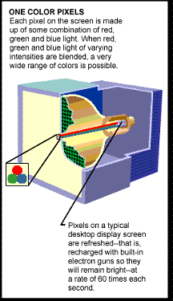
Suppose each primary colour has 256 brightness levels.
Then each pixel requires 3 bytes.
So for our 1280 x 1024 grid we require:
1280 x 1024 x (3 bytes) = 3,932,160 bytes or ~3.9 MB
How many of these files fit on a 258 Mb USB key?

Summary:
Depending on the...
  - size of the grid
  - number of colours
...photographs require a great deal of memory!

Notation for counting numbers of bytes:
Obviously we sometimes deal with information requiring a lot of storage and so we need notation for counting bytes.
TERM | ABBREVIATION | NUMBER OF BYTES
kilobyte | KB | 1,024 (roughly 1,000)
megabyte | MB | 1,048,576 (roughly 1,000,000)
gigabyte | GB | 1,073,741,824 (roughly 1,000,000,000)
terabyte | TB | 1,099,511,627,776 (roughly 1,000,000,000,000)
How big are files?
A file containing text (a text file) has 1 byte for each character.
So a file containing a large novel such as "War and Peace" has about a million characters and so would take around 1 MB.
A text file containing a personal letter might have a thousand characters and so would take 1 KB.
Photographic files take anywhere from a few hundred KB to a few MB.
It would not be unusual to have a 3 MB picture file.
This file would take more space to store than "War and Peace"!
For example: HERE is an image file that is 59 MB! - It is 3947 x 5240 pixels.
So much for `a picture is worth a thousand words'.

How do these files fit on different disks?
  - Floppy disks store 1.44MB of data.
  - Zip disks store about 100MB of data.
  - How many bytes of data can be stored onto a hard disk?
    - Used to be around 20MB (15 years ago).
    - Now 20GB, 30GB, and 65GB are common.
    - 200GB to 400GB also available.
  - How many 3.5" floppies would be needed to backup a full 200GB hard drive?
    - Answer is roughly 200,000,000,000 / 1,440,000 ~= 139,000 floppies.
    - Over 5 times taller than the Peace Tower
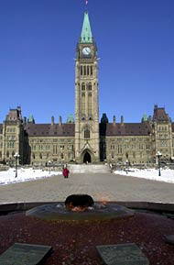
  - What about a zip disk instead of a hard drive?
    - Answer is 100,000,000 / 1,440,000 ~= 70 floppies.
Most users don't really care how data is physically stored.
From our point of view, we just store our data in terms of files.
but...
What is a File?
  - A file is a collection of data that is stored on a disk. This is also called a document.
  - The files are organized in directories (also known as file folders or just folders).
  - Directories can contain files or other directories.
  - Every drive (a disk, although some disks can contain multiple drives) has a root directory.
There are many types of files and files can hold data for different things.
Every file and directory MUST have a name which is called the filename.
Often, a period and 3 characters finish the name and this is called the file extension.
The file extension gives an indication as to the type of file (i.e. the filetype) it is and what can be done with it.
(After all...when there is no limit as to what names to use...how do we know what any file does ?)
- Program or Application
  - .exe - Executable file (the usual)
- Text file and Documents
  - .txt - A plain text file (for notepad or wordpad, simple text editing programs)
  - .htm/.html - Web page files, also plain text (for Netscape, IE, Firefox, and other browsers)
  - .doc or *.docx - Microsoft Word document
    - an essay typed into the computer
    - a recipe for some chicken noodle soup
    - a list of all your CDs or video tapes
    - a book you've written

- Image or Picture files
  - .gif - Graphic Interchange Format (compressed image, most common format on web, can be animated)
  - .jpg/.jpeg - Joint Photgraphic Experts Group (also compressed)
  - .bmp - A bitmap image also known as a raster image (not compressed)
  - .tif/.tiff - Tagged Image File Format (very flexible)
    - hand drawn images
    - scanned in pictures
    - photos
    - screen snapshots
- Sound
  - .wav - Waveform audio (raw uncompressed sound file - large but high-quality)
  - .mp3 - MPeg audio layer 3 (compressed CD-quality audio by a factor of ~10)
  - .au - AUdio file (from Sun)
  - .aiff/.aif - Audio Interchange File Format (from Apple, originally for Macintosh)
  - .ra - Real Audio format (designed for streaming audio over the internet)
  - .ram - A file that specifies a link to a Real Audio file on the data
  - .wma - Windows Media Audio file (developed by Microsoft)
  - .msv - Memory Stick compressed Voice file format (from Sony)
    - recorded sounds
    - music files
    - recorded voice
- Multimedia
  - .avi - Audio Video Interleaved (from Microsoft)
  - .mpg/.mpeg - Moving Pictures Experts Group
  - .mov - MOVie file format from Quicktime (Apple Macintosh)
  - .rm - Real Media file format (for use with RealPlayer program, web streaming)
    - video or movie clip
- Compressed
  - .zip - Zipped compression (originally created by Phil Katz for PKZIP program)
  - .rar - Roshal ARchiver compression (for the program WinRAR)
  - .sit - StuffIt compression format (for Macintosh)
  - .gz - GNU project's Zip compression format (for the program GZIP - Linux)
    - any file that has been compressed to save space on the disk
    - must be unzipped before using it
- Application specific files
    - lots of weird and unknown files come with software
    - nobody really knows what all the files mean except those people that create them

What is a directory structure ?
  - It is a (family) tree of files and folders (directories) usually forming a hierarchy:
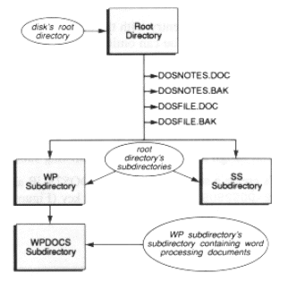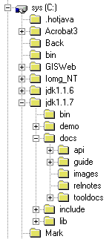
  - Folders just hold more files and folders
  - A pathname identifies a file and it's location in a directory structure.
  - Here is an example of a directory structure with files and folders (i.e. directories).
(The bolded words are directories):
A:\
outline.doc
outline.html
notes
intro.html
files.html
assignments
assignment1
assignment1.txt
sheet.txt
marks.txt
Since a computer typically has many disk drives (floppy disk, hard disk, CR rom, zip drives ...),
We need to specify the drive.
Each drive is assigned a letter (varies from machine to machine, network to network).
- The A: in the example above indicates the drive letter. The A: and B: drives often indicate floppy disk drives (although not always).
- The C: drive usually indicates the hard disk drive while the E: or F: drives are usually CD drives.
- The Z: drive in the lab is your network drive.
  - Your network drive is actually a part of a hard drive that is accessed across the LAN.
  - It seems as though this drive is located within the machine that you are working on but...
    - it is in a totally different room.
  - You (used to) have 25 MB of space on this drive and it is automatically backed up every night (very useful!).
We must specify the name of the file as well.
In the example above outline.doc is one filename.
Lastly, it may be that the file is inside a folder which itself may be inside another folder etc...
So...
We need to specify the full pathname.
These are often separated by backslash characters.
For example:
A:\assignments\assignment1\assignment1.txt
What are the typical file operations?
- View files and folders
- Select a drive
  - A: (diskette drive at home)
  - B: (diskette drive in SCS lab)
  - C: (typically the hard drive)
  - Z: (your network drive in the SCS lab)
- Select or open a file or folder
  - openning a file usually causes some kind of application to start up.
  - in windows 95/NT, programs are associated with file extensions
- Create
- Move
- Copy
- Delete
- Rename
- Format a diskette
- Copy a diskette (A: drive)
- Search a diskette / drive
- Determine size
- When created
- When last modified

