Statistics Crib
Stem and Leaf Rules
Stem
- Stems should be between 6-13
- Stems need to be consecutive or repeated numbers
- Stem unit must be indicated
- There must be one leaf associated with first and last stem.
Leaf
- The leaf for each data value is the next single digit after the stem. Order is reversed for negatives. 0-4 and 5-9. OR, 0-1, 2-3, 4-5, 6-7, 8-9
- No rounding off
- Leaf values are written in ascending order for positive, descending order for negative
- Leaf values must be evenly spaced
- No commas or dashes between numbers

Describing Data Distribution
Stem and Leaf and Histograms
Skewed to the Left The bulk of the data is on the right side (bottom of distribution)
Symmetrical
Skewed to the Right The bulk of the data is located on the left side (top of distribution)
Mean and Median
Skewed to the Left Mean < Median
Symmetrical Mean = Median
Skewed to the Right Mean > Median

Sheet

Measure | Population Parameter  N | Sample Statistic  n
Mean | μ | X
Variance | σ^2 | S^2
Standard Deviation | σ | S

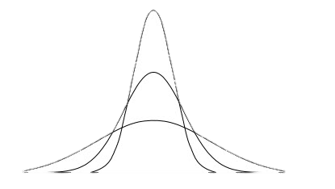
Measures of Variance
Range: Max – Min
Inter Quartile Range (IQR): Q3 – Q2
Variance:

Standard Deviation:
Coefficient of Variance: Standard Deviation / Mean

Measures of Central Tendency
Mean - Average, always used unless extreme outliers
Median – Middle, not sensitive to extreme values.
Mode – Most frequent value, not effected by extreme values.
MEAN AND MEDIAN USUALLY REPORTED TOGETHER

Right Skewed sharp peak
Kurtosis Statistic: >0
Symmetrical Skewed Bell Shaped
Kurtosis Statistic: 0
Left Skewed flatter shape
Kurtosis Statistic: <0
Kurtosis
Finding Percentiles and Quadrants
- Order data into ascending data array
- Use formula to calculate K percentile
R= Half round [n(k/100) + 0.5]
N= number of values and k= any percentile asked.
- Use rank to find the right data value.

Nice Numbers
Frequency Distribution and Class Rules
- 5-10 classes
- Classes need to be close ended.
- Class Width: Classes have upper and lower boundaries
- Estimating Class Width: (Highest Value – Lowest Value)/ 5
- No gaps between classes
- All classes must have same width
- First and last class have to have frequencies
- Boundaries must look like the data and be a multiple of class width

Mean and Median 10% Rule
- Calculate the difference between the Mean and Median
- Calculate 10% of the smaller value
Deciding
- If the difference is less than 10%, mean is approximately equal to median. Mean is preferred measure and the data are symmetrical
- If the difference is greater than 10%, mean is not equal to median. Median is preferred measure and data is skewed.

