ECOR 1010 – Introduction to Engineering

Alexandre mougeot
Assignment #2
Assignment Title: Unit Conversions, & Introduction to CAD
TO Marking TA:
Name: Alex Crain
Email: alex.crain@carleton.ca

Lab Section: ??
Room: ME2556 – Carleton University

FROM:
Email: alex.mougeot@cmail.carleton.ca
Student Number: 101071728

Number of Figures and Tables (Including handwritten ones): 2
Last Date and Time of Revision: 03 October 2017

Introduction
This lab report identifies which of 3 pumps are the most efficient. This will be done by comparing a ratio calculated to find the efficiency of each pump. This lab also focused on a 3D modelling program and will contain a pdf that includes a model made in such program. The pumps will then be ranked from most to least efficient.

Materials and Methods
The values that were needed to calculate the efficiency was known. However, they were in many different units that were converted so that they could cancel out. All unit conversions were done through a list of formulas that was given.

As for the 3D model, it was created in a program called CREO Parametric. An in-depth, step by step, procedure was given in the report instructions. The surface area was calculated through the program itself.

Results
As shown in Table 1, pump 1 has the highest percent efficiency at 71.73%. The second most efficient pump is pump 3 that had an efficiency of 61.28%. Lastly, pump 2 had the lowest efficiency with a result of 45.02%.

As seen in Figure 1, the surface area of the object modelled in part 2 is 7.2677295e+ 02 INCH^2.

Discussion
As we see in the result section, the pump had the highest efficiency of all pumps, it is considerable higher than pump 2. There is a difference of 26.71% between pump 1 and pump 2 and a difference of 10.45% between pump1 and pump 3. this shows that there is a large difference between the different pumps and cements the fact that pump 1 is more efficient than the two others.

Conclusions
In conclusion, pump 1 is the most efficient of the pumps and should be the one that is used in the future.
As well, the surface area of the model mad in part 2 is 7.2677295e+ 02 INCH^2.

APPENDIces- Figures and Tables

Pump | Efficiency(%)
Pump #1 | 71.73
Pump #2 | 45.02
Pump #3 | 62.84
Table 1 (Above)
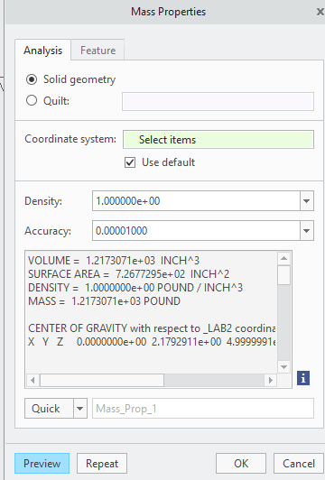
Figure 1 (Above)

