Reducing Accidents Caused by Human Error via Autonomous Automobiles
Report of Findings

Prof. Luke Russell, School of Engineering and Design
TA: Kent Williams, School of Linguistics
Peer Mentor: Robbie Graham, School of Engineering and Design

Daniel Dupuis, School of Engineering and Design
CCDP 2100N, Team 7, Report of Findings Individual
April 4, 2017

1.0 Introduction

Vehicular transport has played a major role in society. From when it was first invented to now it has served to fulfill the need of travel and has advanced tremendously. Though with each new advancement a new risk is posed on society. With the safety features and non-deteriorating materials of the vehicle, the risk is now in human error. Team 7 of CCDP 2100 is looking to eliminate this risk of human error by introducing the technology of autonomous vehicles. This team is comprised of 4 members each focusing on their area of study which includes, route choice in section 2.1 and risk analysis in section 2.2 (Danny Dupuis), satellite location and traffic congestion (Charlene Souliere), distance finding and winter conditions (Jackie Feng), and image recognition and traffic reading (Yuwei Zhang). These features will help explain the benefits of autonomous vehicles and discount any doubts of risks that it may pose on society. All terms in italics will be defined in the glossary and references may be found at the end of the document.

2.0 Summary of Findings

Below are the specific areas of study in which each member will explain their engineering principles that help answer their specific research questions.

2.1. Determining the Best Route to the Destination

Due to the nature of autonomous vehicles, having no human driver, certain problems must be addressed that would otherwise not be problematic with a human driver. One of these issues is getting the vehicle to the desired destination in an efficient manner. To explore this issue sections 2.1.1 and 2.1.2 will look in depth at principles such as graph theory, and real-time data collection, that allow the vehicle not only to create routes but to sort through them and determine the best one.

2.1.1. Graph Theory

How does an autonomous car choose the best route to the destination?

To begin route creation is heavily dependent on graph theory. Graphs are usually made up of vertices and edges, or in the case of autonomous automobiles, road blocks and roads. Each vertex is associated with a specific edge. In the case of auto-motives a vertex can represent a road block, turn, or a building for example. The edges represent roads while a set of vertices and their associated edges create routes, (see Figure 1), [1][2]. An example of how graph theory is used to create routes is seen below.

Fig.1. Routes modelled by a graph [3].

2.1.2. Search Algorithms and Real-time Data Collection

Due to the amount of routes that can be created it is important to have a search algorithm (see Figure 2), that can reduce the found amount. This search algorithm will use a variation of if statements and while loops which is quite common in coding. This code will allow the vehicle to create certain parameters and discount routes that would either take too long or cost more, fuel wise. Many factors can influence a search algorithm; thus it is necessary to have real time data collection that can update the vehicle of any sudden route changes [4].

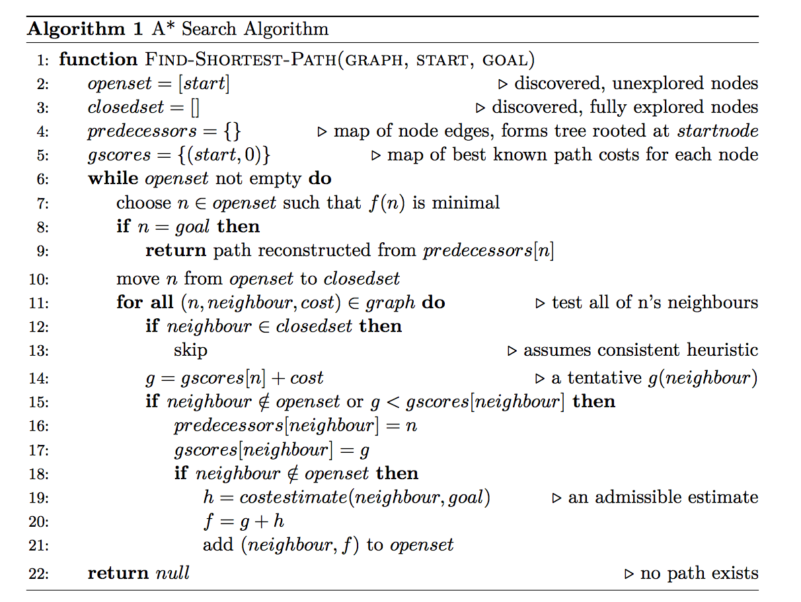
Fig.2. Search Algorithm that determine best route [2].

2.2. Risk Analysis and Prevention

Another issue arises when discussing the risks that an autonomous car will pose on society. Sections 2.2.1 and 2.2.2 will look to explain the different ways an autonomous car will avoid risk and what the vehicle will do when the risk cannot be avoided.

2.2.1. Markov Chains and Monte Carlo Simulation

How does an autonomous vehicle assess risk?

To begin two mathematical options will be explored to determine how the vehicle will first attempt to avoid risk all together. The first mathematical way an autonomous car will assess a situation is something called Markov Chain Abstraction. A Markov chain is an adaptation of the law of big numbers, which states that as the number of experiments increases, the actual ratio of outcomes will converge on the theoretical, or expected, ratio of outcomes [5]. In other words, if we have 30:20 black versus white beads in a jar and the experiment of taking out a bead recording its color and then replacing the bead was repeated often enough the ratio would eventually become 3:2. Markov chains use the idea that choices cannot be made on past instances and only are made upon future probabilities [6]. Figure 3 is an example of a Markov chain that can be used to predict the weather for the next day.

Fig.3. Markov Chain for Weather [7].

This chain will use the weather that it is currently and give the predictions for what the weather will be the next day. For example, if it is rainy it has a 0.5 chance that it will be rainy tomorrow, with a 0.4 chance of being sunny and a 0.1 chance of being cloudy. Note that it does not matter the weather of the day previously.

In terms of autonomous automobiles, the most probable route the vehicle takes will be dependent on the route it is currently on. Figure 3 shows that if the vehicle were to begin in the green square the probability that it stays on that route is very high for there are no obstacles. The probability of it taking a separate route is quite low because there are many obstacles and thus it makes it difficult to maneuver. Therefore, an autonomous vehicle will most likely choose the route with the least number of obstacles to avoid any collisions [6][8].

Fig.4. Possible routes that will be simulated [9].

Monte Carlo Simulation, the second method, is a method of risk probability analysis. A Monte Carlo simulator is given specific parameters to the situation it is faced with. The simulator will then do a series of calculations where it will use different parameters within the given parameters and determine outcomes. Based on the frequency of an outcome, that outcome will be given its probability. The simulator, in relation to automobiles, is used when faced with a situation where an accident is imminent, the simulator will first asses its parameters, what is the car capable of doing in the period of time and the speed its going at, as well as the distance from the crash. These parameters will be very numerous and must be taken account for to produce more accurate results. The simulator will then assign certain routes of action a random number and then asses the outcome. Based on these outcomes the one with the highest frequency that does not result in a crash will be taken. It is important to note that these determinations are mere estimates because none of these outcomes can be known for certain, yet with the greater amount of trails done the more accurate the determination is [6].

2.2.2. Utilitarianism

To conclude, the ethics of autonomous vehicles must be explored. An incident could arise whereby there is no avoidance of a crash despite Markov chain and the Monte Carlo Simulator. It is important to note that with the use of autonomous vehicles the number of accidents will reduce tremendously. Yet in the case where there is no alternative, people must make a choice to insert into their autonomous vehicles brain. In a technical document discussing the ethics of autonomous vehicles it was suggested that the future will have utilitarian cars [10]. Utilitarianism can be visualized by the famous trolley problem in which a train is on a track headed to kill 5 people yet someone is near a switch that can divert the train to miss the 5 people and in turn only kills one person. The large question being do we allow nature to take its path or do we in essence play “God” and decide who lives and dies. Most people chose the latter, saying that it is in the best interest of humanity to save the greatest amount of lives [11]. This will now leave into question where does the liability fall. Different companies have suggested that the liability will fall with the manufacturer but some companies such as Tesla, require you to choose the settings in which your car will act in this situation thus the liability would fall on yourself. This problem will always be controversial but it needs to be noted that autonomous vehicles will reduce accidents by almost 90%. These situations must be accepted in order for a greater outcome [8][9].
Glossary

Graph Theory - A theory proposed by Leonhard Euler which states that graphs are made up of vertices and edges which represent and route like significance in the world of automobiles [1]

If statement – A type of code that allows for certain parameters to be set and to discount non
desirable out comes. For example, ‘if’ the route ends in a collision, then discount it [12]

Markov Chain Abstraction – A mathematical way of determining the safest route, using present and future parameters to determine probabilities to future routes [6]

Monte Carlo Simulation – A mathematical way of determining safest route by inputting certain parameters into a simulation and returning probable outcomes based on frequency of outcome [6]

Real-Time Data Collection - A system in which autonomous vehicles will receive live updates of its surroundings and future route choices [4]

Search Algorithm – A computer code that uses if statements and while loops to sort routes and determine the best one based off of given parameters [2]

Set – Group of (x,y) coordinates that create a route. The ‘x’ and the ‘y’ would be representative of road blocks, or buildings etc. [1]

Utilitarianism – A theory that explains that the greatest good for the greatest amount of people outweighs that of the minority [11]

While Loops – A type of coding that allows for if statements to repeat until completion. For example, it allows the if statement to keep discounting routes until the best route is found [12]

[1] P. Van Dooren, "Graph Theory and its Applications", 2009. [Online]. Available: http://www.hamilton.ie/ollie/Downloads/Graph.pdf. [Accessed: 04- Apr- 2017].

[2] J. Cracknell, "Simulating and Optimizing a Delivery Network of Autonomous Courier Agents", 2015. [Online]. Available: http://www.doc.ic.ac.uk/teaching/distinguished-projects/2015/j.cracknell.pdf. [Accessed: 04- Apr- 2017].

[3] Geographic Information Systems, Graph Theory Example,2017.

[4] P. Lubell-Doughtie, P. Pokharel, M. Johnston and V. Modi, "Improving Data Collection and Monitoring through Real-Time Data Analysis", 2013. [Online]. Available: http://qsel.columbia.edu/assets/uploads/blog/2014/02/dev13posters-final25.pdf. [Accessed: 04- Apr- 2017].

[5] G. H. Hardy, D. R. Heath-Brown, and E. M. Wright, An introduction to the theory of numbers, 5th ed. Oxford: Oxford Univ. Press, 1979.

[6] M. Althoff and A. Mergel, "Comparison of Markov chain abstraction and Monte Carlo
simulation for the safety assessment of autonomous cars - IEEE Xplore document,"
in IEEEexplore.ieee.org, 2011. [Online]. Available:
http://ieeexplore.ieee.org/abstract/document/5875884/. Accessed: Feb. 6, 2017.

[7] proft.me, Markov Chain for Weather. 2014.

[8] H. Milger and S. Gillgreen, “Simulation of autonomous vehicles in an urban environment,” diva-portal.org, 29-May-2015. [Online]. Available: http://www.diva-portal.org/smash/get/diva2:815681/FULLTEXT01.pdf. [Accessed: 14-Mar-2017].

[9] Wolfram, Monte Carlo Simulation, 2017.

[10] J.-F. C. B. Bonnefon, A. Shariff, and I. Rahwan, “Autonomous Vehicles Need Experimental Ethics: Are We Ready for Utilitarian Cars?,” semanticsscholar.org, 13-Oct-2015. [Online]. Available: https://pdfs.semanticscholar.org/13d4/56d4c53d7b03b90ba59845a8f61b23b9f6e8.pdf. [Accessed: 14-Mar-2017].

[11] J. J. Thomson, The Trolley Problem, vol. 94. Yale Law Journal Company, 2008.

[12] "If Statements, Loops and Recursion – OCaml", Ocaml.org, 2017. [Online]. Available: https://ocaml.org/learn/tutorials/if_statements_loops_and_recursion.html. [Accessed: 04- Apr- 2017].

