Criminal Law Final Exam Study Notes:
How Do Judges Decide?
Discretion
- May result in non-legal factors impacting decision-making
- May contribute to sentence disparity
- Political party, religion & gender influence decision-making
- Limits of discretion:
  - Criminal Code maximums
  - Decisions in similar cases
Statutory Guidance
- Included in Criminal Code, Controlled Drugs and Substances Act
- Maximum sentences are specified
- Some mandatory minimum sentences
  - E.g. Murder, using a firearm
Mandatory Minimum Sentences (MMS)
- Support for:
  - General and specific deterrent
  - Prevents crime by removing offenders from the community
  - Symbolic denunciation for certain behaviors
  - Reduces sentencing disparity
- Against:
  - Little or no deterrent value
  - Limit judicial discretion
  - Significant cost implications
  - May lead to unfair sentencing practices
MMS & Research Evidence
- Modest effect on crime prevention
- No effect on drug consumption or drug-related crime
- No effect in reducing sentencing disparity
- Increased costs:
  - Increase in guilty pleas
  - Increase in prison populations
- MMS – lack of evidence:
  - Essentially – a political Initiative
Appeal Court Function
- Limits judicial discretion if sentence too lenient/severe
- Set guidelines to assist trial court judges
- General ‘measure of acceptability’ of trial court judge decisions determined by:
  - Reviewing judicial precedents & decisions of appeal court judges
Appeals and Legal Precedents
- Appellate courts determine if deviation from norm is warranted by reviewing:
- Aggravating factors
  - Child or spousal abuse, abuse of trust
  - Priors, premeditation
  - Force, injury, vulnerability of victim, value of goods
- Mitigating factors
  - Situation, provocation, need
  - Psychological problems, addictions, victim of abuse,
  - Aboriginal status
Sentencing Aboriginal Offenders
- S. 718.2(e)
  - SCC reaffirmed in R v. Gladue (1999)
  - Reduce Aboriginal overrepresentation in correctional institutions
  - Appears s. 718.2(e) has not achieved this goal
    - Offence seriousness, prior criminal record, and the offender’s plea are the primary determinants in sentencing Aboriginals
Other Factors
- Pre-sentence reports
  - Socio-biographical & offence-specific information
  - Suitability of sentencing options
  - PSR increases likelihood of community sentence rather than custodial sentence
- Plea Bargains
  - May result in dropping of charges, conviction on a less serious charge, joint submission for sentence by defense and Crown
Sentencing in Youth Court
- Serious offenders
  - Intensive custody and supervision for high risk youth
    - Treatment plans
  - Adult sentences
    - For serious offences
    - For repeat violent offenders
    - Publication of name
- Victim impact statements
- Less serious
  - Use community-based options
Additional Sentencing Options
- Prohibitions
  - Stay away from children
  - No possession of firearms
  - No driving
- Forfeitures
  - Counterfeit money, narcotics, weapons, hate propaganda
- Proceeds of crime
  - Government can seize accumulated money, property or goods acquired from criminal activity
Extraordinary Measures
- Dangerous Offender
  - Indeterminate sentence
  - Pattern of violent behavior
  - Likelihood of serious harm in future
  - Prison and/or supervision for life
  - Application by Crown post-conviction, pre-sentence
- Long-Term Offender
  - Applicable to only federal offenders
  - Extends supervision order after expiry of sentence
  - Easier to obtain than DO
  - Administered by National Parole Board
Sentencing and Crime Victims
- Victim impact statements
  - May be read in court
  - Can’t ask for specific sentence
- Victim Fine Surcharge
  - 15% of fine or maximum $10,000 if no fine imposed
  - Used to fund victim services
- Victim-offender mediation
  - Conciliation agreement included in the probation order
Sentencing and Restorative Justice
Circle Sentencing
- Uses traditional Aboriginal healing practices
- Focus on reconciliation, restitution, reparation
- Circle may include judge, lawyers, police, victim, offender, members of community
- Offender must acknowledge responsibility
- Variety of sentencing options
- Process more important than sentence
- May be effective in reducing and eliminating criminal & disruptive behaviour
- Process not appropriate with all offences or all offenders
- Concern with use in cases involving:
  - serious offences
  - domestic violence
    - Pressure to participate?
- Most successful when participants believe in restorative justice principles
Measuring the Effectiveness of Sentencing Options
Reasons for Difficulty in Measuring
- Court can’t control the actual implementation of the sentence
- Hard to match sentencing options with offender needs (and the risks they pose)
- Studies of impact of sanctions are inconclusive
CHAPTER 9: alternatives to confinement
Alternatives to Confinement
- The majority of offenders are sentenced to supervision in the community
- Use driven by:
  - Escalating costs of incarceration
  - Questionable effectiveness of incarceration as a specific & general deterrent
  - Ability to target resources to higher-risk offenders in prison
Community Corrections
- Difference between alternatives to confinement & strategies post-incarceration
- Term does not imply community participation & support
- Offenders do not view imprisonment as most severe sanction
- Lack of Canadian research on effectiveness of alternatives
Diversion
- Pre-charge, post-charge & post-sentence diversion programs
- Objectives:
  - Avoid further processing in the CJS
  - Avoid negative labelling & stigmatization
  - Reduce the costs of criminal justice
  - Provide services
- Concerns:
  - Potential for net-widening
  - “Choice” in participation
Diversion Programs
- Most require:
  - Offenders accept responsibility
  - Follow certain conditions
- Directed at specific offender groups
- Few formal Canadian evaluations
  - No evidence:
    - that diversion impacts recidivism or correctional populations
    - demonstrating which offenders benefit most from diversion
Probation
- Most widely used alternative
  - 45% of all sentences
- Falls under provincial/territorial jurisdiction
- May be used alone, or following imprisonment
- Only federal offenders sentenced to exactly two years may be given probation
- Average length
  - 15 months
- Maximum terms
  - Three years adult
  - Two years youth
Conditions of Probation
- Objective: to keep the offender from reoffending
- Mandatory conditions
  - For all probationers
- Additional conditions
  - To meet specific needs of offender
- Breach of probation
  - Hybrid offence
Probation
Probation Officers
- Assess client needs & risks
- Provide individualized case management
  - Objective: reduce criminal behavior
- Supervise offenders on probation and those on bail
- Up to 2/3rds of time spent writing Pre-Sentence Reports (PSR)
Case Management & Supervision
- Identify offender risk & needs determine appropriate level of supervision
- Positive relationship with probationer
- Consistency in supervision
- Shift toward control and surveillance:
  - ⇧ caseloads
  - ⇧ # of special categories
  - Focus on risk assessment:
    - ⇧ accountability
    - ⇩ liability
The ‘Dual Role’ of Probation Officers
- Assistance & support for offenders
  - Assist with addressing issues related to criminal behavior
  - Identify community resources
- Enforcing the conditions of the probation order
  - Ensure compliance
  - Greater concern with enforcement in recent years
Obstacles to Effective Probation
- Increasing:
  - Workloads
  - Caseloads
  - Populations of special categories of offenders
- Funding cutbacks & lack of resources
- Probation officer stress & burnout
Effectiveness of Probation
- Effectiveness is still questioned despite use
- Few evaluations of specific programs
- Offender surveys indicate probation is viewed as:
  - A deterrent ;
  - Rehabilitative rather than punitive; and
  - that specialized supervision can increase accountability & reduce recidivism
Improving Probation
- Supervision in the community
- Supervision 24/7/365
- Strict enforcement of probation conditions
- Address client needs & issues
- Develop community partnerships for treatment & services
- Performance-based indicators to assess effectiveness
- Build in restorative justice approaches to supervision
Intermediate Sanctions
- Alternative sanctions or community sanctions
- Objectives
  - Offender-specific: assurance of real punishment, retribution, and some degree of incapacitation and control of offenders
  - System-oriented: include reducing institutional populations, system costs & recidivism rates
Intensive Supervision Probation
- Reduced caseloads
- Increased surveillance
- Rigorous conditions
- Premises:
  - Reduce prison admissions & operational costs
  - Protect the public
  - Increase supervision
Conditional Sentences I
- Serve sentence in community rather than prison – when convicted & sentenced to less than 2 years
- Required to fulfil certain conditions
- Objective:
  - An alternative to imprisonment
- Eligibility: a.) risk of recidivism & b.) harm if re-offence was to occur
Conditional Sentence II
- Non-compliance with conditions
  - Reverse onus on accused when returned to court
  - Can result in offender being incarcerated
- Different objectives than probation
  - Probation: rehabilitation
  - Conditional sentence: punitive justice AND rehabilitation
    - Stricter conditions
Conditional Sentence III
- Steady increase in use
  - Regional variation in usage
- Increasing length and severity of conditions
- Used to reduce imprisonment
  - Require community resources
- Controversial
  - Supported by courts
  - Misunderstood and disliked by public
Electronic Monitoring I
- Used in many provinces
  - Offenders under sentence in community
  - Offenders on parole
- Objectives:
  - Alternative to imprisonment
  - Reduce operating costs of corrections
  - Promote employment & community ties
- Passive & Active EM programs – can only verify offender location
  - Future: use of GPS for ‘real-time’ information tracking offender’s movement
Electronic Monitoring II
- Not widely used in Canada
- Criticisms:
  - Potential for net-widening
  - Privacy issues
  - Impact on offenders’ families
  - Cannot prevent reoffending
  - Use of GPS: legal & ethical issues
- Mixed results
  - No evidence it reduces prison admissions
  - May off-set costs of incarceration
  - May reduce the likelihood of recidivism
CHAPTER 10: Correctional institutions
Corrections in Canada
- Incarceration rate
  - 116 per 100,000
    - Includes conditional sentences
- Costs $3B per year
  - Only 5% of convicted offenders are incarcerated
    - Nearly 75% of corrections budget
  - 95% in the community
    - 13% of corrections budget
- Almost all will return to the community
History
- Prior to 1867
  - Many public punishments
  - Local jails and workhouses
- First penitentiary
  - Kingston Ontario (1835)
  - Labor, silence, rules (Auburn system)
  - Separation: gender & offence
Structure of Institutional Corrections
- Custodial
  - About 20% of correctional population
- Non-custodial
  - Bail supervision, probation, temporary absences, parole, statutory release
- Responsibility
  - Shared by federal, provincial and municipal governments
  - Two-year rule
Provincial/Territorial Corrections
- Who?
  - Serving less than 2 years, on remand, awaiting trial, awaiting transfer, serving short sentences
- What?
  - Jails, correctional centres, detention centres, reformatories, specialized treatment facilities
  - All security levels
- Inmates
  - Increase in the risk of offenders being admitted, more mental health and substance abuse issues, and increasing rates of infectious diseases
Federal Corrections
- Minimum security
  - Unrestricted movement during day, generally no fencing
- Medium security
  - Perimeter fencing, more freedom than maximum
- Maximum security
  - Video surveillance, fencing, restricted movement
- Special handling units
  - High level of risk to staff & inmates
- Regional health centers
  - Violent offenders
- Multi-level units
  - Several security levels in one institution
Federal Corrections
- Female offenders
  - Kingston P4W closed 2000
  - Replaced with several smaller, regional prisons
  - Some are housed in sections of men’s prisons
- Aboriginal offenders
  - Pe Sakastew
    - Minimum security, Alberta
  - Aboriginal Men’s Healing Lodge
    - Saskatchewan
  - Okimaw Ohci Healing Lodge
    - For women
Who Goes to Federal Institutions?
- Gender
  - Typically male
    - Females make up less than 10% of provincial/territorial inmates & about 5% of federal admissions
- Age
  - Generally in their 30s
  - Average age in federal system, increasing
    - Over age 50 population increasing
- Offence History
  - Most for property offences but higher percentage for violent offences within federal system
- Marital status
  - Single
- Mental impairments
- Parents
  - About 60% males
  - Nearly 70% females
- Marginally skilled
  - Low-education
  - Unemployed
- Disproportionately Aboriginal
  - Exceptionally high for Aboriginal women
- Disproportionately black
  - 002% of general population
    - 7% of male and female federal inmate populations
- Substance-addicted
  - Drugs and/or alcohol use at time of offence
Women in Federal Prisons
- Less than 5% of federal prison population
- Mental Health Diagnosis
  - About 30% previous psychiatric hospitalization
- 70% incarcerated for violence or murder
  - Higher rates of violence among Aboriginal women
- Marginalized Social Group
  - Poverty, a history of abuse, childcare responsibilities, limited education, poor employment opportunities, substance abuse issues
Prison Life
- Total institutions (Goffman)
  - Cut off from broader society
  - Under constant control and surveillance
  - Control varies with level of security
  - Split personality of corrections, conflicting institutional goals:
    - Confinement and control
    - Reform and rehabilitation
- Citizen Advisory Committees
  - Federal prisons
  - Volunteers provide input into policies and programs
  - Independent observers of day-to-day activities of the CSC
  - Community liaisons
Managing Correctional Institutions
Warden
- Factors outside the control of the warden
  - Sentencing patterns
  - Placement decisions
  - Changing legislation
    - Increased duration of sentences
    - Less funding
Communicable Diseases
- HIV/AIDS, hepatitis B and C, Tuberculosis
  - Much higher rates than general public
- Spread through anal intercourse, intravenous drug use, sharing of contaminated syringes and needles
- CSC initiatives
  - Methadone programs, condoms, bleach kits,
Correctional Officers
- Low prestige, poor pay, limited training (varies with institution and region)
- Prisons use static security but also rely heavily on dynamic security
- More punitive than administrators and treatment staff
- Learn how to get along with inmates without being “taken in”
- Direct versus indirect supervision models
Challenges of being a Correctional Officer
- Occupational stress
  - Safety concerns
  - Inadequate training
  - Shift work
  - Unrealistic and/or vague administrative policies
  - Female officers:
    - Psychological and sexual harassment
  - Generally: most officers develop effective coping strategies
Doing Time
- Status degradation ceremony
  - Psychologically and materially stripping offender of real-world possessions
  - Replaced with prison identification, clothes, rules & regulations
- Inmate code
  - Do your own time, don’t rat on anyone, don’t trust anyone, don’t whine, don’t be a sucker
- Inmate solidarity
  - Declining, much exploitation and manipulation
- Violence and victimization
  - Increasing; group formation may result
    - Lifers, ethnic identity, gang membership
  - Suicide is most common cause of death
  - Incarcerated suicide rate is higher than general population
  - Females engage in self-injurious behaviors
    - Self-mutilation
    - Slashing
- Prisonization
  - Socialization into prison culture
- Pains of imprisonment
  - the loss of security, autonomy, contact with family and friends, and independence to move freely
  - Spouses, relatives & friends may experience pains of imprisonment too
- Institutionalization:
  - Offenders are unwilling or unable to function in the outside world
Assessing Inmate Risk and Need
Classification
- Objective
  - To place inmate in appropriate setting
    - Take into account needs & risks of individual and protection of society
- Psychological, personality and behavioral inventories
  - Vary with jurisdiction
  - Federal inmates: Offender Intake Assessment and Custody Rating Scale
Risk/Needs Profile
- Risk analysis
  - Facility to be confined in
  - Support & Intervention needs
  - Needs upon release
  - Release decisions
  - Public concerns about release
- Static factors
  - Can’t be changed
    - Inmate history
    - Nature of the offence
- Dynamic factors
  - May be altered through intervention
    - Education
    - Cognitive skills
Case Management
- Matching offender risks and needs with services and resources
- Correctional plan
  - Determines initial placement, training and work, conditions of release
  - May use assessment tools to assess risk, identify treatment requirements, readiness for lower security level
  - Used primarily at federal level
Institutional Treatment Programs
- Education
  - All levels
  - Inmates pay for post-secondary
- Living skills
  - Anger management, parenting
- Cognitive skills
  - Problem-solving
- Substance abuse
  - Education and treatment
- Sex offender
  - Identify triggers, skills to control
- Family violence
  - Information and skills to alter behavior
Treating Special Offender Groups
- Sex offenders
  - Are very difficult to treat, especially pedophiles
  - Deny or minimize the behavior: blame victim
  - Strategies to manage & control deviant impulses
- Women
  - Smaller regional centers, focus on history of abuse, drug problems, parenting skills
- Aboriginal offenders
  - Culturally-appropriate treatment programs
    - “Sweat lodges”, wilderness camps
- Mentally Ill Offenders
  - Federal: approximately 12%
  - Provincial/territorial: approximately 25%
- Inmates with mental health issues, not having needs met:
  - ‘the new asylums?’
Effectiveness of Treatment Programs
- Recidivism rates
  - Based on being returned to prison for technical violation or new offence
- Criticisms
  - No recognition of relative improvement
  - How long behavior should be monitored?
  - Based on getting caught not actual behavior
  - Based on level and style of supervision
  - What outside factors are involved in reducing recidivism? Family, employment, etc.
- Few Canadian evaluation studies
  - Findings are not consistent
  - Push for “best practices” approach
- Principles to increase success
  - Match treatment to risk of offender
  - Relate treatment to offender’s needs
  - Relate treatment to offender responsivity
  - Use professional discretion
  - Respect the original design of the program
Obstacles to Treatment in Correctional Institutions
- Total institution
  - Not like the real world
- Post-release behavior is hard to predict
  - Hard to predict based on behavior inside prison
- Many inmates are marginal
  - Few life skills, many educational and intellectual deficits
- Attitudes and behavior are hard to change
  - Few supports for change
- Needs must be matched with specific treatment
  - Differential treatment effectiveness
- Short length of incarceration
  - Majority 3 months or less in prison
  - Difficulty addressing treatment needs
Program Fidelity
- Program must be implemented as designed
  - Program manual
  - Staff training and supervision
- Hindered by
  - Stress levels of treatment staff
  - Isolated and poorly designed facilities
  - Participant transfers, work orientations of staff, lack of resources
Accountability in Corrections
- Inmate complaints
  - Dealt with at provincial and federal level
- Common complaints
  - Overcrowding, double-bunking, living conditions, health care, grievance procedures, involuntary transfers
- Increasing involvement of external investigators
- Rights of inmates protected by Charter
  - With certain limitations
- Supreme Court decisions relevant for inmates in recent years:
  - Right to vote
  - Right to have counsel present at disciplinary hearings
  - Double-bunking & compulsory urinalysis have not been found to violate rights
How Effective is Incarceration?
- Not an effective individual deterrent
  - Except for high-risk, violent offenders
- Not an effective general deterrent
- Treatment approaches more effective than punishment approaches in reducing reoffending
- Community programs have higher success-rates than institutional programs
- US research: community supervision more harsh than prison extensive behavioural conditions, strict levels of supervision & discretionary decision making of community supervisors
Throughcare I
- Ensuring continuity of treatment interventions from institution to community on release
  - Challenge
- Obstacles to treatment-continuity:
  - Absence of resources
  - Lack of communication between institutional and community-based counterparts
  - Loss of participation eligibility at WED
Throughcare II
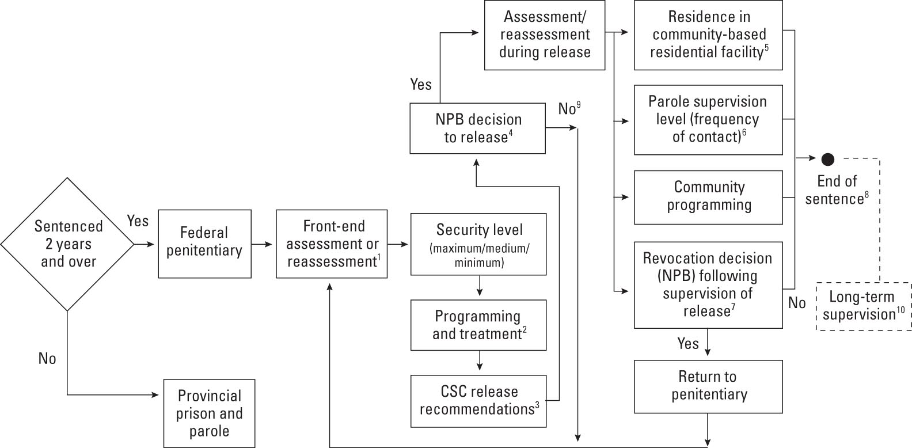

CHAPTER 11: Release and Re-entry
Conditional Release
- Means of leaving a correctional institution before end of sentence
  - Includes conditions to be followed
  - May be revoked if violated
- Parole
  - Type of conditional release
Parole Process
- Release plan
  - Staff assist in developing a plan for housing, job, community-based support
  - Requires a community assessment to determine feasibility of plan and availability of resources
    - Supplemented with background reports
  - police, victim, correctional staff, court records
  - Submitted to parole board for decision
Corrections and Conditional Release Act
- Purpose
  - To contribute to the maintenance of a just, peaceful and safe society through decisions on the timing and conditions of release that will facilitate the rehabilitation of offenders and their reintegration into the community as law-abiding citizens
- Principles
  - Protection of society
  - Consideration of all available information
    - Least restrictive option to ensure protection of society
    - Not likely to re-offend or provide risk to society OR
    - Risk can be managed through specific interventions
      - Release will facilitate reintegration
Types of Conditional Release
- Temporary absence
  - E.g. to attend funeral
  - May involve monitoring, escort
  - Granted by institution
- Day parole
  - For work, education
  - Must complete at least 1/6th of sentence
  - Granted by parole board
- Full parole
  - Must complete at least 1/3rd of sentence
  - Granted by parole board
- Statutory release
  - Normally granted at 2/3rd of sentence
  - Granted by Correctional Service of Canada
  - Only applicable to federally-incarcerated inmates
Cold-turkey Release
- Inmates are released with no conditions or supervision
  - Provincial Inmates
    - Release at two-thirds point of sentence
      - “Probable Discharge Date” or “Release Date with Remission”
- Federal Inmates
  - Release at Warrant Expiry Date
Probation versus Parole
- Probation
  - Ordered by judge
  - Part of sentence
  - Maximum 3 years
  - May replace or follow prison term
    - Can follow parole
  - Non-compliance may lead to new charges and trial
- Parole
  - Granted by parole board
  - Applies only to those in prison
  - Length depends on sentence and timing of release
  - May be revoked for violations
  - Conditions easier to enforce
Parole Boards
- Provincial parole boards
  - Quebec and Ontario
  - Deal with provincial offenders and federal offenders serving time in provincial institutions
- National Parole Board
  - Division of Public Safety and Emergency Preparedness
  - 5 regional offices
  - Meets with federal inmate applicants
  - Deals with provincial inmates in provinces without parole boards
Provincial/Territorial Release Options
Temporary Absence
- Used for
  - Medical
  - Humanitarian; and
  - Rehabilitative reasons
    - Stay in community residential agency
- Use varies by province
- Benefits: reduces prison overcrowding & beneficial for offenders to be in community setting
Provincial Parole
- May apply for full parole after serving 1/3rd of sentence
- Heard by provincial board in QC and ON or NPB elsewhere
- Supervised by provincial probation officers or CSC parole officers
- Grant rate increasing in ON – just under 40% now, previous years in the 20% range
Discharge
- Remission
  - “Time off for good behavior”
    - No institutional misconduct
    - Up to 1/3rd of sentence off
- Not supervised
- May occur by default
- Must be “earned” in Ontario
Timeline for Provincial Parole: 18 month sentence
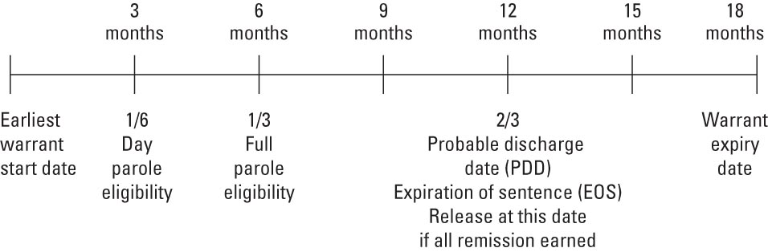

Federal Release Options
Temporary Absence
- Earliest release
- Escorted (ETAs) or unescorted (UTAs)
- Medical treatment, family contact, counseling, etc.
- UTAs not available to maximum security inmates
- Eligibility for ETAs at any point of sentence
- Eligibility for UTAs depends on length of sentence
Parole
- Day parole
  - Non-violent offender eligibility is usually 1/6th of sentence or 6 months prior to full parole eligibility
    - Whichever is longer
- Usually live in community residential facility
- Used to prepare for full parole
- Does not usually exceed 6 months
- Full parole
  - Usually may apply after 1/3rd of sentence (or 7 years)
    - Whichever is less
- About 45% are approved
- Most serve 40% of sentence
- More females get full parole
- Aboriginals serve longer before release
The end of Accelerated Parole Review
- Existed prior to 2009
  - Part of federal conservative government’s approach to “safety and security” in criminal justice
- Eligibility
  - First time federal offender
  - Not serving life sentence and not convicted of serious violent or drug offence
  - Parole was not set at one-half of sentence
Statutory Release
- For offenders who haven’t been paroled
- Must have served 2/3rds of sentence
- Administrative decision by CSC
- Supervised until sentence expires
- May be denied in unusual circumstances – recommended by CSC
  - Detention or one-chance statutory release
Conditional Release Eligibility Dates for Federal Offenders
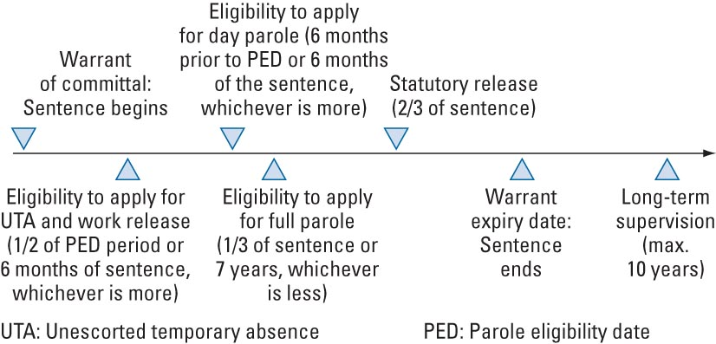

Judicial Review
- S. 745 of Criminal Code: “Faint hope” clause
- Reduction of parole eligibility to
  - Encourage rehabilitation and cooperation
  - Allow non-dangerous offenders to be productive citizens
  - Deal with elderly offenders
- Must serve at least 15 years
- Not available to multiple murderers
- Few apply, most applications succeed, low recidivism
Lifers” and Parole
- First degree murder
  - May apply after 25 years
- Second degree
  - 10-25 years: if no previous culpable homicide conviction (25 years if previous conviction)
  - Determined by judge at sentencing
- Other offences
  - 7 years
- Not eligible for statutory release
Other Offenders
- Long-term Offenders
  - Up to 10 years of extra supervision
  - Attached to end of sentence (WED)
  - Violations may result in further incarceration
- Dangerous Offenders
  - Indeterminate sentence
  - Mostly sex offenders
  - Not eligible for Statutory Release
  - Rarely released
Victims and Conditional Release
- Victims may
  - Be kept informed
    - Eligibility dates
  - Release status
  - Provide impact statements
  - Attend parole hearings
  - Receive written copies of NPB decisions
  - Address parole board in some provinces, except Que
Re-entry
Concern for Victims
- Often lack information despite victims’ rights initiatives
- Unaware of conditional release criteria
  - Least restrictive determination
  - Decisions rest most on whether offender is likely to reoffend before WED
- Unaware of sentence duration:
  - Most common is less than one month for provincial/territorial offenders
  - For federal offenders, less than 3 years
Parole Board Decision Making
- Parole hearing
  - Inmate is interviewed, may be accompanied
- If denied
  - Reasons for denial are in writing
- If granted
  - Certificate of parole is prepared
  - Includes mandatory and special conditions
- Criticisms
  - Parole board members may not have expertise or be adequately trained
  - No clear criteria for release
  - No feedback to parole board about outcomes of their decisions
Social Reintegration
- Process rather than event
- Federal offenders: begins with participation in institutional treatment programming, continues with release plan development
- Goal: prevent recidivism prior to WED, and ideally, in the long-term
Pains of Re-entry
- Prison
  - slow, structured, few choices or responsibilities
- Outside
  - Fast-paced, complex, many choices and obligations
- Problems
  - Employment, family reunification, housing, friends, substance abuse issues
Re-entry Courts
- U.S. states
- Collaboration between justice & social service personnel
  - Assist offenders in addressing challenges of reintegration
- Preliminary evidence: courts can be effective if sufficient resources are provided
Special Populations
- Female offenders
  - More health needs, problems with employment, custody of children, lack of affordable housing
- Sex offenders
  - Risk-management issues
- Mentally Ill Offenders
  - Lack of housing & support services
- Aboriginal offenders
Aboriginal Offenders
- Fewer personal and community resources
- Lack understanding of parole process
- Cultural insensitivity at hearings
- Solutions:
  - S. 81 of CCRA, 1992
  - Elder-assisted hearings
  - Cultural-awareness training
  - Active recruiting of Aboriginal board members
Parole Supervision
- Intensity varies by case
  - May include public or private facilities, halfway houses
  - Most live with own family
- Parole officers
  - Act as confidant and resource person, as well as enforcer (surveillance focus)
    - Recently: shift towards surveillance approach
  - Concerns about training
Community-based Programs
- Most effective: premised on principles of effective treatment programming:
  - The risk principle
  - The needs principle
    - Cognitive behavioural treatment approach
  - The responsively principle
Innovations in Parole Supervision
- Circles of support
  - Volunteers make covenant with individual high risk sex offenders upon their WED
- Life line concept
  - In-reach workers employed by private agencies
  - Visit jailed offenders, assist with plans and resources, mediate with community
  - In-reach, community resources, and public education
- Judicial recognizance for sex offenders
  - Provides court-ordered conditions after expiry of sentence
    - E.g. Stay away from children, playgrounds
  - Consequences for refusing & for violations
- Intensive supervision program
  - History of violence
  - High-risk offenders, usually on statutory release
  - Public safety: extra supervision, access to resources and services
Community Notification
- Public announcement of release of sex offender into the community
- Policies vary by jurisdiction
  - Concerns about liability
  - Decision made by committee
  - Rights of the community versus rights to offenders’ privacy
Other Provisions
- Long-term offender designation
  - Up to 10 years additional supervision
- Judicial Recognizance
  - Section 810 of Criminal Code
  - For offenders who serve entire sentence in custody
  - Pose a risk to children under 14
  - Court imposes restrictions on those at risk to commit a violent offence
Recidivism
- Day parole and full parole
  - Most complete successfully: “silent majority”
  - Most failures result from breach of conditions
  - Very few new violent offences
- Statutory release
  - Fewer complete successfully
  - 2% had new violent offences
- Significant regional variation in success rates
- Difficulties in tracking cases
Measuring Recidivism
- NPB Performance Indicators
  - Outcomes of conditional release
  - Convictions for violent offences
  - Post-warrant expiry recidivism
- CSC Repeat Offenders
  - Return to federal institution within two years of release
  - Criticisms:
    - No consideration for post two-years after release
    - No consideration for re-admittance to provincial institutions
Factors in Recidivism
- Antisocial values, attitudes and friends
- Interpersonal conflict
- Lack of education, job
- Substance abuse
- Prior convictions
- Previous parole failure
- Sex offenders are more likely to recidivate
Factors in Reducing Recidivism
- Vocational and/or employment programs
- Stable housing
- US research evidence:
  - Long-term residential community treatment programs
    - High-risk, drug-addicted offenders
Suspension of Parole
- For new offence or violation of conditions
  - Parolee is jailed & assessed by parole board
  - May result in cancellation of the suspension, or revocation or termination of the release
- Federal system
  - May also issue a reprimand and cancel the suspension, or cancel the suspension but with a delay in its taking effect (for up to 30 days)
- Most (90%) are for technical violation
  - Does not mean these offenders did not commit a new offence
Does Parole Work?
- Little research in Canada
- US, UK & Australia findings:
  - Parole supervision:
  - May extend time offence-free in community
  - Does not improve public safety
  - Does not reduce rates of reoffending among violent and property offenders
- Lack of effectiveness due to:
  - Heavy caseloads, inconsistent supervision, surveillance-oriented approach
Accountability
- CSC report:
  - 1/3rd of offenders required by NPB to reside in halfway houses upon statutory release, escaped from these facilities
  - Often committed new offences, many violent
- Accountability
  - Many civil suits settled out of court, responsibility not assigned & little insight into how to avoid future incidents

