Security Architecture:

- Architecture is the fundamental organization of a system embodied in its components and the principles guiding its design and evolution.
  - Architectural Description: collection of document types to convey an architecture in a formal manner
  - Stakeholder: individuals, teams, and departments, including groups outside the organization with interests to a system
  - View: The representation of the system from the perspective of a stakeholder
  - Viewpoint: template used to develop individual views that establish the audience, techniques, and assumptions made
- Architecture focuses on what you need to have, while Design focuses on how you do it
- Computer Architecture:
  - 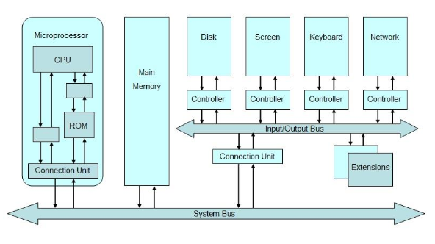
- CPU Architecture (structure view):
- 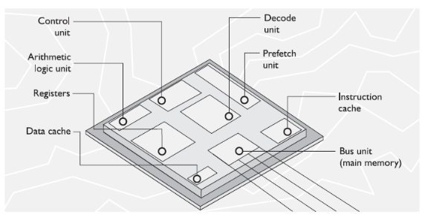
- The program status word register holds different condition bits. One of the bits indicates whether the CPU should be working in user mode (known as problem state) or privileged mode (known as kernel/supervisor mode)
- CPU Architecture (security view):
  - Windows commonly uses only rings 0 and 3 and doesn’t use rings 1 or 2. The vendor of the CPU determines the number of available rings and the vendor of the OS determines how it uses these rings.
- 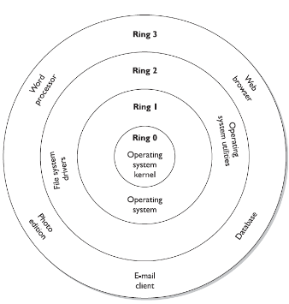
- Operating system architectures:
- 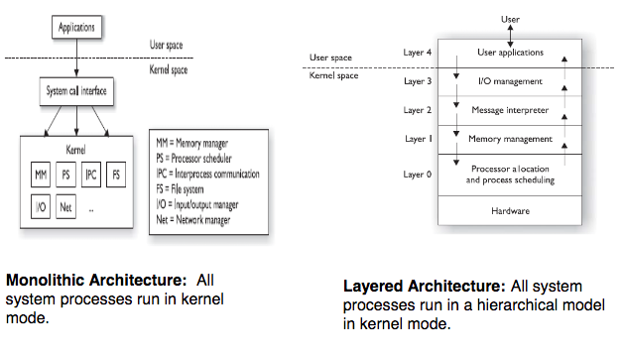
  - Microkernel architecture: Core operating system processes run in kernel mode and the remaining ones run in user mode
  - Hybrid microkernel architecture: all operating system processes run in kernel mode. Core processes run within a microkernel and others run in a client / server model
  - Virtual machine architecture: virtual machines can be used to provide secure, isolated sandboxes
- The patch-in approach has been proven to be ineffective, costly, and unreliable. Patches can introduce new vulnerabilities into the system and fixing security bugs is more expensive.
- Security goals have to be defined before the architecture of a system is created.
- Security Architecture Requirements and Specification:
  - Security Policy: represents the objectives a system must meet to be deemed secure.
    - Security policy provides the baseline for evaluating a system after it is built.
    - Example of security policy statements:
      - DAC based operating system
      - Provides auditing capabilities
      - Provides RBAC functionality
      - Enforces integrity rules on critical files
- Information security model maps the abstract goals of the policy to information system terms by specifying explicit data structures and techniques necessary to enforce the security policy. A security model is usually represented in mathematics and analytical ideas
  - State machine models
  - Bell-LaPadula Model
  - Biba Model
  - Clark-Wilson Model
  - Noninterference Model
  - Chinese Wall Model
- Security Policy provides the abstract goals, and the security model provides the do’s and don’t’s necessary to fulfill these goals. Security model is the design of a security policy.

- State Machine model:
  - all current permissions and all current instances of subjects accessing objects must be captured
  - Security policy: The system must stay in a secure state in each and every instance of its existence
- Bell-LaPadula Model:
  - Bell-LaPadula Model was developed by U.S. military to address the concerns of leakage of classified information.
  - Bell-LaPadula was the first mathematical model of a multilevel security policy used to define the concepts of a security state and outlines rules of access
    - Simple security rule: subject cannot read data located a higher security level than that possessed by the subject (known as no read up)
    - The *- property rule: subject cannot write to a lower level than that possessed by the subject (known as no write down or confinement rule)
    - The strong star property rule: subject can perform both read and write functions only at the same level possessed by the subject.
  - Security policy: secret information should not be leaked to unauthorized parties.
  - Limitations:
    - only addresses confidentiality
    - covert channels leakage is possible

Goals of integrity models:

Prevent unauthorized users from making modifications.

Prevent authorized users from making improper modifications.

Maintaining internal and external consistency of data and program

- Biba Model:
  - Developed after the Bell-LaPadula model but focuses on integrity
  - This model requires both subjects and objects to be assigned with integrity levels
    - * integrity axiom: subject cannot write to a higher integrity level than that to which he has access (no write up)
    - Simple integrity axiom: subject cannot read to a lower integrity level than that to which he has access ( no read down )
    - Invocation property: subject cannot request service of higher integrity
  - Security policy: no one can mess up the data
  - Biba Model doesn’t address all three integrity goals.
- Clark-Wilson Model:
  - Developed after Biba model and takes different approaches to protect integrity of information.
    - Users: active agents
    - Transformation Procedures: programmed operations such as read, write, and modify
    - Constrained data items: data items that can be manipulated only by TPs
  - Clark Wilson model addresses all three integrity goals, which enforces the three goals of integrity by using well-formed transactions (through access triple subject, software, object) and separation of duties.
- Noninterference model:
  - Ensures that actions that take place at a higher security level do not affect actions that take place at a lower level
  - The goal of non-interference model is to strictly separate differing security levels to assure that higher-level actions do not determine what lower level users can see. By maintaining separation of security levels, a non-interference model minimizes leakages that might happen through a covert channel.
  - Security policy: no covert channel exists in the system
- Chinese Wall Model:
  - Also known as Brewer and Nash model, it was created to provide access controls that can change dynamically depending upon a user’s previous actions. The model ensures that a subject can write to an object if and only if the subject cannot read another object that is in a different dataset.
  - The main goal of the model is to protect against conflicts of interest by users’ access attempts.
  - Security policy: unethical actions are not allowed.
- Security modes of operation:
  - In MAC systems (Bell LaPadula, Biba, etc), the mode of operation describes the security conditions which the system actually functions.
    - Signed NDA’s pertaining to the information
    - Proper user clearance to access the information
    - Formal access approval to access the information
    - A valid need-to-know pertaining to the information
  - Security modes:
    - Dedicated security mode
    - System high security mode
    - Compartmented security mode
    - Multilevel security mode
  - 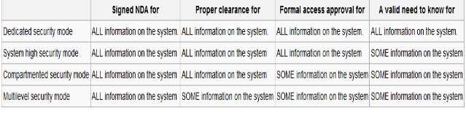
- Security Evaluation:
  - System security can be evaluated and assigned a Trust or Assurance Rating.
  - Assurance evaluation examines the security parts of a system
  - Assurance Rating tells the customer how much protection he can expect out of the system and the assurance that the system will act in a correct and predictable manner
  - Assurance Rating is used to compare security of similar systems.
  - Methods of assigning assurance ratings to systems:
    - TCSEC also known as the orange book
    - TNI also known as the Red book
    - ITSEC
    - Common Criteria
  - Some concepts:
    - Trust computing base: collection of all hardware and software components within a system that provide security and assurance. TCB components should be tamperproof
    - Security perimeter: boundary that divides the trusted environment from the untrusted environment.
    - Reference monitor: abstract machine that facilitates all access subjects have to objects
    - Security kernel: collection of hardware and software components that fall within the TCB and it implements and enforces the reference monitor concept.
    - Open system: designs are built upon accepted standards to allow interoperability.
    - Closed system: designs are built upon proprietary procedures
  - The Orange Book:
    - The Orange Book was used to evaluate operating systems, applications and different products. Known as TCSEC.
    - The criteria breaks down into 7 areas:
      - Security policy
      - Identification
      - Labels
      - Documentation
      - Accountability
      - Life-cycle assurance
      - Continuous protection
    - Orange Book provides a classification system that is divided into hierarchical divisions of assurance ratings:
      - Division D: Minimal protection
      - Division C: Discretionary protection (C1 evaluation level)
      - Division B: Mandatory protection (security labels used in level B)
      - Division A: Verified protection (verified design)
    - A series of books called Rainbow Series were written to extend the coverage of the Orange Book
  - The Red Book:
    - The Orange Book addresses single-system security. The TNI (Red book) addresses security evaluation topics for networks. It addresses isolated LANs. It covers the following:
      - Communication Integrity:
        - Authentication
        - Integrity
        - Nonrepudiation
      - Denial of service prevention:
        - Continuity of operations
        - Network management
      - Compromise protection:
        - Confidentiality
        - Selective routing
    - Assurance is derived by comparing how things actually work to a theory of how things should work.
  - ITSEC:
    - Tried to establish a single standard for evaluating security attributes of computer systems by many European countries. ITSEC evaluates 2 main attributes of a system’s protection mechanisms:
      - Functionality: whether the protection mechanisms are delivered or not
      - Assurance: degree of confidence in the protection mechanisms
    - Set of functionalities and assurance items tested during evaluation:
      - Audit
      - Security management
      - Testing
      - Development
      - Communications
    - In ITSEC criteria, classes F1 to F10 rate the functionality of the security mechanisms and E0 to E6 rate the assurance of those mechanisms
  - Common Criteria:
    - ISO needed an international standard evaluation criteria to be used globally. This was the Common Criteria. Common Criteria evaluates a product against protection profile.
    - Protection profile should be used with requirement specification and a baseline
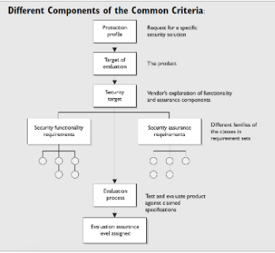

- Assurance rating only indicates the security level of a system from development perspective but can’t assurance security in operation. Security in operation is made up of system administration, physical security, and monitoring.
- Common criteria uses EAL type of rating.
- To achieve rating of EAL 6, use MAC because it allows users with different clearance to interact with a system.
- Certification: comprehensive technical evaluation of security components and their compliance for the purpose of accreditation. Certification process may use safeguard evaluation, risk analysis and testing to asses a system.
- Accreditation: formal acceptance of the adequacy of a system’s overall security and functionality by management. Management understands the level of protection the systems will provide in its current environment and understands the security risks associated with installing a new system. This is the final step in authorizing a system for use in an environment.
- Any changes to software or system should initiate a new certification and accreditation cycle.

Telecommunications and Network Security I:

- Telecommunication:
  - the electrical transmission of data among systems through analog, digital, or wireless transmission types.

- Network Protocol:
  - a standard set of rules that determines how systems will communicate across networks.

- Bandwidth:
  - the maximum amount of bits that can be transmitted over a link within time unit.

- Data Throughput:
  - the actual amount of data that can be transmitted over a link within a time unit.

- Baseband:
  - data is sent as digital signals through the media as a single
channel that uses the entire bandwidth of the media.

- Broadband:
  - data is sent in the form of an analog signal through the media. Each transmission is assigned to a portion of the bandwidth, hence multiple transmissions are possible at the same time

Data transmission media:
- Coaxial cables
- Twisted-pair cable
- Fiber-optic cable

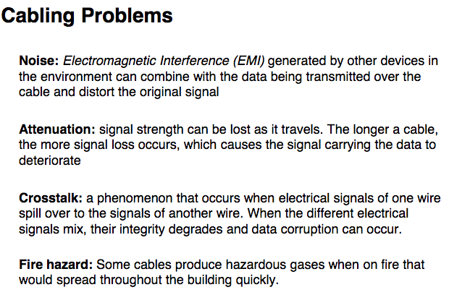

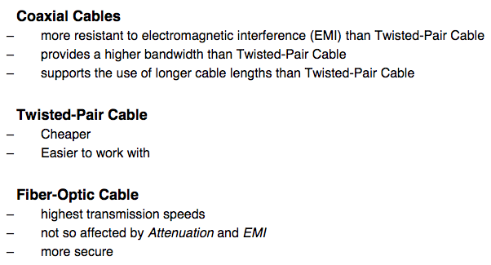
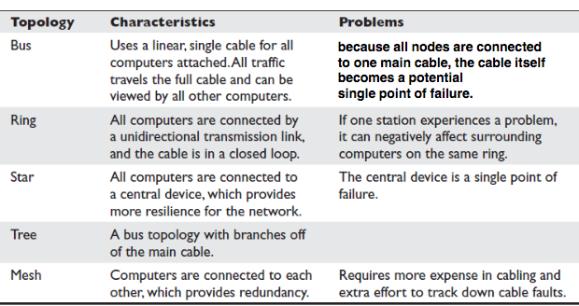

Ethernet:
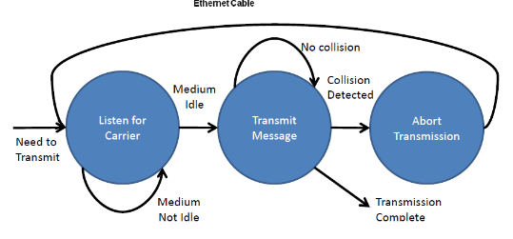
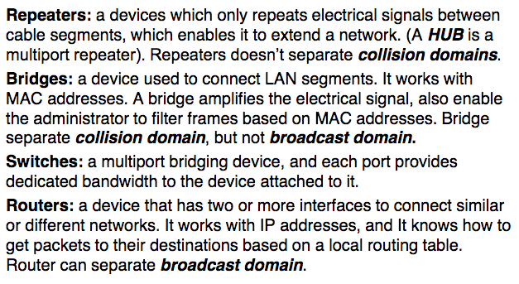

VLAN: enables administrators to separate and group computers logically based on resource requirements.

ARP: Given the IP address, resolve the MAC address.
ICMP: test connectivity and troubleshoot problems on IP networks
SNMP: view the status of the network, traffic flows and hosts within a network

NAT performs transparent routing and address translation. Three basic types of NAT implementations:
- Static mapping: NAT software has a pool of public IP addresses configured. Each private address is statically mapped to a specific public IP.
- Dynamic mapping: NAT software has a pool of IP addresses, but it works on a first-come first-served basis
- Port address translation: company uses only 1 public IP for all systems that need to communicate outside the internal network

Network routing algorithms:
- Link state routing algorithm:
  - All nodes on the network have complete link state information of the network
Network hierarchical routing:
- Internet is divided into regions called AS’s
- Gateway nodes use BGP
- Nodes within AS use routing algorithms like LS (OSPF)

Data encapsulation: add header and trailer information to the original information as you move through the TCP/IP layers

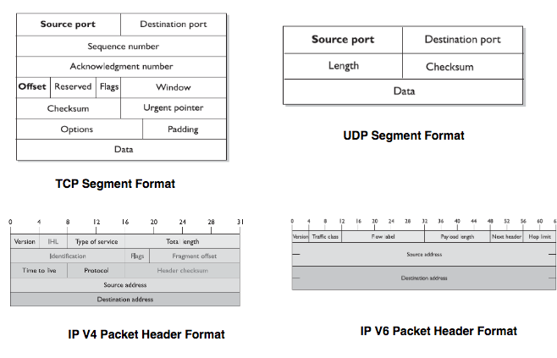

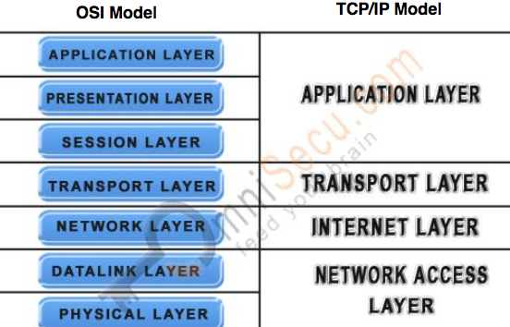

Application Layer security:
- Handle file transfer, virtual terminals, network management. Includes SMTP, HTTP, LPD, FTP.
Presentation Layer security:
- Data encryption, decryption, data compression/decompression. ASCII
Session Layer Security:
- Set up connections between applications. Helps to separate individual application to application communication
Transport Layer Security:
- Handles end-to-end transmission and segmentation of data stream between 2 computers. Provides error detection, correction, recovery, flow control.
Network Layer security:
- Addressing and routing. Point to point security can be implemented at this layer using IPSec
Data Link Layer & Physical Layer security:
- Data link layer prepares frame data into necessary format and manages the reordering of frames if they are out of sequence.
- Physical layer converts frames into voltage for transmission.

Remote connection security:
- Remove connectivity enables remote and home users to connect to networks.
  - Authentication Protocols: protocols used by remote users to authenticate themselves over remote connections.
  - VPN: secure, private connection through an untrusted network
- PAP: password is sent in clear text DON’T USE !
- CHAP: based on a handshake authentication.
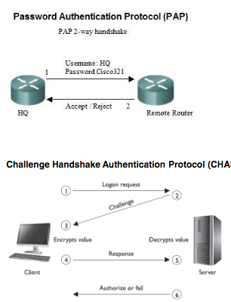
VPN requires end to end connection to work. Point to point protocol is a protocol used for these connections. In computer networks, a tunneling protocol allows a network user to provide a network service that the underlying network doesn’t support.

Telecommunications and Network Security II:

VPN Solutions:

- PPTP+IPSEC: PPTP tunnels PPP traffic over IP networks.
- L2TP + IPSEC: L2TP tunnels PPP traffic over various network types (IP, ATM…etc), not just restricted to IP networks
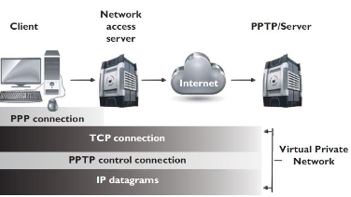

PPTP VS. L2TP:

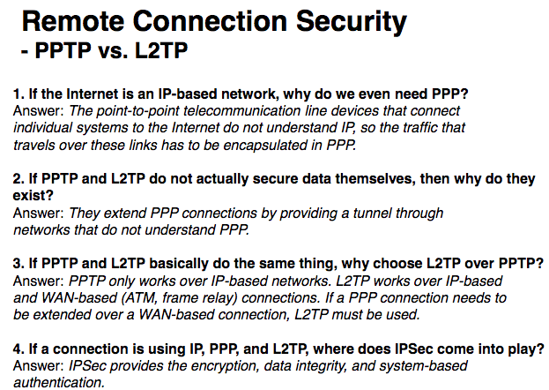

IPSec is a suite of protocols developed to protect IP traffic. IPv4 doesn’t have integrated security by default so IPSec was developed to bolt onto IP and secure the data. IPv6 has IPSec built in it by default.

IPSec protocols:
- Authentication Header: provides integrity, authentication and protection from replay attacks
- Encapsulating Security Payload: provides confidentiality, authentication and integrity
- ISAKMP: provides framework for security association creation and key exchange
- Internet Key Exchange: provides authenticated keying material for use with ISAKMP
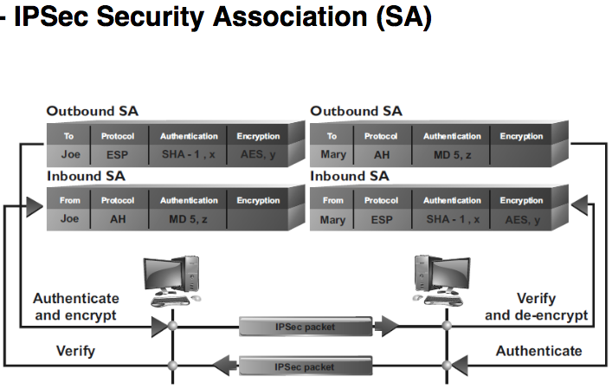

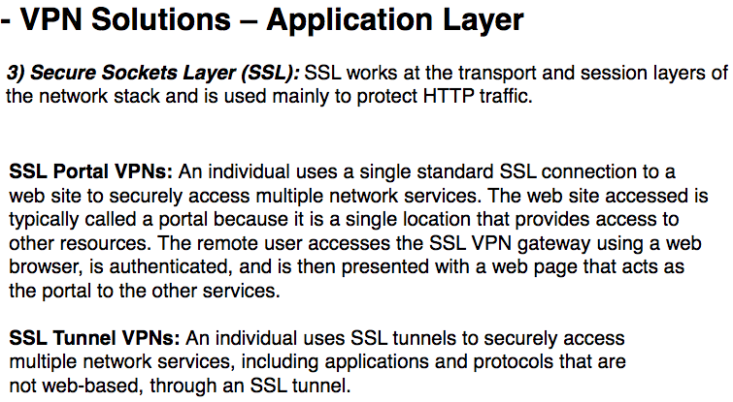

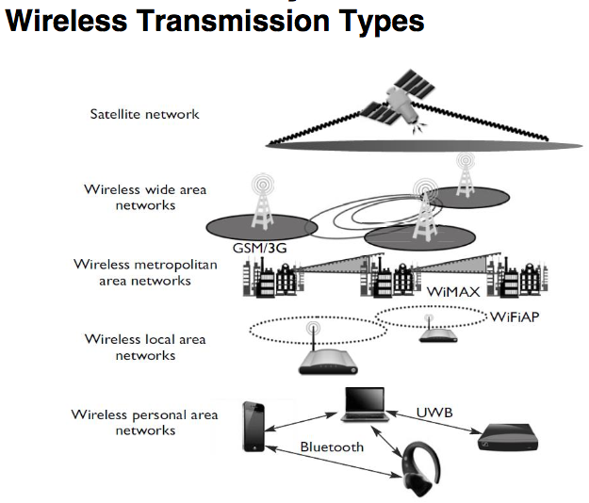
WLAN elements:
- Access Point: a transceiver which connects to a wired network
- SSID: AP’s identification information
- Wireless Devices: devices that communicate with an AP
- Channel: a certain frequency within a given frequency band. The AP is configured to transmit over a specific channel
WLAN types:
- Infrastructure WLAN: AP’s are used to connect wireless devices and wired networks
- Standalone WLAN: one AP acts as a wireless hub and it is not connected to a wired network
- Ad hoc WLAN: No AP’s are used, the wireless devices communicate with each other using their wireless NIC’s.
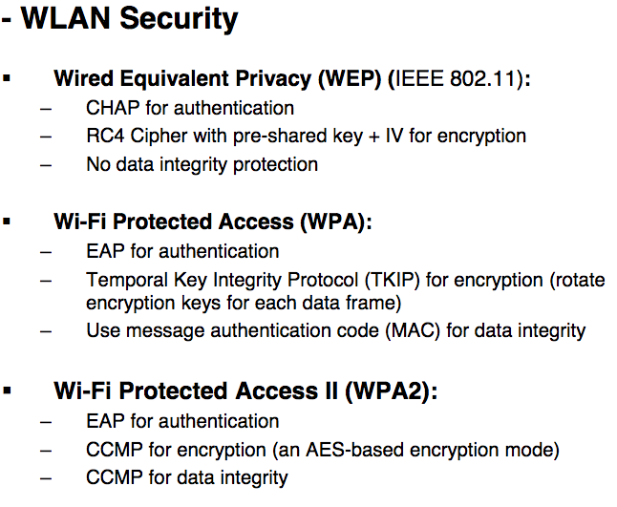
Wireless Security:
- Bluetooth Security (802.15 standard)
  - Both users and Bluetooth developers have responsibilities to minimize the risk of compromise via Bluetooth
  - Recommendation to users:
    - Make devices discoverable when necessary
    - Make devices connectable when necessary
    - Pair Bluetooth devices using long randomly generated passkeys
    - Maintain physical control of devices at all times
  - Recommendation to Developers:
    - Passkeys should be at least 8 digits long. Passkeys must not be valid indefinitely.
    - Use LED’s
    - Use non-descriptive Bluetooth device names on each device and identify all connected devices by MAC address
    - Require user authorization for all incoming connection requests.
- Mobile Devices security
  - Only devices that can be centrally managed should be allowed access to corporate resources
  - Remote policies should be pushed to each device and user profiles should be encrypted
  - Data encryption and remote wipe should be enabled
  - Bluetooth capabilities should be locked down. Restrict social media
  - Endpoint security should expand to mobile endpoints
  - Implement 802.1X on wireless VoIP clients on mobile devices.

Network threats & countermeasures:
ICMP attacks:
- Ping of death: type of DoS attack where oversized ICMP packets are sent to victim which freezes the machine
- Smurf: attacker sends ICMP ECHO request packet with spoofed source address to victim’s network broadcast address.
- Port scanning: ICMP can be used to scan the network for open ports
- Countermeasures: use firewall rules, use IDS or IPS to watch activities. Host-based firewalls and IDS can be installed.
Email attacks:
- Email spoofing: sending an email that looks like it came from someone but it came from malicious person
- Spear phishing: phishing attack that is targeted to 1 person
- Spam: sending massive emails for profit.
- Countermeasures: SMTP authentication on sending server, implementing sender policy framework, anti-spam services, regulating with laws

Other attacks:
- DNS cache poisoning: provide a DNS server with incorrect information, which would point the victim to a malicious website.
  - Countermeasure: use DNSSEC
- ARP poisoning: provides incorrect MAC address information for an IP address
  - Countermeasure: use IDS system
- URL hiding: divert traffic to a fake website using embedded URLs
  - Countermeasure: be careful!
- Session hijacking: hijack a connection session to impersonate victims
  - Countermeasure: protect session token!
- Eavesdropping: sniff data on the network (passive attack)
  - encryption
- DDoS: attacker triggers large amount of service requests to victim’s computer from set of zombie machines (Smurf attack)
  - Smart firewalls
- War driving for WLANs: wireless device capable of identifying and breaking into AP’s
  - Disable broadcast SSID
  - MAC address filtering

Legal Regulations and Compliance:

- Computer-assisted crime: computer used as a tool to help carry out a crime
- Computer targeted crime: computer is victim of an attack crafted to harm specifically
- Incidental computer crime: computer involved in a computer crime without being the victim of the attack
- Computer prevalence crime: crime which relies on computer’s prevalence
- Zombies, Bot, Botnet: zombie refers to computers controlled by hacker’s computer; bots are malicious software installed on zombie machine; botnet is a system that consists of a set of zombie machines with bots installed
- White Hat: does not have malicious intent
- Black Hat: has malicious intent
- Gray hat: somewhere in the middle of black and white
- Obtaining trail of evidence of activities performed is hard because evidence is intangible
- Legal system and law enforcement are behind in their efforts to track down cybercriminals
- Intellectual Property:
  - Intellectual property: law that protects rights for creations of the mind.
  - Patent: Legal ownership of an invention which enable patent owners to exclude others from using the invention
  - Copyright: legal protection for the expression of an idea
  - Trade secret: something that is proprietary to a company and important for its survival and profitability
  - Trademarks: word, name, symbol which represents the company
- Software piracy: act of infringement on ownership rights which can result in being sued
  - Four categories of software licensing:
    - Freeware
    - Shareware (trialware)
    - Commercial software
    - Academic software
  - Software Protection Association
  - Federation against Software Theft
  - Business Software Alliance
  - DMCA: U.S. copyright law that criminalizes the production and dissemination of technology that circumvent access control measures
- Privacy is the ability of an individual to control who has certain types of information about them:
  - Which personal information can be shared with others
  - Which people are permitted to know that data
  - When those people can access it
- Privacy Laws are needed because:
  - Data aggregation
  - Loss of borders
  - Convergent technologies advancements
- Privacy is different with Security. Privacy defines the personal data access rights, and Security is used to enforce these privacy rights.
- PII: set of data that can be used to uniquely identify a single person.
- Liability is the legal responsibility to another entity because of your actions or. Senior management is responsible for organizational liability
- Due diligence: means that the company properly investigated all of its possible vulnerabilities
  - Due diligence is about gathering information
  - When due diligence occurs, organizations will recognize areas of risk
- Due care: means that an organization takes all the actions it can reasonably take to prevent security issues or to mitigate damage if security breaches occur.
  - Due care is all about action
  - When due care occurs, organizations take the areas of identified risk and implement plans to protect against the risks
- Negligence means that an organization was careless resulting in a person being injured
- Downstream liability: refers to liability that an organization accrues due to partnerships with other organizations
- Contractual agreements: cover regulatory, legal, and security requirements
- Procurement Process: procurement is not just about purchasing something, but includes the activities and processes involved with defining requirements and evaluating vendors
- Compliance: auditors can be internal or external to the organization, who will determine if an organization is compliant with the specifics of regulations and laws

- Civil Law System:
  - Focused on codified law – written laws
  - Most widespread legal system in the world and most common legal system in Europe
- Common Law System:
  - Uses judges and juries of peers. IF jury trial is waived, the judge decides the facts
- Customary Law System:
  - Based on traditions and customs of the region
- Religious Law System:
  - Based on religious beliefs of the region
- Mixed Law:
  - Two or more legal systems used together

- Regulation in information security covers many areas:
  - Data privacy
  - Computer misuse
  - Software copyright
  - Data protection
- Security professionals should know:
  - The name of the law
  - The purpose of the law
  - The industry affected by the law
- Information Security Regulations:
  - SOX Act: provides requirements for how companies must track and report on financial information
  - HIPAA: U.S. federal regulation to provide standards for storage, use, and transmission of personal medical information
  - GLBA act: requires financial institutions to develop privacy notices and give their customers the option to prohibit financial institutions from sharing their information with 3rd parties
  - CFAA: U.S. federal antihacking statute related to computer hacking
  - PIPEDA: a Canadian law that deals with protection of personal information
  - PCI DSS: applies to any entity that transmits or accepts credit card data
  - FISMA: U.S. law that requires every federal agency to create and implement agency-wide security program for information protection.
- Incident Response:
  - Triage: take in the information available and investigate its severity
  - Investigation: actions for proper collection of data
  - Containment: actions for minimizing the damage
  - Analysis: computer forensics takes place (audit logs, video captures)
  - Tracking: determine whether the source of the incident was internal or external
  - Follow up: implement the fix to ensure this incident doesn’t happen again
- Computer Forensics is a set of specific processes relating to reconstruction of computer’s usage in order for evidence to be admissible in a court of law.
  - Identification, Preservation, Collection, Examination, Analysis, Presentation
- Forensic field kids include: Documentation tools, disassembly and removal tools, package and transport supplies.
- Chain of Custody: history that shows how evidence was collected, and preserved in order to be presented in court. This provides evidence is trustworthy.
- Evidence must be relevant, legally permissible, reliable, properly identified, and properly preserved
- Evidence must be authentic, accurate, admissible, complete, convincing
  - Best evidence: original signed contract
  - Secondary evidence: oral evidence
  - Direct evidence: prove a fact all by itself
- Ethics are the right and wrong actions that are moral principles
- CISSP professionals should understand ethics published by:
  - ISC2: four mandatory canons for Code of Ethics:
    - Protect society, and the common good
    - Act honorably, responsibly, and legally
    - Provide diligent and competent service to principals
    - Advance and protect the profession.
  - Computer Ethics Institute
  - Internet Architecture Board

Business Continuity and Disaster Recovery:

- Disruptions: unplanned event resulting in temporary interruption of organizational asset
  - Non-disasters: short term interruption caused by system failures
  - Disaster: long term impact on business:
    - Technological disasters
    - Man made disasters
    - Natural disasters
  - Catastrophes: disaster that has a much wider and much longer impact to business than regular disaster
- Disaster recovery: goal is to minimize the effects of a disaster. A DRP is carried out when everything is still in emergency mode
- Business continuity: BCP includes getting critical systems to another environment while repair of the original facilities is under way.
- BCM includes DRP and BCP.
- BCP should focus on providing minimum acceptable level of outputs and services
- BCP includes 5 component plans:
  - Business resumption plan
  - Occupant emergency plan
  - Continuity of operations plan
  - Incident management plan
  - Disaster recovery plan
- NIST 800-34 is a popular business continuity and disaster recovery planning standard. They deal mainly with IT contingency plans
- BCP project initiation is kicked off by senior management.
- Business impact analysis is a functional analysis that determines impact of losing a resource. It identifies the minimum resources needed to recover
- First step in BIA is to gather information and identify resources
- Maximum tolerable downtime is the max amount of time that an organization can tolerate a single resource being down. Used to evaluate critical level of resources. This is part of BIA.
- Risk assessment is part of BIA. Risk assessment evaluates real risk level of business disruption.
- When BIA is complete, you know the MTD.
- Preventive methods are actions that are necessary to recover the system after a disruption.
  - Redundant systems
  - Fault tolerance technologies
  - Insurance: if organization purchases insurance, it ensures that organization has access to additional financial resources. Business interruption insurance provides monetary protection for expenses
  - Data backup: provides prevention against data loss but not against disruptive event.
  - Fire detection and suppression: organizations should implement these systems as part of BCP
- Recovery strategies are processes on how to rescue the company within a timeline after disaster happens
  - RPO: acceptable amount of data loss measured in time
  - RTO: earliest time period which a business process must be restored after a disaster to avoid consequences. Get systems back up and running!
  - WRT: remainder of overall MTD value. Deals with restoring data and testing processes
- Higher level recovery strategies identify order which processes and functions are stored. BCP committee can define these strategies
- System level recovery strategies define how a particular system is to be restored. System administrators need to be involved in development of recovery strategies for IT assets.
- Recovery strategies sections:
  - Business Process Recovery: Required roles, required resources, workflow steps
  - Facility recovery: Hot site, warm site, cold site, tertiary sites, reciprocal agreements, redundant sites
    - Hot site: can quickly recover IT functionality in minutes
    - Warm site: doesn’t have organization computer systems
    - Cold site: doesn’t contain any immediately available hardware
    - Redundant sites: exact duplicate of a system that can operate all IT operations without loss of service.
    - Tertiary site: secondary backup site
    - Reciprocal agreement: 2 organizations have agreement in which one promises another that it can share space if it experiences a disaster
  - Supply and Technology Recovery: network equipment, HVAC issues
  - User environment recovery: user working computers
  - Data recovery:
    - Full backup
    - Differential backup: backup of all changes made since the last full backup
    - Incremental backup: quicker to perform and only backs up the files changed since the last backup.
  - Establish teams for DRP:
    - Damage Assessment team: members assess the damage to physical assets to determine what can be salvaged and restored
    - Legal team: deals with legal issues during disaster recovery phase. They oversee public relations events. They make sure recovery operations adhere to federal laws
    - Media relations team: informs media when emergencies extend beyond the organization’s facilities.
    - Relocation team: oversees the transfer of assets between locations.
    - Restoration team: ensures assets are restored to operations. They need access to backup media
    - Salvage team: return the primary processing site to normal business operations
    - Security team: Manage security at all sites (physical security)
- BCP should be kept up to date with regular audits.
- Cost budget is NOT included in a damage assessment.
- Last step in damage assessment is to declare a disaster.
- Disaster recovery test plans:
  - Checklist test is detailed review of DRP documents performed by individuals on their own
  - Parallel test: perform all steps of a real recovery except you keep the real live production systems running. The production systems run in parallel with the disaster recovery systems.
  - Full interruption test: primary systems are shut off. This tests the DRP because it checks to see if the recovery system is available.
- What action should take place to restore a system and its data files after a system failure: implement recovery procedures

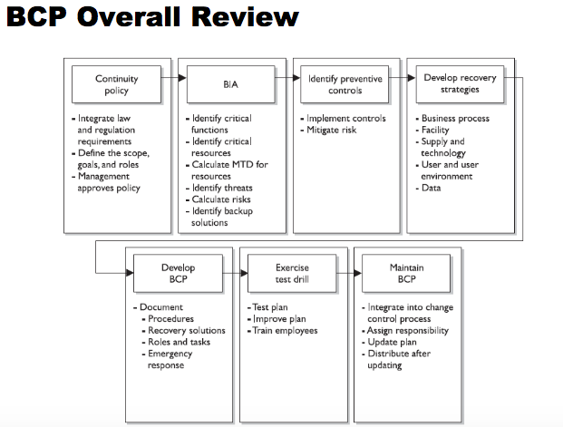

Software Development Security:

- SDLC: puts repeatable processes in place to help ensure functionality and quality requirements are met.
- 1.
- Project initiation
- 2.
- Functional design analysis and planning
- 3.
- System design specifications
- 4.
- Software development
- 5.
- Testing
- 6.
- Installation/implementation
- 7.
- Operational/maintenance
- 8.
- Disposal
- Software development models:
  - Build and Fix model: development takes place immediately with no planning involved. Problems are dealt as they occur.
  - Waterfall model: uses linear-sequential life-cycle approach. Each phase must be completed in its entirety before next phase begins
- 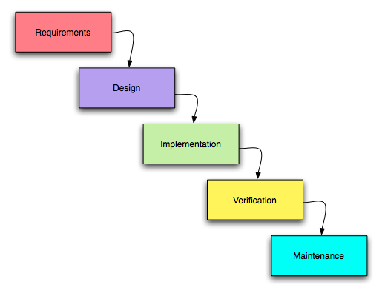 WATERFALL MODEL

  - V model: extension of Waterfall model and it emphasizes verification and validation of the product at each phase.
    - Verification determines if product represents the specifications
    - Validation determines if product provides necessary solution for intended real world problem
  - Prototyping model: sample of software code can be developed to explore a specific approach to a problem before investing expensive resources.
    - Rapid prototyping: quickly develop prototype to see if their ideas are feasible
    - Evolutionary prototyping: prototype can be continually improved until it reaches final product stage
    - Operational prototyping: extension of evolutionary prototype method but improved within a production environment.
  - Incremental model: software development goes through multi-waterfall cycles. Each cycle results in a deliverable that is an operational product.
  - Agile model: collection of values and principles which is based on software dev best practices
    - Focus on individual interaction
    - Promotes customer collaboration and abilities to respond to change instead of strictly following a plan
- Programming languages:
  - Generation 1: machine language (RISC, 100101010)
  - Generation 2: assembly language (ADD, PUSH, POP)
  - Generation 3: high level language (C, C++)
  - Generation 4: very high level language (Java, C#)
  - Generation 5: natural language
- Software programming tools:
  - Assembler: tool that converts assembly language code into machine code
  - Compiler: converts high level language to machine level binary code
  - Interpreter: tool converts intermediate platform format like Java bytecode into machine level format
- Procedural programming: classic input-processing-output programming method that contains a series of computational steps to follow
- OOP: programming paradigm based on concept of objects, and have procedures.
  - Cohesion: measurement that indicates how many different types of tasks a module needs to carry out. High cohesion is expected in OOP
  - Coupling: measurement that indicates how much interaction one module needs from another module to carry out tasks. Low coupling is expected in OOP.
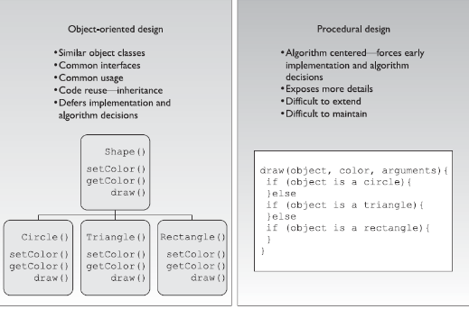

- Software testing:
  - Unit testing: individual component is in a controlled environment where programmers validate data structure and boundary conditions
  - Integration testing: verify that components work together as outlined in design specifications
  - System testing (known as end to end testing) tests a completely integrated system to verify that it meets its requirements
  - Security testing focuses on security of system
  - Acceptance testing ensures that code meets customer requirements
  - Regression testing: after a change to a system takes place, retest to ensure functionality, performance, and protection
- Software change control is process of controlling the changes that take place during life cycle of a system and documenting the change control activities.
- Software versioning deals with keeping track of file revisions which makes it possible to roll back to a previous version of the file
- Capability Maturity Model Integration (CMMI): model that describes maturity of an organization’s software development processes.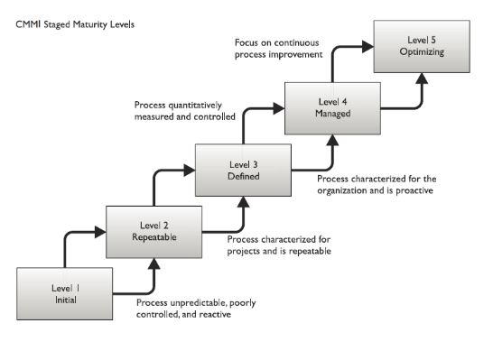
- Why security issues created in software development:
  - Software vendors:
    - Time to market constraints therefore don’t take time for property security design
  - Software development:
    - Software developers make false assumptions when developing
    - Software developers don’t have complete insight to security vulnerability issues
    - Developers implement hidden features for self testing purposes
  - Software operation:
    - Disable security controls for usability and performance
- Attack surface is what is available to be used by an attacker against the product itself.
  - Aim of attack surface analysis is to identify and reduce the amount of code and functionality accessible to untrusted users
  - Attack surface analysis attempts to count the list of features that an attacker will try to exploit. These attack points are then assigned a weight or bias known as attack bias valued between 0 and 1 based on their severity.
  - The RASQ was introduced by Microsoft to describe the relative opportunities for attack against software in comparison to a baseline.
  - RASQ can be used as measurement to determine the improvement of code quality and security
- Threat modeling is systematic approach used to understand how different threats could be realized and how a successful compromise could take place.

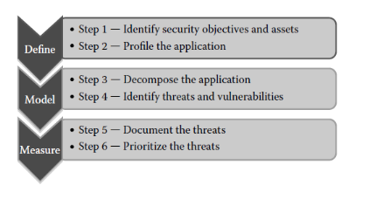

- Define phase:
  - Profile the application: Identify physical topology, and logical topology
- Model phase:
  - Attack tree is hierarchical treelike structure that has a type of attack or attacker’s objective at its root node.
  - STRIDE is a threat modeling methodology in which threats are grouped into (spoofing, tampering, repudiation, information disclosure, denial of service, elevation of privilege)
- Measurement phase:
  - DREAD is a risk calculation or rating methodology to calculate the average of numeric values assigned to risk ranking categories. It is preferred to use a smaller range such as 1-3 instead of 1-10 to make the ranking more defined. (damage potential, reproducibility, exploitability, affected users, discoverability)
- Best practices:
  - WASC: organization that provides best practices for web based applications
  - OWASP: organization that monitors web attacks
  - Build Security In initiative promotes a process-agnostic approach that makes security recommendations with regard to architectures
  - IEC creates the 27034 standard. These standards provide guidance to organizations in integrating security into software development.
Civil code is rule based and Common law is based on previous interpretations of the law

Software Development II:

Mobile code: code that is transmitted across a network to be executed on a local system
  - Java Applet
  - Java script
  - Adobe Flash
  - Microsoft ActiveX
Java Applet is delivered in Java Bytecode. Java applets run in a web browser using JVM and can be easily reverse-engineered. The applet security manager is often run by default rules. Java employs a sandbox in its security scheme, but if an applet can escape the confines of the
sandbox, the system can be easily compromised

- 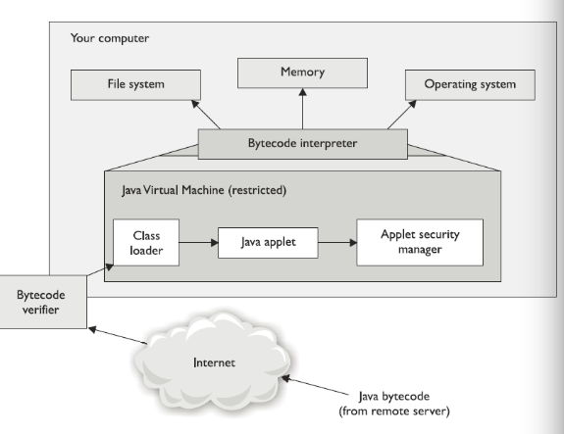

- ActiveX Security:
  - Uses Authenticode technology which relies on digital certificates and trusting certificate. ActiveX controls should be run only when you completely trust the entity that signed the control. ActiveX has no sandbox restrictions so only run the code that is trusted.
  - Allow web browsers to execute other software applications within the browser
  - Once allowed to run, they are able to download further ActiveX components without user authentication
  - Completely self-sufficient programs that can be executed in Windows environment.
  - Shared the privilege levels of the current user on a system.
- Web based applications are applications remotely accessible through HTTP. The most common ports related to web application are 80 and 443.
  - Web applications are facing directly external attacks
  - Web applications understand the most application logic from presentation perspective
  - Back end applications usually rely on front end web applications to implement many security controls
  - 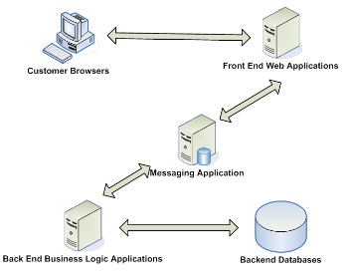
- Web application security issues:
  - Same Origin Policy: Browser same origin policy is a key concept applying to client-side web security.
    - The browser SOP identifies each web site using its origin, which is a unique combination of protocol, domain, port, and creates a context for each origin.
    - Under the policy, a web browser permits scripts contained in a first web page to access data in a second web page, but only if both web pages have the same origin
      - Same origin policy for cookies
      - Same origin policy for DOM access
      - Same origin policy for XMLHttpRequest
- Essential security problem of web applications:
  - Users have complete control over the client end:
    - Can submit arbitrary input
    - Can modify all data passing between browser and server
    - Can send requests and parameters in any sequence
    - Can use tools instead of the browser
    - In principle, web application should NOT rely on any client-side security controls
  - Attacking Client-Side controls:
    - Some web applications store application state on client side
      - Hidden form fields : <input name=”price” type=”hidden” value=”125”>
  - Attacking Session Management:
    - Vulnerabilities in session management mechanisms fall into 2 categories:
      - Weaknesses in generation of session tokens
      - Weaknesses in handling session tokens
        - Disclosure of tokens within the URL
        - Session token can be sent to malicious party theough XSS vulnerability
  - Code injection attack:
    - Code injection arises because crafted input can break out of the data context and get interpreted as code.
    - SQL injection attack:
      - Malicious user can submit search term:
        - ‘Wiley’ or 1=1—which returns all title items in books table because 1=1 is always true
  - Attacking the same origin policy control:
    - Reflect cross Site Scripting Attack:
      - Known as non-persistant attacks occur when a malicious script is reflected off a web application to victim’s browser. The script is activated through a link which sends a request to a website with a vulnerability that enables execution of malicious scripts.
      - Reflected attacks only require malicious script to be embedded into a link. User needs to click on infected link.
  - Database Security Issues:
    - Aggregation Threat:
      - Aggregation is act of combining information from separate sources. The combination of the data forms new information, which the subject does not have the necessary rights to access. The combined information has a sensitivity that is greater than that of the individual parts.
    - Inference Threat:
      - Inference is the ability to derive information not explicitly available. Inference is the intended result of aggregation. The inference problem happens when a subject deduces the full story from the pieces he learned of through aggregation. This is seen when data at a lower security level indirectly portrays data at a higher level.

      - 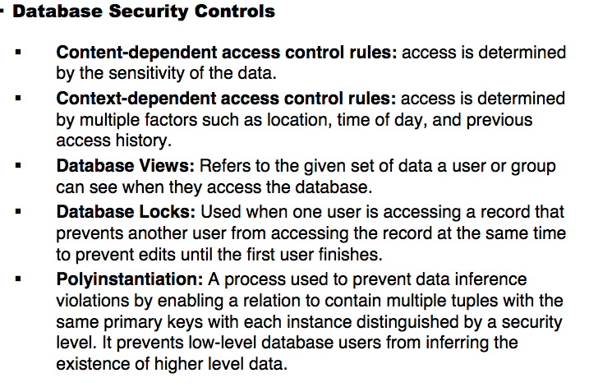

      - Polyinstantiation: purpose is to make a copy of an object and modify the attributes of the second copy. This is done to ensure that a lower level subject cannot access an object at a higher level. Used to prevent data inference.

