Background of Elmdale Tennis Club
Elmdale Tennis Club was founded in 1937 and is a not-for-profit tennis club with a focus on the community currently located at 184 Holland Avenue, Ottawa, Ontario. The main mission of the Elmdale Tennis Club is to provide reasonably priced membership packages to members of the community who are interested in playing the sport of tennis competitively or recreationally. The club provides access to six clay courts for club members and guests alike. The three key objectives of the tennis club are;
- to maintain and conduct a tennis club for the accommodation, recreation and convenience of the members of the Club, and others; (“Governing By-Laws « Elmdale Tennis Club,” 2016)
- to promote, sponsor, and generally carry out athletic activities and games with affiliated social activities; and (“Governing By-Laws « Elmdale Tennis Club,” 2016)
- to accept donations, gifts, legacies and bequests. (“Governing By-Laws « Elmdale Tennis Club,” 2016)
The club enforces a code of conduct with a view towards promoting a culture of courtesy, kindness and respect. The goal is to foster a good atmosphere within the tennis club where members of the community can play and interact in a pleasant, conducive and stress-free atmosphere. The club offers inexpensive summer camps and junior programs geared towards younger individuals, adult instructional programs to help older individuals learn and play the sport of tennis, and hosts social events and tournaments to help connect and maintain a good relationship with members of the community in addition to selling memberships for court access. The club manages court usage by providing calendars on their website with bookings that show the times the court is occupied by the pros and for special events. The website also contains two calendars that cover five months separately (May, June, September & July, August). The wo calendars show court wait times at various times during the week and indicate the duration using different colors. This page helps members organize and schedule their court booking by choosing the optimal timeslot that fits best suits them. The top management is made up of a board of directors entirely comprised of volunteer members that constantly change every two years. The board deals with hiring the manager, tennis pros and the court master. They also handle social events, major financial purchases, and club-related rules and regulations. The club is pushing forward to better integrate with the community to make it easier for members to register for programs/events, attracting new members through those programs and events, allowing members to maximize playing time on the courts, and making guest registration more efficient and error-free. The club is also striving to listen to the voices of its members and the broader community while utilizing feedback to better adjust/tailor their services and business processes to satisfy customer needs.

Phase A: Architecture Vision
Stakeholder’s View
The stakeholder’s viewpoint displays the relevant individuals and entities with vested interests in the business. The viewpoint also shows their pressing concerns as drivers, assessments of those concerns, and provides links to the high-level goals that address those concerns and assessments. (Jonkers, Band, & Quartel, 2012)
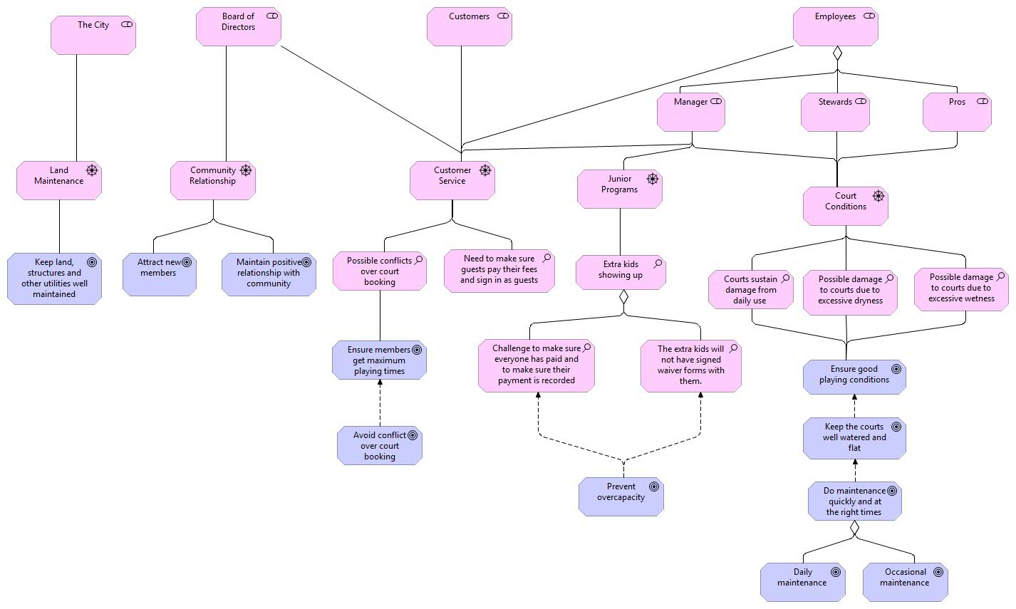
The stakeholders associated with the club are the city, the board of directors, their customers and the club employees. The board of directors is most concerned with the community relationship which can be solved by meeting their goals of attracting new members and sustaining a good rapport with the community. The employees of the club are comprised of stewards, tennis pros and the manager. Customer service is a shared concern of the board of directors, club employees and the customers. The club has discovered some problems with their customer service (court booking conflicts, guest sign in and fee payment) and have set the goal of ensuring members get maximum playing time (achieved through avoiding court conflicts). Court conditions is a shared concern of the club’s employees. The manager’s other concern is managing the junior programs. The assessment of the junior programs yielded two key issues (extra kids showing up without signed waivers, recording and checking that every extra child has paid) that would be remedied through achieving the goal of preventing overcapacity. The assessment of court conditions has yielded three key issues (court damaged through daily uses, excessive dryness and wetness) that would be resolved by reaching the goal of ensuring good playing conditions. The goal of ensuring good playing conditions can be further refined into maintaining the courts quickly and at the correct times which is accomplished via daily and occasional maintenance tasks

Principles View
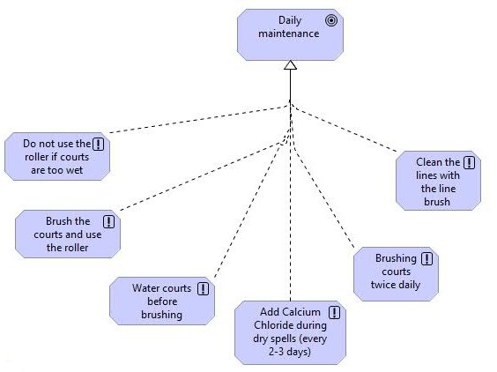
The Principles viewpoint shows goals, the principles through which they are accomplished, and relationships between both of them (positive or negative influence). A principle is the method through which a goal will be attained

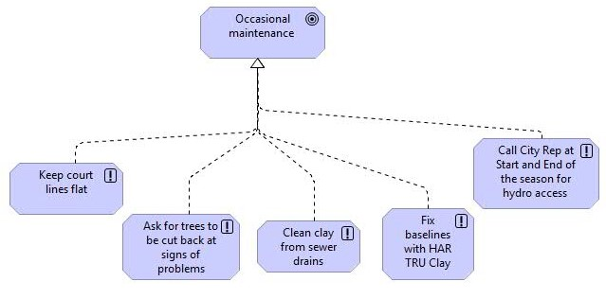
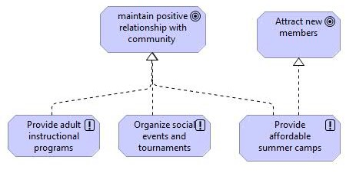
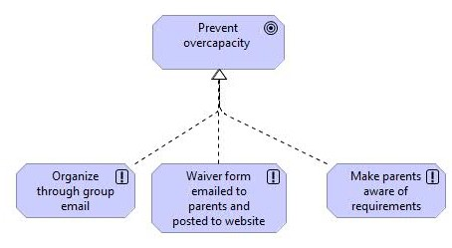
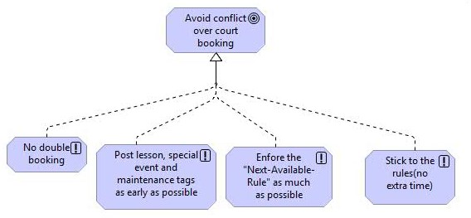
The goal of daily maintenance is achieved by completing these six daily maintenance tasks regularly (add calcium carbonate, brush courts twice daily, ...) The goal of occasional maintenance is realized through completion of the five maintenance tasks (Keep court lines flat, clean clay from sewer drains, …) The goal of preventing overcapacity is accomplished via utilization of group email, emailing and posting waiver forms to parents and the website respectively, and making parents aware of requirements. Avoid court booking conflict can be achieved via these four routines (no double booking, stick to the rules, …) The goal of maintaining a positive community relationship can be realized by providing tennis tutorial programs for adults, organizing social events and tournaments, and providing affordable summer camps which also helps achieve the objective of attracting new members.

Phase B: Business Architecture
The business architecture displays an internal view of the organization which includes aspects relevant to the inner workings of an organization.
Organization View
The organization viewpoint displays an internal view of the organization, department, company network, or organizational entity.(Jonkers, Band, & Quartel, 2012, p. 10) This view helps show responsibilities, authority (span of control and hierarchy) and core capabilities. This is often expressed in a tree-diagram that can be decomposed from general to more specific elements

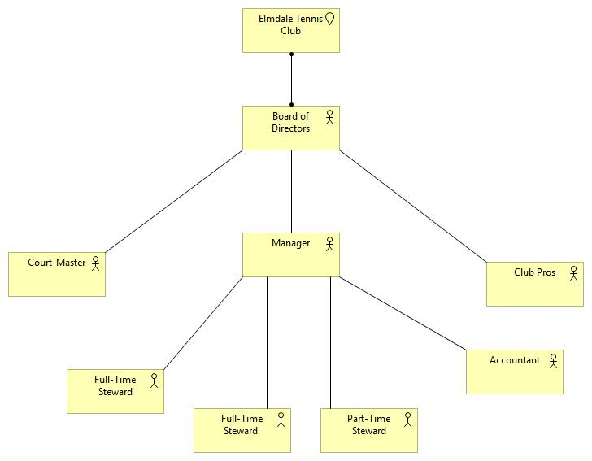
The board of directors has the highest level of authority and span of control in the organization. They also are responsible with hiring the court-master, tennis pros and manager. The manger does not have greater authority than the pros or the court master because he/she has no input into the hiring process of those employees. The manager has the next highest level of authority and span of control. The manager is responsible for hiring the two full-time stewards and the part-time steward. The manager is also responsible for dealing with finances and the accountant needs confirmation from the manager for several financial accounting tasks.
Business Function View
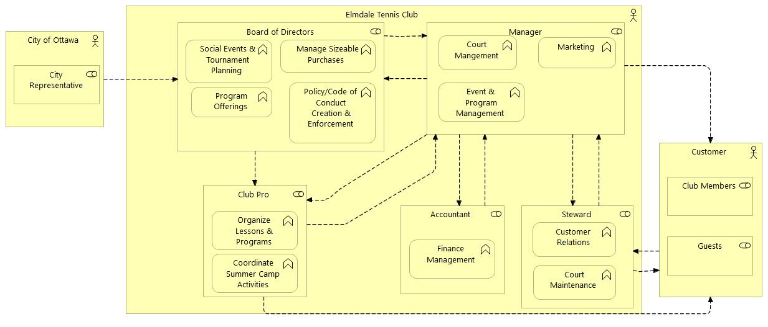
The business function viewpoint displays the important functions of the organization, interrelationships between functions, and any exchanges that happen between them. A business function groups behavior based on a chosen set of criteria, typically required business resources and/or competences.(Jonkers et al., 2012, p. 11)
The important business functions of Elmdale Tennis Club are;
- Code of Conduct/Policy Creation & Enforcement: involves the creation of club policy and guidelines that all individuals (customers and employees) in the tennis club must adhere to. This also includes the reprimand and removal of memberships due to several significant breaches of club policy/code of conduct.
- Coordinate Summer Camp Activities: involves coordinating and communicating with the manager to ensure the summer camp runs smoothly.
- Court Management: comprised of managing the courts, court bookings, ensuring maintenance is performed when needed.
- Court Maintenance: involves the actual work done to keep the courts in playable condition and ensure longevity. This is divided into two categories that are daily and occasional maintenance which is performed by the stewards.
- Customer Relations: involves interactions with the club members and guests (booking courts, member registration at the tennis club…) The stewards are the employees who mainly interact with the customers so they provide the majority of this function.
- Junior Program, Summer Camp & Social Event Management: involves managing and coordinating with the pro responsible for running the summer camp/junior program to ensure success. Also includes managing any social events organized by the board (catering, entertainment, selling tickets, …)
- Marketing: involves online and direct marketing for social events, junior programs and summer camps (posting flyers, calling club members, sending emails to Webmaster, posting on social media accounts and club website)
- Finance Management: involves monitoring the revenues and expenses of the tennis club. Also includes accounting duties (Create daily and end-of-year statements, balancing the books, ….)
- Organize Lessons and Programs: This is the job of the pro and primarily involves planning and tailoring tennis lessons to customers of different levels. Properly instructing club members and guests increases the chances of the individual becoming a regular club member in the future.
- Social Events and Tournament Planning: This involves the organization, gathering and collaboration of the various resources needed to create a social event. Regular tasks involve contacting any outside business that would be needed for the event, setting the event date, booking the necessary court space, gathering and setting up necessary equipment.
- Managing Sizeable Purchases: This involves board discussions about the feasibility of purchases and if necessary approval of purchase requests. Negotiation with the city about financial responsibility for necessary items is also addressed.
- Program Offerings: involves choosing the programs that the tennis club will offer and the criteria for each program.

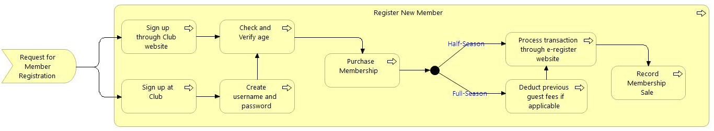
Business Process View
In order to register as a club member, the individual has to sign up through the club website or in person at the tennis club. Signing up in will require the creation of a username and password that will be used to process for the e-register website. Based on the information from the individual, the age will be checked to determine the membership type (adult, student, junior). The individual has the choice of purchasing a half or full season membership which will be processed through e-register.com. The membership ship fee could include deductions based on if the individual has paid guest fees previously and chooses to buy a full season membership. The membership sale will then be recorded for financial purposes.
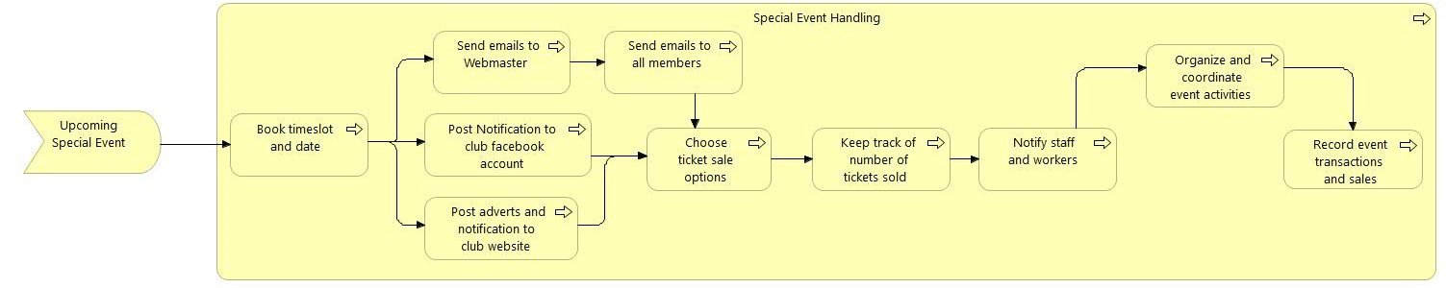
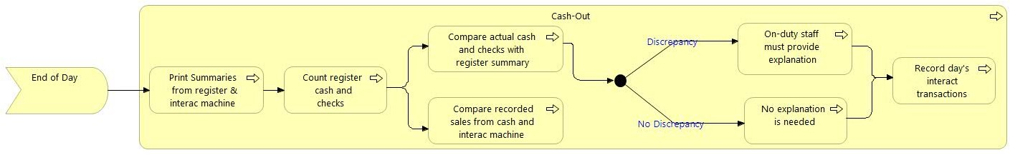
The cash-out process begins with the printing of the sale summaries from both the register and interac machine. Two separate record validations are completed and any discrepancy is noted. In the result of a discrepancy from either comparison, an explanation will be required from the on-duty steward to the manager. After the issue has been resolved, the transactions are recorded for financial purposes.
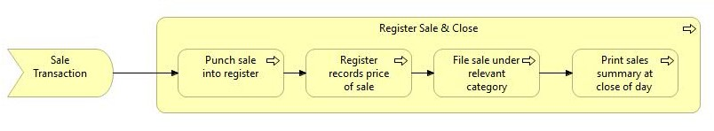
The event date and time needs to be verified first before any notifications can be distributed digitally to club members and guests. Emails need to be sent to the Webmaster first before they are distributed to everyone on the appropriate member list. Tickets can be sold regularly or as an advance sale which are tracked to figure out the number of people who will attend. Staff are notified and the event activities are coordinated (set-up, serving, catering, entertainment, closing). Event transactions are recorded for financial purposes.
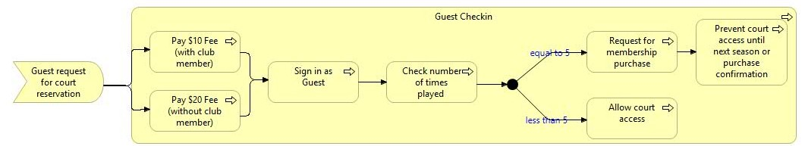
Sales are recorded and filed into one category based on the transaction purpose (memberships, guest fees, lessons, summer camps, canteen). Sales summaries are printed at the end of the day for financial purposes.
When a guest comes into the club to play, they have to pay a fee which is determined based on one factor (with a club member or not). The guest signs in and the staff check the number of times that individual has played previously. Depending on the number, the guest is either allowed to continue or is asked to buy a membership to continue playing.

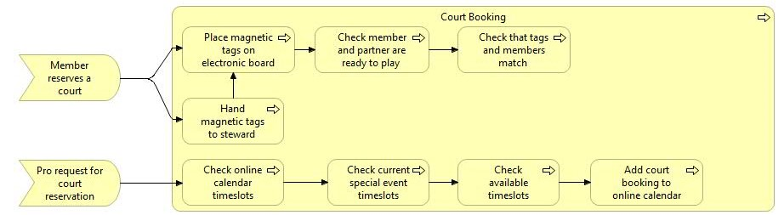
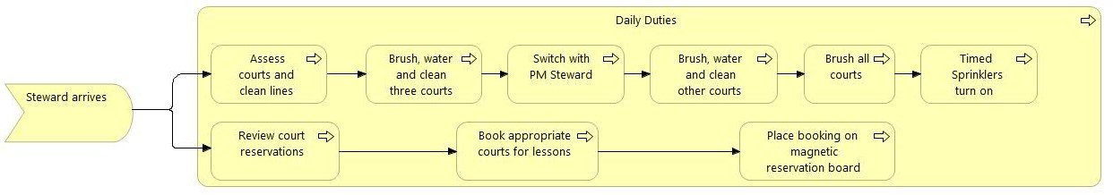
When a steward arrives to start their shift, they follow the daily court maintenance to prepare the courts for the day. When the club is closed for the day, timed sprinklers turn on for a few minutes (15 – 30) depending on the weather conditions and time of year. At the start of the shift, the steward also marks the lessons scheduled for that day on the magnetic board so the appropriate court is not booked for any other activity.
When a member reserves a court, their magnetic tag is placed on the electronic board by the individuals or the steward during prime-time. The steward checks that the two individuals are ready to play to ensure that they get the maximum playing time and other members are not left waiting. If the steward did not place the magnetic tags on the electronic board, he/she checks that the individuals and their tags match before allowing them to play.When a pro initiates a court reservation request by speaking the staff on-duty to reserve a court. The staff updates the online calendar to include the lesson and checks to make sure it does not coincide with special events.
Phase C: Baseline Information Systems Architectures
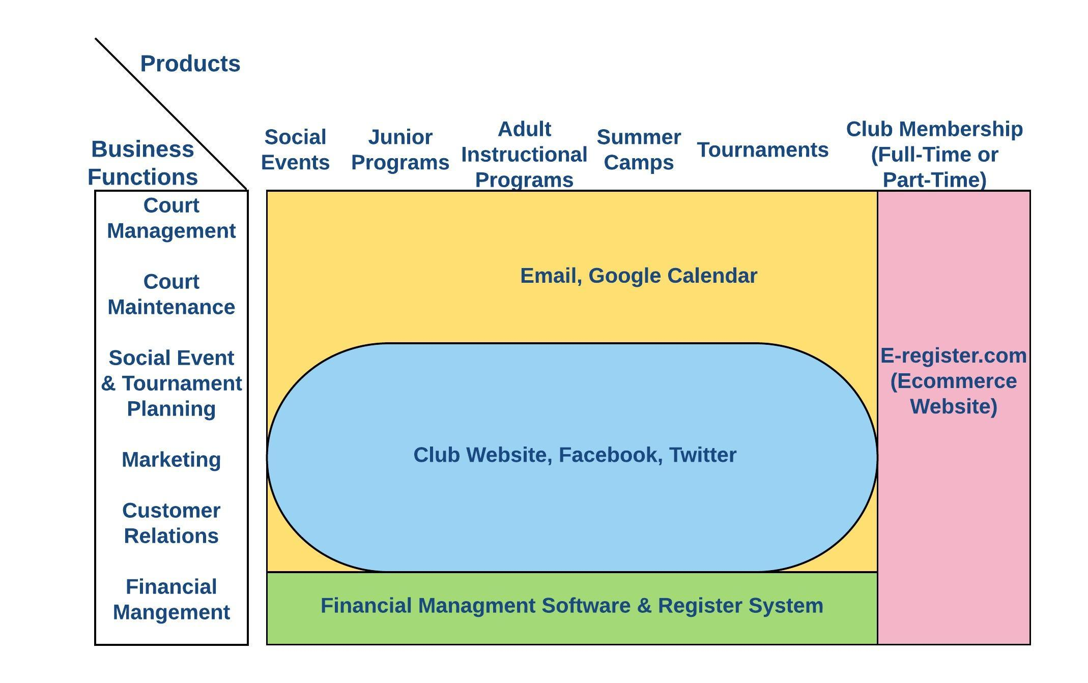
Application Landscape
The Elmdale uses several applications in their daily operations. Every half and full season membership sale is passed through e-register.com to keep track of these finanical transactions. This can help the club track their seasonal memberships and how many customers they should expect for each season.
Email is used internally to help facilitate communication between club staff and customers. The manger can utilize email to communicate with the stewards with isses regarding court management and maintenance. Email is also used for marketing purposes with regards to promoting summer camps, tournaments, programs and social events. Customer concerns can be addressed through email and it is also used to plan events particularly summer camps. Staff cann use email to inform customers of club and event changes.
Google Calendar is used primarily for booking purposes and allows customers to check court availability. This helps facilitate coordination so events are planned without conflicting schedules and customers can carefully choose their timeslots. Club pros also benefit from this because they can choose the best time to book their lessons to enable all members to be able to attend their relevant programs.
Social media websites like Facebook and Twitter are used to communicate with their customers and promote club events. Social media also provides a platform for informal communication with customers and allows club members to interact with each other online. This online community helps better integrate the club and its members and provides crucial information to customers.
The register system is used by the cash register to print sale summaries, record and process transactions. The accountant uses financial management software to keep track, record business transactions and perform his/her accounting duties.

Application Co-operation
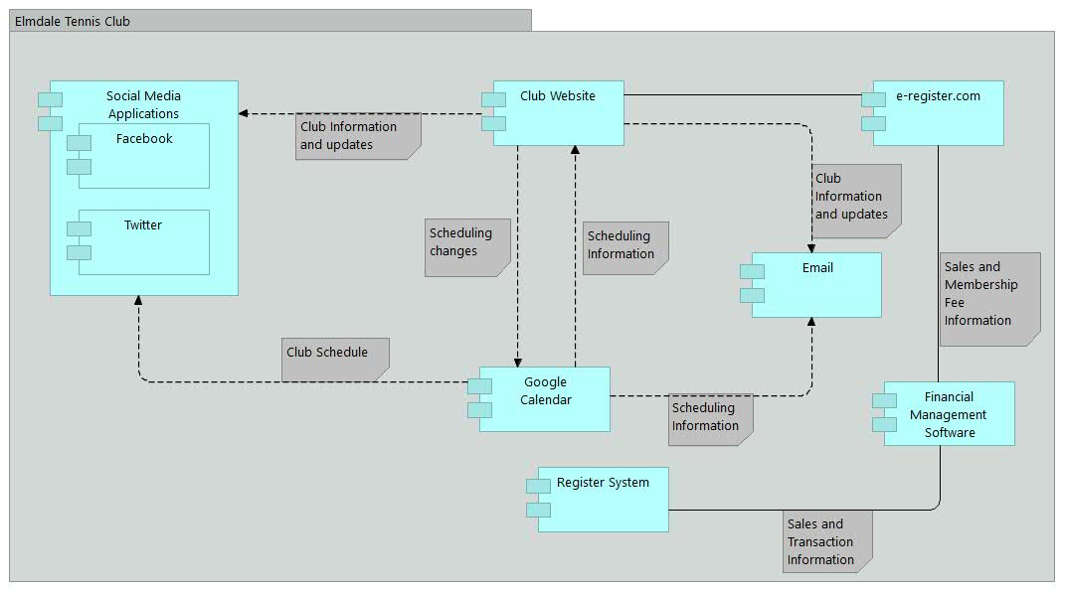
This view displays the interrealtionships between application components and data exhanges that occur between them. This shows how the applications interact to enable and support the organization.
The social media applications interact with the club website and are used to disperse information to customers. This could be in the form of upcoming club events, closures to weather conditions,club changes and other instances.They also interact with Google calendar and can be used to help notify members of event times. The schedule on the website is created and can edited using Google Calendar. Customers can send emails regarding concerns through the club website and event times can be emailed to relevant customers. Customers can register for a club membership via the club website which funnels the transaction through e-register.com to complete the order. The information from the register system and e-register.com is used by the accountant for record-keeping purposes.
Application Usage
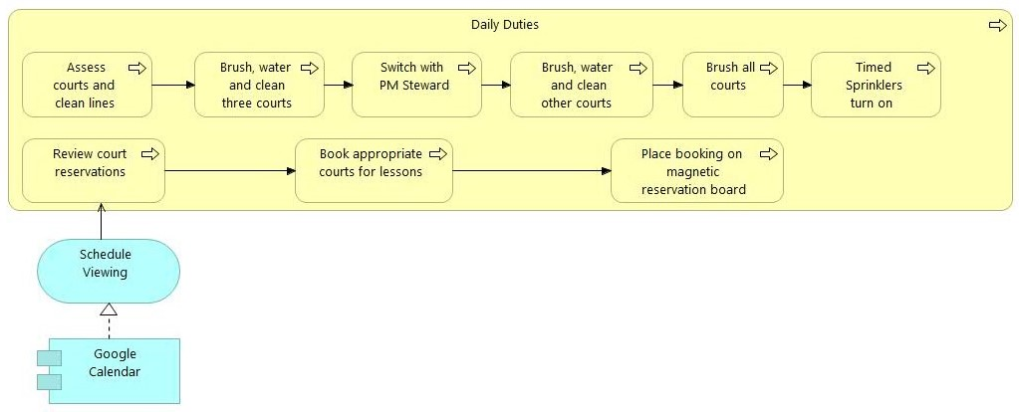
The Application Usage viewpoint describes how applications are used to support one or more business processes, and how they are used by other applications. (Jonkers, Band, & Quartel, 2012)
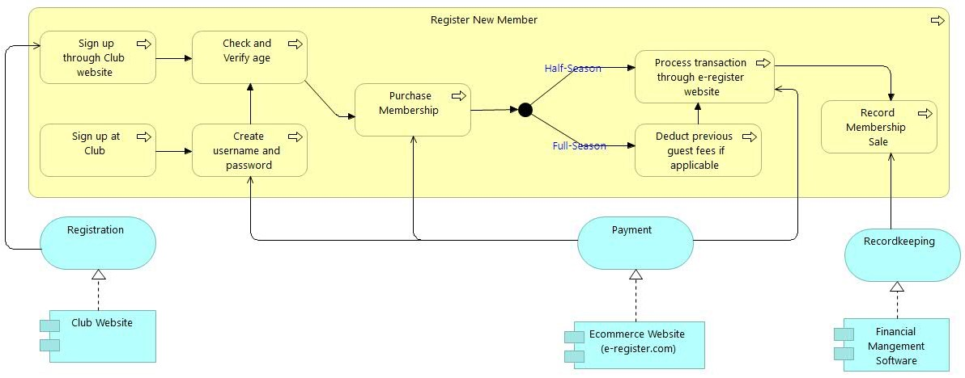
At the beginning of a shift, the steward needs to check Google Calendar to view the schedule for the day including the lessons booked by the pros. This information helps the steward ensure that the relevant court is marked to prevent conflicting court bookings later in the day.

Registration can be processed through the club website or in person at the club. A username and password is needed to purchase a membership if it is done at the tennis club. Membership payment is processed through e-register.com and records are kept via a financial mangement software (spreadsheets, accounting software)
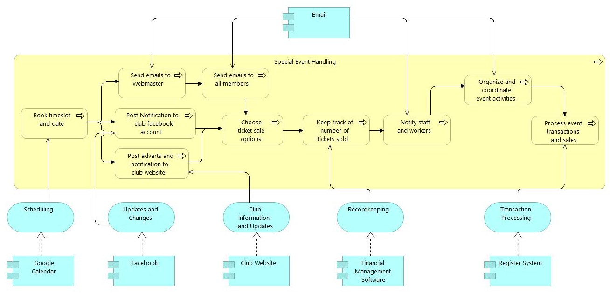
Google Calendar is needed to schedule special events and information is spread through Facebook, Email, and the club website. Email is utilized to coordinate the staff and event activities. Financial mangement software is used to keep track of the ticket sales and the register system is used to process event sales and transactions.
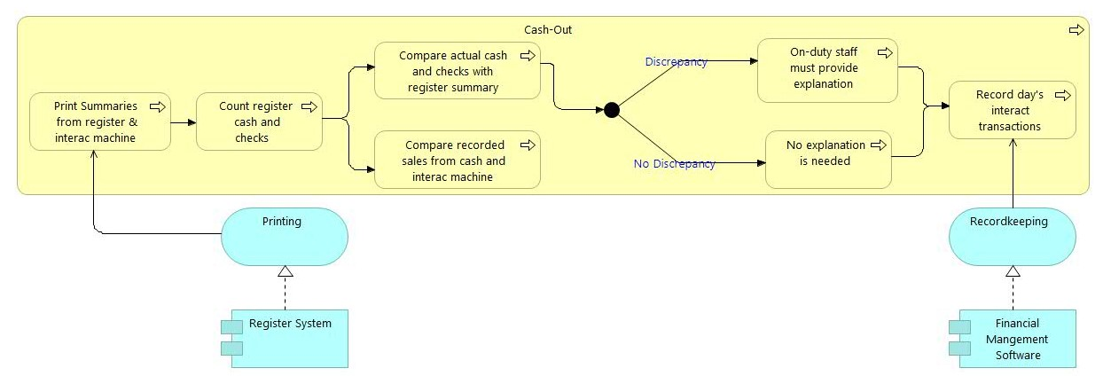
The cash-out process involves using the register system to print the daily sale summary from the register machine. Daily transactions are recorded using financial mangement software (spreadsheets, accounting software) after recorded sales have been validated or discrepancy has been explained.

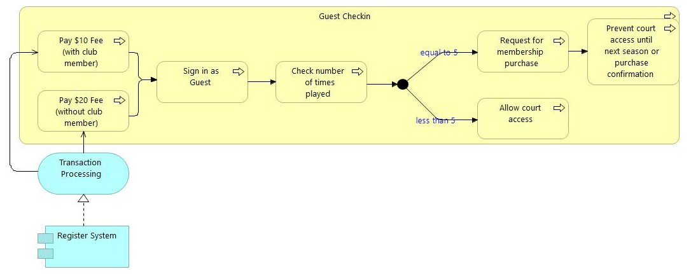
When a guest checks in at the tennis club, the register system is utilized to keep process and record the payment of their fee.

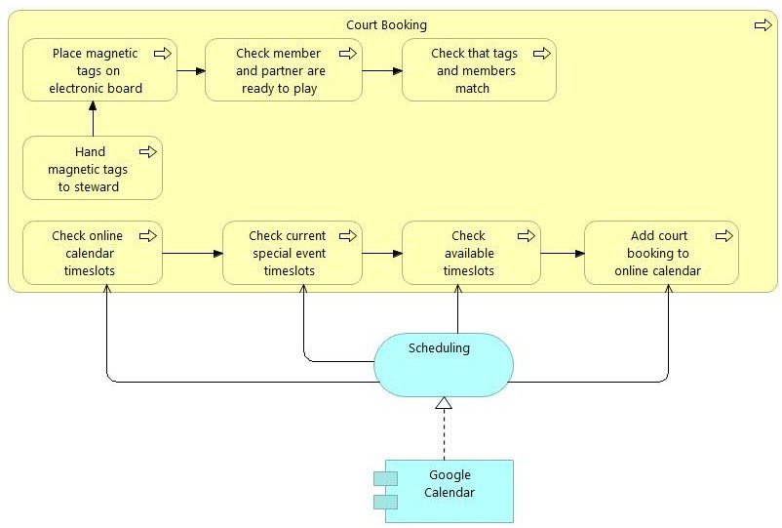
When there is a request by a pro to book a court, Google Calendar is used to crosscheck timeslots on the club schedule for courts for special events, programs, and other pro lessons. Based on the schedule information, an available timeslot is chosen and the requested court is booked. The club schedule is edited using Google Calendar to reflect the new booking.
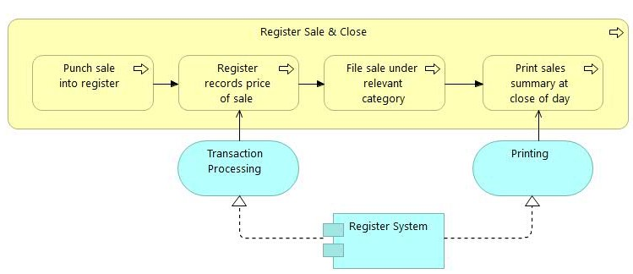
When a sale occurs, the register system processes the transaction and records the sale price. At the end of the day, The steward uses the register system in the cash register to print the sales summary which will be used for validation purposes.
Information Structure
It shows the structure of the information used in the enterprise or in a specific business process or application, in terms of data types or (object-oriented) class structures. (Jonkers, Band, & Quartel, 2012)

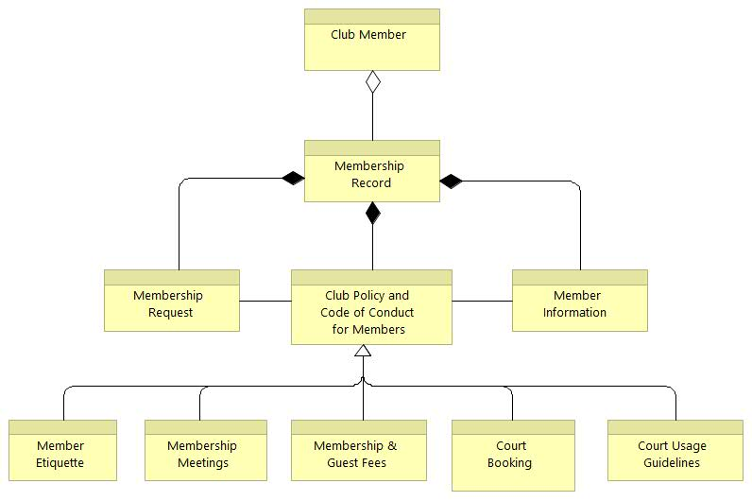
The information from a club member is made up of a membership record which can only be gotten via a membership request. The record is also made up of the club member’s information (age, phone number, address, email,…) and the rules/guidelines that govern club members. The club policy can be split into the rule/guidelines governing member etiquette (behaviour), membership meetings, court bookings and court usage (type of shoes that can be used, clothing that can be worn,…). A member has to make his/her membership payment which may include deductions of previous guest fees or else he/she will no longer be considered a club member.
Data Dissemination Diagram
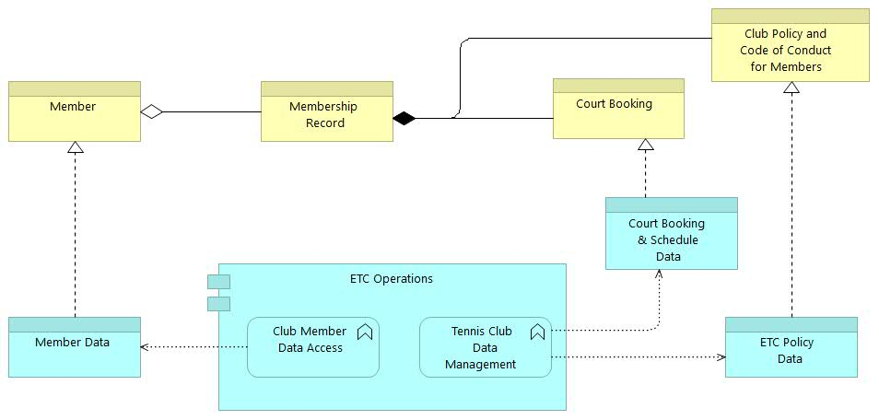
The purpose of the Data Dissemination diagram is to show the relationship between data entity, business service, and application components. The diagram shows how the logical entities are to be physically realized by application components. (Jonkers, Band, & Quartel, 2012)
The figure above shows the data dissemination diagram for one membership record and indicates the flow of information between all the entities. Club members can access their own personal information and have the ability to choose their court bookings. The tennis club manages the court booking data so no conflicting bookings occur. The tennis club also manages the policy data which is used to set the policy for club members. The club must manage all the pieces of data to ensure that club members can arrange court bookings, their information is kept updated and the club standards of conducts are known by all members.
Phase D: Baseline Technology Architecture
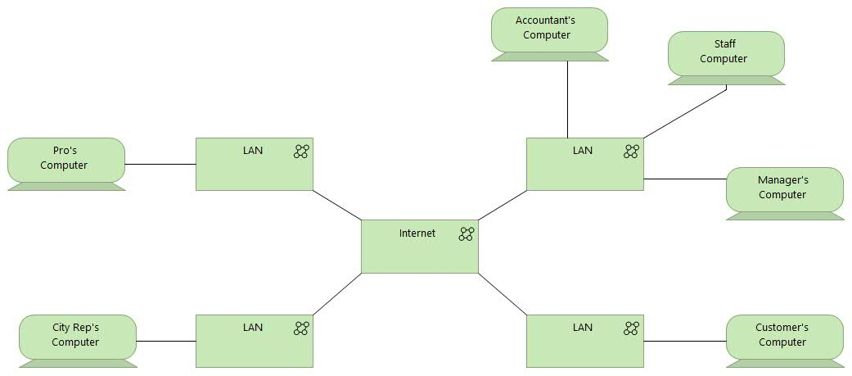
Infrastructure Landscape
The tennis club’s infrastructure is distributed besides the computers that are used at the tennis club. The tennis club does not provide any devices to the employees besides the computer used at the tennis club. The accountant, staff and manager will all connect their
device to the same local area network when they are on-duty at the tennis club but they can also connect from outside the tennis club. The club members, pros and city representative can access the club’s online resources from outside the club via the internet.
Infrastructure Viewpoint
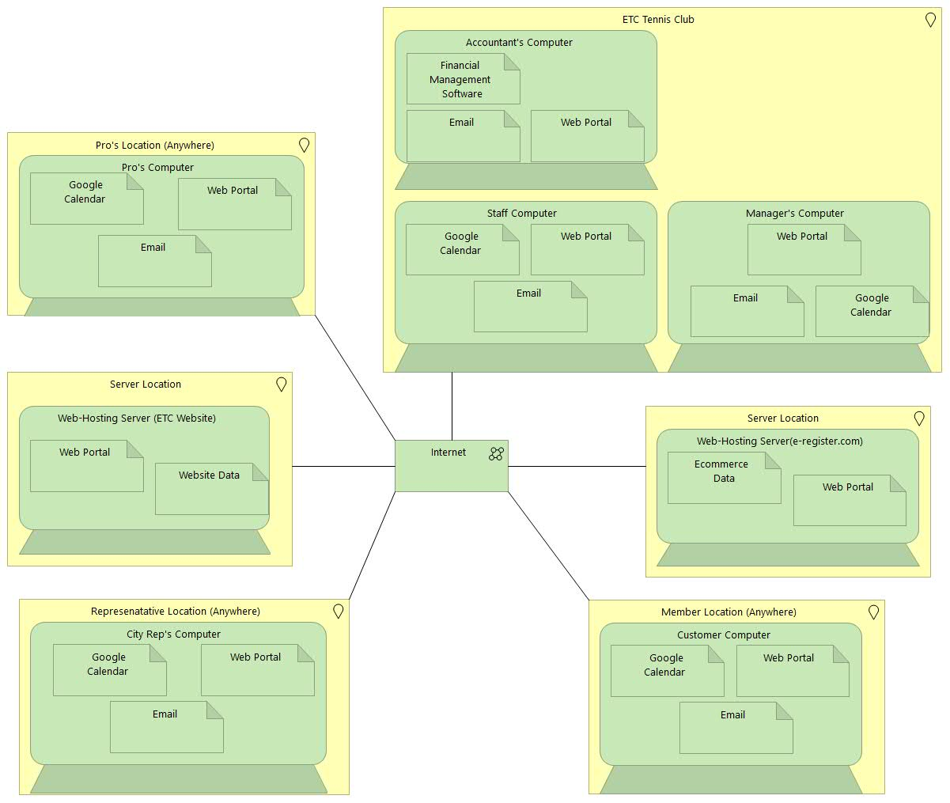
The Infrastructure viewpoint contains the software and hardware infrastructure elements supporting the Application Layer, such as physical devices, networks, or system software (e.g., operating systems, databases, and middleware). (Jonkers, Band, & Quartel, 2012)
The tennis club does stores its data in a server located somewhere else and each device utilizes the internet to access the club website. The club website is also connected to e-register.com through the internet. Each computer uses Google Calendar through the internet to access and view the club schedule. The stewards and manager use Google Calendar to edit, view and update the club schedule which is reflected on the club website via the internet. The accountant utilizes the financial management software located on his/her device to perform financial upkeep and accounting duties. The club connects to its social media applications (Facebook, Twitter) through the internet.
Change Scenario (New Online Booking System)
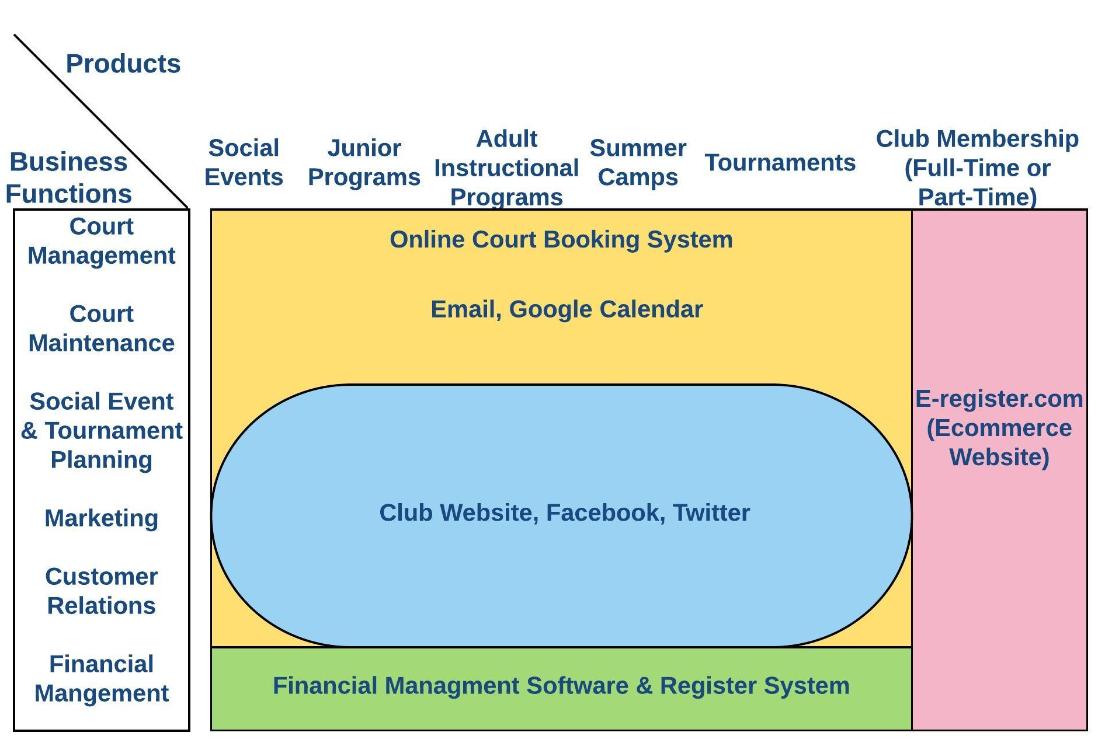
The application landscape will require a minimal change to reflect the usage of the new online booking system. The court booking aspect of court management will be the main user of the new software through club members.

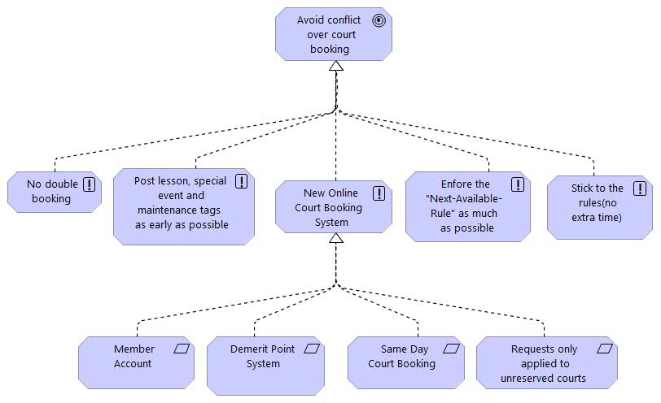
The goal refinement viewpoint for the change will show what changes are made, the principles that help realize those goals and any constraints or requirements that are involved in those principles.
The new court booking system will help reduce conflict over court booking primarily for club members. The new booking system can only used by members who have registered an account and utilizes a demerits point system. The system will also only allow same day court booking through the online system and those court requests are only applied to courts that are not reserved for special events, lessons, or maintenance. This would help reduce conflict over booking because members would already know the time for their court booking.
Phase B : Target Baseline Architecture & Gap Analysis
The business architecture of the Elmdale Tennis Club will not change in this scenario because the new system will not affect their organizational structure or ways of doing business.
Requirements Realization
The Requirements Realization viewpoint allows the designer to model the realization of requirements by the core elements, such as business actors, business services, business processes, application services, application components, etc. Typically, the requirements result from the goal refinement viewpoint. (Jonkers et al., 2012, p. 24)
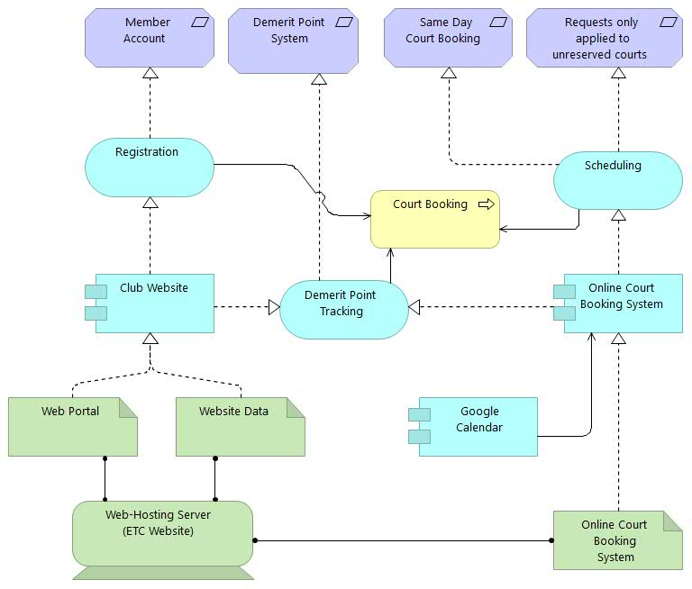
The new online booking system will utilize the existing functionalities of the Elmdale Tennis club to help make court booking easier and more seamless. The club website can be used for online member account registration and Google Calendar can be used for scheduling purposes. The club website and online booking system can be used in conjunction to help track demerit points by member account. Google Calendar will be used to track missed booking appointments and the club website will be used to match those appointments to the relevant member account to allocate demerit points. The court booking process will utilize these services to check if a member is allowed to reserve a court using the online system.
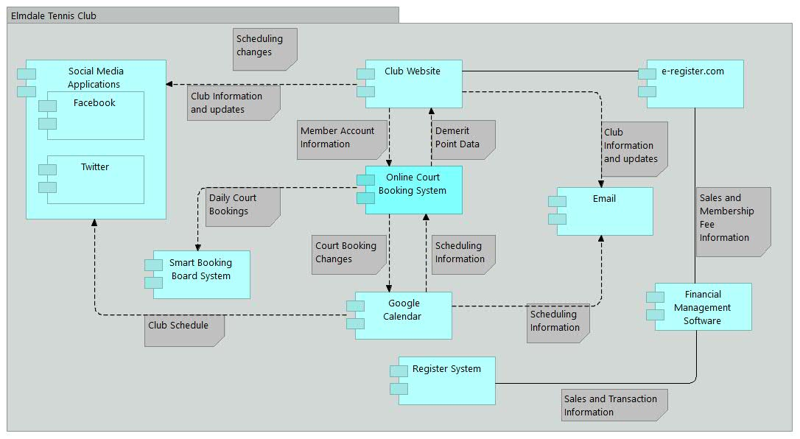
Phase C: Target Application Architecture and Gap Analysis
The diagram above shows the target application architecture and how the changes affect the data exchanges and interrelationships.
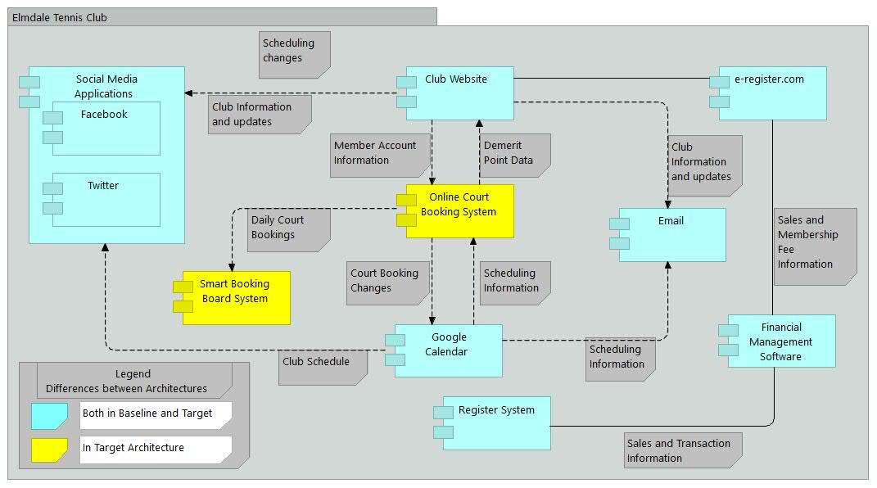
The gap analysis shown below displays that the change does not disrupt the other applications and integrates smoothly. The new online booking system will sit in between the exisiting club website and Google Calendar applications while utilizing their functionalities to offer new services. The court booking system also exhanges daily booking information with the smart booking board system which the smartboard uses to display on the touchscreen monitor.

Phase D: Target Technology Architecture and Gap Analysis
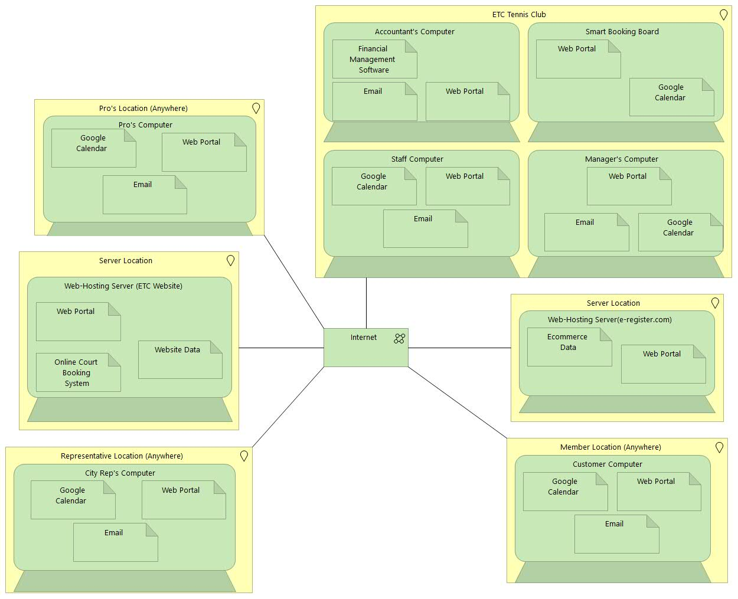
The diagram below shows the target architecture and the changes to the technical infrastructure landscape.
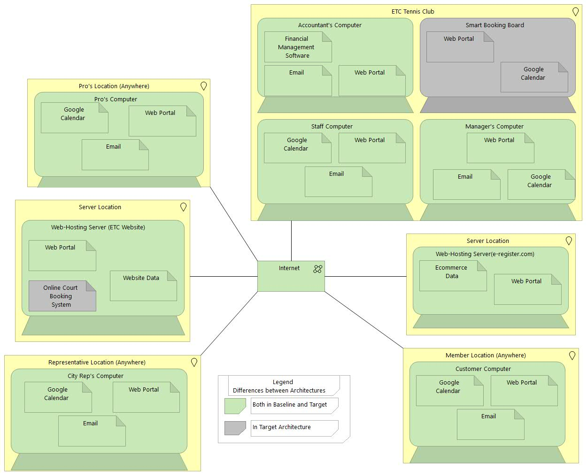
The diagram shown below displays the gap analysis between the target and baseline technology architecture. There are very minimal changes needed due to the fact that the online court booking system will use existing functionalities of the Elmdale Tennis Club. The first key change is the storage of the online court booking system in the club website server because this would allow for easy access of member account and court schedule data. This would also save the cost of buying a new server to store the new system. The consolidation of data storage on the club website server will also allow for easy access and maintenance. The second key change is the addition of the smart booking board which will connect to the online booking system through the internet to retrieve daily court bookings and display them on the touchscreen.

References
A Little History « Elmdale Tennis Club. (2016). Retrieved October 14, 2016, from http://elmdale.ca/about-us/a-little-history/
Code of Conduct « Elmdale Tennis Club. (2016). Retrieved October 14, 2016, from http://elmdale.ca/about-us/a-little-history/
Cousins, T., & MacKinnon, M. (2013). Elmdale Tennis Club Manager’ Manual. Elmdale Tennis Club.
Governing By-Laws « Elmdale Tennis Club. (2016). Retrieved October 14, 2016, from http://elmdale.ca/about-us/governing-by-laws/
Court Usage « Elmdale Tennis Club. (2016). Retrieved October 14, 2016, from http://elmdale.ca/court-usage/

