KEY QUESTIONS 68, 69, 70, 71, 72
68)
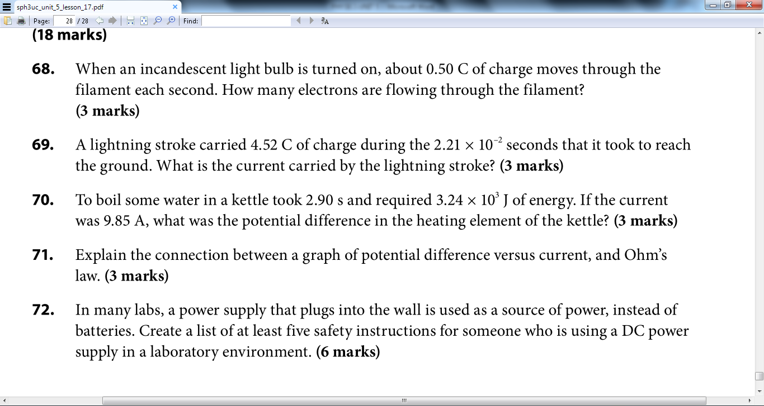
$$Q=Ne →N=\frac{Q}{e} \\ =\frac{\left(0.50 C\right)}{1.60x{10}^{-19} C}=3.1x{10}^{18} \\ 3.1x{10}^{18} electrons are flowing through the filament.$$
69)
$$I=\frac{Q}{∆t}=\frac{4.52C}{2.21x{10}^{-2}s}=205 A$$
The current carried by the lighting stroke is 205 amperes.
70)
$$V=\frac{E}{I∆t}=\frac{3.24x{10}^{3}J}{9.85Ax2.90s}=113 V$$The potential difference in the heating element of the kettle is 113 volts.
71)
$$V=IR is known as Ohm^{'}s law.$$
V: Potential Difference (voltage)
I: Current
R: Resistance
The graph of potential difference versus current indicates a linear relationship; therefore, the slope which is represents resistance is constant. For this reason, when slope is constant and assuming a fixed resistance, potential difference (V) and current (I) are both directly proportional. If you increase or decrease potential difference then current will increase or decrease.
72)
- Before use electrical wires should be checked for any damage on or in wires to avoid significant hazards.
- Electrical equipment near wet areas should have ground (ground-fault interrupters) which shuts off power if current is flowing on an unintended path to prevent electric shock.
- Electrical equipment should be kept away from any liquid including flammable liquid to prevent fire.
- Workers should know the location of shutoff switches in event of fire.
- Chemical or water spills should be minimized near electric equipment because water is a good conductor of electricity and catch fire.
- If not in use the supply should be stored in a dry and well ventilated place and should be unplugged if storing for a long time.
- Do not touch internal parts of the supply when turned on as current is flowing and could release an electric shock.
- Make sure clothing is dry and that rubber equipment or insulating material is being worn for example, rubber boots and gloves. When rubber equipment or any insulated clothing are worn, electric current does not pass through the body since there is no path available to travel from.

KEY QUESTIONS 73 and 74

73)
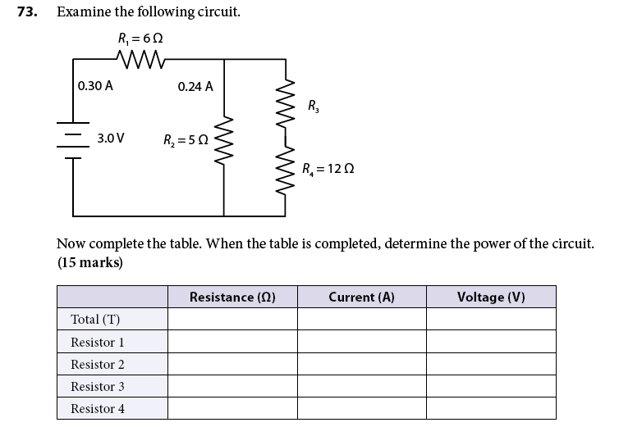
Given data is highlighted in blue. Circuit above is a mixed circuit.
 | Resistance ($Ω$) | Current (A) | Voltage (V)
Total (T) | 10 | 0.30 A | 3.0 V
Resistor 1 | 6 | 0.30 | 1.8
Resistor 2 | 5 | 0.24 A | 1.2
Resistor 3 | 8 | 0.06 | 0.48
Resistor 4 | 12 | 0.06 | 0.72
Calculations:
$V_{2} across R_{2}= V_{3}+V_{4}$
$$I_{3}=I_{4}=0.30A-0.24A=0.06 A \\ V_{3}=0.48 V$$
$$R_{3}=\frac{V_{3}}{I_{3}}=\frac{0.48V}{0.06 A}=8 Ω$$
$$R_{T}=\frac{V_{T}}{I_{T}}=\frac{3.0V}{0.30}A=10 Ω$$
$$V_{2}= V_{3}+V_{4}=V_{AB}$$
$$V_{1}=6Ω x 0.30 A=1.8 V$$
$$V_{4}=0.06 x 12=0.72 V$$
$$V_{AB}=V_{3}+V_{4}$$
$$1.2= V_{3}+0.72$$
$$V_{3}=1.2-0.72=0.48$$

74)
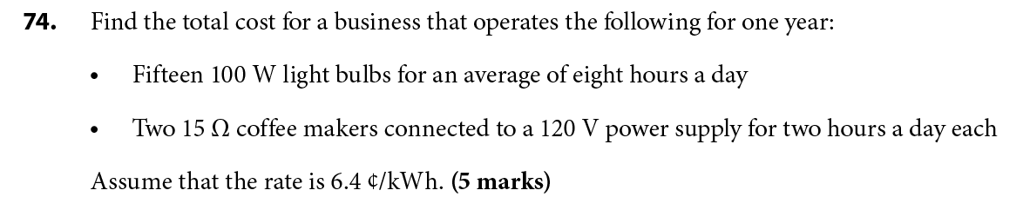
- $$P=15 x 100 W=1500 W or 1.5 kW$$
$$∆E=p∆t=1.5 kW x 8hr=12 kWh$$
$$The energy used per year:12 kWh x 365 days=4380 kWh$$
$$cost= ΔE x rate=4380 kWh x 6.4¢/kWh$$
$$cost=28,032¢ or \$280.32$$

- $$P=\frac{V^{2}}{R}=\frac{{1200}^{2}V}{15Ω}=960 W or 0.960 kW$$
$$2 x 0.960 kW=1.92 kW$$
$$∆E=p∆t=1.92 kW x 2hr=3.84 kWh$$
$$The energy used per year: 3.84 kWh x 365 days=1401.6 kWh$$
$$cost=ΔE x rate=1401.6 kWh x 6.4¢/kWh$$
$$cost=8970.24¢ or \$89.70$$

The total cost for a business that operates the above for one day is 370.02 dollars as calculated below.
$280.32 + $89.70 = $370.02

KEY QUESTIONS 75, 76, 77, 78
75)

76)
Current flows through the circuit, coming out of the positive terminal in circuit 1, hitting the metal which is wrapped around a coil, this would create a strong magnetic field , which would then act upon the 2nd circuit. Then proceeds to close the 2nd switch, the current in the 2nd circuit can then flow.
This device is an example of an electromagnetic relay.
NOT INSTANTLY

