Chapter 7: The Nature and Creation of Contracts

Introduction to Contracts:
- A contract is an agreement that contains legally enforceable rights and obligations.
- A meeting of the minds is a shared decision to enter into a legal transaction on a particular basis
- An exchange of value occurs when the parties each give up something
- A simple promise is not legally enforceable
- A contractual promise is legally enforceable
- Elements of a Contract:
- The parties must have an intention to create legal relations
- They must reach a mutual agreement through the process of offer and acceptance
- They must enter into a bargain by each giving consideration

Intention to Create Legal Relations:
- An intention to create legal relations arises if a reasonable person would believe that the parties intended to create a legally enforceable agreement
- Objective Test of Intention:
  - What would a reasonable person believe?
  - Test is applied at time of purported contract
- The courts usually presume that an intention to create legal relations exists in a commercial context, but no intent between friends or family

Offer:
- An offer is an indication of a willingness to enter into a contract on certain terms
- An offeror is the party making the offer
- An offferee is the party receiving the offer

Invitation to Treat:
- The problem is that a contract is created as soon as an offer is accepted. So if an offeror receives multiple acceptances, there could be multiple contracts created when the offeror can only enter into one contract. Therefore, we need a mechanism to reduce the risk of liability
- An invitation to treat is not an offer but an indication of a willingness to receive an offer. In this case:
  - The person responding to the invitation is the offeror
  - The person making the invitation if the offeree
- Distinguishing Offers vs. Invitations to Treat:
  - Objective reasonable person test
    - Would a reasonable person believe that the person making the statement intended to enter into a contract as soon as an acceptance is received?
    - Advertisements and catalogues are presume to be invitations to treat
      - Recall the example in which 10 people see your advertisement and they each want to buy a car. If your ad is classified as an offer, you might be held liable to fulfill 10 contracts even though you have only two cars to sell. However, if your ad is classified as an invitation to treat, each response is an offer, which you are free to accept or reject.

Communication of Offer:
- A statement is not an offer unless it is communicated and received as an offer
- Communication may take many forms
  - Written document
  - Oral statement
  - Conduct

The Life of An Offer:
- An offer turns into a contract by acceptance. An offer may be terminated before acceptance:
- Revocation
- Lapse of time
- Death or insanity
- Rejection
- Counter offer

- Revocation
  - Revocation occurs if the offeror (master of the offer) withdraws an offer
    - Offeror generally free to revoke at any time
    - Revocation must be communicated to offeree
  - Firm Offer
    - A firm offer occurs when the offeror promises to hold an offer open for acceptance for a certain period
    - An option is a contract in which the offeror is paid in exchange for a binding promise to hold an offer open for acceptance to a specific period
  - Tenders
    - A tender is an offer to undertake a project on particular terms
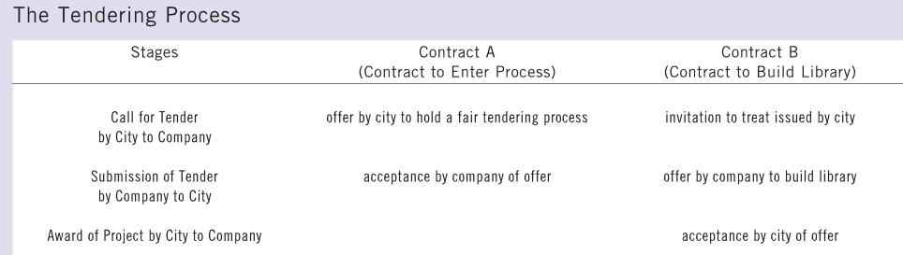

- Lapse of Time
- An offer lapses by passage of time
  - Offeror can set a termination date
  - If there is no termination date, an offer is open only for a “reasonable period”
  - Relevant factors in deciding what is a “reasonable period”
    - The subject matter of the contract
    - The nature of the agreement
    - The volatility of the market
    - The usual practice in the industry

- Death or Insanity
- An offer generally lapses if there is death or insanity, since there is no meeting of minds with dead or insane persons
- However, an offer does not lapse if there is no need for personal performance, and the offeror’s representative can perform the agreement instead

- Rejection
- Rejection occurs when the offeree refuses an offer
- A rejection terminates an offer. The offeree therefore cannot subsequently revive the offeror’s offer
- For example, suppose Bruno offers to sell his business to Helga for $100K. If she says, “No, thank you, I’m not interested,” the offer is dead. She later cannot accept it if she changes her mind unless Bruno repeats his initial offer, Helga must make an offer to him and hope that he accepts it.

- Counter-Offer
- A counter-offer occurs when an offeree responds to an offer by indicating a willingness to enter into a contract but on different terms
- A battle of the forms occurs when each party claims to have entered into a contract on the basis of its own standard form document
- Problems arise if both parties insist upon using their own forms (which contain different terms)
- To decide which contractual form applies, a judge will consider:
  - The usual practice in the industry
  - Past dealings between the parties
  - The precise sequence of events
  - The forms, if any, that the parties actually signed



Acceptance:
- Acceptance occurs when the offeree agrees to enter into the contract proposed by the offeror
- The contract is created immediately upon acceptance
- Acceptance must be a response to an offer
  - There is no contract if we have “cross-offers” (e.g. two letters containing the same terms sent at the same time)
- Forms of Acceptance:
  - Acceptance by promise
  - Acceptance by performance

Acceptance By Promise:
- A bilateral contract occurs when a promise is exchanged for a promise.
- Suppose, that you offer to sell your car for $750. To accept your promise to transfer ownership of the vehicle, I promise to pay the price.
- Rules for Acceptance:
  - Offeror (master of offer) can impose conditions
    - Set rules for time, place, and form of acceptance
  - Acceptance must be reasonable if no rules were set by offeror



Acceptance at a Distance:
- When a contract is not created in face-to-face interaction, and the offeror and offeree are far apart from each other, there are legal issues to address:
  - When does the acceptance have effect?
    - When is it sent or when it is received?
  - Where does the acceptance have effect?
    - Where is it sent or where is it received?
  - What if communication never arrives?
    - Offeror’s problem or offeree’s problem?

- Instantaneous Communications
  - The general rule states that acceptance by instantaneous communication is effective when and where it is received by the offeror
  - An instantaneous communication is any form of communication in which there is little or no delay in the interaction between the parties
  - Includes many modern forms of communication, including phone, fax, or email
  - The General Rules:
    - Suppose that while you are in Alberta, you telephone your insurer, which is located in Manitoba, and accept its offer of coverage. Your acceptance takes effect when and where it is received. Your contract is formed in Manitoba when your insurer hears you say, “I accept.” However, if your statement was inaudible because you went under a tunnel while driving, a contract would not be formed.
      - Communication effective when received
      - Communication effective where received
      - Communication effective only if received
- Non-Instantaneous Communications
  - A non-instantaneous communication is any form of communication that involves a substantial delay between the time that it leaves one person and reaches another
  - The postal rule states that an acceptance that is communicated in a non-instantaneous way is effective where and when the offeree sends it
  - Includes postal letters, courier packages
  - The Postal Rules:
    - Suppose I mail a letter from Saskatoon accepting your offer to pay me $5000 to deliver a series of lectures in Charlottetown. My acceptance takes effect as soon as I send the letter, rather than when you receive it. (which can be a few days in the mail)
      - Acceptance effective when sent
      - Acceptance effective where sent
      - Acceptance effective even if not received
  - Limitations on postal rules
    - Can be eliminated by offeror (you could say that a letter of acceptance is effective only when and where you actually receive it)
    - Applies only to acceptance, not to offers, revocations, rejections, or counter-offers

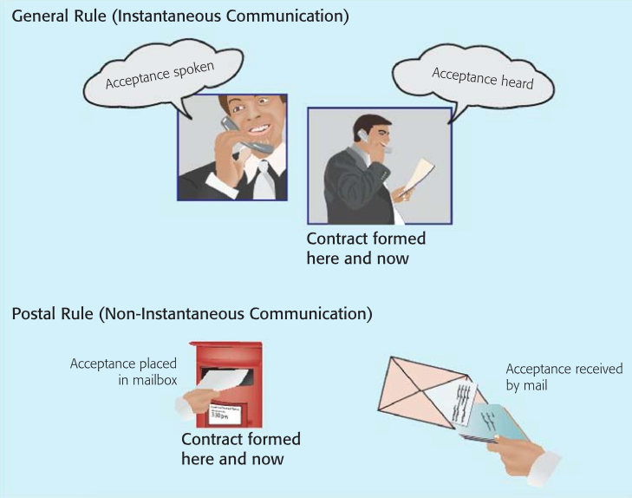

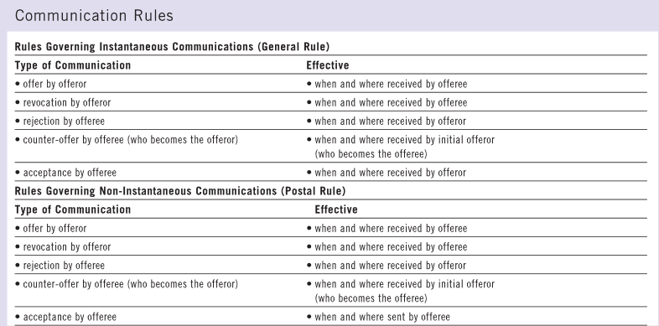

Acceptance By Performance:
- A unilateral contract occurs when an act is exchanged for a promise
- Elements of Unilateral Contract:
  - No contract exists unless and until the offeree fully performs
  - If the offeree performs and the contract is created, the offeror is the only one with an outstanding obligation to perform
- Suppose I offer to pay $100 to anyone who finds and returns my lost cat. At that point, we do not have a contract, and you are not required to look for her however, a contract may be created if and when you bring her home to me. If so, you will not be obligated to do anything more, but I will be expected to pay the reward
- Nature of unilateral contract
  - Contract created once requested act is performed
    - Offeree must intend to accept offer
  - One-sided obligations after contract created
    - Offeree has already fully performed
    - Offeror must still perform in future



Unilateral Contracts:
- The danger of unilateral offers
  - Disappointment for offeree
    - No contract until there is full acceptance (and performance)
    - Offeror can revoke the offer before full acceptance
- From a risk management perspective, however, we must be mindful that:
  - The courts may interpret offer as bilateral offer
    - Both parties bound before any performance
  - The court may find two unilateral offers
    - Offer to pay reward for service
    - Offer to not revoke main offer

REVIEW QUESTIONS:

- What is meant by the term "meeting of the minds?" How is it significant to the formation of contracts?
The phrase “meeting of the minds” refers to a mutual agreement to enter into a legal transaction on a particular basis. (Lawyers often use the phrase consensus ad idem.) A meeting of the minds is significant to the formation of contracts because it shows that the offeror and offeree agreed to enter a contract on certain terms and that they are willing to be bound to those terms. Meeting of the minds occurs through the process of offer and acceptance. Significantly, however, contract law, as usual, takes an objective approach to the issue. Consequently, while rare, a person may be bound by an agreement, even without intending to do so, as long as the reasonable person would have thought they intended to be bound.

- What is a "comfort letter"? What rights and obligations do the parties have under a comfort letter?
“Comfort letters” arise in connection with the requirement that the parties have an intention to create legal obligations. Just as the parties have freedom to contract, so too they have freedom not to contract. Consequently, even if the other elements of contract formation (eg offer, acceptance, consideration) are in place, a court will first ask whether, on an objective assessment, the parties intended to be legally bound by their promises. If not, then although they could have created a contract, they have chosen not to do so. A court will respect that choice.

There is a presumption that parties in a commercial setting do intend to create legal relations. That presumption may be rebutted, however, by evidence to the contrary. Such evidence may take the form of a comfort letter.

A comfort letter is only somewhat comforting in practice. It provides the writer’s promise to perform in a certain way, but it also stipulates that that promise is not legally enforceable. Notwithstanding its inability to create legally enforceable obligations, a comfort letter is valuable to the extent that the writer cares about his or her reputation. A business person who breaks a promise — even a promise that is not legally enforceable
— will be a less desirable trading partner in practice. Comfort letters therefore provide
some assurance that an undertaking will be honoured.

- What risks are associated with offers? Describe two techniques by which the courts reduce those risks.
Since a contract comes into existence as soon as an offer is accepted, the offeror must be careful to avoid offering more than he or she is willing or able to provide. Not only is the offeror obligated to honour the promises contained in the agreement, he or she will be unable to alter the contents of that agreement, or bring the contract to an end, without the agreement of the other party.

The courts have developed two techniques to reduce these dangers. First, judges have developed careful guidelines for deciding which statements qualify as offers. To qualify as an offer, the person making the statement must have the intention to create legal relations. This means that the offeror must have intended that the proposed agreement would be enforceable in law. The test for deciding this issue is an objective one that asks whether the reasonable person, viewing the circumstances as a whole, would believe that the parties intended that the agreement would be legally binding. The court will not take into account the subjective intentions of the parties because: (i) a person could easily lie about the matter, and (ii) one of the primary aims of contract law is to protect reasonable expectations. A court will try to protect the party who, on the basis of his reasonable expectations, may have made arrangements in anticipation of the contract being fulfilled. The courts have also simplified matters by assuming that offers made in a commercial context are generally enforceable, while offers made in a family or social context generally are not. However, these presumptions may be disproved where there is evidence to the contrary.

The second way judges reduce the risks of making an offer is by placing limits on how statements can function as offers. The courts classify some statements about proposed transactions not as offers, but rather as invitations to treat. An invitation to treat is an invitation for others to make an offer and shows a willingness to receive an offer. The test for deciding whether a statement is an offer or an invitation to treat is also an objective one. The court will ask how a reasonable person would interpret a disputed statement in light of all the circumstances.

- Provide a translation of the phrase quantum meruit. Briefly explain the significance of the phrase in connection with the law of contracts.
“Quantum meruit” is a Latin phrase that means “as much as it is worth.” A contract requires offer and acceptance, at least one of which usually involves the payment of a price. Those elements are most easily established when the parties expressly provide offer and acceptance. Nevertheless, a contract may be created even if offer and acceptance are implied rather than express. That may happen if, for instance, a person walks into a restaurant and says simply, “A cheeseburger and a milkshake.” That statement is interpreted by the reasonable person as both a desire to receive the meal and an offer to pay for it. By filling the order, the restaurant provides its acceptance. (Acceptance may occur earlier if the server says something like, “I’ll bring it right up.”) Furthermore, even though neither party mentioned a price, the initial demand implied a willingness to pay a reasonable price. A court would consider all of the circumstances, especially the price list on the restaurant’s menu, in settling on a dollar figure.

- Why do the courts generally rely upon an objective test rather than a subjective test when deciding contractual issues?
The objective “reasonable person” test allows the courts to create a fictional person in order to determine what the parties should have done or thought in the circumstances. The objective test provides the courts with considerable flexibility and makes it possible for a judge to equally say what a reasonable person would or would not have intended. In addition, a test based on subjective intentions would be difficult to apply for two reasons. First, a person could easily lie at trial about what his or her intentions were. Second, a primary aim of the law of contracts is to protect reasonable expectations. Since the business world could not function properly unless people were entitled to rely on outward appearances, the courts will protect the reasonable expectations and interpretations of the parties.

- What is an "option"? When and why is an option important?
An option is a contract in which the offeror is paid in exchange for a binding promise to hold an offer open for acceptance for a specific period. The concept is important because the offeror, as master of the offer, normally is entitled to revoke the offer anytime prior to acceptance by the offeree. That is true even if the offeror issued the offer as a “firm offer,” promising that the offeree would have a certain period of time within which to accept.

An option consequently provides a way in which the offeree of a large offer can compel the offeror to hold that offer open as promised. The option is a separate contract. In exchange for receiving a price (usually a small, but significant, sum of money), the offeror of the large offer agrees to hold that large offer open. Because the promise to hold the large offer open is now contained within its own contract, it is enforceable.

Suppose, for instance, that the defendant offered to sell Blackacre to the plaintiff for $1 000 000. The plaintiff needs a week to think about the possibility before accepting or rejecting. The defendant, however, prima facie can revoke the sale offer at any time. To preclude that possibility, and to compel the sale offer to remain open for a week, the plaintiff may persuade the defendant to create a new contract: an option. In exchange for the plaintiff’s payment of, say, $5000, the defendant enforceably agrees to hold the sale offer open for one week

- Distinguish between an offer and an invitation to treat. Give an example of each. How does the distinction help to promote commercial activity?
An offer is an indication of a willingness to enter into a contract on certain terms, whereas an invitation to treat is an indication of a willingness to receive an offer. The test for deciding whether a statement is an offer or an invitation to treat is an objective one. The court will ask how a reasonable person would interpret a disputed statement in light of all the circumstances. In applying the test, the courts tend to apply certain presumptions: (i) the display of an item on a store shelf, even if marked with a price tag, is an invitation to treat, and (ii) a statement placed in a newspaper or catalogue is generally an invitation to treat. However, an advertisement may be considered an offer if a reasonable person would read it that way. For instance, an advertisement that states, “Men’s 12 speed mountain bike. $400. First come, first served” is an offer, whereas “Men’s 12-speed mountain bike. Seller will accept best offer” is an invitation to treat. The distinction helps to promote commercial activity by eliminating the offeror’s danger of being immediately bound to an unmanageable number of contracts.

- Briefly discuss the commercial and ethical implications of revoking a firm offer.
Revocation occurs if the party who made the offer withdraws it. The offeror is generally entitled to revoke the offer at anytime. But where the offeror promises to hold an offer open for acceptance during a certain period, special attention is required. Strictly speaking, since there is no exchange of value in return for the firm offer, the promise to hold the offer open is not enforceable in law. From a commercial viewpoint, this flexibility is important because it allows the offeror to negotiate with other potential buyers. However, from an ethical perspective, it may be in the offeror’s best interest to honour firm offers. In addition to maintaining good business relations, keeping one’s promises generates goodwill for the business.

- What is a "cross-offer"? Can two cross-offers create a contract? Explain your answer.
“Cross-offers” occur when two people offer each other a contract on the same terms. That would be true, for example, if you wrote a letter to me saying “I will buy your car for $5000” and I write a letter to you saying, “I will sell my car to your for $5000.” It may appear that a contract is created because you and I share the same idea at the same time. A contract, however, requires more than a coincidence of ideas. It requires a consensus ad idem—a meeting of the minds. A contract is created only if one person offers and another person accepts that offer.

- Describe how the tendering process works. Explain the two types of contracts that are involved.
The tendering process limits the revocation of offers during the period in which they are being considered and otherwise ensures a fair bidding process. The courts have found that two contracts may be formed under the tendering process. Under Contract A, the call for tenders is an offer to enter into a special contract to hold a fair tendering process in exchange for an irrevocable bid. In that context, the bid constitutes acceptance of the offer under Contract A. Under the second contract, the call for tenders serves as an invitation to treat to receive offers to enter into the larger Contract B. In that context, the bid constitutes an offer to enter into Contract B. There will be one Contract A for each party that submits a tender, but there can be only one Contract B between the party calling the tenders and the party that submits the winning bid.

- Identify and briefly explain the various ways in which an offer may come to an end.
An offer may come to an end in five different ways.
  - Revocation
    - If an offer has not been accepted, and if the offeror is not compelled to hold the offer open for acceptance under the terms of an option, the offeror is entitled to revoke the offer. Revocation is simply the termination of an offer. Revocation normally can be made in the same manner as the original offer (eg an offer that appeared in a newspaper may be communicated by a revocation in the same paper).
  - Lapse of Time
    - Even if an offer has not been accepted or revoked, it will lapse after the passage of a reasonable time. The calculation of that reasonable period depends upon the circumstances, including the terms of the offer, the nature of the goods, the volatility of the market, and industry practice.
  - Death or Insanity
    - An offer usually comes to an end if, prior to acceptance or termination buy other means, either the offeror or the offeree dies or becomes insane. At least in theory, a mind that no longer exists or that has become defective cannot contribute to a consensus ad idem (a “meeting of the minds”) and therefore cannot support the creation of a contract. In practice, however, an offer may be accepted, notwithstanding death or insanity, if performance of the proposed contract was not personal to the parties — eg if the offer was a simple offer to sell land for a monetary price, rather than a proposal to exchange the performance of a concert for the creation of a computer program. If the offeror’s and offeree’s personalities are not crucial to performance, it may be open for their estates to adopt the agreement.
  - Rejection
    - An offer is terminated if it is rejected by the offeree. Once it is thereby terminated, it cannot unilaterally be revived by the offeree if that party has a change of heart. The offeree must make a new offer or hope that the offeror reiterates and recreates the original offer.
  - Counter-Offer
    - A counter-offer is an attempt to accept an offer but on varied terms. Any variation of the original terms constitutes a counter-offer. And that counter-offer constitutes a rejection of the original offer and the creation of an entirely new one. The offeror and offeree thereby trade positions.

- "As long as it is communicated to the offeror, acceptance is always effective, even if it is communicated in a different manner than the original offer." Is that statement true? Explain your answer.
The statement is not true. As a general rule, the offeree is entitled to communicate acceptance by any reasonable means. As a result, for example, a written offer may be accepted orally, or vice versa. The choice does not always lie with the offeree, however. Most importantly, the offeror is the master of the offer and therefore can stipulate that acceptance must be communicated in a particular manner. Furthermore, even if the offeror has not expressly required a particular form of communication, the circumstances may restrict the offeree’s options.

- What is the effect of rejecting an offer? Why do you think the rule is set up this way? If you change your mind after rejecting an offer, what can you do to revive the transaction?
An offer is terminated once it is rejected. This means that it cannot later be accepted if you, as the offeree, later changed your mind. The rule is set up this way to ensure that there is only one “master of the offer.” In order to revive the transaction, you could do one of two things. You could either ask the offeror to repeat the initial offer or can make an offer yourself and hope that the original offeror accepts.

- What is a “counter-offer?” What effect does a counter-offer have on an offer?
A counter offer occurs when an offeree responds to an offer by indicating a willingness to enter into a contract, but on different terms. A counter offer has the effect of rejecting an existing offer and creating a new one, thereby switching the parties’ roles. Consequently, any attempt to modify the terms of the offer amounts to a counter offer. But because the general rule regarding counter offers tends to inhibit commercial transactions, the courts sometimes characterize an offeree’s statement not as a counter offer, but rather an as inquiry (which does not kill the offer).

- Describe the problems that arise from a “battle of the forms”
A battle of the forms arises when each party claims to have entered into a contract on the basis of its own standard form document, but the parties’ documents incorporate different terms. From a time and cost-saving perspective, it makes sense for a business to use the same form for every transaction. A problem arises, however, where the offeree responds to the offeror with its own standard form containing terms that do not exactly match the terms of the offer. In that situation, the offeree is making a counter offer rather than an acceptance. A further difficulty occurs if the agreement is executed rather than executory. In that situation, the court must address the fact that the parties have already performed. In order to determine which contractual form will govern the transaction, a court will look at a number of factors, including: (i) the usual industry practice, (ii) past dealings between the parties, (iii) the precise sequence of events, and (iv) the forms (if any) that the parties actually signed. The battle of the forms was the subject of Additional Teaching Suggestions in an earlier part of this chapter.

- What is the difference between a bilateral contract and a unilateral contract? How is each type of contract accepted?
A bilateral contract is a contract in which a promise is exchanged for a promise. A unilateral contract is a contract in which an act is exchanged for a promise. A bilateral contract can be accepted by words or conduct, whereas a unilateral contract can only be accepted by the performance of a stipulated act.

- Can an offer ever be accepted through the offeree’s silence? Why or why not?
Silence, by itself, cannot amount to acceptance. The reason for this is to discourage individuals and businesses from foisting obligations upon people. If, however, the parties habitually create contracts on the basis of silence, or if the offeree does something that the reasonable person would interpret as acceptance, silence can amount to acceptance. That exception is especially important when a customer agrees to purchase goods that are sent to her unless she returns them within a stated period (as under a book- of-the-month club).

- What is the difference between instantaneous and non-instantaneous forms of communication? How is that difference relevant to the formation of contracts?
Instantaneous communication is any form of communication in which there is little or no delay in the interaction between the parties. Non-instantaneous communication involves a substantial delay between transmission and receipt. The difference in the form of communication is particularly relevant because it determines when and where the contract was formed. Acceptance by instantaneous communication is generally effective when and where received by the offeror. Acceptance by non- instantaneous communication, on the other hand, is generally effective where and when the offeree sends it.

- “An offeror who is willing to receive an acceptance by mail always runs the risk of being bound by a contract without knowing it” Is that statement true? Explain your answer
The statement is not true. As a general rule, non-instantaneous communications are governed by the postal rule. The postal rule states that a contract is formed when and where an acceptance letter is put into a mailbox or delivery system. If that rule applies, then it certainly is possible that the offeror will be bound to a contract, without knowing it, if the letter becomes lost. Significantly, however, the postal rule is merely a default rule. As master of the offer, an offeror can insist upon any form of acceptance. Consequently, even if an offeror is willing to receive an acceptance letter by mail, it remains possible to say that the postal rule is inapplicable. (That intention may be express or implied.) If so, then the offeree is entitled to accept by post, but a contract will be formed only if, when, and where the offeror actually receives the letter.

- “An offer of an unilateral contract is always accepted through the performance of some act. An offer of a bilateral contract is never accepted through the performance of some act” Are those statements true? Explain your answer.
The first statement is correct; the second statement is incorrect.

A unilateral contract is an agreement under which, at the time of creation or formation, only the offeror has outstanding primary obligations to perform. The contract is “unilateral” precisely because only one party has duties to fulfill. The offeree also performs, of course, but that performance also comprises the stipulated act of acceptance. When acceptance is effective and the contract comes into existence, the offeree has nothing left to do. Suppose, for example, that I say to you, “I will pay you $5000 if you walk to Calgary.” There is no contract at the outset. Moreover, there will be no contract unless and until you fully perform the stipulated act — ie walking to Calgary. A contract will come into existence only if and when you take the final step into that city. At that point, you have both accepted my offer and fully performed your part of the bargain. Only I have an outstanding obligation to perform — ie payment of $5000 to you.

A bilateral contract is an agreement under which, at the time of creation, both parties have at least some outstanding primary obligations. A bilateral contract, in other words, involves the exchange of a promise for a promise. In the classic bilateral agreement, the parties provide offer and acceptance through words. Orally or in writing, each says, in effect, “I promise ….” The promise of performance, however, also may be communicated in other ways, including the performance of some act. For example, by walking into a restaurant and saying, “A cheeseburger and a milkshake,” I not only evince a desire for the meal, but also offer to be bound to an enforceable agreement for the provision of food. My offer is implicit in my act. Likewise, acceptance may be communicated through actions If I walk into your hair salon and silently sit in a chair while you cut my hair, I implicitly have accepted your offer to cut hair for a price. (If no price is stipulated, a court will award quantum meruit or “as much as it is worth.”)

