STUDY GUIDE – PSY MIDTERM II 2016
PSY100- TEST 2
Learning & Memory | Ch. 6 (all Modules)  Ch. 7 (all Modules)
Memory & Thought | Ch. 8 (Modules 8.1, 8.2)
Development & Personality | Ch. 10 (all Modules)  Ch. 12 (all Modules)
Social Psychology, Motivation & Emotion | Ch. 13 (all Modules)  Ch. 11 (all Modules)

LEARNING & MEMORY
Chapter 6

Classical Conditioning: Learning by
Pavlov’s Dogs: Classical Conditioning of Salivation
- Pavlov studied digestion, using dogs
- Discovered that you could teach the salivary system by feeding dogs when a sound went off, eventually making them drool whenever they heard the sound
- Classical conditioning: learning that occurs when a neural stimulus elicits a response that was originally caused by another stimulus
  - Defining characteristic is that a neural stimulus comes to elicit a response
- Unconditioned stimulus: stimulus that elicits a reflexive response without learning
- Unconditioned response: is a reflexive, unlearned reaction to an unconditioned stimulus
- Conditioned stimulus: once neutral stimulus that later elicits a conditioned response because it has a history of being paired with an unconditioned stimulus
- Conditioned Response: the learned response that occurs to the conditioned stimulus

Classical Conditioning and the Brain
- The connections between specific groups of neurons become strengthened during each instance of classical conditioning

Processes of Classical Conditioning
Acquisition, Extinction, and Spontaneous Recovery
- Acquisition: the initial phase of learning in which a response is established
- Extinction: is the loss or weakening of a conditioned response when a conditioned stimulus and unconditioned stimulus no longer occur together
- Spontaneous recovery: the reoccurrence of a previously extinguished conditioned response, typically after some time has passed since extinction

Stimulus Generalization and Discrimination
- Stimulus generalization is a process in which a response that originally occurs to a specific stimulus also occurs to different, though similar, stimuli
- Discrimination: which occurs when an organism learns to respond to one original stimulus but not to new stimuli that may be similar to the original stimulus

Applications of Classical Conditioning
Conditioned Emotional Responses
- Conditioned emotional responses: consist of emotional and psychological responses that develop to a specific object or situation
- Watson and Rayner, trained a child to associate a scary noise with white rats.
- When an organism learns a fear-related association such as a tone predicting the onset of a startling noise, activity occurs in the amygdala, a brain area related to fear
- If an organism learns to fear a particular location, such as learning that a certain cage is associated with an electrical shock, then context-related activity in the hippocampus will interact with fear-related activity in the amygdala to produce contextual fear conditioning
- Psychopathy: disregard the feelings of others

Evolutionary Role Fear Conditioning
- Skin conductance response: such as palms sweating
- Preparedness: the biological predisposition to rapidly learn a response to a particular class of stimuli

Conditioned Taste Aversions
- Conditioned taste aversion: acquired dislike or disgust of a food or drink because it was paired with illness
- Ways they develop: illness associated with food poisoning, the flu, medical procedures, or excessive intoxication
- Humans are biologically prepared to associate food, but not sound, with illness
- Latent inhibition: occurs when frequent experience with a stimulus before it is paired with a US makes it less likely that conditioning will occur after single episode of illness

Learning Without Awareness
Drug Use and Tolerance
- Cues that accompany drug use can become conditioned stimuli that elicit drug cravings
- Conditioning can also influence drug tolerance, or a decreased reaction that occurs with repeated use of the drug
- Conditioned drug tolerance: more of the drug will be needed to override these preparatory responses so that the desired effect can be obtained

Sexual Arousal
- Fetish: involves sexual attraction and fixation on an object
- A conditioned sexual fetish can form if there is an association between the object and sexual encounters

Paradox of “Diet” Beverages
- Humans actually become conditioned to the foods and drinks that they consume, including those that contain real sugar. Sweet tastes send a message to the body that a high dose of calories is on the way.
- The artificially sweetened taste of a diet soda is not followed by a high dose of calories that your body “expects.” So how does the body respond? It continues to send out hunger messages: Your gut “tells” you to make up for the calories by opening up a bag of cookies or potato chips. This linkage may very well help explain why; overall, artificially sweetened beverages do not promote weight loss.

Operating Conditioning: Learning through Consequences
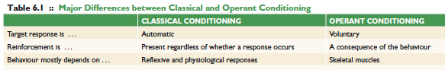
- Operant conditioning: type of learning in which behavior is influenced by consequences
  - Involves voluntary actions such as speaking or listening, starting and stopping an activity, and moving toward or away from something
- In classical conditioning a response is not required for a reward to be presented
- In operant conditioning a response and a consequence are required for learning to take place

Process of Operant Conditioning
Reinforcement and Punishment
- Reinforcement: a process in which an event or reward that follows a response increases the likelihood of that response occurring again
- Thorndike proposed the law of effect: the idea that responses followed by satisfaction will occur again and those that are not followed by satisfaction become less likely
- Reinforcer: a stimulus that is contingent upon a response, and that increases the probability of that response occurring again
- Punishment: a process that decreases the future probability of a response
- Punisher: a stimulus that is contingent upon a response and that results in a decrease in behavior

Positive and Negative Reinforcement and Punishment
- Reinforcement increases the chances of a behavior occurring again
- Punishment decreases the chances of a behavior occurring again
- Positive means that a stimulus is added to a situation
- Negative means that a stimulus is removed from a situation
- Positive reinforcement: strengthening of behavior after potential reinforces such as praise, money follow that behavior
- Negative reinforcement involves the strengthening of a behavior because it removes or diminishes a stimulus
- Avoidance learning: is a specific type of negative reinforcement that removes the possibility that a stimulus will occur
- Escape learning: occurs if a response removes a stimulus that is already present
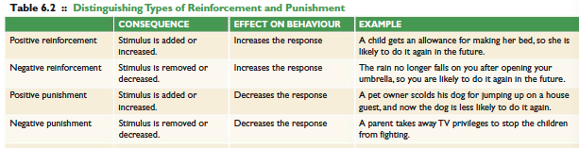
- Positive punishment: a process in which a behavior decreases in frequency because it was followed by a particular, usually unpleasant, stimulus
- Negative punishment: occurs when a behavior decreases because it removes or diminishes a particular stimulus
- The nucleus accumbens becomes activated during the processing of all kinds of rewards, including primary ones such as eating and having sex , as well as “artificial” rewards such as using cocaine and smoking a cigarette
- Secondary reinforces also trigger the release of dopamine in reward areas of the brain
- Discriminative stimulus: a cue or event that indicates that a response, if made, will be reinforced

Discrimination and Generalization
- Discrimination
  - when an operant response is made to one stimulus but not to another, even if they are similar
- Generalization
  - when an operant response takes place to a new stimulus that is similar to the stimulus present during original learning

Delayed Reinforcement and Extinction
- Extinction: the weakening of an operant response when reinforcement is no longer available
- In fact, delays of as little as half a second decrease the amount of neural activity in dopamine-releasing neurons (Hollerman & Schultz, 1996 ).
- This effect of delayed reinforcement influences a number of human behaviors

Reward Devaluation
Application of Operant Conditioning
Shaping
- Shaping is a procedure in which a specific operant response is created by reinforcing successive approximations of that response

Schedules of Reinforcement
- Rules that determine when reinforcement is available
- During continuous reinforcement every response made results in reinforcement
- Partial reinforcement: only a certain number of responses are REWARDED< OR a certain amount of time must pass before reinforcement is available
- Four types of partial reinforcement schedules:
  - Fixed ratio: delivered after a specific number of response have been completed
  - Variable ratio schedule: number of responses required to receive reinforcement varies according to an average
  - Fixed interval schedule: reinforces the firs response occurring after a set amount of time passes
  - Variable interval schedule: in which the first response is reinforced following a variable amount of time
  - Partial reinforcement effect: refers to a phenomenon in which organisms have been conditioned under partial reinforcement resist extinction longer than those conditioned under continuous reinforcement

Cognitive and Observational Learning
Latent Learning
- Edward Tolman proposed human and rats express latent learning: learning that is not immediately expressed by a response until the organism is reinforced for doing so
S-O-R Theory of Learning
- Cognitive theories of learning suggest that the individual is actively processing and analyzing information; this activity influences observable behaviors as well as our internal mental lives. Because of the essential role played by the individual, this early view of cognitive learning was referred to as the S-O-R theory
- S–O–R psychologists, on the other hand, assumed that individual differences were based on people’s (or animals’) cognitive interpretation of that situation—in other words, what that stimulus meant to them
Observational Learning
- Involves changes in behavior and knowledge that result from watching others
- The cultural differences we find in dietary preferences, clothing styles, athletic events, holiday rituals, music tastes, and so many other customs exist because of observational learning
Process Supporting Observational Learning
- Albert Bandura identified 4 processes:
  - Attention to the act or behavior
  - Memory for it
  - The ability to reproduce it
  - And the motivation to do so
Imitation and Observational Learning
- Imitation: recreating someone else’s motor behavior or expression, often to accomplish a specific goal
Mirror Neurons
- Italian researchers discovered that groups of neurons in parts of the frontal lobes associated with planning movements became active both when a monkey performed an action and when it observed another monkey perform an action
- These cells, now known as mirror neurons, are also found in several areas in the human brain and have been linked to many different functions ranging from understanding other people’s emotional states to observational learning

MEMORY
CHAPTER 7

Memory Systems 7.1
The Atkinson-Shriffin Model
- It includes 3 memory stores: retain information in memory without using it for any specific purpose
  - These stores include sensory memory, short term memory (STM), and long term memory (LTM)
- Control processes: shift information from one memory store to another
- Stages of the model:
Sensory Memory: is a memory store that accurately holds perceptual information for a very brief amount of time
Forgetting
Forgetting
Forgetting
- Iconic Memory: the visual form. Held ½-1 second
- Echoic Memory: the auditory form. Held for about 5 seconds
- George Sperling devised a method for testing the storage capacity of iconic memory
  - In his experiment, researchers flashed a grid of letters on a screen for a split second and participants had to report what they saw. Participants could only name one line of letters
  - Sperling concluded that iconic memory could hold all 12 letters as a mental image, but that they would only remain in sensory memory long enough for a few letters to be reported
- Attention allows us to move a small amount of the information from our sensory memory into STM for further processing. This information is often referred to as being within the “spotlight of attention”
- Change Blindness: the sensory memory of photograph A disappears before the onset of photograph B, making it difficult to identify the difference between the two pictures

Short Term Memory and the Magical Number Seven
- Short term memory: is a memory store with limited capacity and duration
- Magical Number Seven: Miller found participants were able to remember seven units of info. STM can rehearse only seven units of information at once before forgetting something
- Whenever possible we expand our memory capacity with chunking: organizing smaller units of info into larger, more meaningful units
  - Experience and expertise plays a role in our ability to chunk large amounts of information so that it fits into our STM

Long Term Memory: holds information for extended periods of time, if not permanently
- All information that undergoes encoding will be entered into LTM
- Once entered into LTM, the info needs to be organized. There are atleast 2 ways this will occur:
  - One way is based on the semantic categories that the items belong to. Semantically related items are stored near each other in LTM (ex: cat and dog go together like drums and guitar go together)
  - LTM is also organized based on the sounds of the word and how the word looks. Tip of the tongue phenomenon: when you are able to retrieve similar sounding words or words that start with the same letter but cant quite retrieve the word you actually want

The Working Memory Model: An Active STM System
- Rehearsal: repeating information until you do not need to remember it anymore
- Working memory: a model of short term remembering that includes a combination of memory components that can temporarily store small amounts of information for a short period of time
  - A key feature of this is that it recognizes stimuli are encoded simultaneously in a number of different ways rather than simply as a single unit for information
- Phonological loop: is a storage component of working memory that relies on rehearsal and that stores information as sounds or an auditory code
- Word length effect: people remember more one syllabus words than four/five syllabus words
- Visuospatial sketchpad: storage component of working memory that maintains visual images and spatial layouts in a visuospatial code
  - Keeps you up to date on where objects are around you and where you intend to go
  - To do this it engages portions of the brain related to perception of vision and space and does not affect memory for sounds
  - Feature binding: combining visual features into a single unit
- Episodic Buffer: storage component of working memory that combines the images and sounds from the other two components into coherent, story-like episodes
  - Holds 7-10 pieces of info
- Central Executive: is the control center of working memory; it coordinates attention and the exchange of information among the three storage components
  - It does so by examining what information is relevant to the person’s goals, interests, and prior knowledge and then focusing attention on the working memory component whose information will be most useful in that situation

Long Term Memory Systems: Declarative and Non-declarative Memories
- Declarative memories/explicit memories: memories that we are consciously aware of and that can be verbalized, including facts about the world and ones own personal experiences
- Non-declarative memories/implicit memories: include actions or behaviors that you can remember and perform without awareness

Declarative Memory (explicit memory)
- Comes in two varieties:
  - Episodic memories: declarative memories for personal experiences that seem to be organized around “episodes” and are recalled from a first person perspective (ex: first day of uni, party you went to last month)

  - Semantic memories: declarative memories that include facts about the world (ex: knowing Halifax is the capital of Nova Scotia)
Non-Declarative Memory (implicit memory)
- Non declarative memory occurs when previous experiences influence performance on a task that does not require the person to intentionally remember those experiences
- Procedural memories: patterns of muscle movements such as how to walk, play piano, drive a car
- Classic conditioning: when a previously neutral stimulus produces a new response because it has a history of being paired with another stimulus that produces that response
- Priming: based on the idea that previous exposure to to a stimulus will affect an individuals later responses

The Cognitive Neuroscience of Memory
- Lasting memories require consolidation: the process of converting short-term memories into long term memories in the brain
  - When neurons fire together a number of times, they will adapt and make the changes more permanent—a process called cellular consolidation
- The initial strengthening of synapses and longer term consolidation of these connections allow us to form new memories, thus providing us with an ability to learn and to adapt our behaviour based on previous experiences.

Memory, the Brain, and Amnesia
- Henry Molaison (neurological patient H.M.)
  - On September 1, 1953, Henry Molaison underwent a resection (removal) of his medial temporal lobes—including the hippocampus—on both sides of his brain
  - The doctors quickly determined that H.M. had amnesia — a profound loss of at least one form of memory.
  - H.M could no longer encode new information. He was experiencing a specific type of amnesia know as anterograde amnesia: the inability to form new memories for events occurring after a brain injury
  - This damage included the hippocampus and surrounding cortex as well as the amygdala. Based on H.M. and several similar cases, researchers concluded that this region of the brain must be involved with consolidating memories, enabling information from STM to enter and remain in LTM, The hippocampus also appears to be essential for spatial memories such as remembering the layout of your house or recalling the route you would take to get to a friend’s house. This function might also be linked to consolidation—remembering spatial information often involves updating a memory with new information such as learning alternative routes to get to your destination
- Memories undergo a process called reconsolidation, in which the hippocampus functions to update, strengthen, or modify existing long-term memories. These memories then form networks in different regions of the cortex where they can be retrieved when necessary
- Cross Cortical Storage: long term declarative memories are distributed throughout the cortex of the brain
- Retrograde Amnesia: a condition in which memory for the events preceding trauma or injury is lost. Common following head injuries

Encoding and Retrieving Memories 7.2
Encoding and Retrieval
- Encoding: process of transforming sensory and perceptual information into memory traces
- Retrieval: process of accessing memorized information and returning it to short term memory
- Storage: refers to the time and manner in which information is retained between encoding and retrieval
Basics of Encoding
- Maintenance Rehearsal: prolonging exposure to information by repeating it
- Elaborative Rehearsal: prolonging exposure to information by thinking about its meaning
Levels of Processing
- Levels of Processing:
  - Shallow processing involves more superficial properties of a stimulus, such as the sound or spelling of a word
  - Deep processing generally related to an items meaning or its function
  - Self reference effect occurs when you think about information in terms of how it relates to you or how it is useful to you
  - Survival processing items that are processed as they relate to survival are more likely to be recalled
Retrieval
- Recognition: involves identifying a stimulus or piece of information when it is presented to you
- Recall: involves retrieving information when asked, but without that information being present during the retrieval process.
- Encoding specificity principle: retrieval is most effective when it occurs in the same context as encoding
- Context dependent forgetting: we believe the change in the environment influenced the forgetting
- Context reinstatement effect: occurs when you return to the original location and the memory suddenly comes back

State Dependent Learning
- Retrieval is more effective when your internal state matches the state you were in during encoding
  - Ex: experienced marijuana smokers who learned info while under the effects of marijuana performed better if they received marijuana before subsequent tests than if they were sober
Mood Dependent Learning
- People remember better if their mood at retrieval matches their mood during encoding
- Mood has a very small effect on recognition memory; it has much larger effects on recall-based tests
- A persons emotional state can have an effect on encoding and retrieval
Emotional Memories
- Emotion has the tendency to enhance our memory
- This suggests that emotion’s largest influence is on the process of consolidation, when information that has recently been transferred from short-term memory (STM) into long-term memory (LTM) is strengthened and made somewhat permanent
- Emotion also changes the type of information that is encoded. Specifically, central information about the gist of a scene (e.g., a snake) receives extra attention and is more likely to be remembered than peripheral information (e.g., the flowers near the snake).
- Biological mechanism that allow emotion to influence memory:
  - Structures in the temporal lobe, the hippocampus (associated with the encoding of long term memories), and the amygdala (involved in emotional processing and responding)
  - Activity in the amygdala then influences the fi ring patterns of other temporal-lobe structures, including the hippocampus; this link is a major part of the emotion-memory relationship
Flashbulb Memories
- Flashbulb memory: an extremely vivid and detailed memory about an event and the conditions surrounding how one learned about the event
- One defining feature of flashbulb memories is that people are highly confident that their recollections are accurate
Forgetting and Remembering
- Ebbinghaus the founder of memory research
Mnemonics
- A technique intended to improve memory for specific information
- Method of loci: a mnemonic that connects words to be remembered to locations along a familiar path
- Acronyms: pronounceable words whose letters represent the initials of an important phrase or set of items
- First letter technique: uses the first letters of a set of items to spell out words that form a sentence
- Dual Coding: occurs when information is stored in more than one form (ex: verbal description and a visual image)
- Testing effect: the finding that taking practice tests can improve exam performance, even without additional studying

Constructing and Reconstructing Memories 7.3
The Schema: an active organization process
- Schemas: organized clusters of memories that constitute one’s knowledge about events, objects, and ideas
- When we encounter familiar events or objects, these schemas become active, and they affect what we expect, what we pay attention to, and what we remember
Memory Reconstruction
- Our memories are organized to a large degree by our schemas, including self-schemas
- False memory: remembering events that did not occur, or incorrectly recalling details of an event
The Perils of Eyewitness Testimony
- Misinformation effect: when information occurring after an event becomes part of the memory for that event
Imagination and False Memories
- Imagination inflation: increased confidence in a false memory of an event following repeated imagination of the event
Creating False Memories in the Laboratory
- DRM paradigm: participants study a list of highly related words called semantic associates (associated by meaning)
  - The most obvious word (critical lure) would be missing from the list
  - Many participants would name the critical lure when asked to repeat the list
  - When individuals recall the critical lure it is called an intrusion, because a false memory is sneaking into an existing memory
Danger of False Remembering
- Recovered memory: memory of a traumatic event that is suddenly recovered after blocking the memory of that event for a long period of time
- Repression: we suppress traumatic memories
- Recovered memory controversy: a heated debate among psychologists about the validity of recovered memories

MEMORY & THOUGHT
Chapter 8

The Organization of Knowledge 8.1
Concepts and Categories
- Concept: is the mental representation of an object, event, or idea
- Categories: clusters of interrelated concepts. We form these groups using a process called categorization
Classical Categories
- Classical categorization: theory claims that objects or events are categorized according to a certain set of rules or by a specific set of features
- Graded membership: the observation that some concepts appear to make better category members than others
Prototypes: Categorization by Comparison
- Prototypes: are mental representations of an average category member
  - Allow for classification by resemblance
  - The main advantage is that they help explain why some category members make better examples than others
Networks and Hierarchies
- Semantic network: an interconnected set of nodes and the links that join them to form a category
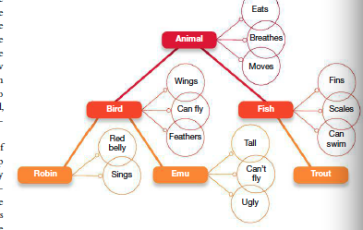
- Hierarchy: consists of structures moving from general to specific
Categorization and Experience
- Geoffrey Norman and colleagues at McMaster University found that recent exposure to an example from one category can bias how people diagnose new cases
- Our ability to form categories is based on our experiences
Culture and Categories
- Linguistic relativity/Whorfian hypothesis: the theory that the language we use determines how we understand the world
- Ex: English language has many words for different colors while Dani has a word for a bluish green color but no words for blue or green
Problem Solving, Judgment, and Decision Making 8.2
Defining and Solving Problems
- Problem solving: means accomplishing a goal when the solution or the path to the solution is not clear
Problem Solving Strategies and Techniques
- When we think logically, we rely on algorithms: problem-solving strategies based on a series of rules
- Heuristics: problem-solving strategies that stem from prior experiences and provide an educate guess as to what is the most likely solution. “Rules of thumb”
Cognitive Obstacles
- The nine dot problem is a good example
- A mental set is a cognitive obstacle that occurs when an individual attempts to apply a routine solution to what is actually a new type of problem
  - They can occur in many different situations: functional fixedness: which occurs when an individual identifies an object or technique that could potentially solve a problem, but can think of only its most obvious function
Judgment and Decision Making
Representativeness and Availability
- Representativeness heuristic: making judgments of likelihood based on how well an example represents a specific category
- Availability heuristic: entails estimating the frequency of an event based on how easily examples of it come to mind
  - In other words, we assume that if examples are readily available, then they must be very frequent
Anchoring effects
- Anchoring effect: occurs when an individual attempts to solve a problem involving numbers and uses previous knowledge to keep the response within a limited range
Framing Effects
- Decision making can also be influenced by how a problem is worded or framed
Belief Perseverance and Confirmation Bias
- Belief perseverance: when an individual believes he or she has the solution to the problem or the correct answer for a question and accepts only evidence that will confirm those beliefs
- Confirmation bias: occurs when an individual searches for only evidence that will confirm his or her beliefs instead of evidence that might disconfirm them
- Confirmation bias and belief perseverance together can dramatically influence a person’s beliefs, especially in relation to complex, emotionally charged areas such as religion and politics

DEVELOPMENT & PERSONALITY- Chapter 10 (see notes)

SOCIAL PSYCHOLOGY, MOTIVATION, & EMOTION
Chapter 12
Personality

12.1- Contemporary Approaches to Personality
- Personality: characteristic pattern of thinking, feeling, and behaving that is unique to each individual, and remains relatively consistent over time and situation

  - Idiographic Approach: creating detailed descriptions of a specific person’s unique personality characteristics (ex: “trying to figure yourself out”)
  - Can be applied to the full range of human experience

  - Nomothetic approach: examine personality in large groups of people, with the aim of making generalizations about personality structure
  - Instead of trying to understand a specific person, this approach may want to understand the factors that predict certain behaviors across people in general

The Trait Perspective
- Personality Trait: a persons habitual patterns of thinking, feeling, and behaving
- Trait descriptors are good short-cuts to understanding people
- Gordon Allport made the first attempt to identify all possible traits
  - Tallied 18000 English words that could be used to describe an individuals physical and psychological attributes
- Barnum effect “there’s a sucker born every minute”
  - The fact that it is easy to convince people that a personality profile describes them well
- Factor Analysis: used to group items that people respond to similarly (ex: the terms friendly, warm, and kind have similar meanings)
The Five-Factor Model
- Using factor analysis Raymond Cattell narrowed the list of key personality traits to 16
- Five Factor Model: a trait based theory of personality based on the finding that personality can be described using five major dimensions (Created by McCrae and Costa)
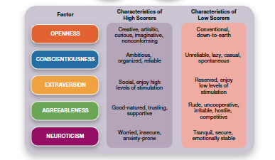

- Psychologists often find that there are other personality traits, outside of the big five, that understand certain things, such as why people do things that are evil

Beyond the Big Five: The Personality of Evil?
- Theodore Adorno suggested that the authoritarian personality is a key to why people will listen to those that encourage evil deeds (Hitler)
- Authoritarians were theorized to be rigid and dogmatic in their thinking, to separate their social world into strict categories of Us and Them, and then the belief in the superiority of Us and the inferiority of Them

- HEXACO model of personality: six-factor theory that generally replicates the five factors of the FFM and adds one additional factor: Honesty-Humility
  - Those who score high tend to be sincere, honest and faithful. Those who score low tend to be greedy and pompous.

- The Dark Triad: refers to three traits-Machiavellianism, psychopathy, and narcissism-that describe a person who is socially destructive, aggressive, dishonest and likely to commit harm in general
  - Machiavellianism: tendency to use people and to be manipulative and deceitful
  - Psychopathy: tendency toward having shallow emotional responses and little empathy towards others
  - Narcissism: an excessive focus on self-importance. They are “full of themselves”.
- Right Wing Authoritarianism: a highly problematic set of personality characteristic that involve three key tendencies:
- Obeying orders and deferring to the established authorities in a society
- Supporting aggression against those who dissent or differ from the established social order
- Believing strongly in maintaining the existing social order

Personality Traits Over the Life Span
- Our personalities start even before we are born and become more stable as we age
Personality Traits and States
- State: is a temporary physical or psychological engagement that influences behavior
- Four general aspects of situations that will influence our behavior (LASS) :
- Locations
- Associations (who you are with)
- Activities
- Subjective states (mad, sick, drunk, happy)

12.2 - Cultural and Biological Approaches to Personality
Universals and Differences Across Cultures: The Big Five
- The Five Factors of personality are found in many cultures
- Basic systems in the human personality are deeper than culture.
- Human personality system is universal

How Genes Affect Personality
Twin Studies
- Research on the big five personality traits of twins has shown that identical twins show a stronger correlation for each personality trait than do fraternal twins
- This implies that the increased similarity in the personalities of identical twins is due to their shared genes

The Role of Evolution in Personality
Animal Behavior: The Evolutionary Roots of Personality
- Aggressive vs passive are traits found in species
Why there are so many different personalities: the evolutionary explanation
- Evolutionary perspectives can help us to understand why humans have evolved the particular personality traits that we have. To the extent that the big five traits are built right into our biology, these traits must have been selected for by being adaptive in past evolutionary epochs helping to promote our survival and reproductive success

The Brain and Personality
- Humourism: which explained both physical illnesses and disorders of personality as resulting from imbalances in key fluids in the body
  - The four humors include blood, phlegm, black bile and yellow bile
- Phrenology: developed by Gall. The theory that personality characteristics could be assessed by carefully measuring the outer skull

Extraversion and Arousal
- Hans Eysenck Arousal Theory of Extraversion: arguing that extraversion is determined by peoples threshold for arousal
  - Extraverts seek greater amounts of stimulation and introverts seek to limit stimulation
- Ascending Reticular Activating System (ARAS): plays a central role in controlling this arousal response
  - Extraverts have a lower baseline for what activates the ARAS than introverts
- Behavioral Activation System (BAS): a “GO” system, arousing the person to action in the pursuit of desired goals
  - Focused on rewards and unresponsive to negative consequences
- Behavioral Inhibition System (BIS): more of a “danger” system, motivating the person to action in order to avoid punishments or other negative outcomes

Contemporary Research: Images of Personality in the Brain
- Extraversion: have a larger medial orbitofrontal cortex and less activation in the amygdala
  - Medial Orbitofrontal Cortex involved in processing reward
  - Amygdala involved in processing danger and fear
- Neuroticism: associated with the size of various brain areas. Smaller dorsomedial prefrontal cortex, smaller hippocampus, lager mid-cingulate gyrus
  - Dorsomedial Prefrontal Cortex controlling emotions
  - Hippocampus controlling obsessive negative thinking
  - Mid-Cingulate Gyrus detecting errors and perceiving pain
- Agreeableness: less volume in the left superior temporal sulcus, and greater posterior cingulate cortex
  - Left Superior Temporal Sulcus activated when interpreting another persons actions
  - Posterior Cingulate Cortex involved in empathy and perspective taking
- Conscientiousness: large volume in middle frontal gyrus involved in working memory processes
- Openness to Experience: greater action in the dorsolateral prefrontal cortex involved in creativity and intelligence

12.3-Psychodynamic and Humanistic Approaches to Personality
The Psychodynamic Perspective
Unconscious Processes and Psychodynamics
- Conscious mind: your current awareness, containing everything you are aware of right now
- Unconscious mind: much more vast and powerful but inaccessible part of your consciousness, operating without your conscious endorsement or will to influence and guide your behaviors
- Freudian Slips “slips of the tongue” offer a glimpse into the otherwise inaccessible workings of the unconscious
Structure of Personality
- Id: represents a collection of basic biological drives, including those directed toward sex and aggression
  - Freud believed the id is fuelled by an energy called libido
- Superego: comprised of our values and moral standards
- Ego: the decision maker, frequently under tension, trying to reconcile the opposing urges of the id and superego
Defense Mechanisms
- Defense mechanisms: unconscious strategies the ego uses to reduce or avoid anxiety
  - Displacement
  - Identification
  - Projection
  - Reaction Formation
  - Sublimation
The Psycho-Sexual Stages

Exploring the Unconscious With Projective Tests
- Projective Tests: personality tests in which ambiguous images are presented to an individual to elicit responses that reflect unconscious desires or conflicts
- Rorschach inkblot test: people are asked to describe what they see on the inkblot, and psychologists interpret this description using a standardized scoring and interpretation method
- Thematic Apperception Test (TAT): asks respondents to tell stories about ambiguous pictures involving various interpersonal situations

Alternatives to the Psychodynamic Approach
- Analytical psychology: focuses on the role of unconscious archetypes in personality development
- Personal Unconscious: vast repository of experiences and patterns that were absorbed during the entire experiential unfolding of the persons life
- Collective Unconscious: a separate, non-personal realm of the unconscious that holds the collective memories and mythologies of humankind, stretching deep into our ancestral past
- Archetypes: are images and symbols that reflect common “truths” held across cultures, such as universal life experiences or types of people
- Alfred Adler Inferiority complex: the struggle many people have with feelings of inferiority, which stem from experiences of helplessness and powerlessness during childhood

Humanistic Perspectives
- Person centered perspective: people are basically good, and given the right environment their personality will develop fully and normally
- Self-actualization: which is the drive to grow and fulfill ones potential

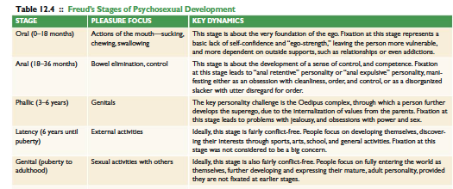

SOCIAL PSYCHOLOGY
Chapter 13
Social Psychology

The Power of the Situation: Social Influences on Behavior 13.1
Mimicry
- Mimicry: taking on for ourselves the behaviors, emotional displays, and facial expressions of others
  - Coordinating our behavior with others is a key part of learning to get along with each other
- Chameleon Effect: people mimic others non-consciously, automatically copying others behaviors even without realizing it
- Social Norms: guidelines for how to behave in social contexts
Group Dynamics: Social Loafing and Social Facilitation
- Social Loafing: occurs when an individual puts less effort into working on a task with others
- What factors encourage loafing:
  - Low efficacy beliefs: occurs if tasks are too difficult or complex, so people don’t know where to start
  - Believing that ones contributions are not important to the groups: people cant see how their own input matters to the group
  - Not caring about the groups outcome: when a person is not personally identified with the group
  - Feeling like others are not trying very hard: people loaf if they feel like others are loafing
- Social Facilitation: occurs when ones performance is affected by the presence of others
  - The presence of others is arousing, and arousal tends to strengthen our dominant responses
Groupthink
- Groupthink: refers to this stifling of diversity that occurs when individuals are not able to express their true perspectives, instead having to focus on agreeing with others and maintaining harmony in the group
- Groups in which members are more similar to each other, especially in terms of shared sociopolitical perspectives, are more likely to fall into groupthink
Asch Experiments: Conformity
- Participants were seated at a table along with several other people who seemed like other participants but who were in fact people working with the experimenter.
- They were asked to look at an image of three lines, and choose which was the same length as a “standard line.” The task was designed to be very easy Asch showed that when people were allowed to give their answers privately, they were correct almost 100% of the time. However, things changed when answers were spoken aloud in front of a group
- Normative Influence: social pressure to adopt a groups perspective in order to be accepted, rather than rejected, by a group
- Informational Influence: which occurs when people internalize the values and beliefs of the group, coming to believe the same things and feel the same ways themselves
The Bystander Effect: Situational Influences on Helping Behavior
- Kitty Genovese murder was witnessed but no one did anything to save her
- Bystander Effect: the presence of other people actually reduces the likelihood of helping behavior
- Diffusion of responsibility: which occurs when the responsibility for taking action is spread across more than one person, thus making no single individual feel personally responsible
- Pluralistic Ignorance: This occurs when there is a disjunction between the private beliefs of individuals and the public behavior they display to others
- Social Roles: are more specific sets of expectations for how someone in a specific position should behave
Social Roles: The Stanford Prison Study
- Zimbardo conducted a prison study where some subjects were arrested as prisoners and others were prison guards
- By the second day the prisoners staged a rebellion and refused to cooperate with the guards, which caused the guards to decide to use force to subdue them. Afterwards, the prisoners followed the guards orders, and tried to be good prisoners
Obedience to Authority: The Milgram Experiment
- The teacher’s job is to read a series of word pairs to the learner, and then to test him on his memory of the word pairs. The learner will be in a separate room hooked up to an electric shock machine. Each time the learner gets an answer wrong, the teacher is to administer a shock, by flipping a switch on a panel in front of him, and increasing the voltage after each wrong answer

Social Cognition 13.2
- Explicit Processes: which correspond roughly to conscious thought, are deliberative, effortful, relatively slow, and generally under our intentional control.
- Implicit Processes: comprise our unconscious thought, they are intuitive, automatic, effortless, very fast, and operate largely outside of our intentional control
- Dual-process models: models of behavior that account for both implicit and explicit processes
Person Perception
- Person Perception: processes by which individuals categorize and form judgments about other people
Thin Slices of Behavior
- We make very rapid, implicit judgments of people based on thin slices of behavior
Self-Fulfilling Prophecies and Other Consequences of First Impressions
- Self-Fulfilling Prophecies: which occur when a first impression affects one’s behavior, and then that affects other people’s behavior, leading one to confirm the initial impression or expectation
The Self in the Social World
Projecting the Self Onto Others: False Consensus and Naïve Realism
- False Consensus Effect: tendency to project the self-concept onto the social world
- Naïve Realism: We tend to assume that the way we see things is the way that they are. We think those who are different from us are wrong and also a little weird
Self-Serving Biases and Attributions
- Self-Serving Biases: biased ways of processing self-relevant information to enhance our positive self-evaluation
- We tend to assume that we are better than average, as a way to keep our self esteem intact
- Internal attribution: the observer explains the behavior of the actor in term of some innate quality of that person
- External Attribution: whereby the observer explains the actors behavior as the result of the situation (ex: a person swerving while driving to avoid debris)
- Fundamental Attribution Error (FAE): tendency to over-emphasize internal attributions, and under-emphasize external factors
  - This is influenced by culture
Ingroups and Outgroups
- Ingroups: groups we feel positively toward and identify with
- Outgroups: those other groups we don’t identify with
- Ingroup bias: as positive biases toward the self get extended to include one’s ingroups, people become motivated to see their ingroups as superior to their outgroups
- Minimal Group Paradigm: how easily people will form social categories, Us vs Them, even using criteria that are meaningless
Stereotypes, Prejudice, and Discrimination
- Stereotype: is a cognitive structure, a set of beliefs about the characteristics that are held by members of a specific social group; these beliefs function as schemas, serving to guide how we process information about our social world
- Prejudice: an affective, emotionally driven process, including negative attitudes toward and critical judgments of other groups
- Discrimination: behavior that disfavors or disadvantages members of a certain social group in some way
Improving Intergroup Relations
- Contact Hypothesis: predicts that social contact between members of different groups is extremely important to overcoming prejudice

Attitudes, Behavior, and Effective Communication 13.3
Changing Peoples Behavior
- Four of the most common approaches taken to attempt to change the publics behavior on a large scale are:
  - Technological, legal, economic, and raising awareness
Persuasion: Changing Attitudes Through Communication
- Elaboration likelihood model: when audiences are sufficiently motivated to pay attention to a message and they have the opportunity for careful processing they will be persuaded by the facts of the argument, the substance; when either of these two factors, motivation and opportunity, are missing, people will tend ot be persuaded by other factors
- Central Route Persuasion: occurs when people pay close attention to the content of a message, evaluate the evidence presented, and examine the logic of the arguments
  - Belief change that occurs during this tend to be strong and long-lasting
- Peripheral Route to Persuasion: persuasion will depend upon other features that are not directly related to the message itself, such as the attractiveness of the person delivering the information
Using Central Route Effectively
Make it personal
- Construal level theory: which describes how information affects us differently depending on our psychological distance from the information
Value Appeals
- More likely to listen to a message relevant to your values
Preaching or Flip-Flopping? One-sided vs Two-sided messages
- Attitude inoculation: a strategy for strengthening attitudes and making them more resistant to change by first exposing people to a weak counter argument and then refuting that argument
Emotions in the Central Route
- Schwarz using different fonts/bolding capture peoples attention
- Processing in fluency: Schwarz. The ease with which information is processed
- Chip and Dan Heath “The Curse of Knowledge” if an argument is overly technical, complex or use specialized language, this can create negative emotion for people
Using the Peripheral Route Effectively
Authority
- The use of authority figures can enhance a message
Social Validation
- We use the behavior of others as a guide to inform us what we should do
Reciprocity
- “You scratch my back, I’ll scratch yours”
- Door in the face technique: involves asking for something relatively big, then following with a request for something relatively small
Consistency
- Foot in the door technique: involves making a simple request followed by a more substantial request
The Attitude Behavior Feedback Loop
- Cognitive dissonance theory: when we hold inconsistent beliefs, this creates a kind of aversive inner tension, or “dissonance”, we are then motivated to reduce this tension in whatever way we can

MOTIVATION & EMOTION- CHAPTER 11
11.1Hunger & Eating
Hunger is a psychological behavior
- The study of motivation
  - Concerns the physiological & psychological processes underlying the initiation of behaviors that direct organisms toward specific goal.
  - Initiating factors = motives that lead to goal direct behavior
    - Thoughts
    - Feelings
    - Sensations
    - Bodily processes
  - Drive
    - A biological trigger that tells us we may be deprived of something
    - Causes is to seek what is needed (ex. Water/ food)
  - Motivation
    - Essential to an individual’s survival
    - Contributes to homeostasis
    - Influenced by current needs & anticipation of future needs= ALLOSTASIS

  - Homeostasis: Body’s physiological processes that allow it to maintain consistent internal states in reponse to the outer environment
  - Not every behavior is motivated by homeostatsis
    - Allostasis
      - the process by which the body responds to stressors in order to regain homeostasis.
- Hunger
  - Need to consume nutrients
    - Physiological
    - Involves Complex congnitive & emotional factors
  - On and off switch involved in hunger
    - In hypothalamus
    - Lateral hypothalamus – On switch
    - Ventromedial region of hypothalamus – off switch
    - Infleunced by hormones
      - Hypothalamus monitors blood sugar
      - Glucostats
        - Detect levels of sugar
      - Insulin
        - Rise in response to meal consumption
        - When you’re full!

  - Satiation
    - Point in a meal when we are no longer motivated to eat
    - Caused by:
      - Cholecytokinin (cck)
        - Released by neurons when the intestines expand
        - Sends info to ventromedial hypothalamus
        - Decreases apetite
    - Can also influence how rewarding we find food
      - When we eat something pleasureable there’s activity in the:
        - orbitofortonal cortex(frontal lobes above eyes)
        - Insula(receives info about taste)
        - Basal ganglia (Reponds to physical rewards)

      - Over eating leads to aversion and:
        - Reduced activity in the reward centers ^^
        - Increased activity in other areas of frontal lobes
Process of satiation

Our bodies developed to like some foods more than others
- We crave fat because of our
  - Specialized receptors on the tongue – sensitive to the fat content
  - This stimulates endorphins & dopamine – Pleasure and reward
  - High energy food
    - More powerful reinforce than highly addictive drugs
    - Stimulates release of the neurotransmitter dopamine in the nucleus accumbens – associated w/ reinforcing efforts of amphetamines & cocaine
- Stress
  - Modulates ghrelin
  - Ghrelin = Hormone secreted in the stomach – stimulates stomach contractions & appetite
  - If you predict that an upcoming event will be threatening- you react by stocking up on energy reserves even if homeostasis indicates that one should stop eating

ATTENTION & EATING
- Quantity we consume
  - Not entirely controlled by the brain or evolutionary mechanism
- Attention
  - Paying attention to what we eat has an influence on how much we eat
- UNIT BIAS
  - Tendency to assume that the unit of sale or portioning is an appropriate amount to consume
  - Ex. Bottomless soup experiment
  - Ex. Banana – ideal unit vs. Packaged food – oversized- unhealthy
- Upward trend in increased size of our meals – North America

EATING AND THE SOCIAL CONTEXT
- Social Facilitation = eating more
  - Hosts may encourage people to eat more
  - Time spent at the table
- Impression management = eating less
  - Minimal eating norm = Aspect of good manner
- Modelling = Eating whatever they eat
  - Imitating what others are eating

Eating Disorders
- Dietary habits are influenced by
  - Biological dispositions
  - Belifs
  - Perceptions
  - Bodies
  - Sociocultural factors
- OBESITY
  - Disorder of positive energy balance in which energy intake exceeds energy expenditure
  - Described as an epidemic
  - Obesity rates:
    - lowest in Quebec
    - Highest in Atlantic Canada, Territories, Saskatchewan
    - Why?
      - More different types of food to choosefrom
      - Craving fatty & energy rich foods
        - Excess- stored as fat
      - Economic
        - Poor are more affected than the rich – due to prices
- Anorexia Nervosa
  - Eating disorder that involves
    - Self- starvation
    - Intense fear of weight gain
    - Dissatisfaction with body
    - Denial of serious consequences of severely low weight
- Bulimia Nervosa
  - Eating disorder characterized by
    - Periods of food deprivation
    - Binge eating
    - Purging
    - Due to being impulsive
  - Experience:
    - Greater levels of activity in medial frontal lobe regions related to emotional processing during viewing of overweight bodies
    - When shown pictures of bodies and asked to compare- Activity present in insula (felt self disgust)
- Causes of Anorexia/ Bulimia
  - Stress
  - Lack of control over life
  - Depression, guilt, anxiety, perfectionism, low self-esteem, suppressed anger
  - Social factors
    - Peer influence
    - Thinspiration sites
    - Family
    - Control
- Reproduction suppression hypothesis
  - Females who believe they have low levels of social support from partners/ family members are more likely to engage in dieting behaviours
  - Intake can influence ovulation – lead to a loss of menstrual periods – making it less likely that the woman becomes pregnant
  - Males
    - Show reverse anorexia- loosing weight to achieve perfect body
11.2 Sex
- Libido
  - the motivation for sexual activity and pleasure.

Psychological influences of sex
  - Sex frequently occurs without an end goal of reproduction
    - This is rare in other species
    - Matrubation though occurs in primates
- Psychological Measures of Sexual Motivation
  - Alfred Kinsey
    - Tackled the topic of human sexual behavior
    - Zoology progressor
    - Interviewed his sutdents (1938-1952)
    - Shit methods
    - 37% of males – had homosexual experiences reulsting in orgasm
    - Believed
      - Heterosexuality & homosexuality - fell on a continuous scale
  - Cindy Meston & David Buss
    - Asked over 1500 Stuednts why they had sex
    - Reasons:
      - Physical
        - Physical attraction
        - Wanting to orgasm
      - Personal
        - To get a raise
        - To hurt someone
        - Emotions- felt in love/ wanted a connection
      - Social
        - Felt obligated
        - Wanted to be nice
      - Reproduction – Ranked very far down the list
- Sexuality declines in seniors

Physiological measure of sex
- Sexual arousal (biological state) can influence our feelings of desire.
- William Masters & Virginia Johson
  - 1950s – conducted research
  - Human sexual response cycle was described after observing 27 guys and 118 prostitutes who agreed to masturbate/ have intercourse while under observation
  - Participants
    - Monitored with
      - Heart rate and blood pressure equipment
      - penile/ vaginal plethysmograph
        - Measures blood flow to genitalia
  - Physiological changes that occur during sex
    - According to Masters & Johnson
    - Sexual Response Cycle
    - Describes the phases of:
      - physiological change during sexual activity
      - 4 primary stages (rope):
        - excitement
        - plateau
        - orgasm
        - resolution

Males | Females
- 1 orgasm  - refractory period – no orgasm  - resolution – unless sex is continued | - Varied response  - Multiple orgasm  - No orgasm  - Single orgasm

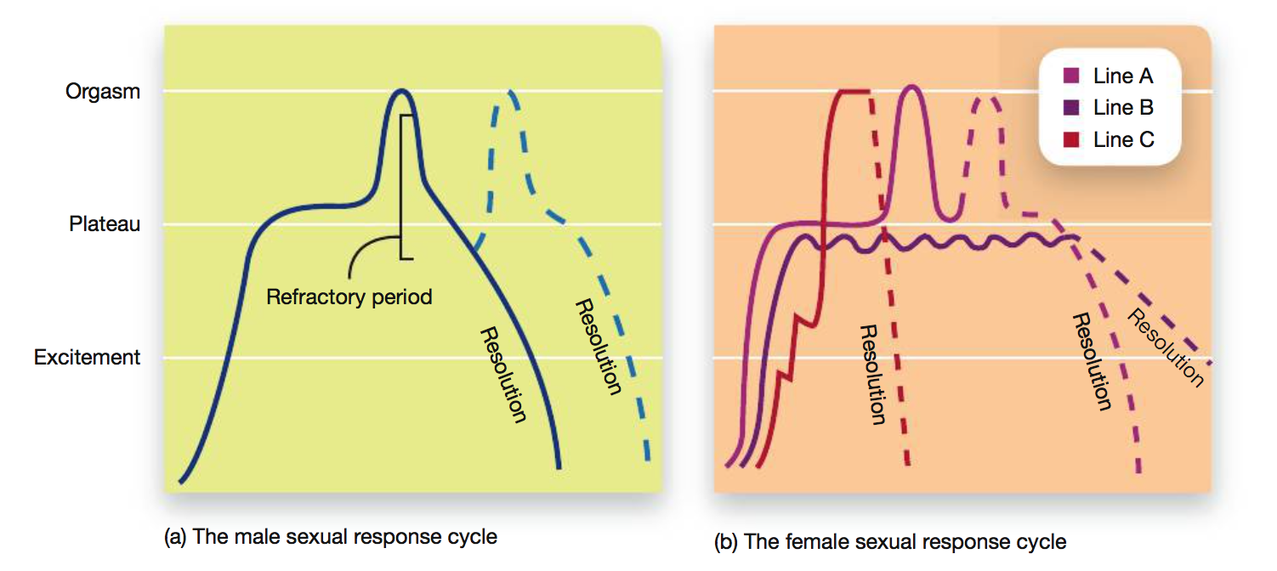
- Males and females – have a subjective experiences during orgasm
- The brain during orgasms
  - Women
  - Stimulation of nipples, and vaginal area
    - Sensory nerves hypothalamus pituitary gland release of oxytocin
    - Oxytocin – surges after orgasm & remains high after at least 5 mins.
  - Males
    - Oxytocin – released during orgasm
    - Dopamine centers of brain – highly active during orgasm
    - After ejaculation
      - Dopamine levels decrease
      - Serotonin increases
      - Once motivation has been satisfied – like with hunger

- Sexual Orientation: Biology & Environment
  - Sexual orientation
    - Consistent preference for sexual relations with members of the opposite sex (heterosexuality), same sex (homosexuality), or either sex (bisexuality).
  - Focuses on
    - Psychological aspects rather than behavioural criteria
      - Desire
      - Emotion
      - Identification
  - Reasons for variation in sexual orientation
    - Sigmund Freud (1905)
      - Homosexuality = due to bossy mother and weak father figure
    - Ellis & Ames
      - Experiencing seduction from an older sibling/ playmate
    - Interactions between biological and sociocultural factors (present day belief)
  - Simon Le Vay (1990) – neuroscientist
    - Compared brains of dead gay & heterosexual males
    - Hippocampus in gay- smaller than heterosexual
      - Could’ve been environmental
      - Some had HIV
      - Results: inconclusive
    - Stimulated curiosity
      - Research using animal subjects (sheep)
      - 8-10% of rams enjoy humping other rams
      - Smaller region of hypothalamus – only difference between those who humped males vs. females
  - Twin studies
    - Higher genetic correlation b/w identical twins that fraternal twins
    - Half of individual differences found in sexual orientation are due to genetic factors
    - Sexual orientation is not determined by gene – it only plays a part

- Cultural Influences
  - Gender roles
    - Accepted attitudes and behaviors of males and females in a given society
  - Sexual Scripts
    - The set of rules and assumptions about the sexual behaviors of males and females
  - Male sexual behaviours – based on competition for most of human history
  - Men
    - Value sexual conquest & physical attractiveness of females
  - Women
    - Taught to be less promiscuous
    - Focused on developing stable relationship before sex
    - Reasons
      - Limited supply of eggs that can be fertilized
      - Children cost money
      - Male has to be a good provider
      - Men – have an unlimited supply of eggs
        - Evolutionary goal = to pass genetic info to as many people as possible
        - Giving birth harder than just jacking off
        - Have higher Testosterone
          - Hormone involved in the development of sex characteristics and the motivation of sexual behavior
  - Reason for changing sexual scripts
    - Emergence of women’s Right movement
      - Women were thus perceived as people rather than possessions
    - Increasing presence of women in the workforce
      - Females could take care of themselves if they got pregnant
      - Didn’t need to be as careful with who they had sex with
    - The invention of the pills
      - Allowed women to have control over their lives
  - Asians
    - Lower sexual desire
    - More conservative sexual attitudes
  - Sex guilt
    - negative emotional feelings for having violated culturally accepted standards of appropriate sexual behavior, is a major factor in these differences.
  - Sexual scripts in homosexual relationships
    - Gender roles that exist with lesbians
      - Butch (traditionally masculine)
      - Femme (traditionally feminine)
Sex & Technology
- Electronic media allow for a lot of porn, sexual encounters, meeting others for sexx offlin, cyber sex
- People communicate with less inhibition via digital media compared to face to face encounters
Sex & ads
- Sexual imagery in ads – sells because it is a memory retrieval cue for a product
- Sex also interferes with our ability to think rationally about persuasive material
- Brain imaging study shoes
  - Sex ads – generated smaller neural responses in several areas of the frontal lobes
  - sexual images lead to less analysis of an ad’s contents than a purely fact-based appeal, making us more vulnerable to persuasive material.

11.3 Social & Achievement Motivation
Belongingness and Love Needs
- NEEDS
  - Self actualizing
    - The point at which a person reaches his/ her full potential as a creative, deep thinking & accepting human being.
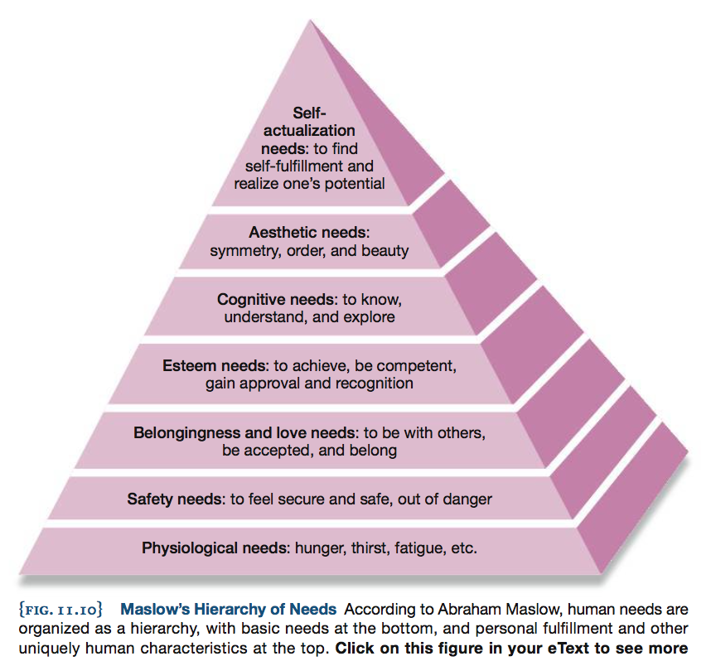
  - Criticism the model has received:
    - It’s possible to have multiple motivations simultaneously
    - Hierchy appeared to be biased towards (western) individualistic culture
    - In collectivistic (primarily eastern) cultures, self actualization would be much less important than acting to make sure everyone was getting along in the community, not just the individual was was successful
- Belonging
  - Affiliation motivation – the need to belong
    - Motivation to maintain relationships that involve pleasant feelings such as warmth, affection, appreciation, and mutual concern for each person’s well being .
    - Sense of permanence
      - An individual who has many positive social interactions with a series of different individuals does not enjoy the same satisfaction and other benefits as an individual who interacts with only a few people, but regularly and for a long period of time.
    - Social connectedness
      - Has a dramatic effect on physical health
      - Loneliness
        - Risk factor for illnesses
        - heart disease
        - cancer
        - hypertension
        - Weaker immune system
        - High stress hormones
      - This holds true even when lonely and non-lonely indivduals have the same amount of social interactions
        - The sense of belonging counts
- LOVE
  - Feeling of belonging that comes with friendships and familybonds becomes a form of love
  - You’d be willing to make great sacrifices for these people/ you trust them/
  - Romantic love
    - Berscheid & Walter
      - First scientific model of love
      - Love is composed of 2 main components
        - Passionate love
          - Physical & Emotional longing for other person
          - Fmri – active dopamine rich areas of the reward system where receptors for oxytocin exist
        - Companionate love
- Commitment
  - Factors that influence commitment
    - Initial strength of attraction
      - Happiness associated with companionship and finding someone similar, enjoyment of sex, economic benefits of being a stable relationship
    - Number of barriers to leaving the relationship
      - Children, religious conviction, social & economic pressures
    - Availability of alternatives
      - Less alternative= more likely to remain committed
  - These factors are weighed by people who consider leaving a relationship
  - Brain activity of those who view images of their exes
    - Activated brain areas in reward centers
    - As the number of days after the break up increased- activity in the brain areas related to craving went down.
- Achievement Motivation
  - Achievement motivation is a very strong force in human behavior
    - Refers to the drive to perform at high levels and to accomplish significant goals.
    - Ex. Michelle was motivated to achieve a goal – to play basketball at a high level
  - Approach goal
    - an enjoyable and pleasant incentive that a person is drawn toward, such as praise, financial reward, or a feeling of satisfaction.
    - Ex. Michelle could’ve beem motivated to make the team because she enjoyed basketball, wanted to play as much as possibl
  - Avoidance goal
    - an attempt to avoid an unpleasant out- come such as shame, embarrassment, losing money, or feeling emotional pain.
    - Ex. Michelle could’ve feared being cut from the team this year, so wanted to make the team to avoid this embarrassment
- Behaviour is influenced by
  - Seeking – reward and/ or avoiding suffering
  - Personal preferences
  - Values
  - Settings we’re in
  - Whether we feel that we’ll have the ability to achieve our goal

- SELF-DETERMINATION THEORY
  - an individual’s ability to achieve their goals and attain psychological well-being is influenced by the degree to which he or she is in control of the behaviors necessary to achieve those goals
  - Used to explain many behaviors
    - Likelihood of successfully learning a 2nd language
    - Motivation to exercise
    - Establishment of healthy identities
    - Ability to adapt to life as an international student
    - Conclusion: increasing feelings of competence, autonomy & relatedness increase motivation

  - Why do we perform or choose not to perform a behavior?
  - Universal needs
    - Needs almost all humans experience
    - Attempts to satisfy these needs influence our motivation to perform one behavior or another and can have an effect on how we act
    - Relatedness
      - Feeling connected with others
        - Satisfied by forming meaningful bonds with other people
          - Family members, teammates, colleagues,
    - Autonomy
      - Need to feel in control of own life
        - Lack of control = lack of motivation o succeed
    - Competence
      - Ability to perform a task at a skill level that’s satisfying to the indivudla
      - Our motivation is influenced by how competent we think we are
      - Ex. If a skilled basketball player didn’t think she was good enough, she wouldn’t practice as hard as she would if she believed in her abilities
  - Self-Efficacy
    - an individual’s confidence that he or she can plan and execute a course of action in order to solve a problem
- If we are able to achieve control or feel like we have control – we’ll be more motivated to perform the action necessary to achieve that goal – and be happier

Two forces of Motivation
Extrinsic motivation/ Performance motive
- Motivation geared toward gaining rewards or public recognition / avoiding embarrassment
- This type of motivation – not always most effective
  - Requires a person to give up some autonomy
  - Ex. If you play basketball to seem cool = you rely on people’s reaction to determine if you succeeded in your goal

- People can become amotivational
  - Feeling of having little or no motivation to perform a behavior
  - Ex. Parents forcing you to stop playing basketball against your will – you’d stop putting any effort
    - Neither feelings of autonomy nor competence will be met
Intrinsic motivations / Mastery motive
- process of being internally motivated to perform behaviours and over- coming challenges
  - (e.g., a genuine desire to master a task rather than being motivated by a reward).
  - Consistent with one’s values, are enjoyable, part of one’s image of one’s future self
Example:
- Children praised for being smart
  - Felt less pleasure during learning and tended to worry about how well they were doing
  - Gave up more easily & performed more upon reward (low autonomy)
- Rewards- can move people’s motivation along the continuum from intrinsic toward extrinsic
Over-justification effect
- when offering a reward ends up reducing the intrinsic motivation to perform an action.

psychologists have focused on framing messages in ways that promote intrinsic motivation.
Framing effect: when the correct course of action is not obvious, the different phrasing of the question or problem can produce different results
Positive emotions:
- make the situation seem less threatening
- there is less motivation to change things.

Negative/ frightening emotions:
- People choose the most uncertain option because it appears that larger changes are needed.
- More likely to grab people’s attention to make a change
  - By increasing people’s feelings of competence and autonomy
- Information – must include some information on how a person can solve the problem in order to work!
- Framing a message in a way that’s congruent with a person’s values
  - can influence the likelihood that people will become intrinsically motivate

  - Ex. People from different particies asked whether they’d support paying a fee for CO₂ emission. Framing – didn’t affect Democrats. When framed as – “tax”Republicans & indpendents opposed it. But when labelled as an offset- they were in favour
  - Taxes= an opposing idea for Republicans – value laden term
  - Emotional response was a motivation to support or oppose the proposed charge for carbon use.
Activity in the medial (close to the middle) region of your prefrontal cortex
- occurring in response to a persuasive message is linked with whether you will actually act on that message over the next week

11.4 Emotion
Emotional Experience:
- Detect an emotional item
- Have an initial emotional reaction prepping us to respond
- Analyze the situation
- Threatening emotional stimuli triggers an increase in the brain area related to planning movements & regions of the spinal cord

Physiology of Emotion
- Initial response
  - The brain shows emotion- dependent responses within 150 ms of seeing/ hearing a potential threat

Amygdala
- Recieves imput stimulates activity in sensory areas so they fire more Increases activity in visual & auditory cortices we pay more attention to potentially emotional stimuli
- Group of nuclei in the medial portion of temporal lobes
- Fires- when we perceive stimuli that’s emotionally arousing
- Responds to fear- relevant images & sounds
- Processing of emotions via slow & fast pathways
- Slow & fast pathways
  - Fast pathway
    - routed from sensory areas of the brain through the amygdala and directly to the autonomic nervous system for quick action.
  - Slow pathway
    - routed through the cortex where the situation is processed at a higher level of awareness.

Autonomic response: Fight/ Flight
- Autonomic nervous system consists of
  - Sympathetic nervous system
    - Helps recruit energy to prepare for a response
  - Parasympathetic nervous system
    - Helps preserve energy & calms one down if no response is necessary
Emotional Response: Movement
- Simplest movements require coordination of many different parts of our nervous system so that the muscles move in the appropriate order
Emotional regulation
- Final evaluation stage of emotional responses
  - Most complex
  - Involves many areas within frontal lobes
  - Frontal Lobes
    - Amygdala & ANS influence frontal lobes
      - Frontal lobes analyze situation & agree that an emotional response is needed generates an appropriate behavior
    - OR Frontal lobes send feedback to reduce intensity of response
      - so the ANS doesn’t deplte the body’s resources
- Emotional Regulation
  - Earliest scientific theory of emotions
  - independently developed by William James & Carl Lange
  - James- Lange theory of Emotions
    - Our physiological reactions to stimuli (ex. Racing heart) follow the emotional experience (ex. Fear)
    - Feeling of fear
      - Determined by how your body responds
      - Emotion is experienced in the following way
        - Based on initial perception of a stimulus
          - Heart races
          - Brain receives feedback about the reponse
          - Brain decides that based on the feed back you should feel fear
  - Walter Cannon and Philip Bard
    - Some of the internal organs involved in emotional feelings cant respond quickly enough to be be the first step in an emotional response
    - Feedback from the body isn’t specific enough to create different emotions we experience
    - Feeling of fear
      - Brain interprets a situation
      - Brain generates subjective emotional feelings
      - These representations in the brain trigger responses in the body
      - Steps occur almost simultaneously
    - Has less empirical support than James- Lange theory because:
      - some of the bodily feedback involved in emotional response
        - Caused by facial response that have direct connections to the brain rather than by slow responses from internal organs 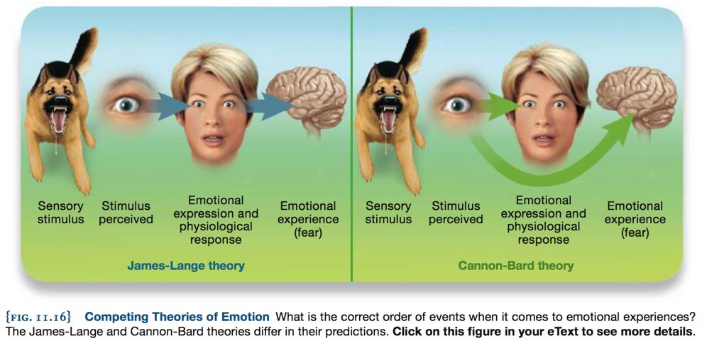
Support for James – Lange theory:
- Physical touch can influence our emotional experiences
- Ex. Holding warm cup of coffee- people described the other person to be warm and caring compared to those who held iced coffee
- Ex. Team mates who do most interpersonal touching – more cooperative, score more points, more likely to win
- Our body feels influences how our brain responds

Facial feedback hypothesis:
- More likely to experience positive feelings if you smile
- Ex. Those who held a pencil in their mouths and were told to manipulate the way they held it

- Botox
  - Interferes with the movement of muscles by inhibiting the release of the neurotransmitter acetylcholine, which is found at the junctions between muscles and nerves
- Emotional feelings also involve thoughts, memories, beliefs, and interpretations of different stimuli and situations
- Schachter & Singer theory
  - 2 factor theory of emotions
    - Pattern of physical arousal & cognitive labels we attach to them form the basis of our emotional experience
    - Physical reactions give rise to our emotional experiences
    - Physical reaction cognitive label for experience (“I’m sad”)
    - Sees a dog stimulus perceived cognitive appraisal conscious feeling of fear
- Cognitive interpretation of an emotional event can have a dramatic effect on how we experience that situation.
- Although we do have rapid physiological responses to emotional situations, it is our interpretation of those events that leads to our emotional experiences.
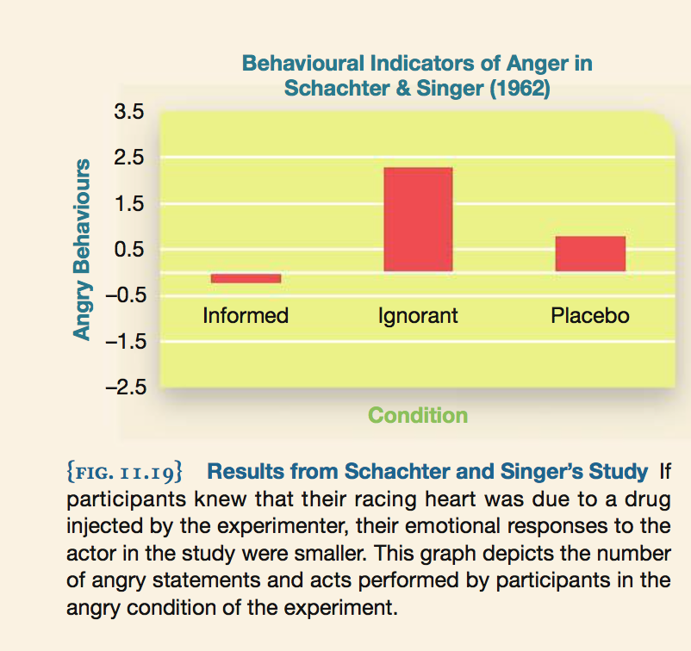

Expressing Emotions
- Polygraph
  - Measures whether heart rate and sweating increase when a person responds to different events or questions.
  - This has been proven to be crap though so people just read faces thanks to Ekman and colleagues
- Microexpressions
  - Don’t tell you why a person is concealing something

Emotional Faces & Bodies
- Each facial expression has it’s own unique combination of muscle movement
  - Crinckling of muscle near the eye orbicularis oculi
  - Movement of the mouth zygomatic major when smiling
- When making a face of disgust
  - We crinckle our noses
  - To reduce airflow into nostrils thus limiting amount of disgusting substance entering the body
    - Evolutionarily: prevents death from smell for example
  - Fear:
    - Causes us to open our eyes wide & inhale deeply
  - Our expressions- have a purpose to enhance survival
  - They’re innate & universal – like body language
- Darwin
  - First person to recognize facial expressions of emotion = universal

- Paul Ekman
  - Performed cross-cultural studies that supported Darwin’s hypothesis
  - like face
Culture, emotion & display rules
- Cultural groups have unique emotional dialects
- Emotional Dialects: variations across cultures in how common emotions are expressed.

- Example:
  - Contempt
  - North Americans are more likely to lower their brow
  - Gabonese people are more likely to raise their upper lip when expressing this emotion.

- Display rules :refer to the unwritten expectations we have regarding when it is appropriate to show a certain emotion.
- Example:
  - Embarrassment
  - Japanese – smile to avoid showing embarrassment
  - North Americans- Blush & look away
  - Sadness
  - British- Limit the emotions they feel
  - Irish – sing and drink beer
Identifying why a person is expressing a certain emotion:
- Method varies across cultures
  - Asians- Focus on those around the central person – look at the whole picture rather than the main one
  - Americans- Focus on the central person

