1. a. (3 marks) Environmental science is often described as being “interdisciplinary.” What does that mean? Give an example of an interdisciplinary approach to an environmental problem, based on something we discussed in our class lectures or from the readings.

Answer: 1 mark for definition of “interdisciplinary,” 2 marks for an example.

Note: Just listing the names of academic disciplines (Physics, Chemistry, Ecology, Geography...) is not enough for full marks – looking for a suggestion of disciplines coming together to contribute to our understanding of the environment, either in the definition or in the example.

Definition (1 mark): “Interdisciplinary” refers to a situation where people from various disciplines bring differing perspectives and expertise to bear on a problem or topic. They all contribute their expertise to find a solution that is “greater than the sum of the parts”. (OR) An interdisciplinary field employs concepts and techniques from numerous disciplines and brings research results from these disciplines together in a broad synthesis.

Example (2 marks; there are many possible examples – the example should show the contribution of at least two different disciplines, showing how they might come together to contribute to understanding or solving an environmental problem):

An example that was mentioned in class and reading: If whales are dying in an estuary, a biologist might be able to determine what is killing the whales and how pollution is affecting them, a chemist might be able to look at the nature and source of the pollution, a hydrologist might be able to shed light on drainage patterns that affect which way the pollution-bearing runoff goes, a agricultural expert or industrial engineer might be able to look at agricultural and industrial processes and make changes to limit pollution, a politician might be able to pass laws regulating the pollution, etc.

b. (3 marks) What is “carrying capacity”? What is “ecological footprint”? How are the two related?

Answer: 1 mark for carrying capacity; 1 mark for ecological footprint; 1 mark for relating them

Carrying capacity: The maximum population size that a given environment can sustain, without undergoing permanent damage.

Ecological footprint: The amount of land and water required to provide the raw materials a person or population consumes and to dispose of or recycle the waste that is produced. (OR) The resources required to support a population, translated into terms of land.

Relationship: Ecological footprint is the inverse of carrying capacity.
(OR)
Ecological footprint is land area need to support a population; carrying capacity is population that can be supported by a particular land area.

c. (2 marks) Define sustainable development.

Answer:

Development that satisfies our current needs without compromising the future availability of natural resources or future quality of life.
(OR)
Development that maximizes economic, social, and environmental goals.

d. (2 marks) What is the difference between a hypothesis and a theory?

Answer: 1 mark for hypothesis; 1 mark for theory (preferably contrasting one with the other)

A hypothesis is an educated guess that explains a phenomenon or answers a scientific question. In contrast, a theory is a widely accepted, well-tested explanation that has been extensively validated by a great amount of research.

2. a. (3 marks) Fill in the spaces indicating the three major zones or layers of Earth.
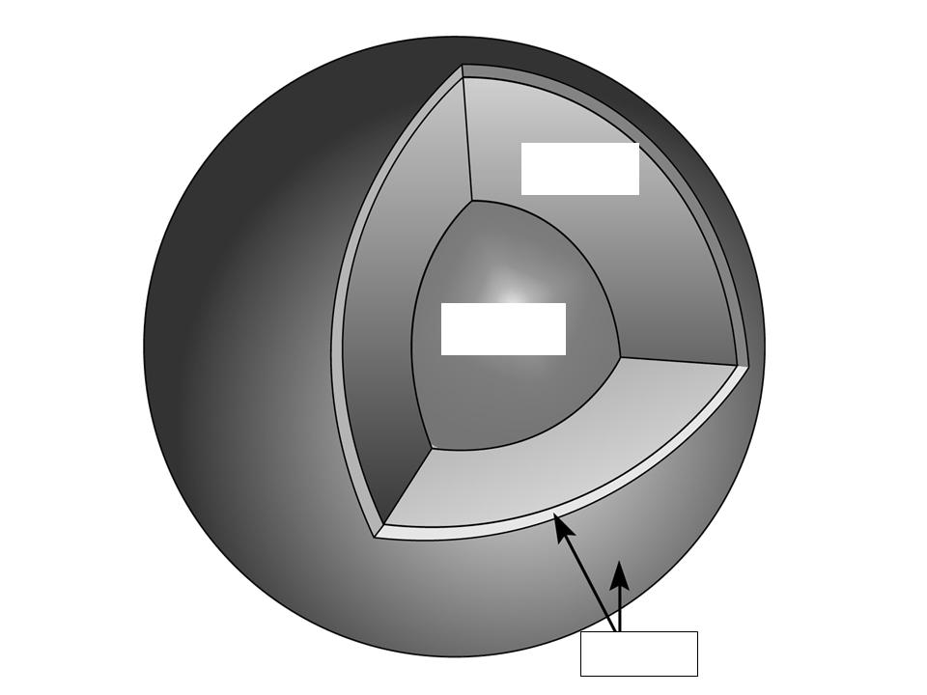

A = _________________
A

B = _________________
B
C = _________________

C

Answer: 1 mark for each

A = Mantle
B = Core
C = Crust (“Lithosphere” also accepted for full marks)

b. (1 mark) What is the force in Earth’s mantle that drives the movement of lithospheric plates?

Answer: (1 mark) Convection (I can’t think of any other possible ways to phrase this – maybe “thermal motion of rocks” or “fluid dynamic movement of mantle material” would work)

c. (2 marks) What makes Earth unique as a planet, as far as we know? Please list four things.

Answer: Any four of the following, at 0.5 marks each

- nitrogen-and oxygen-rich atmosphere (OR) particular composition of atmosphere (it is NOT sufficient to just say “atmosphere”)
- existence of water in three forms (solid, liquid, gas) at the surface (it is NOT sufficient to just say “water”)
- ecosphere (OR) conditions that support life (OR) life-supporting sphere
- biosphere (OR) existence of life
- dynamic nature of rock weathering
- dynamic, multi-component nature of soil
- dynamic nature of the lithosphere (OR) plate tectonics

d. (2 marks) Name and briefly describe one of the common hypotheses that have been proposed to explain the origin of life on Earth.

Answer: (1 mark for name, 1 mark for brief description) Any one of the following:

- Heterotrophic hypothesis (or “primordial soup” hypothesis): life evolved from a “primordial soup” of simple inorganic chemicals (based on experiments by Miller and Urey)
- Panspermia hypothesis (or “seeds from space”): microbes or organic precursors from elsewhere were delivered to Earth on meteorites
- Chemoautotrophic hypothesis (or “life from the depths” hypothesis): life originated at deep-sea hydrothermal vents, in a high-temperature environment where organisms created their food from chemicals (sulphur) rather than by photosynthesis
- There are other possibilities, not discussed in detail in class or in the readings; for example, one hypothesis suggests that life originated in “sea foam,” and another hypothesis suggests that the first RNA was patterned on inorganic molecules found in clay minerals.

e. (2 marks) Name one process that has contributed significantly to the removal of carbon dioxide from the atmosphere over the course of Earth history, and one process that has contributed significantly to the addition of oxygen to the atmosphere over Earth history.

Answer:

Removal of carbon dioxide: (1 mark) Any one of the following:

- carbon sequestration (this is actually a bit general – it’s not a specific process – but it is acceptable)
- formation of limestones
- marine organisms built shells of carbonate, which accumulated when the organisms died
- marine organisms built shells of carbonate, which were eventually made into limestones
- accumulation of organic sediments
- subduction of organic matter into the mantle
- “raining” of carbonic acid (carbon dioxide + water) from atmosphere to ocean
- incorporation of carbon dioxide into rocks

Addition of oxygen: (1 mark) Any one of the following (the MAIN answer should be “photosynthesis,” but there are various possible ways to phrase it):

- photosynthesis
- early bacteria (cyanobacteria) produced oxygen as a waste product (OR)
- cyanobacteria or blue-green algae produce oxygen by photosynthesis (OR)
- plants and other photosynthetic organisms produce oxygen and carbohydrates from carbon dioxide and water
3. a. (2 marks) Contrast the concepts of habitat and niche.

Answer: (1 mark for habitat, 1 mark for niche – preferably contrasting them)

- Habitat is the specific environment in which the organism lives.
- Niche is its use of resources and functional role in the community – in other words, habitat is where it lives, whereas niche is what it does – its “job” or role.

b. (2 marks) What is a heterotroph? Are all consumers heterotrophs?

Answer: (1 mark for “What is...” and 1 mark for “Are all...”)

- What is...: An organism that consumes other organisms.
- Are all...: Yes.

c. (3 marks) Choose one of the following types of natural selection. Explain what it is, and give an example of how it might work:
- stabilizing selection
- directional selection
- disruptive selection

Answer: Any one of the following (2 marks for “what is” and 1 mark for an appropriate examples, or 3 marks overall if the example is well integrated into the answer):

- Stabilizing selection is natural selection that preserves the status quo (OR) selection that doesn’t favour one or the other extreme, but tends to reinforce intermediate traits. For example, in the case of a snail that might have a thicker or thinner shell, stabilizing selection would tend to produce a shell of intermediate thickness. For an organism that might be larger or smaller (such as horses, for example), stabilizing selection would tend to produce horses of intermediate size.

(OR)

- Directional selection is natural selection that selects for a particular feature or trait (OR) that drives a feature in one particular direction. For example, in the case of a snail, directional selection would produce progressively thicker shells. Another example would be a giraffe selected for a progressively longer neck over the course of its evolution.

(OR)

- Disruptive selection is natural selection that reinforces traits that are NOT intermediate (OR) selection that drives features towards more than one extreme – in other words, extreme traits are favoured. For example, disruptive selection might favour both thin-shelled and thick-shelled snails, but not snails with an intermediate thickness of shell.

d. (2 marks) What is the difference between biotic and abiotic components of an ecosystem? Give an example of each, for a forest ecosystem.

Answer: (1 mark for biotic + forest-related example; 1 mark for abiotic + forest-related example)

- Biotic (0.5 marks) = living components of the environment [can include recently dead]
- Forest example (0.5 marks): tree, bird, moss, deer, etc.

- Abiotic (0.5 marks) = nonliving components of the environment
- Forest example (0.5 marks): water, sunlight, minerals/rocks (note soil is not a good example, since so much of soil is alive; 0.25 marks for soil as an example)

e. (1 mark) What is primary production?

Answer: (1 mark)

The conversion of solar energy to carbohydrates [OR sugars] during photosynthesis, performed by autotrophs.
(OR)
Production of biomass through the process of photosynthesis.
(OR)
Production of organic matter by the process of photosynthesis or chemisynthesis.
(OR) Production of biomass by primary producers (bacteria, plants).
(OR) production of biomass from inorganic materials, by autotrophs.

4. a. (2 marks) What factors influence the type of biome that forms in a particular place on land? Please list four.

Answer: (Any four of the following, at 1 mark each)

- temperature
- precipitation
- atmospheric circulation
- soil composition
- altitude
- latitude
- seasonality
- geographic factors (this is vague – only 0.5 marks for this)

b. (1 mark) What is a food web?

Answer: (Mainly looking for some suggestion of the bolded points, 0.25 marks each)

A representation of feeding interactions within an ecological community that shows an array of relationships between organisms at different trophic levels.
(OR)
A “map” of feeding relationships among organisms in an ecosystem showing the many paths by which energy flows among organisms as they consume one another.
(OR)
A number of food chains within an ecosystem that together show the complex paths by which energy moves from one trophic level to another.

c. (4 marks) Here are four examples of climatographs. Refer to the diagrams to answer the following questions, in the underlined blank spaces provided:

- Which climatograph shows a biome that is aseasonal?
- Which one shows a biome that has a clearly defined dry season and wet season?
- Which diagram shows an example of the tundra biome?
- Which diagram shows an example of the tropical rainforest biome?

Answers: 1-B, 2-D, 3-A, 4-B

d. (3 marks) Briefly describe any two of these three types of species interactions, providing an example of each:

- mutualism
- parasitism
- predation

Answer: (Any two of the following, 1 mark for each explanation + 0.5 mark for each appropriate example = 3 marks altogether)

- Mutualism: species interaction that has a positive effect on both participants (OR) that benefits all participating species.
- Example: any symbiotic relationship; corals + zooxanthellae; people + microbes in our digestive tract; pollination (bees help plants by spreading pollen, plants give bees nectar); lichen (a symbiotic relationship between fungi and algae); etc. – many other possible examples.

AND/OR

- Parasitism: species interaction that has a benefit for one but harms the other participant (OR) parasite depends on host for nourishment or other benefit; doesn’t kill host.
- Example: herbivory (animals feeding on plants); lamprey eel attaching to a fish; fungal infections of ants that alter the insect’s behaviour. (Note, there is a fine line between parasitism that harms the host, and parasitism that eventually kills the host, which is technically predation.)

AND/OR

- Predation: species interaction in which one species (the predator) hunts, captures, kills, and (usually) consumes the other (the prey).
- Example: zebra mussels eating phytoplankton; snakes eating frogs; birds eating insects; etc., many possible examples.
5. a. (3 marks) Briefly, what are the differences and similarities between plutonic rocks and volcanic rocks? Try to mention at least one similarity and two differences.

Answer:

Similarities (Any one of the following, for 1 mark):
- Both are igneous rocks.
- Both form from the solidification of molten (melted) rock.
- There are other similarities but they are beyond the scope of the course and probably won’t be mentioned.

Differences (Any two of the following, for 1 mark each):
- Plutonic rocks form under the ground; volcanic rocks form at the surface.
- Plutonic rocks cool and solidify slowly; volcanic rocks cool and solidify quickly.
- Plutonic rocks typically have coarse mineral grains; volcanic rocks typically have tiny mineral grains or no grains at all [“glassy”].
- Plutonic rocks form from magma; volcanic rocks form from lava.
- Plutonic rocks are “intrusive”; volcanic rocks are “extrusive”.
- There are other differences but they are beyond the scope of the course and probably won’t be mentioned.

b. (1 mark) What happens when two continental plates converge?

Answer: (Any one of the following, for 1 mark):

- mountain-building
- great mountain ranges are formed
- collision zone
- earthquakes
- both plates are uplifted

- Answers that are NOT CORRECT: volcanoes; subduction

c. (4 marks) Is Earth a closed system? Why, or why not? Your complete answer should include the definition of a system, and the definition of a closed system.

Answer: (1 mark for system; 1 mark for closed system; 2 marks for Earth as a closed system):

- System (1 mark): A network of relationships among a group of parts, elements, or components that interact with and influence one another through the exchange of energy, matter, and/or information. (OR) A portion of the universe that can be separated by boundaries, for the purpose of studying changes that occur within the system under changing conditions.

- Closed System (1 mark): A system that is self-contained with regard to exchanges of matter (but not energy) with its surroundings. (OR) A system in which energy but not matter can pass through the boundaries. (OR) A system whose boundaries are non-porous with regard to matter, but which allow energy to pass.

- Earth as a closed system (2 marks; must mention both energy and matter; NOTE that the answer can be either “YES” or “NO” – the important thing is the discussion.) Technically, Earth is not a closed system because both energy and matter can pass through the boundaries. However, Earth is a close approximation of a closed system because energy comes in [solar energy] and goes out [heat], but extremely little matter (in comparison to the total mass of the planet) enters or leaves the system. [Meteorites come in, space ships and hydrogen atoms leave; that’s about it.]

d. (2 marks) What does it mean to say that a system demonstrates “emergent properties”? Give an example.

Answer: (1 mark for “emergent properties”; 1 mark for an example OR 2 marks overall, if the example is well integrated into the description):

- A system is said to portray emergent properties when the system as a whole portrays characteristics that are not evident in the individual components of the system on their own. “The whole is greater than the sum of the parts.”

- For example, the individual components of a tree might be a leaf, a twig, an insect, a root, etc. Together, as a tree, they display emergent properties that none of the individual components possess on their own, such as providing shade, providing habitat, producing oxygen via photosynthesis, sequestering carbon, etc. (Other examples are possible.)

6. a. (2 marks) Please name one human activity that significantly modifies the nitrogen cycle, and one environmental impact associated with that modification.

Answer: (Any one of the following – 1 mark for activity + 1 mark for impact):

- Activity: Synthetic [chemical] fixation of nitrogen for fertilizers (OR) excess use of nitrogen fertilizers
- Impact: (any of) excess fertilizer runoff, nutrient over-enrichment of waterways, eutrophication, algal blooms, hypoxia, nitrate contamination of groundwater, blue-baby syndrome

(OR)

- Activity: Emissions containing nitrous oxides (OR) nitrogen-bearing greenhouse gases (OR) smog precursors from fossil fuel burning
- Impact: (any of) climatic change, global warming, enhanced greenhouse effect, acid precipitation, smog

(OR)

- Activity: Overly intensive agriculture, insufficient fallow periods for agricultural fields
- Impact: nutrient loss in soils

b. (2 marks) The global phosphorus cycle differs from the carbon, sulphur, oxygen, and nitrogen cycles in several fundamental ways. Please name two of them.

Answer: (Any two of the following, at 1 mark each):

- No significant vapour form. (OR) Does not occur as a gas.
- Does not occur in significant quantity in the atmosphere. (OR) Mainly involves the geosphere and hydrosphere, not the atmosphere.
- Oxidation and reduction are not important.
- Can’t be synthetically fixed – must be mined for use in fertilizer (only 0.25 marks for this because it only distinguishes P from N, not from C, O, or S.

- Answers that are NOT CORRECT: “comes from rocks” or “plant nutrient” or “limiting nutrient”

c. (2 marks) What is a positive feedback cycle? Give an example, either real or hypothetical.

Answer: (1 mark for “what is” + 1 mark for example OR 2 marks overall, if the example is well integrated into the explanation; doesn’t have to be a “real” example or even an environmental example, as long as it demonstrates a positive feedback.)

A positive feedback cycle is a feedback cycle in which output of one type acts as input that moves the system in the same direction.
(OR)
A cycle in which the input and output drive the system further toward one extreme or another.
(OR)
A cycle that could be characterized as a self-reinforcing or self-perpetuating or “vicious” cycle

Example (there are many possibilities): Global warming leads to more evaporation of ocean water, which leads to more water vapour in the atmosphere; since water vapour is a greenhouse gas, this leads to more warming.

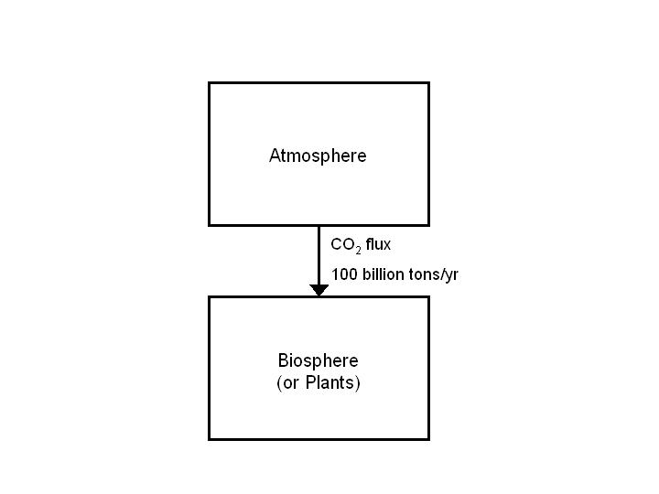 d. (4 marks) The total carbon in the atmosphere is approximately 730 billion tons, in the form of carbon dioxide gas. Plants remove 100 billion tons of CO₂ from the atmosphere through net primary production each year. How long would it take the atmosphere to run out of carbon dioxide as a result of this process, if there were no means of replenishing it?

To answer this question, please provide (1) a clearly labelled sketch of a simple box model illustrating this transfer of material from one reservoir to another, and (2) the answer and a very brief explanation of how you did the calculation (or just show how you set up the math).

Answer: (2 marks for sketch + 1 mark for brief explanation or math set-up + 1 mark for correct answer):

Explanation/Answer: Removing 730 billion tons from the atmosphere at a rate of 100 billion tons/yr:

730 billion tons = 100 billion tons/yr x (? yrs)
730 billion tons ÷ 100 billion tons/yr = 7.3 yrs

7. a. (2 marks) What is the IPAT model intended to represent or quantify? What are four of the five components that are commonly included in it?

Answer: (1 mark for “what is...” + 1 mark for four components)

The IPAT model represents or quantifies the impact of human activity on the environment (1 mark).

Components: (Any four of the following, at 0.25 marks each):

- I = impacts
- P = population
- A = affluence (or level of resource consumption)
- T = technology
- S = sensitivity of the environment to human pressures

b. (3 marks) What is one physical or social characteristic that humans have in common with apes? What are two fundamental ways in which humans differ from apes?

Answer:

Physical or social characteristics humans have in common with apes (any one of the following, at 1 mark):

- strong shoulders with wide range of movement (adapted for life in trees)
- more reliance on sight than smell
- overlapping fields of vision; 3-D sight
- ability to grasp and manipulate small objects; opposable thumb
- relatively large brain in relation to body size
- complex social lives (OR) live in large, complex social groups
- form longlasting social relationships
- participate in social bonding activities
- form strategic coalitions with each other
- genetic similarity, especially with chimpanzees

Fundamental differences (any two of the following, at 1 mark each = 2 marks):

- language (OR) ability to speak (OR) throat structure that allows speech
- bipedal
- brain is more complex and larger relative to body size
- complex reasoning ability and intellectual capacity
- elaborate culture and communications
- Someone might answer “genetic difference from apes”; I think this is only good for 0.5 marks, because in the grand scheme of things it is actually more of a “similarity” than a difference, unless the extent of the difference is specified.

c. (2 marks) Name and briefly describe one of the common hypotheses for the origin of human bipedalism.

Answer: (Naming any one of the following for 1 mark + 1 mark for including the brief explanation):

- Carrying hypothesis suggests that standing upright freed the hands, which was advantageous for carrying food or tools, and made hunting and weapon use easier.

- Thermoregulation hypothesis suggests that standing upright was advantageous for reducing exposed surface area, thus reducing the body's exposure to hot sun, leading to better cooling during the day in an open landscape.

- Postural feeding hypothesis suggests that upright posture made it easier to feed from bushes and low branches.

- Mixed woodland & savanna hypotheses suggests that standing upright led to improved vision to see over tall grass, and that a bipedal gait was better for crossing open terrain.

- Anthropology students might come up with other options that are correct.

d. (3 marks) With reference to this diagram, briefly summarize what Thomas Malthus wrote in the 1700s about human population growth and its consequences.
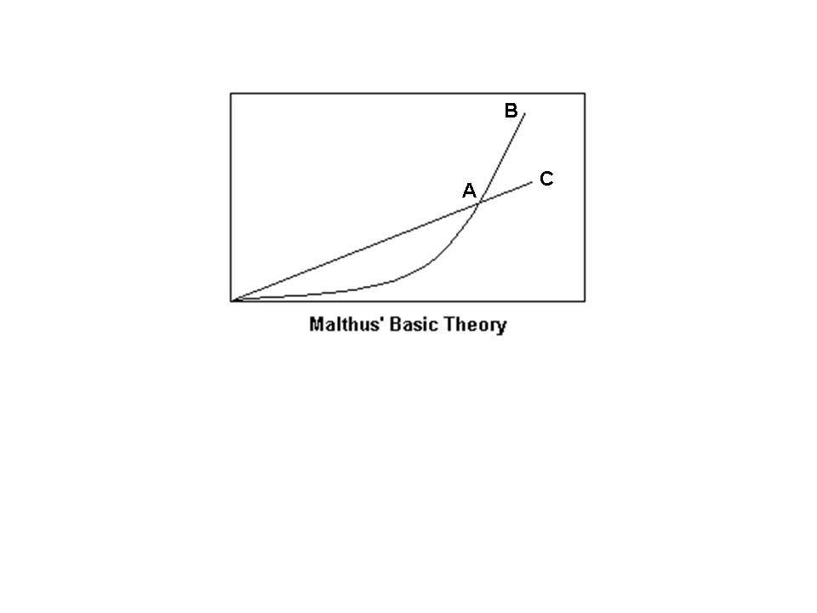
POPULATION/RESOURCE AVAILABILITY
TIME

Answer: (Note that IN PRINCIPLE, the first thing should be to LABEL the axes, but since this wasn’t specifically asked for, we won’t take off marks for not doing it; 1 mark for identifying A, B, C correctly; 1 mark for “population will exceed resource availability”; 1 mark for mentioning one or more possible consequences.)

Malthus said that population (B) grows exponentially [or geometrically] but resource availability (C) increases linearly [or arithmetically].

This means that population will inevitably exceed the availability of resources at some point (A).

Malthus said that the consequence of this would be environmental scarcity, leading to widespread death, famine, disease, war, etc.

8. a. (3 marks) What is the difference between intensification and extensification of resource production? Give an example (real or hypothetical).

Answer: (1 mark for intensification, 1 mark for extensification, 1 mark for example)

Intensification refers to increasing the resource productivity of a given unit of land, usually by applying new technologies to enhance productivity. (OR) Intensification means withdrawing resources from the environment at a greater rate. (OR) Intensification means using some means of technology to increase the carrying capacity of an environment.

Extensification means bringing more land [a greater land area] into resource production.

For example, during the Green Revolution agricultural production was intensified by the use of technologies like fertilizers, pesticides, and irrigation, but before that the only way to increase agricultural production was through extensification, that is, bringing more land into agricultural production. [There are other possible examples, such as aquaculture vs. capture fisheries.]

b. (1 mark) A farm is an example of a managed ecosystem. Name two other types of managed ecosystems.

Answer: (Any two of the following, at 0.5 marks each):

- aquarium
- seed bank
- aquaculture pens or cages
- zoo
- park
- forest plantation
- garden
- green roof
- botanical garden
- There are other possibilities.

c. (2 marks) When and where did agriculture originate?

Answer: (1 mark for “when” and 1 mark for “where”):

- When...: About 10,000 years ago (12,000 years ago is acceptable)
- Where...: In several different localities independently. (OR) Multiple locations independently, including MesoAmerica, Andes, Fertile Crescent, and eastern China.

d. (1 mark) There are five factors that influence soil formation. One is the composition of the parent material. What are two others?

Answer: (Any two of the following, at 0.5 marks each):

- climate (OR) precipitation and temperature
- organisms (OR) action of earthworms and other burrowing animals and soil microbes
- topographical relief (OR) steepness of slope
- time
- rate of weathering (this isn’t “officially” one of the factors but it is acceptable)

e. (3 marks) Briefly describe the processes of chemical weathering, physical (or mechanical) weathering, and biological weathering.

Answer: (All three of the following, at 1 mark each – 0.5 for definition + 0.5 for example)

- Chemical weathering is the breakdown of rocks as a result of interactions with water, air, or other chemicals. [examples optional: rock dissolving because of interaction with groundwater; acid precipitation or acidic surface water (such as in a bog) can cause chemical weathering; common in hot, rainy climates]

- Physical or mechanical weathering is the breakdown of rocks as a result of wearing-down processes that don’t involve any chemical change in the rock. [examples optional: water freezing and expanding in a crack; thermal expansion and contraction of rock as a result of extreme temperatures]

- Biological weathering can be either physical or chemical (or both), with an organism as the agent of weathering. (OR) Biological weathering occurs when living things break down rocks by either physical or chemical means. [examples optional: tree roots breaking apart rocks; lichens producing acid that chemically weathers rocks]

9. a. (2 marks) How does a population of organisms (such as insects) develop pesticide resistance? Explain the process.

Answer: Looking mainly for “only the strongest individuals survive and go on to mate” (for 1 mark), and “resulting population will inherit resistant genes” (for 1 mark).

When pesticides are applied, even if they are very effective and kill 99.99% of insects in a field, a few hardy individuals will likely survive. If an insect survives the application of the pesticide because of a particular characteristic that it possesses, and if it mates with other individuals that also successfully survived the pesticide, over time the resulting insect population will be increasingly dominated by individuals that are genetically resistant to the pesticide.

b. (2 marks) What were four of the agricultural technologies that collectively characterized the Green Revolution?

Answer: (Any four of the following, at 0.5 marks each):

- mechanization of farm machinery (OR) industrialization (OR) increased use of fossil fuels
- increased application of fertilizers
- increased application of pesticides [and development of new pesticides]
- increased irrigation [and development of new, more efficient irrigation technologies]
- monoculture
- use of genetically modified organisms [and development of new GM crop types]
- extensification (more land into agricultural production – only 0.25 for this, as it did happen during the Green Revolution but was also done for 1000s of years before the GR so doesn’t “characterize” the GR)

c. (2 marks) What are four environmental problems that have emerged as a result of the changes to agriculture that occurred during the Green Revolution?

Answer: (Any four of the following, at 0.5 marks each):

- depletion of groundwater
- pollution from agrochemicals (fertilizers, pesticides)
- impacts of increased energy use (fossil fuel use)
- pesticide-resistant pest species
- controversy over crop genetic engineering; escape of GM seeds into native populations
- crop genetic uniformity, loss of biodiversity as a result of monoculture
- soil nutrient depletion from monoculture
- salinization by poorly designed irrigation or over-irrigation in arid climates
- topsoil erosion resulting from mechanization

d. (2 marks) What is a transgenic organism? Please cite one common argument in favour of genetic modification of food crops, and one common argument in opposition.

Answer: (1 mark for “What is...” and 1 mark for “for/against”)

What is... (1 mark): An organism that contains DNA [or genetic material or genes] extracted and transferred from another species.

Common arguments for (any one of the following, at 0.5 mark) – GM crops can be designed with characteristics such as:

- Higher yield – more plant energy into the growth of grain instead of leaves or stem
- Faster growth – early-maturing so that multiple harvests are possible, which increases yield
- Uniform height – easier mechanized farming
- Better growth response to fertilizers – less need for fertilizers
- Drought-resistance – reduces the need for irrigation, reduces crop loss
- Higher nutritional value
- Pest-resistance – reduces the need for pesticides, reduces crop loss
- Resistance to chemicals – herbicides can be applied (for example) without crop damage

Common arguments against (any one of the following, at 0.5 mark) – potential for problems such as:

- Escape of target genes into wild populations, causing genetic contamination
- Reduction of biodiversity – GM organisms could out-breed or dilute native populations; sometimes designed to be infertile
- Human health impacts? (none yet demonstrated)
- Unintentional expression of traits in engineered organisms, such as transfer of allergens
- Decreased access for poor, small-scale farmers
- Perceived to be unfamiliar, not “natural”
- Fear: “something could go wrong”
- Questionable ethics of “messing with nature”
- Lack of labelling of food products with GM content – coerced rather than informed consent
- Perceived “evils” of big business, multinational corporations “hungry for profit,” out to crush small farmers, not accountable

e. (2 marks) In modern society we depend on a mere handful of crops as the basis of our food supply – 90% of the food we consume now comes from just 15 crop species and 8 livestock species. Why is this lack of diversity a concern? In other words, why is biodiversity important in food crops and livestock?

Answer: Looking mainly for something along the lines of, “lack of diversity makes entire population susceptible to pests” (1 mark), and “genetic diversity is the raw material that allows for adaptation to environmental change” (1 mark).

When all plants or animals are genetically similar, all will be equally susceptible to diseases, fungal pathogens, or insect pests, which may then spread quickly throughout the population. This greatly increases the chance of catastrophic failures. Genetic variability within a population or a species is what gives it the ability for some individuals to survive, thus giving the population the ability to adapt to environmental change. Populations with little genetic diversity are vulnerable to diseases, pests, and environmental change.

10. a. (4 marks) What is habitat fragmentation? Explain how fragmentation changes the character of a habitat. What are corridors, and why are they important in addressing the problem of habitat fragmentation?

Answer: (All of the following, at 1 mark each):

What is fragmentation (1 mark): Fragmentation is the process by which large expanses of habitat are broken up into smaller, isolated pieces.

How fragmentation changes the character of habitat (1 mark): Smaller habitat fragments have a greater proportion of edge, compared to the same area of habitat in one large piece. The characteristics of core and edge habitat can differ substantially [such as differences in light or moisture levels], so increasing the proportion of edge changes the character of the habitat.
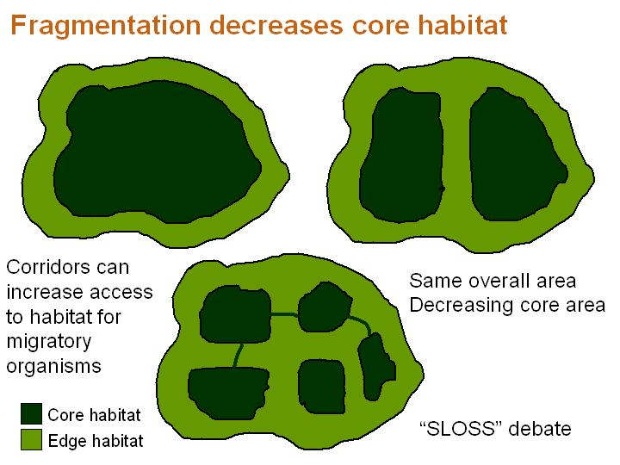
(Optional) drawing is another way to handle “how fragmentation changes the character of habitat:

What are corridors (1 mark): A corridor is a passageway of protected land established to allow animals to travel between “islands” or fragments of habitat.

Why are corridors important (1 mark): Some animals require a very large [contiguous] area of habitat, and/or they migratory animals require the ability to move among areas of habitat. If habitat is fragmented and isolated, this would not be possible. With corridors connecting the fragments, however, the animals would have the opportunity to move among them, thereby greatly increasing their access to habitat.

(Optional) drawing is another way to handle “why corridors are important”:

b. (1 mark) What is the difference between extinction and extirpation?

Answer: Extinction means that the species has completely died out (0.5 marks), whereas extirpation means that it has disappeared from a particular location – extirpation is “local” extinction (0.5 marks).

c. (3 marks) What are the three fundamental levels of biodiversity? Briefly define each of them.

Answer: (All three of the following, at 0.5 marks each):

- ecosystem [or habitat] diversity: The number and variety of ecosystems (and therefore of potential habitats) in a particular area. [Can also refer to the complexity of ecosystem structure or available habitats. OR Habitat heterogeneity and complexity.]
- genetic diversity: A measurement of the differences in DNA composition [or varieties of alleles or genes] present among individuals within a given species or population.
- species diversity: The number and variety of species in the world or in a particular region.
- Partial marks for answers such as species richness, species evenness, or β-diversity, α-diversity, or γ-diversity, all of which are just sub-components or ways of measuring or quantifying species diversity.

d. (2 marks) The letters in the acronym “HIPPO” stand for the five major causes of biodiversity loss today. “H” is for “habitat loss.” What do the other four letters stand for?

Answer: (All four of the following, at 0.5 marks each):

- I = invasive species
- P = human population
- P = pollution
- O = over-harvesting

11. a. (3 marks) What are the main differences in nutrient and water cycling in tropical rainforests, as compared to temperate forests? You can include a neatly labelled diagram as part of your answer, if you wish.

Answer: (Diagram is optional; both of the following, at 1.5 marks each):

Tropical forests have shallow root systems – they don’t need to “dig deep” because they have all the organic matter [litter] and water they need, close to the surface. In other words, nutrient and water cycling are shallow (1 mark) and nutrients are mainly stored in the biomass [trees] (0.5 marks).

In contrast, temperate forests have deep root systems – they draw both water and nutrients from depth in the soil, bringing them to the surface. In other words, nutrient and water cycling are deep (1 mark), and nutrients are mainly stored in the soil (0.5 marks).
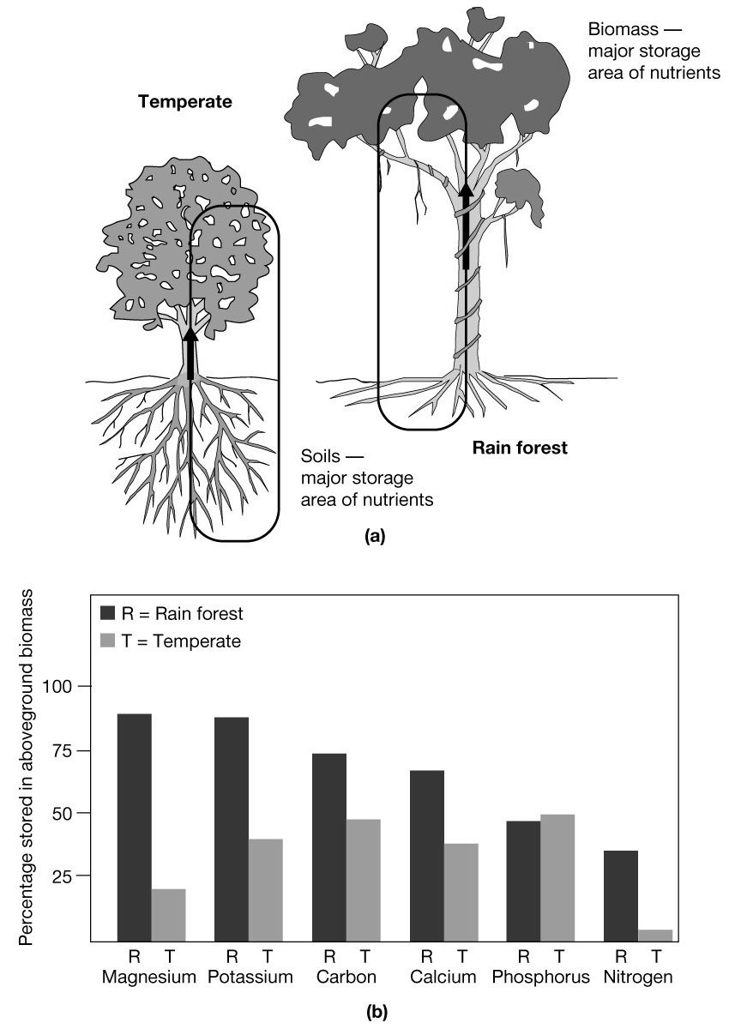

b. (2 marks) What does carbon sequestration have to do with forests?

Answer: Trees are primary producers, taking carbon dioxide out of the atmosphere and converting it into biomass (1 mark). Therefore, forests represent significant carbon storage reservoirs (1 mark), keeping the carbon out of the atmosphere and locked up in the biosphere for the lifetime of the forest.

c. (2 marks) What are some of the main differences between natural forests and forest plantations? Please mention two differences.

Answer: (Any two of the following, at 1 mark each):

- Plantations have much less habitat diversity [OR ecosystem diversity OR complexity of habitat], compared to natural forests.
- Plantations (therefore) typically host less species diversity [OR less biodiversity] than natural forests.
- Plantations are managed ecosystems; natural forests are not.
- Plantations typically consist of even-aged stands, whereas natural forests consist of uneven-aged stands.
- Plantations typically have been affected by human activity much more recently (and frequently) than natural forests.

d. (2 marks) What are four common causes of deforestation today? Please list two proximate causes and two ultimate or “root” causes.

Answer:

Proximate causes:
- Slash-and-burn agriculture
- Land conversion for agriculture or ranching
- Clearcut logging
- Pollution
- Fuelwood use

Ultimate (root) causes:
- Poverty
- Debt (OR Economic pressure)
- Bad policies
- Environmental change (OR Pollution)
- Population pressure

e. (1 mark) Why do some logging companies try to cut trees in a pattern that mimics forest fire disturbances?

Answer: Fires are a common natural type of disturbance in forests [especially boreal forests] (1 mark). Forest-dwelling organisms are adapted to fire (1 mark) – some of them even require fire disturbance in order to thrive. By making cut areas more like natural fire disturbances, it makes it easier for forest organisms to adapt.

Extra Credit: Choose one of these questions to answer, for a maximum of 4 extra-credit marks. Only one extra-credit question will be marked.

X1. The following are three examples in which human activity is thought to have caused the extinction of a species. Choose one of them and summarize, in point form, what you know about the case:

- Extinction of Pleistocene North American megafauna
- Extinction of the New Zealand moa
- Extinction of the North American passenger pigeon

Answer X1: (Looking for four GOOD points, such as any of the following, for 1 mark each)

North American megafauna:

- Megafauna – large mammals of North America, including woolly mammoths, sabre-toothed tigers, giant sloths, etc.
- Diversity peaked about 50–20,000 years ago
- Human arrived in North America about 14,000 years ago
- Massive extinction of the megafauna occurred between 15,000–9,000 years ago (OR) extinctions occurred about 1,400 to 800 years after human arrival
- Caused (at least partly) by hunting – “overkill” hypothesis
- Kill sites found with mammoth bones bearing marks of butchering

New Zealand moa:

- A large, flightless bird (much taller than a person)
- It had essentially no predators prior to the arrival of people in New Zealand
- Humans arrived [1280 AD] – moas gone less than 500 years later [by 1750]
- Extinction was caused mainly by hunting [by Maori hunters]
- Later traders arriving in New Zealand found the bones and reconstructed the birds’ skeleton

North American passenger pigeon:

- Passenger pigeons were so common in North America that their huge flocks were said to “blacken the sky”
- They were hunted, partly for food but perhaps mainly for sport
- They declined [through the 1800s] and then finally disappeared altogether in the early 1900s
- The last passenger pigeon [“Martha”] died in a [Cincinnati] zoo [in 1914]
- They went from being one of the most numerous birds in the world to complete extinction in just one century

OR

X2. Draw a diagram to illustrate the demographic transition model. Include and label all relevant curves, and provide clear labels describing each stage of the model.

Answer X2: (Diagram is required.)

Looking for all of the following items:
- Birth rate curve (labelled; 0.5 marks)
- Death rate curve (labelled; 0.5 marks)
- Population curve (labelled; 0.5 marks)
- First stage described as “Pre-Modern” or “Pre-Industrial” (0.5 marks) [OR “birth rates and death rates both high, population stable”]
- Second stage described as “Transitional” or “Urbanizing” or “Industrializing” (0.5 marks) [OR “death rates begin to fall because of...”]
- Third stage described as “Mature Industrial” or “Industrial” (0.5 marks) [OR “birth rates begin to fall because of...”]
- Fourth stage described as “Post-Industrial” (0.5 marks) [OR “population stable or even declining/contracting”]
- Horizontal axis should be labelled “Time” or “Development” – no numbers required (0.25 marks)
- Vertical axis should be labelled “Growth rate” or “Rate” on the left, and “Population” or “Total Population” on the right – no numbers required on either axis (0.25 marks)

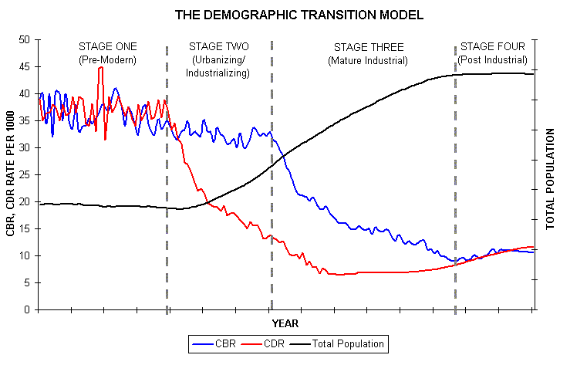
POPULATION
GROWTH RATE
BIRTH RATE
DEATH RATE
POPULATION

