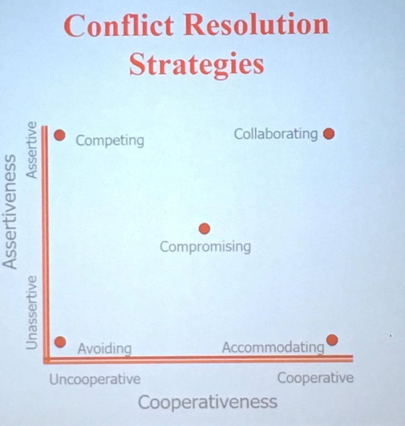
Conflict and Negotiation

Conflict
The process in which one party proceeds that its interests are being opposed threated or negatively offended by another party.

Approaches to conflict
- Avoidance: “I don’t like conflict and try to avoid It whenever possible”
- Accommodation: “I find it easier to give in than to try to change the other person’s point of view”
- Compromise: “I generally meet the other person half way even if I don’t get everything I want”
- Competition: “It is really important for me to win an argument even if the other person is unhappy”
- Collaboration: I work hard to find a mutually satisfactory solution to conflict”

Factors that influences choice of approach
- Source of conflict (using accommodating or collaborating)
- Importance of the conflict issue
- Speed is essential (competing or compromising)
- Relationship is important to you (maybe accommodate, compromising and avoiding)
- Emotions are running high (avoiding – might be best to deal with this issue under better circumstances)
*note: students try to avoid over 56% of their conflicts.

Potential benefits of conflicts
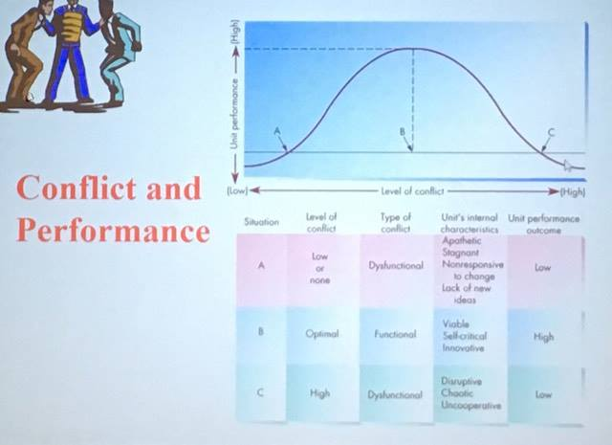
- Enhanced understanding of the problem
- More alternatives
- Increased engagement
- Critical discussion of flaws
- Integration through comparison of goals
- Cohesiveness within group
- Correct of power imbalancement

Conflict – survival theory
Some theorists think that we need conflict in order to evolve and survive. (Conflict -> change -> adaptation -> survival)
*note: over 42% of a manager’s time is spent on dealing for conflicts.

Conflicts at work – cons
- Affects employee job satisfaction
- Productivity
- Effectiveness
- Extremely costly

Potential negative long term consequences of conflicts
- Inhibits collaboration
- Takes up too much time
- May be perceived by outsiders as damaging
- Leads to the identification of winners (ego boost) and losers (undermining of motivation)

Destructive conflicts - causes
- Concentrate on narrowly defined goals and short-term solutions.
- Focus on personalities instead of behaviour.
- Center on face saving and the preservation of power.
- Infringe on individual freedom and dignity.
- Aim at compromising interdependence.
- Are part of repeated cycles of retaliation or avoidance.
Ex: fighting about who should be making the decision instead of which decision would best achieve the goal.

Constructive conflicts – causes
- Focus on issues rather than personalities or power
- Are discussed openly
- Are capable of fostering interdependence
- Focus on flexible means of solving the dispute
- Involve commitment to both parties accomplishing their goals
Ex: collaborative debate about which subject to pick for a group project. Concentrating on the actual goal of the project instead of personalities or power.

Barriers to constructive conflict resolution
- Personalization
- Skewed perceptions
- Advocacy
- Lack of creative thinking

Phases of conflict
- Latent – potential opposition or incompatibility
- Perceived – incompatibility is recognized
- Felt – emotional involvement
- Manifest – behavior

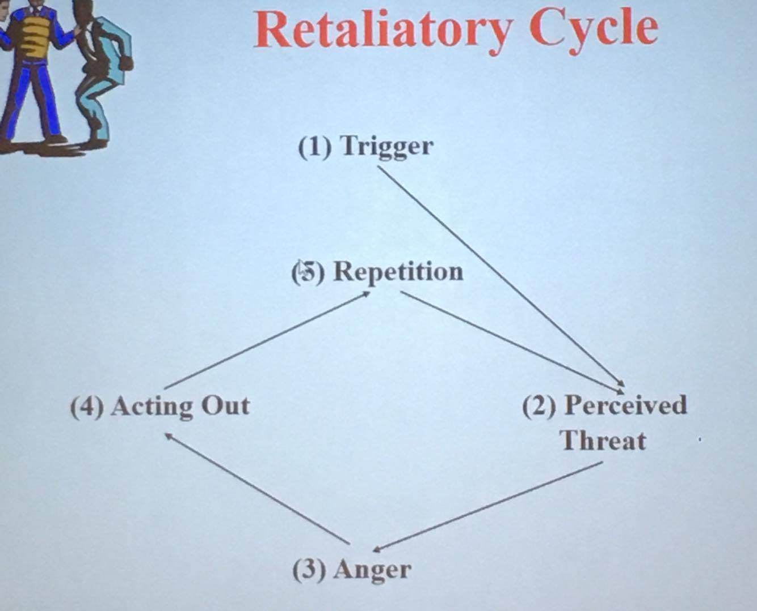
Retaliatory cycle
The steps to the “escalation” of conflict. A conflict is caused by a fear – and if you clear that fear then you clear the conflict.

Perception in conflict
Different people who have different perspective can really influence each other. If we don’t keep an open mind and look at different perspectives then we can’t solve the conflicts.
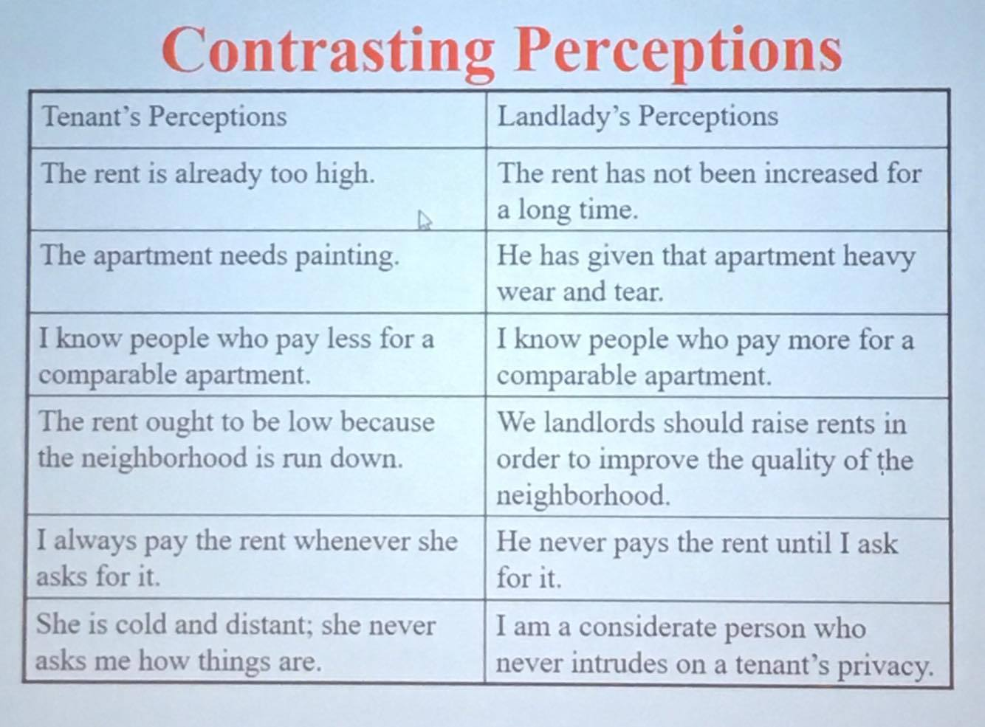

2 major types of communication
- Advocacy: Statement of opinion (most often used)
- Inquiry: Asking questions to enhance understanding “Joint problem solving”

Confrontation communication
Natural tendency in confrontation is to match emotional tone and intensity. This perpetuates the cycle of confrontation. Instead, remain still, composed, quiet and calm.

Breaking the confrontation cycle
- Inquire: focus on the other person’s concern, ask open-ended questions, nod, maintain eye contact as much as possible, and do not interrupt until the other person has shared their concerns fully.
- Empathize: Relate I to YOU and name the emotion, and share I TOO feelings. Ex: I appreciate your frustration, I understand your doubt, I share your concern. I too have felt this way.
- Ask permission: ask permission to share info, if no – then ask what would be helpful. Asking permission gives other people the sense of control and reduces their tensions, and signals that you are a reasonable person doing your best to reach an understanding.
- Explain or offer choices: short and simple, offer choices when feasible. Offering choices enhances the other person’s control and indicates your willingness to solve the problem together.

Notes – confrontation
- Demonstrate sincerity, consistency, and flexible in your behaviour.
- Recognizes in the process is not always linear and anger may break through again even when you think the problem has been solved.
- Remain still, calm, and quiet at all times.

How to remain calm and cool
- Reflect on yourself: pay attention to what speaks your emotions, notice your attributions (internal vs. external attributions), view your attributions with skepticism, ask yourself: how am I interpreting the situation such that I’m reacting this way?
- Reframe the discussion: recognize that the other party sees things you do not and try to learn from each other.

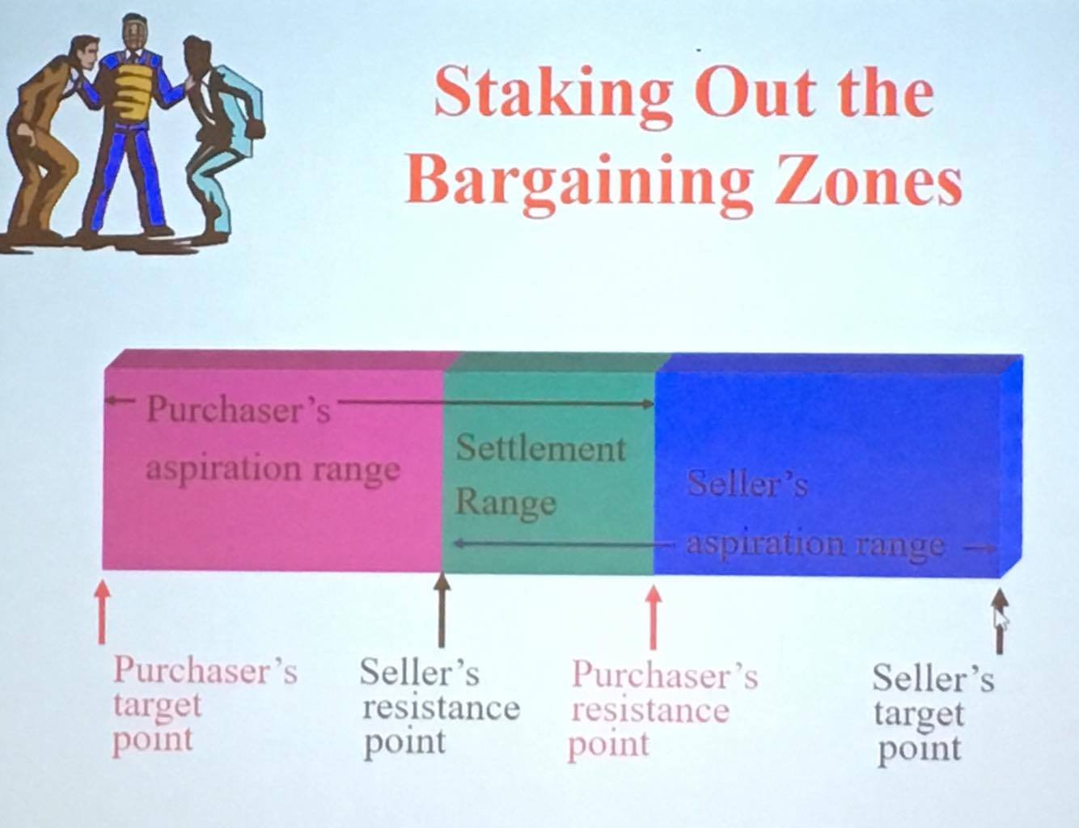
Role of creativity in conflict resolution
Collaborative conflict resolution requires creativity. If there was already a solution that made both parties happy then the conflict would not have taken place in the first place – but this new idea requires creativity that meets both needs

Negotiations
An interdependent decision process whereby two or more parties decide what each will give and take in a relationship.

Two types
- Integrative: collaborative, win-win, non-zero-sum (we can go outside and get more resources, etc), common problem
- Distributive: competitive, win-lose, zero-sum (very competitive and no flexibility in the solutions), own problem

The fundamental negotiation problem
Your negotiation problem is to understands and shape your counterpart’s perceived decision so that the other side chooses in its own interest what you want.

Economics and emotion
A deal Is usually 50% economic, 50% emotional..

Positions and interests
Positions is one party’s stand on an issues, where an interest is the underlying concerns that would be affected by the resolution. Inexperienced negotiators focus on the “dance of position” which is a trade for trade, whereas advanced negotiators concentrate on the reconciliation of underlying interests. FIND THE COMPATIBLE INTEREST!

Potentially valuable differences
Look for differences in:
- Underlying interests
- Priorities
- Forecasts
- Risk aversion
- Timing

BATNA
Best alternatives to a negotiated agreement. Often more potent than ability to inflict damage. Ex: if this agreement doesn’t go through, what is going to happen to me.. knowing this in yourself and your opponent can be very helpful.

Negotiating behaviour – tasks
Asking questions, testing for understanding, summarizing.

Skilled vs. amateur negotiator
- Explore twice as many options
- Spend 3 times as much time exploring common griund
- Make twice as many comments related to the long-term
- Are more likely to think of ranges rather than fixed point
- Are more likely to view issues as independent rather than linked in sequence
- Use fewer loaded terms
- Make fewer immediate counter proposals

Pitfalls – negotiation
- Assuming the pie is fixed
- Stating demands so forcefully that you cant back down
- Being overly concerned about saving face
- Not communicating your concerns accurately and effectively
- Not listening actively to the other party’s concerns
- Not practicing empathy

Effective conflict resolution and negotiation
- Depersonalization
- Empathy
- Inquiry
- Creative thinking

Principled negotiation – four steps
• Separate people from the problem being negotiated. Issues should be decided on their merits, rather than being influenced by emotions or by the individuals who are involved.
• Focus on the negotiating parties’ interests, not their positions. The underlying interests or motivations that drive individuals in a negotiation are often quite similar. By focusing on interests, the parties may see that they are not as opposed as they thought they were initially. Any discussion about interests should offer concrete and specific details. This makes the interests more real and credible.
• Generate different options for mutual gain. Sometimes people will focus too narrowly when generating ideas. For example, they may judge the ideas during a brainstorming session, rather than simply proposing ideas and evaluating them later. Alternatively, parties may limit their focus to their own immediate interests. This stifles options that have appeal to all involved in the negotiation.
• Base the outcome from a principled negotiation session on objective criteria. For example, if two parties are involved in the purchase and sale of a house, certain objective criteria might be applied to the price, such as the recent sale prices of comparable homes in the area, adjustments for depreciation, or the opinion of an independent appraiser.

