Chapter ten –

Group
2+ people with a common relationship

Team
small group of people with complementary skills who are committed to a common purpose, performance goals and approach which they hold themselves mutually accountable.

Group vs. Teams
Group | Team

Why are teams so popular – why don’t people talk about groups more?
Brotherhood/sisterhood with a team, more solidarity, sense of affiliation. A classroom is a group. What’s the difference?

Are groups and teams on the same continuum?
No, although they can be the same thing, they’re not considered as the same (a caterpillar can become a butterfly, but they’re still different).

When are teams helpful for organizations?
Motivated

When are groups helpful for organizations?
Groups rely more on interdependence which can be extremely costly. (ex: if you’re making a sub, you don’t really need intense group work)

Three questions to determine if you should use a team or a group
- Can the work be done better by more than one person?
- Does the work create
- *not done

When do groups become teams? *know a few
- Team members share leadership
- *not done

Problem solving teams
Typically made of 5-12 employees from the same department. Usually meet for a few hours each week to discuss ways of improving quality, efficiency and work environment. Rarely, however, are these teams given powe3r to implement their ideas. Ex: government teams – whey they find a solutions it can be very long before it gets approved.

Self-managed teams
Typically made up of 10-15 employees. The employees perform highly related or interdependent jobs and take on many of the responsibilities of their managers. Fully self-managed teams even select their own members and leaders.

Cross-functional teams
Typically made up of employees from about the same hierarchical levels, but from different work areas, who come together to accomplish a task. Each individual would be expected to contribute knowledge of his or her field, and ways to package together the knowledge in a more integrated fashion. Ex: developing an app . This can prove to be difficult because these people are extremely mentally different and have very different terminologies.

Virtual teams
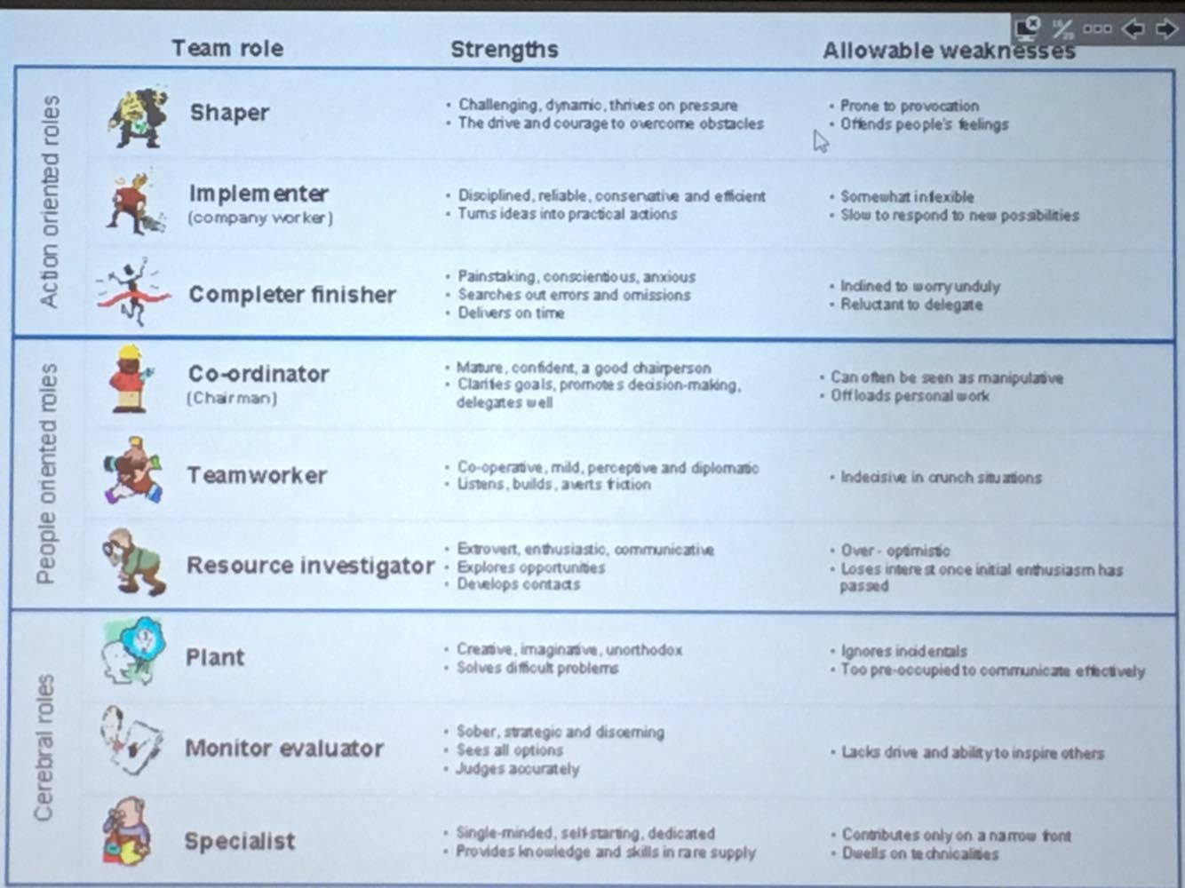
Typically use computer technology to tie together physically dispersed members in order to achieve a common goal. Ex: . Challenges: communication.

Role theory
Argues that in life we have many roles.

Role conflict
When your different roles over lap (I need to be at work, but I also have my daughter’s bday party).

Role ambiguity
When a person is unclear about the expectations of his or her role – creates stress.

Role overload
When a person is overwhelmed by the number of things to do in a certain amount of time. Ex: exam week.

Norms
Are acceptable standards of behaviour in a group that are shared by the group’s members. Ex: wear clothes in public. It can be based on performance, appearance, social arrangement and *not done. Ex: Raise your hands to answer a question.

How do norms develop
- Explicit statements made by a group member
- Critical events in the groups history
- Precedences
- Carry-over behaviours from previous situations

Why – norms
- Facilitates group survival
- Increases predictability of group member’s behaviors
- Reduces embarrassing interpersonal problems
- Allows members to express central values of the group

Five stage model *will be on exam – know the order of the steps
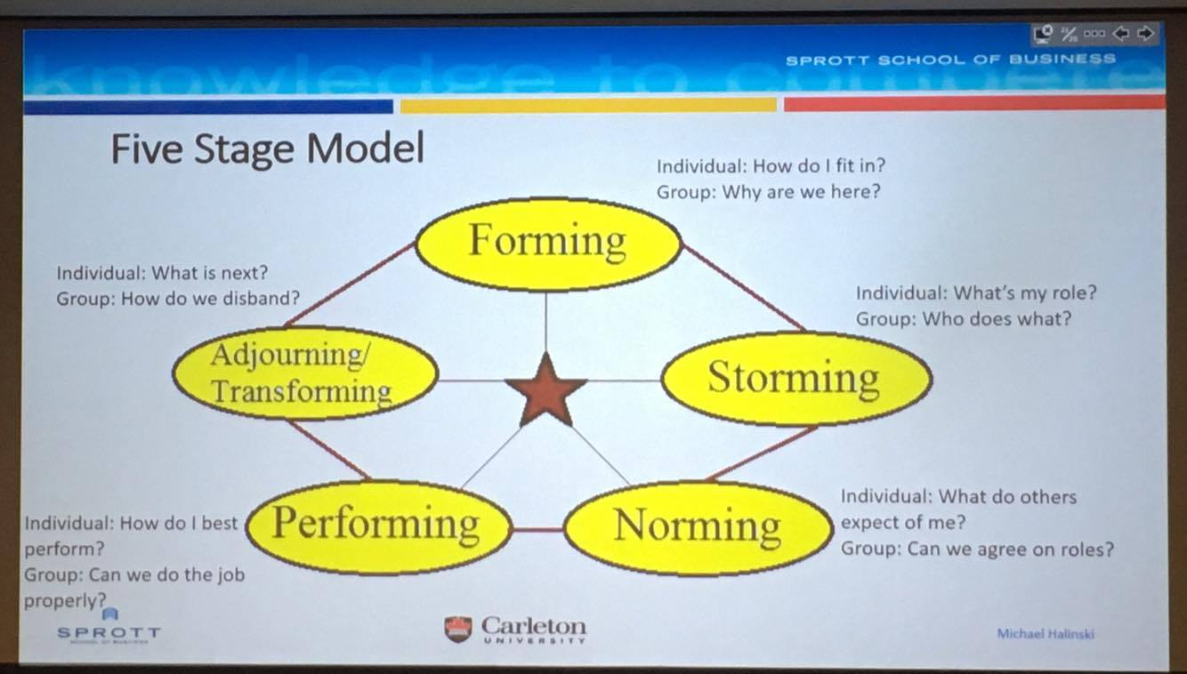

Do all teams follow these steps?
No, in sports there’s consistant trades and norm developments. Politics can change a lot. Groups might go back and forth between steps.

Punctuated equilibrium model
People need pressure in order to complete things so everything is usually done at the last minute.


Creating effective teams
- Context: Adequate resources, leadership, structure, trust, rewards.
- Work Design: Autonomy, skill variety, task identity, task significance.
- Composition: skills, personality, diversity, size, members’ preferences.
- Process: common purpose, specific goals, team efficacy, mental models, managed level of conflict, accountability.

