Chapter Eight: Perception

Perception
The process by which we select, organize, and evaluate the stimuli in our environment to make it meaningful for ourselves. (like an ice berg)

Factors that affect perception

Internal
- Motives
- Values
- Interests
- Attitudes
- Past experiences
- Expectations

External
- Motion
- Intensity
- Size
- Novelty
- Salience

Rosenhan Study
Study in a mental hospital, they sent normal people and told them they were schizophrenic and no one believed them. Then they said they would send some people with “fake” schizophrenia. The staff said they caught over 20% of people but really they hadn’t sent any fakers at all.. Conclusion: We see what we think we will see. Our perception can be distorted by expectations.

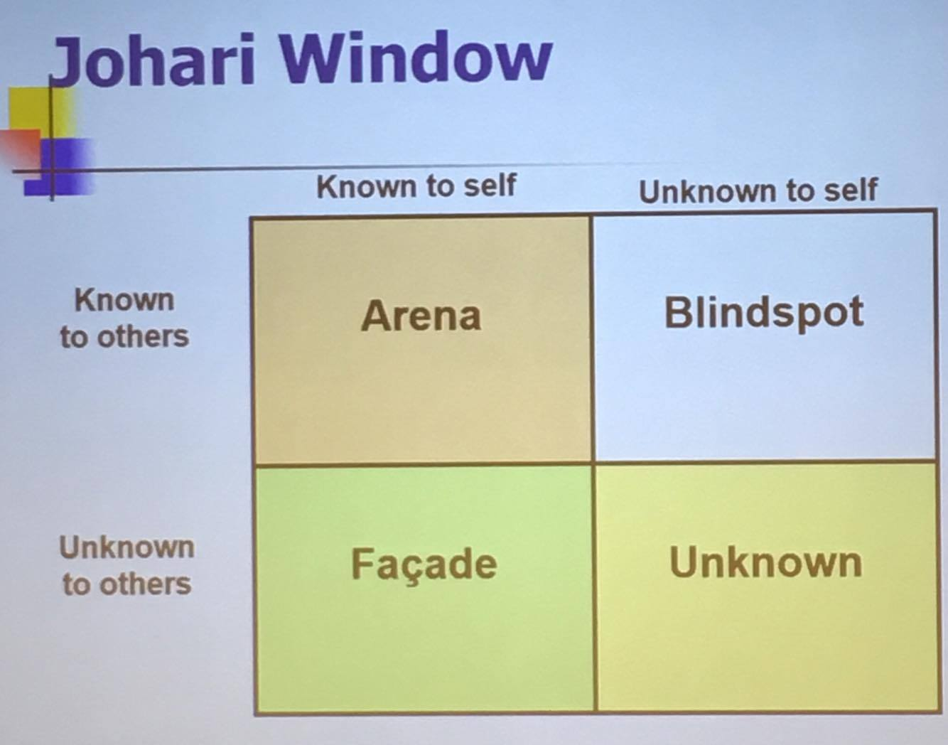
Johari Window
A way to look at perception and stereotyping. Used to understand other’s and our own perception.
- Arena: Both are on the same page and understand each other.
- Blindspot: The person knows but wants to avoid conflict so they work around it.
- Façade: They pretend to understand but they don’t. The chance of conflict is extremely high.
- Unknown: No one knows this perception.
*note: boxes are not the same size.

Disclosing:
When you admit the “façade” lie to someone and being honest about your non-understanding.

Attribution theory*will be on exam
Refers to the beliefs that when people observe behavior, they attempt to determine whether it is internally or externally caused. People look for information about consensus, consistency, and distinctiveness to decide on causation.
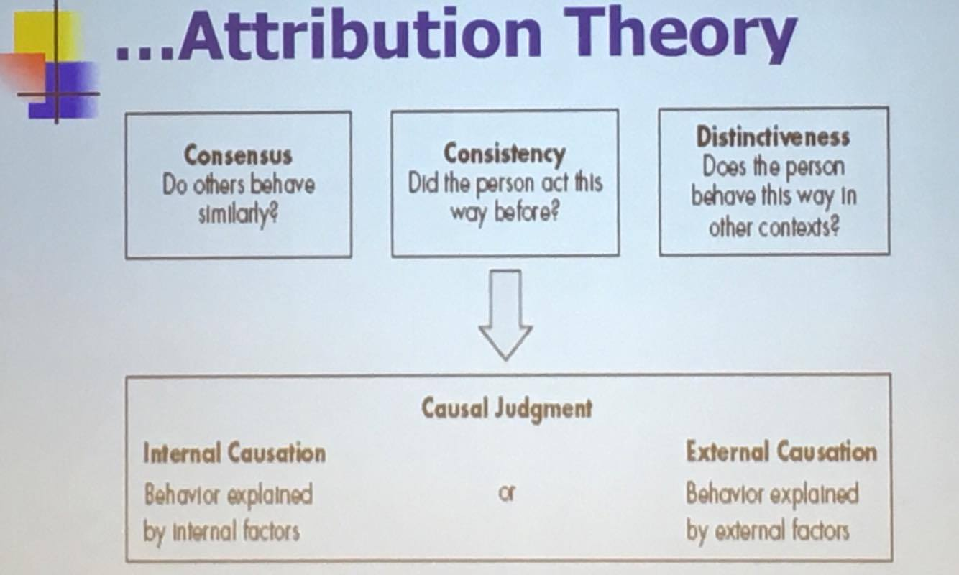

Self-serving bias
The tendency for people to attribute their successes to internal factors while blaming external factors for their failures. It is strongly associated with mental illness because “reality” is kinda fucked up.
“people seek a positive image of themselves and their environment with such vigor that reality is selectively interpreted and often ignored”

Impact of gender on self serving bias
Women tend to blame themselves more than men. Younger children blame it on external reasons but as we grow up women switch to internal blaming.

Impact of culture on self serving bias
Different cultures blame external vs. internal bias. US and other Western cultures. Other countries like Japan have low external biases

Fundamental attribution error
**missed this

Chapter nine – Communication

Communication – process
- Sender: has an idea (first impression goes gender, age, then ethnicity).
- Message: “coding”
- Receiver: “decoding” through different perception
- Feedback:
- According to the feedback, the sender must make sure that the receiver understood the right thing. He might have misunderstood depending on his decoding process.
Note: when we communicate, only 10% are the words. Body language, tone of voice, etc. is the majority.

The best communication method
Face to face communication: scientist prove that you can’t multitask – you think you can until you fail. Which means emailing and texting makes it extremely difficult because we are never only doing that and there are many different perceptions when you can’t see the body language or voice tones.

Context
The situation, environment or circumstances of the communication. Can cause interference in the communication. Ex: if you’re having an important conversation right before lunch – people might not be as patient.
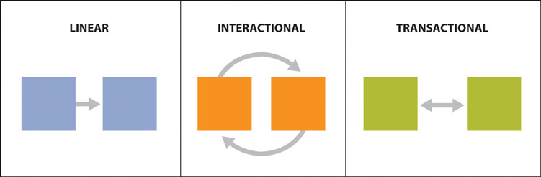Linear: speaker informs a crowd
Interactional: texting back an forth
Transactional: face to face\

Key concepts
- Sender/receiver
- Encoding/decoding
- Competence
- Feedback
- Noise: anything that interferes with the intended communication (environmental, physiological, emotional).
- Feedforward (I tell you what you’re about to feel and then communicate..)
- Altercast (put youself in my shoes…)
- Channel
- Context
- Non-verbal (6 facial expressions, gestures, paralinguistics “vocal aspects of communication”, body language and posture, proxemics, eye contact, hapatics)

