Business Ethics

Ethics
Concerns principles of right and wrong.

Values
Core beliefs or desires that guide or motivates attitudes and actions.

Value congruence
Shared systems of values between two entities.
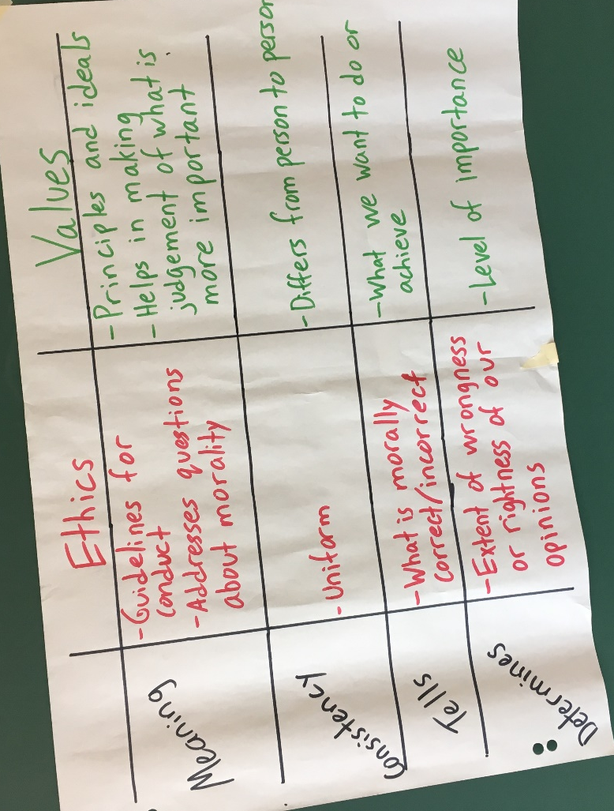

How ethics help set standards of moral behaviour
- Defines things we should and shouldn’t do
- Helps guide our behaviour
- Reflects how we should treat one another
- Underlies our evaluations of the appropriateness of our own and others’ behaviour
- Makes us not animals

Personal values orientation typology

Terminal values
Desirable end states of existence or the goals that a person would like to achieve during his/her life time.
- Personal values: comfortable life, freedom, happiness, salvation
- Social values: world peace, equality, national securityà

Instrumental values
Preferable modes of behaviour or the means to achieving one’s terminal values
- Moral values: cheerful, courageous, helpful, honest
- Competence values: ambitious, capable, intellectual, responsible

Business ethics
A form of “applied ethics” where in principles of ethics are applied to business settings and issues.

Business ethics helps us understand..
- The ethical principles businesses and the people who work for them should adhere to in their activities
- How to promote ethical behaviour by and within businesses
- The impacts of ethical or unethical business behaviour on business performance

Ethical vs. non-ethical values
Ethical/unethical values concentrate on the right vs. wrong, whereas non-ethical values concentrate on the likes and our desires of personal importance (doesn’t keep in consideration of ethics).

Kohlberg’s Moral Reasoning Framework
Values alone do not determine our actions – our behaviour is also influenced by our moral reasoning, organizational culture, the influence of significant others. The type of harm that could result from a decision involving ethics, and who might be harmed. Kohlberg identified three levels of moral development: self-centered, Conformity, principled.

Level 1: Self-Centered
Stage 1. Obedience & punishment: we act based on consequences
Stage 2. Instrumental: what’s in it for me?

Level 2: Conformity
Stage 3. Conformity: people start acting according to what is stereotypical considered to be good girl/boy
Stage 4. Law & order: Do your duty for you community and social system

Level 3: Principled
Stage 5. Social contract/individual rights: starting to understand that people have different values and compromise for social harmony.
Stage 6. Universal ethical principles: act based on one’s personal conscience, self-chosen ethical principles.

Ethical subjectivism
Implies that statements about what’s right and wrong are just a matter of opinion or tastes, and that there’s no real way to say that one person’s opinion is better than any others. This suggests that every should do whatever they themselves think is right.

Contradictions
The fact that people have different opinions about ethics may just mean that some people are wrong. There are, in fact, some ethical principles that seem to be more or less universal among humans. Even people who claim that ethics is subjective are unlikely to act like it’s subjective.

Ethics and the law
Hopefully, the law reflects ethical principles, but it can’t possibly cover all situations where ethics seem important and it can take a very long time for ethical standards to be reflected in the law. Laws can often permit unethical behaviour or even be unethical themselves. Therefore, obeying the law should be the “first steps” to ethical behaviour, but we turn to business ethics to set ethical behaviour in corporations. Ethics may require you to go well beyond the law in terms of how you treat your stakeholders. Your stakeholders are likely to want more from your business than just compliance with the law.

Why be ethical in business
- It’s the right thing to do (by definition)
- To promote long-term profitability
- To protect your reputation and that of your company
- To maintain trust in yourself, the company, the industry, and the market
- To facilitate customer loyalty
- To protect others
- To attract and keep employees
- To avoid criminal liability
- for you and your company
- To avoid regulation
- To reduce penalties if wrongdoing does occur
- To be able to sleep at night

Common Ethical issues in business

Employee-related issues
- Privacy and confidentiality
- Interpersonal abuse (e.g., sexual harassment, bullying)
- Discrimination
- Employee safety
- Violations of rules or the law
- Performance evaluation issues
- Cheating
- Theft, time theft, wage theft
- Hiring, firing, and promotion issues
- Misuse of company resources
- Accessory to unethical act/whistleblowing
- Etc.

Customer-related issues
- Product quality
- Product safety
- Price discrimination
- Deception
- Misleading advertising
- Privacy and confidentiality
- Etc.

Environmental issues
- Pollution and waste
- Animals rights
- Externalities
- Sustainable use of natural resources
- Etc.

Governance Issues
- Fraud
- Misleading accounting
- Executive pay
- Conflict of interest
- Bribery, kickbacks
- Etc.

International Issues
- Cross-cultural differences in ethical standards
- Child labour
- Exploitation
- Racing to the bottom
- Etc.

Ethical considerations when incorporating ethics into your business decisions
- Justice/Fairness
- Rights
- Utility (harms and benefits)
- Generalizability

Justice/Fairness
- Distributive justice concerns fairness in the distribution of resources and/or the benefits and harms of our decisions among those affected.
- Procedural justice concerns the fairness of processes, and the application of them.
- Compensatory justice concerns compensating people fairly if they have been harmed.
- Retributive justice concerns fairness in punishing people for undesirable behaviour.

Rights
Entitlement a person has to behave in a certain way, or be treated in a certain way.
- Human/moral rights are rights that a person has just because (s)he is a human being.
- Legal rights are rights that a person has because the law says they do.
- Contractual rights are rights a person has because (s)he has signed a contract.
- Stakeholder-specific rights include consumer rights, employee rights, investor rights, student rights, animal rights.

Utility
Utilitarian considerations relate to the consequences of our decisions. It argues that your goal should always be to maximize net utility across everyone affected by your decision. It is derived from the benefits (positive utility) and harms (negative utility) of our decisions. These benefits/harms can be physical, psychological, financial, emotional, or of any other type.
*note: utility is often viewed as less important (ethically) than justice and rights. Generally, you should not violate principles of justice and/or people’s rights in order to increase utility.

4. Generalizability
Concerns the rationality of the principle underlying a proposed action. It is irrational to think that something is ethically permissible for you, but not ethically permissible for someone else in the same situation. So, you must be willing to have every behave in the same ways that you do and to be treated in the same ways that you treat other people (similar to the golden rule).

Questions to ask yourself to test the ethics of your decisions…
- Am I treating stakeholders fairly?
- Does the decision maximize the net benefit across all affected stakeholders?
- Does the decision violate anyone’s rights, or will it lead to the violation of their rights?
- Am I willing to be treated this way by others?
- Am I obeying the law?
- How would I feel if everyone knew about my decision?
Basic ethical advice
- Don’t assume you know what’s right.
- Don’t just do what other people do.
- Don’t just do what your boss tells you to do.
- Remember that virtually every decision you make has an ethical component.
- Remember that your stakeholders will expect ethical behaviour, not mere compliance with the law
- Think about situations from a variety of ethical perspectives.
- Remember that considering yourself (and/or your company) is a part of being ethical, but you are no more important than anybody else. (Sorry.)
- Don’t think that money will make you happy.

Ethical Framework

Utilitarian approach

Individual rights principles

Justice principle

Caring principle

Environmentalism

