Chapter four – Personality in the Workplace
  - Greg Sears

Personality
The relatively stable set of psychological characteristics that influences the way an individual interacts with his or her environment and how he or she feels, thinks, and behaves.
Note: 30-40% of one’s reactions are based on their personality.

Broad Personality factors - categories
- Conscientiousness (diligent, responsible, determined, messy, goal-oriented, accomplishment striving, ) note: they are the most “looked for” in job recruitment.
- Agreeableness (kind, sensitive, )
- Neuroticism (Annoying, insecure, jealous)
- Openness to experience (analytical, creative, imaginative)
- Extraverted (fun, optimistic, extraverted, shy, )

Conscientiousness
Dependable, organized, reliable, ambitious, hardworking, and persevering. Strongest influence on performance of the big 5. These individuals prioritize accomplishment striving: spend more time on task, build job knowledge, goal-setting and persistence, exceed work requirements. Also predicts other work/non-work outcomes: career success and health.

Agreeableness
Warm, kind, cooperative, sympathetic, helpful, courteous. Prioritize communion striving : seek to gain acceptance in personal relationships. Focus on “getting along” not necessarily “getting ahead”. Beneficial in many positions/roles but can be detrimental in others (ex: tax collectors, negotiators).

Extraversion
Talkative, sociable, passionate, assertive, bold, dominant. Prioritize status striving: a strong desire to obtain power and influence within a social structure as a means of expressing personality. Tend to be high in positive affectivity: tendency to experience pleasant, engaging moods such as enthusiasm, excitement, and elation. (good at sales jobs, negotiating, management, but not great at listening).

Neuroticism (emotional stability)
Nervous, moody, emotional, insecure, jealous. Synonymous with negative affectivity: tendency to experience unpleasant moods such as hostility, nervousness, and annoyance. Associated with a differential exposure to stressors: neurotic people more likely to appraise day-to-day situations as stressful. Associated with differential reactivity to stressors: neurotic people less likely to believe they can cope with the stressors that they experience.

Openness to experience
Curious, imaginative, creative, complex, refined, sophisticated. Valuable in jobs that require high levels of creativity and spontaneity. Predictive of cross-cultural sensitivity and success in international assignments. More likely to migrate into artistic and scientific fields.
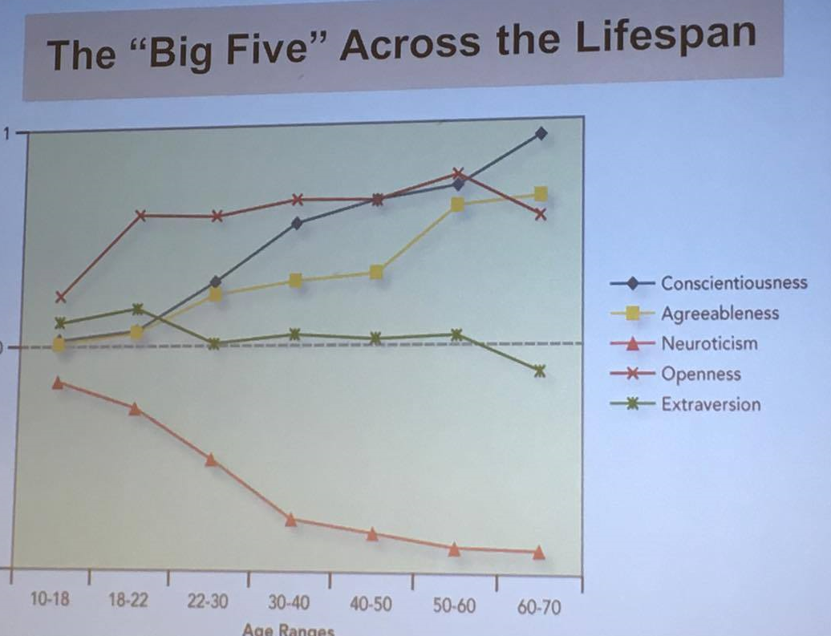

Different measures of big five
NEO, IPIP *read up

Honesty-humility
Scientists argue that this should be added as a 6th. Four dimensions:
- Sincerity – unwillingness to be manipulative/dishonest
- Fairness- unwillingness ti cheat, steal, use fraud
- Ungreedy– less concerned with wealth, status
- Modesty – Acknowledge limits, keep accomplishments in perspective, low self-focus.
Note: *not done

Core self-evaluation “positive self-concept”
Bottom line evaluations that represent one’s appraisal of people, events, and things in relation to oneself. Encompasses 4 traits: self-esteem, self-efficacy, locus of control, emotional stability. It is linked to higher job satisfaction and performance (they have a stronger drive to perform their job effectively)

Proactive personality
Identifies opportunities, show initiative, takes action, and perseveres to completion. Creates positive change in the work environment.

Social dominance orientation
A preference for hierarchy in a social system and ineqyality between groups. Samples items from SDO scale: some groups of people are inferior to others, to get ahead in life , sometimes it is necessary to step on other groups, inferior groups should stay in their place. It is associated with: right-wing authoritarianism, more prejudiced views, more aggressive behavior in the workplace and group conflict.

The “dark triad”
Three interrelated traits sharing a component of callousness and manipulative/exploitative behavior. Linked to destructive workplace behaviour: workplace harassment, bullying, theft, white collar crime, etc.

Machiavellianism
Pragmatic, emotionally distant power-player who believes that the ends justify the means. Manipulative, deceptive, unethical, and persuade more than they are persuaded.

Narcissism
An arrogant, self-centered, entitled person who needs excessive admiration. (ex: Donald trump)

Psychopathy
Prone to deviant behavior partly due to high levels of thrill-seeking, impulsivity, and selfishness, tend to display a super viail charm, and lack of emotions and remorsefulness “workplace psychopath” (ex: the causes of the global financial crisis)
The con: manipulative with their voice, listen well and adjust their stories according to it. Lies to get their way.
The bully: they tend to use dominance and force to get what they want.
The puppet master: the ones who has a wide repertoire of all the psychopathic traits. Tends to make other people do their dirty work. Do it all by not risking their own

Myers Briggs personality type indicator
Very popular measure of personality
- Extrovert vs. introvert
- Sensing vs. Intuitive
- Thinking vs. feeling
- Judging vs. perceiving

Emotional intelligence
The capacity to “monitor one’s own and other’s feelings and emotions, to discriminate among them, and to use this infor to guide one’s thinking and actions”. 4 core dimensions:
- Self-awareness: the apparaisal and expression of emotions in oneself
- Other-awareness: the appraisal and recognition of emotions in others
- Emotional regulation: being able to recover quickly from emotional experiences
- Use of emotions: being able to harness emotion to enhance performance (; leveraging your emotions to maximise performance ex: presentation).
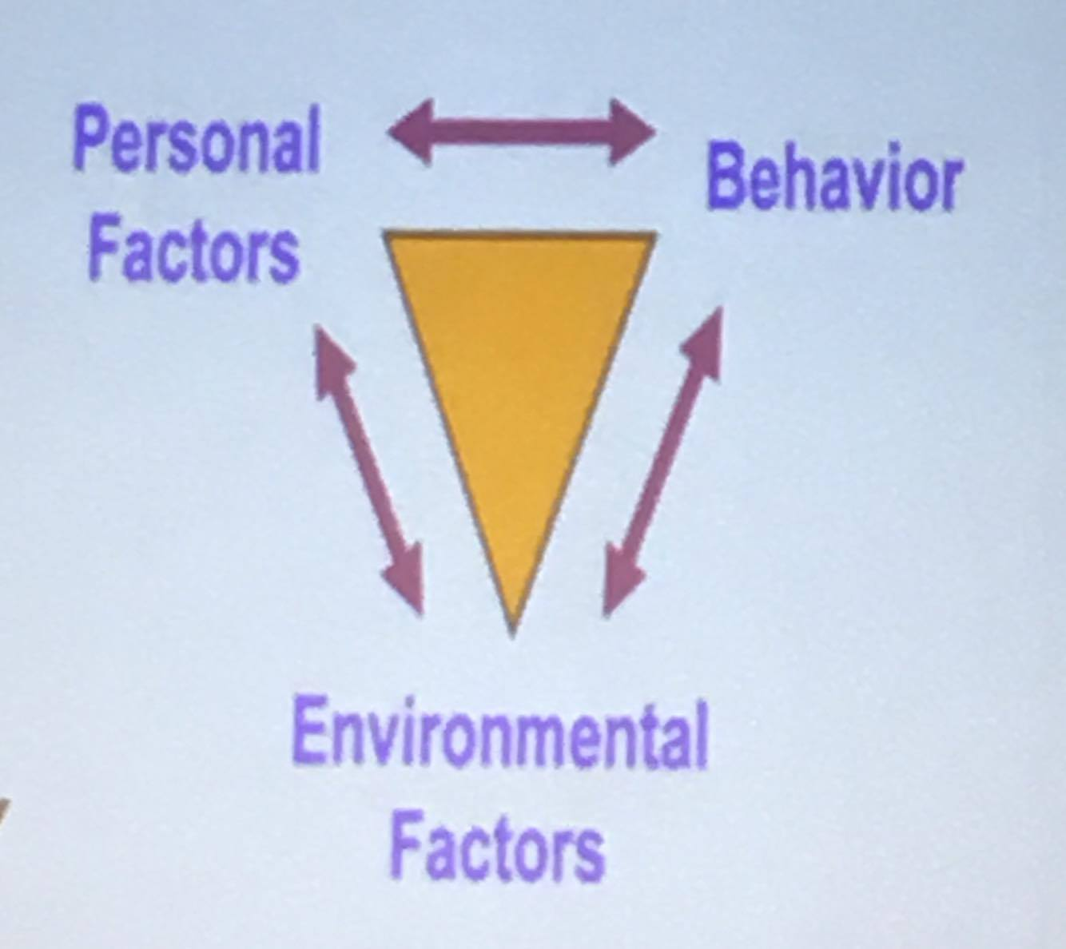
Predicts key work/non-work-related outcomes: stronger social relationship, higher well-beeing /life satisfaction, higher job satisfaction and performance, effective leadership, elevated group performance. EI predicts these outcomes above and beyond effects of IQ and personality. Michael Scott: “business school”.

Interactionist perspective
More complex view of relationships between personality and behavior than trait theory – these relationships contingent on the situation. Theoretical models / frameworks:
- reciprocal determinism: three way influence
- conditional reasoning: people interpret and act on events differently depending on their personality
- Trait activation: certain situational cues are needed to evoke the display of personality traits. Ex: proactive personality.

Workplace applications
- Employee selection
- Succession planning
- Training and development
- Career counseling
- Conflict management

