Chapter three – Individual & organizational learning

  - Harry Chhina

“Knowledge problem” – symptoms
- You repeat mistakes
- You duplicate work
- You have poor customer relations
- Good ideas don’t transfer between departments and units
- You are competing on price
- You can’t compete with market leaders
- You are dependent on key individuals
- You are slow to launch new products, or enter new markets
- You don’t know how to price for service

Organization
An organized body of people with a particular purpose, especially a business, society, or an association.

Characteristics
- Coordination
- Common goals
- Division of labor
- Integration

Learning
A relatively permanent change in behavior that occurs as a result of prior experience
“The desire to learn and curiosity are more fundamental human motives even than the drive to reproduce.” – Edward Hall
“Individual learning, team learning, and organization learning- is a very powerful energy source.” - ?

Organizational learning
The process of detection and correction of errors. Organizations learn through individuals acting as agents for them. An individual’s learning activities, in turn, are facilitated or inhibited by an ecological system of factors that may be called an organizational learning system.
The process of creating, retaining, and transferring knowledge within an organization.
*note: From a behavioral point of view “an entity learns through it’s processing of information, the range of its potential behaviors is changed.”

Constructs
- Knowledge acquisition
- Information distribution
- Information interpretation
- Organizational memory

Characteristics – Organizational learning factors
- Need not be conscious or intentional
- Does not always increase the learner’s effectiveness or even potential effectiveness
- Need not result in observable changes in behaviour

Uses

The social personality perspective
Focuses on the way “people make sense of their experience at work”. These experiences may derive from tactic sources, such as the feel that skilled craftsmen have. Such tacit (meaning the ununderstood) forms of learning involved situated practices and socialization into a community of practice.

Technical personality perspective
Assumes that organizational learning is about effective processing, interpretation, and response to information, both inside and outside the organization.

Learning organization
An organization with an ingrained philosophy for anticipating, reacting and responding to change, complexity and uncertainty. (;An entity that improves and develops through new employees and learning more in the current employees.)
A group of people continually enhancing their capacity to create what they want to change.
“An organization in which you cannot not learn because learning is so insinuated into the fabric of life. So it is a group of people continually enhancing their capacity to create what they want to create.” – Senge 1991

Overview
- Where people continually expand their capacity to create the results they truly desire
- Where new and expansive patterns of thinking are nurtured
- Where collective aspiration is set free, and
- Where people are continually learning to see the whole together

Requirements for a successful learning organization
- Must have commitment to knowledge (selection of good people are very important, people cannot be trained with all they will need to know)
- Must have mechanism for renewal within itself (bureaucratic rigidity does not allow learning)
- Should possess a openness to the outside world (so that it may be responsive, access to new developments, how business environment is changing)

Learning organization - characteristics
- Systematic problem solving; using scientific methods
- Experimentation: take risks, pilot projects, share results
- Learning from past experiences
- Learning from others
- Transferring knowledge

Levels of learning
- Individual
- Group
- Organization
- Inter-organizational

Individual learning
Smallest unit at which learning can occur. An individual learns new skills or ideas; productivity at work increases as they gain expertise. Individual can decide whether or not to share their knowledge with the rest of the group. If the individual leaves the group and doesn’t share their knowledge before leaving, the group loses this knowledge.

Kolb’s individual learning process
- Concrete experience: feeling
- Reflective observation: watching
- Abstract conceptualization: thinking
- Active experimentation: doing
*repeat*
note: Everyone spends a different amount of time in each stage and does them differently.

Learning style inventory
Indicates how different people are stronger at different stages of the cycle and measures the extent that you prefer one mode of learning.

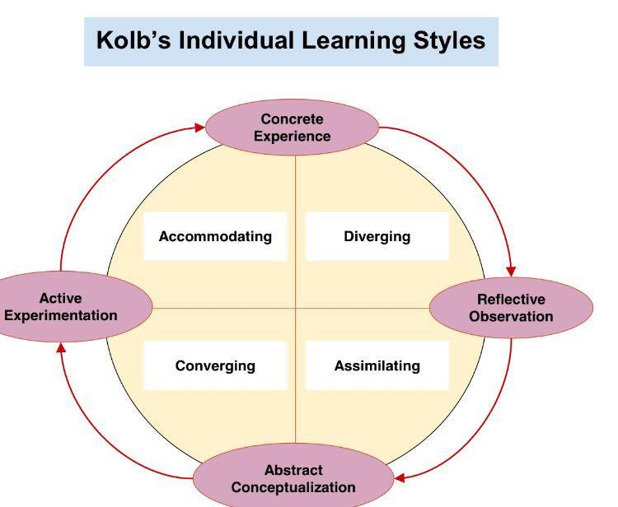
Kolb’s individual learning styles *read into more details.
- Accommodating: Learn from “hands-on experiences”, you act on gut experiences, you rely on people’s information more than analysis information, works best In groups.
- Diverging: Viewing different point of views, they learn by observing, enjoys brainstorming sessions, they have a broad cultural interest and like to gather up information, works in arts, entertainment, and service centers.
- Assimilating: Understand a wide range of information and putting it into concise, logical form. Less interested in people and more into information, they find the importance in logical rather than practical, information and science careers. They learn by reading, thinking, and understanding.
- Converging: They find practical uses for ideas and theories. Likes to solve problems and make decisions based on finding solutions to questions or problems. Likes technical tasks, not interpersonal tasks. Specialists and technology careers. Likes new assignments and experiments. 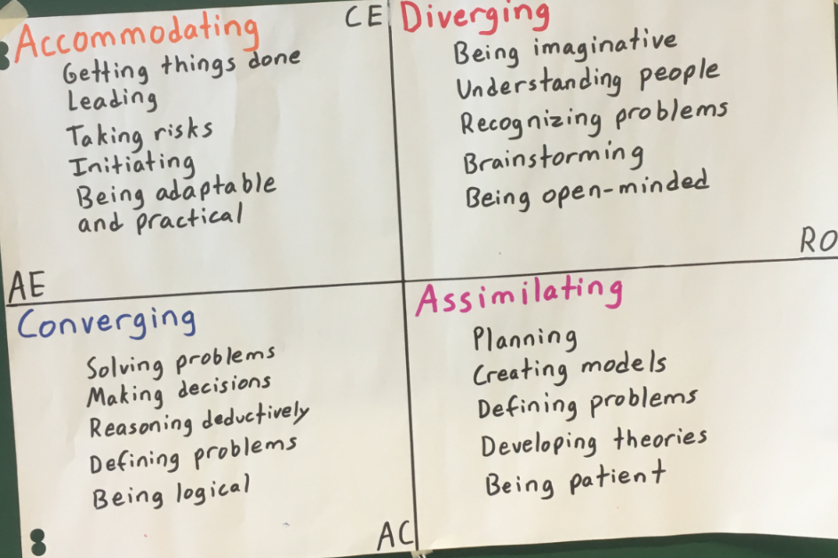

Group learning
Happens when individuals with a group acquire, share, and combine knowledge though experience with one another.

Organizational learning
The way in which an organization creates and organizes knowledge relating to their functions and culture. Organizational learning happens in all of the organization’s activities, and it happens at different speeds. The goal of organizational learning is to successfully adapt to changing environments, to adjust under uncertain conditions, and to increase efficiency.

Single loop
Concerned with identifying and correcting a problem. If the problem persists (because the actions taken failed to address it), then one has to consider alternative actions. (;tries to treat the symptoms instead of analyzing then situation and finding the roots). Ex: this is the mistakes – here’s what you should do. (no analysing as why and if this actually works.. following guidelines).

Double loop
Propounds a problem-solving mentality at the core of learning activity. This form of learning goes more deeply into the cause of the problem and feedback is used to look at past actions. Unlike single-loop, it also modifies underlying norms and objectives which have guided the implementation of the initial action. Ex: What were the considerations of the managers and the employees to adopt certain procedures? What went well and what should be improved? Questioning the theories in single loop and going further.

Stages:
- Obstacles are measured and quantified holistically
- Prioritizations
- Measuring ramifications for not exceeding these. Ex: Problem is larger than just sales, it involves other departments such as HR incentives, production, management. We need to Talk to all participants including customers.

Triple loop learning “Deuterolearning”
In this form of continuous learning, we combine the first two levels with the aim of improving awareness and learning. People learn more from the mistakes of the present and the past and they must be capable of admitting this. One must actively seek to reflect, inquire, and develop new strategies for learning.

Pros – evaluating success in organizational learning
- Provides a standard
- Leads to benefits for stakeholders

Cons – evaluating success in organizational learning
- Maintains the status quo- follow the traditional way
- Can lead to complacency – play it safe
- Can limit additional ideas and searching
- Can limit awareness
- Leads to risk aversion – mistakes are embarrassing

Quality circles
First introduced by a number of large Japanese firms, quality circles are a systematic attempt to involve all their employees, at every level, in their organization’s drive for quality. Consists of a small group of between 3 – 12 people who do similar work. They voluntarily meet together regularly for about one hour per week In paid time, usually under the leadership of their own supervisor. They are trained to identify, analyse, and solve some of the problems in their work. They present solutions to management and, where possible, implement solutions themselves.

Steps
- Start up
- Initial problem solving
- Approval of initial suggestions
- Implementation
- Expansion of problem solving
- Decline

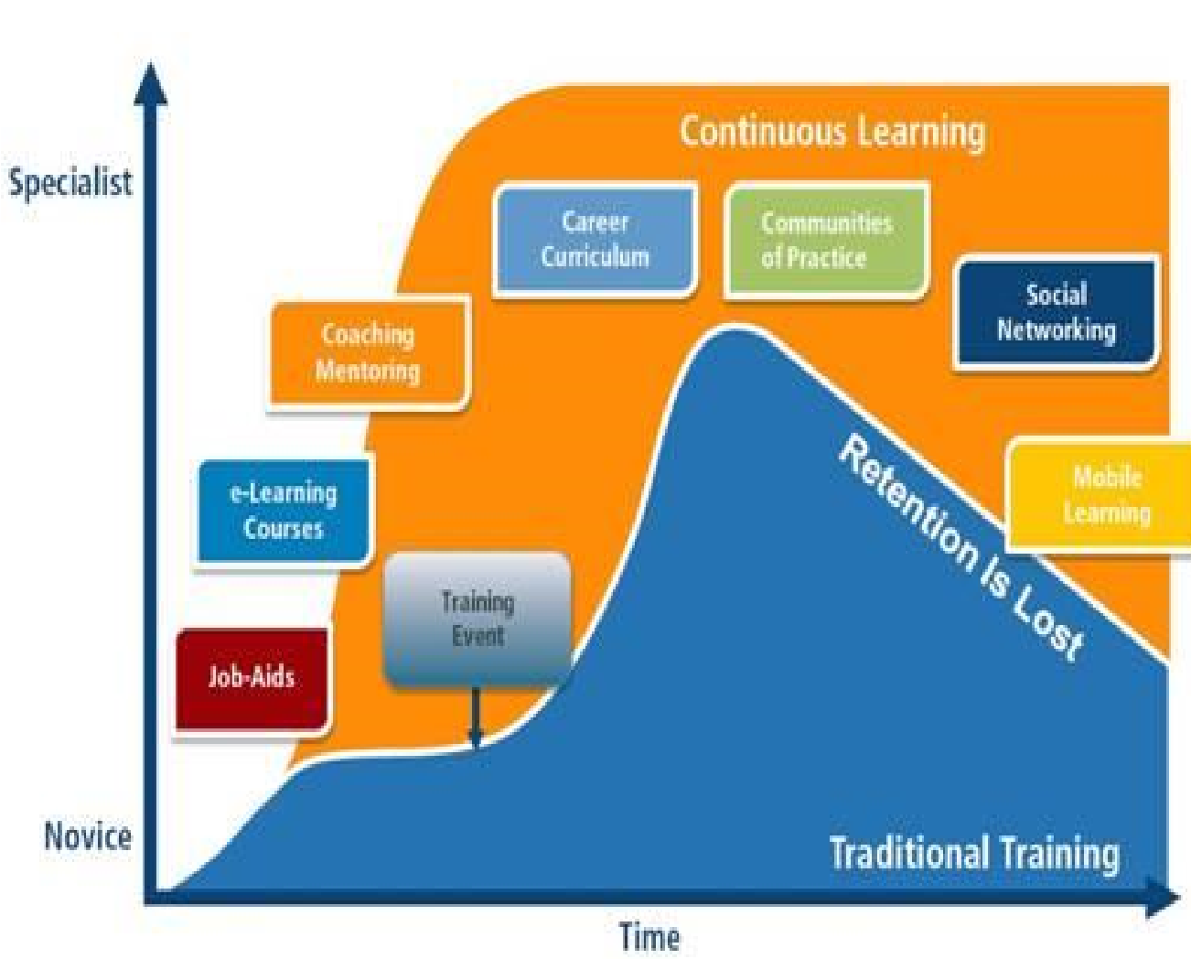
Traditional vs. continuous learning
Formal training contributes to only 25% or less of what we use in our jobs. We learn most of it contrinuously. Learning is no longer considered a singular, unconnected event that happens once. Contrinuous learning is highly encouraged.

Core benefits of e-Learning
1. Standardized training: faster delivery time, compliance
2. Train new hires faster: getting new hires trained faster, while using less resources.
3. Increase productivity & performance: Give staff access to resources that they can benefit from
4. Gain insight: Management can find opportunities that can be used to improve the company, based on the responses given from staff.
5. Increase ROI: Investing in e-learning training is investing in your company

Defensive learning
Defensive routines are the policies or actions we put in place to prevent ourselves and our organizations from experiencing embarrassment or threat. The unintended consequence of these defensive routines is that they also prevent anyone from identifying and thereby reducing the causes of the embarrassment or threat. This is why we all tend to collude in admiring the emperor's new clothes-and why we feel such a sense of chagrin when we realize that the emperor is, indeed, unclad.

Governing variables
- Strive to be in unilateral control
- Minimize losing and maximize winning
- Minimize the expression or negative feelings
- Be rational

Behaviors and actions we use in defensive learning
- Advocate your views without encouraging inquiry
- Unilaterally save your face – your own and other people’s
- Design and manage situations unilaterally
- Evaluate the thoughts and actions of others in ways that do not encourage testing the validity of the evaluation
- Attribute causes for whatever we are trying to understand – without necessarily validating them;
- Engage in defensive actions such as blaming, stereotyping, and intellectualizing to suppress feelings.

