Chapter one – Psychological contract

Organization behaviour
A field study that investigates the impact that individuals, groups and structure have on behaviour within organizations, for the purpose of applying such knowledge toward improving an organizations behaviour effectiveness.

Organization
A consciously coordinated social unit, composed of a group of people, which functions on a relatively continuous basis to achieve a common goal or set of goals.

Psychological contract
An individual’s beliefs, shaped by the organization, regarding the terms and conditions of a reciprocal exchange agreement between individuals and their organizations.

Importance
- Helps orient us to the subject matter of organizational behaviour – the relationship between the individual and the organization.
- Helps us understand what we are doing in the course – as teachers, students and psychological contracts with each other

Pinch model for managing psychological contracts

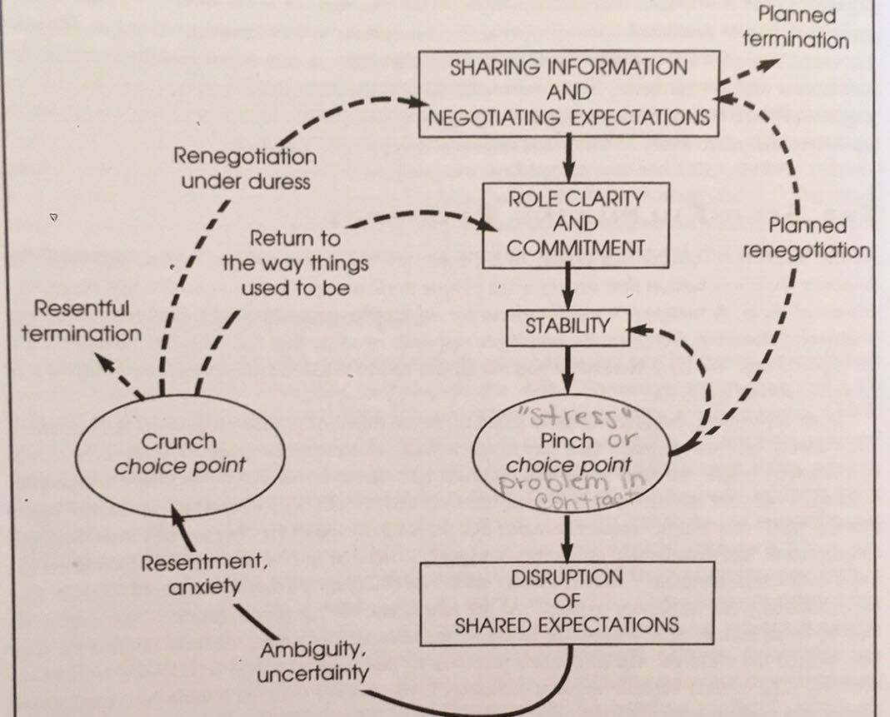

Psychological contract and success in the business world is:
Trust. We trust people very easily, with out even realizing it. (ex: you trust that you baseball coach will work hard to bring you guys to victory.)

Violation
An emotional state that may result from the perception of the psychological contract breach.
- Contract makers
- Systems

Breach
An employee’s cognition that he/she has received less than promised. When we perceive a breach we asses the ability and intent of the other party.

Types of violations
Inadvertent: both parties are willing and able to fulfill their role in the exchange but a misunderstanding lead one party to act at odds with the interests of the other party.
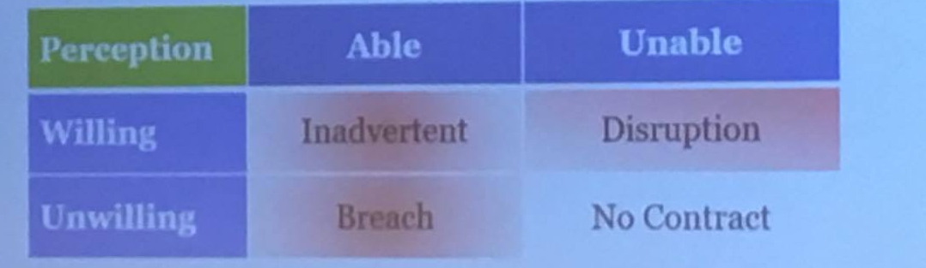
Disruption: both parties are willing, but outside circumstances make it impossible for one or both parties to fulfill their end of the contract.
Breach: one party refuses to honor the contract despite being able to do so.

Responses to breach
- Exit
- Voice
- Neglect
- Silence (loyalty)

Keys to success in this class
- Go to your interactive (every single one). Trust your ITs.
- Build your relationships with your colleagues in your class. Have fun learning.
- Embrace the lecture format. Build your conceptual toolkit.

