Research Notes # 1

Research Question 1
What type of actuator will be used to provide enhanced strength, endurance, and speed?
Information obtained
- Hydraulic actuator can provide enhanced strength, endurance, and speed.
- Hydraulic actuator can be used when large amount of force is needed [1].
- Hydraulic actuator can operate in pressures up to 4,000 psi [2].
- Hydraulic actuator can provide high speed [3].
- The speed of the hydraulic actuator can be controlled [4].
- Hydraulics Principle (Pascal’s Principle) [5] is related to how the hydraulic actuator works.
How information obtained can be used
- Since hydraulics can provide large amount of force, I will be using this information and also use Hydraulics Principle (Pascal’s Principle) [5] to explain how increased strength can be provided in terms of forces
- A hydraulic actuator being able to operate in high pressures, I will be using this information to show how it can provide high endurance.
- I will be using the information on Flow-Control Valves [4] to explain how high speed of the hydraulic actuator can be provided and controlled.
References
[1] “Robot Actuators – Different Types,” https://www.robots.com/education/actuators. Accessed January 23, 2017
[2] C. Gonzalez. (2015, April 16), “What’s the difference between Pneumatic, Hydraulic and Electrical Actuators?,” [Online]. Available: http://machinedesign.com/linear-motion/what-s-difference-between-pneumatic-hydraulic-and-electrical-actuators
[3] C. Benson. (2010, September 02), “How to Make a Robot – Lesson 3: Making Sense of Actuators,” [Online]. Available: http://www.robotshop.com/blog/en/how-to-make-a-robot-lesson-3-actuators-2-3703
[4] Hydraulics and Pneumatics. (2012, January 1), “Engineering Essentials – Flow-Control Valves,” [Online]. Available: http://hydraulicspneumatics.com/200/TechZone/HydraulicValves/Article/False/6409/TechZone-HydraulicValves
[5] The Editors of Encyclopedia Britannica. (2012, June 25), “Pascal’s Principle,” [Online]. Available: https://www.britannica.com/science/Pascals-principle
Research Notes # 2

Research Question 1
What type of fluid will be used to ensure efficiency of the actuator?
Information obtained
- Viscosity affects the performance and efficiency of an actuator [1]
- Viscosity changes with temperature [2], [3].
- Temperature affects the forces of attraction between molecules.
How information obtained can be used
This information will be used to explain why viscosity is important and how the change of viscosity of the fluid will affect the performance of the actuator. I will be using the idea of change in states of matter [4] to explain how temperature affects the attractive forces between molecules. Since the change in viscosity of the liquid is caused by temperature, the idea of how temperature affects the attractive forces between molecules, can be used to explain the change in viscosity by talking about the molecules of the fluid.

References
[1] K. Korane, “Why is viscosity important in hydraulic fluids?”, 2016 [Online]. Available: http://www.fluidpowerworld.com/viscosity-important-hydraulic-fluids/. [Accessed: 05- Feb- 2017].
[2] E. C. Fitch, “Temperature stability of lubricants and hydraulic fluids”, [Online]. Available: http://www.machinerylubrication.com/Read/367/temperature-stability. [Accessed: 07 – Feb – 2017].
[3] T. V. Oommen and G. L. Grune, "Low temperature viscosity behavior of transformer oils," Proceedings:Electrical Electronics Insulation Conference and Electrical Manufacturing & Coil Winding Conference, Rosemont, IL, 1995, pp. 110. [Accessed: 06 - Feb – 2017].
[4] A. M. Helmenstine, “List of Phase Changes of Matter” [Online]. Available: http://chemistry.about.com/od/matter/ss/List-of-Phase-Changes-of-Matter.htm. [Accessed: 07 – Feb – 2017].

Research Notes # 3

Research Question 1
What type of actuator will be used to provide enhanced strength, endurance, and speed?

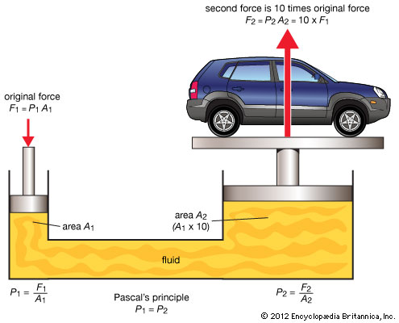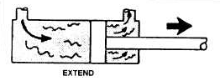
Fluid
A₂
Oil port

A₁
Figure 1: Hydraulic System [1] Figure 2: A simple cross-section of a
Hydraulic Actuator
Hydraulics principle (Pascal’s Principle) [1] is related to how the hydraulic actuator works, and it can be used to explain how the hydraulic actuator can provide enhanced strength in terms of forces. Figure 1 shows a simple set up of a hydraulic system. Hydraulics principle tells us that the change in pressure that occurs anywhere in a confined incompressible liquid, is passed throughout the liquid such that the change remains the same everywhere. It means that, in figure 1, if a force of F1 is applied over an area of A1, the same force, F2, will be outputted over the area, A2. It is because the pressure along the tube remains constant. However, if the area, A2, is 10 times greater than the area, A1, the force, F2, will be 10 times greater than force, F1. But the pressure throughout the tube remains constant. Figure 2 shows a simple cross-section of a hydraulic actuator. The same idea of hydraulics principle can be applied, where the oil is passed through the oil port, which has a small area, A1, and the pressure is applied on the large area, A2, which creates a greater force. Hence, the piston rod is extended at a greater force.

References
[1] The Editors of Encyclopedia Britannica. (2012, June 25), “Pascal’s Principle,” [Online]. Available: https://www.britannica.com/science/Pascals-principle
Research Notes #4

Research Question 1
What type of actuator will provide enhanced strength, endurance, and speed to the user?
Information obtained
Low-carbon steel alloyed with chromium, molybdenum, nickel, and vanadium allows the hydraulic actuator to provide enhanced endurance. This type of material helps the actuator to operate in high temperatures and pressures. [1]

Research Question 2
What type of fluid will be used to ensure efficiency of the actuator?
Information Obtained
Intermolecular forces of attraction can be used to explain why viscosity varies with temperature. The kinetic theory of matter [2] helps us understand how the forces of attraction works.
Dimethyl silicone, and methyl phenyl silicone are fluids that can ensure high efficiency and high performance of the actuator. This is because these fluids have high boiling point and low freezing point [3], which shows that, in extreme temperatures, the viscosity of these two liquids will have little-to-no change.

References
[1] A. Hitchcox, “New steel for hydraulic cylinders”, 2004 [Online]. Available: http://hydraulicspneumatics.com/200/TechZone/Cylinders/Article/False/7143/TechZone-Cylinders. [Accessed: 14- March- 2017].
[2] S. Lal, “Kinetic Theory of Matter”, 2010 [Online]. Available: http://www.mentorials.com/high-school-chemistry-matter-kinetic-theory-of-matter.htm. [Accessed: 14- March- 2017].
[3] Shin-Etsu, “The Unique Properties of Silicones” [Online]. Available: https://www.shinetsusilicone-global.com/products/type/oil/detail/about/index2.shtml. [Accessed: 14- March- 2017].

