Judaism: Milestones
Naming a Child
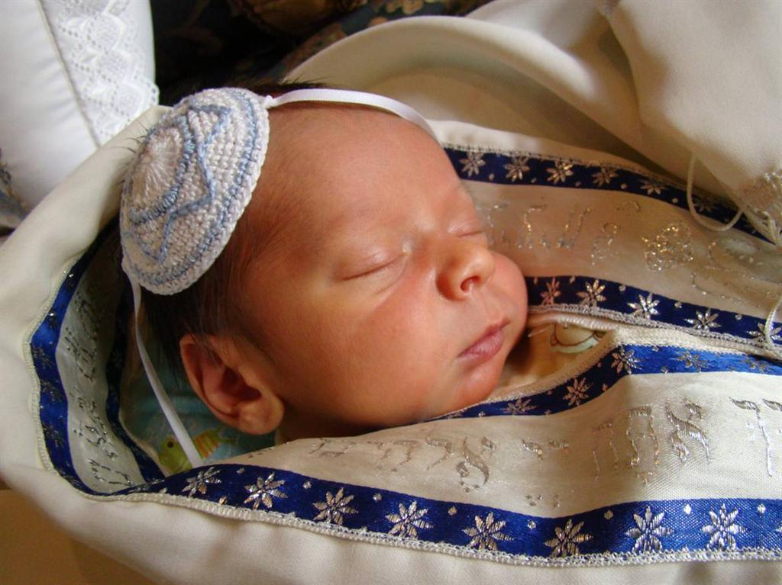
Judaism considers child naming to be a very important event and the naming process follows strict rules. Before the baby is given it’s actual name, a baby is given a Hebrew name, this name is sometimes given in the remembrance of the deceased relatives. This shows how connected Jewish faith is with tradition. The only time the formal name is used is during religious rituals. Jewish boys are circumcised on the eighth day after being born. The circumcision ceremony is performed by a mohel. If a rabbi is not present then a trained doctor would have to preform the ceremony. At one time, fathers used to circumcise their own sons. The reason this circumcision ceremony is so important is because they are also named during it. Jewish people have to get circumcised at a synagogue. Girls are also given their names at the synagogue on a Sabbath soon after their birth.
Coming Of Age
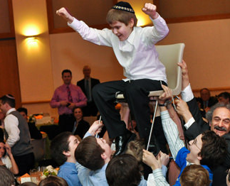
When a Jewish boy turns 13 years old he celebrates his bar mitzvah which means “son of the commandment.” In the Jewish religion the boy is now considered an adult. The boy will usually spend months in advance to prepare for the bar mitzvah. The bar mitzvah takes place on the first Sabbath after their birthday. Girls will celebrate their bat mitzvah which means “daughter of commandment,” after their 12th birthday. After these celebrations you are responsible for your own actions under the Jewish law. Many cultures believe 13 is too young to be considered as adults. The leading cause of this believe is because their brains are still developing, due to this many young people do things they will later on regret. Also, gifts are commonly given at these ceremonies.
Marriage
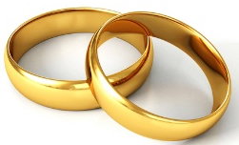

Marriage is a very important event for everyone who gets married but it is even more important for Jewish people because family plays a large role in the Jewish tradition. Jewish people are not required to marry but it is preferred if they do. It is also preferred for Jewish people to marry other religious Jews so they can pass on traditions to the next generation. Most Jewish weddings occur in a synagogue and are conducted by a Rabbi. The bride and groom stand under a special canopy called a Chuppah during the ceremony. The Chuppah is a symbol of the home they will share, it is decorated with flowers. They drink from a glass of wine that has been blessed. The bridegroom reads and signs the marriage contract called a Ketubah which states the husband will look after his wife. The groom gives the bride a ring and at the end of the ceremony, the groom crushes a glass under his foot. This gesture reminds the couple that they will experience bad as well as good things in their lives, which they will face together. It also symbolizes the destruction of the temple in Jerusalem. The primary purpose of marriage is love and companionship, not having children. Marriage between certain close relatives is forbidden. The groom’s father gives the bride’s father a bride price called a mohar in exchange for his daughter. The groom also gives gifts to the bride called mattan.
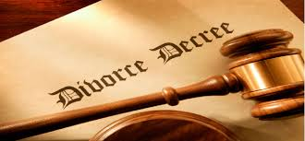
Divorce

Judaism does allow divorce but is a very discouraged act. Friends and family will try to comfort the couple to help them overcome adversity. If there is no other option except divorce, then the husband gives the wife a certificate of divorce called a “get.” If a “get” is not issued, the marriage is considered to be ongoing. Once the couple is divorced, the Jewish religion allows them to marry other people. Under Jewish law a man can divorce a women for no reason or any reason. According to the Torah, divorce is accomplished simply by writing a bill l of divorce, handing it to the wife and sending her away. The rabbis created complex rules regarding the process of writing the document, delivery and acceptance. Most of the time, a man who divorces his wife is required to pay her a substantial amount of money. Also Jewish law prohibits a man from remarrying his ex-wife after she has married another man. Under Jewish law, only the husband can issue a divorce and the wife is not able to prevent the divorce.
Death
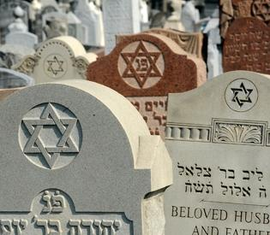
Judaism’s final milestone is death. In Judaism, life is valued above almost all else. The Talmud notes that all people are descended from a single person, thus taking a single life is like destroying an entire world, and saving a single life is like saving an entire world. The funerals are to be conducted within 24 hours of the death. They believe cremation of the body destroys what god made. Whilst they do believe in the concept of life after death they like to focus more on the present instead of the past. There is even a mourning ceremony after the funeral that last 7 days, within these 7 days they are relieved of all day-to-day responsibilities and problems. Many other things are conducted in these 7 days. They have a small meal prepared by neighbours and friends to symbolize that need to live and start the healing. The mourner’s recite the kaddish which is a prayer made specifically for mourners. The last custom, which is covering all your mirrors to avoid vanity is not followed by as many people.
References

Bilad, E. (2015, August 26). A guide to Jewish death and mourning rituals. Retrieved May 18, 2017, from http://www.haaretz.com/jewish/features/1.673158

Death & Mourning: Jewish Customs, Traditions and Practices . (n.d.). Retrieved May 18, 2017, from http://www.shiva.com/learning-center/death-and-mourning/

Dolan, S. (2002). Exploring world religions: the Canadian perspective. Don Mills, Ont.: Oxford University Press.

Issues in Jewish Ethics: Divorce. (n.d.). Retrieved May 17, 2017, from http://www.jewishvirtuallibrary.org/divorce-in-judaism
Rich, T. (2011). Judaism 101. Retrieved May 17, 2017, from http://www.jewfaq.org/divorce.htm

Simmons, R. (2002, June 15). Naming a Baby. Retrieved May 18, 2017, from http://www.aish.com/jl/l/b/48961326.html

Staff, M. (n.d.). Jewish Marriage. Retrieved May 17, 2017, from http://www.myjewishlearning.com/article/jewish-marriage/

Williams, Y. (2009, June 8). Judaism: Coming of Age Ritual . Retrieved May 18, 2017, from http://www.unexplainable.net/religion/judaism_coming_of_age_ritual.php

