BIOL 1p91 Spring 2017

LECTURE 1 – May 1st 2017
Chapter 1.1: Intro

Unifying Principles that Guide our Understanding of Life

- Cells are the simplest units of life
- Living organisms use energy
- Living organisms interact with their environment
- Living organisms have mechanisms that maintain homeostasis
- Living organisms grow, develop, and reproduce
- The genetic material, DNA, provides a dynamic plan for sustaining life
- Populations of organisms evolve from one generation to the next
- All life is related by an evolutionary history
- Organisms follow the laws of chemistry and physics, and structure determines function

Levels of Biological Organization

- Living organisms can be viewed and studied at different levels of organization
- From atoms
- The smallest component of an element
- …To the biosphere
- All places on earth where living organisms exist

  - Atoms
  - Molecules and macromolecules
  - Cells
  - Tissues
  - Organs
  - Organ Systems
  - Organism
  - Species
  - Population
  - Community
  - Ecosystem
  - Biosphere

Clicker
Q: A bird shivers on a cold night to maintain its body temp. What property of life does this represent?
A: B homeostasis

Chapter 2: Atoms, Molecules and Water

Outline

- Atoms
- Chemical Bonds that Create Molecules
- Chemical Forces that Promote Molecular Interactions
- The Importance of Water and its Physical and Chemical Properties

2.1: Atoms

- Smallest functional units of matter that form all chemical substances
- Cannot be further broken down into other substances by ordinary chemical or physical means
- Each specific type of atom is a chemical element
- E.g. Hydrogen, nitrogen, oxygen
- Contain three subatomic particles
- Protons: Positive, found in nucleus, same number as electrons – give nucleus positive charge
- Neutrons: Neutral, found in nucleus, number can vary
- Atoms usually contain the same number of neutrons as protons
- Electrons: Negative, found in orbitals, same number as protons
- Atomic nucleus: Centre of the atom where protons and neutrons are confined
- Entire atom has no net electric charge

Characteristics of Major Subatomic

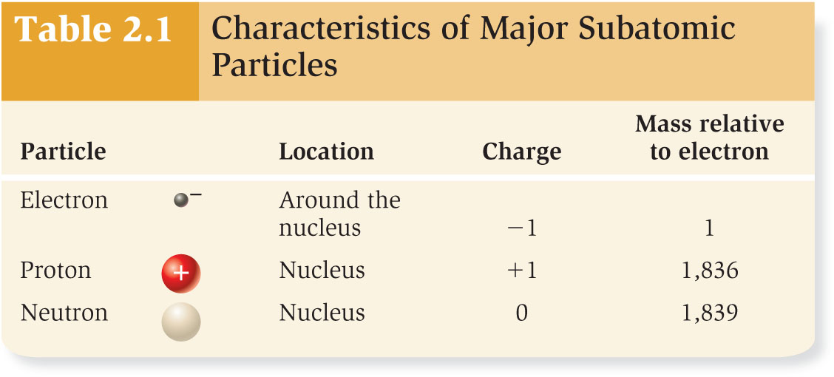

Rutherford’s experiment

- In early 1900s, most scientists believed that the positive charge and mass of an atom were evenly dispersed throughout the atom
- “Plum pudding” atomic model
- Electrons are like plums dispersed in a positively charged pudding
- Think of atom of bowl of pudding – has overall even positive charge and electrons (negative charge) are randomly throughout the bowl of pudding like plums
- Rutherford tested this model
- Hypothesized that atoms in a thin sheet of gold foil would be composed of diffuse, evenly distributed positive charges that would cause alpha particles to be slightly deflected as they pass through

Rutherford’s results

- The data
- 98% were undeflected (no positive charge)
- <2% were slightly deflected
- 0.01% bounced back
- Conclusion: Most of the volume of an atom is empty space, with the positive charges concentrated in a small volume in the middle – positive charge in nucleus and negative charge surrounds it

Clicker
Q: Most of the mass of an atom is found in the
A: D - nucleus

Structure of the Atom

An atom consists of
- A nucleus that contains protons and neutrons
- Electrons in a large, empty space around the nucleus
- 10⁵ = 100,000
- Diameter of atom including electrons is ~ 100,000 times the diameter of the atomic nucleus
- If the atom’s nucleus was a marble (~1cm) the electrons would orbit at a distance of ~1km away!

The Nuclei of Two Simple Atoms and their Electrons
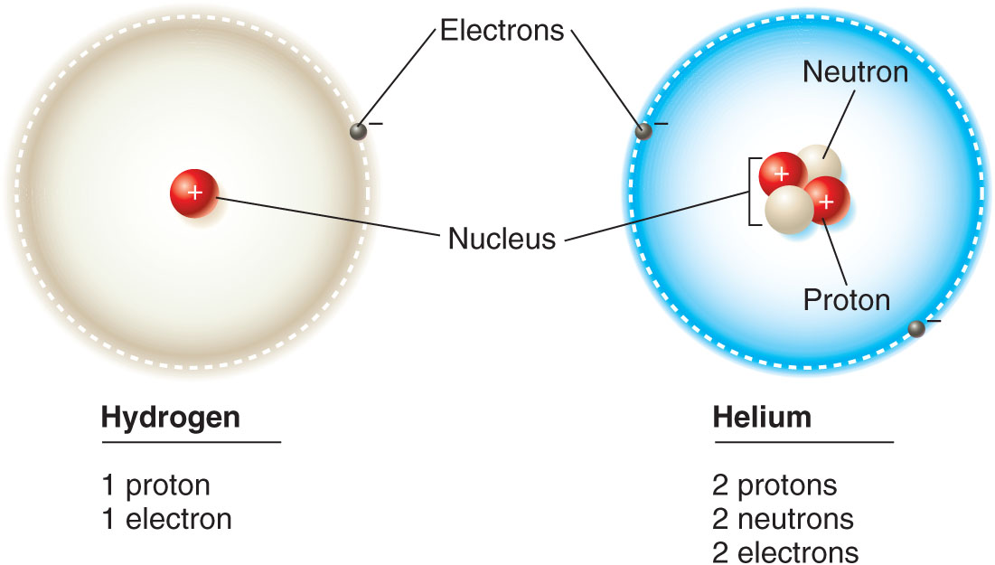

Orbitals

- Areas in which the probability of finding an electron is high
- Think of orbital as a cloud surrounding
- s orbitals are spherical
- p orbitals are propeller- or dumbbell-shaped
- Each orbital can hold only 2 electrons
  - Atoms with more than 2 electrons have more than 1 orbital – entering second energy shell
- Orbitals occupy energy shells that are associated with specific energy levels
- Atoms with progressively more electrons have orbitals within energy shells that are at greater distances from the centre of the nucleus
- 1st energy shell contains one spherical orbital (1s)
- Holds two electrons
- Fills with lowest-energy electrons first
- 2nd energy shell contains one spherical orbital (2s) and three dumbbell-shaped orbitals (2p)
- Holds 4 pairs of electrons (= 8 electrons total)
- 2s has lowest energy and fills up first

Diagrams of Individual Electron Orbitals

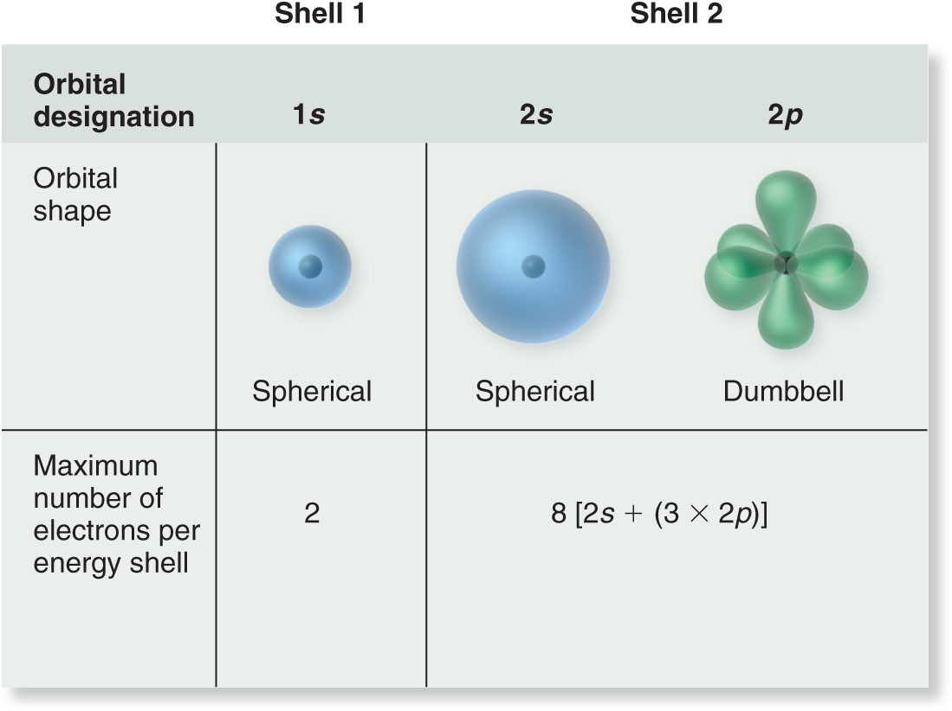

Valence Electrons

- Atoms with unfilled energy shells tend to share, release, or obtain electrons to fill their outer energy shell
- Electrons in the outermost energy shell that are available to combine with other atoms are called valence electrons
- Allow atoms to form chemical bonds with one another

Nitrogen as example

- A nitrogen atom has seven protons and seven electrons
- 2 electrons fill 1st shell: 1s
- 5 electrons in 2nd shell:
  - 2 fill 2s orbital
  - 1 each in the three p orbitals
- Outer shell is not full
  - Five valence electrons, three unpaired

Diagrams of a Nitrogen atom – drawing it
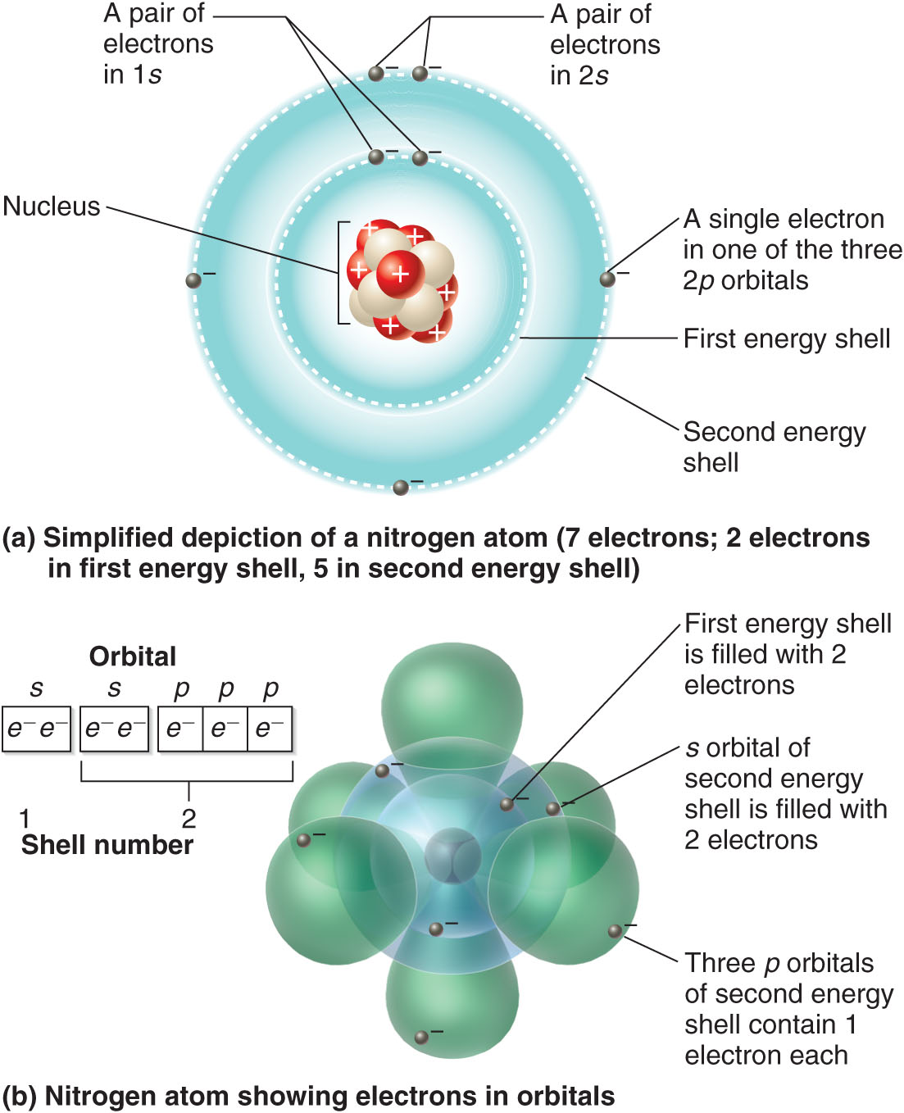

Realistic depiction of Nitrogen

Clicker
Q: True or false the first energy shell can hold 8 electrons
A: False

Protons

- Positive subatomic particles which distinguish one element from another
- Atomic number
- Number of protons in an atom
- Atoms are electrically neutral, so the atomic number also indicates the number of electrons
- Useful criteria for organizing chemical elements into “The Periodic Table”

Periodic Table

- Organizes chemical elements by atomic number and electron energy shells
- Each row, from top to bottom, corresponds to the number of electron energy shells
- Columns, from left to right, indicate the number of electrons in the outer shell
  - Elements within a column have similar chemical properties
  - Same number of electrons in their outer energy shells, therefore similar chemical bonding properties

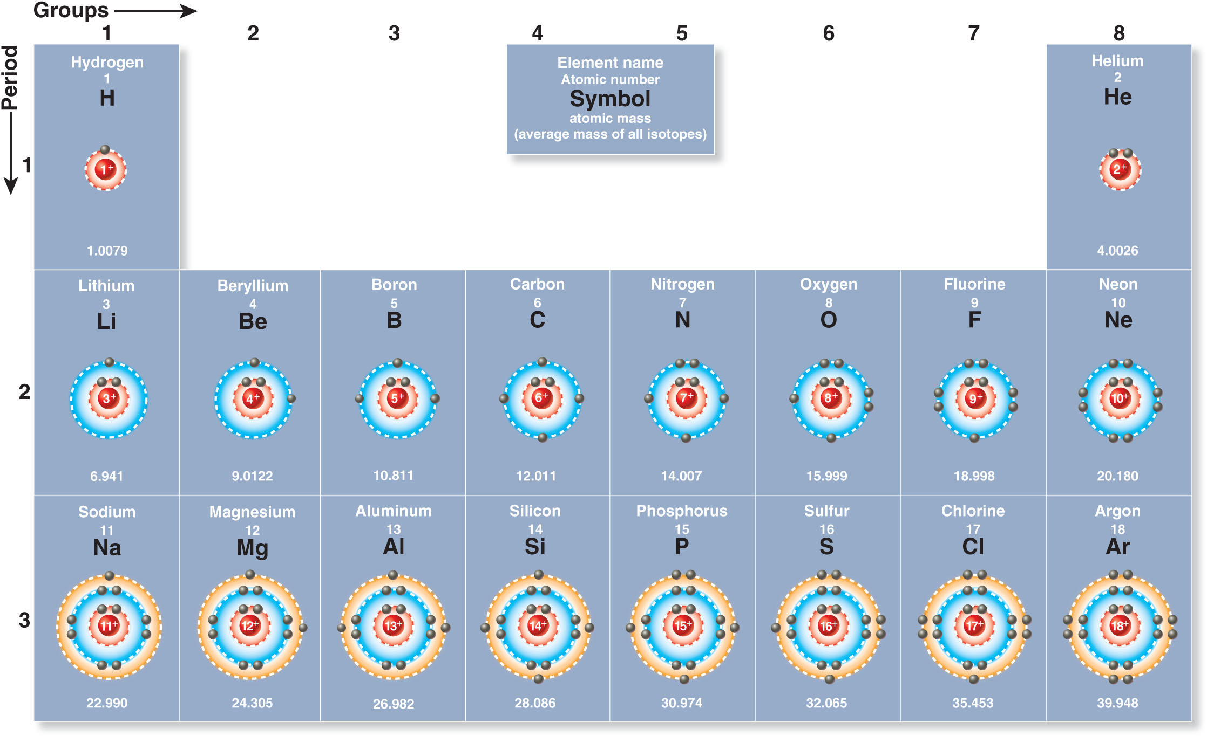

LECTURE 2 – May 2nd 2017

Atomic Mass

- Atoms are extremely tiny & have very little mass
  - e.g. A single hydrogen atom has a mass of 1.67 x 10⁻²⁴ grams
- Protons and neutrons are nearly equal in mass
  - More than 1800 times the mass of an electron
- Atomic mass is measured in units called daltons – not measured in grams
  - Most common form of carbon (6 protons + 6 neutrons) is used as the reference = 12 daltons
  - Hydrogen = 1 dalton (1/12 the mass of a carbon atom)
  - Magnesium = 24 daltons (2x the mass of a carbon atom)
- Protons = atomic number
- Protons + neutrons = atomic mass

Moles

- For chemical reactions, the number of atoms is often more important than the mass
- Equal parts by atom
- 1 D= 1 g/mol
  - 1 g of hydrogen has more atoms than 1 g of carbon, because carbon has a larger mass
- 1 mole of any element contains 6.022 x 10²³ atoms
  - = Avogadro’s constant
  - The same number of atoms as in exactly 12 g of carbon
    - 12 g carbon = 1 mole
    - 1 g hydrogen = 1 mole

Isotopes

- Multiple forms of an element that differ in the number of neutrons
  - ¹²C contains 6 protons and 6 neutrons
  - ¹⁴C contains 6 protons and 8 neutrons
  - super script = atomic number (number of protons)
  - Number of protons never changes
- Radioisotopes: Unstable isotopes found in nature
  - Lose energy through radiation
    - Emit subatomic particles (radioactivity)
- Modern medicine makes use of the high energy level of radioisotopes
  - E.g. Radioactive iodine, Positron Emission Tomography (PET) scans – can cause cellular damage and even cellular death

PET scans
- Adds natural substance such as glucose in the veins
- Adds radioactive part
- Good way to determine cancer
- Used in medical/science

Four main elements of life

- Oxygen, carbon, hydrogen and nitrogen typically make up about 95% of the mass in living organisms
  - Hydrogen and oxygen occur primarily in water (Humans 95% water, plants 65% water)
  - Carbon is a key element in the building blocks of all living matter
  - Nitrogen is found in proteins and nucleic acids
- Many mineral and trace elements that are a small percentage of total mass are essential for normal growth and function
- Minerals such as calcium, phosphorus and sodium for different reasons
- Also iron at a smaller scale

2.2: Chemical Bonds and Molecules

- Single atom cannot do much unless it has another atom to react with
- Molecule
  - 2 or more atoms bonded together
  - Atoms in molecules are held together by chemical bonds
- Compound
  - A type of molecule composed of 2 or more elements
  - Properties differ greatly from the elements that combine to form it
  - Example water (H20)

Molecular formulas

- Contains chemical symbols of all atoms found in a molecule
- Subscript indicates how many atoms are present in the molecule
- Examples:
  - Oxygen (O₂), water (H₂O), glucose (C₆H₁₂O₆)

Covalent Bonds

- Bond that occurs when atoms share a pair of electrons
- Occur between atoms with outer electron shells that are not full
- Each atom will have an electron that is free so they will share
- Strong chemical bonds because the shared electrons behave as if they belong to each atom
- Produces single, double or triple bond
  - 1 shared pair = single bond
  - 2 shared pairs = double bond
  - 3 shared pairs = triple bond

Octet rule

- Atoms are stable (unreactive) when their outer shell is full
  - For many atoms = 8 electrons
  - Hydrogen = 2 electrons
  - Potential to form covalent bonds is based on the number of electrons needed to fill the outermost energy shell

Electronegativity

- Measures an atom’s ability to attract electrons from another atom in a bond - hold them close
- The more electronegative an atom, the more strongly it pulls shared electrons towards itself
- Further away from the atom – negative
- Closer to the atom – positive
- Oxygen (3.44) and nitrogen (3.04) are electron hogs
- Don’t share equally with carbon (2.55) or hydrogen (2.20)

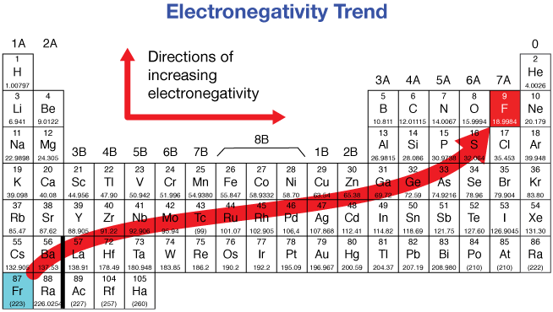

Polar Covalent Bonds

- Occurs when two atoms of differing electronegativity form a covalent bond
  - Shared electrons are likely to be in the outer shell of the atom with higher electronegativity
  - The skewed distribution of electrons creates a polarity across the molecule
- Polar molecule dipole

Water

- Classic example of polar covalent bond
- Two hydrogen atoms share electrons with an oxygen atom
- At any moment, shared electrons tend to be closer to oxygen than either hydrogen
- d = Delta – polarity
- Gives oxygen a partial negative charge, and each hydrogen a partial positive charge

Nonpolar Covalent Bonds

- Bonds that are electrically neutral due to equal sharing of electrons between atoms
- E.g. C‒H and C‒C
- Molecules with mostly nonpolar bonds = nonpolar molecules
- Larger molecules may have some regions with nonpolar bonds and other regions with polar bonds
- E.g. Detergents

Ions

- An ion is an atom or molecule that has gained or lost one or more electrons, resulting in a net electric charge
- When you take an electron you’re negative
- When you give an electron you’re positive
  - Cation = net positive charge – lost electron
    - Cat – positive = PAW
  - Anion = net negative charge – gained electron
    - Ann – negative = aunt anns a bitch
  - Ions may be relatively stable, because the loss or gain of electrons yields elements with a full outermost energy shell
  - E.g. Sodium has 11 protons and 11 electrons
    - One electron in its third (outer) energy shell
    - Loss of one electron to produce Na⁺ results in loss of third energy shell, but full second energy shell

Ionic bonds

- Take electrons
- Forms when a cation binds to an anion – something that gives up electrons and something that takes them
- E.g. Table salt (NaCl)

Molecules form 3D shapes

- Molecules assume different shapes depending on the arrangements and numbers of bonds
- Newly configured orbitals cause the atoms to have defined angles relative to each other

Bond rotation

- Atoms can rotate and change shape without breaking covalent bonds
- Shape of molecule is influenced by environment and neighbouring molecules
- Molecules may change shape to transmit information or accomplish specific chemical changes
- Things changing shape can turn things on or off

Free Radicals

- A special class of highly reactive molecules containing an atom with a single, unpaired electron in its outer energy shell
- Can be formed by exposure to radiation and toxins
- Damages cell membrane & DNA
- Flavonoids and vitamins in some fruits and vegetables exert protective effects
- Donate electrons without becoming highly reactive
- = Antioxidants (fruits and veggies)

Chemical reactions

- Changes one or more substances into other substances
- Reactants products

- Chemical reactions
- Require a source of energy for molecules to encounter each other
- Often occur in water environments & frequently require a catalyst
- Tend to proceed in a particular direction but eventually reach chemical equilibrium
- Ex: CH₄ + 2 O₂ ⇌ CO₂ + 2 H₂O

2.3: Chemical Forces

- Van Der Waal forces occur intermolecularly or between different regions of large molecules
- Occur due to electrostatic interactions between molecules of opposite charges
- Weaker than covalent and ionic bonds
  - Charges are smaller and distances are greater
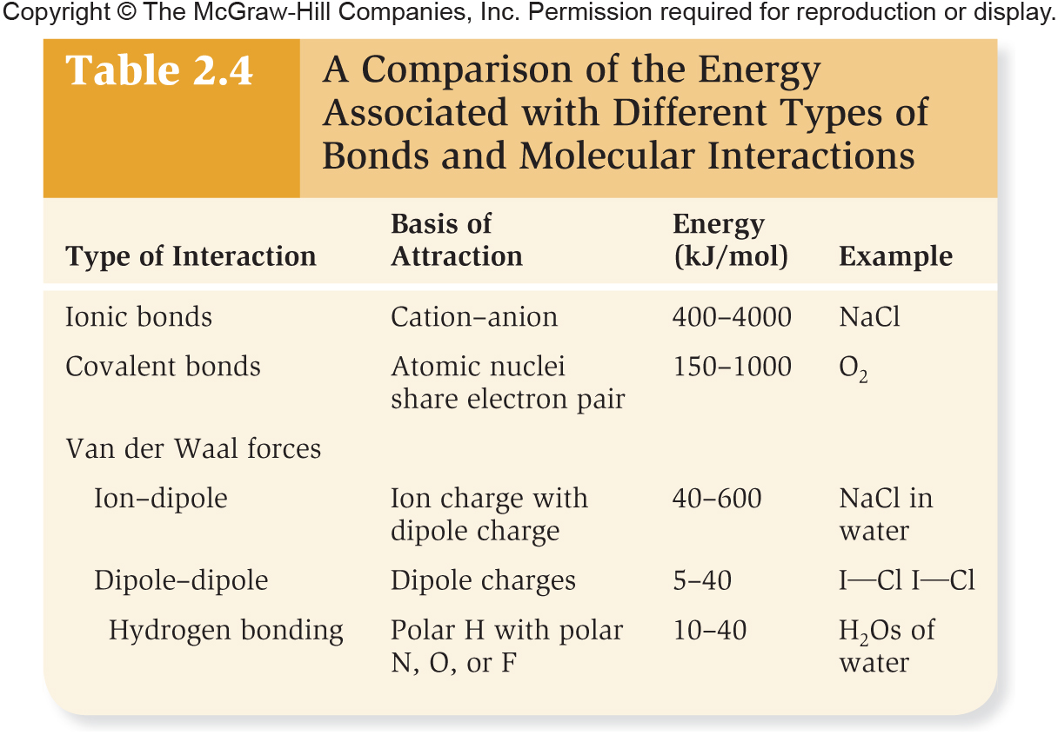

Van der Waal Forces

- Strongest types of van der Waal forces
- Ion-dipole interaction
- Occur between ions and polar molecules
- Dipole-dipole interaction
- Occur between two polar molecules
- One important category is hydrogen bonds
- Strongest between molecules that are complementary in shape & make extensive contact

LECTURE 3 – May 4th 2017

Hydrogen Bonds

- Attraction between a partially positive hydrogen in a polar molecule, and a partially negative atom in another polar molecule
  - Most commonly oxygen or nitrogen
- Stronger than other dipole-dipole interactions
  - Atoms are small and bonds are very polar
- A single hydrogen bond is weak, but a large number of hydrogen bonds between two molecules can be strong

2.4: Physical Properties of Water

- Water exists in three states:
- Solid (ice)
- Liquid (water)
- Gas (water vapour)
- Changes in state involve an input or a release of energy
- Heat of vaporization: Heat required to vaporize 1 mole of any substance at its boiling point under standard pressure
- Heat of fusion: Heat that must be released from a substance to cause it change from a liquid to a solid state (= fusion)
- Specific heat: Heat required per unit of mass to raise the temperature of that mass by one degree Celsius

Physical Properties of Water

- Water has unique properties due to its tendency to form a large number of hydrogen bonds with itself
- High heat of vaporization
- High heat of fusion
- High specific heat
- Much heat is needed to break hydrogen bonds occurring between neighbouring water molecules
- Majority of water on earth is found as liquid water
- Hydrogen bonds continually formed, broken and reformed
- As temperature falls, hydrogen bonds are broken less frequently until water begins to solidify
- Solid water has a more open crystalline structure than liquid
- Floating ice insulates water below and makes lower regions less likely to freeze

Water as a solvent

- Solutes: Substances dissolved in a liquid
- Solvent: Liquid in which they are dissolved
- Solution: Solutes dissolve in a solvent
- Water is a versatile solvent due to its polarity
- Hydrophilic molecules: “water loving”
  - Readily dissolve in water
  - Molecules containing ionic and/or polar covalent bonds

Properties of Nonpolar Molecules in Water

- Hydrophobic molecules: “water fearing”
- Do not readily dissolve in water
- Nonpolar molecules like hydrocarbons
- Oils
- Instead dissolve readily in nonpolar solvents
- E.g. Cholesterol
- In the lab, must be dissolved in a nonpolar solvent such as ether
- In animals, inserts into biological membranes which contain ~50% nonpolar compounds

Amphipathic Molecules

- Have both polar/ionized and nonpolar regions
- May form micelles in water
- Hollow spheres of amphipathic molecules
- Nonpolar ends oriented toward the interior
- Also form bilayers

Solute Concentration

- The amount of dissolved solutes affects the physical properties of a solution
- Solute concentration = Amount of a solute dissolved in a unit volume of solution
- E.g. 1 g of NaCl dissolved in 1 liter of water = 1 g/L
- Does not directly indicate how many molecules of each substance are present
- E.g. 10 g of glucose contains fewer molecules than 10 g of NaCl
- Number of moles dissolved per volume of solution is more informative

Colligative Properties of a Solvent

- Properties of water that depend on the amounts of dissolved substances
- Do not depend on the specific type of particle, only its concentration
- E.g. Temperature at which a solution freezes or vaporizes
- Addition of solutes such as ethylene glycol to water
- Lowers its freezing point below 0°C
- Raises its boiling point above 100°C

Natural Antifreeze

- Some animals produce antifreeze molecules that dissolve in their body fluids and enable survival in extreme cold
  - Lowers freezing points of fluids and prevents blood and cells from freezing
  - Wood frogs can survive freezing of up to 65 – 70% of their body water by redistributing water normally found in tissues, and distributing cryoprotective glucose to cells throughout the body

Acids and Bases

- Pure water has the ability to ionize to:
  - Hydrogen ions (H+)
  - Hydroxide ions (OH-)
- In pure water
- [H⁺][OH⁻] = [10⁻⁷ M][10⁻⁷ M] = 10⁻¹⁴ M
- Certain substances dissolved in water may release or absorb H+ or OH-, altering the concentrations
- Acids are molecules that release hydrogen ions in solution
- E.g. HCl (hydrochloric acid) H+ and Cl-
- Strong acids release more H+ than weak acids
- Bases are molecules that lower the H+ concentration
- May directly release OH- or react with water to produce OH-
- E.g. NaOH (sodium hydroxide) Na+ and OH-
- Is ammonia an acid or a base?
- NH₃ + H₂O NH₄+ + OH-
- Product of [H⁺] and [OH⁻] is always 10⁻¹⁴ M
- Increasing OH- concentration lowers H+ concentration

pH of a Solution

- H+ concentration is expressed as the solution’s pH
  - pH = -log₁₀ [H+]
  - [H+] = 10⁻⁷ M or 0.1 µM = pH 7
  - [H+] = 10⁻⁶ M or 1.0 µM = pH 6
- pH
  - Acidic solutions are below pH 7 (high H+ concentration)
  - pH 7 is neutral
  - Alkaline solutions are above pH 7 (low H+ concentration)

Importance of pH

- H+ and OH- can bind many kinds of ions and molecules
- Therefore, the pH of a solution can affect the:
  - Shapes and functions of molecules
  - Rates of many chemical reactions
  - Ability of two molecules to bind to each other
  - Ability of ions or molecules to dissolve in water
- Many biological processes function best within very narrow ranges of pH

Buffers

- Organisms usually tolerate only small changes in pH
- Buffers minimize changes in pH
- An acid-base buffer system shifts to generate or release H+ to adjust for changes in pH
  - E.g. Bicarbonate pathway
    - If pH increases (H+ decreases), CO₂ combines with H₂O to produce carbonic acid, which dissociates into H+ and bicarbonate
    - If H+ increases, this pathway runs in reverse

Important Roles of Water

- Water is the primary solvent in all living organisms
- Water participates in chemical reactions
  - Hydrolysis: Water used to break apart another molecule
  - Dehydration/condensation reaction: Removal of a water molecule to form a covalent bond between two molecules
- Water is incompressible
- Can be used to provide force or support
- Water is used to eliminate unneeded and potentially toxic waste compounds
- Evaporation helps animals dissipate body heat by removing heat from skin and respiratory tract
- Cohesion between water molecules aids in movement through vessels of plants
- Adhesion between water molecules and other surfaces allows it to line surfaces and act as a lubricant in digestive tracts, between bones, etc.
- Surface tension allows certain insects to walk on the surface of a pond without sinking

LECTURE 4 – May 8th 2017
Chapter 3: Organic Molecules

Outline

- The Carbon Atom and the Study of Organic Molecules
- Classes of Organic Molecules and Macromolecules
- Carbohydrates
- Lipids
- Proteins
- Nucleic Acids

Origin of Organic Chemistry

- Organic molecules: Carbon-containing molecules
  - Originally discovered in living organisms
- Vitalism: Belief that organic molecules were imparted with a vital life force and could not be synthesized
- In 1828 Friedrich Wohler synthesized urea “without the use of kidneys, either man or dog”

Carbon is the Chemical Basis of All Life

- Has the ability to form four covalent bonds with other atoms
  - Four valence electrons in outer energy shell
  - In living organisms, most commonly bonds with other carbons, hydrogen, oxygen, nitrogen and sulphur
  - A vast number of organic compounds can be formed from only a few elements
- Carbon bonds may occur in linear, ringlike, or highly branched configurations
- Offers diversity in terms of shape/structure of molecules
- These molecular shapes can produce molecules with a variety of functions
- Can form both polar and nonpolar bonds, and single and double bonds
- Carbon bonds are stable at the different temperatures associated with life
- Carbon atoms are small, resulting in short carbon-carbon bonds
- Stronger & more stable
- Makes life possible even in extreme environments
- Carbon bonds are stable at the different temperatures associated with life
- Carbon atoms are small, resulting in short carbon-carbon bonds
- Stronger & more stable
- Makes life possible even in extreme environments

Functional Groups
- Groups of atoms with special chemical features that contribute to the molecules’ properties
- Each type of functional group exhibits the same properties in all molecules in which it occurs

Isomers

- Two structures with an identical molecular formula but different structures and characteristics
- Structural isomers: Contain the same atoms but in different bonding relationships
- Stereoisomers: Identical bonding relationships but different spatial positioning of the atoms
- Geometric (cis-trans) isomers
- Cis - The two hydrogen atoms linked to the two carbons of a C=C double bond are on the same side of the carbons
- Trans - The two hydrogen atoms linked to the two carbons of a C=C double bond are on the opposite side
- Enantiomers: Pair of molecules that are mirror images

Classes of Organic Molecules and Macromolecules

- Four major categories of macromolecules
- Carbohydrates
- Lipids
- Proteins
- Nucleic acids (DNA and RNA)

Classes of Organic Molecules and Macromolecules

- Polymer: Large macromolecule formed by linking together many smaller molecules (building blocks) called monomers
- Structure and function of each type of macromolecule depends on:
- Nature of its monomers
- Number of monomers linked together
- The three-dimensional way in which the monomers are linked

Formation of polymers

- Condensation reaction: Two or more molecules combine into a larger one with the loss of a small molecule
- Dehydration reaction: Condensation reaction in which the lost molecule is water

Breakdown of polymers
- Hydrolysis reaction: Process by which a polymer breaks down into a monomer, using a molecule of water each time a monomer is released

Carbohydrates

- Simple sugars and polymers composed of sugar monomers
- Composed of carbon, hydrogen, and oxygen atoms
- Represented by the general formula Cn(H₂O)n, where n is a whole number
- Most of the carbon atoms in a carbohydrate are linked to a hydrogen atom and a hydroxyl (OH) group
- Polar covalent bonds = water soluble

Monosaccharides

- Simplest sugars
  - Consist of a single monomer unit
- Most common have 5 or 6 carbons
  - Pentoses ‒ e.g. ribose (C₅H₁₀O₅), deoxyribose (C₅H₁₀O₄)
  - Hexoses ‒ e.g. glucose (C₆H₁₂O₆)
- Bonds may be depicted by linear or ring structures

Glucose Isomers

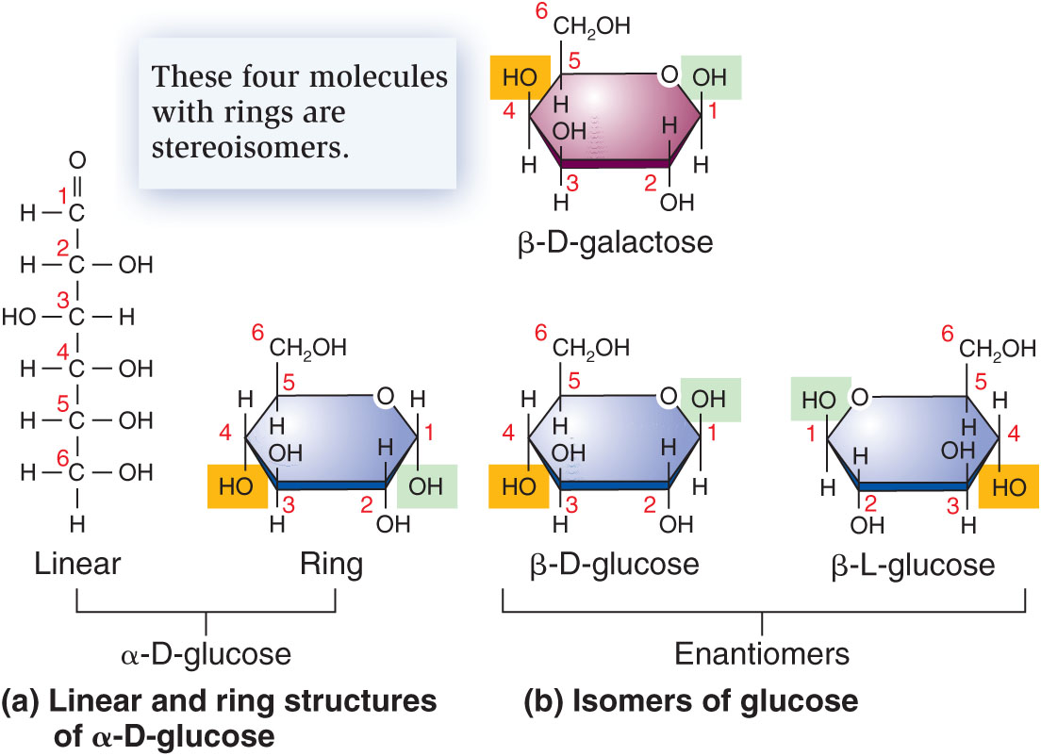

- Only refer to D glucose – it occurs naturally
- Know the difference between alpha and beta
- Above beta (AB)
- Below alpha (BA)

Mutarotation of Glucose

- In solution, cyclic structures open and close and may convert α-D-glucose to β-D-glucose and vice versa

Cyclization of Glucose

- Hydroxyl group of carbon 5 attacks carbonyl (aldehyde) of carbon 1

Disaccharides

- A carbohydrate composed of two monosaccharides
- Joined by a dehydration reaction
- Covalent bond between two sugar molecules = glycosidic bond
- Linkage may be α or β, depending on whether first carbon (C1) is in α or β configuration
- Examples − sucrose, maltose, lactose
- Hydrolysis can break glycosidic bonds by adding water

Polysaccharides

- Many monosaccharides can be successively linked together to form long polymers = polysaccharides
- May be used to store energy
- Individual glucose molecules removed by hydrolysis
- Glycogen = energy storage polysaccharide in animals
- Polymer of glucose
- Highly branched
- α-D-glucose units joined through α-1,4 glycosidic bonds (linear linkages) or α-1,6 glycosidic bonds (creates branches)

Glycogen

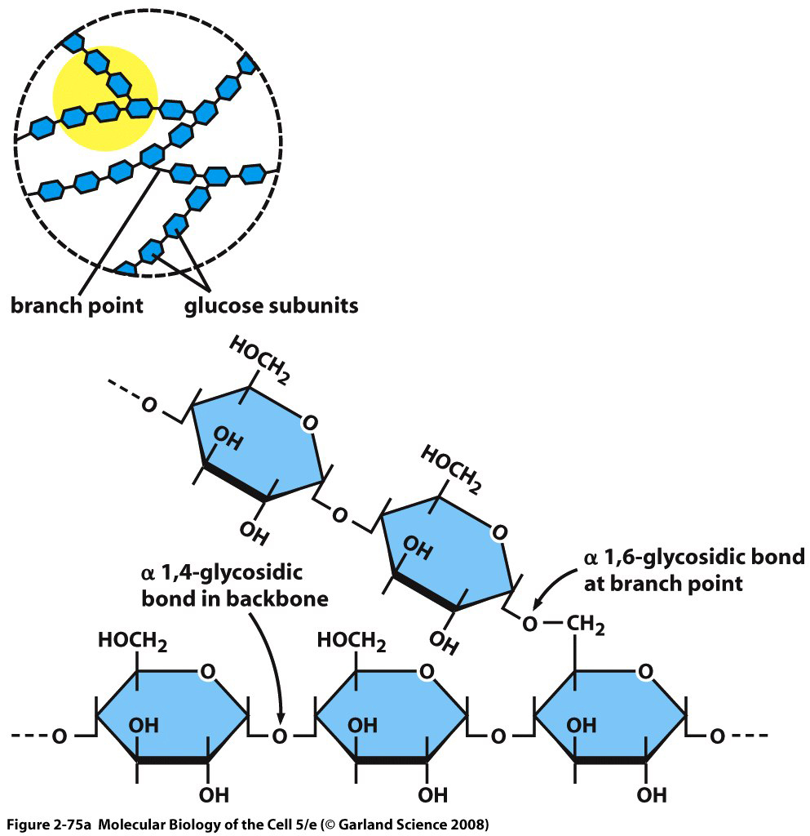

Starch

- Energy storage polysaccharide in plants
- Consists of two polysaccharides:
  - Amylose (~30%)
    - Made of α-D-glucose units bound through α-1,4 glycosidic bonds
    - Linear & helical chains
    - More tightly packed
    - If a vegetable is starchy – takes longer to digest
  - Amylopectin (~70%)
    - Made of α-D-glucose units bound through α-1,4 glycosidic bonds, and branching with α-1,6 glycosidic bonds
    - More soluble & readily digested

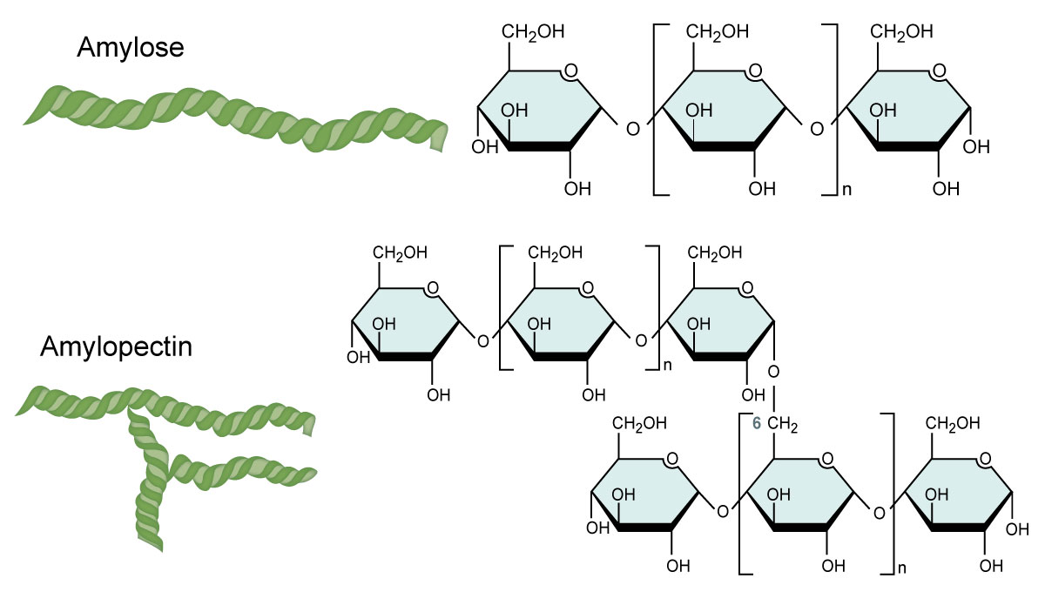
Structural Polysaccharides

- Other polysaccharides provide a structural role, rather than storing energy
- Cellulose
- We do not have enzymes in our body to break apart beta D
- β-D-glucose units bound through β-1,4 glycosidic bonds
- Unbranched, linear chains
- Very tightly packed with hydrogen bonds between chains
- Major structural component of the primary cell wall of plants, algae, and some protists
- Chitin
- Structural polysaccharide that forms the external skeleton of many insects, and cell walls of fungi
- Glycosaminoglycans (GAGs)
- Major component of connective tissues (cartilage, tendons)

Lipids

- Composed predominantly of hydrogen and carbon atoms held together by nonpolar, covalent bonds
- Do not interact with water (insoluble)
  - Hydrophobic
- Include fats, phospholipids, and steroids

Fats

- Fats are a mixture of triglycerides, also known as triacylglycerols
- Consist of glycerol bonded to three fatty acids
- Fatty acid = A chain of carbon and hydrogen atoms with a carboxyl group at the end
- Joined by a dehydration reaction

Fatty acids

- Saturated fatty acid: All carbons in the fatty acid are linked by single covalent bonds
- Unsaturated fatty acid: A fatty acid containing one or more carbon-carbon double bonds
  - One double bond = monounsaturated
  - Two or more = polyunsaturated

Unsaturated Fatty acids

- Trans fats: Unsaturated fats that have the hydrogens in the trans- position, on opposite sides of the double bond
  - Rare in nature, but a common by-product of industrial hydrogenation of fats
    - Hydrogenation adds hydrogen to liquid vegetable oils to increase saturation and “harden” the fat to a solid or semi-solid
- Essential fatty acids: Fatty acids that are necessary for good health and cannot be synthesized by animal cells
  - Must be obtained through the diet
  - Essential fatty acids are always cis

Examples of Fatty Acids

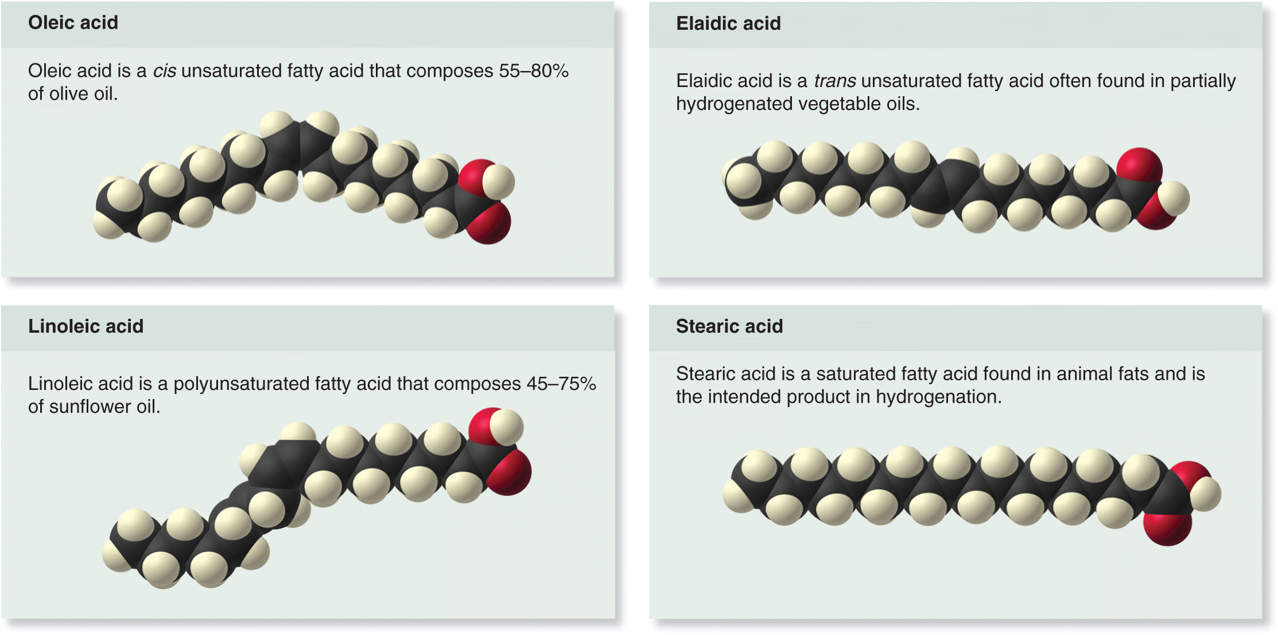

LECTURE 5 – May 9th 2017

Importance of Fats

- Fats are important for energy storage
  - 1 gram of fat stores twice the energy of 1 gram of glycogen or starch
    - C-H bonds are very energy-rich
- Fats also play a structural role by providing:
  - Cushioning that supports organs
  - Insulation that protects against cold weather

Phospholipids

- Similar to triglycerides, but the third hydroxyl group of glycerol is linked to a phosphate group instead of a fatty acid
- Most contain a small polar or charged nitrogen-containing molecule attached to this phosphate
- Amphipathic
- Polar (hydrophilic) head at one end, and nonpolar (hydrophobic) tails at the other end
- Organize into bilayers in water:
- Polar ends face out, interacting with water
- Nonpolar ends face one another in the interior

Steroids

- Four fused rings of carbon atoms form the skeleton of all steroids
- Steroids with polar hydroxyl groups attached = sterols (cholesterol)
- Not numerous enough to make highly water soluble
- Important components of cellular membranes
- Excess cholesterol in the blood of animals can contribute to the formation of clots and block blood vessels

Steroid hormones

- Hormones: Molecules that are produced in one part of the body but can function elsewhere
- Steroid hormones are derived from cholesterol
- Include estrogen and testosterone
- Made by glands then transported to target organ
- Affects growth, metabolism and lots of different things

Waxes

- All waxes contain :
- One or more hydrocarbons
- Long structures that resemble a fatty acid attached by its carboxyl group to another long hydrocarbon chain
- Very nonpolar, and thus repel water
- Secreted by many plants and animals as barrier to water loss
- Can also be used as a structural element,
- e.g. beeswax in the honeycomb of hives

Proteins

- Polymers composed of amino acids
- Contain carbon, hydrogen, oxygen, nitrogen, and small amounts of other elements, notably sulphur
- Amino acids: Monomer units that form the building blocks of proteins
- Common skeleton with a carbon atom (α-carbon) linked to an amino group (NH₂), a carboxyl group (COOH), and a variable side chain “R”
- Different side chains produce 20 different amino acids

Structure of Amino Acids

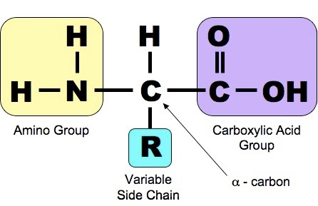

Zwitterions

- At neutral pH (normal cellular conditions), an amino acid is an example of a zwitterion
- Molecule with overall neutral charge, but a positive charge at one location and a negative charge at a different location
- The amino group accepts a hydrogen ion (becomes NH3+) and the carboxyl group loses a hydrogen ion (COO-)

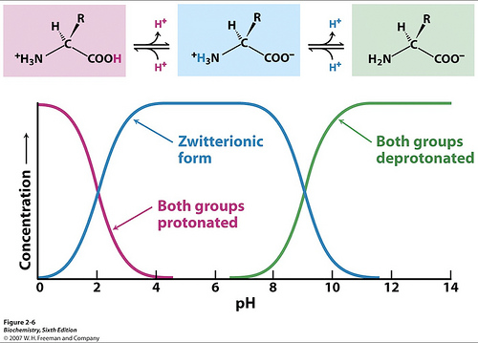

Amino Acid Classification

- Amino acids are categorized as:
- Neutral nonpolar
- Neutral polar
- Charged
- Acidic (negative charge)
- Basic (positive charge)

Peptide Bonds

- Polypeptide: Molecule in which many amino acids are joined by peptide bonds
- Peptide bond: Covalent bond that links together amino acids in a polypeptide chain
- Formed by a dehydration reaction between a carboxyl and an amino group

Proteins Have a Hierarchy of Structure

- A polypeptide is an ordered, covalently linked, collection of amino acids, without considering its shape
- A protein is a functional unit composed of one or more polypeptides that have been folded and twisted into a precise three-dimensional shape
- Allows the protein to carry out its particular function
- Protein structure has four progressive levels:
- Primary, secondary, tertiary, and quaternary

Primary Structure
- The amino acid sequence, from beginning to end
- For a particular polypeptide, the specific sequence of amino acids is specified by the gene that encodes it
- Primary structure of a polypeptide is stabilized by the covalent peptide bonds that link adjacent amino acids together

Secondary Structure

- Regular repeating patterns of two types:
- α helix (spiral) and β pleated sheet (zigzag)
- Hydrogen bonding is the key driving force
- Determined by amino acid sequence and chemistry of the R-groups
- Regions along a polypeptide chain which do not assume an α helix or β sheet conformation are called “random coil”

Tertiary Structure

- A complex three-dimensional shape of a single polypeptide
- Determined by the totality of the amino acid interactions with one another and the aqueous and nonaqueous environment surrounding them
- If a protein is composed of a single polypeptide, this is its final functional structure

Quaternary Structure

- Most functional proteins are composed of two or more polypeptides that each adopt a tertiary structure and then assemble with each other
- Individual polypeptides are called protein subunits of a multimeric protein
- Subunits may be identical polypeptides or they may be different
- Combined three-dimensional structure of multimeric proteins = quaternary structure

Genomes & Proteomes: Domains

- Defined regions of proteins with distinct structures and functions
- Fold independently of the rest of the protein
- These particular amino acid sequences have been duplicated during evolution
- The same domain may be found in several different proteins
- When the same domain is found in different proteins it has the same characteristic three-dimensional shape, chemical properties, and function

Example: Domains of GABP

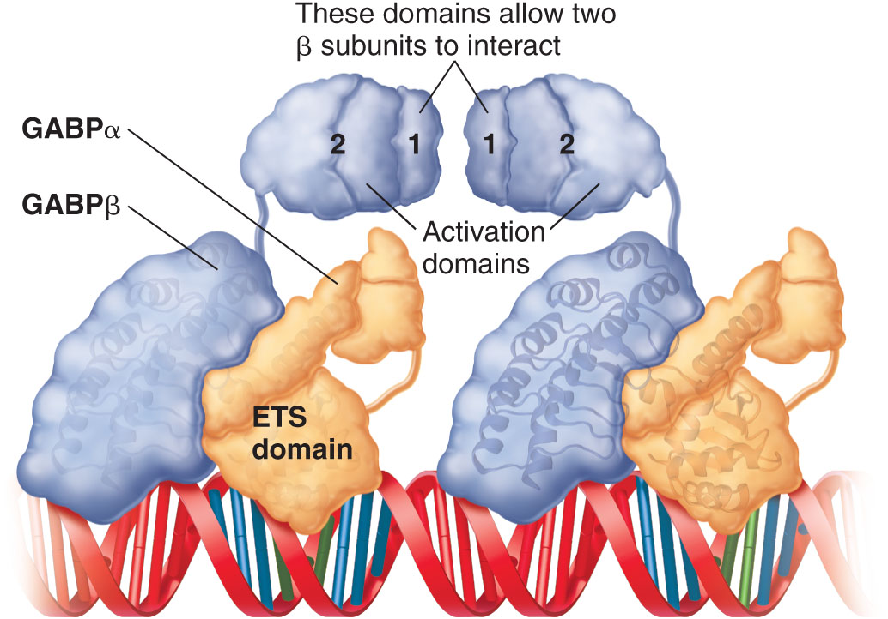

Feature Investigation: Anfinsen’s Experiments on Protein Folding

- Prior to the 1960s, the mechanisms by which proteins assume their three-dimensional structures were not understood
- Christian Anfinsen postulated that proteins contain all the information necessary to fold into their proper conformation without the need for organelles or cellular factors
- Determined by the protein sequence
- He hypothesized that proteins spontaneously assume their most stable conformation based on the laws of chemistry and physics

Anfinsen’s Experiment

- Using purified ribonuclease, found that:
  - Chemicals that disrupt bonds cause the enzyme to lose function
  - Removal of those chemicals restored function
- Therefore, in the complete absence of any cellular factors, an unfolded protein can refold into its functional structure
- We have since learned that some proteins do require assistance from molecular chaperones to fold properly
- Conclusion: Certain proteins can spontaneously fold into their final functional shapes without assistance from other cellular structures or factors

LECTURE 6/7 – May 11th 2017/May 15th 2017

Nucleic Acids

- Organic molecules composed of nucleotide monomers
- Responsible for the storage, expression, and transmission of genetic information
- Two classes of nucleic acids:
  - Deoxyribonucleic acid (DNA)
  - Ribonucleic acid (RNA)

Nucleotides

- Structure relates to function
- Each monomer of a nucleic acid has three components:
- A phosphate group
- A five-carbon sugar (either ribose or deoxyribose)
- A single or double ring of carbon and nitrogen atoms known as a nitrogenous base

Structure of a DNA Strand

- Phosphate group of one nucleotide is linked to the sugar of next nucleotide by a phosphodiester bond
- DNA has all the codes
- Bases protrude from a sugar-phosphate backbone
- Each polynucleotide strand has a defined polarity
- One end: free phosphate attached to the 5’ carbon of the sugar
- Other end: free OH attached to the 3’ carbon of the sugar

DNA

- Store genetic information
- The nucleotides in DNA contain the five-carbon surgar deoxyribose
- Four different nucleotides are present in DNA:
- The purine bases: Double (fused) rings
- Adenine (A) and guanine (G)
- The pyrimidine bases: Single ring
- Cytosine (C) and thymine (T)
- Two strands of deoxyribonucleotides coil around each other to form a double helix
- Strands are held together by hydrogen bonds between bases
- Purine with pyrimidine
- A pairs with T via two hydrogen bonds
- G pairs with C via three hydrogen bonds
- Bases lie in a flat plane perpendicular to sugar-phosphate backbone

Anti-parallel

- Two strands of DNA are anti-parallel
- Oriented with opposite polarity

RNA

- Each nucleotide contains ribose sugar rather than deoxyribose
- The pyrimidine base uracil (U) is used instead of thymine (T)
- Single-stranded & less stable than DNA
- Several types with different functions
- e.g. mRNA (messenger RNA) carries gene sequence from DNA in the nucleus to the cytoplasm, where it is used to make proteins

DNA vs. RNA

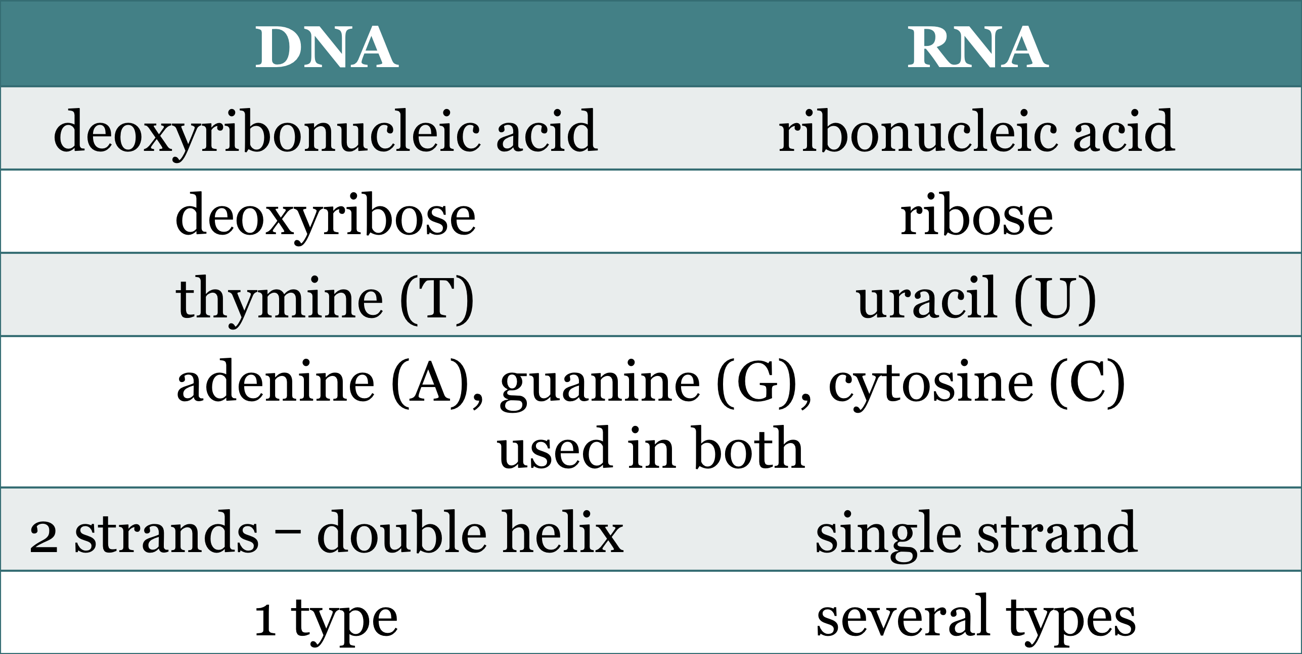

Genomes and Proteomes (CH 1)

- Genome: Complete genetic makeup of an organism
- Acts as a stable informational unit and encodes the information for organismal function
- Provides continuity from generation to generation
- Serves as the substrate of evolutionary change
- Proteome: Collection of all proteins being made in a cell under a particular set of conditions
- Determines cellular and organismal function

Chapter 6: Membrane Structure & Transport

Outline

- Membrane structure and composition
- Phospholipid bilayers of cellular membranes are differentially permeable
- Transport proteins bypass the phospholipid bilayer, allowing biological membranes to be selectively permeable to small molecules and ions
- Macromolecules and large particles are transported via endocytosis and exocytosis

Introduction

- “The cell membrane holds the contents of a cell in one place so that the chemistry of life can occur.”
- Plasma membrane: Biomembrane that separates the internal contents of a cell from its external environment
- Regulates the traffic of substances into and out of the cell

Important Functions of Cellular Membranes

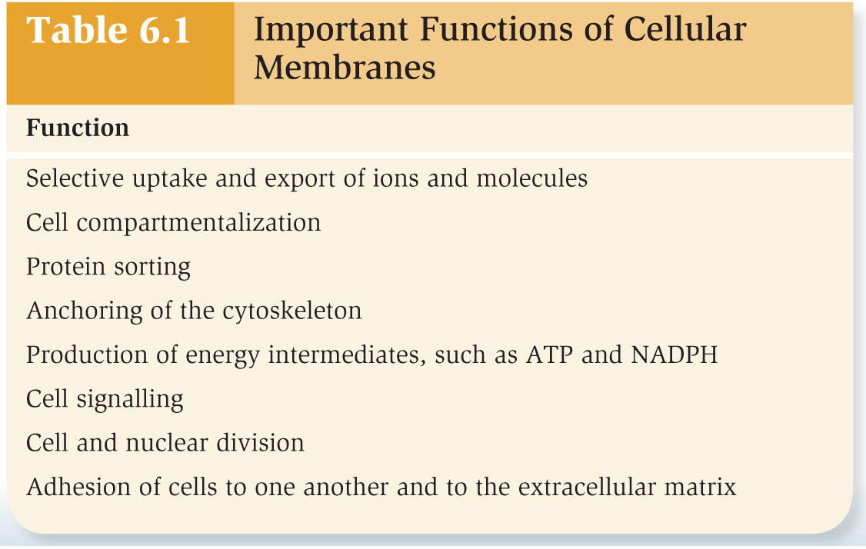

Biological Membranes

- All biological membranes consist of two layers of lipids, with the most abundant lipids being phospholipids
- Membranes always contain proteins and most also have carbohydrates attached to lipids and proteins
- = Glycolipids & glycoproteins
- Phospholipids are amphipathic
- Hydrophobic tails form the interior of the membrane and hydrophilic heads are on both exterior surfaces
- Hydrophobic interior makes it difficult for hydrophilic molecules to move across the membrane
- Fluid-mosaic model: Plasma membrane is a semi-fluid phospholipid bilayer with a mosaic of proteins
- Carbohydrates attached to the lipids or proteins
- Leaflet: Half of a phospholipid bilayer
- Each faces a different region
- E.g. cytoplasm or cell exterior
- Two leaflets are asymmetrical
- E.g. glycolipids found primarily in the extracellular leaflet

Membranes are Semifluid

- Biomembranes exhibit properties of fluidity but lipid molecules move freely in only two dimensions, not three
- Around their long axes (rotational)
- Laterally within the membrane leaflet
- Movements are energetically favourable because fatty acyl tails stay within hydrophobic interior

Lipid Transfer

- Transfer of lipids from one leaflet to the other does not occur spontaneously
- Can be accomplished by three types of proteins:
- Scramblases: Form a protein channel between leaflets for lipids to transfer down a concentration gradient (no ATP)
- Flippases: Move lipids from the outer to inner leaflet using ATP
- Floppases: Move lipids from the inner to outer leaflet using ATP

Bilayer Fluidity

- Optimal level of bilayer fluidity is essential for normal cell function, growth, and division
- Membranes are less fluid at low temperatures and more fluid at high temperatures
- Organisms can alter lipid composition to ensure optimal fluidity

Membrane Cholesterol

- Polar head group aligns with hydrophilic heads of phospholipids
- Nonpolar hydrocarbon tail associates with hydrophobic phospholipid tails
- Ring structure provides rigid structure that also impairs dense packing of phospholipids

Lipid Rafts

- Lipid rafts: Region of a leaflet with a distinct lipid composition
- Lipids have long straight tails that pack tightly together
- Phospholipids, sterols and proteins remain associated and move together in the membrane

Membrane Proteins

- Integral membrane proteins are permanently embedded in the membrane and cannot be released without disrupting the integrity of the membrane. Includes:
- Transmembrane proteins span from one side of the membrane, through the hydrophobic interior, to the other side of the bilayer
- Lipid-Anchored proteins: Covalent attachment of a lipid to an amino acid side chain within the protein anchors the protein to the membrane by inserting into the bilayer
- Peripheral membrane proteins are non-covalently bound to regions of integral membrane proteins that project out from the membrane, or the polar head groups of phospholipids

Experiments on Lateral Movement

- Experiment by Larry Frye and Michael Edidin verified the lateral movement of membrane proteins
  - Mouse and human cells were fused together and incubated at either 0°C or 37°C
  - A fluorescently labeled antibody was used to detect a mouse membrane protein (H-2)
- Results:
  - At 0°C the fluorescence was seen on only one portion of the fused cell
  - At 37°C the fluorescence was distributed throughout fused cells

Experiments on Lateral Movement

- Experiment by Watt Webb used an alternative approach
- Cell surface proteins labelled with red fluorescence
- Laser beam used to bleach a small region
- Cells incubated at 37°C
- Bleached and unbleached regions intermixed over time, confirming lateral movement of proteins

Not all Membrane Proteins Move

- Membrane proteins may be restricted in their lateral movement if attached to:
- Cytoskeleton
- Extracellular matrix
Membrane Proteins

- Membrane proteins participate in many important cellular processes
- These include transport, energy transduction, cell signalling, secretion, cell recognition, and cell-to-cell contact
- Estimated percentage of membrane proteins is substantial
- 20%–30% of all genes may encode membrane proteins
- Membrane proteins are important medically
- Approximately 70% of medications exert effects by binding to membrane proteins

Example: Anti-Histamines

- Immune cells release histamine in response to environmental allergens
- Histamine binds to histamine receptors in cell membranes
- Smooth muscle, endothelial cells, sensory nerves
- Triggers inflammation, narrowing of airways, mucus production, itching & pain
- Anti-histamine drugs block this effect

Glycosylation of Lipids and Proteins

- Glycosylation: Process of covalently attaching a carbohydrate to a protein or lipid
- Glycolipid: A lipid with attached carbohydrate
- Glycoprotein: A protein with attached carbohydrate
- Carbohydrates attached to cell surface serve two main functions:
- Recognition or identification of cell type
- Cell protection
- Cell coat or glycocalyx: Carbohydrate-rich zone on the cell surface that protects from mechanical and physical damage

Membrane Structure Can Be Viewed with an Electron Microscope

- Electron microscopy is a valuable tool for examining membrane structure and function
- In transmission electron microscopy (TEM), a biological sample is sectioned and stained with heavy-metal dyes
- e.g. Osmium tetroxide
- Binds tightly to the polar head groups but not fatty acyl tails

Freeze fracture electron microscopy

- Permits visualization of the surface of membranes
- Samples are frozen in liquid nitrogen then fractured
- Membranes located in the fractured region may split along their leaflets (i.e. peel apart)
- Sample is sprayed with a heavy metal and viewed with scanning electron microscope

Transport through the Membrane

- If plasma membranes were composed of only phospholipids, transport would be limited
- Substantial amounts of proteins create a membrane that is selectively permeable
- Membrane structure ensures …
- Essential molecules enter
- Metabolic intermediates remain
- Waste products exit

Diffusion

- Diffusion: Movement of a solute from a region of high concentration to a region of lower concentration
- Passive diffusion: Diffusion occurring through a membrane without the aid of a transport protein
- Rate depends on chemistry of solute and its concentration
- Hydrophobic interior is a barrier to movement of ions and hydrophilic molecules
- Highest permeability observed for gasses and small, uncharged molecules

LECTURE 8 – May 16th 2017

Passive Diffusion through the Bilayer

- Hydrophobicity is a key determinant of how readily a small molecule can diffuse across the bilayer
- E.g. Diethylurea is more hydrophobic than urea
- Contains two nonpolar ethyl groups
- Rate of passive diffusion through a phospholipid bilayer is about 50 times higher even though it is a little larger

Gradients Across Cell Membranes

- Living cells maintain a relatively constant internal environment that is distinctly different from their external environment
- Transmembrane gradient: Concentration of a solute is higher on one side of a membrane than the other
- Gradients involving ions have both an electrical and a chemical (solute) component = Ion electrochemical gradient

Ways to Move Across Membranes

- Passive transport: Does not require an input of energy
- Molecules diffuse down a concentration gradient
- Passive diffusion: Without the aid of a transport protein
- Directly through the phospholipid bilayer
- Facilitated diffusion: Diffusion across a membrane with the aid of transport proteins
- Active transport moves molecules against a concentration gradient using energy from ATP

Osmosis

- Movement of water across membranes in response to solute concentration gradients
- Bilayer is relatively impermeable to many solutes, but is somewhat permeable to water
- If solute cannot cross membrane to reach equilibrium, water may move to the environment with the higher solute concentration
- Isotonic: Equal water and solute concentrations on both sides of the membrane
- Hypertonic solution: HIGHER solute concentration outside the cell
- Hypotonic solution: LOWER solute concentration outside the cell
- In a hypertonic environment, cells will lose water to the environment and shrink
- In animal cells this process is known as crenation
- In plants and algae it is called plasmolysis
- Hypertonic environments are generally rare and only regularly occur for organisms in salt water
- In a hypotonic environment, cells will take up water
- Animal cells will swell and may lyse
- Cell wall of plant cells prevents major expansion
- Generates osmotic pressure that stops the net flow of water

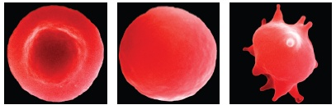
Isotonic Hypotonic Hypertonic

- The internal water pressure generated in plant cells as the cell membrane presses on the cell wall is called turgor pressure
- Counters osmosis and prevents further entry of water
- Land plants rely on turgor pressure for support & thrive in a freshwater environment

Contractile Vacuoles

- Animal cells cannot generate osmotic pressure to counter the flow of water when in a hypotonic environment
- Some wall-less protists have contractile vacuoles to actively expel water and prevent bursting when in a hypotonic environment

Transport Proteins

- Transmembrane proteins that provide a pathway for the movement of specific ions and hydrophilic molecules across membranes
- Bypass the phospholipid bilayer
- Allow biological membranes to be selectively permeable to small molecules and ions
- Two classes: Channels and transporters

Channels

- Transmembrane proteins that form a passageway for the facilitated diffusion of ions or molecules across the membrane
- Most channels are gated
- Can open to allow the diffusion of solutes and close to prohibit it
- Allows cells to regulate the movement of solutes
- When channel is open, movement of solutes can be very rapid

Gating Mechanisms

- Ligand-gated channels open in response to binding of an extracellular ligand (A)
- Noncovalent binding of intracellular regulatory proteins (B) or covalent attachment of a small molecule (C) can also trigger opening
- Voltage-gated channels open and close in response to electrical gradients (D)
- Mechanosensitive channels are sensitive to changes in membrane tension (E)

Discovery of Aquaporin by Agre

- Water can passively diffuse across plasma membranes
- However, water moves very quickly across the membrane of certain cell types
- Peter Agre and colleagues identified a protein that was abundant in red blood cells and kidney cells, but not found in many other cell types
- = CHIP28
- Hypothesized that this protein may function as a water channel
- Conclusion: CHIP28 functions as a transport protein that allows facilitated diffusion of water across the membrane
- Renamed aquaporin

Transporters

- Membrane proteins that bind a solute and undergo a conformational change that moves it to the other side of the membrane
- Slower than channels
- Biological roles:
- Principal pathway for uptake of organic molecules (sugars, amino acids, nucleotides)
- Allow uptake of certain hormones and nucleotides
- Play a key role in export of waste products
- Transport ions to regulate internal pH and cell volume

Categories of Transporters

- Uniporters: Bind a single molecule or ion and transport it across the membrane
- Symporters or co-transporters: Bind two or more different types of ions or molecules and transport them in the same direction
- Antiporters: Bind two or more different types of ions or molecules and transport them in opposite directions

Transporters that Function as Pumps

- Some transporter proteins are pumps
- Conformational change is coupled to an energy source
- Can be uniporters, symporters, or antiporters
- ATP-driven pumps hydrolyze ATP to actively transport solutes against a gradient

Active Transport

- Movement of a solute across a membrane against its gradient, from a region of low concentration to higher concentration
- Primary active transport: Pump directly uses energy to transport a solute against a gradient
- E.g. ATP-driven pump
- Secondary active transport: Pump uses an existing gradient to drive the active transport of another solute
- E.g. H+/sucrose symporter
- Hydrogen ions move down their gradient, sucrose is actively transported against its gradient

Na+/K+ pump

- A single pump exports sodium ions (Na+), and imports potassium ions (K+) against their gradients using ATP
- = Antiporter
- An example of an electrogenic pump
- Generates an electrical gradient
- Net export of one positive charge

Important Functions of Ion Electrochemical Gradients

- Transport of ions and molecules
- Symporters and antiporters use H+ and Na+ gradients to take up nutrients and export waste products
- Production of energy intermediates
- H+ gradients are used in mitochondria and chloroplast to synthesize ATP
- Regulation of cytosolic pH
- Transporters sense pH changes and regulate internal pH
- Osmotic regulation
- Animal cells control internal volume by regulating ion gradients between cytosol and extracellular fluid
- Nerve signaling
- Na+ and K+ gradients are involved in conducting action potentials (signals transmitted by nerve cells)
- Muscle contraction
- Ca²⁺ gradients regulate ability of muscle fibres to contract
- Bacterial swimming
- H+ gradients drive rotation of bacteria flagella

Endocytosis and Exocytosis

- Two mechanisms transport larger molecules across the membrane:
- Exocytosis
- Endocytosis
- Both mechanisms involve the packaging of the transported substance, sometimes called the cargo, into a membrane vesicle

Endocytosis

- Plasma membrane folds inwards to form a vesicle that brings substances into the cell
- Receptor-mediated endocytosis is triggered by binding of the cargo to a specific receptor, which initiates vesicle formation
- Pinocytosis: Membrane forms around extracellular fluid to take in fluid and solutes
- “Cell drinking”
- Phagocytosis: Formation of an enormous vesicle in some cell types to engulf a very large particle, such as a bacterium
- “Cell eating”
- E.g. Macrophages in the immune system

Exocytosis

- Packages material inside the cell into vesicles that will be excreted into the extracellular environment
- Vesicles usually form and are released from the golgi apparatus Fusion with the plasma membrane releases the cargo contents into the extracellular environment

