Task 1: Knowledge and Understanding questions
- Evaluate f(x)=9x²−4x for:
(8 marks: 2 marks each)
  - f(2)
$$f\left(2\right)=9(2)^{2}-4(2)$$
$$=9\left(4\right)-\left(8\right)$$
$$=36-8$$
$$=28$$
  - f(−4)
$$f\left(-4\right)=9(-4)^{2}-4(-4)$$
$$=9\left(16\right)+16$$
$$=144+16$$
$$=160$$
  - f(−2h)
$$f\left(-2h\right)=9(-2h)^{2}-4(-2h)$$
$$=9\left(-2h\right)\left(-2h\right)+8h$$
$$=9\left(4h^{2}\right)+8h$$
$$=36h^{2}+8h$$

Or to simplify it more, factor 4h.
Therefore,
$$=\frac{36h^{2}+8h}{4h}$$
$$=9h+2$$
  - f(a+b)
$$f\left(a+b\right)=9(a+b)^{2}-4(a+b)$$
$$=9\left(a+b\right)\left(a+b\right)-4a-4b$$
$$=9\left(a^{2}+ab+ab+b^{2}\right)-4a-4b$$
$$=9\left(a^{2}+2ab+b^{2}\right)-4a-4b$$
$$=9a^{2}+18ab+9b^{2}-4a-4b$$
$$=9a^{2}+9b^{2}+18ab-4a-4b$$

- Determine whether the following functions are even, odd, or neither. Show your calculations. (6 marks: 2 marks each)
  - f(x)=5x⁷+6x
$$f\left(a\right)=5a^{2}+6a$$
$$f\left(-a\right)=5(-{a)}^{2}+6(-a)$$
$$f\left(-a\right)=-5a^{2}-6a$$
$$f\left(a\right)=-f\left(a\right)$$
Therefore, the function is odd.
  - g(x)=(2x+3)²
$$g(x)=(2x+3)^{2}$$
$$g\left(-a\right)=(2\left(-a\right)+3)a^{2}$$
$$g\left(-a\right)=2(-a)^{2}+3^{2}$$
$$g\left(-a\right)=-2a^{2}+3^{2}$$
Therefore, the function is neither even nor odd.
  - h(x)=−2xsinx
$$h(x)=-2sinx$$
$$h\left(-a\right)=-2sinx$$
$$h\left(-a\right)=-2\left(-a\right)\sin\left(-a\right)$$
$$h\left(-a\right)=2a\left(-sina\right)$$
$$h\left(x\right)=h(-x)$$
Therefore the function is neither odd or even.
0/1 this will be 2a[-sina] = -2asina which makes it even
- If f(x)=log4x5, g(x)=3log4x, and h(x)=2log42, evaluate:
(6 marks: 2 marks each)
  - (f−g)(x)
$$=f\left(x\right)-g\left(x\right)$$
$$=\frac{f(x)}{g(x)}$$
$$=\frac{log_{4}x^{5}}{3log_{4}x}$$
$$=\frac{log_{4}x^{5}}{log_{4}x^{3}}$$
$$=log_{4}(\frac{x^{5}}{x^{3}})$$
$$=log_{4}x^{5}-log_{4}x^{3}$$
0/1 final answer looks like $=log₄x²$
$$=2log₄x$$

  - (g+h)(x)
$$=g\left(x\right)+h\left(x\right)$$
$$=g\left(x\right)*h\left(x\right)$$
$$=3\log_{4}x*2\log_{4}2$$
$$=log_{4}x^{3}*\log_{4}2^{2}$$
$=\log_{4}(x^{3}*2^{2})$becomes adding, see below
=$log_{4}(4x^{3})$
=$log_{4}{4x}^{3}$
0/1 last few lines are $\log_{4}{x³}+\log_{4}{4}$
$=\log_{4}{x^{3}}+ 1$ Where $(log_{4}4=1)$
$$= 3\log_{4}{x+1}$$

  - (f+g−2h)(x)
= $\log_{4}(\frac{x^{5}*x^{3}}{2^{2}})$
=$log_{4}(\frac{8}{4})$
=$log_{4}2$
0/1 answer is $=log_{4}x^{5+3}-4[\frac{1}{2}]$
$$=log_{4}x^{8}-2$$
$$=8log₄x-2$$
- Answer the following:
  - Determine the instantaneous rate of change at x=4 for the graph of f(x)=2x−3. Round all non-terminating decimals in the calculation to seven significant digits. Round your final answer to two decimal places. (2 marks)
For the first point:
$$x=4-0.01=3.99$$
$$x=3.99→f\left(x\right)=\frac{2}{x-3} Subtitute x, to find y$$
$$y=\frac{2}{3.99}=\frac{2}{.99}=2.0202020$$
The first point (3.99,2.0202020)
For the second point:
$$x=4+1.01=4.01$$
$$y=\frac{2}{4.01-3}=\frac{2}{1.01}=1.9801980$$
Second point, (4.01, 1.9801980)
Slope of the secant line between the first and second:
$$slope=\frac{1.9801980-2.0202020}{4.01-3.99}=\frac{-0.040004}{0.02}=-2.00$$
Therefore, the slope of the tangent line is$-2.00.$

  - Determine the equation of the tangent line. (3 marks)
$$Point of tangency \left(4,2\right), m=-2$$
$$y=mx+b$$
$$2=\left(-2\right)\left(4\right)+b$$
$$2=\left(-8\right)+b$$
$$2+8=b$$
$$10=b$$
Therefore the equation of the tangent line is $y=-2x+10.$

Task 2: Thinking questions
- On the graph of f(x)=2x4−9x, determine whether (2,14) is a maximum point, a minimum point, or neither. If it is neither, indicate whether the graph is increasing or decreasing at this point. Explain your answer. (3 marks)
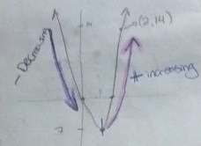
The point (2, 14) is neither a maximum nor minimum point. The graph is increasing from point (-1, 7) to +$∞$ from point (2, 14), the graph is still increasing as it is still heading towards infinity (+$∞).$0/1 mention the slope to help your answer

- The tangent line to the graph of g(x)=2x3−7x at (1,–5) intersects the curve at another point. Find the coordinates of the other point. Round all non-terminating decimals in the calculation to seven significant digits. Round your final answer to two decimal places. Sketch a graph to show the function, the tangent line, and the points of intersection. (10 marks)
$$g\left(x\right)=2x^{3}-7x at (1,-5)$$
$$x=1-0.01=0.99$$
$$x=0.99→g\left(x\right)=2x^{3}-7x$$
$$y=2(0.99)^{3}-7\left(0.99\right)=-4.989402$$
The first point ($0.99,-4.989402$)
The second point:
$$x=1+0.01=1.01$$
$$y=2(1.01)^{3}-7\left(1.01\right)=-5.009398$$
Therefore, the second point ($1.01,-5.009398$)
Slope = $\frac{-5.009398-(-4.989402)}{1.01-0.99}= -0.9998= -1.00$
Therefore the slope is -1.00.
The tangent line:
$$y=m\left(x-x_{1}\right)+y { x}_{1}=1, y_{1}=-5, m=-1$$
$$y=-1\left(x-1\right)+(-5)$$
$$y=-1x+1-5$$
$$y=-1x-4$$
Therefore, the equation for the tangent line is $y=-1x-4$.
To find the points where the tangent intersects the graph:
$$g\left(x\right)=2x^{3}-7x and y=-1x-4$$
$$2x^{3}-7x =-1x-4$$
$$2x^{3}=7x-1x-4$$
$$2x^{3}=6x-4$$
$$\frac{2x^{3}-6x+4}{2}=x^{3}-3x+2$$
$$x^{3}-3x+2=0$$
$$\left(x-1\right)\left(x-1\right)\left(x+2\right)$$
Therefore, $x=1 or x=-2$
To find y-value point, substitute $x=-2$
$$y=-1x-4$$
$$=-1\left(-2\right)-4$$
$$=2-4$$
$$=-2$$
Therefore, the other point of intersection is $\left(-2,-2\right).$
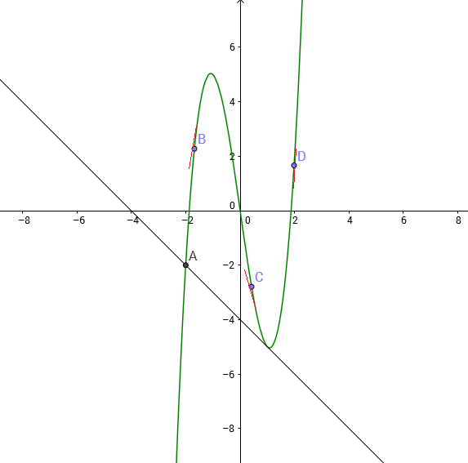

- A baseball player hits a ball out of the park. The equation h(t)=−2(x−3)2+19 models the path of the ball, where h(t) represents the height of the ball above the ground in metres, and t represents the time in seconds. (12 marks)
  - Construct a table of values to show the height of the baseball for each second it is in the air (0 to 7 seconds). (2 marks)
X | f(x)
0 | 1
1 | 11
2 | 17
3 | 19
4 | 17
5 | 11
6 | 1
7 | -13

  - Calculate the average rate of change in height for each second. What does this represent? (2 marks)
T | $$∆h$$ | v=$\frac{∆h}{∆t}$
1-0 | 11-1 | 10
2-1 | 17-11 | 6
3-2 | 19-17 | 2
4-3 | 17-19 | -2
5-4 | 11-17 | -6
6-5 | 1-11 | -10
7-6 | -13-1 | -14
This represents the average rate of change of height over that time interval.

  - Why does the velocity change from positive to negative? (2 marks)
Velocity changed from positive to negative because the baseball’s magnitude and direction changed. At first, the ball was hit upwards and then at a point when the ball stopped in the air to change directions.
  - When is the velocity 0 m/s, and what does this represent? (2 marks)
Velocity is 0 m/s when the ball is at its highest point. In our case, (3,19) this point represents the change in direction from positive to negative.
  - What is the instantaneous speed of the ball when it hits the ground? Round all answers to two decimal places. (4 marks)
$$h\left(t\right)=-2{(t-3)}^{2}+19$$
$$0=-2{(t-3)}^{2}+19$$
=$-2(t^{2}-9)+19$
=$-2t^{2}+18+19$0/1 after expanding you will get $$-2x^{2}+12x+1=0$$

$\frac{2t^{2}}{2}=\frac{37}{2}$0/2 with the quadratic above you must use the quadratic formula to solve for t.
$t^{2}$=$\sqrt{18.5}$
$t$=4.30 m/s
$$t=\frac{4.30}{2}$$
$t=2.15 m/ s$0/1 after you have two times, use the slope formula to find the speed.
The instantaneous speed of the baseball will be zero at the highest point of the path which is halfway from the total time of flight.

Task 3: Communication questions
- In your own words, define “rate of change.” Give an example. (2 marks)
Rate of change refers to how one quantity changes in relation to another quantity. An example would be when you are riding a bike; the distance with respect to time will describe the rate of change.
- What does it mean when the average rate of change is:
  - Zero:When the average rate of change is zero, the function is not changing. i.e: $y=c,where "\text{c"} is any constant.$
  - Constant:When the average rate of change is constant, the function is at a constant rate. i.e: $y=mx+b$
  - Variable:When the average rate of change is a variable, it is neither constant nor a linear function. i.e: $y=x^{2}$
Give an example of each. (6 marks: 2 marks each)
- Describe three factors that influence the domain of a combined function. Give an example of each. (9 marks: 3 marks each)
Domain of (f$∙$g)(x) is (1) contained in domain of g ; (2) range of g must intersect the domain of ; (3) the inverse image of (2) is the domain of the composite
3/9 two factors are the whether the function has a denominator and whether the function includes a radical sign. Be very specific in your description and example
- In your own words, define even and odd symmetry. Use examples to show how even and odd symmetry look on a graph. (6 marks: 3 marks each)
Even functions are symmetric to y=axis. Therefore, f(x) =f(-x) opposite of x, meaning the graph remains unchanged after reflection an y-axis.
Odd functions have $180°$ rotational symmetry with respect to the origin. Therefore, positive values f(x) = -f(x) negative values
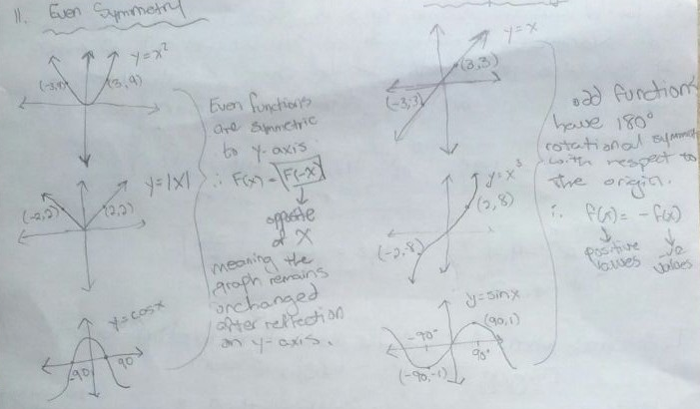
- Explain the difference between a combined function and a composite function. (2 marks)
A composite function is a function that is composed of one function using another function as its argument (a function in anther function)
Ex:
Given f (x), g (x); h (x) = f (g (x)) is a composite function. Likewise, h(x) = g (f(x)) is a composite function.

Often we hear the phrase "a function that is a (linear) combination of f(x) and g(x)" so that might provide insight to what is meant by a combined function.
If that is the case, the idea is that given f(x), g(x), then
Example:
h(x) = f(x) + g(x)

Task 4: Application questions
- Find the intersection points of f(x)=3√x and g(x)=2x. For what interval is 3√x≥2x? Use GeoGebra to graph the individual functions and the combined function. (8 marks: 3 marks for the graph and 5 marks for the two zeros, the two intersection points, and the correct interval)0/1 the combined function is missing on your graph
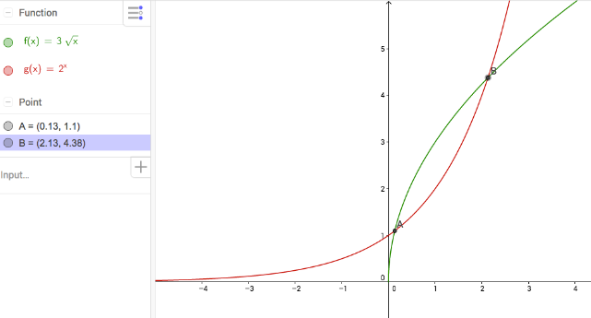
$f\left(x\right)$=$\sqrt{0.13}=1.1$
$$g\left(x\right)=2^{x}=2^{2.13}=4.38$$
Points of intersections (0.13, 1.1), (2.13, 4.38)
Intervals: $g(x)=2^{x}$ is smaller than $f(x)=3√x$
$2^{x}≤3\sqrt{x}$is$0.13≤x≤2.13$

- The population of a culture of bacteria is calculated and recorded after each hour, for a six-hour period.
  - Sketch a graph to illustrate these data. (2 marks)
Hours | Number of Bacteria
0 | 98
1 | 206
2 | 405
3 | 783
4 | 1550
5 | 2520
6 | 5630
0/1 graph is missing
  - Use a spreadsheet program to compare the linear, quadratic, and exponential regression models. List the equations and correlation coefficients for each type of function. Provide a graph and include the regression lines. (8 marks)

  - Use each model to determine the initial number of bacteria at the beginning of the study. (3 marks
The initial number of bacteria:
For linear $y=\left(798.8x\right)-797.8$
At time = 0 seconds
$$y=-797.8$$
For quadratic $y=233.8x^{2}-604.1x+371.4$
At time = 0 seconds
$$y=371.4$$
For exponential$y=104.0e^{0.660x}$)
At time = 0 seconds
$$y=104.0$$
  - Which model gives the most realistic answer? (2 marks)
Quadratic and exponential gives the most realistic data. 0/1 answer is exponential
  - Which function is the best model for these data? Explain your reasoning. (2 marks)
Model 3 is realistic (exponential) because the value of 104 is close to the original value at zero time (98).

