Key Questions #1:
SCH4U- Chemistry
- For increasing current funding for atomic-structure research:
Understanding the Atomic-structure has gained a lot of benefits for society, we have come to understand atoms from quantum mechanical theory. It has led to computers, medical scanners such as M.R.I’s. but this understanding comes from fundamental research in atomic structures. Therefore, the funding invested in this research previously was more than beneficial. Increasing funding can gain a lot more understanding and led to endless opportunities.
Against increasing current funding for atomic-structure research:
In the other hand there is no proof that increasing funding for the research will result in any new discoveries. The fundamental research is expensive and generally only benefits the rich, for example a recent study proves that well of Ontarians was 38% likely to get MRI’s done rather than their proper counterparts. Increasing funding for research that not all people can benefit from is unfair.
2)
According to Bohr electrons orbit on specific orbits with specific energy that’s why they don’t crash into the nucleus. If the electrons get energy from an external source they well jump to a higher orbit for high energy and the energy absorbed is equal to the difference energy between the two levels. If the electron jumps from a higher level to a lower level energy orbit it will emit light and the energy of this light is equal to the difference between the energy of two levels. For the line on the visible portion it is produced when electrons jump from higher levels (5th or 6th levels) to a lower level (2nd level). For the line in the ultraviolet region the electron jumps from the highest level higher than the previous energy level (6th level) to the lowest energy level (1st level ) and releasing more energy and shorter wavelengths.
3) a) Electron configuration:
1s² 2s² 2p⁶ 3s² 3p⁶ 3d¹⁰ 4s² 4p⁶ 4d² 5s²
Energy level Diagram:
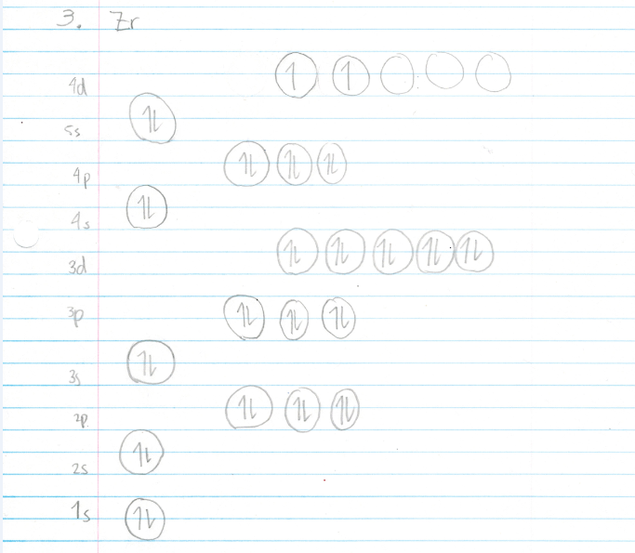

b) Zr ⁴⁺ exist because the electrons from 4d and 5s orbitals are lost to form a more stable electron configuration as it becomes a Nobel gas (Kr) configuration. Therefore, Zr leaves 4 electrons to achieve a more a stable state.
c) The Zr ⁴⁺ ion is more stable because its valence shell is completely filled meaning it is less likely to react. The Zr atom doesn’t have a filled valence shell which makes it more reactive and therefore less stable.

Lesson 2
4)
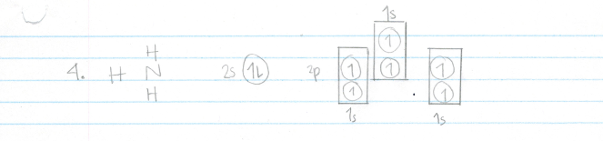5)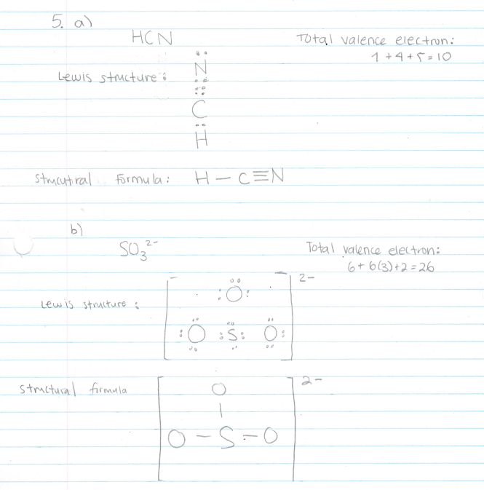
6)
a) Energy level Diagram: Ammonia (NH3)
Ground state for Nitrogen:
2p
2s
1s

Hybrid orbital for Nitrogen
sp3
1s

b) The name for the type of hybrid for ammonia is SP3. In the ammonia molecule, 2s and 2p orbital create four sp3 hybrid orbitals, one of which is occupied by a lone pair of electrons. Three of the electrons are unpaired and are ready to make covalent bonds with Hydrogen.
c) Carbon Energy level Diagram:
sp3
1s

The bonding with N atom compared to the bonding of a C atom is different even though both atoms have 4 hybrid orbitals orientated in a tetrahedral shape. The C atom has 4 hybrids that point towards the corners of a tetrahedron at 109.5º to each other. But NH₃ only has 3 hybrids ready to bond.

7) a)
 | CaBr₂ | Na₃N | CH₄
Electronegativity difference (∆EN) | 2.9 - 1.0 = 1.9 | 3.0 - 0.9 = 2.1 | 2.5 - 2.2 = 0.3

b)
Ionic ∆EN >1.7, Polar Covalent 1.7>∆EN>0.4 , and non-Polar Covalent ∆EN less than 0.4.
CaBr₂ is ionic because it’s ∆EN is greater than 1.7.
Na₃N is ionic because its ∆EN is greater than 1.7.
CH4 is non-polar covalent because it’s ∆EN is less than 0.4
c) Rank of the bond: Na₃N, CaBr_{2,} CH₄
The compounds found with metal are usually found at the beginning of the ranking. The compounds with no metal at all have the least ionic character i.e. CH4. A compound with a non-metal and a metal has a greater ionic character.

Lesson 3
8)
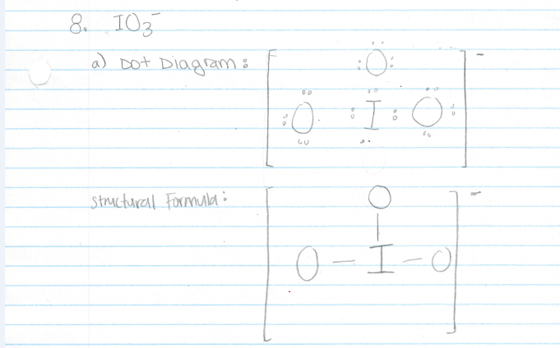

b) I predict that the shape for IO₃⁻ is AX3 Pyramidal.
C) The central iodine is bonded to three oxygen atoms and has a lone pair. It has the pyramidal shape, it is not symmetrical, and it is therefore polar.

9)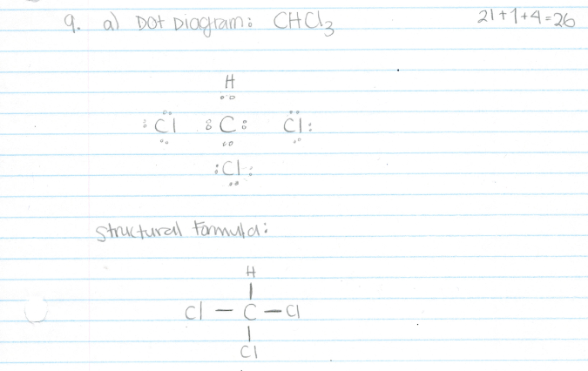

b) Based on VSEPR Theory (Valence Shell Electron Pair Repulsion Theory) the atoms around the Carbon atom will repel each other. As a result they will be pushed apart giving the CHCl₃ molecule and the shape is AX4 tetrahedral molecular shape
c) CHCl₃ is polar. This molecule will have the carbon in the middle surrounded by the three chlorine atoms and the hydrogen. Therefore the bonds are not symmetrical resulting in a polar molecule.
10)
Methane forms a perfect tetrahedron with sp3 hybridization with four hydrogen atoms around the central carbon the bonds are symmetrical and showing bond angles of 109.5 degrees. A water molecule also shows sp3 hybridization, but two of the pairs of electrons around the central oxygen are bonded to hydrogens and two are lone pairs. The lone pairs are often described as taking up more room .The lone pairs repel more strongly, pushing the bonded pairs away from them and closer to each other. The bond angle shrinks from 109.5 degrees to approximately 104.5 degrees.

11) a) Liquid CO₂ is non polar, which is a greater solvent to use on non-polar stains.
b) Advantages:
1. Overall cost of CO₂ cleaning averages about 20 percent cheaper than chemical solvent-based processes
2. CO2 is environmentally friendly replacement for ordinary detergent. Most detergent is a toxic substance and is known to cause health issues including liver and central nervous system damage.
Some issues:
1. The cost of installing a CO₂ dry cleaning machine, however, can be up to four times more expensive than a regular machine.
2. The natural state of CO₂ is gas and keeping the solvent at a liquid state would be very difficult.

12)
A) London dispersion force is the only force that acts on halogen molecules. This force becomes stronger as size of atoms or molecules increase, this force is due to the protons attracting more electrons from the neighbouring molecule. As the size of the molecule increases the boiling point increases as well.
b) Graph on a separate document. The halogens increase in size and number of electrons from chlorine to bromine to iodine and so the strength of the London force increases. As the intermolecular forces increase, more energy is needed to separate the molecules in the liquid state so that they can form a gas. Thus, the boiling points will increase as the London Forces increase
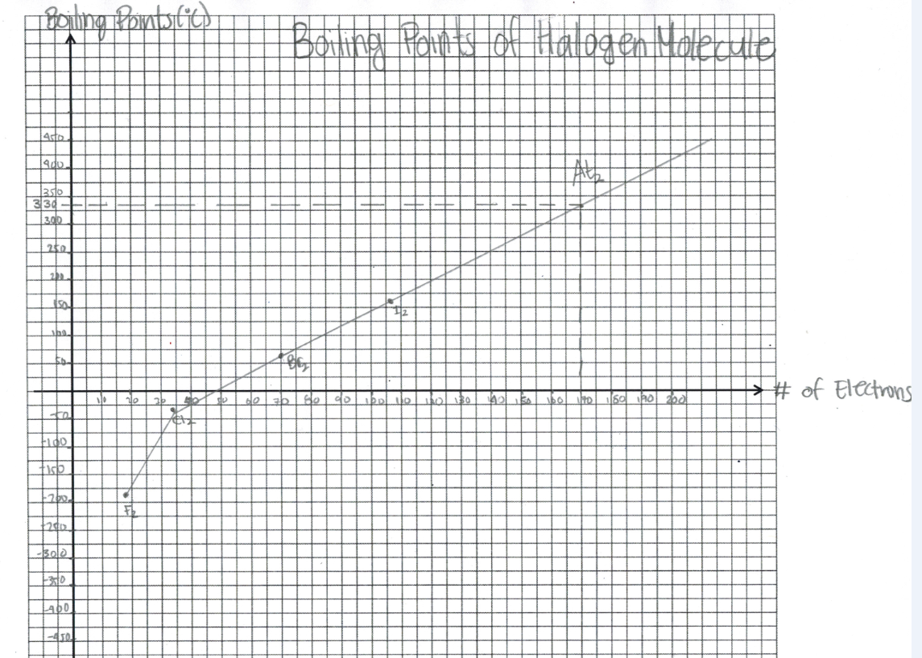
c) Astatine’s melting point around 330⁰C.

13)
Formula | Molar mass (g/mol) | Boiling point (⁰C)
C₂H₆ | 30 | -89
CH₃OH | 32 | 65
Alkanes are nonpolar and are thus associated only through relatively weak London dispersion forces. Alkanes with one to four carbon atoms are gases at room temperature. In contrast, even methanol (with one carbon atom) is a liquid at room temperature. Methanol is a Hydrogen bonding because of the group OH. Hydrogen Bonding greatly increases the boiling points of alcohols compared to hydrocarbons of comparable molar mass. The boiling point is a rough measure of the amount of energy necessary to separate a liquid molecule from its nearest neighbours. If the molecules interact through hydrogen bonding, a relatively large quantity of energy must be supplied to break those intermolecular attractions.

14.
A cable with a high tensile strength, and that's lightweight would be preferable for a space elevator. The cable would have to support its own weight, plus whatever is being transported. Thus it must be lightweight and strong. I also think we would need something that is not brittle, otherwise it would be vulnerable to snapping somewhere along the cable. Also, Must be immune to oxidization and reduction from constant pounding of solar radiation and solar wind. A compound that is preferably would be an carbon nanotube.

