Question 2: Standard Normal Samples

1. Done in Computer software. The data used is
0.412952139 2.067691327 3.267628421 5.588958775 3.235680607 3.808981960
3.477821751 1.375299925 3.728733545 2.334951864 0.748093447 2.245366601
2.729560265 4.384186285 3.204834928 2.872207258 -0.007751366 1.510677007
1.926971936 1.803367773

Histogram for the data is given below:

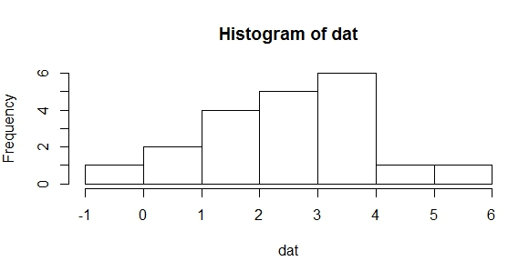
2. The sample mean is 2.535811

3. The sample standard deviation is 1.378675

4. A 95% confidence interval for the population mean is given by:
x-bar ± z_{0.025} * σ/sqrt(n)
2.535811 ± (1.96)*(2)/sqrt(20)
2.535811 ± 0.87653865
(1.6593, 3.4123)

5. The 95% confidence interval for µ lies between 1.6593 and 3.4123, which contains the true mean value of 3.

Question 3: NHL Goals Real Data

1, 2:
Population Values
Mean | 20.173
Standard Deviation | 19.663

4, 5:
Sample Values
Mean | 21.700
Standard Deviation | 22.441

3.

6.
91% Confidence Interval for the Sample Mean:
A 91% confidence interval for the sample mean (using population standard deviation) is given by:
Here, we need to assume a normal distribution for the population and random sample to use the z-statistic since population standard deviation is known.
x-bar ± z_{0.045} * σ/sqrt(n)
21.7 ± (1.695)*(19.663)/sqrt(20)
21.7 ± 7.45254289
(14.2475, 29.1525)

A 91% confidence interval for the sample mean (without using population standard deviation) is given by:
Here, we need to assume a normal distribution for the population and random sample to use the t-statistic since the population standard deviation is not known.
x-bar ± t_{19;0.045} * s/sqrt(n)
21.7 ± (1.786)*(22.441)/sqrt(20)
21.7 ± 8.96207682
(12.7379, 30.6621)

The population mean, µ, is 20.173, which is contained in both of the above intervals. The one with the z-statistic is more accurate and shorter in width since we make use of the true population standard deviation, which is the correct value.

7. Since, the population mean µ is 20.173, which is below the sample mean (x-bar) value of 21.7, we set µ equals to the lower limit of the confidence interval.
The lower limit is given by (x-bar) – z* σ/sqrt(n) = µ
Which implies that 21.7 – z*(19.663)/sqrt(20) = 20.173
Which implies that z*(19.663)/sqrt(20) = 21.7-20.173
Which implies that z = [(1.527)*sqrt(20)]/19.663
Where z = 0.3473

This z value corresponds to a lower 63.58% of the area. So, alpha/2 = 1-0.63582 = 0.36418
Which implies that alpha = 0.7284
Thus, the smallest possible confidence level for population mean, µ, is 0.7284, which is an approximate 73% confidence interval for µ.

Question 4: Generating Random Samples
Samples and generated values are provided in the Excel Sheet
Part 1:

Expected mean of sample means is the mean of the original distribution from which samples are taken, which is 0.
Expected standard deviation of the sample means is the standard deviation of the population divided by square root of the sample size. That is 1/sqrt(10) = 1/3.16227766 = 0.3162.

Part 2:

Expected mean of sample means is the mean of the original distribution from which samples are taken, which is (1+2)/2 = 3/2 = 1.5.
Expected standard deviation of the sample means is the standard deviation of the population divided by square root of the sample size. That is sqrt[((2-1)²/12)/10)] = sqrt[0.00833333333] = 0.091287.

Part 3:

Expected mean of sample means is the mean of the original distribution from which samples are taken, which is 0.
Expected standard deviation of the sample means is the standard deviation of the population divided by square root of the sample size. That is 1/sqrt(100) = 1/10 = 0.10.

Part 4:

Expected mean of sample means is the mean of the original distribution from which samples are taken, which is (1+2)/2 = 3/2 = 1.5.
Expected standard deviation of the sample means is the standard deviation of the population divided by square root of the sample size. That is sqrt[((2-1)²/12)/(100)] = sqrt[0.00083333333] = 0.02887.

