BUSI2101 Midterm & Final Exam Review

Week 1 – Psychological Contracts (Chapter 1)
- The two types of contracts (Hint: Iceberg model)
  - Implicit
    - Defines the unwritten agreements about what the employee will do (e.g. work hard, be supportive etc.) in exchange for what the employer will do (develop opportunities, respect, promotions etc.)
    - Psychological contracts are an individuals beliefs, shaped by the organization, regarding the terms and conditions of a reciprocal change agreement between individuals and their organization
  - Explicit
    - Clearly defined written contracts
- What is the difference between these two types? How might a violation of an implicit contract affect a working relationship?

- Violations:
  - Inadvertent: both parties are willing and able to fulfill their role in the exchange but a misunderstanding lead one party to act at odds with the interests of the other party.
  - Disruption: both parties are willing, but outside circumstances make it impossible for one or both parties to fulfill their end of the contract.
  - Breach: one party refuses to honor the contract despite being able to do so.
- Reactions:
  - Exit – leave contract
  - Silence – do/say nothing
  - Neglect – deliberately working less
  - Voice – confrontation and negotiation
- Be able to name and differentiate violations and reactions.

Week 2 – Individual & Organizational Learning (Chapter 3)

- Learning Process/Cycle (P 58)
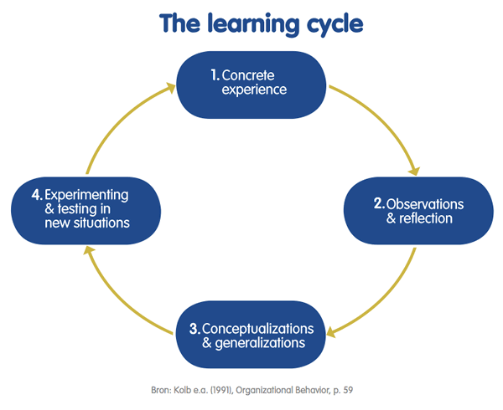
- Learning Style Inventory Elements/modes (P 59)
  - Concrete Experience (taking the OB midterm)
  - Reflective Observation (Doing poorly on the midterm and reflecting on what went wrong…did I devote enough hours to studying? Does my studying style coincide with my preferred learning style? Is there something I could do differently?)
  - Abstract Conceptualization (Developing a study plan…I will study for 1.5 hours every day for one week. I will complete various practice problems and practice writing out theoretical concepts)
  - Active Experimentation (Taking a practice test or a follow-up quiz)
- Kolb’s Learning Style Types – Accommodating, Diverging, Converging, Assimilating (P 60)
  - Know your learning style and have an understanding of how it differs from the others (be able to differentiate the styles)
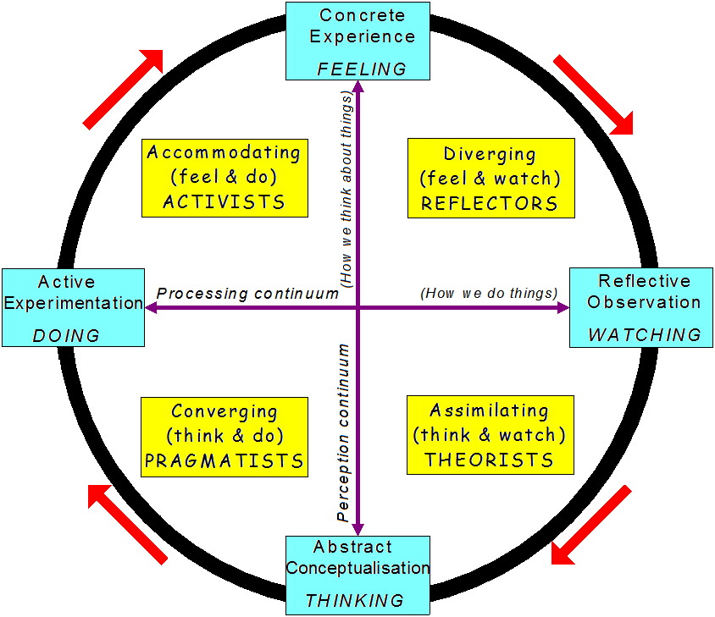
  - Chart on P 56 – Strengths
- Learning Style Dominance – Drawbacks (P 67)
  - Understand the drawbacks of having too many or too few of one learning style in a group (be able to identify one point for each)
- Learning Formal Definition (Slides)
Permanent change in knowledge, behavior, skills, understanding etc *CHANGE*
- Types of Learning – 3 Types (Slides) : COGNITIVE – recall, analyze, synthesize, problem solve, PSYCHOMOTOR – learn a new skill operate machine, swim, drive, ride bike , AFFECTIVE – learn to like fear, through emotion

- Classical Conditioning; Operant Conditioning (notes)
- Cognitive Learning: Capacity and skills to “learn better”;
•Manifested by capacity and skills to learn better, or potential behavioral changes
•Intrinsic rewards, ‘knowledge of results’ or ‘feeling of accomplishment’, rather than extrinsic rewards
- Social Learning: learning through experience and observation of others (ex; learning how to dance from videos)
- Organizational Learning: organization’s ability to acquire process, apply, and spread knowledge(Slides)
2 types of organizational learning
1. Exploration: search for and experiment with new kinds of organizational activities and procedures
2. Exploitation: learn ways to refine and improve existing organization activities and procedures

- Single, double, triple loop learning

Week 3 – Decoding Human Behaviour & Personality (Chapter 4)
- Trait Models (P 80)
  - MBTI (Myers Briggs Type Indicator)
•Extroversion/Introversion (E/I)
•Sensing/Intuiting (S/N)
•Thinking/Feeling (T/F)
•Judging/Perceiving (J/P)
  - Big 5 (C.A.N.O.E)
Conscientiousness, Agreeableness, Neuroticism, Openness, Extraversion

*forgotten one* honesty – humility: sincerity, fairness, greed avoidance, modesty

- Other Traits (P 82)
  - Self-esteem: overall evaluation of one self,
  - Self-efficacy: belief in own abilities to execute behaviors to produce specific performance attainments ,
  - Dark Triad: Machiavellianism + Psychopathy + Narcissism, Locus of Control: extent to which individuals believe they can control events affecting them
- Dealing with Difficult People: Four Steps (P 85)
- Create a rich picture of the problem person
  - The problem person what motivates this person? What obstacles are preventing them from achieving what they want?
  - Yourself what might you be doing to encourage the problem behavior?
  - The situation what might be causing both you and the problem person to behave poorly?
- Reframe your goals: Try to think flexibly about what you want to happen
- Stage the Encounter: schedule a face-to-face meeting to discuss the issues
- Follow-up
Interactionist models – If I …. Then my environment ……
Cognitive Affective processing system (CAPS) – People will interpret situations differently; people with different mental representations and different emotions might construe even the same situations quite differently. (E.g.; going to a party some people will be dancing and socializing but others may feel uncomfortable and not want to dance)
Emotional Intelligence- The capacity to ‘monitor ones own and others’ feelings
•Self awareness- appraisal/expression of emotion in one self.
•Other – awareness – recognition of emotion in others
•Emotional regulation – recover quickly from emotional experiences
•Use of emotion – harness emotion to enhance performance
- Think about the activity we did with Juanna and Joanna…how might this approach have improved the negotiations?
•Juanna is the bullying worker that has a friendship with Jose that has made Joanna hesitant to fire or talk to her because of her relationship with a head manager.

Week 4 – Motivation (Chapter 5)
- In this class we did the Moon Tent exercise…think about your role, and the roles of others, within the Moon Tent factory and the nature of the work you performed. This is a good example to use when applying motivational theory and in trying to understand concepts within a contextual framework.
- Motivation (P 101)
  - The psychological forces that determine the direction of people’s behavior, their level of effort, and level of persistence.
Need based theories
- Maslow’s Hierarchy of Needs (P 103)
  - Physiological
  - Safety
  - Love/belonging
  - Esteem
  - Self-actualization
- McClellands Need Theory (P 105)
  - Need for Power: need to influence and lead others and be in control of one’s environment * socialized power * and * personalized power *
  - Need for Affiliation: the desire for friendly and close interpersonal relationships
* Affiliative interest and *affiliative assurance
  - Need for Achievement: need to accomplish goals, excel, and strive continually to do things better.
  - Be able to identify the positive and negative aspects of each need.

Process Theories
Hackman & Oldham Job Characteristics Model (P 107 Chart) *FOCUS ON INTERNAL WORK MOTIVATION.
Job Design
  - Core characteristics
    - Skill Variety
    - Task Identity
    - Task Significance
    - Autonomy- degree to which job provides freedom, independence
    - Job Feedback- degree to which an individual receives feedback from work
  - Critical psychological states
  - Personal work outcomes
- Goal-Setting Theory (P 109)
Specific/clear and challenging realistic goals along with appropriate feedback contribute to higher and better task performance

- Equity Theory (P 109)
(in)justice in allocation of awards. According to equity theory, employees evaluate what they receive from a job (outputs such as pay, bonuses, job security, promotions, recognition, etc.) in relation to what they contribute inputs such as time, skills, creativity, effort, etc.)

Distributive justice – perceived fairness in amount and allocation of awards
Procedural justice – perceived fairness in process used to determine distribution of reward
International justice – degree to which one perceives that they were treated with respect and dignity
- Expectancy Theory (P 110)
People have different goals
*positive correlation between effort and performance
*favorable performance will result in desirable reward
*reward will satisfy need
*desire to satisfy need is strong enough for effort

Reinforcement Theory (P 111)
Modifying reinforcement through appropriate use of rewards and punishments
Behavior that is reinforced is repeated, those that are not reinf are not repeated
Positive reinf, neg reinf, extinction, punishment
Cognitive evaluation theory – offering extrinsic rewards for work that was previously rewarding intrinsically will decrease motivation and performance

- Be able to define and contrast each theory

Week 5– Communication; Perception & Attribution (Chapters 8 & 9)
- Communication (P 195)
  - The process by which information is exchanged between communicators with the goal of achieving mutual understanding.
- Transactional Model of Communication (P 195)
  - Understand the shared field of experience
  - Be able to identify the three types of noise (Environmental, psychological, emotional)
- Arc of Distortion (P 196)
  - The difference between what the sender intended to communicate and what the receiver actually understood (be able to draw and label the arc of distortion)
- Barriers to Communication (P 197-201)
•Poor relationships •Lack of clarity •Culture differences •Gender •listening skills, etc ,etc
- Perception
  - Benefits
  - Drawbacks
- Perceptual Process – 3 Stages (P 220)
•Selection •Organization •Evaluation
- Social Identity Theory (P 222)- Belief that people tend to perceive themselves and others in terms of social categories rather than as individuals.
- Perceptual Distortions (P 224)
  - Be able to identify and briefly explain the perceptual distortions identified
•Primacy effect- Means one’s perception is dominated by the first impression of another person
•Halo Effect- Occurs when our evaluation of others is dominated by only one of their traits.
•Recency Effect- Ones perception is overly dominated by the most recent interactions with a person.
•Central Tendency- is a perceptual distortion that occurs when a person avoids extreme judgments and rates everything as average.
•Contrast Effects- Are present when our evaluations are affected by comparisons with other people.
•Projection- the tendency to attribute ones personal attitudes or feelings to another person, thereby relieving ones own sense of guilt or failure.
•Perceptual Defense- These defenses act as a screen or filter, blocking out that which we do not want to see and letting through that which we wish to see.
- Johari Window (P 226)
  - Understand the elements of the window (arena, façade, blind spot, unknown) and the role that they play in the communication process (e.g. how would a large blind spot hinder effective communication?)
- Barriers to Communication (Slides)
- Noise (Slides)
- Gender (Slides)
- Big 3 – Content, Style, Structure (Slides)

Week 6 – Group Dynamics & Work Teams (Chapter 10)
- Task Behaviours (P 260)
Intent to get the group goal accomplished (TASK)
Initiating – “lets build an agenda”
Seeking information or opinions
Giving information or opinions
Clarifying and elaborating
Summarizing
Consensus testing
Reality testing
Orienting
- Maintenance Behaviours (P 261)
Improve or patch up relationship among members (MAINTENANCE)

Gate keeping- direct flow of conversation
Encouraging – ensures all potential information the group needs is shared
Harmonizing and compromising
Standard setting and testing
Using humor
Be able to identify and briefly define task and maintenance behaviors
- Difference between task/maintenance behaviours
Self-Oriented Behaviours (P 260)
Exert control over group, pursue own goals, draw attention to self
Tension-Reducing Styles (P 263)
  - Friendly Helper – mutual affection, sympathy. Influence: appeasing, appealing to pity
Threats: he or she will not be loved, will be overwhelmed by feelings of hostility
  - Tough Battler – conflict, fighting, assertive. Influence: Giving orders, offering challenges, threatening. Threats: lose ability to fight, become soft
  - Logical Thinker – systematic approach, understanding. Influence: use rules and regulations, logic, facts, and knowledge. Threats: world is not ordered, overwhelmed by emotions
  - Be able to briefly explain each tension reducing style, their preferred method of influence, and their respective threats (i.e. be able to describe how they might behave within a group conflict setting)
- Team Development – 5 Stage Model (Slides)
-Forming norming storming performing transforming

Week 7 – MIDTERM

Week 8 – Conflict & Negotiation (Chapter 13)
•Conflict (P 341)
-Form of interaction between parties that differ in interests, perceptions, and preferences.

•Conflict Handling Modes (P 344), Chart on P 346
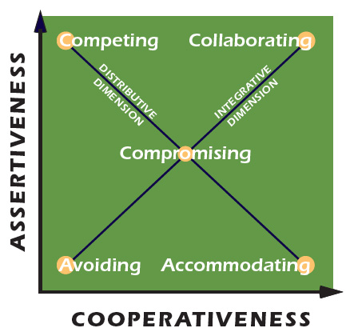

•Competing (win-lose)
-Chance to win everything but also chance to lose everything
-Exercise own sense of power
-Alienates others
•Collaboration (win-win)
-Both sides win
-Maintains the relationship
•Compromising (50-50)
-No one returns empty handed
-Sense neither side is totally satisfied conflict could likely occur again
•Avoiding (lose-win)
-No energy or time expenditure
-Conserve for fights that are “more important”
•Accommodating (lose-win)
-Loss of power
-Others may view you as supportive
-Energy free for other pursuits

•Bargaining Approaches (P 347)
Distributive bargaining – win/lose fixed amount of resources are divided (ex; union gets a favorable salary increase but, management loses because its cost have increased)
Integrative bargaining – win/win search for various settlements that would be agreeable to both parties doesn’t assume that there is a fixed amount of resources.
-Maintains long term relationships

•Fisher & Ury Theory of Principled Negotiation (P 348)
(Based on Integrative Bargaining)
1.People: Separate the people from the problem
-Relates to the need to maintain the relationship
-“Soft on people and hard on problem” approach
2. Interests: Focus on interests, not positions
-Parties should assertively present their own interests and own interests and mutually identify those that are shared, opposed, and simply different
3. Options: Invent Options for mutual gain
-Parties brainstorm options that are favorable to both parties
-This requires creativity and a commitment to joint problem solving
4. Criteria: Insist on objective criteria
-Look for criteria that are agreeable to both parties
-Both parties should agree to objective standards that everyone considers fair

•Negotiation Terms (P 348):
•BATNA (Best Alternative to a Negotiated Agreement)
-Recommend that negotiators arm themselves with an alternative in case the negotiation does not go as expected.
•Reservation point- Point beyond which you will not accept a deal + will turn to your BATNA (aka your minimum value you are willing to accept)

•Bargaining Zone- Range between 1 party’s “high” + the other parties “low”

Tutorial Fruit Medicine interaction done in class

•Perception in Conflict (Slides)

Communication in Conflict (Slides)
•Advocacy- Statement of opinions
•Inquiry- Asking questions to enhance understanding

Phases of Conflict
Latent- Potential opposition/incompatibility
Perceived- Incompatibility recognized
Felt- Emotional involvement
Manifest- Behavior

Retaliatory Cycle
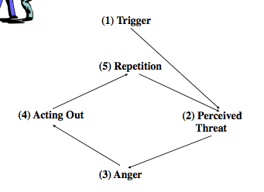

Week 9 – Decision Making (Chapter 17)

Groupthink (P 471)
-The practice of approaching problems or issues as matters that are best dealt with by consensus of a group rather than by individuals acting independently. Thus creating lack of individual creativity, or sense of personal responsibility.
•How do you recognize it:
-Agreeable, openness
-Avoid conflict
-Conformity
-High Affiliative assurance

•5 Components to Avoiding Groupthink
- Encourage to all members to express doubts
- Assign devils advocate who challenges arguments
- Adopt the perspectives of stakeholders (anyone affected by decision)
- Bring in qualified outsiders to discuss decisions
- “Lets sleep on it”
Tutorial Example: of choosing the items to take on a stranded lifeboat in the middle of the ocean first choosing by yourself and then afterwards in groups. Seeing if your answers had changed.

Vroom’s Leadership Participation Model (P 475)
-Understand how to use the model each step you rate high or low on the topics at top until you reach decision. (Find examples)

Models of Decision Making (P 468)
•Rational Decision Making- Strongest, implement, and check back on it later and assess how well it is doing
- Recognize and define the problem
- Identify the objective of the decision and the decision criteria
- Allocate weights to the criteria
- List and develop the alternatives
- Evaluate the alternatives
- Select the best alternative
- Implement the decision
- Evaluate the decision

•Bounded Rationality- People are restricted in the information they process to make decisions, engage in limited search for solutions, and settle for less than optimal solutions. So in other words there are limits or bounds on rationality.
- Managers select the first alternative that is minimally acceptable, which is called satisficing
- Both the available information and the definition of the situation are incomplete and inadequate to some degree
- Managers are comfortable making decisions without first determining all the alternatives
- Managers use judgment shortcuts to make decisions, which are call heuristics

•Garbage Can Model- bunch of ideas and randomly pick one out, no thought on it
4 Factors
- Problems
- Participants
- Solutions
- Choice Opportunities
-All float randomly inside an organization
-Assumes decision making is chaotic, unpredictable, and sometimes depends on luck

- Understand that important decisions need to be supported with factual evidence (Slides)

Week 10 – Power & Influence (Chapter 18)

•Power & Influence (P 492)
Power- The capacity to influence others
Influence- The process to persuade others

•Resistance Definition (P 492)- Occurs when a person’s influence is rejected

•Influencing Styles (P 495)
Push Styles- (Complying)
Assertive Persuasion
- Using logic and reason to push others
- Using facts, logic, rational argument

Reward and Punishment
- Pushing our will onto other by using bargaining, incentives and pressures
- Using bargaining, incentives, pressures
- Rewards may be offered for compliance, and punishment may be threatened for non compliance
Pull Styles- (Committing)
Participation and Trust-
- “pulls” others toward what is desired by involving them
- Developed the capacity to be effective listeners
- Build on others ideas and are quick to credit others for their contribution

Common Belief/ Vision
- -Identifies a common vision for the future to strength the groups beliefs that vision can become a reality
- Appeals to people emotions and values
- Ex; Speech’s of Martin Luther king

•Influence attempts will have both a content and relationship outcome:

Content- Can be satisfied but the relationship will be damaged if manipulated or coerced
Relationship- Will be damaged if manipulated/coerced

Commitment vs. Compliance- Commitment is more effective when the goal is long term and their belief and values need to be on board, whereas compliance is best for short-term objectives that ‘need’ to be done.

- Understand the affect that diverse influence styles of them know ITTT has on employee commitment vs. compliance…when certain styles may be necessary or more effective.

•Sources of Power (Slides)
- Coercive Power- Power comes from expertise, effort, and ones position or ability to reward and punish others
- Charismatic Power- Power to attract others, influence over others
- Expertise- Knowledge that is well respected/ valued
- Right place right time- Control over resources or access to information

•Influence Strategies (Slides)
- Reciprocity- Repay in kindness, give what you receive ,do favors
- Social Proof- Follow the lead of similar others, demonstrate how many people agree with you
- Consistency- People align with clear, public comment. Make commitments active, public, and voluntary.
- Scarcity- People want more scarce items. Highlight unique benefits and exclusive information
- Expertise and Authority- Task relevant expertise and experience persuades. Demonstrate specialized knowledge and expertise
- Liking- People response to pleasant, likeable and charismatic individuals

•Power Distance (Slides)- Measure of extent to which the less powerful members of organizations and institution accept and expect that power is distribute unequally.

Week 11 – Ethics & Values (Chapter 6)

Terminal vs. Instrumental Values (P 137)
•Terminal Value
-Are desirable end states of existence or the goals that a person would like to achieve during his/her lifetime.
- Personal Values- Comfortable life, freedom, happiness
- Social Values- World peace, national security, equality

•Instrumental Value
-Are preferable modes of behavior or the means to achieving ones terminal value.
- Moral Values- Cheerful, courageous, helpful: tend to have interpersonal focus
- Competence Values- Ambitious, capable, responsible: Have personal focus

•Ethical Values vs. Non-ethical Values (P 138)
  - Ethical Values: directly relate to beliefs concerning what is right and proper, or that motivate a sense of moral duty
  - Non-ethical Values: deal with things we like, desire, or find personally important (NOTE: these things are not necessary UNETHICAL…they are more ethically neutral)
•Moral Reasoning Stages Framework (P 138)

Level 1: Self -Centered
Stage 1
- Obedience and punishment
-Sticking to the rules to avoid punishment.
Stage 2
- Instrumental
-Following rules only when it is in one’s immediate interest
-Following rules to gain something good in exchange
Level 2: Conformity
Stage 3
- Conformity
-Stereotypical “good” behavior
-Living up to the expectations of people close to you (friends/family)
Stage 4
- Law and order
-Fulfilling duties and obligations of social system.
-Doing duties to contribute to society or group
Level 3: Principled
Stage 5
- Social contract/ individual rights
-Being aware that people hold variety of values
-Upholding rules because they are the social contract.
-Upholding nonrelatives values and rights regardless of majority opinion
Stage 6
- Universal Ethical Principles
-Following self chosen ethical principles of justice and rights. When laws violate principles act in accord with principles

•The progression through these levels can be summarized as moving from (1) a self centered conception of right and wrong to (2) an understanding of the importance of conformity and social accord and finally to (3) universal principles of justice and rights.
  - Understand each level and the stages within them. Be able to differentiate between the stages and understand how they progress from one to the next.

• Ethical Frameworks (P 141)
- Unitarianism- A moral act produces greatest good for greatest number of people. But the good of the group takes precedence over consideration for individuals. Disadvantage of this approach is that the rights of minority groups can be easily overlooked.
- Individual Rights Principle-Emphasizes personal entitlements in form of legal and human rights of individuals. (Ex; Person’s right to privacy, free speech)
- Justice Principle- People are guided by fairness, equity and impartiality when treating groups and individuals. (Ex; Employee discrimination)
- Caring Principle- The well being of another person An ethical person is aware of the needs and feelings of others and takes the initiative to respond to that need.
- Environmentalism- The well being of the earth. The belief that people have an obligation and a duty to act as stewards who protect the earth and its resources.
(Also just a reminder to think and apply of activities done in the tutorials)

Week 12 – Organizational Culture (Chapter 16)

•Organizational Culture (P 430)- Pattern of shared beliefs held by members that produce particular norms of behavior that can distinguish one organization from another. “Way we do things around here”

Dominant Culture & Sub Culture (P 430)
•Dominant Culture - Values shared by the majority of the organization’s members
•Sub Culture- Share the dominant culture’s core values as well as values that characterize their own department. (Ex; Accounting department may be more structured than their dominant culture because accountants have a professional subculture that influences their behavior no matter where they work.)
  - Counterculture- Values are in opposition of those of the dominant culture

Schein’s Levels of Culture (P 430)
- Artifacts- Visible or tangible (e.g.; Stories, buildings, rituals)
- Espoused Values- Such as strategies, goals, and philosophies (Ex; the company mission)
- Assumptions- Which are unconscious, taken for granted beliefs, perceptions, thoughts, and feelings (Ex; its more important to save face than correct a problem)
Tutorial example of coming from the future and looking at Carleton

Internal Integration & External Adaptation (P 432)
Internal Integration
-Foster the internal integration of new members and ensure that its members fit the culture.
-People in the organization can easily identify values
-Selection processes target people who are likely to fit in culture
External Adaption-
-Organizational cultures need to fit with the environment
-Policies and adaptations aligning with external culture

Mechanisms for Transmitting Culture (P 435)
- Socialization- The systematic process by which organizations bring new members into their cultures. Process of becoming a new member of a group, learning the ropes, and being taught how to communicate and interact to get thing done.
- Stories–All organizations have stories they repeat to newcomers about events of past people. Many of the stories prescribes how member should act others describe how the organization overcame hardships.
- Symbols– Symbols transmit culture and convey meaning. Material objects e.g. Dunton Tower.
- Jargon– Communication among employees. As they sometimes develop their own language or slang.
- Rituals– Repetitive celebratory activities e.g. grad ceremony.
- Statement of Principles– Organizational values and basic assumptions (e.g. motto)
- Heroes– Role model

•Socialization Process in Strong Cultures (P 435)
- Selection of entry level candidates
-Picking people who want to join that will fit in well
- Humility– inducing experiences
-Make the new members feel open to norms of the organization
- In trenches training
-Start learning things and procedures of the organization
- Rewards & control systems
-Rewarding or punishing
- Adherence to firm’s core values
-Volunteering or respecting
- Reinforcing Folklore
-Stories and rituals
- Consistent Model
-People who are good at this organization and give new members an example of what to do or how to act

- Advantages/Disadvantages of Strong Culture
Advantages and Disadvantages of Strong Culture
Advantages
-Clear sense of purpose
-Employee commitment and loyalty
-Pride in working for the organization
-Constitute a competitive advantage
-High performance

Disadvantages
-Resistance to change
-Pressure for conformity
-Inward focus

Final Exam – Cumulative (Weeks 1 – 12)
STUDY, STUDY, STUDY !!

