Lecture 11
Environmental Issues

There are many global environmental issues including
- fresh water availability, local and interregional garbage disposal, pollution, ozone depletion, ecosystems modification and destruction.
Short term - Anthropocentric
- Refers a period spanning the past 30 to 300 years.
- Most directly related to human production/consumption.
- Impacts on all species including humans.
- Most global in its range and regional in its impacts.
- Most inequitable across time and space.
- Science is extensive.

Longer term - Geologic
- Causes directly related to natural, not human, processes.
- Effects all species and earth systems.
- Refers to geologic timescales

Global Climate Change (GCC)
- Must be set into geologic context
- Human concerns about GCC revolve around its impact on humans in the short term

Climate Change doesn’t mean:
- Climate has always been cooler in the past – it has been much cooler and much warmer.
- Nature warms and cools the earth significantly

Climate Change does mean:
- That natural processes work on the geologic timescale. That even when models incorporate natural processes it does not account for a substantial part of recent warming. That recent warming is happening much quicker than in the past.
- That anthropomorphic processes are the cause of most of the climate change in the past 200 years.

Conclusion?
Global temperatures have been considerably higher and lower in the geologic past, resulting in global climate change. Reasons have been natural – geologic, volcanic, oceanic and results have caused radical environmental change.

But little scientific doubt that temperature increases during the past 200 years have been caused predominantly by industrialization starting in the early 1800s, and continues as globalisation drives more industrialization, consumption, and fossil fuel use.
And little doubt that radical climate change is occurring and will continue to do so.

EXAM REVIEW

Know what the Hadley Centre climate model incorporated and what it found.

- Hadley Centre climate model has recently demonstrated that warming over individual continental areas in the last few decades can only be explained if human activities are included.
- To simulating the global mean temperature, the model also simulates the pattern of changes in temperature, across the surface of the Earth and through the depth of the atmosphere.
- These ‘fingerprints of man-made warming’ have been compared to observations, providing even stronger evidence for the majority of the long-term trend over the last 50 years having been due to human activity.

Know the general global trends in temperature, sea levels, ice coverage, and greenhouse gases.

- Global temperatures have been considerably higher and lower in the geologic past, resulting in global climate change Know the difference between short term and longer term climate change.
- Little scientific doubt that temperature increases during the past 200 years have been caused predominantly by industrialization starting in the early 1800s, and continues as globalisation drives more industrialization, consumption, and fossil fuel use.

Understand how major ocean currents and volcanism affect surface temperatures.

- Air temperatures are rising twice as fast as the global average, and models predict that the region could see temperatures rise by between 6 °C and 14 °C by 2100
- Less ice in the Arctic means more light enters the ocean beneath, fueling more life but it also means warmer surface waters and more energy released into the atmosphere.

Know why sea levels are changing.

- As the oceans warm, it might be expected that sea ice will melt.
- Largest risk for sea level rise is from melting of the Greenland Icecap – 7 meters if it all melts.
- Artic/Antarctic ice melting, Glacier
- Thermal Expansion: Heated water expands in an exponential relationship to increasing temperature.
- On average it accounts for about half of all sea level increase.

What happens to hurricanes with global warming?
- Global warming which increases temperatures, which ultimately causes storms to become stronger.

How are the bell curve for temperatures affected by climate change?
- There is a shift in the curve towards the high tail because here are more hotter days and occasional unprecedented heat days.

Know what the Malthusian, Cornucopian and Zimmerman’s views of resource use are.

Malthusian: First large scale computer model of population growth, pollution, and resource use.
Cornucopian: Maintains that humans have always found technical and/or social-economic solutions to resource use and will continue to do so.
Zimmerman’s: Resources aren’t, they become. Resources are replaced altogether by new things.

Know what carrying capacity is.

Ultimately carrying capacity is an upper limit to what’s available for use. However, more subtly put…
For renewable resources, the carrying capacity is a flexible limit governed by time.

That is, you cannot use more of a resource than gets replenished over time. In this case carrying capacity is as much a rate of use as it is a measure of quantity.

For non-renewable resources, the carrying capacity is a fixed limit governed by quantity of a resource.

That is, you cannot use more of the resource than you have. In this case carrying capacity is a fixed measure of quantity that declines as you use up the resource.

What has happened to oil prices over time?
- Oil price per barrel from 1900 to 1973 has been decreasing
- Iron ore Prices going up
- Nickel prices are constant
- Cooper prices going down

What proportion of accessible drinking water exists?
- 97%

What is Brexit and how did the countries of the U.K. vote in general?

- a contraction of Britain Exit – is the name given to a referendum that took place in the United Kingdom on June 23rd 2016.
- It was a vote whether the U.K. should leave the European Union.
- The result of the vote was 51.9% to Leave the E.U. and 48.1% to Stay.
- The referendum was very divisive for the UK splitting it regionally, even by family, and followed much misinformation from the Leave side.
- Brexit is an example of the rise of populist sentiment in Europe and North America, and its consequences.

What were the general demographic attributes of the Brexit voters?

Young people, who voted mainly to Stay, turned out in very low numbers, thus helping the Leave vote to win.
Areas with high numbers of degrees-educated people tended

Leave
17,410,742
51.89%

Remain
16,141,241
48.11%

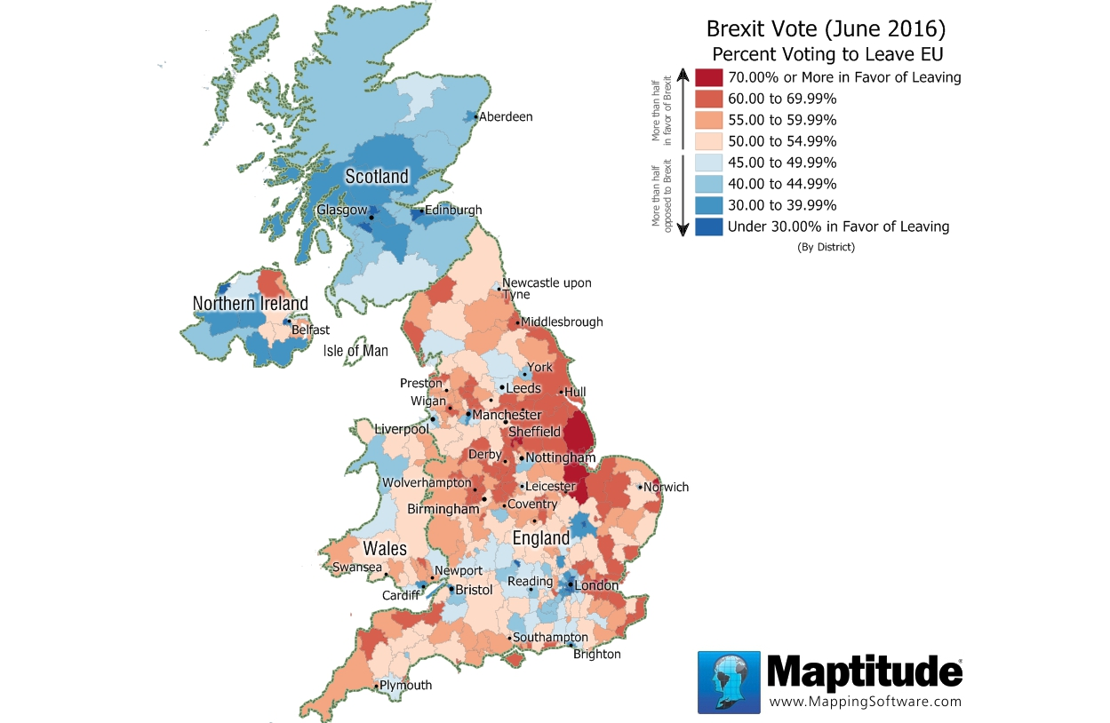

What were the general economic attributes of the Brexit regions voting to leave?
- The relationship Is weak but still notable. The highest leave votes tended to come from ow income areas.

- The demographic profile of leave voters was:
- Education: Lower levels.
- Occupation: Less education, less skilled.
- Income: Lower.
- Age: Older.
- Knowledge of World: Lower.
- UK Ethnicity: English.

Other reported characteristics of Leave districts were:
- Low numbers of immigrants.
- Little knowledge of their share of exports to EU.
- Belief that UK was highly regulated by EU.
- Belief that immigrant populations were far larger than they were.
- Belief that immigrants took jobs and/or drove down wages.

Know what income inequality is, how it is measured, and what the general trends are for the U.S.A., Canada, and the U.K.

- Income inequality is the unequal distribution of household or individual income across the various participants in an economy. Income inequality is often presented as the percentage of income to a percentage of population
- The general trends for USA is that In the US the highest income quintile has been growing at magnitudes of difference over the lower, and especially the lowest.Thus the poor, the middle, and the upper middle class have been falling behind faster and faster.
- In the U.K., income inequalities grew during Conservative administrations. These were also the periods when social welfare, regulation and taxes decreased.
- In Canada, income inequalities grew during Liberal administrations, periods where generally social welfare, regulation and taxes increased.
- Generally, the richer the country the more equally distributed income is (Low Gini coefficients) however, the US is an outlier where income and inequality are both high.

