MARKETING BASICS
MKTG 2P51 M. Finley

FINAL EXAM REVIEW by Jake Parrotta

This review was made to aid studying for the MKTG 2P51 final exam. Reading/studying this review should be used in conjunction with other methods of studying, and should not be relied on wholly.
In sections labeled Terms, not all terms within the chapter are provided, information that may be more crucial to understanding the chapter objectives and highlighted in lecture was included. You may notice Terms in this review often provide an example (unlike the Mid-Term review) this is because, in contrast to the mid-term exam, the final exam has no multiple choice and will need additional information to support short answer type questions. I’ve underlined terms that I think are important to consider when writing strong marketing plans.

Do not forget, the examination is in Ian D. Beddis Gymnasium (right next to Academic/South Block) at 8:00 am Monday December 8th.

To everyone using this review, I sincerely hope it helps, and best of luck when writing, and have an awesome winter break!

Chapter 11
Marketing Channels and Supply Chain Management
  - Terms
Distribution: movement of goods and services from producers to customers.
Firms using the Panama Canal to move goods
Marketing (Distribution) Channel: system of marketing institutions that enhances the physical flow of goods and services, along with ownership title, from the producer to consumer or business user
Michael Dell decided to use phone to sell his ‘Dell’ computers
Logistics: process of cording the flow of information, goods and services among members of the distribution channel
Supply Chain Management: control of the activities of the purchasing, processing, and delivery through which raw materials are transformed into products and made available to finals consumers
Physical Distribution: broad range of activities aimed at efficient movement of finished foods from the end of the production line to the consumer
Includes transporting goods, inventory control and even customer service
Customer-Service Standards: State the goals and define acceptable performance for the quality of service that a firm expects to deliver to its customers
A pizza brand that commits to delivering pizza within 30 minutes
Marketing Intermediary (Middleman): wholesaler or retailer that operates between producers and consumers or business users
Best Buy does not manufacture laptops, but sells a variety of brands including Apple, Samsung, Dell and Sony, making them a ‘middleman’
Wholesaler: Channel intermediary that takes title to the goods it handles and then distributes these goods to retailers, other distributors or B2B customers
McLane co. provides grocery and foodservice supply chain solutions for convenience stores, drug stores and chain restaurants throughout the USA
Direct Channel: marketing channel that moves goods directly from a producer to the business purchaser or ultimate user
The Internet and direct mail are important tools for direct selling.
Direct selling: strategy designed to establish direct sales contact between producer and final user
Buying eggs directly from a farmer
Manufacturers’ Representative: agent wholesaling intermediary that represents manufacturers of related but noncompeting products and receives a commission on each sale
A kitchen manufacturer might have its own manufacturers’ representative to market its goods
Dual Distribution: Network that moves products to a firm’s target market through more than one marketing channel
Sears Canada sells goods through stores, catalogues and the Internet.
Reverse Channel: Channel designed to return goods to their producer
Customers receiving return shipping label in the mail
Intensive Distribution: distribution of a product through all available channels
Consumers can buy Campbell’s soup just about anywhere, grocery stores, drug stores, even staples
Selective Distribution: distribution of a product through a limited number of channels
Gucci only sells merchandise to a limited number of boutiques globally
Exclusive Distribution: distribution of a product through a single wholesaler or retailer in a specific geographic region
Ford cars only being sold by Ford car dealerships
Closed Sales Territory: exclusive geographic selling region of a distributor
Tying Agreement: an arrangement that requires a marketing intermediary to carry items other than those they want to sell
Apparel dealer might be required/forced to carry an unpopular line of clothing if they also want to carry desirable, fast-moving products
Channel Captain: Dominant and controlling member of a marketing channel
A company like Kraft foods is considered a channel captain
Grey Goods: goods produced for sale in one market and then diverted to another market
Amazon is not licensed to sell Kindle in China, however the product is available in China’s grey market
Vertical Marketing System: planned channel system designed to improve the distribution efficiency and cost effectiveness by integrating various functions throughout the distribution chain
One owner owns multiple pieces of the channel
Forward Integration: process through which a firm attempts to control downstream distribution
Setting up a retail chain to sell products
Backward Integration: process through which a firm attempts to gain greater control over inputs in its production process, such as raw materials
Acquiring the supplier of raw materials to use in production
Corporate VMS: VMS that achieves channel coordination when a dominant channel member exercises its power
Roots (apparel)
Contractual VMS: VMS that coordinates channel activities through formal agreements among participants
Franchises
Administered marketing system: A dominant channel member exercises power to achieve channel coordination.
Shoppers Drug Mart
Horizontal Marketing Systems: When two or more companies at one level join together for a new marketing opportunity
Companies need to gain economies of scale so by joining together they could address financial, productions or marketing resources. Walmart with McDonald’s
Supply Chain: complete sequence of suppliers and activities that contribute to the creation and delivery of merchandise
Begins with raw-material inputs for production. Ends with the movement of final product to customers
Upstream Management: controlling part of the supply chain that involves raw materials, inbound logistics, and warehouse and storage facilities
Downstream Management: controlling part of the supply chain that involves finished product storage, outbound logistics, marketing and sales, and customer service
Radio Frequency Identification (RFID): technology that uses a tiny chip with identification information that can be read from a distance by a scanner using radio waves
Can be used to grant access to restricted areas or to speed delivery processing
Enterprise Resource Planning (ERP) System: software system that consolidates data from among a firm’s various business units
Third-Party (contract) Logistics Firm: Company that specializes in handling logistics activities for other firms
Suboptimization: condition that results when individual operations achieve their objectives but interfere with progress toward broader organizational goals
Common Carriers: businesses that provide transportation services as for-hire carriers to the general public
Contract Carriers: for-hire transporters that do not offer their services to the general public
Private Carriers: transporters that provide service solely for internally generated freight
Intermodal Transportation: combination of transport modes such as rail and highway carriers (piggyback), air and highway carriers (birdyback) and water and highway carriers (fishyback) to improve customer service and achieve cost advantages
Inventory Control Systems: systems put in place so companies balance maintaining enough inventory to meet customer demand with incurring unneeded costs for carrying excess inventory
RFID technology, VMI
Vendor-Managed Inventory (VMI): inventory management system in which the seller—based on an existing agreement with a buyer—determines how much of a product is needed
Larger businesses may have your shipping cartons, office supplies, or cleaning/maintenance supplies managed by the vendor
Materials Handling System: set of activities that move production inputs and other goods within plants, warehouses, and transportation terminals
  - Concepts
Distribution Strategy
- The process by which you get a product from Creation to the customer.
- That process is the supply chain
  - A chain is a broader concept starts with raw materials, component parts and supplies necessary to produce a good or service PLUS the firms that facilitate the movement of that product to the end user
- The Channel consists of all the separate organizations that pass the product along
  - Distribution Strategy has two components:
- Marketing Channel
- Logistics and supply chain management
- This must be efficient and support customer service, enhancing the customer relationship
- Each member of a channel plays a specific role
1. Marketing Channel
Four functions of marketing channels:
- Facilitating the exchange process by reducing the number of marketplace contacts necessary to make a sale
- Adjusting for discrepancies in the market’s assortment of goods and services via sorting
- Standardizing exchange transactions by setting expectations for products
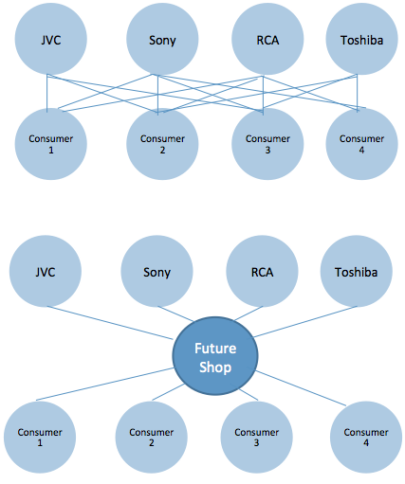
- Facilitating searches by both buyers and sellers
⬆ Marketing Channels reduce the number of Transactions

⬇  Marketing channels
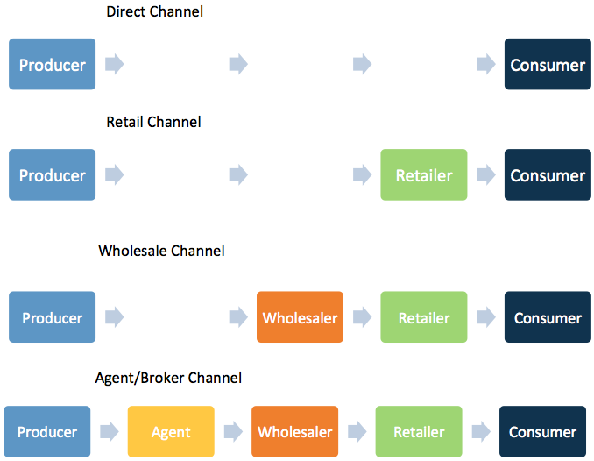
Direct selling Strategy designed to establish direct sales contact between producer and final user. Important option for goods that require extensive demonstrations in persuading customers to buy

Producer to wholesaler to retailer to consumer The traditional channel for consumer goods. Gives small producers access to hundreds of retailers. Gives small retailers access to wholesaler’s specialized distribution skills.

Producer to agent to wholesaler to retailer to consumer Common in markets served by small companies
Agent may or may not take possession of goods but does not take title

2. Logistics and Supply Chain Management
HP’s supply chain/channel ⬇ 
Supply chain management is a complete sequence of suppliers and activities that contribute to the creation and delivery of merchandise.
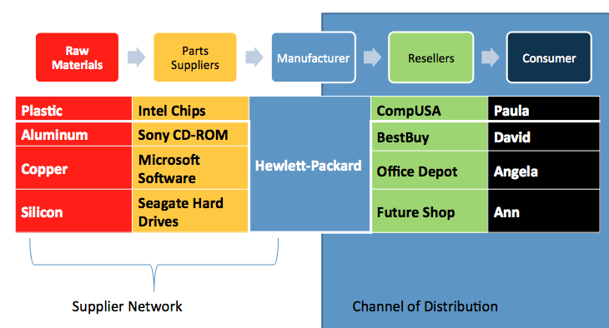
Proper supply-chain management insists on the control of the activities of purchasing, processing, and delivery.

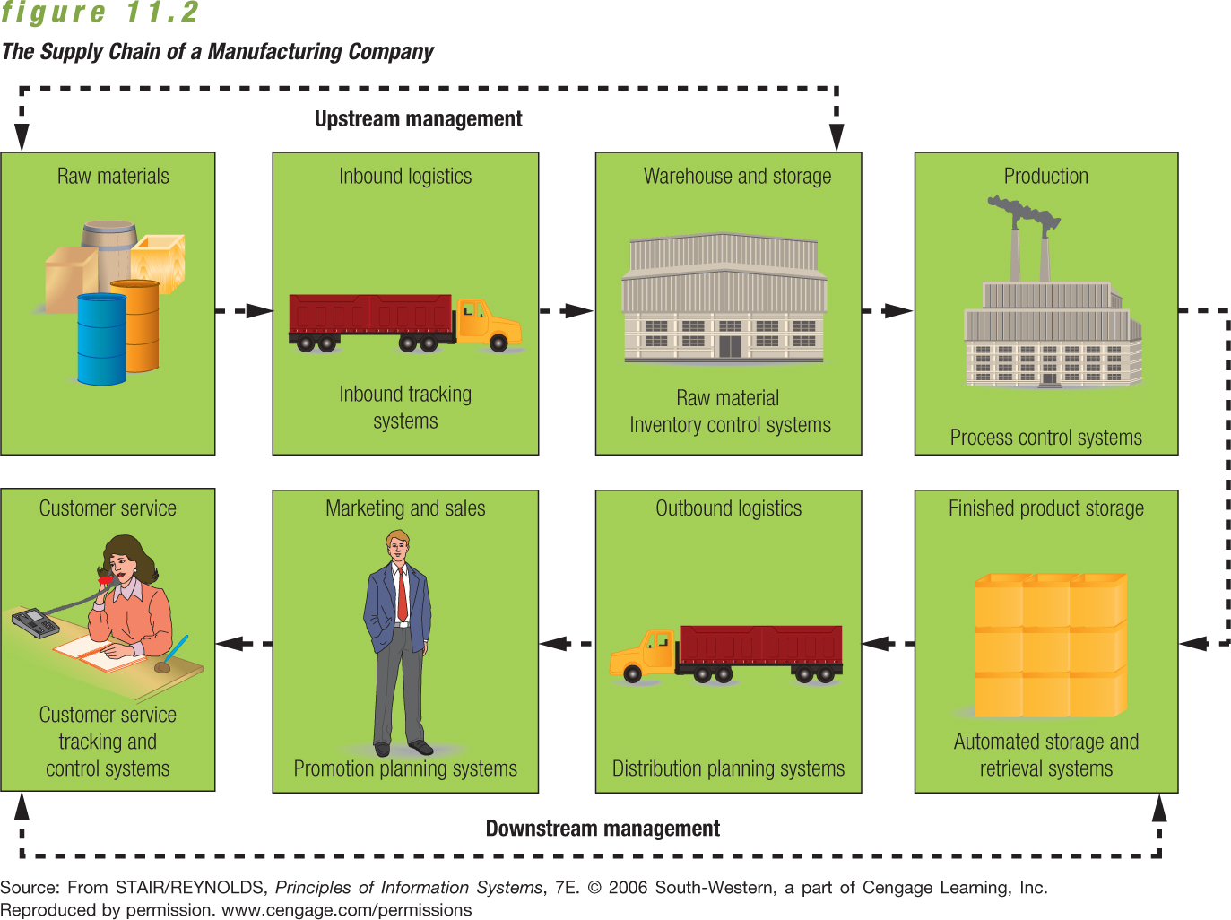
See Terms for more information

Major Modes of Transportation
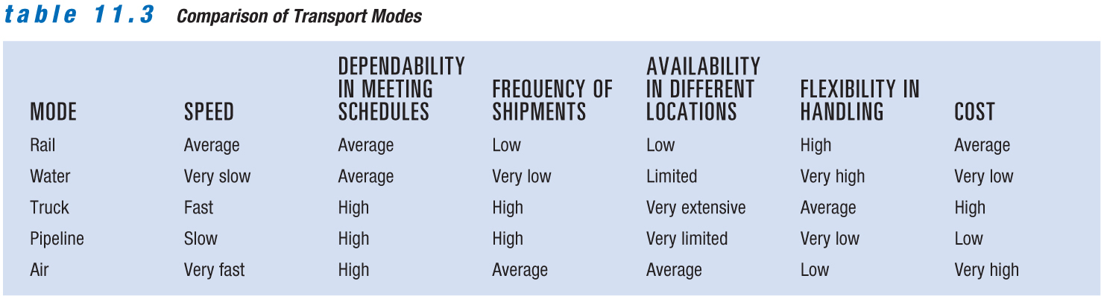
Logistics manager’s select the best option to buy matching these features to their specific transportation needs.
Chapter 12
Retailers, Wholesalers, and Direct Marketers
  - Terms
Retailing: Activities involved in selling merchandise to ultimate consumers
Retailers act as both customers and marketers in their channels.
Wheel of retailing: Hypothesis that each new type of retailer gains a competitive foothold by offering lower prices than current suppliers charge; the result of reducing or eliminating services
Markup: Amount a retailer adds to the cost of a product to determine its selling price
Markup is influenced by two factors. 1, Services performed by the retailer. 2, Inventory turnover rate
Markdown: Amount by which a retailer reduces the original selling price of a product
Planned Shopping Centre: Group of retail stores planned, coordinated, and marketed as a unit
The Pen Centre
Selling up: Persuading customers to buy higher-priced items than originally intended
Suggestion selling: Broadening a customer’s original purchase by adding related items, special promotional products, or seasonal merchandise
Atmospherics: Combination of physical characteristics and amenities that contribute to a store’s image.
Includes interior and exterior. Hollister has wooden paneling in the front and low lighting inside.
Kiosk: Primarily used to sell food items, lottery tickets in Canada. Other countries use vending machines to offer a wider variety of goods.
Koodo Mobile kiosks in malls
Direct marketing: Direct communications, other than personal sales contacts, between buyer and seller, designed to generate sales, information requests, or store or website visits
Direct Mail, Direct Selling, Telemarketing
  - Concepts
Components of Retail Strategy
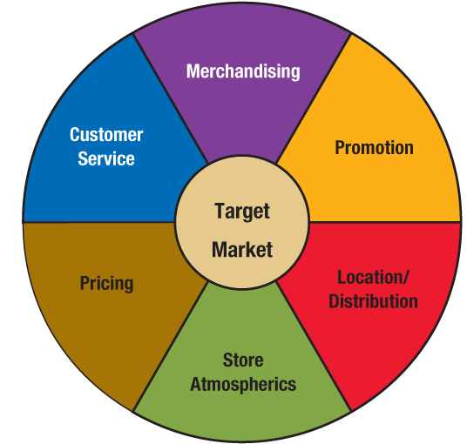
Retailers base key decisions on two fundamental steps in the marketing strategy process:
  - Selecting a target market
  - Developing a retailing mix to satisfy the chosen market
    - 4Ps +

Product Merchandizing strategy
- Guides retailer’s decisions on the items it will offer
- While developing the merchandise mix, retailers should consider:
  - Needs and preferences of its target market
  - Competitive environment influencing choices
  - Overall profitability of each product line and category
Product Category Management
- Seeks to improve retailer’s product performance through coordinated buying, merchandising, and pricing
- Category management evaluates performance according to each product category.
- Categories that underperform may be dropped even if they are strong brands.
Price
- Prices reflect a retailer’s marketing objectives and policies.
- Price defines the value of both the merchandise and the service provided
- They affect consumer perceptions.
- Markup/Markdown
Selecting a Target Market
- Consider size and profit potential of the market and the level of competition
  - Example: Walmart draws customers away from traditional department stores with trendy but affordable lines of clothing
Customer-Service Strategy
- Heightened customer service is one possible retailing strategy.
- The goal is to attract and retain target customers to increase sales and profits.
- Some services that retailers could provide:
  - Enhanced comfort through lounges, complimentary coffee, convenient restrooms
  - Child-care services for customers
  - Virtual assistance programs
Location/Distribution Strategy
- Location depends on many factors, including the type of merchandise, the retailer’s financial resources, characteristics of the target market, and site availability.
- Planned shopping centre – Group of retail stores planned, coordinated, and marketed as a unit. Includes five main types:
  - Neighbourhood shopping centre
  - Community shopping centre
  - Regional shopping centre
  - Power centre
  - Lifestyle centre
Promotional Strategy
- Promotion informs customers about locations, merchandise selections, hours of operation, and prices.
- Helps retailers attract shoppers and build customer loyalty
- National chains purchase advertising in print and broadcast media.
- Salespeople play an important role
  - Selling up – Persuading customers to buy higher-priced items than originally intended
  - Suggestion selling – Broadening a customer’s original purchase by adding related items, special promotional products, or seasonal merchandise
- Poor service can influence customers’ attitudes about a retailer.

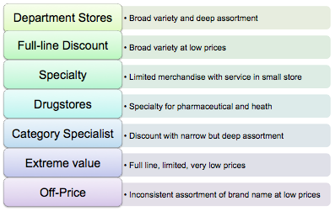
Types of Retailers Categorizing Retailers
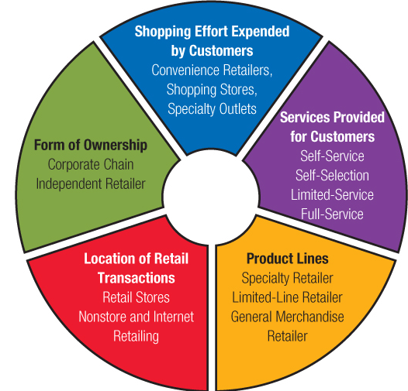
Channels for Selling to Consumers
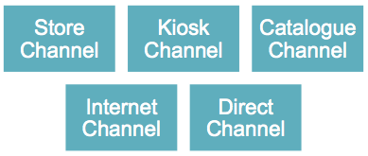

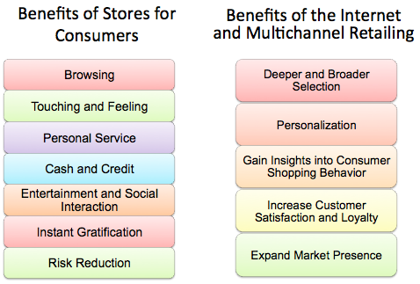
Benefits Provided by Different Channels
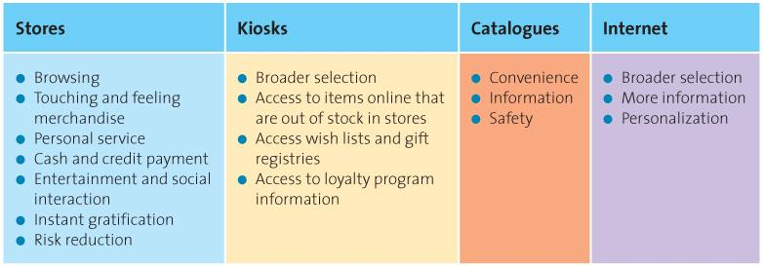

Chapter 13
Integrated Marketing Communications
  - Terms
Integrated Marketing Communications: the coordination of all promotional activities to produce a unified, customer-focused promotional message
Media advertising, direct mail, personal selling, sales promotion, public relations, and sponsorships
Promotion: Communications link between buyers and sellers. Function of informing, persuading, and influencing a consumers purchase decision
Marketing Communication: messages that deal with seller-buyer relationships
AIDA: Attention, Interest, Desire, Action. A process thorugh which an individual reaches purchase
Encoding: translating a message into understandable terms
Decoding: receivers interpretation of a message
Noise: any stimulus that distracts a receiver
Channel: medium through which a message is communicated/delivered
Websites, Magazine advertisement
Product Differentiation: When consumers regard a firm’s products as different in some way from those of competitors
Some consider the iPad much different than other Tablets
Public relations: a firm’s communications and relationships with its various publics
Marketing public relations, Nonmarketing public relations
Publicity: Nonpersonal stimulation of demand through unpaid placement of news in published medium or a favourable presentation of it on the radio or television
Facebook users sharing company commercials for fun
Product placement: The marketer pays a motion picture or television program owner a fee to display his or her product prominently in the film or show
Judges of American Idol drinking from Coca-cola cups
Sponsorship Relationship in which an organization provides funds or in-kind resources to an event or activity in exchange for a direct association with that event or activity
McDonalds sponsoring the Olympics as official restaurant for games

  - Concepts
Integrated Marketing Communications
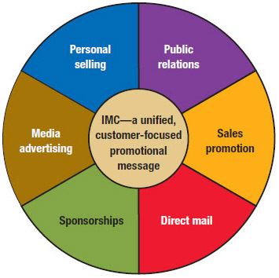
- IMC begins with their wants or needs and then works backward to the product.
- The Internet allows companies to gather information faster and organize it easily.
- Successful implementation of IMC requires consistent, coordinated promotional effort at every stage of customer contact
- 6 components
Advertising | Personal Selling
Public Relations | Sales Promotion
Direct Mail | Sponsorships

Objectives of Promotion
Promotion has five basic objectives:
1. Provide information.
  - Goal is to inform the market about the availability of a product
2. Increase demand.
  - May increase primary demand or desire for a particular product category
  - May increase selective demand or desire for a specific brand
3. Differentiate the product.
  - Differentiation provides firms more control over marketing variables such as price.
4. Accentuate the product’s value.
  - Greater value helps justify a higher price in the marketplace.
5. Stabilize sales.
  - Can stabilize variations in demand
Advertising
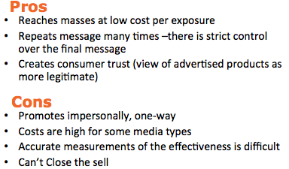
Any paid, nonpersonal communication through various media about a business firm, not-for-profit organization, product, or idea by a sponsor identified in a message
See advertising flowchart next page ⬇
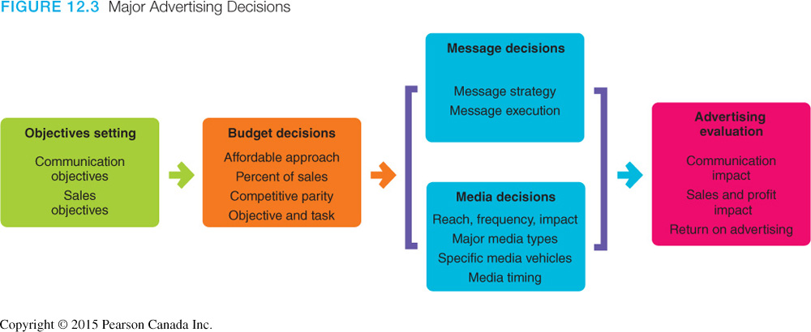Personal Selling
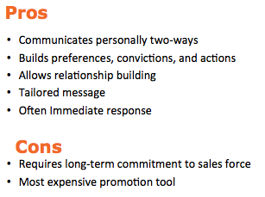
Personal Selling: Refers to a seller’s promotional presentation conducted on a person-to-person basis with the buyer
- Enhances customer relationship
- Can be extremely effective
- Definitely the most expensive promotional tool

Public Relations
t
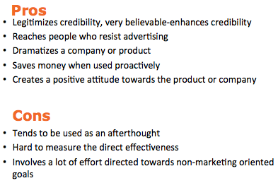
Public relations — Firm’s communications and
relationships with its various publics
  - Marketing public relations
  - Non-marketing public relations
Publicity, Product placement, Sponsorship

Sales Promotion
t
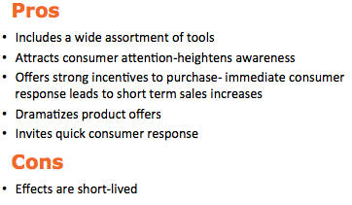
- Can be aimed at both end user consumers or channel members
- Used in conjunction with other forms of IMC
- Can be used for both short-term and long-term objectives

Direct Marketing
t
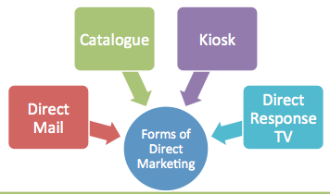
Direct communications, other than personal sales contacts, between buyer and seller, designed to generate sales, information requests, or store or website visits.
Four defining characteristics:
  - targeted
  - motivates an action
  - measurable
  - can provide information for a marketing database

Guerrilla marketing — Unconventional, innovative, and low-cost marketing techniques designed to get consumers’ attention in unusual ways
Types of guerilla marketing:
- Buzz marketing
- Viral marketing
Forms of Direct Marketing
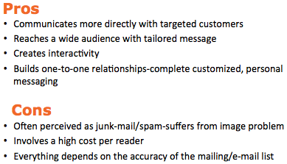
- Direct Mail
  - Targeted, printed communication sent to a prospective consumer’s mailbox
- Catalogues
  - Hard copy and online welcomed in 80% of Canadian homes
E.g. Sears, Ikea, and Business Depot
- DRTV
  - short television commercials and/or infomercials
  - strong call to action via 1-800 number, mail or website
- Kiosks
  - Facilitate service delivery, e.g. airline ticket printing
  - Sell services and products to consumers, e.g. Dell, Virgin Mobile, Hallmark
Sponsorships
t
- Sponsorships are often more cost effective.
- Sponsorships usually offer less control over market coverage.
- Nature of the message and audience reaction differs.
    - Ambush marketing
      - Attempt by a firm that is not an official sponsor of an event or activity to link itself to the event or activity
Developing an Optimal Promotional Mix
- Marketers create a promotional mix by blending advertising, personal selling, sales promotion, and public relations.
- Several factors can influence the effectiveness of the promotional mix.
- Nature of the market.
  - Market’s target audience, type of customer
- Nature of the product.
  - Highly standardized products usually depend less on personal selling.
  - Consumer product sellers rely more on advertising than business products.
- Stages in the
product life cycle
- Personal selling in introductory stage
- Advertising in growth and maturity stages
- Differentiation when competitors enter the market
- Price
- Advertising for low-unit-value products
- Funds available for promotion
- Size of the budget influences promotional mix
Pushing and Pulling Promotional Strategies
Pulling strategy — Promotional effort by the seller to stimulate final-user demand, which then exerts pressure on the distribution channel
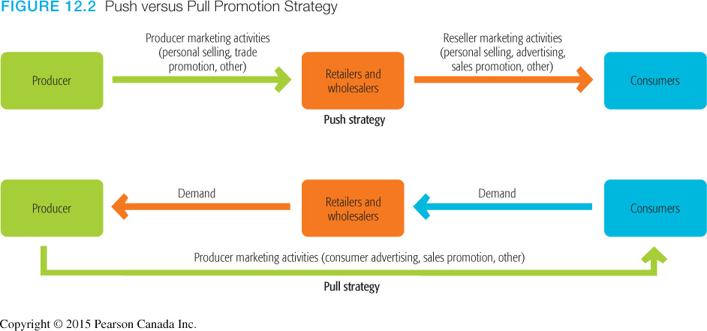
Pushing strategy — Promotional effort by the seller directed to members of the marketing channel rather than final users

Measuring the Effectiveness of Promotion
Marketers use two basic tools:
  - Direct sales results test
  - Indirect evaluation
- Measuring on-line Promotion
- Direct response in promotions
- Three major ways of setting Internet advertising rates:
  - Cost per impression
  - Cost per response (click-throughs)
  - Conversion rate

Chapter 14
Advertising and Digital Communications
  - Terms
Advertising: Paid, nonpersonal communication through various media about a business firm, not-for-profit organization, product, or idea by a sponsor identified in a message that is intended to inform, persuade, or remind members of a particular audience
Cooperative advertising — Strategy in which a retailer shares advertising costs with a manufacturer or wholesaler
Cross Promotion: promotional technique in which marketing partners share the cost of a promotional campaign that meets their mutual needs
Pretesting: research that evaluates an ad during its development stage
Using software to determine where a billboard at is most looked at
Post-testing: research that assesses advertising effectiveness after it has appeared in a print or broadcast medium
Split runs: Allow advertisers to test the relative effectiveness of two ads
Advertising Campaign: Series of different but related ads that use a single theme and appear in different media within a specified time period
Got milk campaign
Advertising Agency: a firm whose marketing specialsts assist advertisers in planning and preparing advertisements
Reach: Percentage of people exposed to an ad campaign in a given time period
Frequency: Number of times a person is exposed to an advertisement
Media Impact: Qualitative value of a message exposure through a given medium
Media research: Assesses how well particular medium delivers message, where and when to place the message, and the size of the audience
Message research: Tests consumer reactions to an advertisement’s creative message through pretesting and post-testing

  - Concepts
The AIDA Model
Awareness  -Senders first must gain the attention of the consumers  -A multichannel approach increases the likelihood the message will be received | Interest  -After the customer is aware, they must be persuaded  -The customer must want to further investigate the product/service
Desire  I like it, I want it! | Action  The action of purchasing

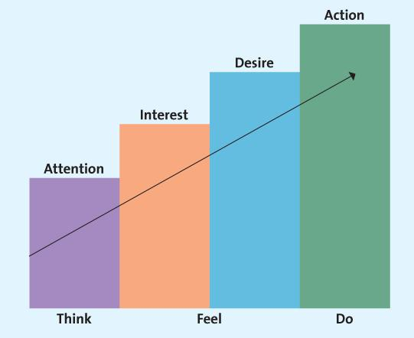
This chart represents the AIDA model

Types of Advertising
Institutional Advertising
- Of a concept, idea, philosophy, or goodwill of an industry, company, organization, person, geographic location, or government agency
Product Advertising
- Nonpersonal selling of a particular good or service
Informative Advertising
- Promotion that seeks to develop initial demand for a good or service, organization, person, place, idea, or cause
- Use informative advertising to educate consumers about the product/service
Persuasive Advertising
- Promotion that attempts to increase demand for an existing good, service, organization, person, place, ideas or cause
- Generally occurs in the growth and early maturity stages of the PLC when competition is most intense
Reminder Advertising
- Advertising that reinforces a previous promotion activity by keeping the name of a good, service, organization, person, place, ideas or cause
- After the products have gained market acceptance
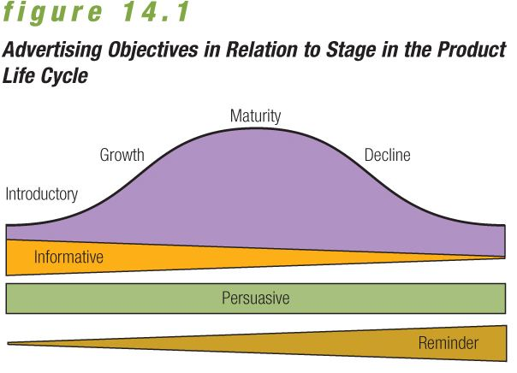

Advertising Strategies
Comparative Advertising
- Advertising strategy that emphasizes messages with direct or indirect promotional comparisons between competing brands.
- Coke, Pepsi
Retail Advertising
- Includes all advertising by retail stores that sell goods or services directly to the consuming public
- Cooperative advertising — Strategy in which a retailer shares advertising costs with a manufacturer or wholesaler
Interactive Advertising
- Involves two-way promotional messages transmitted through communication channels that induce message recipients to participate actively in the promotional effort
- AppStore game that promotes product
Cross Promotion
- A technique in which marketing partners share the cost of a promotional campaign that meets their mutual needs
- Burger King, Spongebob (toys)
Celebrity Testimonial
- Use of celebrity spokespeople for products
- Can improve product recognition, and reach consumers of various ethnic groups
- Can build brand equity but can also hurt brand if hurt by scandal
Creating an Advertisement
With so many dollars at stake, companies must create effective and memorable ads that increase sales and enhance a firm’s image

Advertising campaign — Series of different but related ads that use a single theme and appear in different media within a specified time period
  - Fear appeals
  - Humour in advertising messages
  - Ads based on sex
  - Emotional appeal
- After idea conception, ad must be refined from rough sketch to finished layout.
- Use of advertising in games, or advergames
- Banners and pop-ups
- Social networking advertising is a new form of online advertising.
Digital channels
    - Email
    - Online communities and social networks
    - Blogs and podcasts
    - Other digital communications — mobile
- After selecting media, marketers determine the most effective timing and sequence for a series of advertisements.
- Influenced by a variety of factors:
  - Seasonal sales patterns
  - Repurchase cycles
  - Competitors’ activities
Media Selections
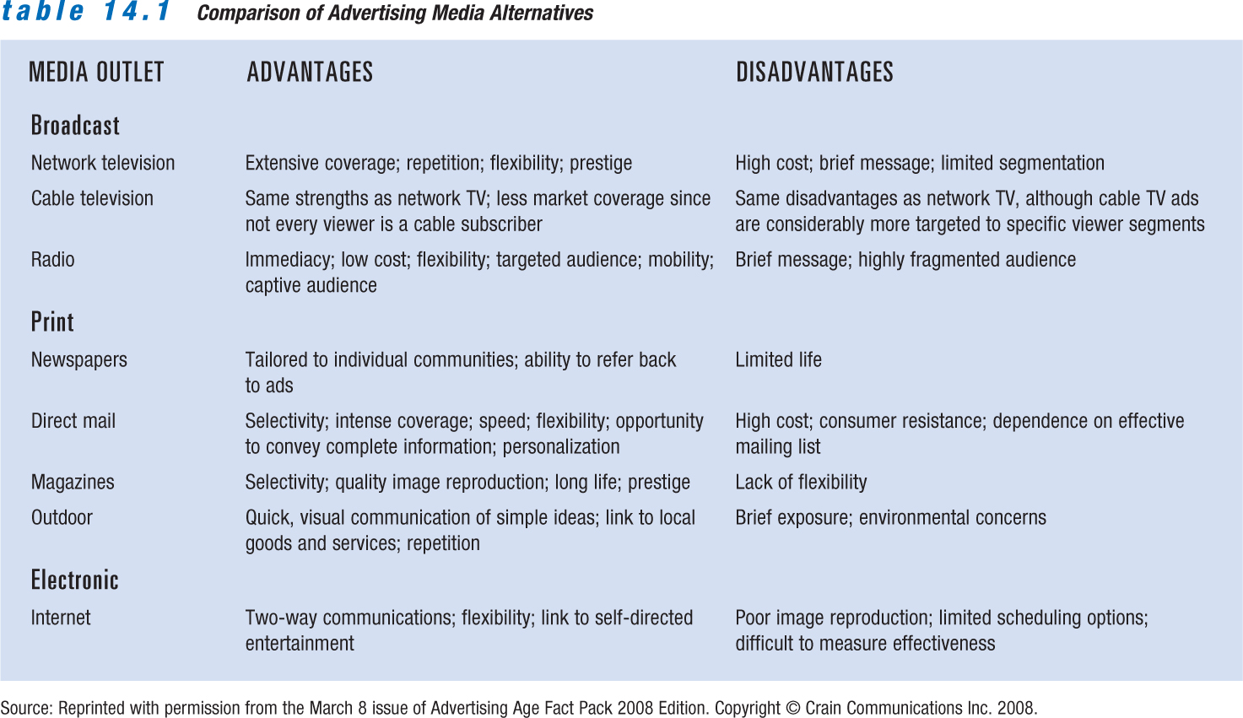

When selecting a medium it is important to consider
- Reach, Frequency, Impact
- Media research, Message research
- Pretesting
- Post-Testing
- Split-Runs
Evaluating Interactive/Online Media
- Hits — User requests for a file
- Impressions — Number of times a viewer sees an ad
- Click-throughs — User clicks ad for more information.
- View-through — Measures response over time

Chapter 14
Advertising and Digital Communications
  - Terms
Marginal analysis: Method of analyzing the relationship among costs, sales price, and increased sales volume
Profit maximization: Point at which the additional revenue gained by increasing the price of a product equals the increase in total costs
Target-return objective: Short run or long run pricing objectives of achieving a specified return on either sales or investment
Value Pricing: pricing strategy emphasizing benefits derived from a product in comparison to the price and quality levels of competing offerings
Walmart Rollback pricing
Demand: The amounts of a firm’s product that consumers will purchase at different prices during a specified time period
Supply: The amounts of a good or service that will be offered for sale at different prices during a specified period
Pure competition: A market structure with so many buyers and sellers that no single participant can significantly influence price. A product’s total cost is composed of total variable costs and total fixed costs
Variable costs: Change with the level of production.
Raw materials and labor costs
Fixed costs: Remain stable at any production level within a certain range
Lease payments or insurance costs
Cost-plus pricing: Uses a base-cost figure per unit and adds a markup to cover unassigned costs and to provide a profit. Allows businesses with low costs to set prices lower than those of competitors’ and still make a profit
Loss leader: Product offered to consumers at less than cost to attract them to stores in the hope that they will buy other merchandise at regular prices
Often featured items in flyers
Leader pricing:Enticing consumers into the store with the popular aggressively priced item and hoping they will pick up other items while shopping
Odd pricing: Setting prices at odd numbers just under round numbers
Unit pricing: Prices stated in terms of some recognized unit of measurement or a standard numerical count
Customary prices: Traditional prices that customers expect to pay for certain goods and services.
Elasticity: measure of responsiveness of purchasers and suppliers to a change in price
  - Concepts

