Carleton University

Lab Report

Course #: PHYS 1008 Experiment: 5

Introduction to Ray Optics

Liam Golding
101049885

Performed: March 12, 2017
Submitted: March 20, 2017
Period: Mon. AM
Partner: Isabel M.
Station #: 5
TA: Urvi

Purpose

The purpose of this experiment if to investigate many properties of light such as total internal reflection, dispersion and refraction. The effect of dispersion will be matched with converging and diverging lenses using different methods of determining the focal distance.

Theory

Part A: Refraction index
When light passes from one medium to another, the rays that transmit will not have the same angle or frequency. As for reflection, rays always reflect at the same angle as the incident ray. By shining light at different angles, the refractive ray will change accordingly. This phenomenon is described using Snell’s law
$$n_{1}sinθ_{1}=n_{2}sinθ_{2}$$
When passing from a low-density medium to a high one, if the angle is increased sufficiently on the incident ray then an effect called total internal reflection occurs in which all the rays of light are reflected along the surface and none are refracted. Knowing Snell’s law and this phenomenon, the two can be interpolated.
$$n_{1}sinθ_{1}=n_{2}sin⁡(90°)$$
The refracted rays and the reflected are one in the same in this situation therefore we can use the angle from the surface to the normal 90$°$.
$$n_{1}sinθ_{1}=n_{2}$$
$$sinθ_{1}=\frac{n_{2}}{n_{1}}$$
This equation can be used to derive the refractive index of the material.

As it is difficult to shine an exact amount of photons at a point. The ray box was used in this experiment to help focus the light rays into a concentrated region due to the precisely set focal distance from the collimating lens and the source of light.

Part B: Dispersion at a Critical Angle
The second method for determining the refractive index is to measure the critical angle. The critical angle is when the incident ray angle increases or decreases so much that no light can transmit. Before the critical angle, monochromatic light will divide into the visible spectra. Using a protractor and a clear semi-circular material, light is shone on the surface while increasing the angle until the blue light disappears on the visible spectrum produced before the critical angle.
$$n_{1}sinθ_{1}=sin⁡(90°)$$
$$n_{1}=\frac{1}{sinθ_{1}}$$
$$σ_{n_{1}}={n_{1}}^{2}cosθ_{c}σ_{θc}$$
Part C: Image of a Convex Lens
Many instruments such as glasses, microscopes, telescopes and magnifying glasses use a converging lens in which the shape of the lens in bi-parabolic converging at two points the top and bottom. The role of the shape of convex lenses is to smoothly vary the incident angle from the middle outwards. All the rays meet a certain distance away from the lens, known as the image distance. Convex lenses focus images on the other side from the object but inverted, known as a real image. Furthermore, light that was on the upper plane (above the middle of the lens) will be projected in the lower plane. Real images can be seen with any bright object that is infinitely far away from a very thin lens (one that is much smaller than its focal distance).

Part D: Tracing Rays from an Object at Infinity
When describing this type of experiment, it’s is crucial to put a drawing showing the bending of light as it passes through a lens. This diagram can show two ray lines or three. For this part, we are no longer using thin lenses to generate an image, instead, the lenses will be much thicker. The thickness of the lens makes it easier to draw the incoming and outgoing rays thank with a thin lens, purely for simplicity but will be more difficult to incorporate into the thin lens equation. The thicker lenses will be a diverging and a converging, separating the light respectively.
Unlike converging lenses, diverging lenses create a virtual image (one on the same side as the object). The inverted bi-parabolic shape, bend the incoming rays outwards. The effect of a virtual image, created by a diverging lens, is that light doesn’t meet at a focal point rather some light is reflected to a focal distance closer to the object. It is possible for a converging lens and diverging to have the same focal length, described by having the same but opposite parabolic shape. The focal point on the diverging lens will be negative due to virtual imaging.

Part E: Object near Lens
This part uses objects not at infinite but close to the lens representing the distance from the lens to the object as p and the projected image distance from the lens q (could be negative if a virtual image). A mathematical relation between the focal length and p and q can be described as
$$\frac{1}{f}=\frac{1}{p}+\frac{1}{q}$$
$$σ_{f}=f^{2}\sqrt{{\left(\frac{σ}{p}\right)}^{2}+({\frac{σ}{q})}^{2}}$$
Part F: Compound Lens
When collimated light passes through a diverging lens to a converging one, the focal point will appear to begin before the diverging lens when really it is emitted by an object not a infinite. The converging lens will focus the rays transmitted by the diverging lens at the sum of both focal points with the gap distance of their centers.

Apparatus
Part A:
The refractive index of the semi-circular material was found by shinning collimated light through and reading the refracted angle from the normal. With a protractor underneath, centered precisely in the middle of the material. Multiple readings were taken between 30 and 50 degrees. The reading error on the protractor is ½ the smallest deviation. The two objects, once centered, should not be moved to stay consistent with the readings.
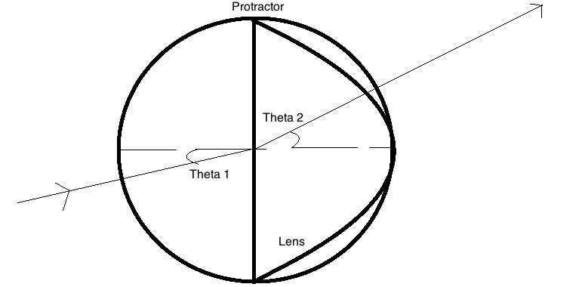
Figure 1. Diagram of lens and protractor with parallel light passing through.
Part B:
The second experiment uses the same idea as Part A however instead of taking readings within 30-50 degrees this one only requires a single degree measurement at the critical angle. The first angle is reached when the blue rays in the visible spectrum, produced by the large angle of incidence, disappear; the second when the red disappears. The reading error is ½ the smallest division.
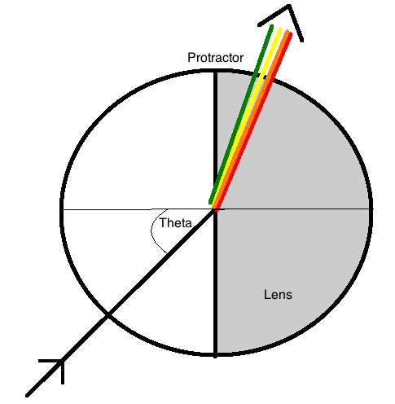
Figure 2. Critical angle diagram with blue light invisible in the refracted visible spectrum.

Part C:
Thirdly for this experimental lab, the magnifying lens (the thinnest convex lens) was placed facing a window with light passing through. With the infinitely far away object, the lens will focus it a certain focal length away. Since the light coming in is reflected from lots of objects, it is impossible to focus the entire image; therefore, the image should be focused where it is best viewed. A meter stick was used to measure the focal length of the image but using ½ the smallest deviation is too large an error for this part. The error will be calculated in the Calculations section.
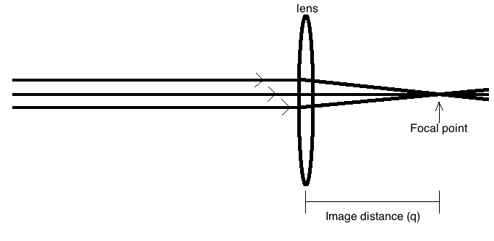
Figure 3. Convex lens with light from infinity passing through and directed at the focal point.
Part D:
Using the collimator, the rays from the paralleled source and the rays passing through a lens (both concave and convex) can be interpreted with drawings. Since the source is considered to be at infinity then the p value would be infinitely small, this value can be neglected and the lens-image distance can be measured to calculate the focal length. The error on the meter stick was 0.05cm.

Part E & F:
This part requires a source not at infinity, and a lens to focus the light. Using the non-collimated light, the lens is placed so that the light is directed to a point on a piece of paper. The lines can then be drawn and the p and q value can be measured.
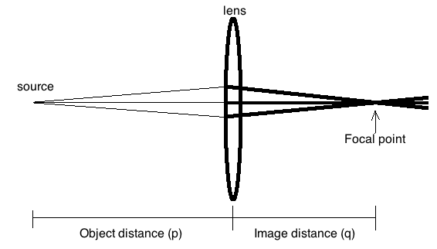
Figure 4. Object closer to lens
For the compound lens, the same rules apply but a diverging lens is placed before the converging and the source of light must be collimated. This way the virtual image produced by the diverging lens will be the object for the converging lens. The object is still the source of light and the error on the meter stick is 0.05cm.
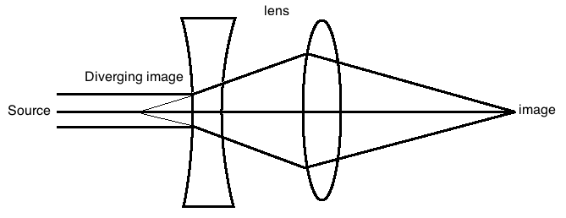

Figure 5. Compound lens made from a diverging lens portraying an object for the converging to focus

Calculations

Part A:
The two graphs produced by LoggerPro shows the relation between the incident angle and the refracted angle. Two were created one for the left side for the lens and one for the right. The slopes give the refractive index of the material which can both be compared by the consistency test.
$$∆=\left|X-Y\right|$$
$$∆=\left|1.443-1.595\right|$$
$$∆=0.152$$

$$σ_{∆}=\sqrt{{\left(0.0742\right)}^{2}+{\left(0.0798\right)}^{2}}$$
$$σ_{∆}=0.109$$

$$\frac{∆}{σ_{∆}}≤2$$
$$\frac{0.152}{0.109}≤2$$

$$1.39≤2$$
Average value:
$$X=\frac{σ^{2}x_{1}+σ^{2}x_{2}}{σ^{2}+σ^{2}}$$
$$X=\frac{{0.0742}^{2}(1.443)+{0.0798}^{2}(1.595)}{{0.0742}^{2}+{0.0798}^{2}}$$
$$X=1.525$$

$$σ_{X}=\frac{σ_{1}σ_{2}}{\sqrt{σ^{2}+σ^{2}}}$$
$$σ_{X}=\frac{(0.0742)(0.0798)}{\sqrt{{0.0742}^{2}+{0.0798}^{2}}}$$
$$σ_{X}=0.054$$

Part B:
Critical angle (blue): 42°
Critical angle (red): 43°
$$n_{b}=\frac{1}{sinθ_{b}}$$
$$n_{b}=\frac{1}{sin⁡(42.00)}$$
$$n_{b}=1.49$$

$$σ_{n_{b}}={(1.494)}^{2}(cos⁡(42.00))(0.05)$$
$$σ_{b}=0.08$$

$$n_{r}=\frac{1}{sinθ_{r}}$$
$$n_{r}=\frac{1}{sin⁡(43.00)}$$
$$n_{r}=1.47$$

$$σ_{n_{r}}={(1.47)}^{2}(cos⁡(43.00))(0.05)$$
$$σ_{n_{r}}=0.08$$
The dispersion factor:
$$∆=\left|n_{b}-n_{r}\right|$$
$$∆=\left|1.49-1.47\right|$$
$$∆=0.02$$

$$σ_{∆}=\sqrt{{\left(0.08\right)}^{2}+{\left(0.08\right)}^{2}}$$
$$σ_{∆}=0.11$$
Part C:
Image distance (q) = 12.80 cm
Object distance (p) = ∞ cm
$$\frac{1}{f}=\frac{1}{p}+\frac{1}{q}$$
$$\frac{1}{f}=\frac{1}{}+\frac{1}{12.80}$$
$$\frac{1}{f}=0+\frac{1}{12.80}$$
$$f=12.80 cm$$

$$σ_{f}=f^{2}\sqrt{({\frac{σ}{q})}^{2}}$$
$$σ_{f}={12.80}^{2}\sqrt{({\frac{0.05}{12.80})}^{2}}$$
$$σ_{f}=0.64 cm$$
Part D:
Thin convex lens
Image distance (q) = 8.00cm
$$\frac{1}{f}=\frac{1}{p}+\frac{1}{q}$$
$$\frac{1}{f}=\frac{1}{8.00}$$
$$f=8.00cm$$

$$σ_{f}=f^{2}\sqrt{{\left(\frac{σ}{p}\right)}^{2}+({\frac{σ}{q})}^{2}}$$
$$σ_{f}={8.00}^{2}\sqrt{({\frac{0.05}{8.00})}^{2}}$$
$$σ_{f}=0.40$$
Thick convex lens
Image distance (q) = 4.40cm

$$\frac{1}{f}=\frac{1}{p}+\frac{1}{q}$$
$$\frac{1}{f}=\frac{1}{4.40}$$
$$f=4.40cm$$

$$σ_{f}=f^{2}\sqrt{{\left(\frac{σ}{p}\right)}^{2}+({\frac{σ}{q})}^{2}}$$
$$σ_{f}={4.40}^{2}\sqrt{({\frac{0.05}{4.40})}^{2}}$$
$$σ_{f}=0.22cm$$
Diverging
Image distance (q) = -6.60cm
$$\frac{1}{f}=\frac{1}{p}+\frac{1}{q}$$
$$\frac{1}{f}=\frac{1}{-6.60}$$
$$f=-6.60cm$$

$$σ_{f}=f^{2}\sqrt{{\left(\frac{σ}{p}\right)}^{2}+({\frac{σ}{q})}^{2}}$$
$$σ_{f}={6.60}^{2}\sqrt{({\frac{0.05}{6.60})}^{2}}$$
$$σ_{f}=0.33cm$$
Part E:
Image distance (q) = 6.60cm
Object distance (p) = 9.60cm
$$\frac{1}{f}=\frac{1}{p}+\frac{1}{q}$$
$$\frac{1}{f}=\frac{1}{9.60}+\frac{1}{6.60}$$
$$f=3.91cm$$

$$σ_{f}=f^{2}\sqrt{{\left(\frac{σ}{p}\right)}^{2}+({\frac{σ}{q})}^{2}}$$
$$σ_{f}={3.91}^{2}\sqrt{{\left(\frac{0.05}{9.60}\right)}^{2}+({\frac{0.05}{6.60})}^{2}}$$
$$σ_{f}=0.14cm$$
Consistency with Part D (thick convex)
$$∆=\left|X-Y\right|$$
$$∆=\left|4.40-3.91\right|$$
$$∆=0.49cm$$

$$σ_{∆}=\sqrt{{\left(0.22\right)}^{2}+{\left(0.14\right)}^{2}}$$
$$σ_{∆}=0.26cm$$

$$\frac{∆}{σ_{∆}}≤2$$
$$\frac{0.49}{0.26}≤2$$
$$1.88≤2$$

Part F:
Image distance (q) = 7.60cm
Object distance (p) = 9.20cm
$$\frac{1}{f}=\frac{1}{p}+\frac{1}{q}$$
$$\frac{1}{f}=\frac{1}{9.20}+\frac{1}{7.60}$$
$$f=4.16cm$$

$$σ_{f}=f^{2}\sqrt{{\left(\frac{σ}{p}\right)}^{2}+({\frac{σ}{q})}^{2}}$$
$$σ_{f}={4.16}^{2}\sqrt{{\left(\frac{0.05}{9.20}\right)}^{2}+({\frac{0.05}{7.60})}^{2}}$$
$$σ_{f}=0.15cm$$
Consistency with Part D (thick convex)
$$∆=\left|X-Y\right|$$
$$∆=\left|4.16-4.40\right|$$
$$∆=0.24cm$$

$$σ_{∆}=\sqrt{{\left(0.22\right)}^{2}+{\left(0.15\right)}^{2}}$$
$$σ_{∆}=0.26cm$$

$$\frac{∆}{σ_{∆}}≤2$$
$$\frac{0.24}{0.26}≤2$$
$$0.92≤2$$

Results
The average index of refraction for the semicircular lens is 1.525 ± 0.054. With consistency results showing the two slopes are consistent by 1.39. For part b, the following table shows the index of refraction for blue and red disappearing, and the dispersion factor.
Table 1. Organized data for part B: dispersion and critical angle
Colour | $$(θ±σ)°$$ | $$n±σ$$ | Dispersion factor
Blue | 42.00 $±$ 0.05 | 1.49 $±$ 0.08 | 0.2 $±$ 0.11
Red | 43.00 $±$ 0.05 | 1.47 $±$ 0.08 | 0.2 $±$ 0.11

Table 2. Organized data for part D including the calculated focal length (f)
Lens | $$\left(f±σ\right) cm$$
Thin converging | 8.00$±$0.4
Thick converging* | 4.40 $±$0.22
Diverging | -6.60 $±$0.33

Table 3. Organized data for parts E & F including the consistency test results
Part | $\left(p±σ\right)$ cm | ($q±σ)$cm | $(f±σ)$cm | Consistent with 4.40 $±$0.22 cm
E* | 9.60 ± 0.05 | 6.60 ± 0.05 | 3.91 ± 0.14 | Yes
F* | 9.20 ± 0.05 | 7.60 ± 0.05 | 4.16 ± 0.15 | Yes

Discussion
The lenses are very delicate objects that require care when handling. Any smudge or even a fingerprint on the lens will act as a new refractive index for light to pass through and will therefore change the angle of incidence for the lens. It was very important for all elements of this experiment to go as planned or else any effect on the incident ray or even the refracted ray will change the results for the calculations in the end. Another issue is excess light coming in from various sources in the room such as light diffracting around the curtains, or even the slightest amount from the window on the door entrance beside the table. In either case the lens should not be touched and the light should be as limited as life will allow. As shown in the results each of the thick lens focal points calculated for each are consistent but vary slightly. By comparison, the compound lens (used in part F) was more similar to the thick lens’ examined in part D. The variation between these result, however, may have been due to interfering residue on the lens surface. Otherwise, the compound lens appears to be the most accurate in terms of its relating the refraction of light rays to calculating its focal point. Primarily, this part, due to the diverging lens, made measurements a lot easier since the concave lens gives an accurate focal point that acts as a strong reference point. Amplified having one more measurements than part D, in terms of the infinitely far object from a relatively measureable one. The issue with using the thin lens equation is that none of the lenses are thin relative to their focal point; so the curvature is important as it changes greatly as the lens gets thicker. However, the focused image distance and object distance are weighed upon more heavily when calculating the focal point making the thin lens equation useful for estimating the distance. A derived formula that considers the refractive index, the radius of the curve, the thickness as well as the object and image distances known as the Lensmaker’s equation.
$$\frac{1}{f}=(n-1)\left(\frac{1}{R_{1}}-\frac{1}{R_{2}}+\frac{t(n-1)}{nR_{1}R_{2}}\right)$$
This would provide an accurate reading for the focal point, considering most of the variables a lens must accommodate.
For the infinitely far away source, this experiment requires a collimator to polarize light into parallel rays similar to as a set of rays were travelling years and end up travelling in a specific direction rather than appearing as a blur of light. The collimator works by allowing light to travel parallel to a specific direction while eliminating light in any other direction. A lens may be polarized in which the same law applies. A certain substance in a specific arrangement on a lens will block certain direction of light and only allow specific paths to be taken. Similarly, a diamond, due to its molecular structure tends to reflect light in all directions giving it that shiny look. The rays that enter the diamond bounce multiple times off of its highly refractive material (n = 2.417) sending different wavelengths in different direction as they travel different lengths. Furthermore, this high refraction is why if UV light was shined on a diamond, it would glow momentarily as the rays are trapped inside its lustrous structure. Thus, when a diamond is shined on, the refracted and reflected rays experience a high amount of polarization giving it a shiny glow.
As for the rainbow formed at the critical angle of the plano-convex lens, uses the same idea as the diffraction grating which divide the spectrum of visible light into specific wavelengths depending on the element of the source. The light was dispersed when it reached a certain angle and the wavelengths can be vaguely changed from all the spectra to just one apparent colour. The process occurs due to light passing through (from low-high-low density) mediums at a specific angle to the surface normal. The lens in the telescope of the diffraction grating instrument did the same thing at a much higher precision. These processes are better referred to as diffraction.
In this experiment, the objective is to investigate the properties of light such as diffraction, refraction and total internal reflection. Refraction is used by lensmaker’s to create lenses of specific and precise focal lengths for patients of eye clinics. Using specific glass materials for the desired refraction index, this process can be used to cure people (and even animals) with myopia and hyperopia. For myopia, a diverging lens is used since people who have this are prescribed to be unable to see objects further than their retina can allow. Diverging lenses brings this disorder back into focus by creating a focal point in front of the retina. Hyperopia is the opposite, in which people cannot see close objects, this can be corrected by converging lenses. Convex lenses focus a focal point past the retina. A cool property about refraction with convex lenses is that on a hot clear day, when the solar protection factor is recommended to be high, you can burn things with a magnifying glass; as a magnifying glass can burn the fuck out of some shrub. This practice is highly recommended by this party but, perhaps not for Carleton University’s Physics 1008 L3 teachers. Another topic on light is reflection. Total internal reflection, specifically, utilizes the property of reflection (obviously) but mainly critical angles. As the lab showed, certain wavelengths can be reflected off a denser surface. Using this property, it is also possible to send high frequency signals through dense metallic surfaces such as platinum. If light is shining through a platinum coated wire, at a certain angle then small wavelength, high frequency messages can be sent to an internal converter then sent to a receiver such as a wired computer. This property is used widely and has been known as fiber optics.

