ECOR 1010 – Introduction to Engineering

Dena al-rubaye
AssignMent #7
Assignment Title: MATLAB Matrix Operations
TO Marking TA:
Name: Ali Shegaf
Email: Ali.Shegaf@cmail.carleton.ca

Lab Section: D1
Room: ME2556 – Carleton University

FROM:
Email: DenaAlrubaye@cmail.carleton.ca
Student Number: 101053193

Number of Figures and Tables (Including handwritten ones): 12
Last Date and Time of Revision: 27/03/2017 @ 11:45 (AM)

Introduction
This lab focused on learning how to use MATLAB in order to solve matrices, solve for variables and plot graphs. This program proved useful when doing these tasks and did it in a timely manner. Doing the calculations for the matrices, and plotting the graphs would have taken much longer and would therefore be much less efficient. There was one part that dealt with the use of intelliCAD to create a diagram of a circuit in which the values were found in MATLAB.

Materials and Methods
This exercise was completed with the help of two programs; MATLAB and intelliCAD. MATLAB was a very useful tool because the linear equations given in the problem statement involved more than three unknowns meaning that it would be a tedious task to compute the unknown by hand. MATLAB only requires the user to input the given values in proper format on the command window and then it will give out the answers in a matter of seconds. IntelliCAD was used to visualize a circuit with resistors and power cells whose values were found in MATLAB.

Results
Many results were collected in this exercise, it was a series of questions and case studies. Each question is found with the commands and solutions in the appendix. Findings that are worth the mention are mainly the path of the CCGS Panda search boat (Part1 question 2), how many tonnes of anthracite and bituminous burned when the steam planned produced certain amounts of heat, sulfur dioxide and particulate matter and also the currents found in the circuit. The CCGS Panda ended up not returning back to its starting point (0,0) when plotted; the voyage ended at (13.5,9) instead. This means the boat was actually 8km East and 13.5 North of where it started when the trip came to an end. When the steam plant produced 162 million Btu of heat, 23 614 g of sulphur dioxide, and 1 566 g of particulate matter, 3.89 tons of anthracite and 1.80 tons of bituminous were burned. For the intelliCAD portion, the values came out to 7, 5, 1, and 7 for the resistances, 5.94 and 3.94 for the voltages, and-0.7099, -0.1644, and -0.2857 for the currents.

Discussion
This laboratory exercise was a useful introduction to MATLAB, knowing how to operate such program will help engineering students in future problem solving and linear equations. In addition to finding unknown variables MATLAB is also able to sketch plots so it helps the student visualize his or her findings. For instance, when solving for the path traveled by the GCS panda travel test, and the plot helped us judge the inefficiency of the new navigational system just by looking at the graph and realizing that the end point was not the same as the start point, which was the purpose of the whole system. It might have been the systems fault, but an interesting factor might have been a wrong linear equation used for the path traveled. When looking at the values derived for the currents, they all turned out to be negative. This is because current flows in opposite direction compared to electron flow. Unfortunately the matrices do not recognize the opposite flow of energy; which could account for the negative results.

Conclusions

MATLAB is proved to be efficient in both time and accuracy when complex linear equations are given. One of the main advantages of this program is the neat organization, it is easy for the users to find the variables, results, equations and so on. MATLAB also helps users with drawing intelliCAD figures, it is easier to draw a figure when all the exact measurements are neatly organized and accessible. Other than a few dimension mismatches, this program had the ability to solve most of the equations that were inputted to be computed.

APPENDIces- Figures and Tables
Part 1
Table 1: Question 1
%Declare Variable  H= [8;3;-6];  I= [0;1;-4];  J= [9 4 -7];  K= [6;4;0;1];  L= [10;9];  p= 0.32;  q= 2.45;  r= -0.4;  %Answer A  A= dot(H,I)  %Answer B  B= p*K  %Answer C  %Dimension mismatch  C= dot (L,H)  %Answer D  %Dimension mismatch  D= J'-K | >>  A =  21.00  B =  1.92  1.28  0  0.32  Error using dot (line 33)  A and B must be same size.  Error in Part1Number1 (line 19)  C= dot (L,H)  >>

Table 2: Question 2
%Declare vectors,and plot  vector=[[0 0];[1 10];[11.5 2];[7 20];[10 7];[4 10]];  position = cumsum(vector);  x= position(:,1);  y= position(:,2);  plot (x,y)  %Restrictions  axis([0 20 -10 15])  %Graph labels  title ('CCGS Panda Path Travelled (Dena Al-Rubaye)')  xlabel ('North-East')  ylabel ('East-West')  %Norm  totalNorm = norm(x) + norm(y) | >>  totalNorm =  48.20  >>

Figure 1: Boat Path

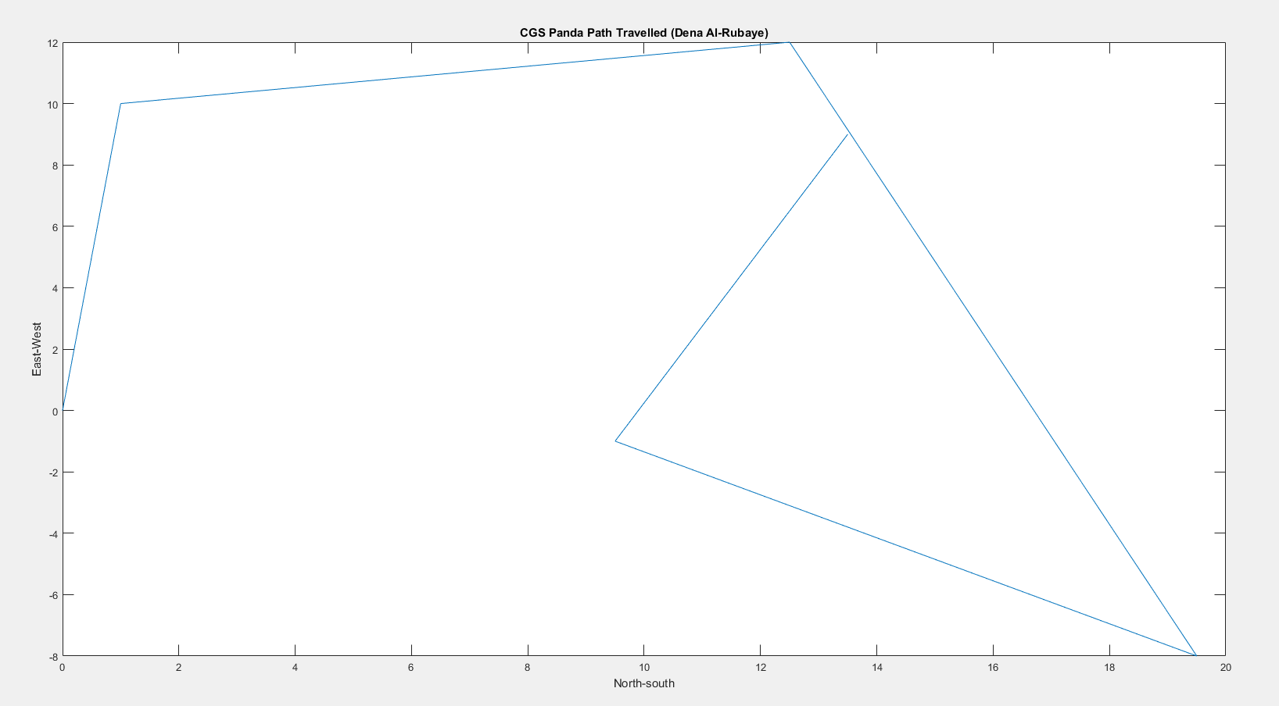
Table 3: Question 3
%Declare The Function  y= @(x) sin(x^2)+ ((x^2 + 2*x + 10) / (2*x^2 + 5))  %Graph the fonction with resrictions  fplot (y,[-2,2]) | >> Part1Number3  y =  @(x)sin(x^2)+((x^2+2*x+10)/(2*x^2+5))  >>

Figure 2: SIN GRAPH
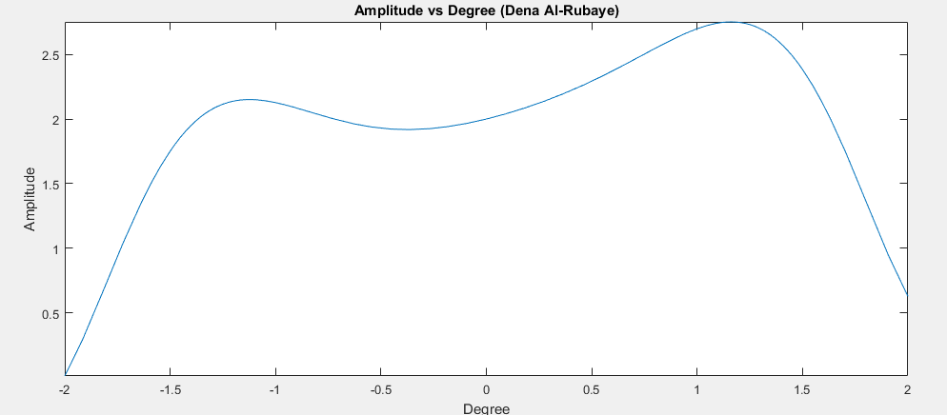

Part 2
Table 4: Question 1
%Declare Vectors  F= [3 9; 7 -2; 5 0; 6 8; 9 4; 5 2];  G= [-9 2 8 5 -1 2; 7 -1 -2 9 3 8];  Q= [4 -7 2; 1 0 8; -5 3 5];  U= [1 0; 0 1];  H= [8;5;-6];  r= -0.4;  p= 0.32;  q= 2.45;  %Answers  A= (F*G)*r  B= G'  W= F - B  C= sort(W)  X= [1 2 3 4 5 6]'  plot (X,C)  D= U*G  E= F*U  F= Q*H  %Dimension mismatch for G, can't be done  G= dot(q,G) + dot(p,F') | >> Part2Number1  A =  Columns 1 through 2  -14.40 1.20  30.80 -6.40  18.00 -4.00  -0.80 -1.60  21.20 -5.60  12.40 -3.20  Columns 3 through 4  -2.40 -38.40  -24.00 -6.80  -16.00 -10.00  -12.80 -40.80  -25.60 -32.40  -14.40 -17.20  Columns 5 through 6  -9.60 -31.20  5.20 -0.80  2.00 -4.00  -7.20 -30.40  1.20 -20.00  -0.40 -10.40  B =  -9.00 7.00  2.00 -1.00  8.00 -2.00  5.00 9.00  -1.00 3.00  2.00 8.00  W =  12.00 2.00  5.00 -1.00  -3.00 2.00  1.00 -1.00  10.00 1.00  3.00 -6.00  C =  -3.00 -6.00  1.00 -1.00  3.00 -1.00  5.00 1.00  10.00 2.00  12.00 3.00  X =  1.00  2.00  3.00  4.00  5.00  6.00  D =  Columns 1 through 2  -9.00 7.00  2.00 -1.00  Columns 3 through 4  8.00 -2.00  5.00 9.00  Columns 5 through 6  -1.00 3.00  2.00 8.00  E =  3.00 9.00  7.00 -2.00  5.00 0  6.00 8.00  9.00 4.00  5.00 2.00  F =  -1.00  -40.00  -61.00  Error using dot (line 33)  A and B must be same size.  Error in Part2Number1 (line 30)  G= dot(q,G) + dot(p,F')  >>

FIGURE 3: GRAPH FOR C
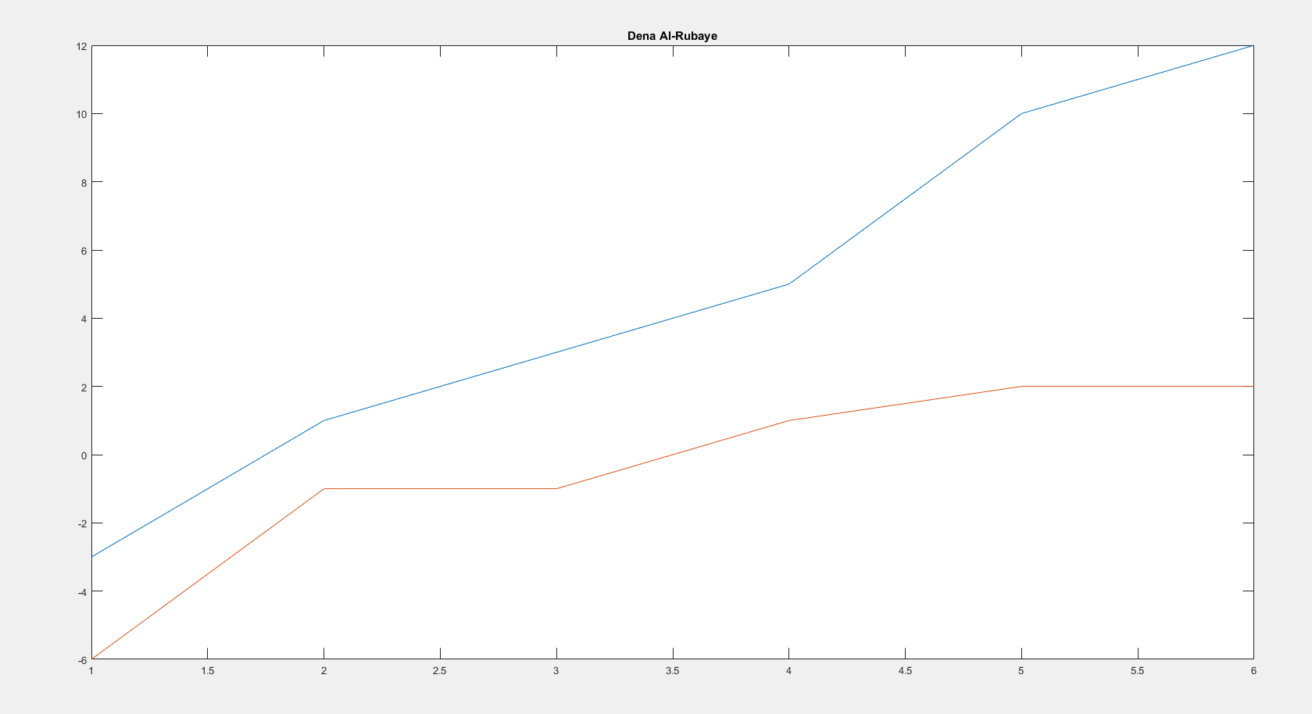

Table 5: Question 2
%Variables  A= [9 2 5; 1 4 6; 2 3 1];  B= [5;1;3];  %Find x  x= inv(A)*B | >> Part2Number2  x =  0.62  0.72  -0.41  >>

Table 6: Question 3

%Eqn  syms x1 x2 x3 x4 x5 x6  eqn1= x1 - x2 == 75;  eqn2= x2 - x3 == -60;  eqn3= x3 - x4 == 115;  eqn4= x4 - x5 == -120;  eqn5= x5 - x6 == 55;  eqn6= -x1 + x6 == -65;  %Convert to matrix  [A,C]= equationsToMatrix([eqn1, eqn2, eqn3, eqn4, eqn5, eqn6], [x1, x2, x3, x4, x5, x6])  %Find x (not a unique solution)  x= pinv(A) \ C | >> Part2Number3  A =  [ 1, -1, 0, 0, 0, 0]  [ 0, 1, -1, 0, 0, 0]  [ 0, 0, 1, -1, 0, 0]  [ 0, 0, 0, 1, -1, 0]  [ 0, 0, 0, 0, 1, -1]  [ -1, 0, 0, 0, 0, 1]  C =  75  -60  115  -120  55  -65  Warning: The system is  rank-deficient. Solution is not  unique.  > In symengine  In sym/privBinaryOp (line 908)  In \ (line 321)  In Part2Number3 (line 16)  x =  275  -35  375  -35  260  0  >>

Table 7: Question 4

%Variables  A=[27600000 30200000; 3100 6400; 240 350]  B=[162000000; 23614; 1566]  %Calc tons of A burned  X=A\B | X =  3.8985  1.8013

Table 8: Question 5
%Resistance  R1= 7;  R2= 5;  R3= 1;  R4= 7;  %Voltage  V1= 5.94;  V2= 3.94;  syms i1 i2 i3  eqn1= R2*(i1-i3) + R1*(i1-i2) == -V1;  eqn2= R3*(i2-i3) + R1*(i2-i1) == V2;  eqn3= R2*(i3-i1) + R3*(i3-i2) + R4*i3 ==0;  [A,B]= equationsToMatrix([eqn1, eqn2, eqn3], [i1, i2, i3])  %Value for i1,i2,i3  x= A \ B | >> Part2Number4  V2 =  3.94  A =  [ 12, -7, -5]  [ -7, 8, -1]  [ -5, -1, 13]  B =  -297/50  197/70  0  x =  -11679/16450  -541/3290  -2/7  >>

Figure 4: IntelliCAD drawing



