Lab 5 (ITM 315)
1. The HR026 OU was created under Dovercorp026. Then the following OUs: South026 and North026 were created under HR026. The snapshot below outlines the commands used to create them.
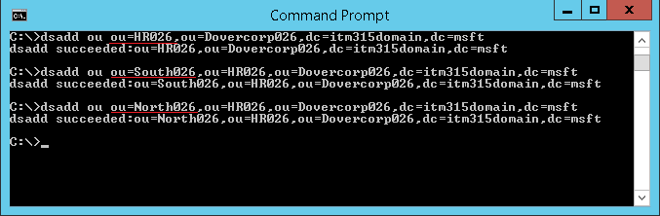
2. Using the commands below, the HRMGR026 global group was created under HR026 OU and the SOUTHMGR026 global group was created under South026 OU. 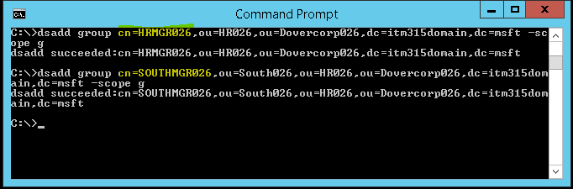
3. Two users, Mike026 and Sue026 were created under HR026 OU and were added to the HRMGR026 global group as members. This was accomplished with the commands shown in the snapshot below. 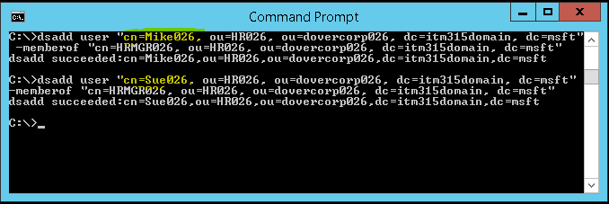
4. Two users, Paul026 and Cathy026 were created under South026 OU and were added to the SOUTHMGR026 global group as members. This was accomplished with the commands shown in the snapshot below. 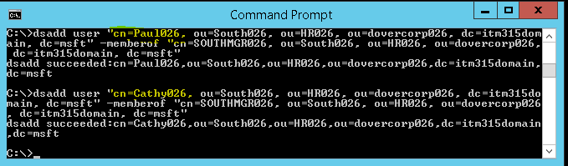
5. Three users: Norman026, James026, and Paris026 were created under North026 OU. 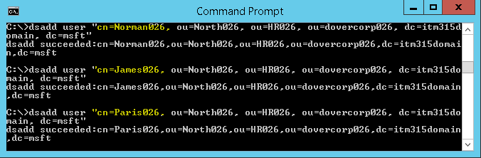
6. The snapshot below shows how certain attributes (Description, Telephone, Emails, and profiles) were added to users Mike026 and Sue026. 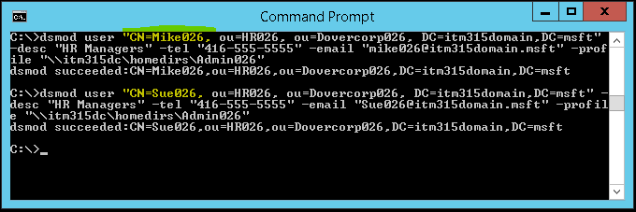
7. The command shown in the snapshot below will delete the user, James026. 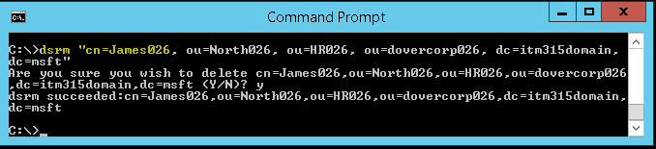
8. The following command will add a computer to the HR026 OU. 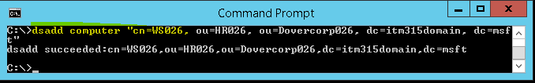
9. 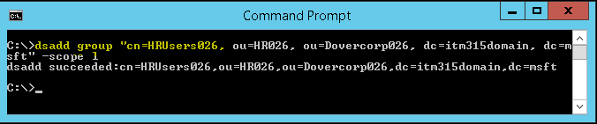
10. 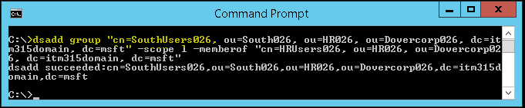
11.
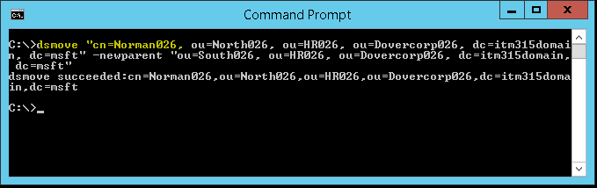
12.
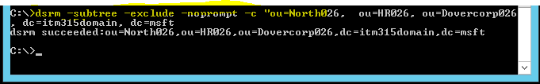

13.
First I added the User Mike026 to the Global026 group.
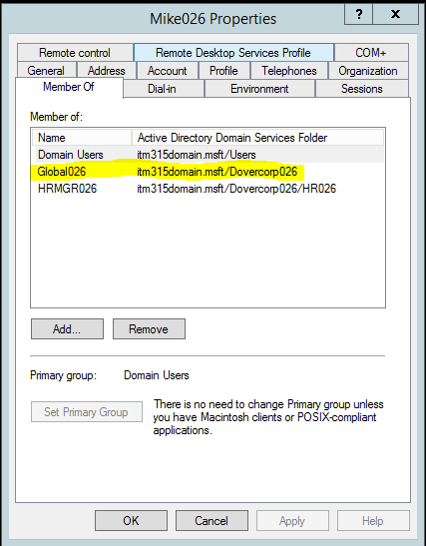

Then, I logged in through the User I has added, Mike026 and used the passwrod that I had assigned.
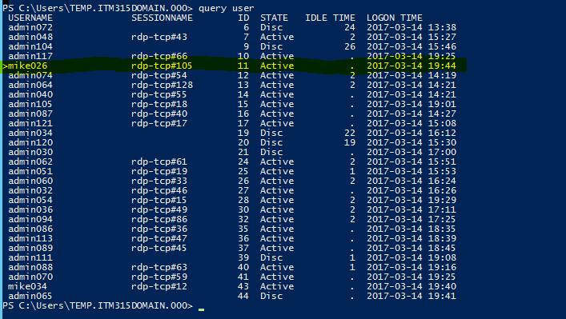
14.
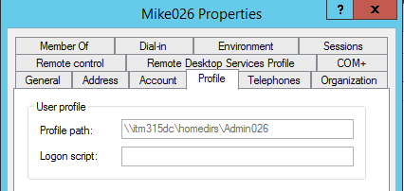
15.
SOUTHMGR026 does not have an SID, because it is a global group and it consists Paul026 which has SID.


