ECOR 1010 – Introduction to Engineering

Jinrong yan
AssignMent #4
Assignment Title: Creo Parametric (Bearing Solid Model)
TO Marking TA:
Name: David Cull
Email: davidcull3@cmail.carleton.ca

Lab Section: D2
Room: ME2556 – Carleton University

FROM:
Email: jinr
Student

Number of Figures and Tables (Including handwritten ones): 4
Last Date and Time of Revision: 17/02/2017 @ 9:05 (AM)

APPENDIces- Figures and Tables
Graph 1: Wireframe
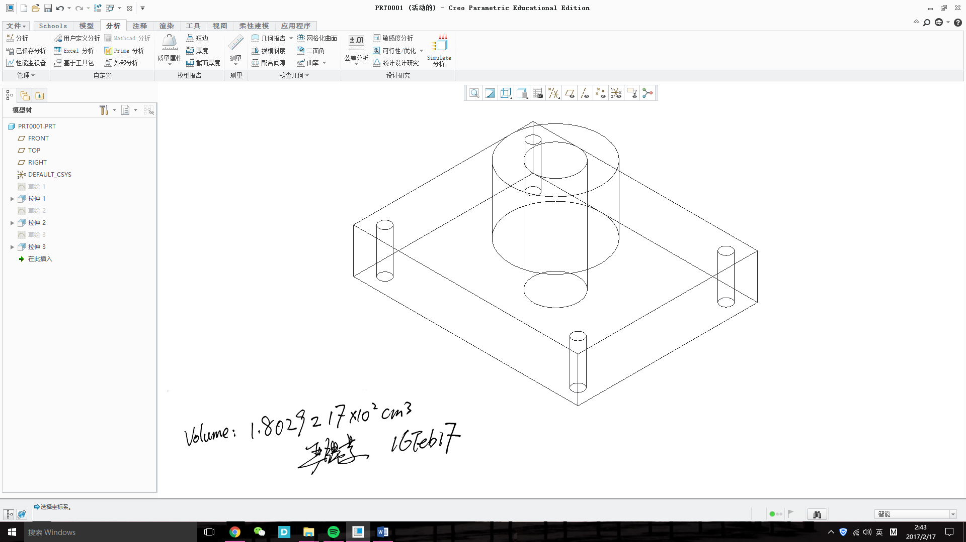

Graph 2: data

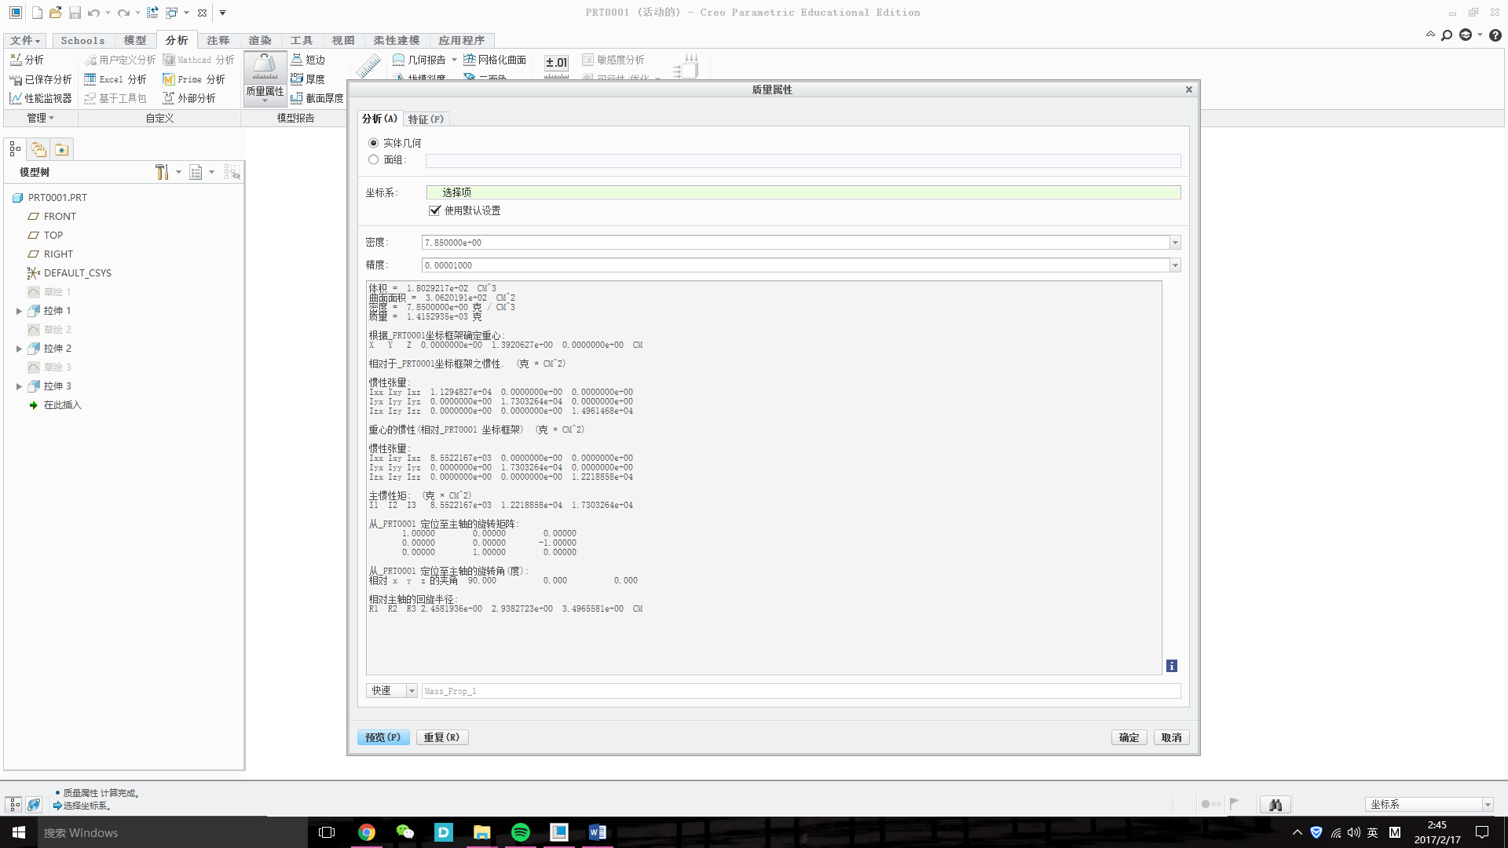

Graph 3: particle with number


