Individual Residency – is determined on a year to year basis.
- Only residents of Canada are subject to tax
  - They are also taxed on worldwide income
- Non-Residents are only taxable on income earned in Canada
- Soujner (ITA 250 (1)) – Deemed resident for the whole year
  - Individuals that do not exhibit a continuing state of relationship, but
  - Spend more than 182 days in Canada
- Part-time Resident
  - Subject to tax in Canada on WW income earned while resident
  - Once residency ceases only subject to tax on Canadian source income.

Determination of Individual Residency
  - Must maintain a “continuing state of relationship” with the country (i.e. Children, job, moved all assets over to Canada)
  - Motives for being present or absent
  - The existence of social and financial connections with Canada.

Corporations
  - If incorporated in Canada – Residents of Canada (subject to tax on world income)
  - Foreign Corporation may Canadian resident of “central management and control” over the major policy affairs of the entity’s business is exercised from within Canada.

Withholding Tax – Tax on amounts originating in Canada but paid to non-resident.

- Interest (only to non-arms length)
- Dividends
- Rents
- Royalties
- Pension Benefits

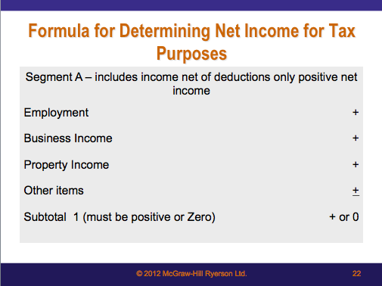

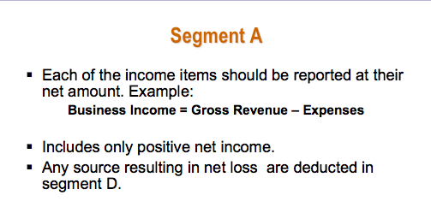

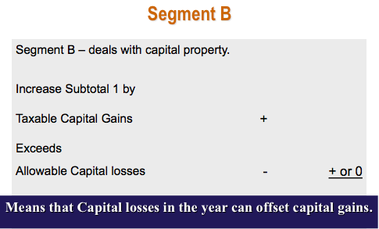

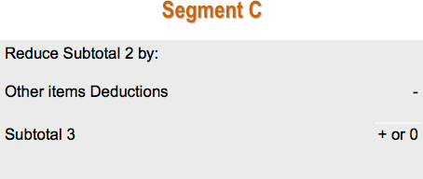

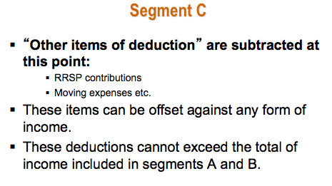

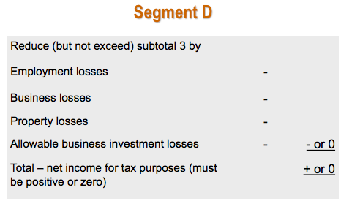

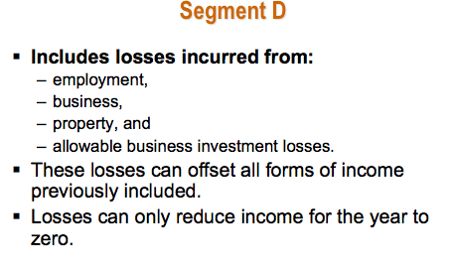

Consider Employed When:
- Agreement to provide your services – in return for a specific salary or wage
- Your at full direction and control of the employer

Employment Income = ( A + B + C) – D

A = Salary, wages, commissions, gratuities and other forms of remuneration received.

B = Sum of Benefits received or enjoyed

C = Sum of the allowance received

D = Deductions that are specifically permitted as exceptions to the general rule.

- Compensation is taxed on a cash basis, when received not necessarily when earned.
- Assume that all benefits are taxable unless specifically excluded, list:
  - Rent-free or low-rent housing
  - Gifts in cash or in kind
  - Group term life insurance policies
  - Incentive awards in recognition of job performance, prizes holiday trips
  - Interest-free or low-interest loans
  - Club dues when membership = no advantage to the employer

To be Continued……

Business Income Vs. Capital

The difference between the two is the intended use

- Capital treatment can be distinguished from business treatment by employing the following guidelines:

- Assets acquired for long-term benefits – its disposition results are of a capital nature
- Property acquired for the purpose of reselling for a profit – it is considered inventory and its disposition is of a business income nature.

Expenses are deductible only if the following conditions are met:
- Income earning purpose test:
  - Must be incurred for the purpose of gaining, producing, or maintaining income from business.
  - Expenses incurred in carrying on a business activity with an expectation to profit.
  - Primary test for the deductibility of expenses
- Capital Test
  - Cannot deduct items of capital nature – long-term or enduring benefit.
  - Main reason is to remove flexibility and estimates
    - Can deduct using uniform system – CCA
- Exempt Income Test
  - An expense is not deductible even though it was incurred to earn income if the income that is expected to be generated is itself not taxable revenue.
- Reserve Test – No reserves are deductible for tax purposes – however, exceptions are permitted.
- Personal Expense Test
  - No deductions are permitted for a taxpayers personal or living expenses except for those travel expenses incurred away from home in the course of carrying on business.
- Reasonableness test
  - An outlay or expense is deductible only if reasonable in the circumstances.
  - Even if meets the other general criteria for deductibility, still subject to the reasonability test
  - Designed to combat abuse and confine business expenses to those incurred in the income-earning process.
- Expenses that are denied as deductions even though they would otherwise qualify under the general rules – are added back in the taxable income calculation

Expenses Denied
- Use of recreational facilities and club dues
  - No deduction permitted for the use of maintenance of a yacht, a camp, lodge or golf course
  - Also denies all expenses incurred as membership fees or dues in any club.
- Political contributions
  - No political contributions are deductible – Tax credit is received
- Advertising Expenses
  - Advertising in a non-Canadian newspaper or broadcasting undertaking cannot be deducted if the advertising is directed primarily at a Canadian market.
    - Ex. Advertising placed with an American television station to appeal to the Canadian market – not deductible. If it was a Canadian station – Deductible or If it was for appealing to an American market – deductible.
- Allowance for an Automobile
  - Limits the allowable amount to the prescribed amount:
    - Maximum that can be deducted by an employer is $0.52 for first 5000 km and $0.46 for each additional km.
  - Limitation applies only if allowance is tax-free to employee
    - If allowance is taxable to employee the employer can deduct the full amount.
- Soft Costs – Certain costs during construction period
  - Legal and accounting fees, interest costs, mortgage costs, property taxes and promotional expenses – That relate to the construction project
  - Costs are instead added to the cost of the building and deducted through CCA
- Work space in home not permitted unless one of the following conditions is met:
  - The space is “the individual’s principal place of business. –or-
  - If first condition not met:
    - Used exclusively for the purpose of earning income from business, and
    - Used on regular or continuous basis for meeting clients, customers or patients of the individual
- Meals and Entertainment
  - Amount is permitted is limited to 50% of actual costs incurred.
    - One of the exceptions: 100% deduction
    - Cost of food, beverages and entertainment events general available to all employees (limited to 6 “occasional events” per year)
- Costs of an automobile
  - Costs for purposes of claiming a deduction for CCA cannot exceed $30,000 (before taxes) – if you buy
  - The interest cost on money borrowed to acquire a vehicle can not exceed$300/month – if you finance
  - The deduction for a leased automobile cannot exceed $800/month – If you lease
- Stock based compensations
  - Record as an expense for accounting purposes – but then added back for tax purposes
  - Not deductible for tax purposes
- Unpaid remuneration
  - Not deductible unless paid within 180 days after the business year end

Expenses permitted – Specific items that are permitted even though they do not qualify according to the 6 general limitations
- Capital Cost Allowance and Amortization
- Interest
  - Deducted provided that the long-term asset is used to assist in the income process
  - It can be added to the cost of the depreciable asset or deducted as incurred
- Financing Expenses
  - Deduction is permitted in equal proportions over 5 years
  - Items such as: registering a mortgage, the cost of issuing shares, appraisal fees for financing etc., selling commissions and finder’s fees.
  - Life insurance can be deducted fully for the year if it is used as collateral for a loan
- Reserves for Doubtful Debts
  - Can claim a reserve on amounts receivable if:
    - It is anticipated that they wont be collected
    - Reserve is reasonable and determined on an account to account basis
- Reserves for delayed payment revenues
  - Reserve may be deducted when
    - Inventory has been sold and all or part of payment not due until after two years
  - Long-term payment schedule can be recognized over a period of time
  - Utilized for no more than 3 years – even if payments are longer
    - By then the profits are fully recognized for tax purposes even though not received.
- Expenses deductible on a cash basis
  - Convention, landscaping, utility service connections and investment counsel fees

Treatment of Reserves
- Whenever a reserve is allowed, the deduction must be added back to income the following year.
  - A new reserve can be deducted if it can still be justified

Unpaid Remuneration
- Business income is determined on an accrual basis; salaries are deductible when incurred – even if not paid
- Unpaid remuneration can be deducted paid within 180 days of its taxation year
  - Payments beyond 180 days can only be deducted in subsequent years once paid.

- This standardized system is used to match its cost against the income it generates
- Process requires useful life, salvage value and contributions to the business in each year.
- Taxpayers who carry on a business or use assets to earn investment income can claim CCA on a number of different types of assets. Also individuals who are employed are entitled to claim CCA on their assets they are required to use in the course of their employment duties.
  - They must have legal tittle and the asset must be available for use for the purpose of earning income

Gains and losses on depreciable property – only capital gains are recognized for tax purposes – capital loss denied on depreciable property
  - Accounting depreciation is dis allowed
  - CCA system is used to expense asset’s cost
- The system divided the capital assets into two general categories
  - Depreciable property
  - Eligible capital property
- Calculation of the CCA
  - Start with opening balance (UCC)
  - Add any additional purchases
  - Deduct any disposals
  - Apply the appropriate CCA rate to the resulting balance
- CCA system uses the declining balance method – with some exceptions
  - New assets limited by half-year rule – some exceptions
  - CCA claim may be limited when a taxation year is less than 365 days
    - CCA is prorate by the number of days in the taxation year divided by 365.

Dispositions
- If asset is involuntarily disposed of – price of disposition is original cost
  - The tax payer has 24 months from after the taxation year in which the forced disposition occurred to defer recognition of the recapture
- If voluntary – price of disposition is price it was sold for
  - In order to defer the recapture the asset must be acquired within 12 months from after the taxation year in which the voluntary disposition occurred in.

Pooling of Assets of the Same Class
- Assets of the same class are placed in a common pool
  - Provided they are all used in the same business
- Pooling results in the assets losing its individual identity
  - Purchases will add to it
  - Sales will remove from it
- CCA on the UCC at the beginning of the year is treated differently from CCA on net additions(disposals)
- The one-half rule applies only on net additions
  - If disposals exceed purchases, no half-year rule
- When assets are sold the CCA pool is reduced by the lower of:
  - Original cost or proceeds of disposition

Gains and losses on Disposal
- Gains and losses remain in the pool, and are averaged over the life of the pool except when: Sale price>Original Cost
- A loss remains in the pool to be deducted in the future
- 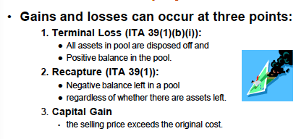

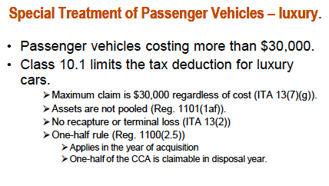

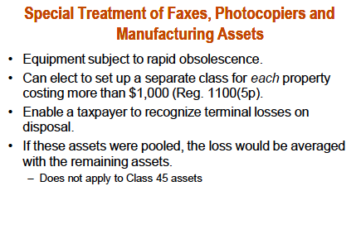

Leasehold Improvements – Class 13
- Tenant is responsible for the cost of making the rented space suitable to their needs
- Expenditures are:
  - Tangible improvements to the rental property and,
  - At the end of the lease, cannot be removed
- Costs qualify as depreciable property
- Allocated using the straight-line method over the life of the lease plus one renewable option period
- Minimum 5 year lease terms; maximum is 40 years
- Additional improvements are allocated over the remaining term of the lease and one renewal period – Half-year rule applies
- Inducement payments
  - Maybe recognized as either business income or reduction of the cost of leasehold improvements

Franchises, Concession and Licenses
- In order to qualify under class 14 – it must have a limited legal life
- CCA is determined separately for each item
- The annual CCA:
  - Straight-line basis based on number of days owned in the year divided by the total number of days in the life of the asset
- The half-year rule is not applied to class 14 assets – ownership is pro-rated for the year

Change in Use

From person use to business use:
- Deemed disposition
  - FMV<Original Cost – FMV is the proceeds of disposition and new cost base for CCA
  - FMV > Original Cost the - FMV + Taxable capital gain is new cost base for CCA

From Business use to personal use
- Causes a disposition at FMV
- If Acquired by related party – adjust capital for CCA purposes
  - Reduce by ½ capital gain

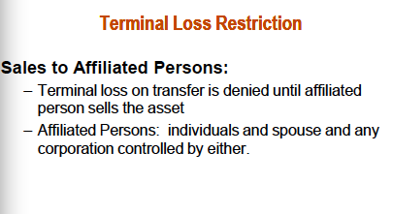

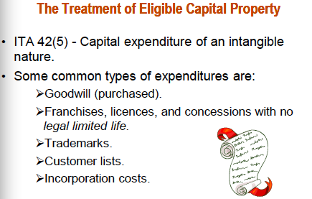

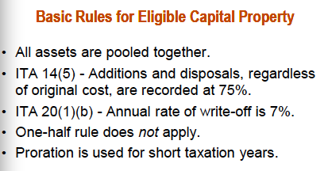

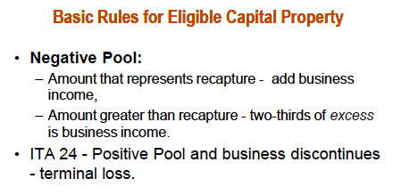

I. Income from Property Defined
- Income tax act does not provide a specific definition of property income.
- Common-law court decisions have defined it as the return on invested capital where little or no time, labor, or attention has been expended by the investor in producing the return.
- Property income is the annual or regular return received for allowing another party to use one’s property.

Income from property includes:
- Dividend income
- Interest income
- Rental income
- Royalty income (such as patents or mineral rights)

II. General Rules for Determining Property Income
- The general rules for establishing a taxpayer’s property income are the same as those used for determining income from business.
- The ITA simply states that a taxpayer’s income from property for the year is “the income therefrom”.

In general, expenses can be deducted from property income for tax purposes provided:
- They are incurred for the purpose of earning income that is taxable,
- They are not an expenditure of a capital nature, an expenditure on account of capital, or depreciation/amortization,
- They are not a reserve,
- They are not a personal or living expense, AND
- They are reasonable under the circumstances.

Property income and the taxation year
- The taxation year for an individual is the calendar year, for a corporation it is their fiscal year.
- Property income must be determined the same for each type of taxpayer

The deduction of interest expense
- Interest on loans used to purchase investments such as bonds, bank certificates, shares of corporations, and real estate, is deductible against the interest, dividends, and rental income earned.
- Proof through documentation should be kept to prove the loan was specifically used to purchase the income earning properties.
- A separate, investment bank account is often useful.

Loan financing in order to maximize after-tax cash flow:
- Personal assets should be acquired with excess cash. These assets can then be used as collateral to obtain loans for investment purposes.
- When individuals have both personal and investment loans, excess cash should first be used to repay the personal loans that are incurring non-deductible interest. It is important that separate loans be arranged for personal use and for investment use.

III. The Unique Features of Property Income

A. Interest Income
- The compensation received for the use of borrowed funds.

Recognition of revenue
- The timing of income recognition for tax purposes is important because it affects the net after-tax cash flow and, by extension, the yield of a particular investment.
- Corporations must pay tax on an accrual basis, meaning they need to record interest revenue whether cash has been received or not.

Individuals, unlike corporations, have three methods for recognizing interest income:
- The receivable method (recognized when legally due and receivable)
- The cash method (recognized when cash is received)
- The anniversary day accrual method (an overriding rule)
- Once a method is chosen, it must be consistently used for THAT investment.
- The anniversary day accrual method is an overriding rule that requires that interest income be recognized for every 12-month period from that date the investment was made.

Foreign interest
- Interest earned on investments in a foreign country.
- Recognized in terms of Canadian dollars under the same rules as interest income.

Life insurance policies
- Whole life insurance includes a savings and a life insurance component.
- Term life insurance solely provides life insurance protection.

Deductions from interest income
- Interest income from property is calculated on a net basis.
- Typical expenses permitted
- Interest expense on loans used to acquire interest-bearing investments
- Investment counseling fees
- Costs incurred to obtain a loan, such as legal fees, mortgage appraisal fees, registration fees
  - Amortized over 5 years at 1/5 per year
- Fees paid to managers of investment portfolios
- Safe-custody costs, such as safety deposit box fees
- Accounting fees for record-keeping and determination of property income
- Reserves or complete deductions for interest income that has been accrued but is not collectible because of a debtor’s inability to pay
- If expenses exceed interest income, a loss from property occurs that can be offset against the taxpayer’s other sources of income, in accordance with the general aggregating formula (Ch. 3) and the “reasonable expectation of profit” (Ch. 5)

B. Dividend Income

- Returns on the investment in shares of a corporation.
- Corporations can own shares.
- Dividend income can be received by both individuals and corporations
- Corporate earnings are taxed in the hands of the shareholder, either as dividends (property income) or capital gains.
- Page 221, Exhibit 7-1 and the following text is important
- The methods by which dividends are included in income for individuals and corporations are designed to deal with the problem of multiple taxation, though in some situations, multiple taxation exists.

Dividends received by corporations
- Dividends paid by one corporation to another are included in the recipient’s ‘net income for tax purposes’ when received.
- The ‘taxable income’ of a corporation is determined by reducing ‘net income for tax purposes’ by certain, specific items, one of which is dividends received from other taxable Canadian corporations.
- The result is that dividends received by one Canadian corporation from another Canadian corporation are excluded from taxable income and are therefore not subject to normal tax.
- Dividends received from a foreign corporation are excluded from taxable income ONLY IF the foreign corporation qualifies as a foreign affiliate.
  - Qualifies if the Canadian corporation’s equity share in the foreign corporation is at least 10%

Dividends received by individuals
- Dividends received by individuals are grossed-up as part of an overall scheme to reduce the amount of double taxation when after-tax corporate profits are distributed and taxed a second time in the hands of individual shareholders.
- All dividends from Canadian public corporation are grossed-up to 138%
- Dividends from CCPCs are grossed-up to either 125% or 138%
- Eligible dividends are grossed-up to 138%
- Non-eligible dividends are grossed up to 125%
  - Depends on source of CCPC’s income. 125% if investment income or business income that is entitled to a special low tax rate.

- Dividends received by individuals are grossed up to include 125% or 138% of the dividend when included in income. The gross-up supposedly reflects the corporate taxes already paid by the corporation on its income. In theory, the grossed-up dividend represents the pre-tax income earned by the corporation.
- The individual shareholders determine their tax on the same corporate earnings reflected in the grossed-up dividend by applying the individual tax rate to income. At this point, the corporate profits have been taxed twice.
- The individual tax on the grossed-up dividend is then reduced by the amount of corporate tax that has already been paid on the same income. This is referred to as a ‘dividend tax credit’. The dividend tax credit is more or less equal (depending on the provincial tax rate) to the gross-up because the gross-up, at least in theory, reflects corporate taxes that have already been paid.

- Individuals receiving foreign dividends are not subject to the dividend tax credit and the gross-up.
- Instead, the actual amount of dividends (before withholding taxes) is included in income in the year received.

Stock dividends
- Stock dividends are additional shares in lieu of a cash dividends.
- If the shareholder is an individual, the amount is subject to the normal treatment, which includes a gross-up and a dividend tax credit

C. Rental Income

- Rental income is the compensation received for allowing another party to use one’s tangible property.
- Most commonly derived from ownership in real estate (land and buildings).
- This chapter emphasizes the return of rental income from real estate.

Recognition of income
- Rental revenue most conforms to the normal rules of profit determination.
- Included in income for tax purposes on the accrual basis when earned.

Deductions from rental income

Deductible expenses typically incurred to earn rental revenue:
- Interest expenses incurred on loans used to acquire the rental property or to fund repairs and improvements
- Costs incurred to obtain loan financing (mortgage, legal, appraisal fees)
  - Amortized over 5 years at 1/5 per year
- Insurance expense
- Property taxes
- Non-capital repairs
- Maintenance costs
- Utility costs
- Landscaping costs, even though such costs may be of a capital nature
- CCA on building and other related tangible assets (equipment, furniture)
- Salaries/wages to those who supervise and/or maintain the property
- Property management fees paid to independent management organization
- Accounting costs for record-keeping and income determination
- Costs incurred to collect rents
- Advertising

Two types of leases
- Gross lease/rental agreement – Requires the tenant to pay only a specific rent. The landlord is responsible for all expenses.
- Complete net lease – Requires the tenant to pay a base rent as well as all of the costs associated with the running of the property with the exception of financing costs.

- Most lease agreements fall somewhere in between these two extremes.
- When total expenses exceed rental revenue, a loss from property occurs.
- The loss can be offset against all other sources of income, such as employment income, business income, and capital gains.
- Subject to the restriction discussed below

Special rules for CCA
- Capital cost allowance on rental properties can be deducted only to the extent that it does not create or increase a net loss from ALL rental properties combined.
- Each rental building having a cost of $50,000 or more must be held in a separate CCA class. This is contrary to the normal requirement that assets of a similar class be pooled.
- From a tax point of view, it can be advantageous to acquire several partial ownerships (tenancies in common) rather than a lesser number of wholly owned buildings costing over $50,000.
- Sales and acquisitions can be pooled to avoid recapture of CCA
- The rules that limit CCA and create separate classes do not apply to corporations “whose principal business is leasing, rental, development, or sale of real property owned by it”.
- When other types of property are leased, the amount of CCA is limited to net rental income except for corporations whose principal business is the leasing or sale of such property.

IV. Impact on Investment Decisions

A. Cash Flow and Return on Investment

Interest-bearing securities
- The return is fully taxed when earned or, for individuals, at least 12 months from the date the investment is made.

Investments in corporate shares
- Combined annual yield in form of dividend payments and growth in share value.
- The dividend is taxed when received. However, for individuals, the dividend tax credit reduced the effective rate of tax.
- The shares are taxed when sold, and usually considered a capital gain, and so only half is taxable.

Real estate investments
- Yield both rental income, which is fully taxable annually when earned, and capital growth, which is taxed as a capital gain only when the property is sold.
- A distinguishing feature is that the cost of the building can be deducted as CCA against rental income over future years.
- This deduction is valuable because it is permitted, even though most rental buildings do not decline in value but rather appreciate in value.
- When the property is sold, the prior CCA may be recaptured and taxed at that time. The result is that rental income is not fully taxed until the property is sold.
- This delay enhances after-tax yields.
- Capital gains are also not taxed until realized

B. Business Organization Structure
- The special rules and definitions relating to property income can have an impact on corporate structure.
- It is not uncommon for a business to separate ownership of appreciating assets, such as real estate, from other business assets.
- The purpose could be to shield the appreciating assets from risk of business failure.
- Management could want to share profits with employees, but not fortuitous gains.

Corporate financing
- Managers need to be aware that investors are aware of different tax treatments. They should structure their debt issuance to provide favorable options for the tax treatment of investments in their company.
- This will attract more investment.

Splitting Property Income Among Family Members – Attribution Rules
- Each family member may be subject to different tax rates due to income level.
- Regarding property income, it may be desirable to have some/all the family’s investments held in the name of a lower tax rate member.

Capital gains/loses are realized on the disposal of capital property. Which is property that provides a long-term and enduring benefit to its owners. It is enough that the intended purpose of the acquisition was to achieve benefits over a long period of time.
  - Capital gains/loses are only realized after the property has been sold.

A - Capital Vs. Busines Income
  - Property acquired for the purpose of resale at a profit is classified as inventory. Its disposition results in as business income/loss
  - Property acquired for the purpose of providing the owner with a long-term or enduring benefit is classified as capital property. Its disposition will result in a capital gain/loss
  - This could mean property used to generate business income is a capital property. But property purchased to appreciate in value and to be resold for a profit would be seen as inventory.

B - Intention
- Factors that are taken into account when determining the intended purpose of the property
  - Period of Ownership – How long the property was held for. It is assumed that the longer it is held on to the more likely its purpose was long-term. But since there’re many circumstances where this factor may be breached, this by it self is not substantial enough evidence of intention.
  - Nature of the Transaction – The course of conduct over the ownership of the property is examined as well. What the property was used for during ownership and what was done to it that would provide evidence of it’s intended purpose.
  - Number and Frequency of Transactions – If there is a pattern of constant buying and selling it supports the premise that the intended purpose is for business income. – But the reverse of this does not conclude that the isolated transaction is that of a capital nature.
  - Relation of Transaction to Taxpayer’s Business – The property that is sold is similar in nature to property normally deal with as part of the owner’s occupation – It is difficult to assess the type of transaction it is.
- These factors are only guidelines – Each factor by itself is not significant evidence they must be considered all together. Every factor must be judged on it’s own merits.
- 1st – Sometimes the intended purpose of ownership changes so that the property is held for a period of time for two different purposes. 2nd – Marketable securities are acquired for two purposes – to provide annual benefits and be sold for a profit. – special tax treatment

I - Change in Purpose
- Property which was acquired to generate business income has ceased and now is being held for property development and resale. Or inventory purchased for resale may be converted to capital property. Capital gain or not?
  - The capital gain is set at the difference between the market value at the time of change and the original cost. Any further gain would be business income.

II - Canadian Securities
- Canadian securities almost always have a dual purpose.
- Share of a resident Canadian corporation, Obligations issued by a resident of Canada such as,
- a unit of a mutual fund,
- bond,
- debenture,
- mortgage, or
- other similar obligations
  - The income act permits taxpayers (other than security dealers) to elect all sales of Canadian securities to be treated as capital transactions.
  - This locks the investor into using this method which will limit their use of capital losses when they occur. Many investors opt-out that option which gives them the option of treating substantial losses as business losses. Which can be offset against all other sources of income.

C - Categories of Capital Property

Personal-use Property – Property owned by the taxpayer that is used primarily for the personal use or enjoyment of the taxpayer or person related to them and it does not generate financial returns. Subject to capital gains treatment.

Listed Personal Property – Items that are for personal use but also have some element of investment value. Limited to several specific items:
- Print, etching, drawing, painting, or sculpture of other similar works of art.
- Jewelry
- Rare folios, manuscripts and/or books
- Stamps
- Coins
- Any personal property not listed above is categorized as personal-use property.

Financial Property – Capital property acquired for primarily to generate a benefit through a financial reward. Includes items such as shares, bonds, loans, land, buildings, equipment, patents, licenses, franchises and vehicles. - Property that qualifies as eligible capital property is excluded.

Determining Capital Gains and Losses – General Rules

A – General Calculation

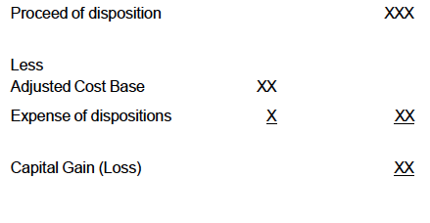

only one-half of Capital gains/losses is included in net income for tax purposes. Losses and gains deducted from each other.

B – Disposition and Proceeds of Disposition
- Gains and losses are not recognized for tax purposes until disposition.

Disposition Occurs when:
- Property is sold
- It is involuntarily eliminated by theft, destruction or expropriation.
- A share, bond, debenture, note or similar property is cancelled, redeemed or settled.
- A share owned by a taxpayer is converted by amalgamation or merger.

Proceeds of Disposition

Property Sold = Selling Price

Property Exchanged for other property = FMV of the property received

Involuntary disposition = compensation received

Deemed Disposition
- Transferred by way of gift to another party = Property was sold at its FMV.
- Use of property changes = Sold at its FMV
- Taxpayer ceases to be a resident = Property sold at FMV

* Certain properties such as real estate situated in Canada and inventory, eligible capital property, and capital property from a business in Canada are exempted. However if adequate security is posted the tax payment can be delayed until the property is sold.

- Death – It is deemed the property has been sold immediately prior to the death.

C – Adjusted Cost Base (ACB)

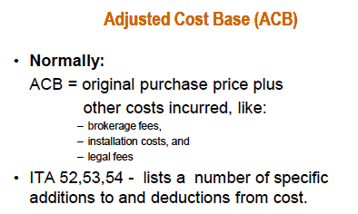
- When the accumulated cost base reductions are greater than the cost of the asset - the negative balance is considered a capital gain.
- Any government grants or subsidy to acquire an asset – the purchase price is reduced by the amount of the grant to arrive at the adjusted cost base for tax purposes.
- Persons who receive gifts of property - the person who made the gift is deemed to have sold the property at FMV and consequently the recipient of the gift is deemed to have an ACB of the same amount.
- Taxpayer immigrating to Canada is deemed to have acquired all assets immediately before immigrating. Therefore the acquisition amount is at the asset’s FMV.

D – Expenses of Disposition
- All costs incurred to complete the disposition are deductible when arriving at the capital gain or loss.

E – Deferred Proceeds

Sales of property are sometimes chosen to be financed over time.
- Capital gain rules allow for deferral of recognition based on receipt of proceeds:
- Deferred recognition is restricted to a maximum of 5 years. It is extended to 10 yrs if the sale is made to a child of the taxpayer and the property sold is shares of a small business corp. farm property, or an interest in a family farm partnership.
- Minimum of 20% of the capital gain must be recognized for each of the five years.
- Maximum reserve in any year is equal to the lesser of:
- [ Deferred proceeds / Total proceeds ] x Taxable gain; or
- 80% of the gain in year 1, 60% in year 2, 40% in year 3; 20% in year 4; and 0 in year 5.
- The reserve is deducted from the taxable capital gain in the year to arrive at the taxable amount.
- The reserve is a discretionary deduction.

Unique Aspects of Capital Losses
- Only recognized when a disposition occurs
- Can only be deducted against capital gains were realized in the same year.
- If it cannot be used in the current year:
  - Carry-forward indefinitely and used against future capital gains, or
  - Carried back to the previous three years.

A – Allowable Business Investment Losses (ABIL)
- Allowable capital loss incurred on disposition of a loan to a small business corp. or on a sale of that corporations shares. (Only one half of the loss is realized.)
- A small business corporation (SBC) is defined in ITA 248(1) as a Canadian-controlled private corporation (CCPC) with all or substantially all (90% or more) of the fair market value of its assets attributable to one of the following:
  - Used principally in an active business carried on primarily in Canada by the particular
  - corporation or by a corporation related to it,
  - Shares or debt of one or more connected SBCs (greater than 10% ownership), or
  - A combination of the two.

B – Deemed Disposition on Loans and Shares
- An exception to the deemed disposition rules that permit the loss to be recognized before an actual disposition occurs.
- Loan to SBC
  - the loan can be deemed to be disposed of for a value of nil and, thus, trigger a capital loss before the debt is actually disposed of.
- Share of SBC
  - deemed disposition cannot be triggered until the corporation has become legally bankrupt or equivalent.

C – Depreciable Property
- NO CAPITAL LOSS ON DEPRECIABLE PROPERTY
- Original cost is written off through CCA
- Any loss arising reflected in the annual CCA calculation or the terminal loss or recapture, if any.

D – Superficial Losses
- NO INTENTION OF DISPOSING OF THE ASSET
  - Disposed of and then reacquired within 30 days
- Classified as a superficial loss, and deemed nil
- The actual loss is not permanently denied
  - Added to the ACB of the reacquired asset.
- This rule also applies when the asset is sold to a related corp. or transferred by an individual to his/her RRSP.

E – Personal – Use Property
- Losses are deemed to be nil
  - Even though gains are taxable
- This restriction is applied to each item of personal property. Capital losses of one item can not be offset against a capital gain of another asset.
- These assets have a deemed minimum proceeds: (De Minimis Rule)
  - Minimum POD = $1000
  - Minimum ACB = $1000

F – Listed Personal Property (LPP)
- Losses are recognized, but only deductible against gains on LPP
- Unused losses (which are only deducted against LPP gains)
  - Carried back 3 years or,
  - Carried forward 7 years
- Also the De Minimis Rule applies as well

Unique Aspects of specific Capital Properties

A – Identical Properties
- The ACB of each identical property acquired is the W.A. cost of all the identical properties acquired up to the point of sale.

C – Options and Warrants

Purchaser:
- Grant option – no tax consequences at the time of payment.
- Option Exercised – The cost of the option is added to the ACB of the property acquired .
- Option Expires – No property was purchased, the full cost of the option is considered a capital loss in the year of expiry.

Vendor:
- Grant Option – The proceeds received for the grant option is considered a capital gain in the year it was received.
- Option Exercised – The original option price is included as part of the POD in that year, and the original option amount reported as a capital gain at the grant option is reversed through the filing of an amended tax return. (to avoid double taxation).
- Option Expires – no tax consequences.

F – Principal Residence
- Owned and ordinarily inhabited for personal use. (PUP)
- May be subject to capital gain on sale, losses are not recognized. However
- Can be reduced if deemed principal residence
- The decision to designate a particular property is made at the time of sale.
- One principal residence per family unit (husband + wife)

Reduction Formula

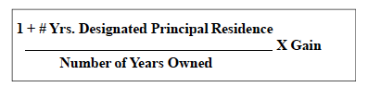
- The “+1” is included to cover the year in which two houses are owned as a result of the normal process of selling one house and acquiring a new one.

Other Sources of Income:
- Scholarships, fellowships or bursaries:
  - Not taxable if student can claim the education tax credit. Otherwise,
  - Only $500 of those funds annually are exempt from being taxed.
- Research Grants – Total grant less expenses is taxable. Anything in excess after expenses is taxed.
- Support payments from a former spouse: taxable providing received as periodic payments and are pursuant to a court order or written agreement. NOTE: Support payments are only taxed for the former spouse, but the payments for the support of the child are not taxed.

Not taxed under the Canadian tax system:
- Lottery winnings
- Receipt of a gift or inheritance
- Life insurance proceeds on the death of an individual
- Profits from betting or gambling – when conducted for enjoyment or pleasure
- Proceeds from accident, disability, sickness or income maintenance insurance policies – if the employee has paid all of the premiums.

Other Deductions – usually only applies to individuals
- RRSP contributions
- Support payments to a former spouse are deductible as long as it is a court order and is paid periodically. Support payments for a child are not deductible.
- Fees/expenses paid to conduct an objection or appeal in relation to a tax assessment under the income tax act
- Moving Expenses to relocate to commence a business or employment in another part of Canada or to attend post-secondary to the extent of income earned in the new location.
  - Deductible expenses include travel costs(meals, lodging, and auto expenses, transportation and storage of belongings, temporary lodging near the old or new resident (up to 15 days), costs of cancelling a lease of the old residence, selling costs of the old residence, legal fees and land transfer taxes for the new residence.
  - Costs of maintaining a vacant former residence for up to a maximum of $5000. – includes mortgage interest, property taxes, insurance, heat and power (eligible moving expenses will also include fees to transfer legal documents to reflect your new address)
- Child Care Expenses include: babysitting, daycare, and boarding school. For children 16 years of age or less.
  - If it is incurred so the taxpayer could pursue employment, business or research activities.
  - It is limited to $4000 per child 7 – 16 & $7000 per child under 7 (age limit does not apply if the child is dependent because of mental or physical disability) $10,000 if the child has a serious disability and is approved for the tax credit. OR-THE LESSER OF
  - 2/3 of the taxpayer’s earned TOTAL income for the year - Lower income spouse makes the claim.

Registered Retirement Savings Plans (RRSP)
- Private, tax-sheltered retirement program
- Investments in an RRSP are not taxed until withdrawn, therefore
  - They generate higher return because they permit investment of pre-tax earnings.

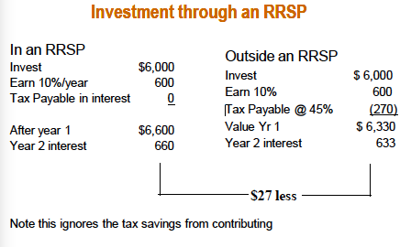

Contribution Limits

For individuals not belonging to an RPP or DPSP:
- Annual limit is equal to:
  - 18% of the individual’s prior year’s “earned income”
  - Up to a maximum of $22,450 (2011)

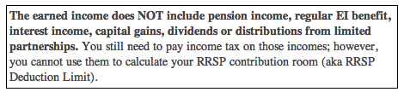

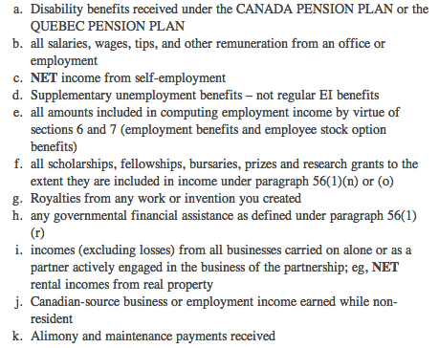
- Individuals belonging to an RPP or DPSP, the RRSP contribution limit is integrated with those plans. Ie. (if the contribution limit is $9,000 for the year and the employer contributes $3,000 that year. The contribution limit is now reduced to $6000 to reflect the contribution of the employer.)
- Unused portions can be carried forward indefinitely:
  - If the individuals prior years earned income is > $22,450
    - If there is no carry forward contribution room, amount total will total $22,450 which is the contribution cap.
    - If there was a carry forward amount, this is the only way to contribute over the contribution cap for the year.
    - Withdrawals do not reset the contribution room.
- Contributions exceed the annual limit are subject to a penalty tax of 1% per month on the excess – permitted up to $2,000.
- Over-contribution can be carried forward and deducted in a future year.

Retirement Options
- Funds accumulated in an RRSP can be paid out in a lump sum or gradually over a period of time in the form of a pension.
- To receive regular payments from an RRSP, the plan must be converted into a pension vehicle.
  - Life annuity – risk vehicle
    - After 65 – can transfer up to ½ of RRSP to a spouse for income splitting.
    - If the annuitant dies before their normal life expectancy the payments cease and the remaining funds go to the financial institution.
    - Highest pension income
  - Guaranteed fixed-term annuity – full funds are paid out to the owner or any designated beneficiaries.
  - Registered retirement income fund (RRIF) – minimum amount of withdrawal required.
    - The annuitant can withdraw any additional funds when needed – also ½ of RRIF income can be transferred to a spouse to reap the benefits.
- It is mandatory to convert RRSP funds to a retirement income vehicle in the year they reach the age 71 (the December 31 of the year they have turned 71).
- Retirement income can begin the following calendar year
- Failure to convert by the age of 71 will result in the full amount of the RRSP to be taxable

Spousal RRSP
- An individual can contribute all or any part of their contribution limit to the RRSP of a spouse – it will not affect their contribution limit.
- The contributor is entitled to the tax deduction
- This will allow for income splitting:
  - Which will allow income to be taxed in the spouse’s hand rather than that of the contributor. Which will result in lower annual taxes.
- Limitation – Withdrawal from the spousal plan with 2 taxation years of the contribution year are included in the contributor’s income. Which means 2 years after the last contribution from the contributor.

Registered Education Savings Plan
- Primary purpose is to provide funding for post secondary education.
- Contribution to an RESP can not extend past the child turning 31 years old.
- There is a lifetime cap of $50,000
- Earn income on tax deferred basis.
  - Income is taxed when funds are withdrawn from the plan.
- Contributions are not tax deductible – unlike RRSP contributions
- Canada Education Saving Grant (CESG) is for children ages 17 or under.
  - Lifetime grant per child is $7,200 but is limited to an annual amount of 20% of the contribution (maximum for contribution is $2,500). The maximum per year is $500 from the CESG.
    - it may be increased $1,000 if maximum grant was not reached in prior yrs.
  - The child must pursue post-secondary education or else the CESG must be returned
- Education assistance payments (EAPs) – is support for the cost of studies for students at a post-secondary institution
- During the first 13 weeks of consecutive studies:
  - Full-time students – Max withdrawal of $5,000 per year
  - Part-time student - Max withdrawal of 2,500 per year.
    - After that 13 week intermission – no limit to the amount of EAPs
- Receipts from contribution made by contributor (principal amount) – Paid Tax Free
- Receipts from Earnings and Grant (CESG) – Taxable when received
  - Earnings – face two levels of tax
    - Income Taxed at usual levels & An additional tax of 20%
      - This is done to remove the deferral benefits

- To avoid both levels of tax – The contributor may rollover excess funds from the RESP to their RRSP’s. But they must have contribution room to do so.

Benefits – RESP
- Investment returns accumulate in plan on a tax deferred basis – similar to RRSP
- It also allows for maximum growth – due to compounding of interest
- Income Splitting Benefits – investment returns are taxed in the child’s hands (which is usually in a lower tax bracket)
- CESG – Federal grant of up to a maximum of $7,200

Tax-Free Savings Account (TFSA)
- Investment returns are not taxed when earned or withdrawn. Also must be 18 yrs old to contribute
- Contributions are limited to $5,000 per year – inflation will increase the limit but only when it needs to be increased by $500 (that’s also the maximum increment per year)
  - Any unused portion of the annual limit is carried forward, indefinitely
  - Combined contribution for spouses plan is $10,000
  - Contributions are not tax deductible
- Withdrawal are added to accumulated contribution limit – which means withdrawals can be replaced later, and not affect the contribution limit.
- No attribution on contribution to spouse’s TFSA

Non Arm’s Length Transactions
- Individuals are related if they are direct-line descendants (grandparents, parents, children, grandchildren, and so on) or brothers, sisters spouses or in-laws. Excluded are cousins, aunts, uncles, nieces and nephews.
- Individual is related to a corporation if:
  - They control it, a member of a related group, or is related to an individual who controls the corp.
- Between corporations:
  - Same individual is the majority shareholder of two corp., one corp. owns another and two individuals are related and own separate corp.

Property transferred to a Spouse or Child
- If property is transferred to a child (under 18 yrs old) – it is deemed for tax purposes to have been sold at FMV
- Property transferred to a spouse – is deemed for tax purpose to have been sold at its ACB. (no taxable income is created on the transfer of property between spouses)

The Attribution Rules - Income splitting
- Income received by the spouse on transferred property must be included in the net income for tax purposes of the original owner for as long as the couple remains married. – this prevents taxpayers from transferring income to a spouse in a lower tax bracket.
  - The attribution rules does not apply if the property is transferred to the spouse in a arm length transaction manner (loan to a spouse must have real interest rate and the property must be paid in commercial terms)
- Income received from property transferred to a child is attributed to the parent until the child’s 18th birthday. (not restricted to children may apply to other minors)
  - Dividends received by minor children from a private corporation or foreign corporation - these specific dividends are taxed at the top marginal rate (less any dividend tax credit) aka kiddy tax.
    - Capital gains from the sale of private corp. shares – the kiddy tax does not apply. BUT if it is derived from a sale to a non-arm’s length party the gain will be treated as a dividend and subject to the kiddy tax.
  - Dividend income from shares of a public corp. is subject to the attribution rules.

Determination of Taxable Income
- Net income for tax purposes must be converted to taxable income.
  - Taxable income = Net Income – Special Reductions
  - Special reductions are grouped together in Division C of the Act. (Stock options, losses not utilized in other years & lifetime capital gain deduction)

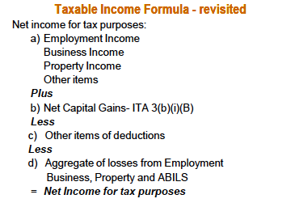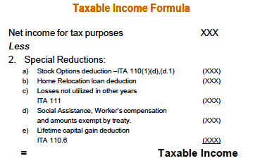

Loss Carry- Overs

Losses from other years and losses incurred in the current year are deducted first (as part of the net income calculation)

Net Capital Losses – Allowable capital losses incurred in current year bust cannot be utilized
  - - Carried back 3 years and forward indefinitely
  - only deductible against capital gains
- Exception upon the death
  - Any unused losses may be deducted against any type of income earned in the year of death or in the preceding year

Non-Capital Losses

Unused business, property and employment losses and ABILs
  - Can be carried back for 3 years
  - Forward for 20 years – used against any source of income
- ABIL – Special treatment
  - Only carried forward for 10 years
    - If unused after 10 years:
      - Reclassified as a net capital loss and can be carried forward indefinitely (to be used against future capital gains)

Loss Utilization – Impact on Decision Making

Organizational structure chosen has an influence on loss utilization.
  - Corporate structure – risk of loss expiration is increased as losses are locked in the corporation
  - Proprietorship or partnership – losses can be used against all other sources the individual may have

The Capital Gain Deduction

The final step is to apply the capital gain deduction.
- Lifetime Capital Gain Deduction is available only for:
  - Qualified small business corp. shares
  - Qualified farm property
- The limit of deductions in a life time is one-half of $750,000 ($375,000)
  - Deductible from taxable income
- The deduction is discretionary

Qualified farm property includes:
- Real property
- Eligible capital property used in farming business
- Share of a family farm corp.
- Interest in a farm partnership

Calculation of Tax for Individuals

Income tax is imposed by the federal and provincial governments :
- Provincial rates are different in every province, federal rates tend to be more stable – non-residents pay a 48% tax rate
- Federal & Provincial Tax - % of taxable income

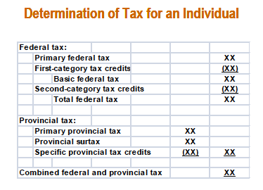

Primary Federal Tax
- Progressively higher tax rates to higher levels of annual income.
- Each rate of tax is applied separately to the portion of the individual’s income that falls within the applicable range.

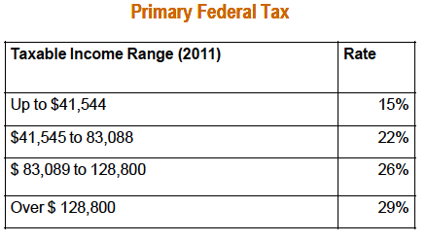

Personal Federal Tax Credits

It is a specific reduction of the tax otherwise payable and has a value equal to its stated amount.
- Tax deduction on the other hand – reduces taxable income ; the related amount of tax saving is based on the marginal tax bracket of the individual for that particular year. ( tax deduction of $150, would reduce federal taxes by $44 for taxpayers in the 29% bracket)

* For summaries of the first & second category of Federal Tax credits – PPT

Provincial Taxes
- The primary tax is determined by applying specified tax rates to the federal taxable income.
- Rates vary from province to province
- They must specify their own tax credits
- Individuals are subject to tax based on the province they live in on Dec. 31 of the taxation year.

Incorporated company Artificial person
  - Separate from owner

Recognized by law as an entity:
  - Has the power to act in its own right
  - To enter into enforceable legal agreements

Corporation:
  - Can buy, own, sell and lease property and
  - Can borrow funds for its own use as well as loan funds to others

Primary Relationship

Shareholder contributes cash or other property in exchange for shares

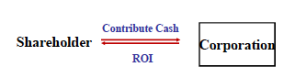

their return on investments through dividends or through a capital gain when they sell their shares at a profit

Secondary Relationships
- Creditor
- Supplier
- Employee
- Customer or lessor
- Tax consequences and cash flows between the parties are different from those in the primary relationship

Difference between the two relationship centers on the tax treatment of income flows:
- Primary relationship:
  - Dividends paid by the corporation are not deductible, but are taxable to the recipient
- Secondary relationships
  - Payments such as salaries, interest and rents are deductible and taxable to the recipient

Determination of Taxable Income

Net Income for tax purposes – Special deductions
- Donations to charitable organizations
- Net capital losses
- Non-capital losses
- dividends from taxable Canadian corporations
- Dividends from foreign affiliates

Loss Carry-overs – same as with individuals

Net-capital losses:
- can be carried back 3 yrs and forward indefinitely
- used only against taxable capital gains

Non-capital losses:
- Can be carried back 3 yrs and forward 20 yrs
- Used against any other source of income
- However, losses incurred in taxation years ending from March 23, 2004 to December 31, 2005 expire after 10 years
  - those incurred in taxation years ending before March 23, 2004 expire after 7 years

Change in Control
- ownership can change when shares are transferred or sold
- the carry-forward of unabsorbed losses may be attractive to acquiring shareholders
  - if they can use those losses
- Change in beneficial ownerships:
  - Restricts the use of the non-capital losses and
  - Eliminates the net-capital losses

Non-capital losses resulting from business operations are restricted as follows:
  - Must carry on business in which losses occurred
  - Reasonable expectation of profit
  - Losses can only be deducted against business income earned by same or similar business

Must recognize unrealized losses
  - Purpose is to prevent the transfer of unrealized corporate losses to other parties

Deemed year-end – at the date of change in control
  - Purpose is to recognize unrealized losses
  - Adds any operating losses making them subject to the restrictions
  - Depreciable property, eligible capital property and other capital property are deemed to be sold at FMV if : FMV < TAX COST

Acquisition of Control – summary
  - Year-end – deemed to occur immediately prior to the date of acquisition of control – they must also file a tax return for that period. – if less than 365 days related short taxation rules will apply
  - Inventory – valued at the lower of cost or market – any loss is recognized for tax purposes
  - A/R – Reserve for bad debt – not permitted. Instead each account is examined and written if uncollectible. Any subsequent payments of written off accounts are added to income -
  - Depreciable Property – if FMV> tax cost the UCC remains. But if its less than the UCC there is a CCA reduction to the amount it matches the FMV.
  - Cumulative eligible property – deduct the UCC until it is ¾ of the FMV
  - Non-depreciable capital property – Deducted to the extent that the FMV of each non-depreciable capital property is less than the adjusted cost base of that property, the difference is deemed to be a capital loss for the period and a reduction to the ACB – the loss can be carried back or offset any capital gains in the period, but can not be carried forward.
  - LOSS CARRY OVERS – UPON ACQUISITION OF CONTROL - NET CAPITAL LOSSS AND ABIL EXPIRE AND CAN’T BE USED AFTER THE DEEMED YEAR-END (ALSO ANY UNUSED DONATIONS)

Dividends from Other Canadian Corporations
- Dividends received included as property income for net income for tax purpose (no mark up)
- Dividends are deducted from taxable income if:
  - Received from a taxable Canadian corporations or,
  - Foreign affiliates corps. – they must have at least a 10% equity interest
- Result is dividends flow-tax-free
- private corporations may be subject to a temporary – Part IV tax
- removes the second level of tax until dividends are received by individuals

Calculation of Corporate Tax

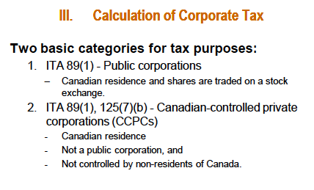

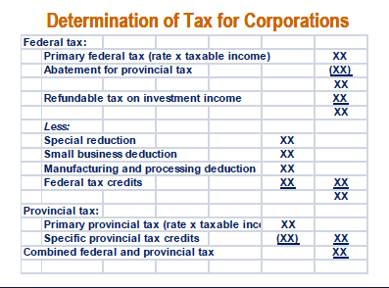

Federal Tax
- Federal tax rate – 38% - then reduced by the provincial abatement of 10%
- Federal tax may be increase or reduced further based on specific types of income earned by certain corporations
- Taxable income earned in Canada is calculated in a prescribed manner as follows :
  - ½ (% of Revenue allocated to Canada + % of Salaries allocated to Canada) x taxable income – only for the abatement
  - for the federal and general reduction for CPC – it is on total taxable income

Refundable tax on investment income

- special tax is applied to the investment income from CCPC – rate of 6 2/3%

Special Reduction
- General rate reduction – applies to particular types of income:
  - Public Corporations
    - Federal tax is reduced by 13% of the corporations taxable income not subject to manufacturing and processing activities
  - CCPC
    - Federal tax is reduced by 13% on active business income:
      - Above the annual small business limit
      - Not eligible for the M&P reduction or investment income
- Refundable tax on investment income – applies only to the investment income of CCPC
  - Addition tax is 6 2/3% of investment income
  - Fully refundable to the corporation when dividends are paid
- Small Business Deduction – Available only CCPCs
  - Deduction permits the normal federal tax rate to be reduced by 17% for the first $500,000 of annual active business income of the corporation
    - Deduction = (38%-10%-17%) = 11%
- Manufacturing and Processing Deduction
  - Profits from manufacturing and processing activities
    - Public corporations – rate reduction of 13%
    - CCPCs – same rate reduction
      - Only on annual manufacturing profits in excess of the SBD limit

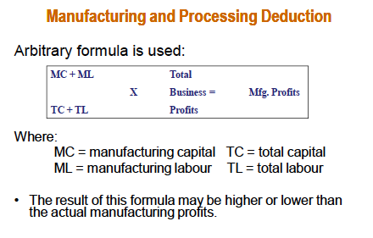
- if the corporation activities are divided into corporations only the profits from the manufacturing subsidiary are used in the arbitrary formula
  - but if the activities are put into one corp. the total business profits are used into the formula

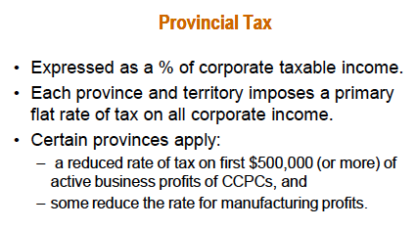

The Integration of Corporate and Individual Taxation
- Corporations are taxed on their profits separate from their shareholders
- After-tax corporate profits are distributed in the form of a dividend
  - Tax is again payable on the dividends received
- Two-teir system creates the possibility of double taxation
- Special provisions are designed to reduce the possibility of double taxation
  - Attempts to ensure equal tax treatment that regardless of the structure used to run the business
- Dividend tax credit attempts to integrate the personal and corporate tax

Corporate Capitalization – Debt or Equity
  - Must have a capital base for the purposes of acquiring assets and conducting business
    - This capital base can be contributed in the form of debt (shareholder loan) or equity (additional share capital)

Shareholder’s perspective
  - Debt and equity are capital property for tax purposes
    - They yield a ROI in the form of interest or dividends
  - Debt and equity are subject to capital gains treatment
  - Capitalizing of a corporation by shares and debt:
    - Mainly in closely held private corporations
      - Which the affairs of the corp. and shareholders are closely linked

Corporate Capitalization by Shareholder Debt

Return on Investment
    - Shareholder loans may bear some rate of interest or be interest-free
    - Interest paid by the corporation is deductible for tax purposes

Return of Capital
    - Capital contributed in form of debt can be returned with relative ease and without tax consequences

Loss of Investment
    - A loss incurred on shareholder debt is a capital loss
      - Only ½ is deductible for tax purposes
    - Loan to a small business corporation
      - The capital loss becomes a business investment loss
      - ½ of the loss can be offset against all other sources
    - a loss on a loan is recognized for tax purposes in the year in which it is established to be uncollectible

Corporate Capitalization by Share Capital

Return on investment
    - return in the form of dividends
    - Dividends are:
      - not deductible by corporation
      - taxable to individual shareholder

Loss of investment
    - A loss on a share capital is normally a capital loss
      - ½ is recognized for tax purposes
    - share capital loss is recognized only in the year in which
      - the shares are disposed of
      - corporation becomes legally bankrupt
      - corporation is insolvent and has ceased operations

Return of capital
    - Sale of shares to other shareholders:

Gain = Sale Price > Purchase Price

Loss = Sale Price < Purchase price

2. Sale of share back to the corporation:
    - Referred to as “share redemption” or “buy-back”
    - Involves:
      - Distribution of corporate assets, and
      - A cancellation of all or some of their shares

Tax consequences when a redemption occurs are as follows:
    - Redemption price>Paid up capital PUC – Deemed Dividend
    - For Capital Gains (loss) purposes:
      - Shares deemed to be sold at = PUC of shares
    - When redeeming corporate shares, the company:
      - Cannot simply repay the original share capital but
      - Also distribute the attached retained earnings as a dividend
    - PUC can be returned without redeeming shares. The tax treatment varies
      - Public Corporation
        - Return of capital considered a taxable dividend for the entire payment

Transferring Assets to a Corporation
- Transfer of assets constitutes a sale and disposition
- Fair Value > purchase price = tax implications
- Existing or proposed shareholder can transfer asset at:
  - FMV or at an elected value
    - Normally equal to the asset’s cost for tax purposes
- Gains are recognized
- Resulting income depends on nature of the asset:
  - Capital Gain
  - Recapture of CCA or
  - Normal business income
- Corporation:
  - Assets acquired at FMV increase the tax cost that may – reduce taxes payable by the corporation

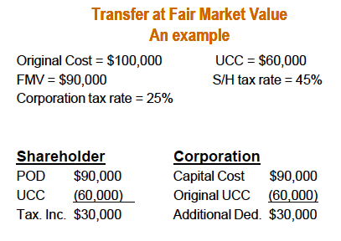

Election to Transfer Assets at Tax Values
- The Act permits assets to be transferred to a corporation at their tax cost
- Permitted even though the transfer price for legal purposes may be at FMV
  - This will result in the shareholder having no taxable income from the transfer and that the corporation would incur any taxable income in the event that it ultimately sold the equipment to a third party
  - Called a “roll over”
    - Shareholders personal taxable income is rolled over to the corporation but not eliminated
- Election Limitations
  - Corporation can pay in the form of share or non-share consideration
  - Tax-free transfer:
    - Consideration must include some shares
    - Non-share consideration (cash, note receivable, debt):
      - Cannot be over the elected value
  - Tax Implications
    - Shareholder – it defers the tax at the time of the transfer
      - There will be future tax implications
- Assets eligible for transfer at tax cost are:
  - Capital Property – Depreciable and non-deprciable
  - Inventory
  - Eligible capital property – goodwill, patents, franchises and licenses with undefined legal life
  - Resource property

Exceptions: property that is not of capital use and real estate owned by non-resident (unless used for business)
- Use of the election
  - Proprietorship to Corporation – where the proprietor becomes the shareholder.
  - Transfer assets from parent to new or existing subsidiary.
  - Transfer assets from one sister corporation to another within the corporate group
  - A corporation of an individual can sell assets to an unrelated 3rd party and defer tax by use the election
    - BUT, seller must become shareholder of purchasing corporation

Corporate Distributions to Shareholders
- Corporate distributions consist of either accumulated profits or the return of capital.

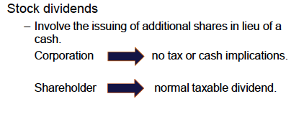

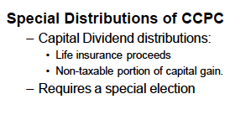

Definition

Private Corporation that is not controlled by:
  - Public Corporation
  - Non-resident of Canada

Rate of Taxes
- There are different rates of tax for different levels of income
- First $500,000 of annual active business income is subject to a reduced rate of tax
  - Lower than Public Corp,
  - Substantially lower than majority of personal tax rates
- not subject to double taxation, unless business income is over $500,000

Taxation of Income Earned by a CCPC
- Net income for tax purposes must be allocated into 5 areas before taxes can be computed:
  - Active business income
  - Specified investment business income
  - Capital gains
  - Personal services business income
  - Dividends

Active Business Income – business income from any business carried on by the corporation other than:
  - A specified investment business and
  - Personal services business
- Includes property income closely related or incidental to business activities:
  - i.e. interest income earned on overdue A/R
- Tax treatment
  - First $500,000 x 15% combined fed. & prov.
    - Due to the small business deduction
  - The $500,000 SBD limit is an annual amount;
    - If unused, cannot be carried over to other years

Specified Investment Business Income – a business with a primary purpose to earn Property income includes:
  - Interest
  - Rents
  - Royalties
  - Dividends from non-affiliated foreign corp.
- Dividends from other Canadian corporations and foreign affiliates are excluded
  - These dividends are not taxable
- Exceptions made on specified investment business income:
  - Rental income that is derived from the leasing of movable property – active business income
  - Other property income that the corp. is only considered to be active business income is if it - has employed more than 5 full-time employees to generate that income – active business
- Tax Treatment
  - Disqualified as Active Business Income – it is not entitle to the small business deduction or the General Rate Deduction
  - A special refundable tax of 6 2/3% - so total tax rate is 44 2/3%
    - The special refundable tax is fully refundable to the corporation upon payment of dividends
    - All property income subject to a high tax rate is entitle to a tax refund of 26 2/3%

Capital Gains
- Taxable capital gains are treated the same as specified investment business income
  - Capital Dividend – distribute the tax-free portion of the gain to the shareholders – an election is required
- Personal Business Income

Is a business that provides services:
  - Person providing the services is a specified shareholder of the corporation and
  - The relationship between the person providing the services and the entity receiving the services is of an employment nature
- It is not eligible for the SBD on that income
- Faces significant restrictions on deductions
- No employment relationships = business income is ABI

