ITM 820
Lecture 1
CIA: Is a model designed to guide policies for information security within an organization
- Confidentiality: protecting personal privacy and proprietary information
- Integrity: Guarding against improper information modification or destruction, including ensuring information nonrepudiation and authenticity
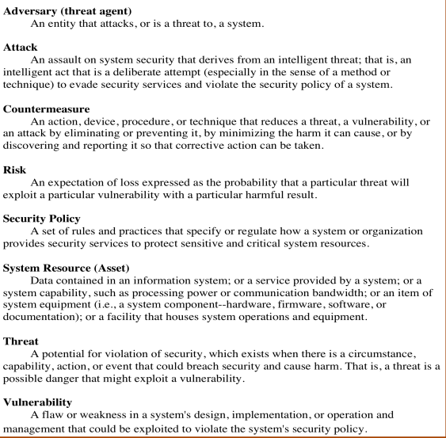
- Availability: Ensuring timely and reliable access to and use of information

Asset of a computer system: Hardware, software, data, communication facilities and network
Vulnerabilities: corrupted; loss of integrity, leaky; loss of confidentiality, slow; loss of availability
Threats: Capable of exploiting vulnerabilities, potential security harm to an asset
Attack: passive; use the system that doesn’t affect system resource, active; affect operation

Information security policy
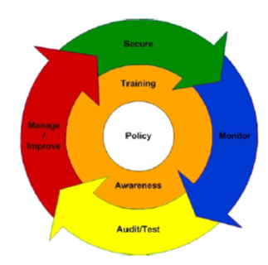
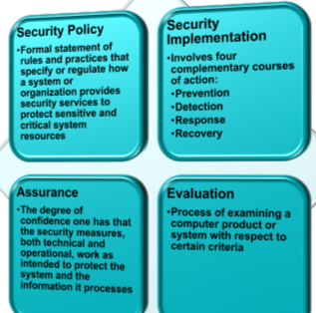

Lecture 2
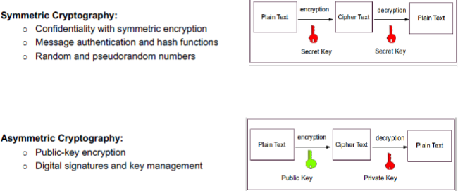

Symmetric Encryption: provide confidentiality for transmitted or stored data
- Conventional or single-key encryption
  - Requirement: strong encryption, sender & receiver both need copies of secret key

Cryptography
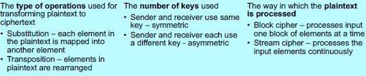
Block ciphers: Symmetric block cipher algorithms are designed based on the Feistel Cipher structure. The block cipher looks more like very large substitution algorithm using the idea of a product cipher. (RC4, RSA, AES, AEB), more secure in most of time
DES (Data encryption standard): widely used scheme “FIPS PUB 46”, also called DE algorithm
3DES (Triple DES): repeat DES 3x, 1st standardized for use in financial applications in ANSI standard
AES (Advanced Encryption standard): block cipher providing a symmetric-key algorithm
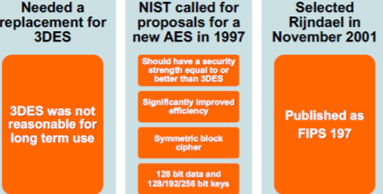
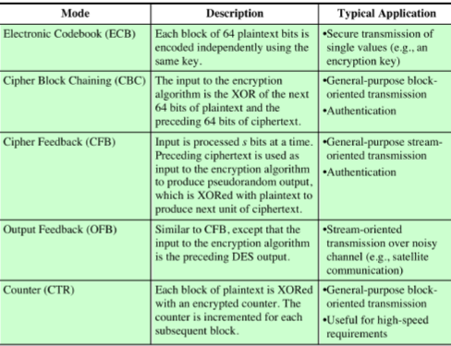
Block Cipher modes of operation

ECB is simplest mode, plaintext is handled b bits at a time and each block is encrypted using same key
- Not secure for long msg
Advanced Encryption Standard AES is a block cipher providing a symmetric-key algorithm
Elliptic Curve Cryptography ECC is a field of cryptography (utilizing the algebraic structure of elliptic curves over finite fields) providing an asymmetric-key algorithm.
  - Indeed, both can be used, strong configuration for a cryptographic protocol such as TLS (Transport layer security) can be use ECC for key-exchange, and AES for the cipher, and SHA-2 for message authentication.
Stream Ciphers: Generating statistically random larger linear complexity numbers directly dependent on a large key. The stream cipher is usually considered to be much simpler and faster when compared to the block cipher. (DES, RC5), pseudo-randomness, faster and simple.
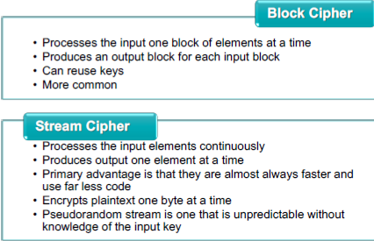
Attacking symmetric encryption
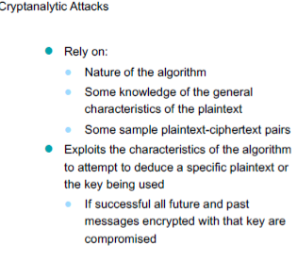
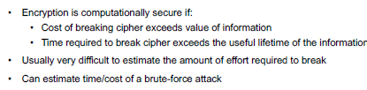
Computationally secure encryption schemes

Key management: delivering a key to 2 parties that wish to exchange data without allowing other to see the key (A <- B -> C -> A)
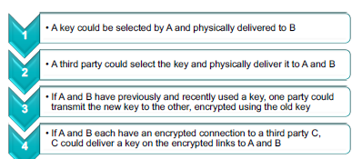
Message Authentication
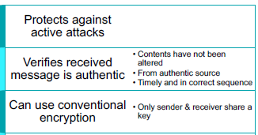
Hash function requirements: MD5, Iran, Stuxnet, Cyber marforce
- Can be applied to block of data of any size
- Produces a fixed-length output
- H(x) is relatively easy to compute for any given x
- One-way or pre-image resistant (computationally infeasible to find x such that H(x) = h)
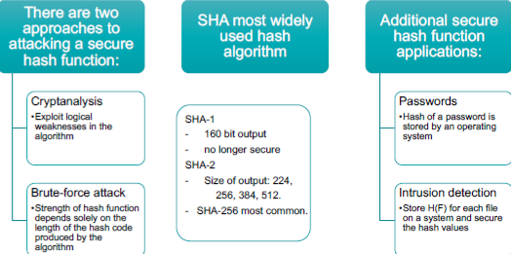
- Collision resistant or strong collision resistance

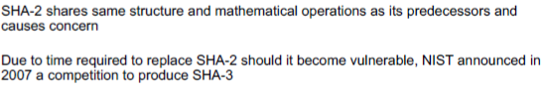
(Lecture 3) Asymmetric cryptography
Requirement for public-key:
- Computationally easy to create key pairs
- Computationally easy for sender knowing public key to encrypt messages
- Computationally easy for receiver knowing private key to decrypt ciphertext
- Computationally infeasible for opponent to determine private key from public key
- Computationally infeasible for opponent to otherwise recover original message
- Useful if either key can be used for each role
Asymmetric algorithms
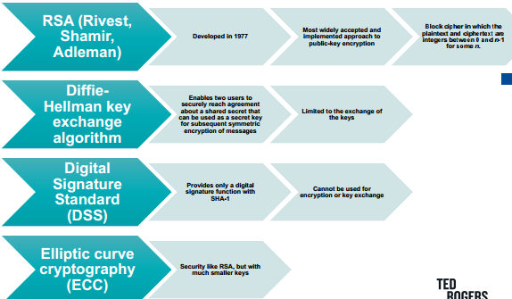
Public-key encryption elements: plaintext, encryption, public and private key, cipher text, decryption key
Security of RSA
- Brute force: Involves trying all possible private keys
- Mathematical attacks: There are several approaches, all equivalent in effort to factoring the product of two primes
- Timing attacks: These depend on the running time of the decryption algorithm
- Chosen ciphertext attacks: This type of attack exploits properties of the RSA algorithm
Diffie-Helman (DH): generating a secret key between two parties in such a way that delivery information can’t be observing by the hacker or attackers. In this mechanism, user not sharing information during the key exchange, but creating keys together. (Pros: provide Perfect forward secrecy, cheap, produce or generating new DH key fast; Cons: Less secure and easy to crack because DH is pack with one-roundtrip key exchange)
A man in the middle (MITM): attack is a general term for when a hacker positions himself in a conversation between A1 and A2, either to eavesdrop or to impersonate one of the parties, making it appear as if a normal exchange of information is underway. For instance, user visit a website by using public Wi-Fi, man in the middle can create an interception between the connection and draw any active activity that user has been done, within the period connect with public Wi-Fi. Or in other explanation, A1 and A2 think they are sharing same secret key, but instead A1 share key1 and A2 share key2, which is created by hacker.
ECC (Elliptic curve cryptograph): Equal security for smaller bit size than RSA
- IEEE P1363 as standard
- Confidence level in ECC is not yet as high as that in RSA
Digital Signatures: use for authenticating both source and data integrity
- Created by encrypting hash code with private key
- Not provide confidentiality
- Msg is safe from alteration but not eavesdropping
SHA-2 56 is most secure system for e-signature
Random numbers:
- Keys for public-key algorithms
- Stream key for symmetric stream cipher
- Symmetric key for use as a temporary session key or in creating a digital envelope
- Handshaking to prevent replay attacks
- Session key
  - Requirements:
    - Uniform distribution: Frequency of occurrence of each of the numbers should be approximately the same
    - Independence: No one value in the sequence can be inferred from the others
    - Unpredictability: Each number is statistically independent of other numbers in the sequence. Opponent should not be able to predict future elements of the sequence based on earlier elements
Random vs Pseudorandom: 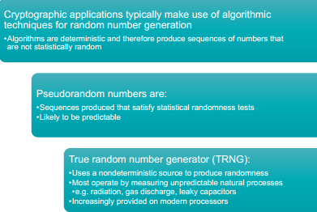
True randomness uses an unpredictable source to produce randomness. For instance, measuring random natural processes, as rolling dice, ionizing radiation events, and leaky capacitors.
Pseudo-randomness creating a sequence of random numbers that close enough to achieve randomness. In other words, it’s not truly random because it’s completely determined by a relatively small set of initial values.
Their application as RSA can generate keys for public-key encryption and stream key for symmetric stream cipher or creating a digital envelope. Encoding information by true randomness and pseudo-randomness in large exponent numbers. Therefore, enhance IT security level by prevent attacker or hacker’s decryption the information within short-time.
(Lecture 4) User Authentication & Access Control
“Authentication”, RFC 4949 defines user authentication as: “The process of verifying an identity
claimed by or for a system entity.”
- process:
  - Identification step: Presenting an identifier to the security system
  - Verification step: Presenting or generating authentication information that corroborates the binding between the entity and the identifier
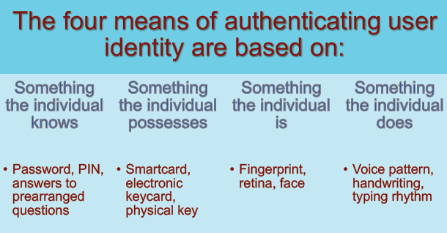

Risk Assessment for user authentication
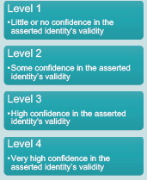
- Assurance Level: an organization’s degree of certainty that a user has presented a credential that refers to his or her identity.
- Potential impact: FIPS 199 defines three levels of potential impact on
organizations or individuals should there be a breach of security:
  - Low: A limited adverse effect on operations
  - Moderate: Serious adverse effect
  - High: Severe or catastrophic adverse effect
- The user ID is used in discretionary access control, determine privileges
- Area of risk

PSW cracking Modern approaches
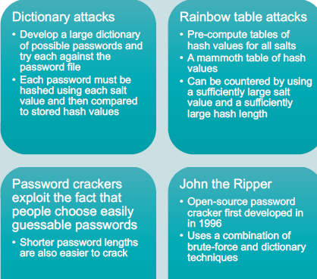
Complex psw policy: forcing user to pick
stronger psw (8 at least)
PSW cracking tech improve: speed increase
-use of sophisticated algorithm
PSW selection strategies
User education: Users can be told the importance of
using hard to guess passwords and can be provided
with guidelines for selecting strong passwords

Computer generated passwords: Users have trouble remembering them
Reactive password checking: System periodically runs its own password cracker to find guessable passwords
Complex password policy: User can select their own
password, however the system checks to see if the password is allowable, and if not, rejects it
- Goal is to eliminate guessable passwords while allowing the user to select a password that is memorable
Proactive psw checking
Password cracker: Compile a large dictionary of passwords not to use
Rule enforcement: Specific rules that passwords must adhere to
Bloom filter: Used to build a table based on dictionary using hashes
• Check desired password against this table
Token: Objects that a user possesses for user authentication are called tokens.
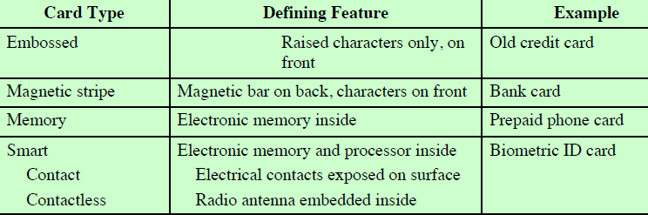

Smart cards 3 type of memory: Read-only memory (ROM), Electrically erasable programmable ROM (EEPROM), Random access memory (RAM): Holds temporary data generated when applications are executed
Authentication security issues
Eavesdropping: Adversary attempts to learn the password by some sort of attack that involves the physical proximity of user and adversary.
Host Attacks: Directed at the user file at the host where passwords, token passcodes,
or biometric templates are stored.
Replay: repeats a previously captured user response
Client Attacks: achieve user authentication without access to the remote host or the intervening
communications path.
Trojan Horse: An application or physical device masquerades as an authentic application or device for capturing a user psw
Denial-of-Service (DOS): disable a user authentication service by flooding the service with numerous authentication attempts

Access control principles: RFC 4949 defines computer security as: “Measures that implement and assure security services in a computer system, particularly those that assure access control service.”

Access Control Policies 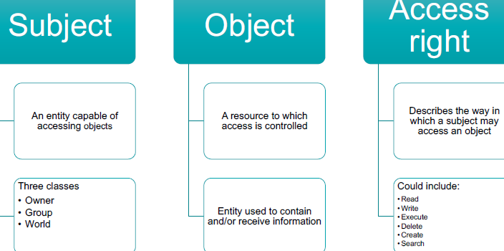
Discretionary access control (DAC): Controls access based on the identity of the requestor and on access rules (authorizations) stating what requestors are (or are not) allowed to do
- Often provided using an access matrix
  - One dimension consists of identified subjects that may attempt data access to the resources
  - The other dimension lists the objects that may be accessed
- Each entry in the matrix indicates the access rights of a subject for a object

Role-based access control (RBAC): Controls access based on the roles that users have within the system and on rules stating what accesses can users in given roles 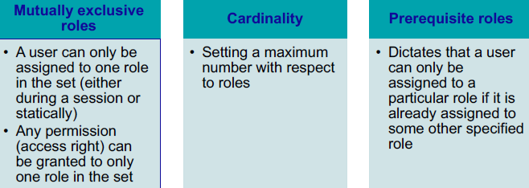

Mandatory access control (MAC): Controls access based on comparing security labels with security clearances
Attribute-based access control (ABAC): Controls access based on attributes of the user, the resource to be accessed, and current environmental conditions
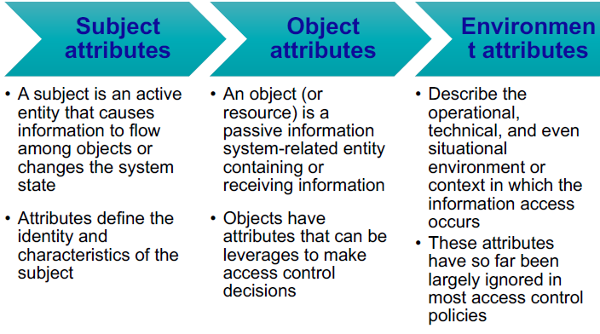
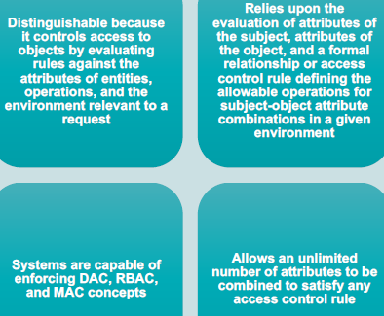

Identity management
- Concerned with assigning attributes to a digital identity and connecting that digital identity to an individual or NPE
- Goal is to establish a trustworthy digital identity that is independent of a specific application or context
- Most common approach to access control for applications and programs is to create a digital representation of an identity for the specific use of the application or program
- Maintenance and protection of the identity itself is treated as secondary to the mission associated with the application
- Final element is lifecycle management which includes:
  - Mechanisms, policies, and procedures for protecting personal identity information
  - Controlling access to identity data
  - Techniques for sharing authoritative identity data with applications that need it
  - Revocation of an enterprise identity

Credential Management
The management of the life cycle of the credential: smart cards, private/public cryptographic keys, and digital certificates.
Encompasses five logical components:
- An authorized individual sponsors an individual or entity for a credential to establish the need for the credential
- The sponsored individual enrolls for the credential
  - Process typically consists of identity proofing and the capture of biographic and biometric data
  - This step may also involve incorporating authoritative attribute data, maintained by the identity management component
- A credential is produced: Depending on the credential type, production may involve encryption, the use of a digital signature, the production of a smart card or other functions
- The credential is issued to the individual or NPE.
- A credential must be maintained over its life cycle: Might include revocation, reissuance/replacement, reenrollment, expiration, personal identification number (PIN) reset, suspension, or reinstatement

Access Management
- Deals with the management and control of the ways entities are granted access to resources
- May be internal to a system or an external element
- Covers both logical and physical access
- Purpose is to ensure that the proper identity verification is made when an individual attempt to access a security sensitive building, computer systems, or data
- 3 support elements are needed for an enterprise wide access control facility:
  - Resource, Privilege, Policy management

Identity Federation: technology, standards, policies, and processes that allow an organization to trust digital identities, identity attributes, and credentials created and issued by another organization

Lecture 5 (Database and cloud security)
Relational Database Elements
- Primary key: Uniquely identifies a row, Consists of one or more column names
- Foreign key: Links one table to attributes in another
- View/virtual table: Result of a query that returns selected rows and columns from one or more tables
SQL injection attack (SQLi): most prevalent and dangerous network based security threats
- exploit the nature of web application pages
- send malicious SQL commands to the database server
  - change system command, launch denial of service (DOS) attacks
SQLi countermeasures
- Defensive coding: Manual defensive coding practices, Parameterized query insertion, SQL DOM
- Detection: signature based, anomaly and code analysis
- Run-time prevention: check queries at runtime to see if they conform to a model of expected queries
Inband attack
- Tautology: This form of attack injects code in one or more conditional statements so that they always evaluate to true
- End-of-line comment: After injecting code into a field, legitimate code that follows are nullified through usage of end of line comments
- Piggybacked queries: The attacker adds additional queries beyond the intended query, piggy-backing the attack on top of a legitimate request
Inferential attack: no actual transfer of data, but the attacker can reconstruct information by sending request
- illegal/logically incorrect queries: virus website
- Blind SQL injection: QQ file sending
Out of bank attack: Data are retrieved using a different channel, can be used when there are limitations on information retrieval, but outbound connectivity from the database server is lax

Database encryption: last line of defense in database security, can be applied to the entire database, at the record level, the attribute level, or level of the individual field
- Disadvantages
  - Key management: users must have access to the decryption key for data which they have access
  - Inflexibility: When database is encrypted it becomes more difficult to perform record searching
NIST SP-800-145 cloud computing: Ubiquitous, convenient, on-demand network access to a shared pool of configurable computing resources (Networks, server, storage, applications and services)
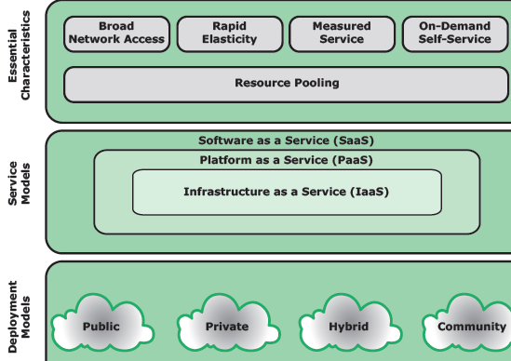
(SaaS) (PaaS)
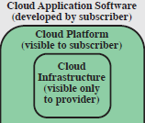
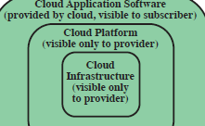

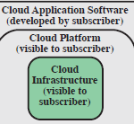
(IaaS)

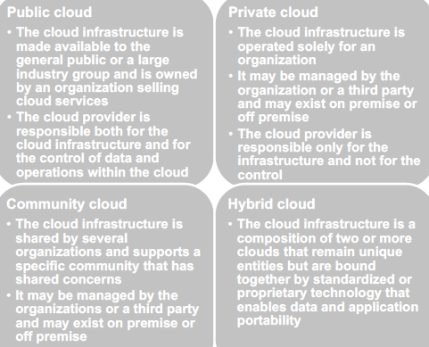
NIST developed reference architecture:
- Illustrate and understand the various cloud services in the context of an overall cloud computing conceptual model
- Provide a technical reference for consumers to understand, discuss, categorize, and compare cloud service
- Facilitate the analysis of candidate standards for security, interoperability and portability and reference implementations

Cloud security risks: Abuse and nefarious use of cloud computing, Insecure interfaces and APIs, Malicious insiders, Shared technology issues, Data loss or leakage, Account or service hijacking.
SecaaS: segment of the SaaS offering of a CP: Provision of security applications and services via the cloud either to cloud-based infrastructure and software or from the cloud to the customer’s on-premise systems
Malicious Software
Zombie, Bot: Program activated on an infected machine that is activated to launch attacks on other machines
Advanced persistent threat: business and political targets, using a wide variety of intrusion technologies and malware, applied persistently and effectively to specific targets over an extended period
Adware: Advertising that is integrated into software. It can result in pop-up ads or redirection of a browser to a commercial site.
Auto-rooter: Malicious hacker tools used to break into new machines remotely.
Backdoor (trapdoor): Any mechanisms that bypasses a normal security check
Downloaders: Code that installs other items on a machine that is under attack.
Drive-by download: attack using code in a compromised web site that exploits a browser vulnerability to attack a client system when the site is viewed.
Exploits: Code specific to a single vulnerability or set of vulnerabilities
Flooders (DoS client): Used to generate a large volume of data to attack networked computer systems
Keyloggers: Captures keystrokes on a compromised system
Logic bomb: Code inserted into malware by an intruder. A logic bomb lies dormant until a predefined condition is met; the code then triggers an unauthorized act.
Macro Virus: macro or scripting code, typically embedded in a document, and triggered when the document is viewed or edited, to run and replicate itself into other such documents.
Mobile Code: Software that can be shipped unchanged to a heterogeneous collection of platforms and execute with identical semantics.
Rootkit: Set of hacker tools used after attacker has broken into a computer system and gained root-level access.
Spammer Programs: Used to send large volumes of unwanted e-mail.
Spyware: Software that collects information from a computer and transmits it to another system by monitoring keystrokes
Type of Malicious software (Malware)
Propagation mechanisms include:
- Infection of existing content by viruses that is subsequently spread to other systems
- Exploit of software vulnerabilities by worms or drive-by-downloads to allow the malware to replicate
- Social engineering attacks that convince users to bypass security mechanisms to install Trojans or to respond to phishing attacks
Payload actions performed by malware once it reaches a target system can include:
- Corruption of system or data files
- Theft of service/make the system a zombie agent of attack as part of a botnet
- Theft of information from the system/keylogging
- Steal thing/hiding its presence on the system
Attack Kit: tools for generating new malware automatically using a variety of supplied propagation and payload mechanisms.
- Toolkits are often known as “crime ware” widely use (Zeus, balckhole, sakura, phoneix)
  - Variety of propagation mechanisms and payload modules that even novices can deploy
Advanced Persistent Threats (APTs): Well-resourced, persistent application of a wide variety of intrusion technologies and malware to selected targets (usually business or political)
- careful target selection, high profile attack includes Aurora, RSA, APT1 and Stuxnet
APT attacks: varies from theft of intellectual property or security and infrastructure related data to the physical disruption of infrastructure
- Tech: spear-phishing email, social engineering, drive by downloads
- Intent: infect the target with sophisticated malware wit multiple propagation mechanisms and payload

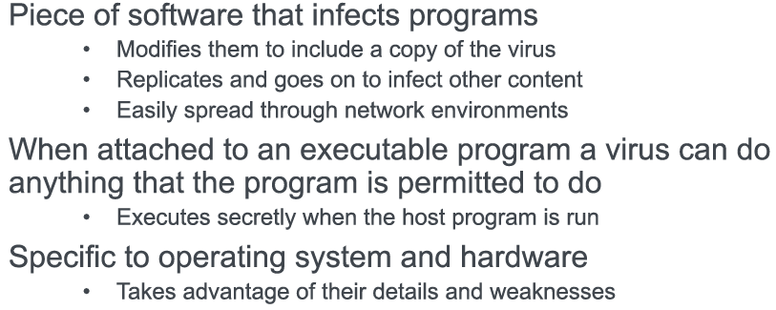
Viruses
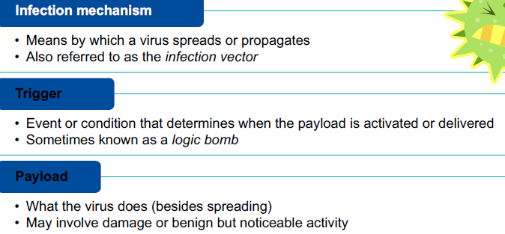

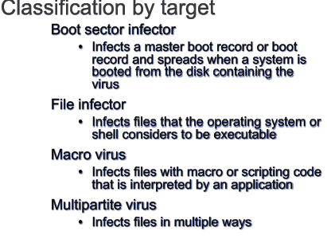
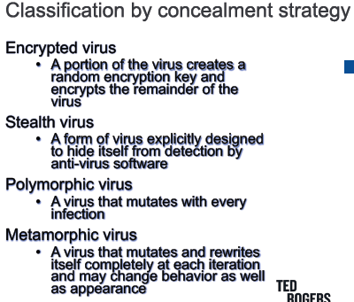

Worms:
- Program that actively seeks out more machines to infect and each infected machine serves as an automated launching pad for attacks on other machines
- Exploits software vulnerabilities in client or server programs
- Can use network connections to spread from system to system
- Spreads through shared media (USB drives, CD, DVD data disks)
- E-mail worms spread in macro or script code included in attachments and instant messenger file transfers
- Upon activation, the worm may replicate and propagate again
- Usually carries some form of payload
- First known implementation was done in Xerox Palo Alto Labs in the early 1980s
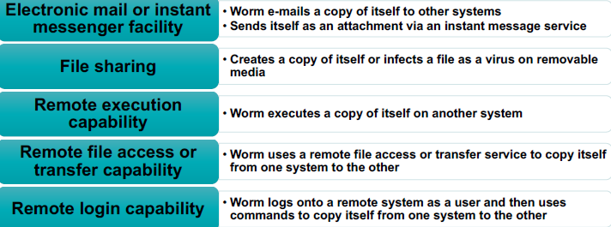
Worm Replication

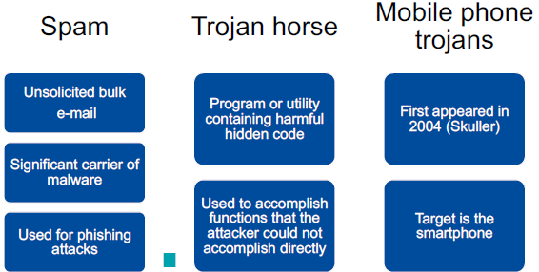
“Tricking” users to assist in the compromise of their own systems

Worm Countermeasures
Considerable overlap in techniques for dealing with viruses and worms
Once a worm is resident on a machine anti-virus software can be used to detect and possibly remove it
Perimeter network activity and usage monitoring can form the basis of a worm defense
Worm defense approaches include:
  - Signature-based worm scan filtering
  - Filter-based worm containment
  - Payload-classification-based worm containment
  - Threshold random walk (TRW) scan detection
  - Rate limiting
  - Rate halting
Malware countermeasure approaches: best solution is prevention
- if prevention fail, technical mechanisms can be used to support detection, identification, removal
  - 4 main elements of prevention: Policy, Awareness, Vulnerability mitigation, Threat mitigation
Lecture 6
DoS attack: NIST computer security: “Prevents or impairs the authorized use of networks, systems, or applications by exhausting resources such as central processing units (CPU), memory, bandwidth, and disk space.
DoS (Denial of Service): A form of attack on the availability of service
- Network bandwidth (internet service provider ISP), system resources, application resources (load of request)
Classic DoS Attacks- Flooding ping command
- Aim of this attack is to overwhelm the capacity of the network connection to the target organization
- Traffic can be handled by higher capacity links on the path, but packets are discarded as capacity decreases
- Source of the attack is clearly identified unless a spoofed address is used
- Network performance is noticeably affected
Flooding attacks: classified based on network protocol used
- Intent is to overload the network capacity on some link to a server
- Virtually any type of network packet can be used
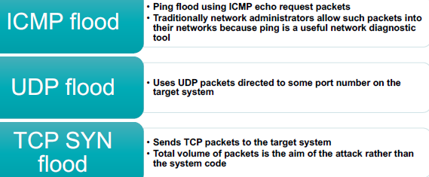

Source Address Spoofing (Tor, VPN, IP change)
SYN Spoofing: Common DoS attack
- Attacks the ability of a server to respond to future connection requests by overflowing the tables used to manage them
- Thus legitimate users are denied access to the server
- Hence an attack on system resources, specifically the network handling code in the operating system
DDoS (Distributed Denial of service) attack: Use of multiple systems to generate attacks
- Attacker uses a flaw in operating system or in a common application to gain access and installs their program on it (zombie)
- Large collections of such systems under the control of one attacker’s control can be created, forming a botnet
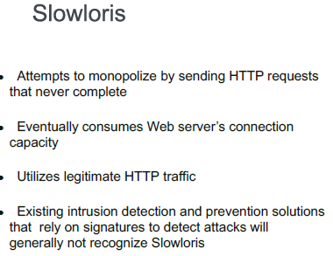
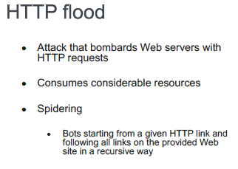
Hypertext Transfer Protocol (HTTP) Based Attacks

Reflection attack is a method of attacking a challenge-response authentication system that uses the same protocol in both directions. That is, the same challenge-response protocol is used by each side to authenticate the other side.
DNS amplification attack is a reflection-based distributed denial of service (DDos) attack. The attacker spoofs look-up requests to domain name system (DNS) servers to hide the source of the exploit and direct the response to the target.
DoS Attack Defenses: Attack prevention and pre-emption “before attack”
- Attack detection and filtering “during attack”
- Attack source traceback and identification “during and after the attack”
- Attack reaction “after the attack”
DoS attack prevention: Block spoofed source addresses
- Filters may be used to ensure path back to the claimed source address
- Use modified TCP connection handling code (Cryptographically encode critical information)
- Block IP directed broadcasts
- Block suspicious services and combinations
- Use mirrored and replicated servers when high-performance and reliability is required
In general, cryptographic schemes will only get less secure with the passage of time our processing power (hence, computational power of the adversary) increase and more sophisticated attacks are discovered or more flaws are discovered. there is more time for the attacks to run.
a. Substitution and transposition are operations used in Symmetric cryptography.
b. ECC stands for Elliptic Curve Cryptography and is a type of Asymmetric cryptography.
c. Security of RSA is based on the hardness of Factoring, prime factoring Problem.
d. Security of ECC is based on the hardness of discrete logarithm Problem.

What properties must a hash function have to be generally useful in cryptography?
- Size reducing, One-way (pre-image resistant), second pre-image resistant, collision resistance.
What properties must a hash function have to be useful in digital signature schemes?
- One-way (pre-image resistant), collision resistance. Size reducing.
What properties must a hash function have to be useful in securing stored passwords?
- One-way (pre-image resistant). Size reducing.
Principal physical characteristics used for biometric identification
- Facial characteristics, Voice, Signature, Fingerprints, Hand geometry
- Retinal pattern: Each individual retinal pattern is unique; therefore, it is suitable for identification. This system requires a digital image of individual’s retinal pattern, by projecting a low-intensity beam into the eye.
- Iris: unique physical characteristic is the detailed structure of the iris.
Principal threats to the secrecy of passwords
- Workstation hijacking: The attacker waits until a logged-in workstation is unattended.
- Electronic monitoring: If a password is connected across a network and log on to a remote system, its vulnerable to eavesdropping. Simple encryption can’t prevent or fix this situation because the encrypted password can be observed and reused by attacker.
4 common techniques for selecting or assigning passwords.
1.User edu 2. computer generated passwords
3.Reactive password checking: Application system periodically runs its own password cracker and notifies the user if it could crack his or her password.
4. Proactive password checking: The user chooses his password based on rules given by the system, as recently at least 8-digit password contain at least one capital, numbers and symbols.

1.A Database management system (DBMS) is a suite of programs for constructing and maintaining the database and for offering ad hoc query facilities to multiple users and applications.
2. In a relational database columns are referred to as Attribute
3. A View is the result of a query that returns selected rows and columns from one or more tables.
4. In a discretionary access control environment database users are classified into three broad categories: administrator, end user other than application owner, and Application Owner
5. The information transfer path by which unauthorized data is obtained is referred to as an Inference channel.
6. The Public cloud is responsible both for the cloud infrastructure and for the control of data and operations within a public cloud.
7. The Private cloud infrastructure is operated solely for an organization.
8. A Query language provides a uniform interface to the database for users and applications.
9. Cloud computing is a model for enabling ubiquitous, convenient, on-demand network access to a shared pool of configurable computing resources that can be rapidly provisioned and released with minimal management effort or service provider interaction.
10. A Public cloud infrastructure is made available to the general public or a large industry group and is owned by an organization selling cloud services.
11. The Multi-tenant model provides a predefined environment for the cloud subscriber that is shared with other tenants, typically through tagging data with a subscriber identifier.
12. A Rootkit is a set of programs installed on a system to maintain covert access to that system with administrator (root) privileges while hiding evidence of its presence.
13. A Blended attack uses multiple methods of infection or propagation to maximize the speed of contagion and the severity of the attack.
14. A computer Virus is a piece of software that can “infect” other programs or any type of executable content and tries to replicate itself.
15. Sometimes referred to as the “infection vector”, the Infection mechanism is the means by which a virus spreads or propagates.
16. Sometimes known as a “logic bomb”, the Time bombs is the event or condition that determines when the payload is activated or delivered.
17. The four phases of a typical virus are: dormant phase, triggering phase, execution phase and Propagation phase.
18. During the Triggering phase the virus is activated to perform the function for which it was intended.
19. A Stealth virus is explicitly designed to hide itself from detection by anti-virus software.
20. Generic decryption (GD) technology is an anti-virus approach that enables the anti-virus program to easily detect even the most complex polymorphic viruses and other malware, while maintaining fast scanning speeds.

