MKT 400 Notes
CHAPTER ONE
LO1 MARKETING ETHICS AND CONSUMER MISBEHAVIOUR
- Ethics refers to standards or moral codes of conduct to which person, group, or organization adheres.
- Marketing ethics consists of societal and professional standards of right and fair practices that are expected of managers as they develop and implement marketing strategies.

LO2 CONSUMPTION AND CONSUMER BEHAVIOUR
- Consumer behavior can be defined from two different perspectives.
  - Human thought and action
  - A field of study (human inquiry) that is developing an accumulated body of knowledge.

CONSUMER BEHAVIOUR AS HUMAN BEHAVIOUR
- Consumer behavior is the set of value-seeking activities that take place as people go about addressing needs.
The Basic CB Process
- A want is a way a consumer goes about addressing a recognized need.
- An exchange is the acting out of a decision to give something up in return for something of greater value.
- Costs are negative results of consumption (ex. money, time, and effort).
- Benefits are positive results of consumption.
- 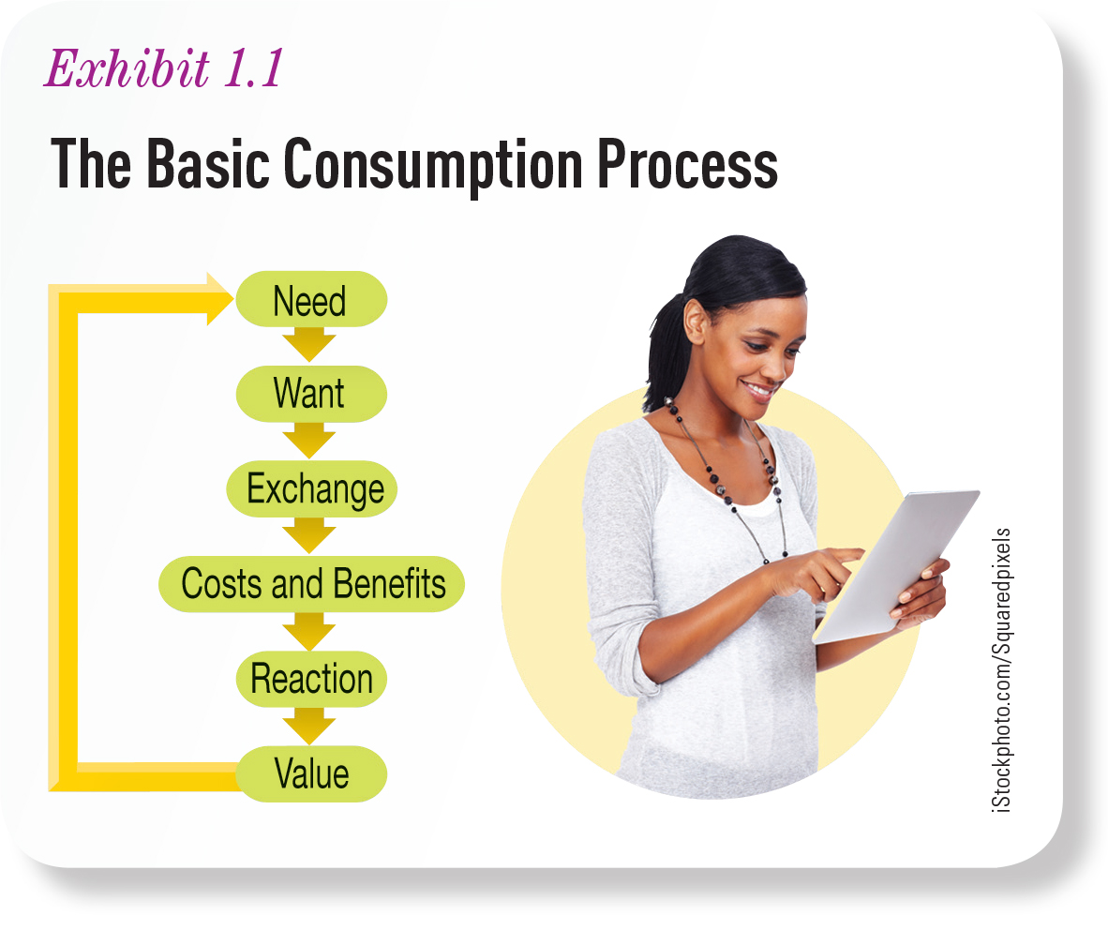
Consumption
- Consumption represents the process by which goods, services, or ideas are used and transformed into value.

CONSUMER BEHAVIOUR AS A FIELD OF STUDY
- Consumer behavior as a field of study represents the study of consumers as they go about the consumption process.
Economics and Consumer Behavior
- Economics is the study of production and consumption.
- Behavioral Economics is the study of what happens in markets with decision makers who display human limitations and complications
Psychology and Social Psychology
- Psychology is the study of human reactions to their environment, including behavior and mental processes.
  - Psychologists seek to explain the thoughts, feelings, and behaviors that represent human reaction.
- Social psychology is a study that focuses on the thoughts, feelings, and behaviors that people have as they interact with other people (group behavior).
- Cognitive psychology is the study of the intricacies of mental reactions involved in information processing.
Marketing
- Marketing involves the multitude of value-producing seller activities that facilitate exchanges between buyers and sellers
  - These activities include the production, promotion, pricing, distribution, and retailing of goods, services, ideas, and experiences that provide value for consumers and other stakeholders.
Consumer Behavior and Other Disciplines
- Marketing as a recognized discipline, grew out of economics and psychology.
- Sociology is the study of groups of people within a society.
  - With relevance for consumer behavior because consumption often takes place within group settings or is affected by group behavior.
- Anthropology is the study in which researchers interpret the relationships between consumers and the things they purchase, the products they own, and the activities in which they participate.
- Other disciplines such as geography and medical sciences overlap with consumer behavior.
- Neuroscience is the study of the central nervous system, including brain mechanisms, associated with thoughts, emotion, and behavior.

LO3 THE WAYS IN WHICH CONSUMERS ARE TREATED
- Two questions are considered in order to understand how important serving well should be to any given organization.
  - How competitive is the marketing environment?
  - How dependent is the market on repeat business?

COMPETITION AND CONSUMER ORIENTATION
- Consumer (customer) orientation is a way of doing business in which the actions and decision making of the institution prioritize consumer value and satisfaction above all other concerns.
- Market orientation is an organizational culture that embodies the importance of creating value for customers among all employees.
  - Monitors and understand competitor actions in the marketplace and the need to communicate information about customers and competitors throughout the organization.

RELATIONSHIP MARKETING AND CONSUMER BEHAVIOUR
- Relationship marketing is activities based on the belief that the firm’s performance is enhanced through repeat business.
- Touch-points are direct contacts between the firm and a customer.
  - Every touch-point is a way to build a relationship with a customer in a competitive environment.

LO4 CONSUMER BEHAVIOUR’S ROLE IN BUSINESS AND SOCIETY
- Consumer behavior is important in at least three ways.
  - CB provides an input to business/marketing strategy.
  - CB provides a force that shapes society.
  - CB provides an input to making responsible decisions as a consumer.

CONSUMER BEHAVIOUR AND MARKETING STRATEGY
- Resource advantage theory explains why companies succeed or fail. The firm goes about obtaining resources from consumers in return for the value of the resources create.
What Do People Buy?
- Attribute is a product feature that delivers a desired consumer benefit.
- Product is potentially valuable bundle of benefits.
Ways of Doing Business
- Undifferentiated marketing the same basic product is offered to all customers.
  - They rely on selling high volume to be successful.
  - Production orientation where innovation is geared primarily toward making the production process as efficient and economic as possible.
    - The emphasis is on serving customers while incurring minimum costs.
- Differentiated marketers are firms that serve multiple market segments each with a unique product offering.
- One-to-one marketing the firm offers a unique product to each individual customer and so each customer is treated as a segment of one.
- Niche marketing practiced by firms that specialize in serving one market segment with particularly unique demand characteristics.
- 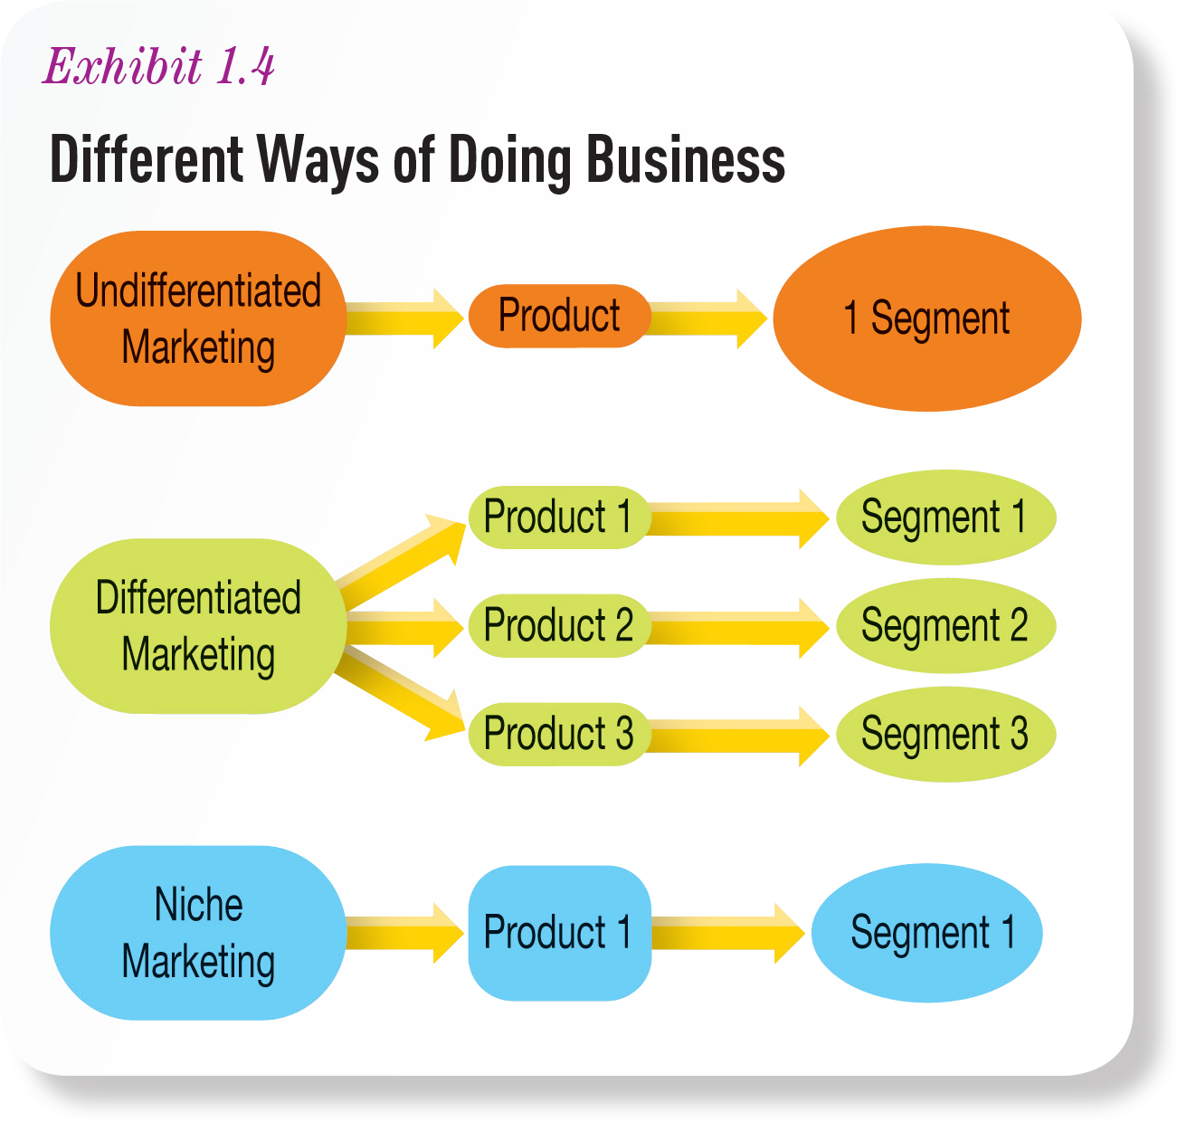

CONSUMER BEHAVIOR AND SOCIETY
- The things that people buy and consume end up determining the type of society in which we live in.
  - Things like customs, manners, and rituals all involve consumption – value-producing activities.

CONSUMER BEHAVIOUR AND PERSONAL GROWTH
- When consumers study consumer behavior, they can make better decisions.
  - Understanding consequences of poor budgeting.
  - Understanding role of emotions.
  - Understanding the avenues for seeking redress for unsatisfactory purchases.
  - Understanding social influences.
  - Understanding the effect of the environment.

LO5 DIFFERENT APPROACHES TO STUDYING CONSUMER BEHAVIOUR
- Different types of research settings may call for different approaches and the use of different tools.

INTERPRETIVE RESEARCH
- Interpretive research seeks to explain the inner meanings and motivations associated with specific consumption experiences.
- Qualitative research tools are for gathering data in a relatively unstructured way, include case analysis, clinical interviews, and focus group interviews.
- Researcher dependent is subjective data that requires a researcher to interpret the meaning.
  - The interpretation is a matter of opinion until collaborated by other findings.
- Phenomenology is qualitative approach to studying consumers that relies on interpretation of the lived experience associated with some aspect of consumption.
- Ethnography is qualitative approach to studying consumers that relies on interpretation of artifacts to draw conclusions about consumption.

QUANTITATIVE CONSUMER RESEARCH
- Quantitative research addresses questions about consumer behavior using numerical measurement and analysis tools.
- Experimental methodology a quantitative approach to research that examines cause-and-effect relationships by measuring changes in one or more key variables, while systematically manipulating and controlling other variables.
- 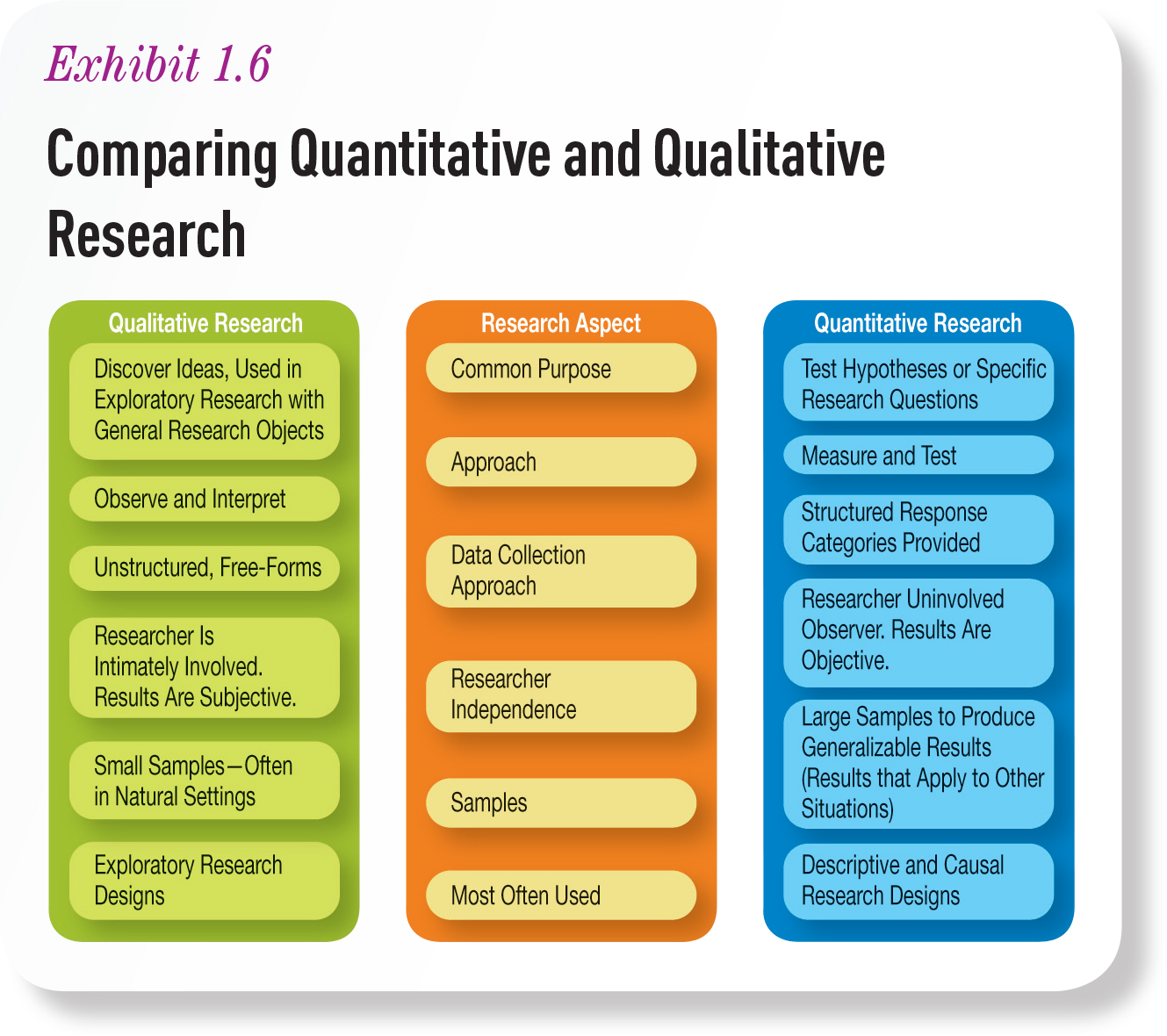

LO6 CONSUMER BEHAVIOUR IS DYNAMIC
- There are several trends that are shaping the value received by consumers today.
INTERNATIONALIZATION
- These firms can be found worldwide; consumers are not alike everywhere these firms operate. Every culture’s people will interpret products and behaviors differently, and so consumer behavior research is crucial.

TECHNOLOGICAL CHANGES
- Retailers look at WEB technologies more as a complementing traditional retailing than competing with bricks-and-mortar option.

CHANGING COMMUNICATIONS
- The ways people communicate has changed. One in three of all internet users in the world use Facebook.
  - Marketers are learning how to use these tools to communicate with consumers.

BIG DATA
- Massive amount of information available. Predict customer behavior and discover patterns. Technological trend that will affect how companies study their customers.

CHANGING DEMOGRAPHICS
- Trends have shaped consumer behavior patterns greatly.
  - Households have two primary income providers (stereotypical working dad and stay-at-home mom as been removed).

CHANGING ECONOMY
- Consumers are more cautious about spending money.
  - Private label brands are more attractive alternatives.

CHAPTER TWO
LO1 THE CONSUMER VALUE FRAMEWORK AND ITS COMPONENTS
THE CONSUMER VALUE FRAMEWORK
- Consumer value framework (CVF) represents consumer behavior theory illustrates factors that shape consumption-related behaviors and ultimately determine the value associated with consumption.

VALUE AND THE CVF COMPONENTS
- Factors that shape consumption related behaviors ultimately determine the value.
- Value is the heart of experiencing and understanding consumer behavior.
  - It’s associated with consumption.
- 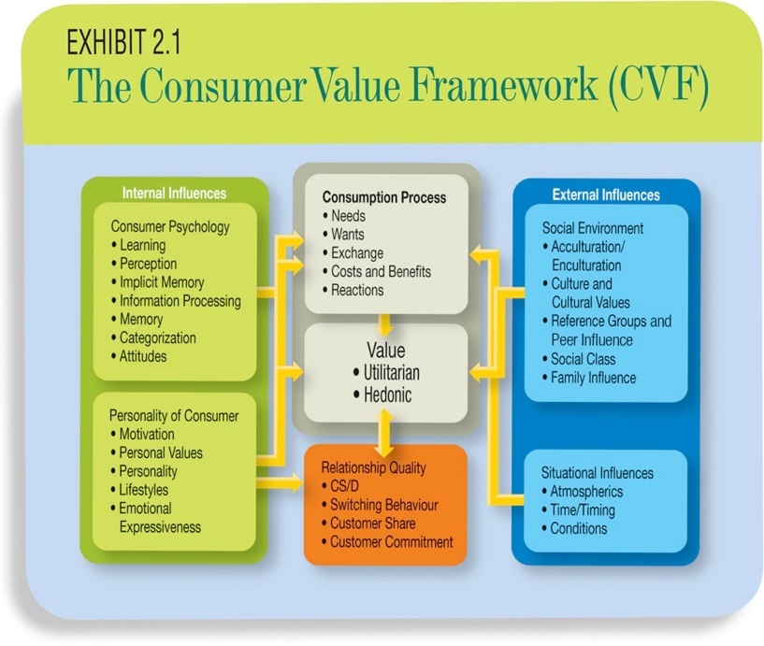
Relationship Quality
- Customer relationship management (CRM) a systematic management information system that collects, maintains, and reports detailed information about customers to enable a more customer-oriented managerial approach.
- Relationship quality reflects the degree of connectedness between a consumer and a retailer, brand, or service provider.
  - It is a key component of value.
Consumption Process
- Many factors influence the consumption process, and these factors can be divided into two categories, internal and external influences.
Internal Influences: The Psychology and Personality of the Consumer
- Psychology of the consumer how consumers process and react to information, form attitudes, and remember.
  - Internal influences are things that go on inside of the mind and heart of the consumer.
  - Cognition refers to the thinking or mental processes that go on as we process and store things that can become knowledge.
  - Affect refers to the feelings that are experiences during consumption activities or that are associated with specific objects.
- Personality of the consumer What makes individuals different – includes motivation, values, individual lifestyle, and emotion.
  - Individual differences are characteristic traits of individuals, including personality and lifestyle.
External Influences
- External influences include social and cultural aspects of life as a consumer.
  - Includes reference groups, opinion leaders (friends, family, and celebrities).
- Social environment are elements that specifically deal with the way other people influence consumer decision making and value.
Situational Influences
- Situational influences are things unique to a time or place that can affect consumer decision making and the value received from consumption.
  - Purchase decisions include store design, lighting, music, and etc.
LO2 VALUE AND TWO BASIC TYPES OF VALUE
- Value is a personal assessment of the net worth obtained from an activity.
  - It is subjective, influences by factors such as expectations and consumer personality. The same consumption experience can be assessed very differently by two individuals.

THE VALUE EQUATION
- 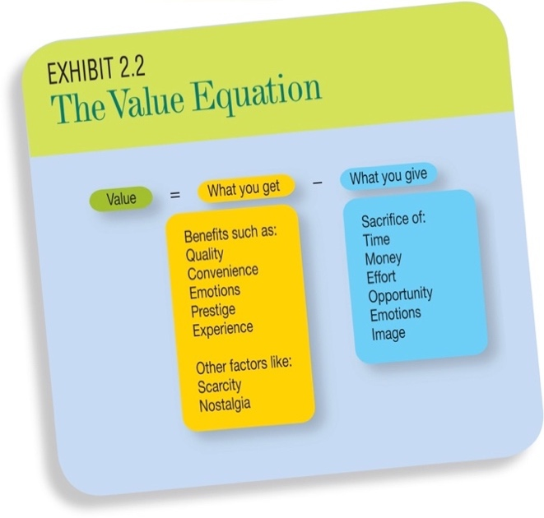

UTILITARIAN VALUE
- Utilitarian value derived from a product that helps the consumer solve problems and accomplish some tasks.
  - Deliver purely functional value.

HEDONIC VALUE
- Hedonic value is the immediate gratification that comes from experiences some activity.
  - There are emotions associated with consumption.
- 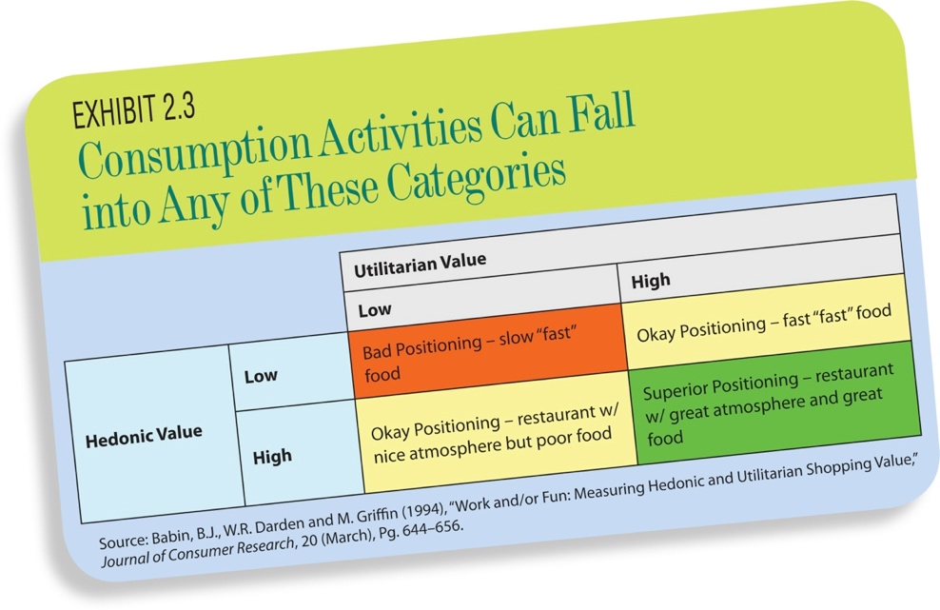

LO3 MARKETING STRATEGY AND CONSUMER VALUE
- Strategy a planned why of doing something to accomplish some goal.

MARKETING STRATEGY
- Marketing strategy is the way a company goes about creating value for its customers.
  - Marketing myopia is a common condition in which a company views itself in a product business rather than in a value, or benefits producing, business. In this way, it is shortsighted.
- Corporate strategy deals with how the firm will be defined and sets general goals.
- Marketing tactics ways marketing management is implemented; involves price, promotion, product, and distribution decisions.
- 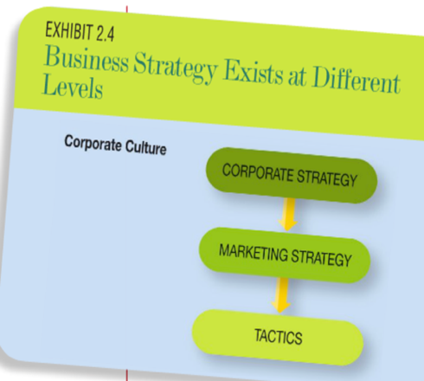

TOTAL VALUE CONCEPT
- Augmented product means the actual physical product purchased plus any services such as installation to use the product and obtain its benefits.
- Every product is made up of the basic benefits, plus the augmented product, plus the “feel” benefits.
- Total value concept is practiced when companies operate with the understanding that products provide value in multiple ways.

VALUE IS CO-CREATED
- Value co-creation is the realization that a consumer is necessary and must play a part in order to produce value.
  - Consumer adds knowledge and skills.

LO4 MARKET CHARACTERISITICS: MARKET SEGMENTS AND PRODUCT DIFFERENTIATION
- Marketing mix is the combination of product, pricing, promotion, and distribution strategies used to implement a marketing strategy.
- Target market is an identified segment or segments of a market that a company serves.

MARKET SEGMENTATION
- Market segmentation is the separation of a market into groups based on the different demand curves associated with each group.
- Elasticity reflects how sensitive a consumer is to changes in some product characteristic.

PRODUCT DIFFERENTIATION
- Product differentiation is a marketplace condition in which consumers do not view all competing products as identical to one another.

LO5 ANALYZING MARKETS WITH PERCEPTUAL MAPS
- Product positioning is a way a product is perceived by a consumer.

PERCEPTUAL MAPS
- Perceptual map is a tool used to depict graphically the positioning of competing products.
- Ideal points are the combination of product characteristics that provide the most value to an individual consumer or market segment.
- Blue ocean strategy seeks to position a firm far away from competitors – the firm creates an industry of their own.

LO6 VALUE TODAY AND TOMORROW – CUSTOMER LIFETIME VALUE
- Customer lifetime value (CLV) represents the approximate worth of a customer to a company in economic terms; overall profitability of an individual consumer.
  - CLV = net present value (sales-costs) + net present value (equity)
- Authenticity is a potential product characteristic that creates product differentiation.

CHAPTER THREE
LO1 DEFINING LEARNING AND PERCEPTION
- Value cannot be communicated without involving consumer learning and perception.
- Learning refers to a change in behavior resulting from the interaction between a person and a stimulus.
  - Learning can be intentional or unintentional.
- Perception consumer’s awareness and interpretation of reality.

CONSUMER PERCEPTION
- The perceptions that consumers develop do not always match the real world.
- Perception represents a subjective reality whereas what actually exists in the environment determines objective reality.

EXPOSURE, ATTENTION, AND COMPREHENSION
- Exposure refers to the process of bringing some stimulus within the proximity of a consumer so that it can be sensed by one of the five human senses (sight, smell, taste, touch, or sound).
  - Sensation describes a consumer’s immediate response to this information.
- Attention is the purposeful allocation of information-processing capacity toward developing an understanding of some stimulus.
- Comprehension occurs when consumers attempt to derive meaning from information they receive.

LO2 CONSUMER PERCEPTION PROCESS
- Consumer perception includes three phases: sensing, organizing, and reacting.

SENSING
- Sensing is an immediate response to stimuli that have come into contact with one of the consumer’s five senses (sight, smell, touch, taste, or sound).

ORGANIZING
- Organization takes place so quickly in most cases that we are unaware of the process.
- Cognitive organization refers to the process by which the human brain assembles sensory evidence into something recognizable.
- If a consumer has difficulty categorizing a stimulus, the brain tries to reconcile the inconsistencies by reacting in three possible ways:
  - Assimilation occurs when a stimulus has characteristics such that consumers readily recognize it as belonging to some specific category.
  - Accommodation occurs when a stimulus shares some but not all of the characteristics that would lead it to fit neatly in an existing category, and consumers must process exceptions to rules about the category.
  - Contract occurs when a stimulus does not share enough in common with existing categories to allow categorization.

REACTING
- This is the end of the perceptual process and it can be both physical and mental in response to stimulus.
  - For ex. a driver notices that the car ahead has its brake lights on so the learned response is to apply brakes as well.
  - The reaction occurs as a response or behavior
- 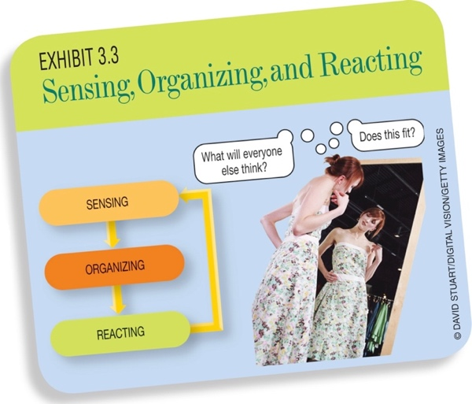

SELECTIVE PERCEPTION
- Selective exposure involves screening out most stimuli and exposing oneself to only a small portion of stimuli.
- Selective attention involves paying attention to only certain stimuli.
- Selective distortion is a process which consumers interpret information in ways that are biased by their previously held beliefs.

SUBLIMINAL PROCESSING
- Subliminal processing refers to the way that the human brain deals with very low-strength stimuli, so low that the person has no conscious awareness.
- Absolute threshold the minimum strength of a stimulus that can be perceived.
- Subliminal persuasion behavior change induces by subliminal processing.

APPLYING THE JND CONCEPT
- Just noticeable difference (JND) represents how much stronger one stimulus has to be relative to another so that someone can notice that the two are not the same.
  - Deals with changes in the strength of stimuli.
- Weber’s law is a law stating that a consumer’s ability to detect differences between two levels of the stimulus decreases as the intensity of the initial stimulus increases.
- The JND has numerous marketing implications for marketers attempting to provide value to consumers.
  - Price changes by small increments do not attract a lot of consumer attention.
  - Quantity changes by small increments do not attract a lot of consumer attention.
  - Quality improvements in small amounts will not attract attention so the difference must be large enough to create a true perceptual difference.
  - Add-on purchases work if it does not create the perception of increased spending.

JUST MEANINGFUL DIFFERENCE
- Just meaningful difference (JMD) represents the smallest amount of change in a stimulus that would influence consumer consumption and choice.

LO4 IMPLICIT AND EXPLICIT MEMORY
- Explicit memory is memory that develops when a person is exposed to, attends, and tries to remember information.
  - Intentional learning.
  - The knowledge a person gets from reading a textbook.
- Implicit memory is memory for things that a person did not try to remember.
  - Unintentional learning.
  - Banner ads on websites are a good example of implicit memory.
- Pre-attentive effects are learning that occurs without attention.

MERE EXPOSURE EFFECT
- Mere exposure effect that which leads consumers to prefer a stimulus to which they’ve previously been exposed.
  - Once exposed to an object, a consumer exhibits a preference for the familiar object over something unfamiliar.
  - Another way that consumers can learn unintentionally.
- Familiarity
  - Pre-attentive effects
  - Easy to elicit
  - Greatest effect on novel objects
  - Weak effect
  - Best when consumer has lower involvement
- Product Placements
  - Product placements are products that have been placed conspicuously in movies or televisions shows.

ATTENTION
- The purposeful allocation of cognitive capacity toward understanding some stimulus.
- Involuntary attention is attention that is beyond the conscious control of a consumer.
  - Occurs as the result of a surprising or novel stimulus.
- Orientation reflex natural reflex that occurs as a response to something threatening.

Lo5 ENHANCING CONSUMERS ATTENTION
FACTORS THAT GET ATTENTION
- Intensity of Stimuli
  - Vivid colors and loud sounds can capture more attention compared to dull colors and quieter sounds.
  - Consumer is more likely to pay attention to stronger stimuli than to weaker stimuli.
- Contrast
  - Contrast is effective because it is doing something different from what the consumer was expecting.
    - For ex. having a silent commercial when consumer expects a loud one.
- Movement
  - Capture consumer’s attention by the principle of movement.
    - For ex. electronic billboards, electronic retail shelf tags, and flashing lights.
- Surprising stimuli
  - Unexpected stimuli can gain consumer’s attention.
- Size of stimuli
  - Larger items garner more attention than smaller ones.
- Involvement refers to the person relevance a consumer feels toward a particular product.
  - The more personally relevant an object, the greater the chance that the object will be attended to.

LO6 THE DIFFERENCE BETWEEN INTENTIONAL AND UNINTENTIONAL LEARNING
- Unintentional learning consumers simply sense and react (or respond) to the environment.
  - Learning that occurs when behavior is modified through a consumer – stimulus interaction without any effortful allocation of cognitive processing capacity toward that stimulus.
  - Consumers “learn” without trying to learn.
- Intentional learning consumers set out to specifically learn information devoted to a certain subject.

BEHAVIOURISM AND COGNITIVE LEARNING THEORIES
- Behaviorist approach to learning (behavioral learning perspective) theory of learning that focuses on changes in behavior due to association, without great concern for the cognitive mechanics of the learning process.
  - The term conditioning is used in behavioral learning, as behavior becomes conditioned in some way by the external environment.
    - Consumers are exposed to stimuli and respond in some way.
- Information processing (or cognitive) perspective approach that focuses on changes in thought and knowledge and how these precipitate behavioral changes.
  - The consumers mind acts like a computer processing bits of knowledge to form meaning.

UNINTENTIONAL LEARNING
- Unintentional learning occurs when behavior is modified through a consumer – stimulus interaction without cognitive effort to understand a stimulus.
  - The focus is on reacting, not cognitive processing.
- Unintentional learning can be approached from the behavioral learning perspective. There are two major approaches found in behavioral theory.
Classical Conditioning
- Classical conditioning is change in behavior that occurs simply through associating some stimulus with another stimulus that naturally causes some reaction; a type of unintentional learning.
  - Unconditioned stimulus stimulus with which a behavioral response is already associated.
    - Condition stimulus object of event that does not cause the desired response naturally but that can be conditioned to do so by pairing with an unconditioned stimulus.
- Unconditioned response response that occurs naturally as a result of exposure to an unconditioned stimulus.
    - Conditioned response response that results from exposure to a conditioned stimulus that was originally associated with the unconditioned stimulus.
  - 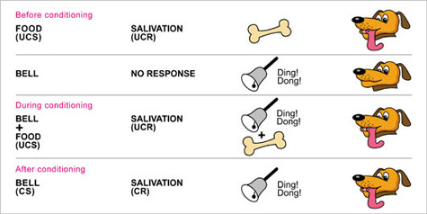
Instrumental Conditioning
- Instrumental conditioning type of learning in which a behavioral response can be conditioned through reinforcement – either punishment or rewards associated with undesirable or desirable behavior.
  - For ex. getting children to be potty trained. When they perform the desired result they will get rewards such as toys, hugs and kisses.
  - Behavior is conditioned through positive or negative reinforcement.
- Positive reinforcers are reinforcers that take the form of a reward.
Discriminative Stimuli, Reinforcement, and Shaping
- Discriminative stimuli are stimuli that are differentiated from other stimuli because they signal the presence of a reinforce.
  - These stimuli essentially signal that a type of reward will occur if a behavior is performed.
    - For ex. an advertisement saying come shop at the store and get 10% off. This ad is presented before the behavior occurs, and the behavior must occur in order for the reinforcement to be delivered.
- Shaping is a process through which a desired behavior is altered over time, in small increments.
  - For ex. a business first offers free hotdogs, then coupon for free pizza if they test drive a new car, then $200 rebate on the purchase of the car. The small rewards along the way help shape the desire behavior from a consumer.
- Punishers represent stimuli that decrease the likelihood that a behavior will occur again.
  - For ex. a consumer buys a bad laptop that deliver less value that expected, they are punished and they will not buy the same one again.
- Negative reinforcement refers to the removal of bad or harmful stimuli as a way of encouraging behavior.
  - For ex. another laptop company’s advertisement shows that “if you bought our laptop, this bad thing would not have happened to you”.
- Extinction is the process through which behaviors cease because of lack of reinforcement.
  - For ex. when you Toyota gives you a free cupcake every time you change your car oil. If Toyota stops offering the free cupcake, you will find a different place to change your car oil.

CHAPTER FOUR
LO1 WHAT INFLUENCES COMPREHENSION?
- Comprehension refers to the interpretation of understanding a consumer develops about some attended stimulus based on the way meaning is assigned.
  - The way people cognitively assign meaning to things they encounter.
  - For ex. the warning label on a cigarette packet.
- There are three important issues regarding comprehension.
  - The process of comprehension is largely influenced by other internal factors within the consumer.
  - Comprehension includes both cognitive and affective elements, thereby involving both thoughts and feelings.
  - Consumers don’t always comprehend messages in the intended way and, to this extent, consumer comprehension is not always “correct.”
    - Signal theory tells us that communications provide information in ways beyond the explicit or obvious content.
- 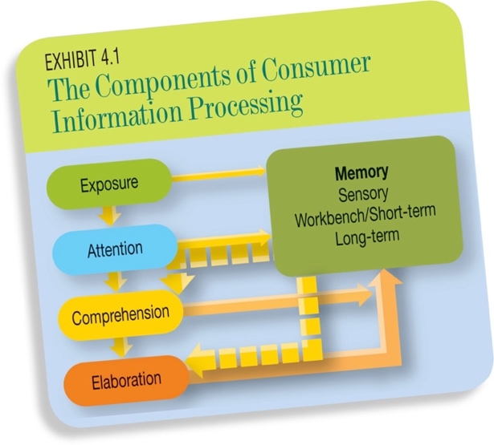

FACTORS AFFECTING CONSUMER COMPREHENSION
- There are three factors affecting consumer comprehension
  - Characteristics of the message
  - Characteristics of the message receiver
  - Characteristics of the environment (information-processing situation).
- 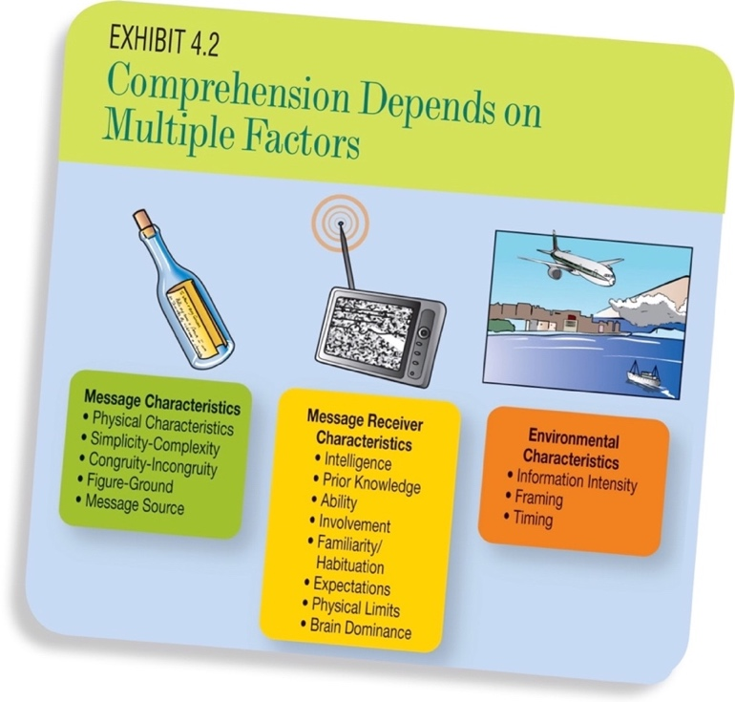

CHARACTERISTICS OF THE MESSAGE
Physical Characteristics
- Physical characteristics are tangible elements or the parts of a message that can be sensed directly.
  - Intensity is the greater the movement, the larger the picture, or the louder the sound, the more likely a consumer is to attend and comprehend something from a message.
  - Color Use of colour depends on the culture and can impact how an ad is comprehended.
  - Font the actual text of a message and the visual presentation of the message send meaningful signals to the consumer.
    - Research suggests that some fonts portray a masculine image while others portray a feminine image
  - Numbers names with letters and numbers used in combination signify a “technologically based” meaning. Numbers are often used in the auto industry as model names of cars.
  - Spacing consumers display greater recall on intended message when information is presented in intervals rather than in sequence.
    - Three 30-second ads spread over three hours achieve better consumer recall than one 90-second ad.
Simplicity–Complexity
- The simpler the message, the more likely a consumer develops meaningful comprehension.
  - For ex. terms like fat-free often communicate more clearly than detailed information.
Message Congruity
- Message congruity represents the extent to which a message is internally consistent and fits surrounding information.
Figure and Ground
- Every message is presented with background, although sometimes the background becomes the message.
- Figure object that is intended to capture a person’s attention; the focal part of any message.
- Ground background in a message.
  - Everything besides the figure should be less important and simply represent the ground.
- The contrast between the two represents the psychological figure ground distinction.
  - Figure – ground distinction notion that message can be separated into the focal point (figure) and the background (ground).
Message Source Factors
- Likeability, attractiveness, expertise, trustworthiness.
- A likeable and attractive source can change the interpretation of a stimulus.
- Expertise refers to the amount of knowledge that a source is perceived to have a subject.
- Trustworthiness refers to how honest and unbiased a source is perceived to be.
- Credibility extent to which a source is considered to be both an expert in a given area and trustworthy.
  - Consumers associate expertise and trustworthiness with credibility.
- Counterarguments are thoughts that contradict a message.
- Support arguments are thoughts that further support a message.

MESSAGE RECEIVER CHARACTERISTICS
Intelligence/Ability
- Intelligent, well-educated consumers are more likely to accurately comprehend a message than are less-intelligent or less-educated consumers.
Prior Knowledge
- The human brain matches incoming information with pre-existing knowledge. The prior knowledge provides resources, or a way through which other stimuli can be comprehended.
Involvement
- Highly involved consumers tend to pay more attention to messages and exert more effort in comprehending messages.
Familiarity/Habituation
- Familiarity can lower a consumer’s motivation to process a message.
- Consumer habituation is a concept resulting from familiarity.
  - Habituation is the process by which continuous exposure to a stimulus affects the comprehension of and response to the stimulus.
  - Adaptation level level of stimulus to which a consumer has become accustomed.
  - Dostats is a Russian word that can be roughly translated as “acquiring things with great difficulty”.
Expectations
- Expectations are beliefs of what will happen in a future situation.
Physical Limits
- Physical limitations can influence comprehension. Limits in our ability to hear, see, smell, taste, and thing.
  - Someone how is color blind might not understand a warning label that is red, and so the consumer will not comprehend this aspect of the message.
Brain Dominance
- Brain dominance refers to the phenomenon of hemispheric lateralization.
  - Some people tend to be either right-brain or left-brain dominant.
    - Right-brain dominant consumers tend to be visual processors (favor images for communication).
    - Left-brain dominant consumers tend to deal better with verbal processing (words).

ENVIRONMENTAL CHARACTERISTICS
Information Intensity
- Information intensity refers to the amount of information available for a consumer to process within a given environment.
Framing
- Framing captures the idea that the same information can take on different meanings based on the way the information is presented.
- Prospect theory is a theory that suggests that a decision, or argument, can be framed in different ways and that the framing affects risk assessments consumers make.
- Priming refers to a cognitive process in which context or environment activates concepts and frames thoughts and therefore, affect both value and meaning.
Timing
- Timing refers to the amount of time a consumer has to process a message and the point in time at which the consumer receives the message.

LO2 MULTIPLE STORE THEORY OF ACQUIRING, STORING, AND USING KNOWLEDGE
- Memory is the psychological process by which knowledge is recorded.

MULTIPLE STORE THEORY OF MEMORY
- Multiple store theory of memory views the memory process as utilizing three different storage areas within the human brain.
  - The three areas are sensory memory, workbench (or short-term) memory, and long-term memory.
Sensory Memory
- Sensory memory is the area in memory where we store what we encounter with our five human senses.
- This portion of memory is considered to be pre-attentive.
- There are two distinctive mechanisms.
  - Iconic storage is the storage of visual information as an exact representation of the scene.
    - The idea that things are stored with a one-to-one representation with reality.
  - Echoic storage is the storage of auditory information as an exact representation of the sound.
Workbench Memory
- Workbench memory is the storage area in the memory system where information is stored and encoded for placement in long-term memory and retrieved for future use.
  - Encoding is the process by which information is transferred from workbench memory to long-term memory for permanent storage.
  - Retrieval is the process by which information is transferred back into workbench memory for additional processing when needed.
- The relevancy of duration, capacity, and involvement occurs when looking at workbench memory,
  - Duration
    - The term short-term is often used when describing workbench because because this memory storage area has limited duration.
  - Capacity
    - Workbench has limited capacity, unlike sensory memory. The capacity limit for workbench memory is between three to seven units.
  - Involvement
    - The capacity of workbench memory expands and contracts based on the level of a consumer’s involvement.
    - The more involved a consumer is with a message, the greater will be the capacity of his workbench memory.
- 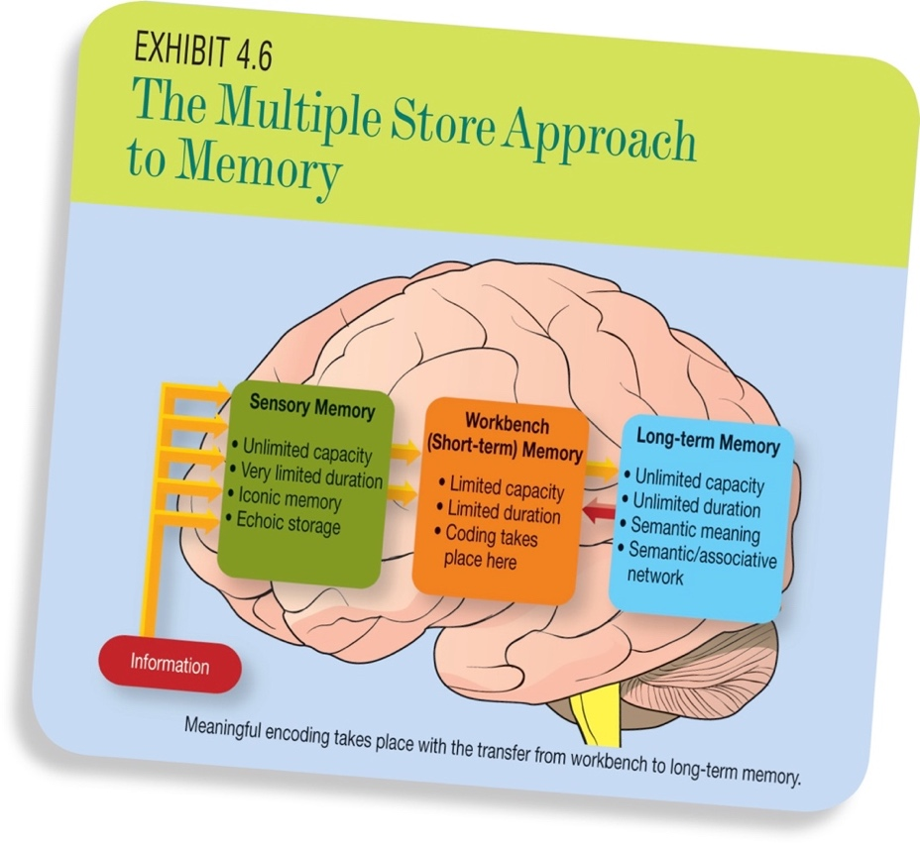

LO3 MAKING ASSOCIATION WITH MEANING AS A KEY WAY TO LEARN
- Four mental processes help consumers remember things.
  - Repetition, dual coding, meaningful encoding, and chunking.
Repetition
- Repetition is a process in which a though is held in short-term memory by mentally repeating the thought.
  - This process is known as rehearsal.
  - One major problem with this approach is cognitive interference.
    - Cognitive interference simply means that other things are vying for processing capacity when a consumer rehearses information.
Dual Coding
- Dual coding is coding that occurs when two different sensory traces are available to remember something.
  - Dual coding can be more effective than repetition.
Meaningful Encoding
- Meaningful encoding involves the association of active information in short-term memory with other information recalled from long-term memory. This leads to new information being coded with meaning.
Chunking
- Chunking is the process of grouping stimuli by meaning so that multiple stimuli can become one memory unit.
  - Chunking is an important mental activity because better chunking leads to improved recall.
Retrieval and Workbench Memory
- When a consumer retrieved information from long-term memory, it is processed once again in a workbench memory and as a part of this process, long-term memory is scanned for relevant information.
  - Through a process of response generation consumers reconstruct memory traces into formed recollection of the information they are trying to remember.
Long-Term Memory
- Long-term memory is a repository for all information that a person has encountered.
- Information stored in long-term memory is coded with semantic coding, which means the stimuli are converted to meaning that can be expressed verbally.
- Memory trace is the mental path by which some thought becomes active.
  - A memory trace shows how cognitive activation spreads from one concept to another. This is called spreading activation.
- Mental Tagging (tag) is a small piece of coded information that helps with the retrieval of knowledge.
- Rumination refers to unintentional but recurrent memories of long-ago events that are spontaneously triggered, but not evoked by the environment.
- Nostalgia a mental yearning to relive the past associated with emotions related to longing.

LO4 ASSOCIATIVE NETWORKS AND CONSUMER KNOWLEDGE
ASSOCIATIVE NETWORKS
- Associative network is referred to as a network of mental pathways linking all knowledge within memory.
  - It is sometimes referred to as a semantic network.
  - Knowledge in long-term memory is stored in an associative network.

DECLARATIVE KNOWLEDGE
- Declarative knowledge is a term used in psychology to refer to cognitive components that represent facts.
- Nodes simply represent concepts in the network.
- Paths show the association between nodes in the network.

LO5 PRODUCT AND BRAND SCHEMAS
- Schema is a type of associative network that works as a cognitive representation of a phenomenon that provides meaning to that entity.

EXEMPLARS
- Exemplar is a concept within a schema that is the best representative of some category.
  - McDonalds may be the category exemplar for fast-food.

PROTOTYPES
- Prototype is a schema that is the best representative of some category but that is not represented by an existing entity; gathering of the most associated characteristics of a category.
  - For ex. a “car salesman” category does not evoke a specific person who best represents that category. The image contains the characteristics most associated with a care salesperson.

REACTION TO NEW PRODUCTS/BRANDS
- When consumers encounter new products or brands, they react to them by comparing them to the existing schema.

SCRIPT
- Script is a schema representing an event.
  - Consumers derive expectations for service encounters from these scripts.
    - For ex. at a fine Italian restaurant, consumers expect the script to include valet parking, a formal greeting, etc.

EPISODIC MEMORY
- Episodic memory refers to the memory for past events, or episodes, in one’s life.

SOCIAL SCHEMATA
- Social schema (or social stereotype) is the cognitive representation that gives a specific type of person meaning.
  - The stereotype captures the role expectations of a person of a specific type.
    - Consumers are comforted by a surgeon who looks like a surgeon and acts like a surgeon.

ELABORATION
- Elaboration refers to the extent to which one continues processing a message even after an initial understanding is achieved.
  - Personal elaboration in which a person imagines himself or herself somehow associating with a stimulus that is being processed.
    - This provides the deepest comprehension and greatest chance of accurate recall.

CHAPTER FIVE
LO1 WHAT DRIVES HUMAN BEHAVIOUR?
- Motivations are the inner reasons or driving forces behind human actions as consumers are driven to address real needs.

HOMEOSTASIS
- Human motivations are oriented around two key groups of behavior. The first behavior is aimed at maintaining one in a current acceptable state.
- Homeostasis refers to the fact that the body naturally reacts in a way so as to maintain a constant, normal bloodstream.
  - For ex, when blood sugar falls low, the physiological reaction is hunger. This leads to motivating the consumer to get something to eat.

SELF-IMPROVEMENT
- The second group of behavior results from self-improvement motivation.
- Self-motivation is aimed at changing one’s current state to a level that is more ideal, not at simply maintaining the current state of existence.
  - For ex. consumers exercise to not only maintain themselves, but to improve their health and well-being.

LO2 A GENERAL HIERARCHY OF MOTIVATION
- Maslow’s hierarchy of needs is a theory of human motivation that describes consumers as addressing a finite set of prioritized needs.
- The list displays the set of needs starting with the most basic need.
  - Physiological is for basic survival (food, drink, shelter, etc.)
  - Safety and security is the need to be secure and protected.
  - Belongingness and love is the need to feel like a member of a family or community.
  - Esteem is the need to be recognized as a person of worth.
  - Self-actualization is the need for personal fulfillment.
- 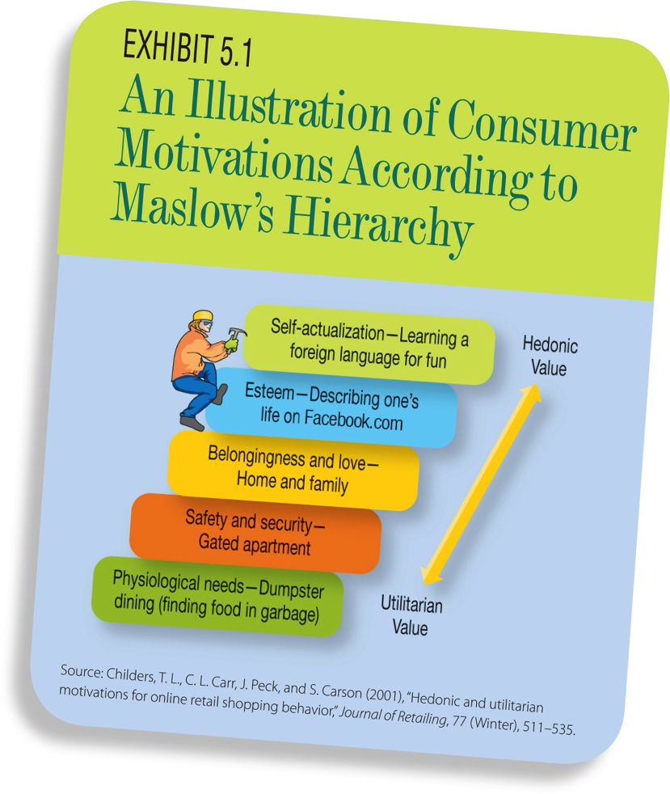

SIMPLER CLASSIFICATION OF CONSUMER MOTIVATIONS
Utilitarian Motivation
- Utilitarian motivation is a drive to acquire products that can be used to accomplish something.

Hedonic Motivation
- Hedonic motivation involves a drive to experience something personally gratifying.
- 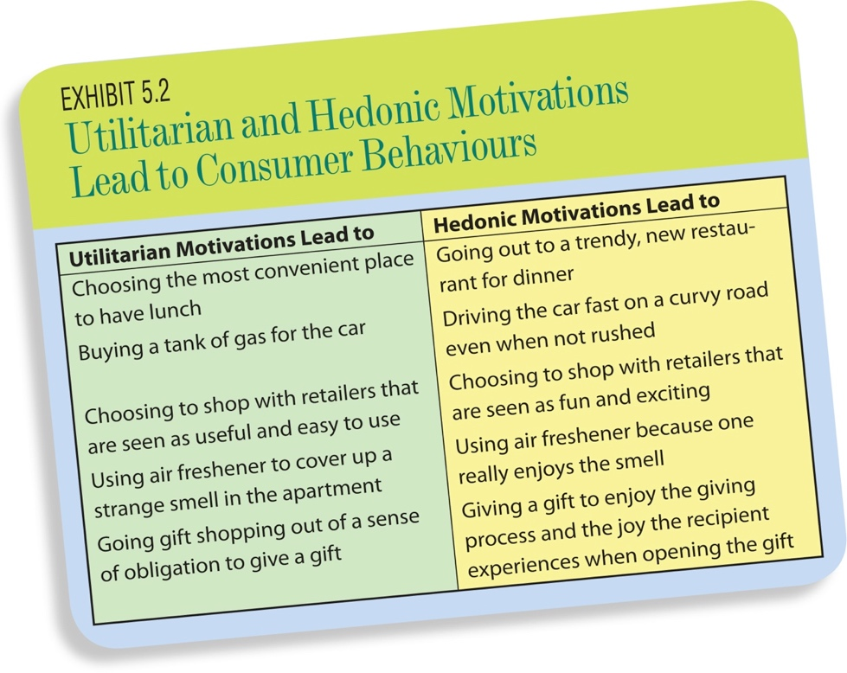

CONSUMER INVOLVEMENT
- Consumer involvement represents the degree of personal relevance a consumer finds in pursuing value from a given category of consumption.
Consumer Involvement as a Moderator
- Moderating variable is a variable that changes the nature of the relationship between two other variables.
- Consumers either have high involvement or low involvement depending on the situation.
Different Types of Consumer Involvement
- Product involvement means that some product category has personal relevance.
  - Product enthusiasts are consumers with high involvement in some category.
- Shopping involvement represents the personal relevance of shopping activities.
- Situational involvement represents the temporary involvement associated with some imminent purchase situation.
- Enduring involvement is not temporary but rather represents a continuing interest in some product or activity.
  - The consumer is always searching for opportunities to consume the product or participate in the activity.
- Emotional involvement represents how emotional a consumer gets during some specific consumption activity.
  - Emotional involvement is closely related to enduring involvement because the things that consumers care most about will eventually create high emotional involvement.

LO3 CONSUMER EMOTIONS AND VALUE
EMOTION
- Emotion are specific psychobiological reactions to human appraisal.
- Emotions are psychobiological because they involve both psychological processing and physical responses.
- Emotions create visceral responses as certain feeling states are tied to behavior in a very direct way.
- Both love and anger are controlling emotions in that they tent to shape one’s behavior strongly.

COGNITIVE APPRAISAL THEORY
- Cognitive appraisal theory represents an increasingly popular school of thought. Cognitive appraisal theory describes how specific types of thoughts can serve as a basis for specific emotions.
- There are four types of cognitive appraisals that are relevant for consumer behavior.
  - Anticipation appraisals which focuses on the future and can elicit emotions like hopefulness or anxiety.
  - Agency appraisals which reviews responsibility for events and can evoke gratefulness, frustration, guilt, or sadness.
  - Equity appraisal which considers how fair some event is and can evoke emotions like warmth or anger.
  - Outcomes appraisal which considers how something turned out relative to one’s goals and can evoke emotions like joyfulness, satisfaction, sadness, or pride.
  - 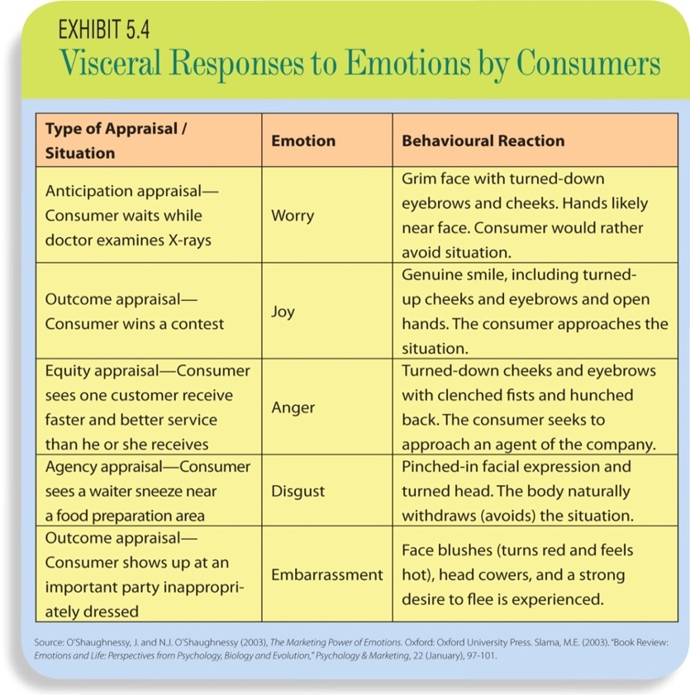

EMOTION TERMINOLOGY
Mood
- Consumer mood can be thought of as a transient (temporary and changing) and general feeling state often characterized with simple descriptors.
  - Mood-congruent judgments are evaluations in which the value of a target is influenced in a consistent way by one’s mood.
Affect
- Affect is another term used to represent the feeling a consumer experiences during the consumption process.
  - In consumer behavior, consumer affect is more often used to represent the feelings a consumer has about a particular product or activity.

LO4 MEASURING EMOTION
AUTONOMIC MEASURES
- Autonomic measures are those responses that are automatically recorded based on either automatic visceral reaction or neurological brain activity.
  - Autonomic measures assess emotional arousal by measuring physical responses such as sweat, heart rate, and neurological brain activity.
  - Such measures are objective (not subject to interpretation), but are highly intrusive and may themselves arouse emotions such as stress and anxiety.
SELF-REPORT MEASURES
- Self-report measures rely on an individual’s recall of emotions experiences in a situation.
  - While less intrusive, these assessments are limited by the individual’s ability to accurately recall and express their emotions in words.
PANAS (Positive-affect-negative-affect scale)
- Allows respondents to self-report and assess their emotional state.
- The scale like PANAS allows them to capture both positive and negative dimensions of emotional experience.
PAD (Pleasure-arousal-dominance)
- PAD is a self report measure that asks respondents to rate feelings using semantic differential items.
- The theory behind PAD, unlike PANAS, is that pleasure – the evaluative dimension of emotion – is bipolar.
  - Bipolar is that one feels joyful, one cannot also experience sadness.
    - Arousal, which is the degree to which one feels energized, excited or interested is also seen as bipolar.

LO5 DIFFERENCES IN EMOTIONAL BEHAVIOUR
EMOTIONAL INVOLVEMENT
- Motivation and involvement are closely related.
Flow
- Flow is extremely high emotional involvement in which a consumer is engrossed in an activity.
  - For ex. you yell at the TV.

EMOTIONAL EXPRESSIVENESS
- Emotional expressiveness represents the extent to which a consumer shows outward behavioral signs and otherwise reacts obviously to emotional experiences.
  - For ex. a bad poker player is unable to hide emotions from other players.
  - Two individuals may feel the same level of emotion, but not show it equally.

EMOTIONAL INTELLIGENCE
- Emotional intelligence is a term used to capture an individual’s awareness of emotions experiences in a given situation and the ability to control reactions to these emotions.
  - This includes the awareness and sympathy for the emotions experienced by others.
  - Awareness of emotions in themselves and in others.
  - Emotional intelligence consists of multiple elements.
    - 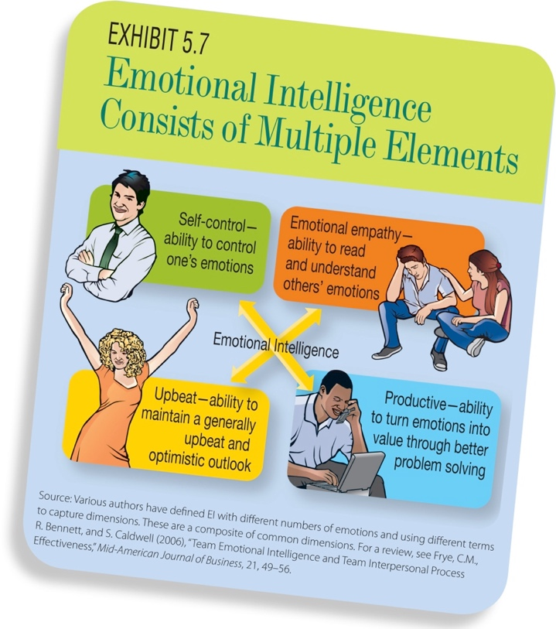

LO6 EMOTION, MEANING, AND SCHEMA-BASED AFFECT
SEMANTIC WIRING
- Consumers link concepts for memory retrieval.
- The active process and storage of knowledge is influenced by emotions.
  - This expression is called “emotional effect on memory”.
    - Emotional effect on memory refers to relatively superior recall for information presented with mild affecting content compared with similar information presented in an affectively neutral way.
- When marketing presents a product that evokes emotions, consumer recall is likely to increase.

MOOD-CONGRUENT RECALL
- Events are associated with moods.
- When a mood can be controlled by marketing, consumer’s evaluations of a product can be influenced.
- Autobiographical memories are memories of previous, meaningful events in one’s life.
- Mood-congruent recall is consumers will remember information better when the mood they are currently in matches the mood they were in originally exposed to the information.

NOSTALGIA
- Events in the past may be remembered more positively than they were in reality.
- Consumer can make purchases based on nostalgic feelings brought up about the past by the product.

SCHEMA-BASED AFFECT
- Schema-based affect are emotions that become stored as a part of the meaning for a category (a schema).
- 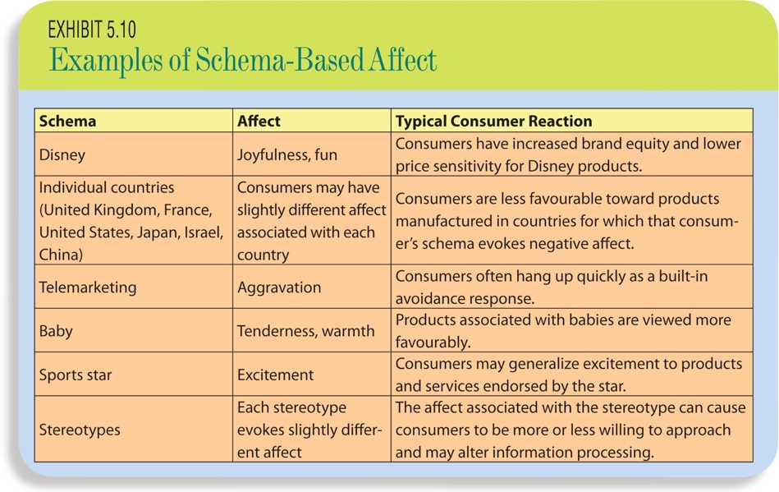
Aesthetic Labor
- Aesthetic labor is effort put forth by employees in carefully managing their appearance as a requisite for performing their job well.
- To generate a specific emotional reaction from consumers, employees carefully manager their personal appearance.

SELF-CONSCIOUS EMOTIONS
- Specific emotions that result from some evaluation or reflection of one’s own behavior, including pride, shame, guilt, and embarrassment.
- Self-conscious ads can be very powerful.

EMOTIONAL-CONTAGION
- Emotional contagion represents the extent to which an emotional display by one person influences the emotional state of a bystander.
Emotional Labor
- Emotional labor effort put forth by service workers have to overtly manage their own emotional displays as part of the requirements of the job.
  - For ex. flight attendants have to remain happy even if they feel angry.
Product Contamination
- Product contamination refers to the diminished positive feelings someone has about a product because another consumer has handled the product.
  - For ex. the cardboard is missing inside the shirt, makes you think if someone else returned the shirt and it creates uneasiness.

