Lecture 1- 01/17/2017
Chapter 1&2

Cost: resources used to actualize a specific object
Object: cost object or cost objective (a product or service for which costs are measured and assigned.
- Refers to value forgone to achieve a purpose
- In specific refers to economic resources paid for goods and services
- Direct costs: costs that are easily traced to a cost object
  - i.e. purchase cost of fresh fruits and vegetables
- Indirect Costs: costs that can’t be traced to an object.
  - Ex. Manufacturing companies have 3 inventor accounts to account for costs
- Raw material inventory
- Work in process
- Finished goods inventory
- In manufacturing accounting there are 3 cost components
- Direct materials: those inputs that physically turn into output. Materials that are part of the final product and are directly traced to the goods being produced.
  - Ex. Paper to produce books
- Direct labour: wages for employees who convert direct materials into products
  - Ex. Wages paid to assembly line workers
- Overhead: includes all other manufacturing costs associated with the manufacturing process except direct materials and direct labour. Known as the factory burden or indirect manufacturing costs. These can’t be easily traced to object.
  - Ex. Factory rent, factory utilities, factory repair and maintenance costs, factory insurance , indirect labour
Manufacturing costs= direct material + direct labour + overhead

Seven cost equations for manufacturing companies
- Beginning direct materials | + direct materials purchased | = direct materials available for use
- Direct materials available for use | - Ending direct material inventory | = direct materials used
- Direct materials used | + direct labour cost | + overhead cost | = total manufacturing cost
- Total manufacturing cost added | + beginning work in process | = total manufacturing cost in process
- Total manufacturing cost in process | - ending work in process | = cost of goods manufactured

Equations 1 to 5 can be used for the cost of goods manufacturing statement
- Cost of goods manufactured | + beginning finished goods inventory | = cost of goods available for sale
- Cost of goods available for sale | - ending finished goods inventory | = cost of goods sold

Equations 6&7 are represented by cost of goods sold statement section on the income statement

Cost Classifications:
- Actual cost vs. estimated cost
- Actual cost is historical (what actually happened)
- Estimates costs are not actual, based on estimation
  - Predetermined costs
  - Forecasted cost estimate based on assumption of the future
  - Budgeted cost
- Total costs vs. average cost per unit
- Average cost= total cost / activity volume(activity level)
  - Eg. If company produces tables and spends $1000 to produce 10 tables. What is the average cost?
    - Average cost= $1000/10= 100 per unit
- Fixed cost vs. variable cost
- Cost behaviour the relationship between cost and activity volume
- Variable cost: the total cost change in response to the change in activity volume
- Fixed cost: when the total cost is constant within a specific relevant range
  - Relevant range: can be in terms of time length or activity volume
  - Ex. Factory rent is $50,000 to rent space of 10,000 sq.m. to produce up to 400,000 table every year
  - **diagram
  - Ex 2. We pay $80,000 to rent more space, 16,000 sq.m. to produce up to 640,000 every year
  - **diagram
Combining 1 & 2 classification
 | Total cost | Average cost
Variable cost | Change | no change
Fixed cost | No change | Change

Eg. $50,000 rent
Year 1: volume= 5000 units.
Average cost= 50,000/5000= $10 per unit
Year 2: volume= 10,000
Average cost= 50,000/10,000=$5 per unit

- product cost vs. period cost
- product cost: inventoriable cost can be inventory but depends on the time you sell your product
  - cost directly attached to product units when the cost is incurred.
  - i.e. the product units is the direct cost object
    - Eg. Merchandise purchases
    - Eg. Cost of goods manufactured
- period cost: non-inventoriable cost it is 100% sure this will become an expense at the end of the year
  - cost allocated to the accounting period when it is incurred
  - i.e. the functional item are the cost objects
    - Eg. Selling expenses cost incurred to the selling function
    - Eg. Administrative expenses
**diagram 2
- Prime cost vs. conversion cost
- Prime cost: direct material + direct labour
- Conversion cost: direct labour + overhead
  - Cost to convert materials into products
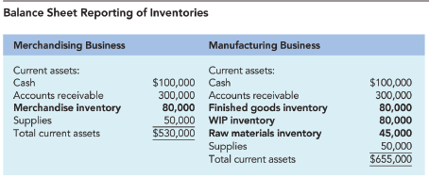

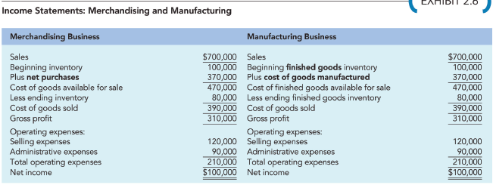
Homework: Q:29, Case 38

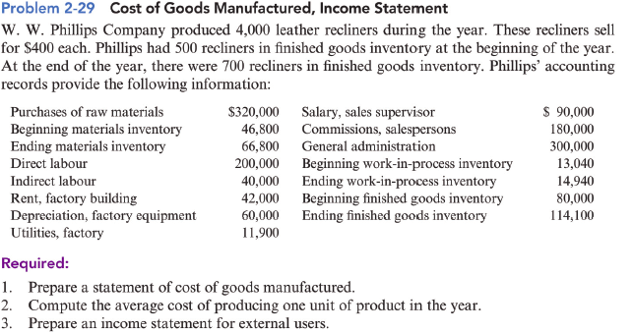

- W.W. Phillips company
Statement of cost of goods manufactured
For the year
beginning material inventory $46,800
+ material purchased $320,000
=material available for use $366,800
- ending direct material inventory $66,800
=direct materials used $300,000
+direct labour cost $200,000
+overhead costs:
indirect labour $40,000
Rent $42,000
Depreciation factory equipment $60,000
Utilities $11,900
total overhead costs: $153,900
=total manufacturing cost added $653,900
+beginning work in process inventory $13,040
=total manufacturing cost in process $666,940
- ending work in process inventory $14,940
=cost of goods manufactured $652,000

production volume: 4000
price: $400
beginning finished goods inventory in units- 500
ending finished goods inventory in units- 700

2) average cost to produce 1 unit: total cost/ production volume
$652,000/4000
$163 per unit
3) W.W.Phillips
Income Statement
For the year
Sales revenue $400 x sales volume = 400x3800 = 1,520,000
- cost of goods sold
cost of goods manufactured $652,000
+ beginning finished goods inventory $80,000
=cost of goods available for sales $732,000
- ending finished goods inventory $114,100
= cost of goods sold $617,900
= gross margin/profit (sales rev – CofGS) = $902,100
- operating expenses
selling expenses
sales supervisor’s salary $90,000
commissions $180,000
=Total selling expenses $270,000
+administrative expenses
General admin expenses $300,000
= Total operating expenses $570,000
Income = (GP – Total operating expenses) 332,100

Equation 6&7 in units:
sales volume= beginning finished goods inventory in units
+
units produced in the year
-
ending finished goods inventory in units
∴ Sales volume= 500 +4000 – 700
= 3800

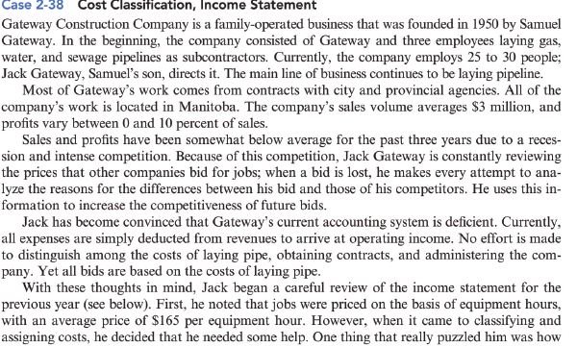
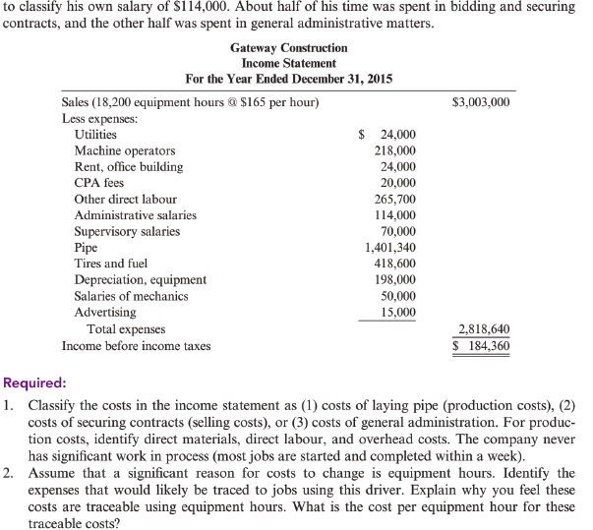

Professional judgment: the reason why accountants make more money then book-keepers. The difference is that a professional accountant exercises professional judgment while a book-keeper follows rules ∴they are considered professionals and make more money
How to Evaluate Professional Judgement:
Based on facts, logics, Accounting Principles

1)
Production cost | Selling cost | General administration
- supervisory salary -OH  - pipe-DM  - tires and fuel-OH  - depreciation, equipment-OH  - salaries of mechanics -OH  - machine operators - DL  - other direct labour-DL | - admin salaries (1/2)  - advertising | - machine operating-DL  - rent  - admin salaries (1/2)  - utilities

2)
traceability: cost and effect relationship
cost driver: an indirect cost allocation base
supervisors salary is not traceable because it depends on the amount of hours the employee works ∴ not fixed
sometime pipes would be excluded because it is not going through the indirect allocation process
Continuation from 2i) traceable cost for equipment hour
= 2,551,640/18,200 eq hour
= 140,000 per equ hour
ii) **without supervisor salary and direct materials (pipe)
traceable cost per hour
= $1,150,000/18,200 eq hour
= $63.20
iii) **without materials(pipe) but add back supervisor salary
traceable cost per hour
=

