

People, Places and Environments

GEOG/ENST 1020B (2017)

Tutorial Assignment 1
Uneven Development

Prof. Paul B. Williams
TA: Doug Pawson
Name: Rajarshi Bose
Student ID: 101014164
Date: 14/02/2017

Questions

- Explain one weakness of using GDP (PPP) per capita as an indicator of a country’s standard of living or quality of life. (1 mark)

- Gross Domestic Product (GDP) can be described as the value of goods and services provided in a country in one-year time period. GDP per capita can be defined as the total GDP of a country divided by the number of people which helps to analyze and compare relative performances between countries. However, a performance of a country and standard of living/quality of life in a country are two different things due to many reasons. GDP does not incorporate the factor of leisure and happiness into peoples’ lives. For instance, a country can have massive production of goods and services if people work for long hours however they don’t get any time to spend with their family/ friends. They get no time to do anything productive for themselves. GDP per capita does not measure the change in the quality of life, uneven wealth distribution, economic health, literacy rates, life expectancy showing that the country has good healthcare systems, and many similar factors as such.

- Outline the key features of the Human Development Index (HDI). Explain why it is considered a better indicator of quality of life than GDP (PPP) per capita. (3 marks)

- Human Development Index (HDI) measures the overall well-being of a person in a country. It incorporates various factors such as literacy rates, life expectancy, measures the standard of living by looking at gross national income (GNI). The fact that it incorporates so many factors makes it very comprehensive in order to track a country’s development. In addition, measuring a country’s wealth cannot be regarded as a good indicator as the country has to invest that wealth so that the lives of the people improve. There is more economic development rather than better quality of life for people. Country like India has a high GDP growth but has a very low HDI. India’s GDP is growing because the country is determined for mass production of goods and services however there is a huge uneven distribution of wealth and uneven development where there are poor facilities in the rural areas which is not letting the HDI index grow. In order for a better quality of life, implements have to be made that strictly relates with the people’s lives such as health care, education, safety etc. India has to improve in those areas in order for the people to have a good quality of life.

- Identify and describe a specific example of social and spatial disparity for India evident in Table 1. Identify and describe a social or spatial disparity that Nigeria shares with India. Do national-level data or indexes hide more than they reveal? Discuss with reference to specific indicators presented in Table 1. (5 marks)

Table 1: Selected social and economic indicators for India (national, and the states of Bihar and Kerala) and Nigeria (national, and the states of Abia and FTC Abuja)

Country/state | Life Expectancy | Literacy rate |  | HDI Rank^ | Income Inequality Indicator* | GDP (PPP)  per capita
 |  | National | For women
INDIA | 65.4 years | 61.0% | 47.8% | .619 | 7.0 | 3,104
Bihar | -- | -- | -- | -- | -- | 2,162
Kerala | -- | -- | -- | -- | -- | 5,263
NIGERIA | 51.9 years | 61.3% | 50.4% | .470 | 24.9 | 2,276
Abia | -- | -- | -- | -- | -- | 407
FTC Abuja | -- | -- | -- | -- | -- | 10,208

Notes: * The inequality indicator (10% richest/10% poorest) is a measure of wealth discrepancy in a country. A value of 30, for instance, indicates that the richest 10% of the population earns 30 times more than the poorest 10% of the population. ^ Using HDI Index in 2010 or before.

Sources: Human Development Report 2005, http://hdr.undp.org; Human Development Report, Nigeria (2008-2009), www.ng.undp.org; CIA Factbook, https://www.cia.gov/library/publications/the-world-factbook/ and http://www.imf.org/external/pubs/ft/weo/2011/02/weodata/index.aspx

- One prominent social disparity in India can be clearly seen in the section of literacy rate. It is clearly evident that the female literacy rate is lower than the average national literacy rate. The two states for comparison of spatial disparity in India have been provided in Table 1 which are Bihar and Kerala. Kerala has a much higher GDP (PPP) than Bihar with a difference of 3101 (PPP). Kerala’s GDP (PPP) is a lot higher than the national average as well with a difference of 2159 (PPP). The fact that Kerala has a higher GDP (PPP) is because Kerala is considered as the state of India with the highest literacy rate as shown in Image 1. Literacy rates have a huge correlation with the GDP because with better knowledge and with better ideas, production of advanced technologies grow resulting in a better economy. Both India and Nigeria share a common social disparity and that is the average women and the average national literacy rates. The average women literacy rate in Nigeria is 50.4% whereas in India it is 47.8% and the average national literacy rate in Nigeria is 61.3% whereas in India it is 61.0%. It can be clearly seen in both countries that the women literacy rates are lower than the national literacy rate with an average difference of 12%. There are a lot of distortions regarding national level data or indices where the data is usually hidden than revealed. Here the data is distorted because countries like India and Nigeria are victims of child marriage, gender inequality, and female infanticides. By thinking about these factors it can be deduced that the literacy rates shown here are a lot higher than it should be.
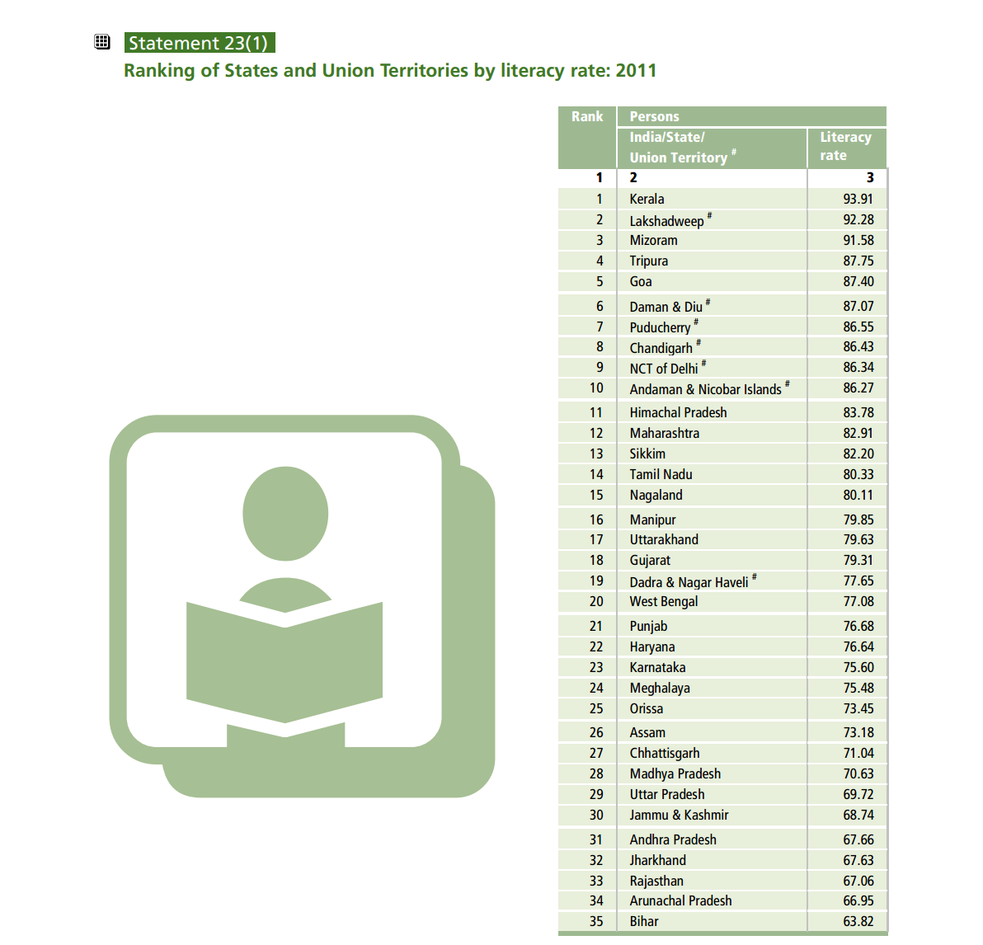
- Image 1- showing the literacy rates of all the states of India
Source: http://censusindia.gov.in/2011-prov-results/data_files/india/Final_PPT_2011_chapter6.pdf

- To answer this question, please refer to “Window on the World 7.2: China’s Economic Development” (pp. 244-245), and to the required readings as necessary.

Provide a brief description of China’s economic development and the pattern of uneven development created by these relatively recent changes. How does China’s economic development highlight the interdependence of places in the globalizing economy? Provide your answer in a carefully-worded paragraph, referring to the term “de-industrialization” (p. 254) and other important details from “Window on the World 7.2” (6 marks)

- China’s illustrious economy has always had its significant place in the world economy. In 2001, China became a member of the World Trade Organization which became very profitable for its economy. The production levels increased by 10% which made China’s economy the world’s third largest economy. Foreign investments in China is the major reason for its booming economy resulting in many opportunities for the growth of industries as well as real estates. Uneven economy however is clearly evident as the northwestern region of Gansu province and the southwestern region of the Sichuan province still struggle to thrive due to extreme poverty. China’s big economy makes it a major producer however the labor wages have stayed the same for many years. The average labor wage is said to be 60 cents an hour imposing a pattern of deflation and extreme competition leading to intensified globalization and deindustrialization in different countries such as South Korea, Taiwan, and Japan. These countries suffered as it was hard for them to compete with China in terms of low cost production thus, they had to shift their production to China which heavily impacted their economies. The aftermath was high levels of unemployment rates and a huge negative impact on the economy.

