QMS 102: Business Statistics l
Lecture 1:
Statistics: Way to get information from data. Tool utilized to create a new understanding from a set of numbers.

- Transforms numbers into information
- Quantify & Identify

- Reduces variations

Data: Facts collected together. DefineCollectOrganizeVisualizeAnalyze (DCOVA)
- Interval data: Numerical. Consistent & meaningful.
- Ratio: 2 things to compare
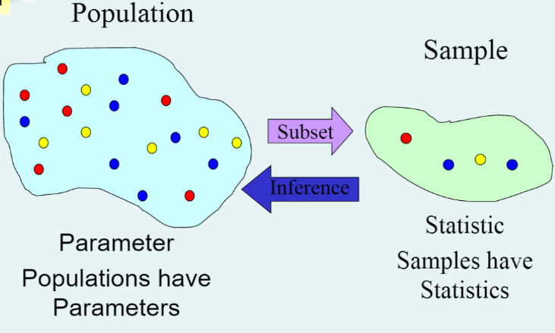
- Nominal data: Categorical. Arbitrary.
- Frequency distribution
- Relative frequency distribution: proportion in which the category occurs.
- Ordinal Data: Based on order. Ranking is important.
Mean: Average of numbers
Population: Group of all the items of interest
Parameter: A descriptive measure of a population.
Sample: A set of items drawn from the population.

Statistic: A descriptive measure of a sample. We make inferences about the population.
- Descriptive Statistics: Methods for Arrangement, Analyze, summary and presentation of data. No conclusions.
- Graphical techniques
- Visual techniques
- Inferential Statistics: Estimation, inferences and conclusions.
- Estimation
- Hypothesis testing
Inference from sample of a Population.
Variable: A characteristic of population or sample.
- Categorical(qualitative): yes/no
- Numerical: have valuables that represent quantities.
- Discrete: Counting process
- Continuous: Measuring process

Lecture 2:
Stem and Leaf
Stem Rules:

- 6-13 stems
- Consecutive or repeated numbers. Twice or 5 times.
- Always indicate stem units
- Always one leaf associated with the first and last stem

Leaf Rules:

- Leaf is the next singles digit after the stem
- NO rounding
- Ascending order when they’re positive and descending when they’re negative
- The shape of the data can be Skewed to the Left, Symmetrical or Skewed to the Right

Frequency Distribution

- 5-10 classes
- N# and under N# (Boundaries0
- Class Width = Upper Boundary – Lower Boundary
- No Gaps
- All classes must have the same width
- The first and last class must contain frequencies
- Boundaries must look like the data, they should be multiples of the class width

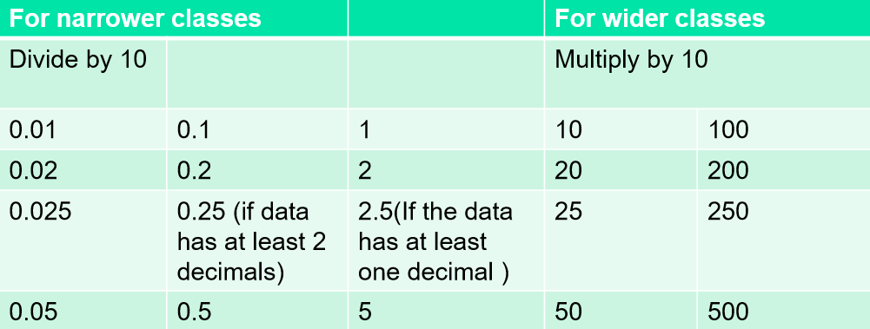

- Nice numbers; 1, 2, 2.5, 5
- Estimated class width =
Highest value – Lowest value
Number of classes (5-10)
- The estimated number will give you two numbers from the nice numbers table that will give you the class width

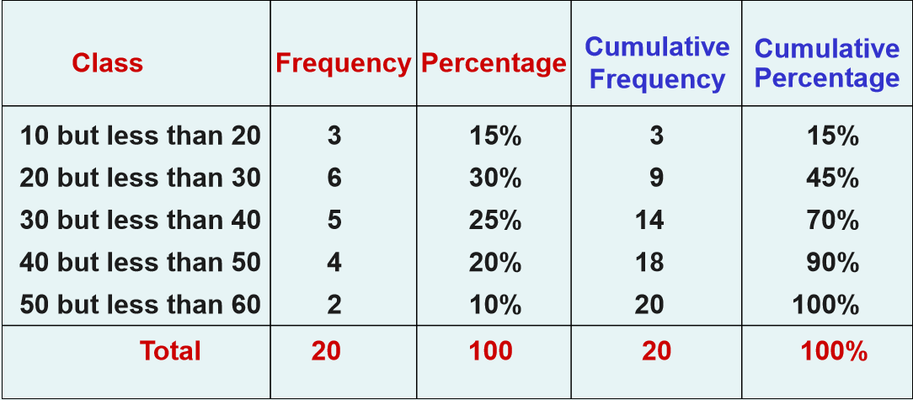

Histogram:
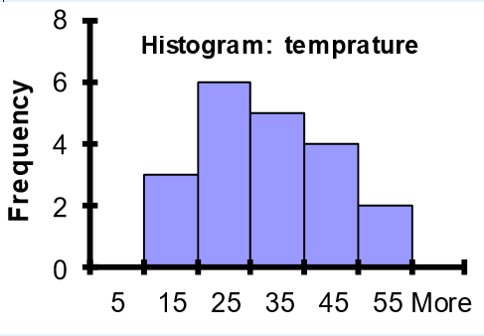
- Vertical Bar chart
- NO gaps between bars
- Class boundaries (or class midpoints) are on the horizontal axis
- Vertical axis shows: frequency, relative freq. or %

Percentage Polygon
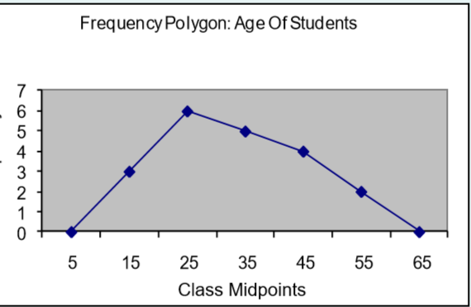
- The midpoint of each class represents the data in that class and then connects the sequence of midpoints

Cumulative Percentage Polygon – Ogive
- Displays variable of interest along the X axis and cumulative along the Y axis

Lecture 3:
Histogram v/s Bar chart
- Everything is next to each other
- Numerical data ex: discrete/continuous
- There’s space between
- There’s Nominal data

Percentiles

Tienes que redondear al 0.5 más cercano. Ejemplo 4.7 se convertirá en 4.5. 5.8 se convertirá en 6.
3.5 < 3.7 < 4 -> 4
4.5 < 4.8 < 5 -> 5

Step l: Arrange the data into an ascending data array.
Data 18 18 18 20 20 20 20 21 22 22 24 25 28 29 29 38 40 45 52 63
Rank 1 2 3 4 5 6 7 8 9 10 11 12 13 14 15 16 17 18 19 20
18, 18, 18, 20, 20, 20, 20, 21, 22, 22, 24, 25, 28, 29, 29, 38, 40, 45, 52, 63
1 2 3 4 5 6

Lecture 4:
Central Location(Average): Reflects the locations of all the data points.
Mean / Average / Arithmetic Mean/ Promedio:
Se suman todas las propiedades y se divide por la cantidad total de propiedades.
Mean = Sum of the observations
Number of observation

_
X = Arithmetic mean for a Sample
Extreme Values: Outliers

Population:
Size: N
Mean: µ

Sample:
n
__
X

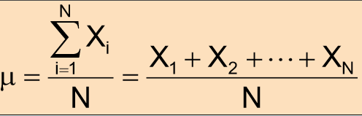
Population Mean (µ):
N = Population size
Xi = ith value of the variable X

Properties:

